Sri Lanka Institute of Information Technology



IT3091 – Machine Learning
Year 2, Semester 2- 2026

Practical Answer Submission

Practical Sheet No: 03

Student ID | IT24103352
Student Name | M.A.W.AHAMED
Campus/ Center name | Kandy Uni
Specialization | AI
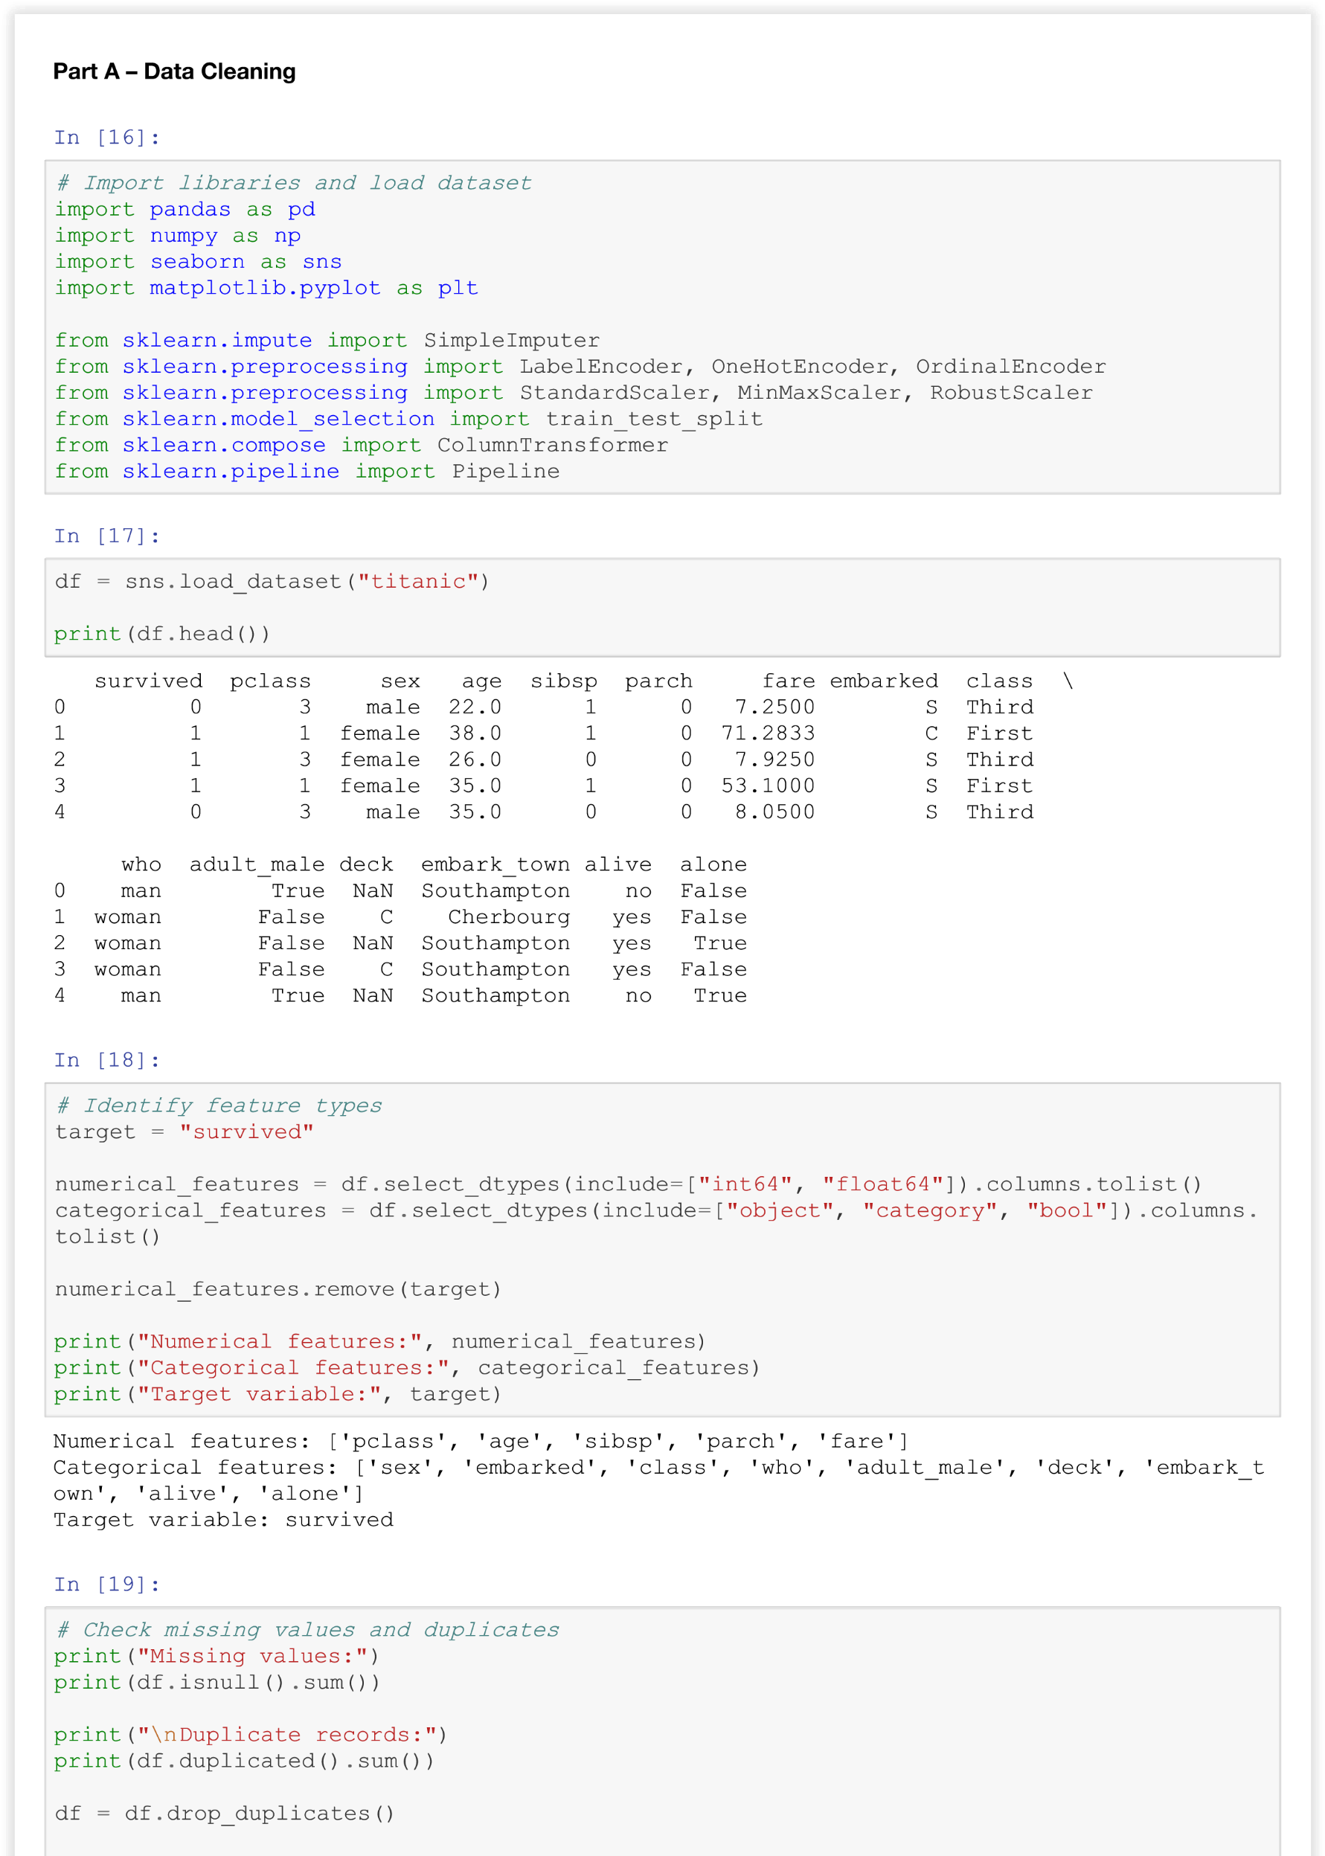

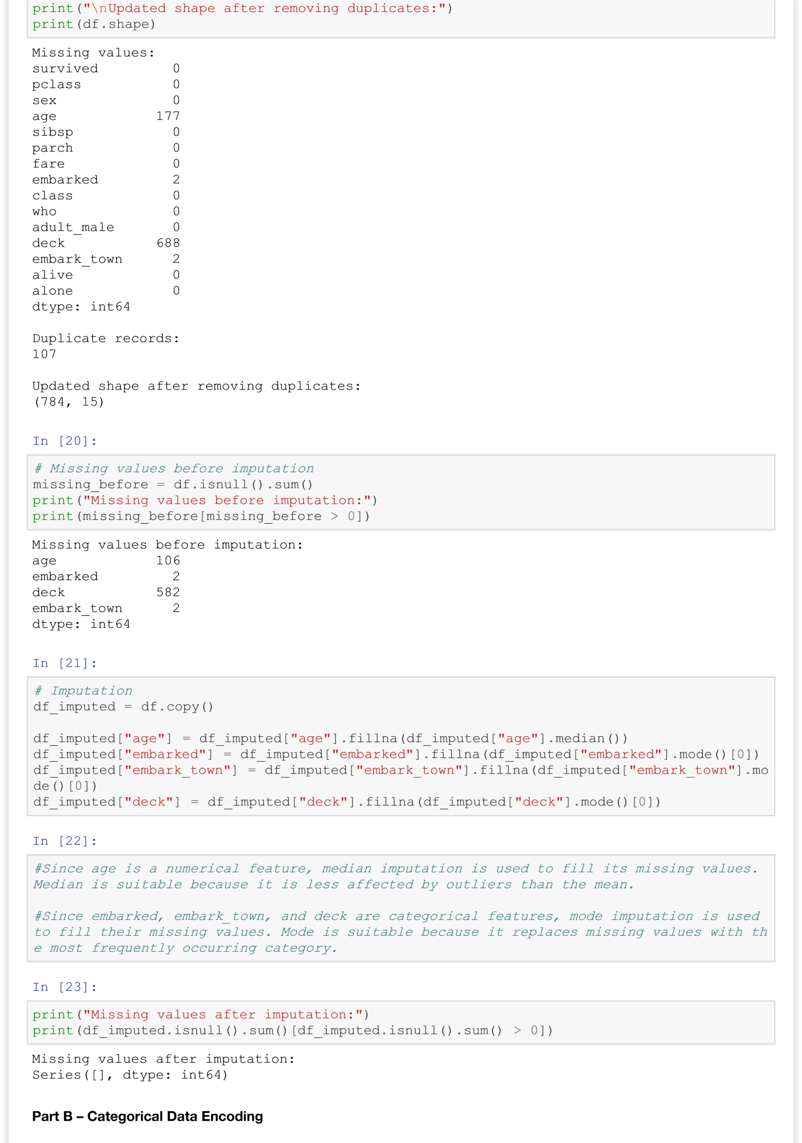
In [24]:



# Identify categorical feature types target = "survived" categorical_features = df_imputed.select_dtypes(include=["object", "category", "bool"]). columns.tolist()
binary_categorical = [col for col in categorical_features if df_imputed[col].nunique() =
= 2]
nominal_categorical = ["embarked", "embark_town", "who", "adult_male", "alone"]
ordinal_categorical = ["class", "deck"]
print("Binary categorical features:", binary_categorical)
print("Nominal categorical features:", nominal_categorical) print("Ordinal categorical features:", ordinal_categorical)
Binary categorical features: ['sex', 'adult_male', 'alive', 'alone']
Nominal categorical features: ['embarked', 'embark_town', 'who', 'adult_male', 'alone'] Ordinal categorical features: ['class', 'deck']
In [25]:
# Encoding encoded_df = df_imputed.copy()
# Label encode binary categorical features label_encoder = LabelEncoder()
for col in binary_categorical: encoded_df[col] = label_encoder.fit_transform(encoded_df[col])
# One-hot encode nominal categorical features encoded_df = pd.get_dummies(encoded_df, columns=nominal_categorical, drop_first=True)
# Ordinal encode class class_order = [["First",
"Second", "Third"]] class_encoder =
OrdinalEncoder(categories=class_order) encoded_df[["class"]] = class_encoder.fit_transform(encoded_df[["class"]])
# Ordinal encode deck deck_order = [["A", "B", "C",
"D", "E", "F", "G"]] deck_encoder =
OrdinalEncoder(categories=deck_order) encoded_df[["deck"]] = deck_encoder.fit_transform(encoded_df[["deck"]])
print(encoded_df.head())
survived pclass sex age sibsp parch fare class deck alive \ 0 0 3 1 22.0 1 0 7.2500 2.0 2.0 0
- 1 1 0 38.0 1 0 71.2833 0.0 2.0 1
- 1 3 0 26.0 0 0 7.9250 2.0 2.0 1
- 1 1 0 35.0 1 0 53.1000 0.0 2.0 1
- 0 3 1 35.0 0 0 8.0500 2.0 2.0 0
embarked_Q embarked_S embark_town_Queenstown embark_town_Southampton \ 0 False True False True
- False False False False
- False True False True
- False True False True
- False True False True
who_man who_woman adult_male_1 alone_1 0
True False True False
- False True False False
- False True False True
- False True False False
- True False True True
In [28]:
#Binary categorical features such as sex, alive, adult_male, and alone are encoded using
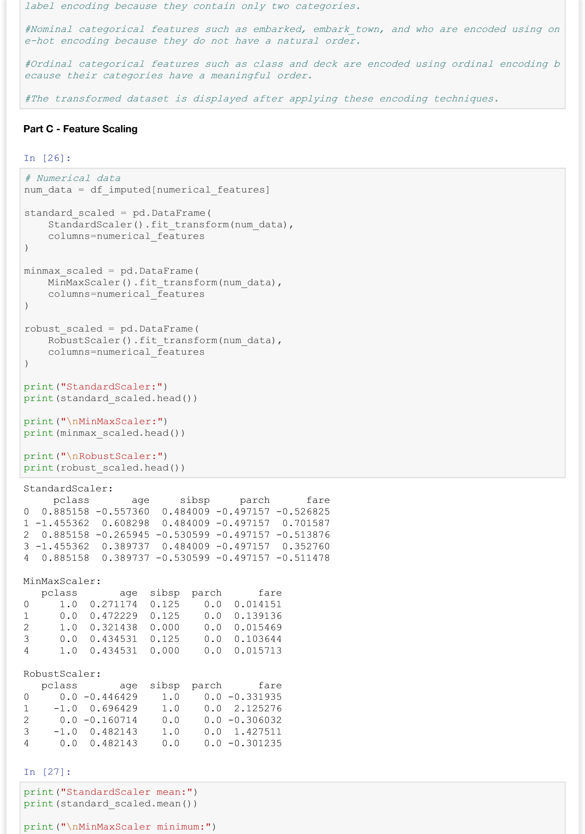
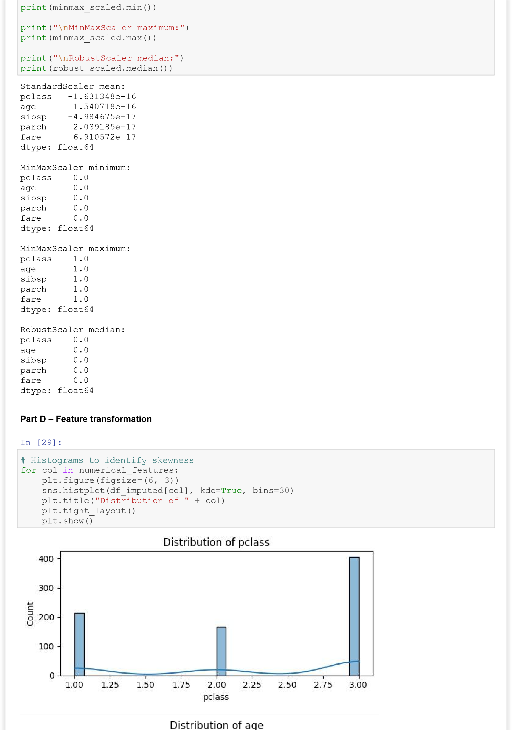
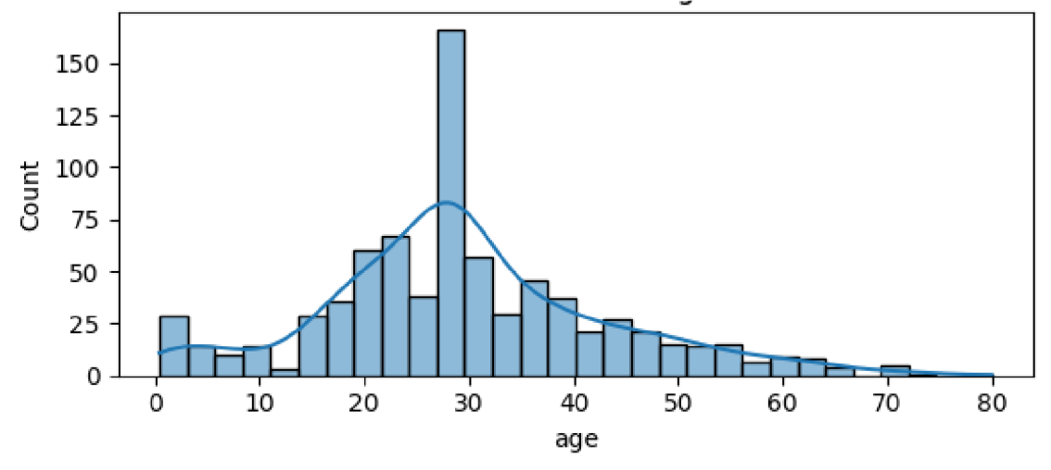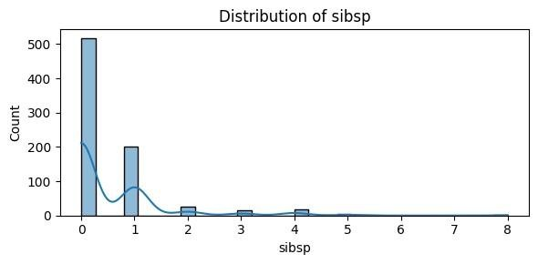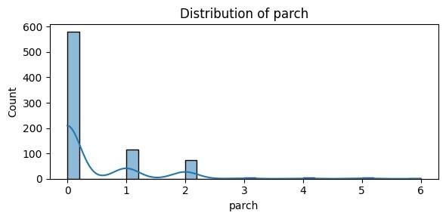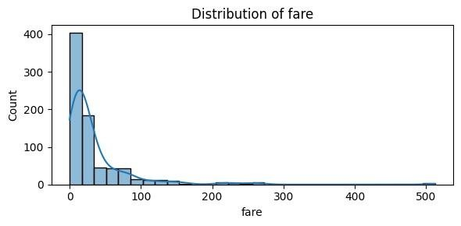
In [30]:
