
Sri Lanka Institute of Information Technology

SE2020 - Web and Mobile Technology

Year 2, Semester 2- 2026

Lab Test Answer Submission

Student ID | IT24103352
Student Name | AHAMED
Campus/ Center name | KANDY
Specialization | AI
Batch No

SE2020 – Web and Mobile Technologies​
Faculty of Computing
SLIIT
Lab Test
2 Hours
STUDENT-IT = IT24103352
NAME = AHAMED M.A.W

Item Manager MERN Application Enhancement and Deployment

1. Lab Test Overview
You are provided with a starter MERN Item Manager project containing separate frontend and backend applications. Your task is to complete the given project, extend it by adding a new field called Discount Percentage, test it locally using your own MongoDB connection string, publish the source code to a public GitHub repository, and deploy the frontend and backend separately using free hosting platforms.

2. Expected Skills Demonstrated
- Understanding and completing an existing MERN project structure.
- Updating both frontend and backend to support a new data field.
- Testing the system locally using MongoDB Atlas or an equivalent MongoDB connection.
- Using Git and GitHub to publish the full project in a public repository.
- Deploying frontend and backend separately and connecting the live frontend to the live backend.

3. Resources Provided
- Frontend project of the Item Manager application.
- Backend project of the Item Manager application.
- Basic CRUD functionality already included in the starter project.
- You are expected to complete, test, and deploy the provided codebase during the lab test.

4. Tasks to Be Completed

Task 01 – Project setup and local verification
• Extract the provided Item Manager project (Frontend & Backend).

Backend Setup
• Open the backend project in a terminal or VS Code.
• Install required dependencies:
npm install
• Configure the environment variables:
- Add your MongoDB Connection URL in the .env file
- Example:

MONGO_URI=your_mongodb_connection_string
PORT=5000
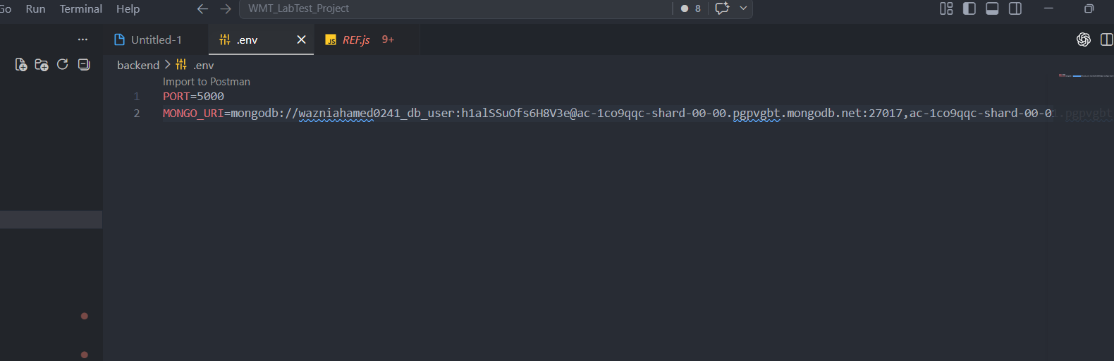

• Start the backend server:
npm run dev
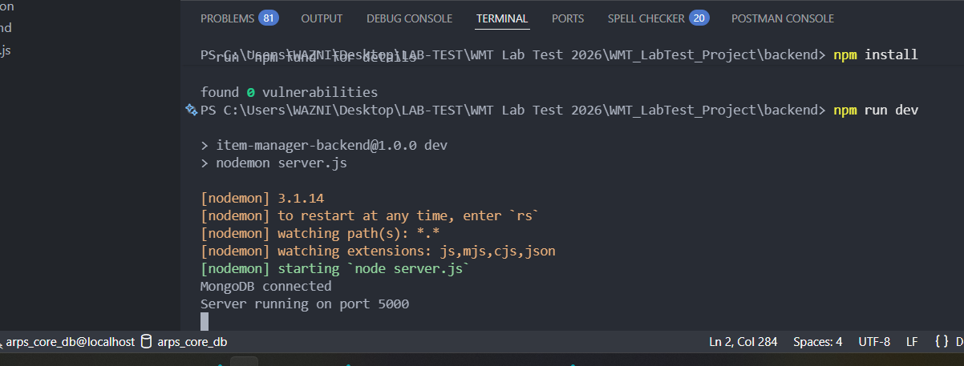
• Ensure the backend runs without errors.

Frontend Setup
• Open the frontend project in a new terminal or VS Code.
• Install dependencies:
npm install
• Start the frontend application:
npm run dev
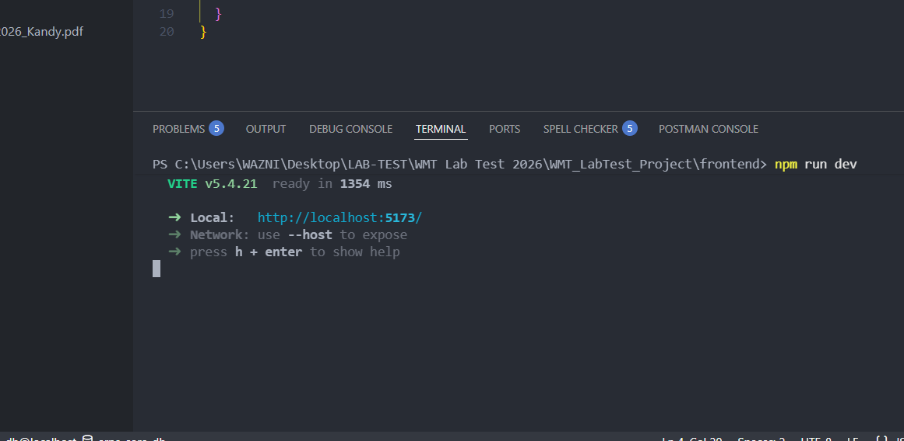

Verification
• Open the application in your browser (http://localhost:5173).
• Verify the following:
- Application loads successfully
- You can navigate between pages
- Existing features (Add Item / View Items) are working
- Capture screenshots of the local running existing system.

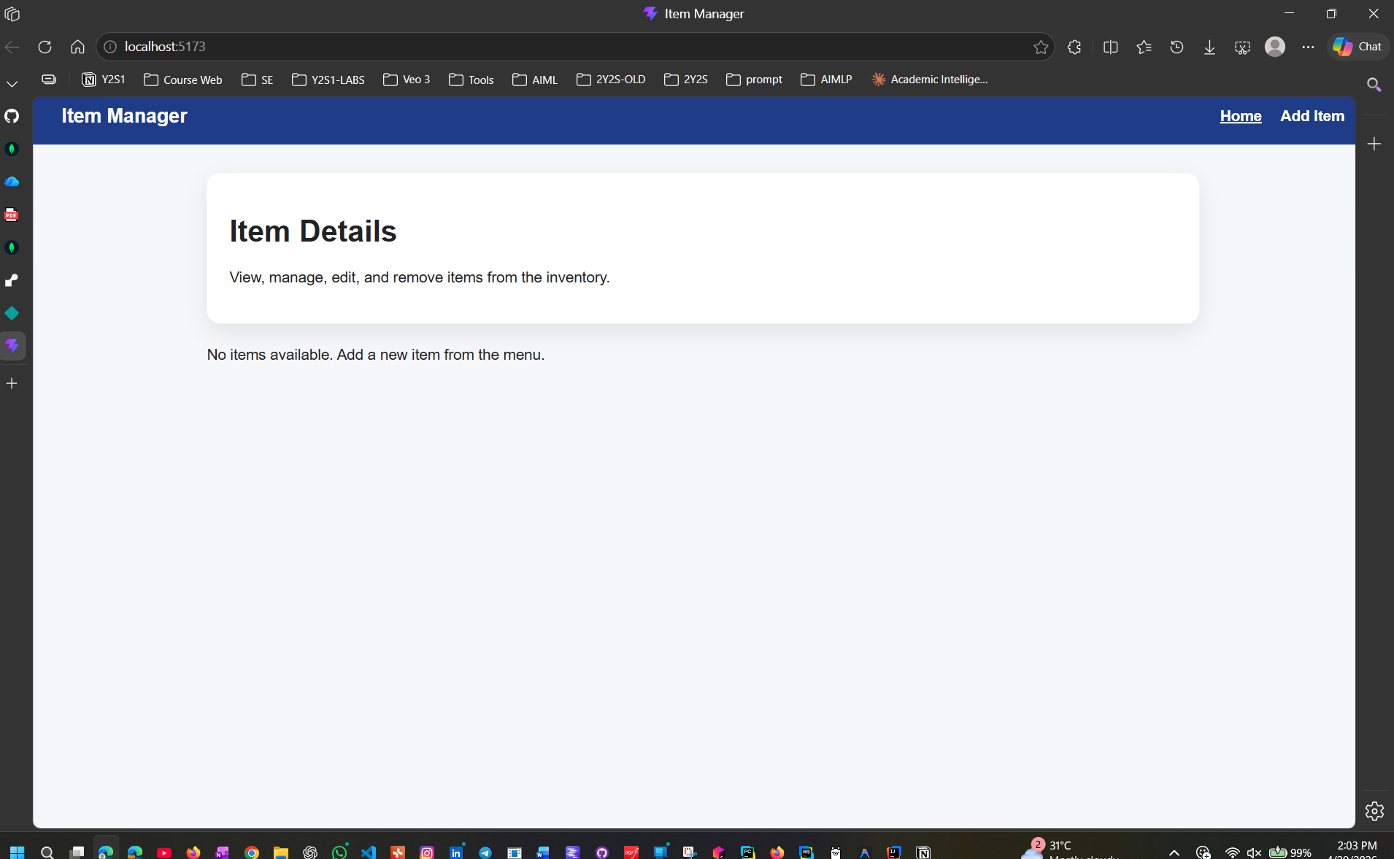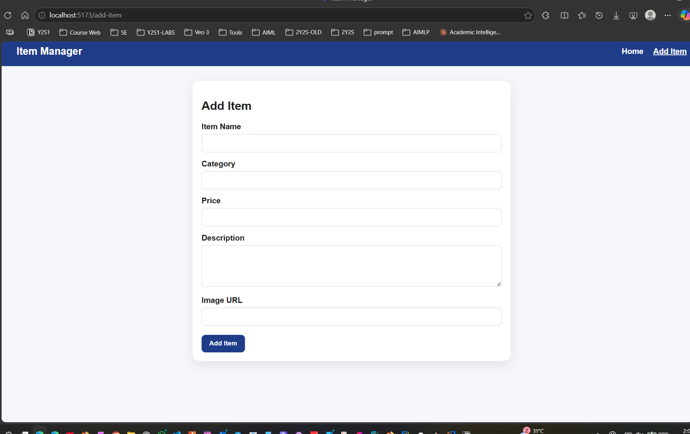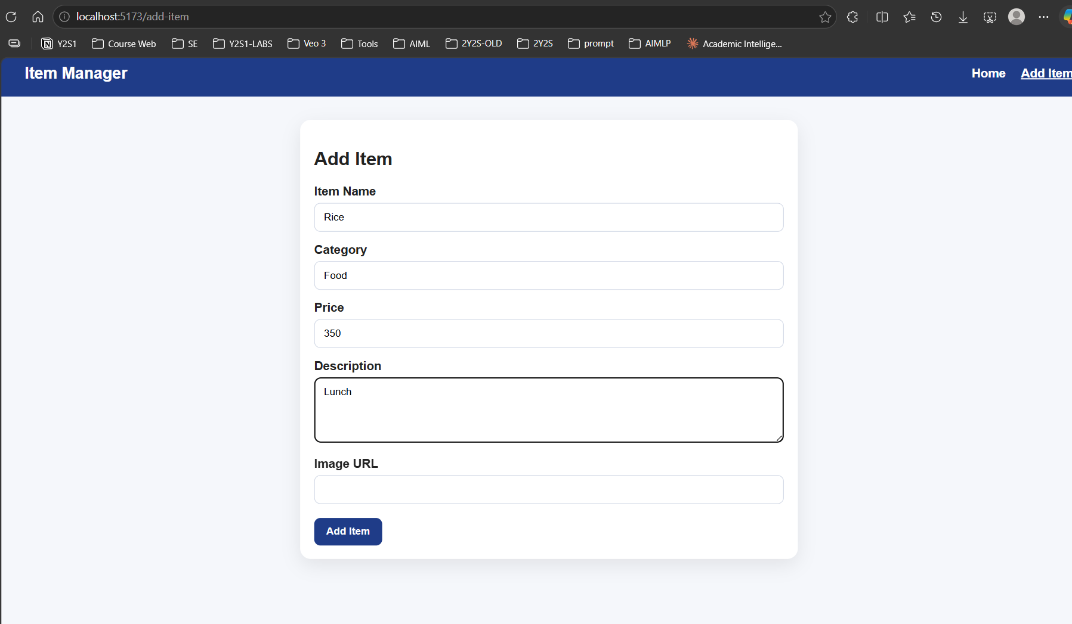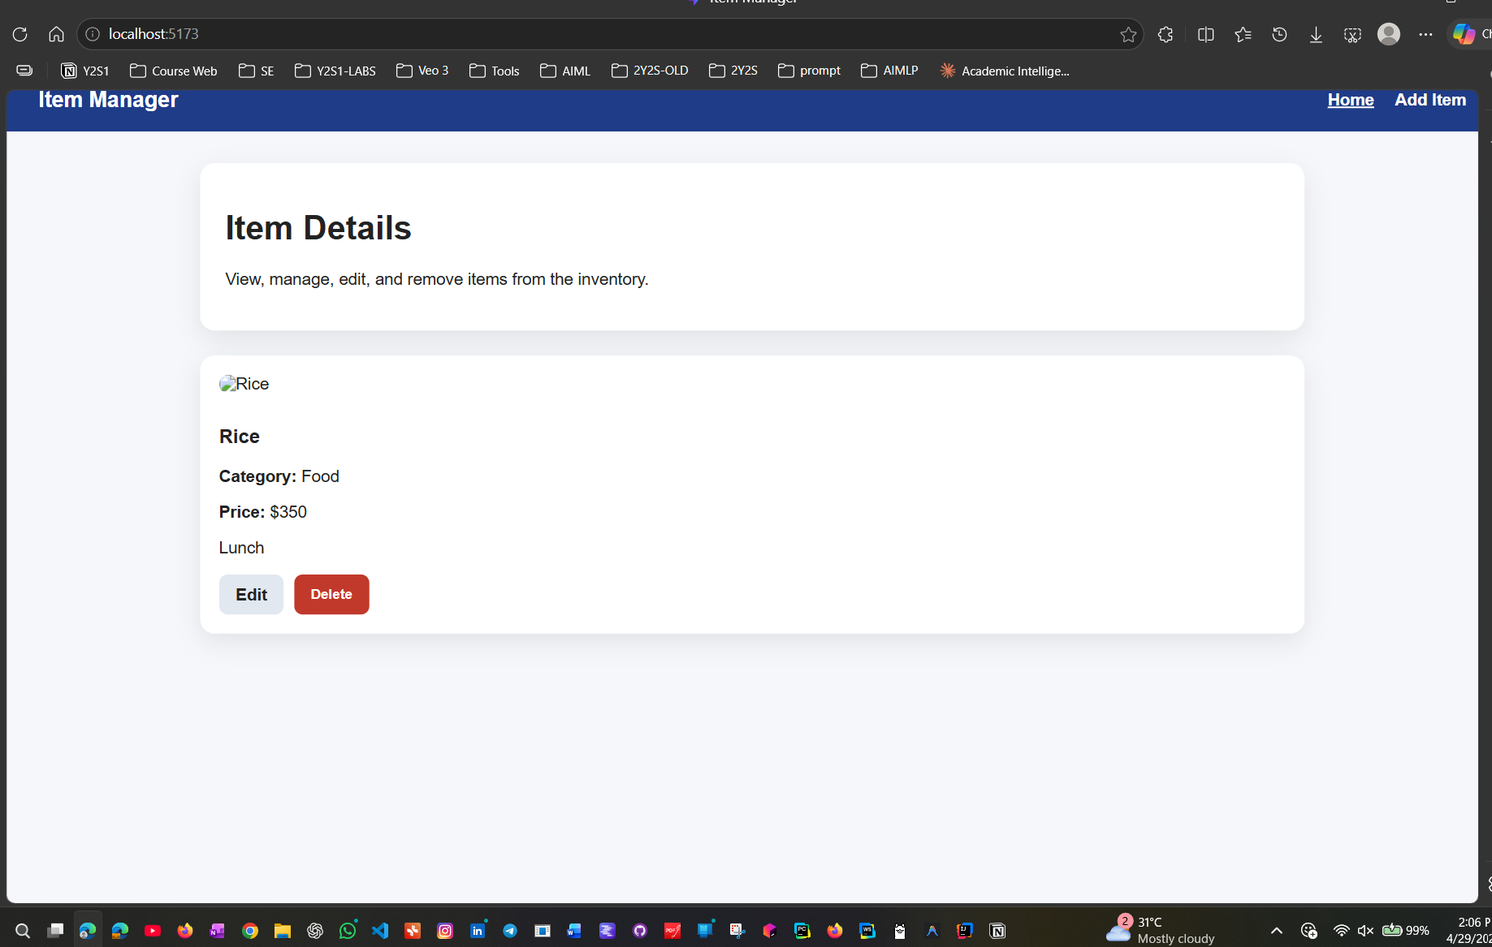

Task 02 – Functional enhancement
- Modify the application by adding a new field named Discount Percentage to the Add Item form.
- Update the relevant frontend component(s) to collect this value from the user.
- Update the backend model, controller logic, and API flow as needed so the value is saved correctly.
- Ensure that the Discount Percentage value is shown on the Home page together with the other item details.
- Make sure the new field behaves correctly during add, read, and any related update operations.
- Capture screenshots of the local running updated system as instructed in the submission section.

Task 03 – GitHub publication
- Create a new public GitHub repository using your own GitHub account (Use your SLIIT GitHub account. If there are any issues, you may use your personal GitHub account.)

- You may choose ONE of the following approaches:
- Option 01: Use a single repository containing both frontend and backend
- Option 02: Use two separate repositories (one for frontend and one for backend)
- Push the complete project to GitHub after testing locally
- Ensure:
- The repository structure is clean and well organized
- Both frontend and backend codes are clearly separated (if using a single repository)
• The GitHub repository/repositories must be created before starting deployment
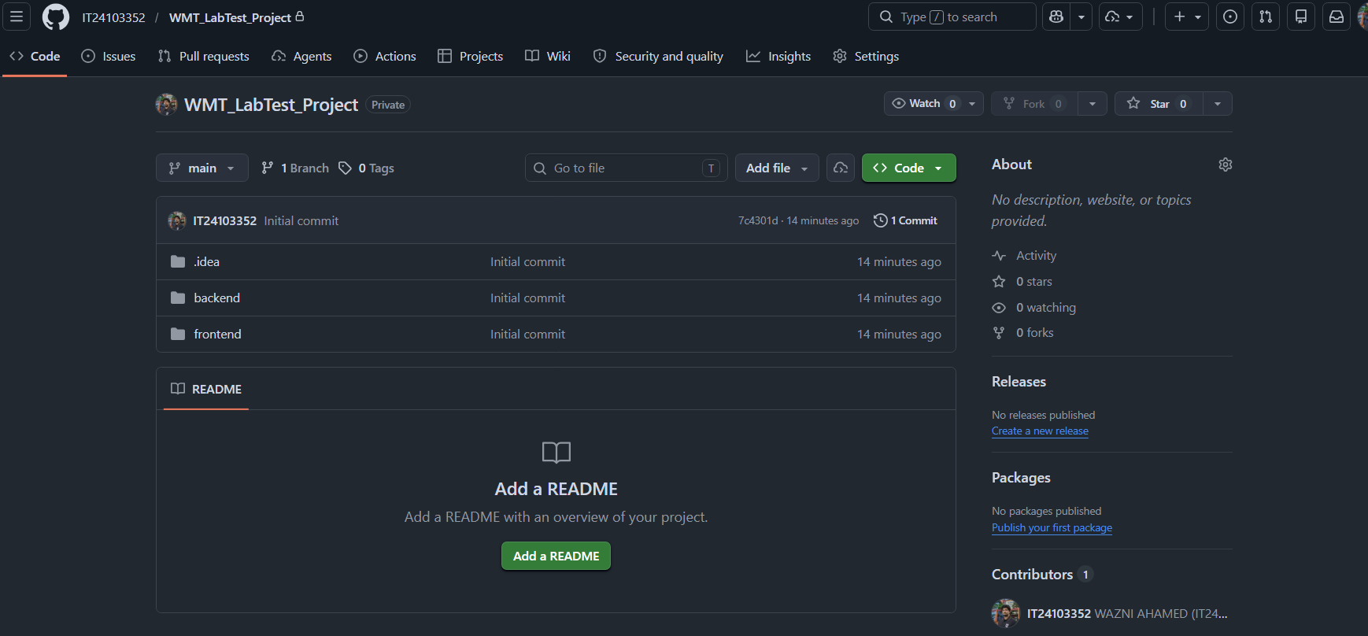
https://github.com/IT24103352/WMT_LabTest_Project.git

Task 04 – Separate deployment
- Deploy the backend to a free hosting platform such as Railway, Render or another equivalent service.
- Deploy the frontend to a free hosting platform such as Netlify, Vercel or another equivalent service.
- Update the frontend configuration so that it communicates with the deployed backend URL.
- Verify that the live system works successfully after deployment.
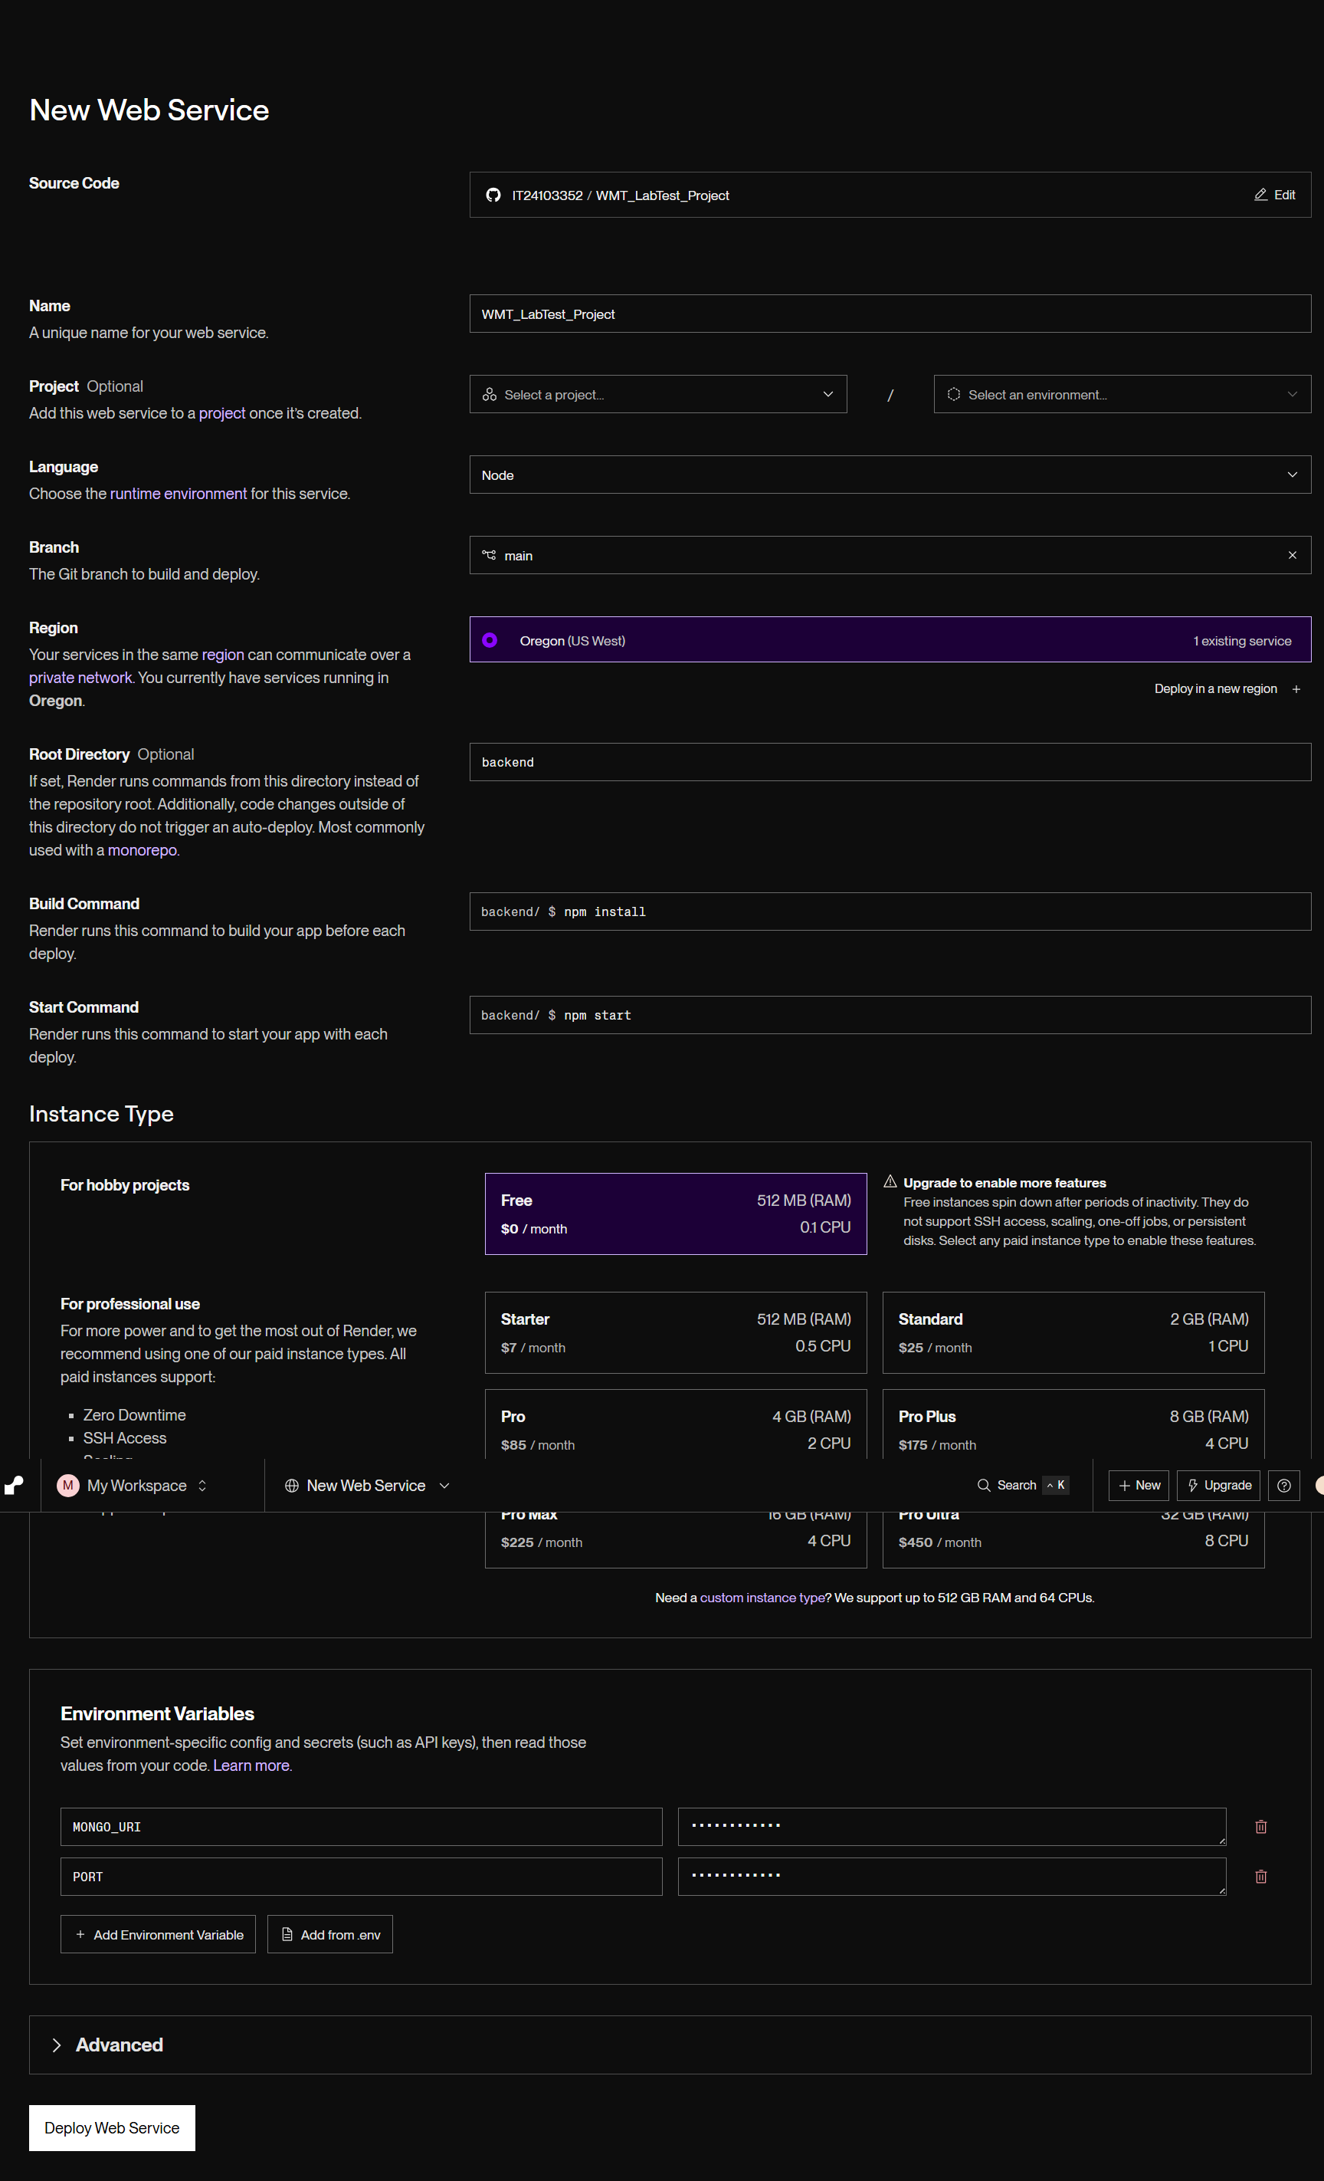
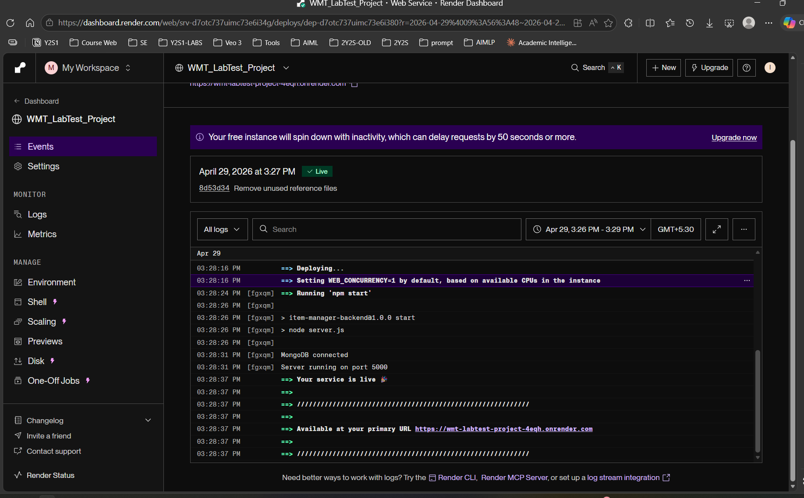
wmt-labtest-project-4eqh.onrender.com
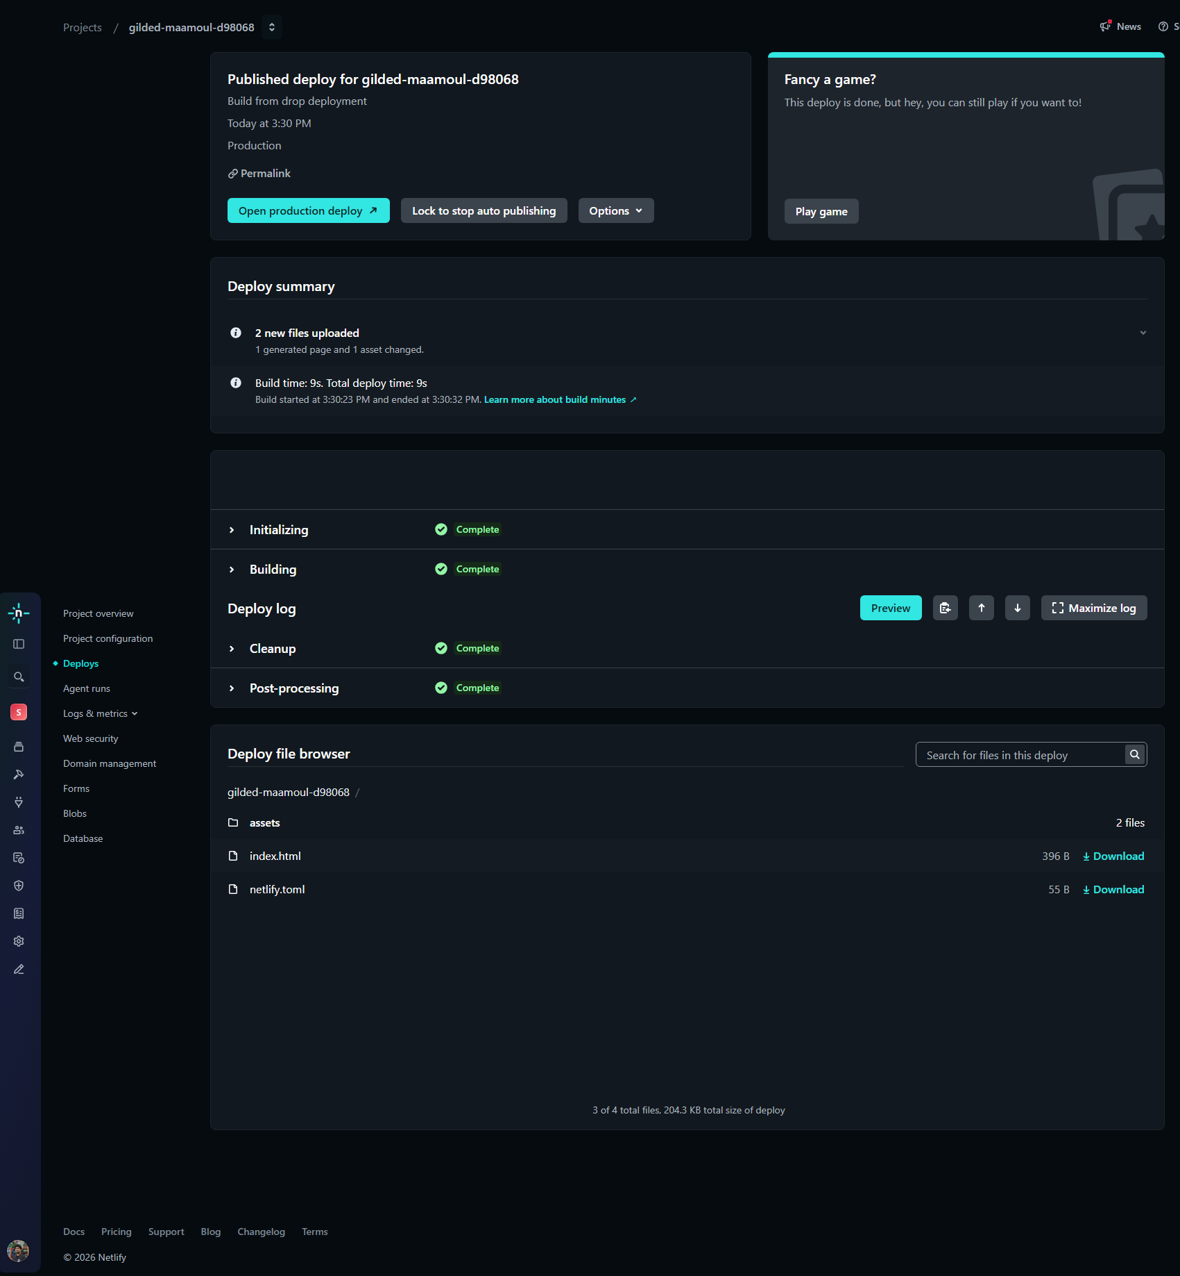
Item Manager
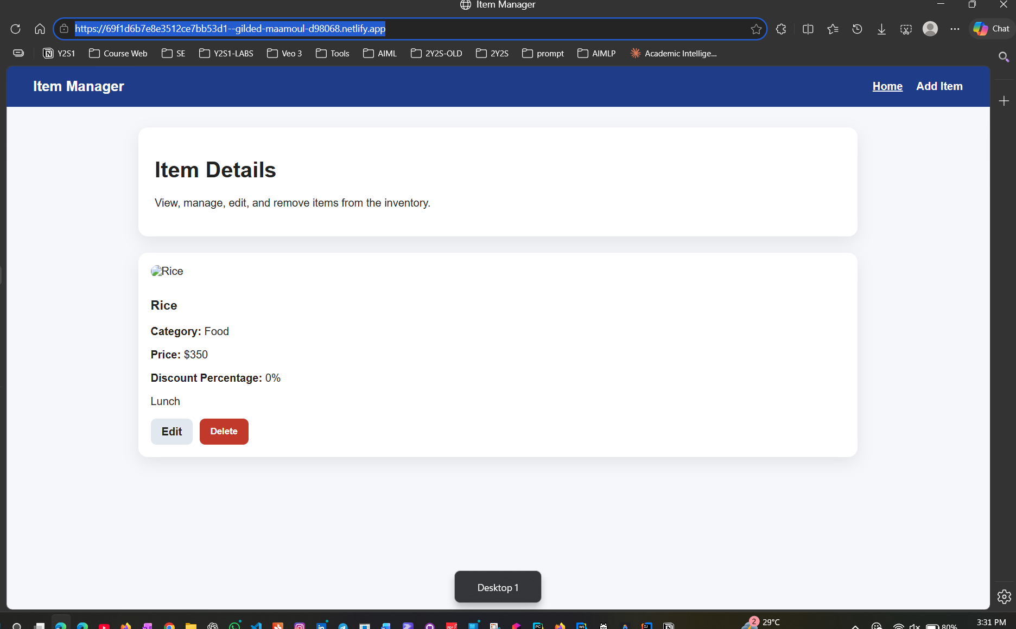

5. Required Contents of the Submission Word Document
Your submitted Word document must include all of the following items clearly and in order:
- Student Name – AHAMED M.A.W
- Student ID – IT24103352
- GitHub Repository Links - https://github.com/IT24103352/WMT_LabTest_Project.git
- Screenshot of the locally running existing project Add Item page
- Screenshot of the locally running existing project Home page
- Screenshot of the locally running updated project Add Item page
- Screenshot of the locally running updated project Home page
- Frontend Live URL
- Backend Live URL
- Brief deployment notes including the platforms used

6. Marking Scheme (100 Marks)
Component | Description | Marks | Comments for Students
Local setup and MongoDB configuration | Correctly configures the connection URL and verifies the project locally before deployment. | 10 | System should run without major local errors.
New field integration | Adds the new field to the form and updates the relevant frontend and backend logic correctly. | 20 | This is the main development task in the lab test.
Home page display and application behavior | New field is shown properly on the Home page and the overall flow works correctly. | 10 | Visible evidence must match the implementation.
GitHub repository management | Creates a public repository and pushes the complete project in a clear structure. | 10 | Repository must be accessible to the examiner.
Backend deployment | Deploys the backend successfully and provides a valid live backend URL. | 20 | Backend should support the required live requests.
Frontend deployment and integration | Deploys the frontend successfully and connects it to the live backend correctly. | 25 | Live application should function end to end.
Submission document quality | Includes all requested details, screenshots, and deployment notes clearly. | 5 | Missing evidence will reduce marks.

7. Important Rules
- This is an individual lab test.
- Use only your own GitHub account and your own deployment accounts.
- Do not remove existing core functionality from the provided starter project.
- Do not submit broken, inaccessible, or private links.
- Make sure screenshots are readable inside the submission document.

