Practical 06
Genetic Algorithms for the 0/1 Knapsack Problem
Student: Hirusha.S.S Student ID: IT24103448

Problem summary
This practical applies a Genetic Algorithm (GA) to select a high-value subset of items while respecting a fixed carrying capacity. The instance has 100 items and capacity C = 525. Each chromosome is a binary vector of length 100: 1 includes an item and 0 leaves it out.

Dataset and fitness
The selected uncorrelated instance is kp_uc_100.txt from the KP_data collection, which attributes its 0/1 knapsack files to Pisinger's generator. The fitness is total value minus M times the excess weight, where M = 10 times the maximum item value = 1000. Feasible solutions score their actual total value; overweight solutions are penalized.

GA design
Setting | Baseline value
Population / generations | 150 / 200
Selection | Tournament, k = 3
Crossover | Two-point, probability 0.90
Mutation | Bit flip, 0.02 per gene
Elitism / baseline seed | 2 individuals / 42

Baseline result (seed 42): value/fitness = 1712, total weight = 524 of 525. The solution is feasible. The convergence plots are shown on page 2.
Operator comparisons use five fixed seeds (1-5). Results report the mean and sample standard deviation of final best fitness. The script also saves the individual runs and convergence information in experiment_results.csv.

Baseline convergence
Figure 1. Best and population-average fitness over 200 generations for the baseline run. The initial random population contains overweight chromosomes, so hard penalties compress later improvements on this full-scale view.
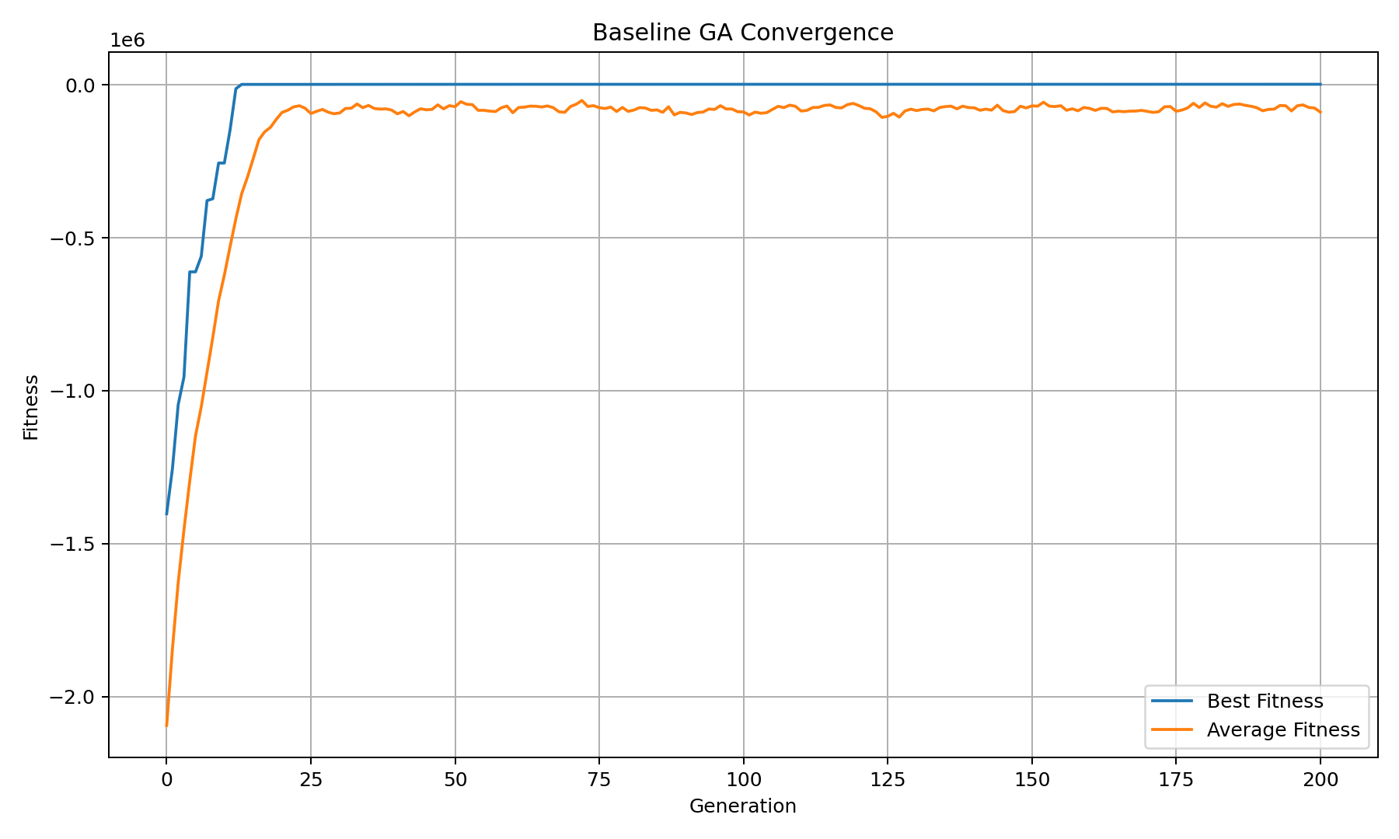
Figure 2. Best-fitness curve zoomed after the initial penalty-dominated generations. Elitism keeps the best-so-far fitness from decreasing; the best solution reaches 1712 and then plateaus in this seed-42 run.
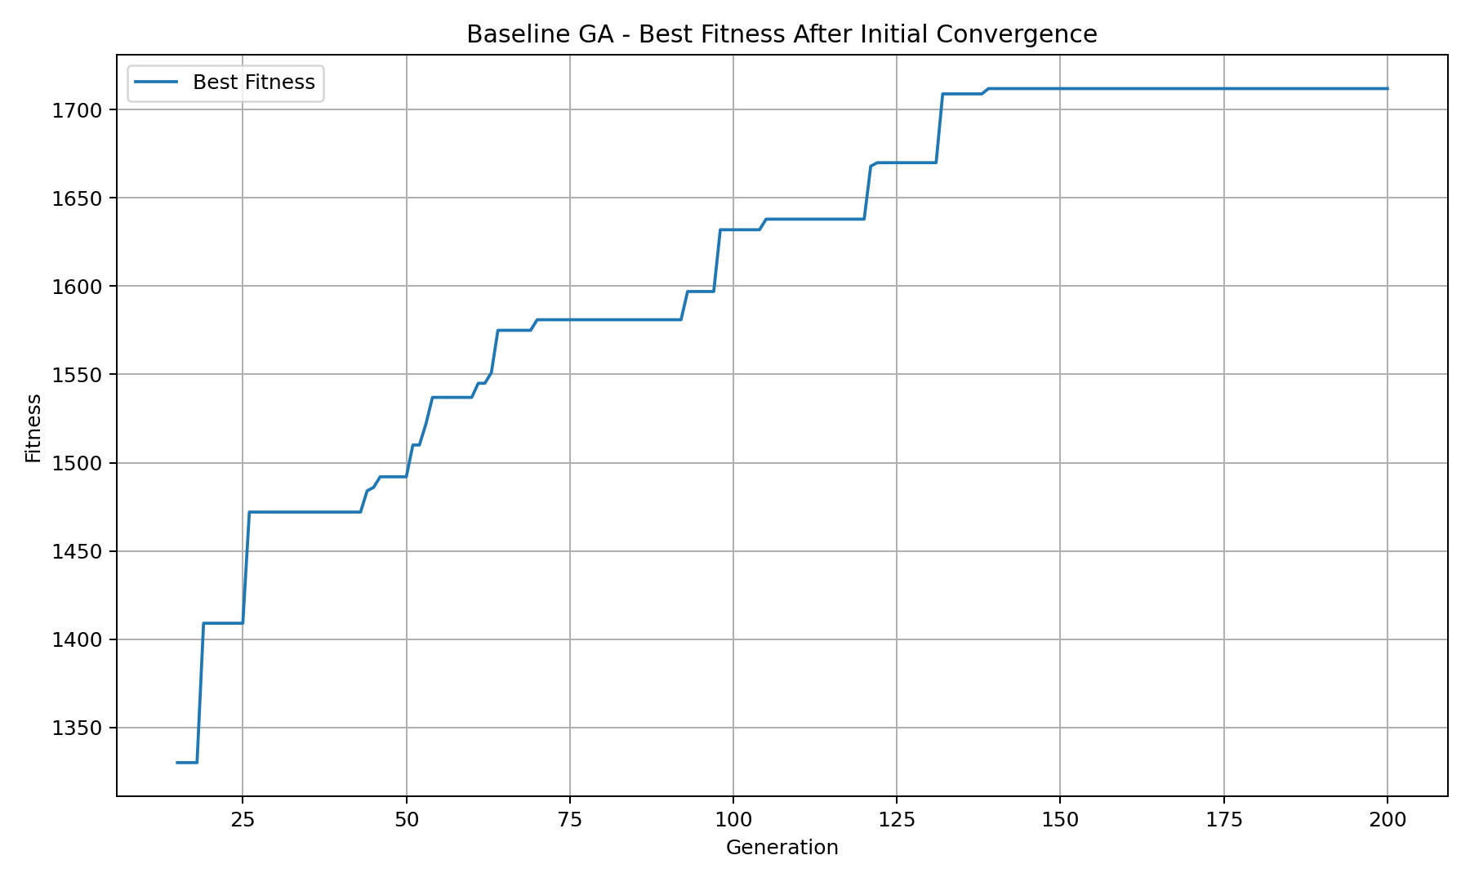

Operator comparisons and discussion
The table gives mean +/- sample SD of best fitness over five runs. The target is the baseline median fitness of 1705; the generation value is shown only if all five trials reach it. Feasible shows how many final best solutions meet the capacity.
Variant | Fitness mean +/- SD | Feasible |  | Gens to target
Baseline: k=3, 2-point, pm=0.02 | 1706.00 +/- 16.82 | 5/5 |  | Not all 5
Tournament k=2 | 1590.60 +/- 51.62 | 5/5 |  | Not all 5
Tournament k=4 | 1752.40 +/- 24.06 | 5/5 |  | 77.6
One-point crossover | 1690.00 +/- 45.90 | 5/5 |  | Not all 5
Uniform crossover | 1714.60 +/- 43.57 | 5/5 |  | Not all 5
Mutation pm=0.01 | 1800.00 +/- 10.34 | 5/5 |  | 51.0
Mutation pm=0.05 | 1391.20 +/- 43.85 | 5/5 |  | Not all 5
Mutation pm=0.10 | -23858.20 +/- 26014.65 | 2/5 |  | Not all 5

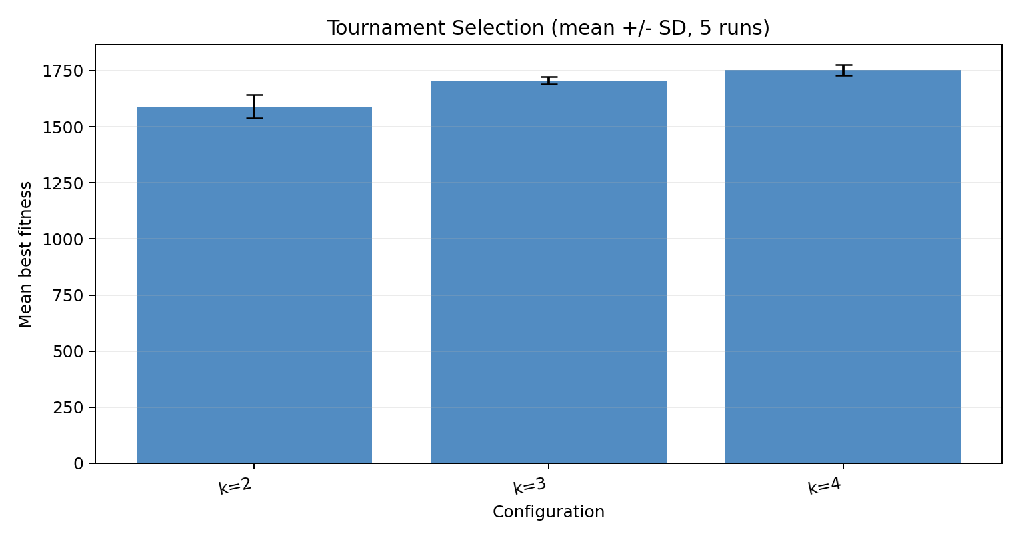

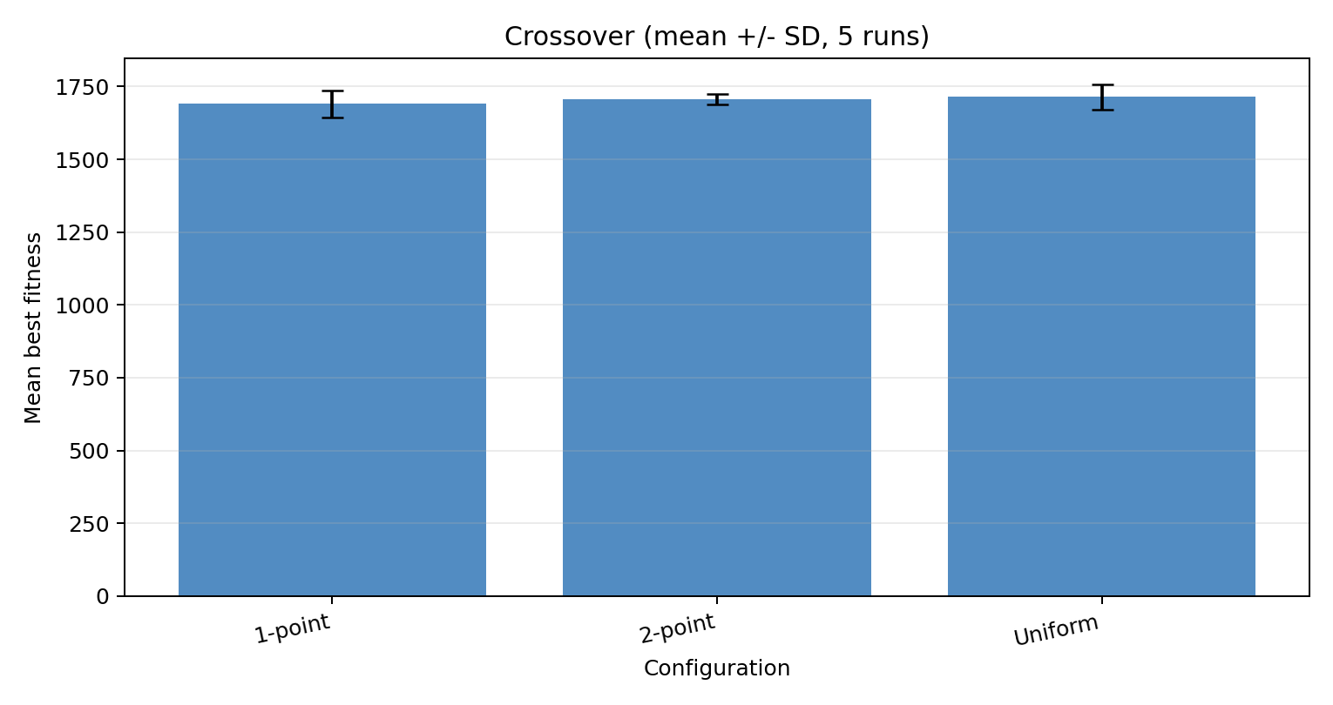

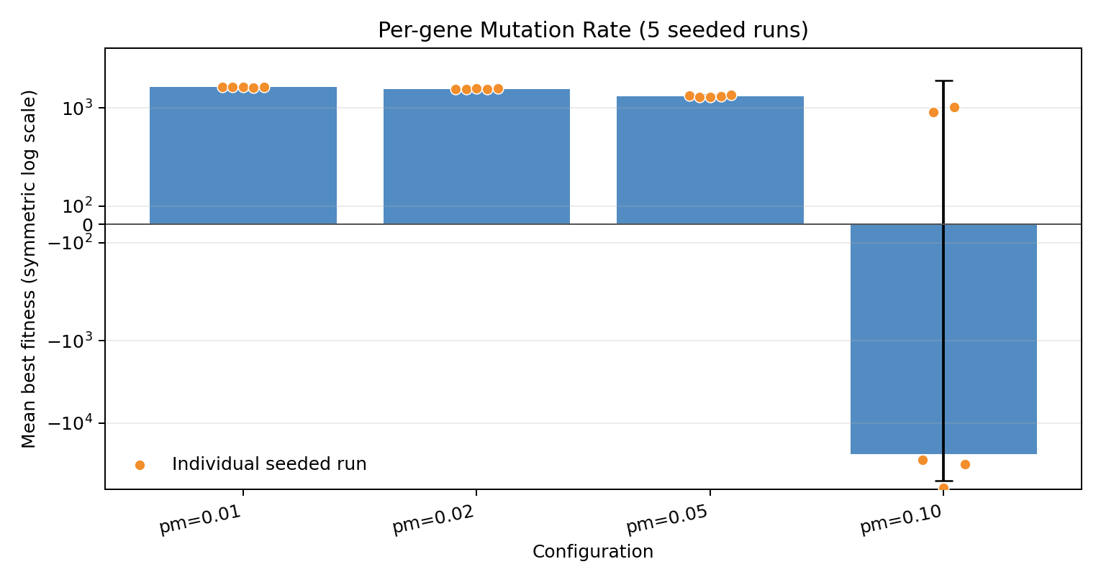

Figures 3-5. Measured comparisons across five seeds; bars show mean +/- SD. Mutation uses a symmetric log scale to display its extreme negative outcomes.
Discussion. Tournament k=4 performed best in this test (1752.40 +/- 24.06), while k=2 was lower (1590.60 +/- 51.62), consistent with stronger selection pressure helping these runs. Uniform crossover had a slightly higher mean than two-point crossover (1714.60 vs 1706.00), but greater variation (SD 43.57 vs 16.82). The 0.01 mutation rate was strongest and most consistent (1800.00 +/- 10.34). At 0.10, only two of five final solutions were feasible; frequent bit flips disrupt useful chromosomes and the hard penalty lowers infeasible scores.
Conclusion. GA performance depends on operator settings. On this instance, tournament k=4 and mutation pm=0.01 were favorable among the tested configurations. These results describe this dataset and parameter range, not a universal guarantee.

