MOLECULAR DYNAMICS - critical and reduction
The zip with the original code was not included in this repo, so the
classic EPCC MolDyn C code was re-created with the same structure
(main.c -> domove, forces, mkekin, velavg, prnout).

Files
main.c main time-step loop (unchanged between serial and parallel)
md_util.c fcc, mxwell, domove, mkekin, velavg, prnout, dfill, dscal
forces.c SERIAL force calculation
forces_omp.c OpenMP force calculation (the only file that was edited)
Makefile make builds md_serial and md_omp;
make CHUNK=n uses schedule(static,n)

Compile / run
make # md_serial + md_omp
./md_serial
OMP_NUM_THREADS=4 ./md_omp
make CHUNK=10 && OMP_NUM_THREADS=4 ./md_omp # schedule(static,10)

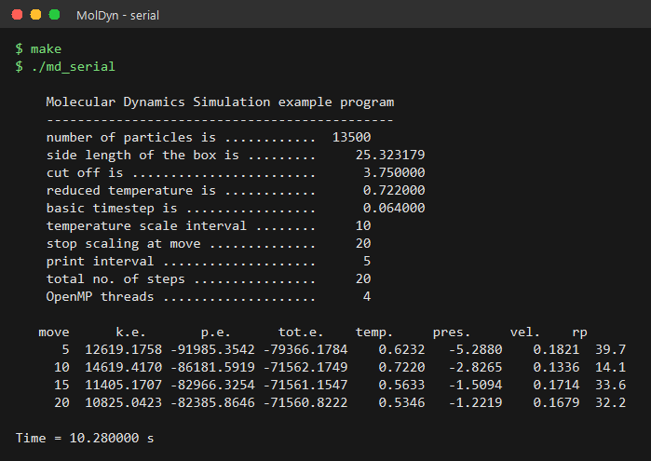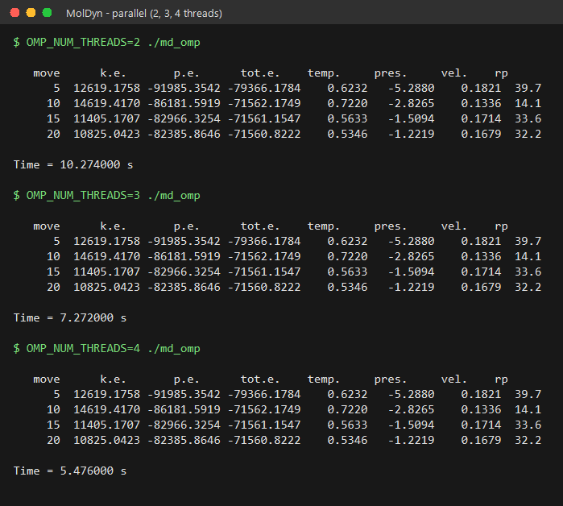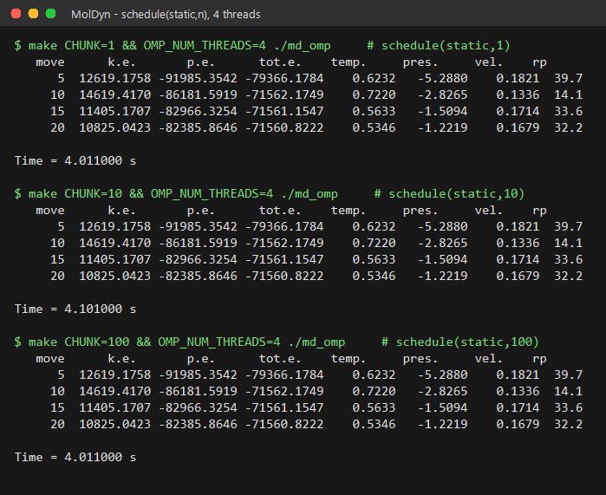
Parallelising forces()
----------------------
#pragma omp parallel for schedule(static) default(none) \
shared(npart_, x, f, side, sideh, rcoffs) \
private(j, xi,yi,zi, fxi,fyi,fzi, xx,yy,zz, rd, rrd, rrd2, \
rrd3, rrd4, rrd6, rrd7, r148, forcex, forcey, forcez) \
reduction(+:epot, vir)
for (i = 0; i < npart_*3; i += 3) {
...
#pragma omp critical
{ f[j] -= forcex; f[j+1] -= forcey; f[j+2] -= forcez; }
...
#pragma omp critical
{ f[i] += fxi; f[i+1] += fyi; f[i+2] += fzi; }
}

1. PRIVATE - all per-pair scratch variables (j, xi..zi, xx..zz, rd,
rrd..rrd7, r148, forcex/y/z, fxi/fyi/fzi).
2. The 2 REDUCTION variables - epot (potential energy) and vir (virial).
Every pair adds to them, so each thread keeps a private partial sum
that is combined at the end of the loop.
3. CRITICAL - the force array f[]. Thread A working on particle i
subtracts forces from f[j] for every j > i, while thread B may be
adding to the same element from its own row. These read-modify-write
updates are therefore wrapped in #pragma omp critical.

Results
-------
2, 3 and 4 threads - every printed value is identical to the serial run
(total energy ~ -71 561 conserved in all cases).

version threads time (s)
------------- ------- --------
serial 1 10.28
omp, static 2 10.27
omp, static 3 7.27
omp, static 4 5.48

schedule(static,n), 4 threads
schedule time (s)
----------- --------
static 5.48
static,1 4.01
static,10 4.10
static,100 4.01

The loop is triangular (j runs from i+1 to N), so with the plain static
schedule thread 0 gets the heaviest rows. A small chunk size interleaves
rows between the threads and improves the time by ~25 %. Beyond that the
chunk value makes little difference: the remaining overhead is the
critical section inside the inner loop, which serialises every force
update, so the speed-up stays well below the number of threads.

