

BSc (Hons) in Computer Science
SE3082 – Parallel Computing | Year 3, Semester 1, 2026

Parallel Computing: Lab 07 (MPI Collective Operations)

Name :- Jananjana J.W.C – IT24104006

GitHub Repo Link: https://github.com/IT24104006/SE3082-Lab07

Lab 07

Table of Contents
Objectives: 2
The Problem 2
Exercise 1 to 6 and 8: Compile and run 2
Exercise 7: Summary comparison 4

Objectives:
This lab replaces manual MPI_Send/MPI_Recv communication with collective operations (Bcast, Scatter, Gather, Reduce, Allreduce, Scan) using six programs, each built from the previous one. All programs sum the integers 1 to 1,000,000 and verify the result against the expected value 500,000,500,000. The programs were compiled and run with OpenMPI on Ubuntu (WSL).

The Problem
All exercises in this lab solve the same problem: sum an integer array of 1,000,000 elements (values 1 to 1,000,000) in parallel using MPI. The expected answer is 500,000,500,000.
You will start with a complete working program using MPI_Bcast, then progressively replace parts of it with more efficient collectives. Each exercise builds on the previous one.

Compile: mpicc -o program program.c
Run: mpirun -np 4 ./program

Note: The number of processes must evenly divide 1,000,000. Use 4, 5, 8, 10, etc.

Exercise 1 to 6 and 8: Compile and run
A Makefile compiles all six programs (sum_bcast, sum_scatter, sum_gather, sum_reduce, sum_allreduce, sum_scan) using mpicc. The run target executes each one with 4 processes. Every program reports Correct? = YES

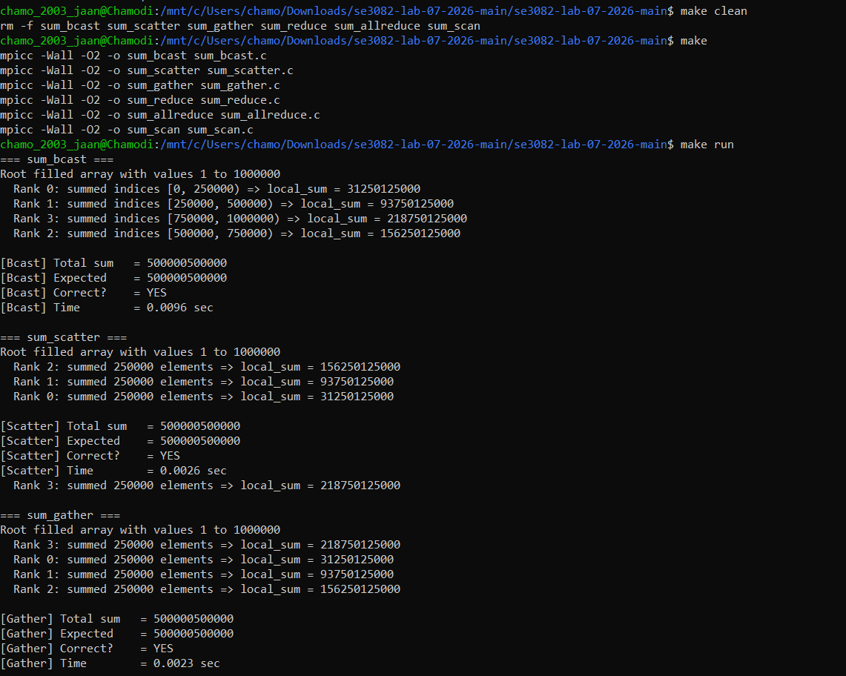
Figure 1: Exercise 8 (Compiling all six programs with make and running them with make run)

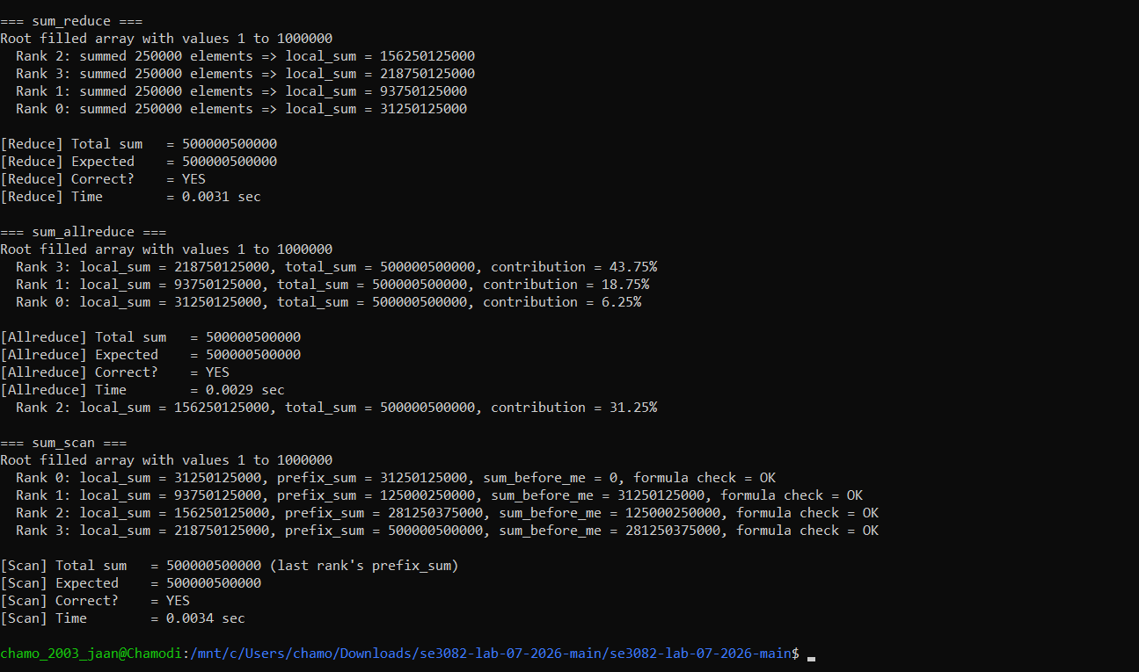
Figure 2: the 2, 4 and 8 process timing runs (Exercise 7)

Exercise 7: Summary comparison
Each program was run 5 times with 2, 4 and 8 processes and the average execution time was recorded (saved in Exercise07/timings.txt). sum_bcast is the slowest at 4 and 8 processes because Bcast sends the whole array to every process, while Scatter sends each process only its own chunk. The differences among the Scatter-based programs are within run-to-run noise. The comparison table and the answer to the Scan vs Allreduce question are in Exercise07/readme.txt.

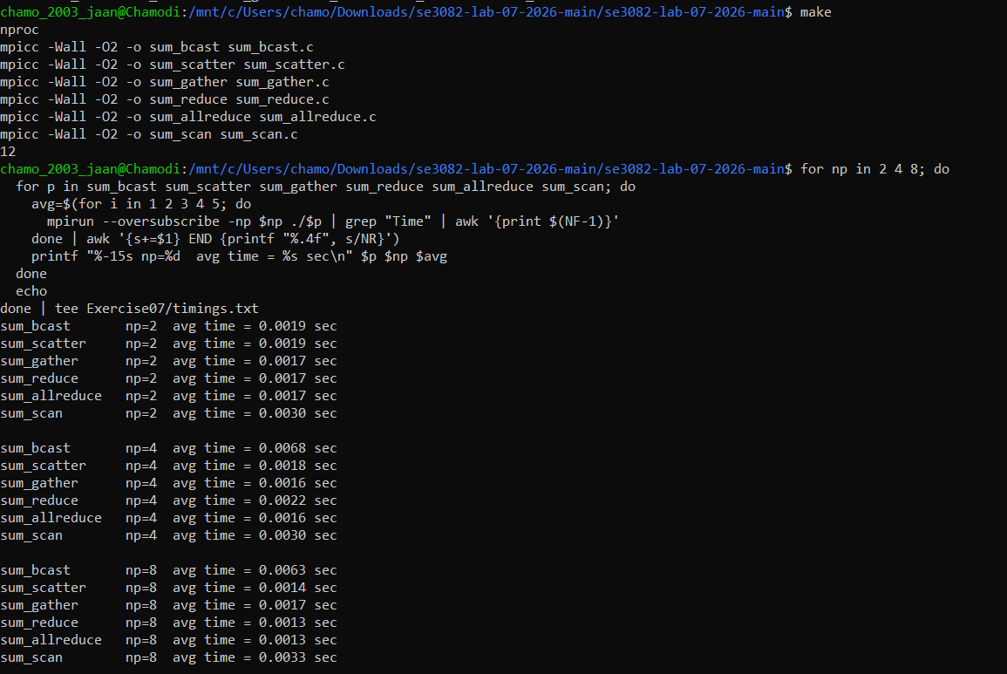
Figure 3: Exercise 7 (Comparison of MPI collective operations, average execution time of 5 runs with 2, 4 and 8 processes)
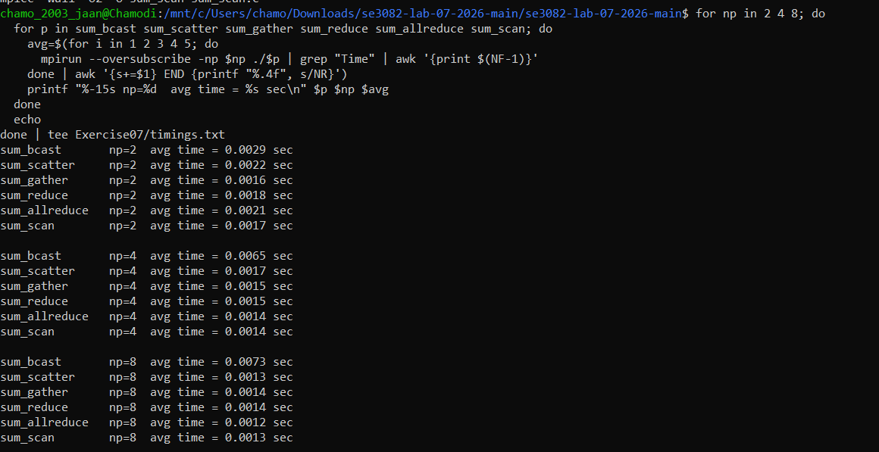
Figure 4: Exercise 7 (Comparison of MPI collective operations, average execution time of 5 runs with 2, 4 and 8 processes)

  - Comparison Table(Compare the sum_scan)
Processes | Before the barrier | After the barrier
2 | 0.0030 | 0.0017
4 | 0.0033 | 0.0014
8 | 0.0033 | 0.0013
Table 01: Comparison Table

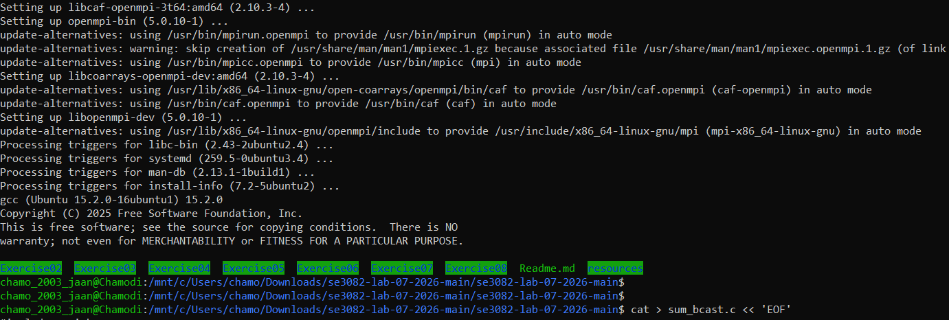
Step 1: mpicc is installed, and has Exercise02 to Exercise08, Readme.md and resources.

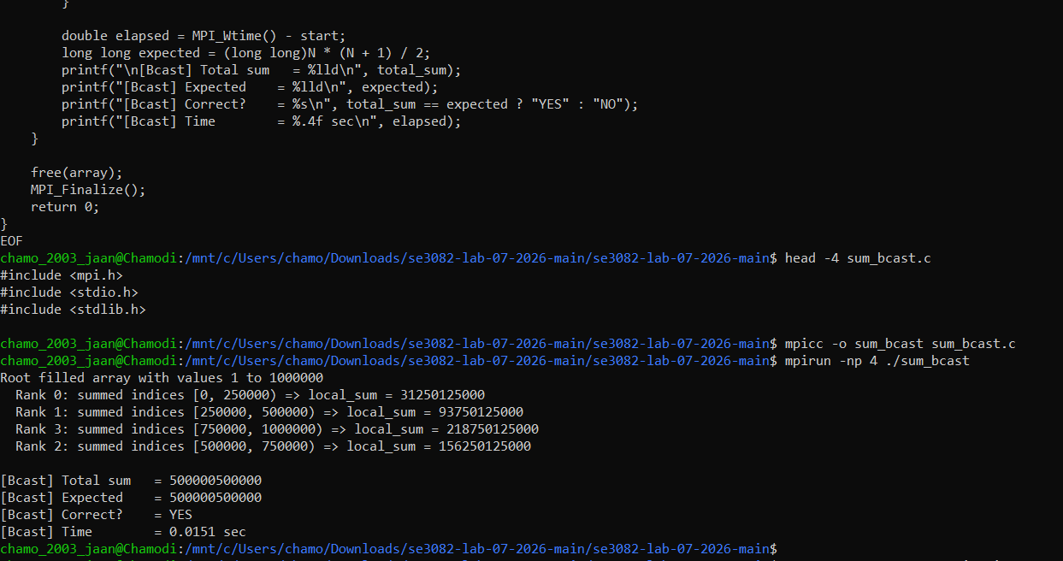
Step 2: Exercise 1, the given program
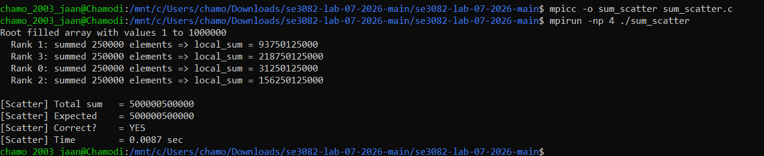
Step 3: Exercise 2, replacing Bcast with Scatter

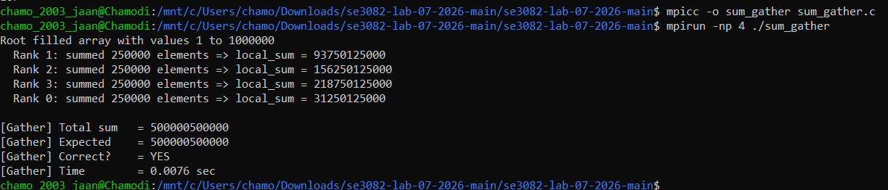
Step 4: Exercise 3, replacing Send/Recv with Gather.

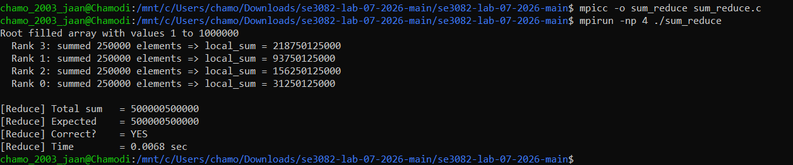
Step 5: Exercise 4, replacing Gather with Reduce

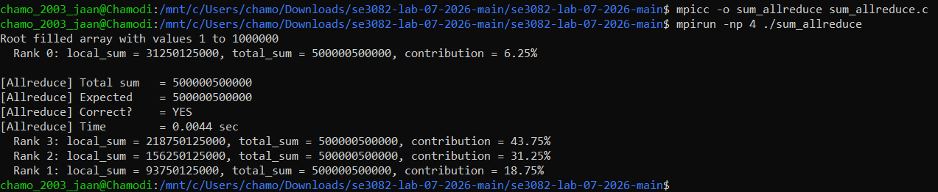
Step 6: Exercise 5, replacing Reduce with Allreduce

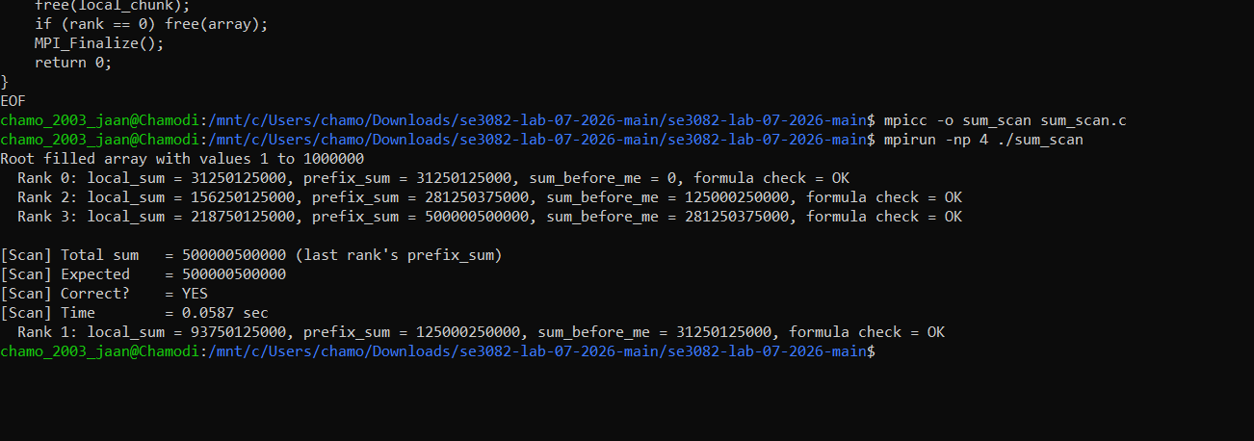
Step 7: Exercise 6, replacing Allreduce with Scan

