**EDA_Visualizations**

**IT24101102 - Mohotti C.H. (Handling missing data)**

**IT24101206 - Karunarathne N.W. (Encoding categorical variables)**

**IT24300015 - Da Silva H.V.N.N (Outlier removal)**

**IT24101093 - Chathurya K.G. Y** **(Normalization / Scaling (keeping Level as target)**

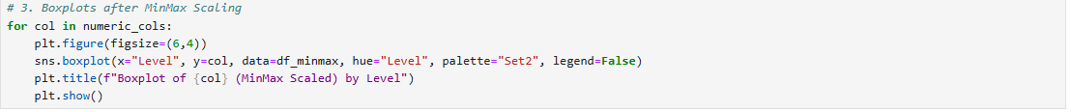

**IT24300019- Kumara M.P.H. S (Feature Engineering with Random Forest)**

**IT24101247-- Hettiarachchi D.G.P.M. (Class Imbalance)**

