**EDA Visualizations**

1.Class Imbalance (IT24510004-Suhansa D.C.)

2.Outlier Removal (IT24100626-Silva M.G.N.)

3.Feature Engineering (IT24100693-Adhikari R.D.A.H.R.)

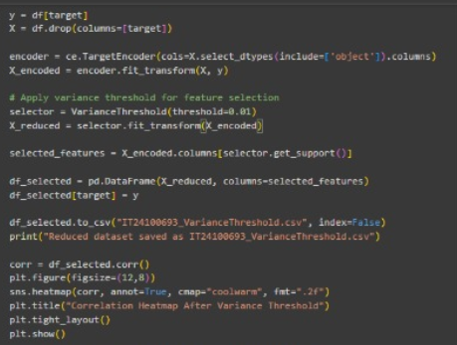

4.Encoding for categorical variables (IT24100662-Liyanage N.S.)

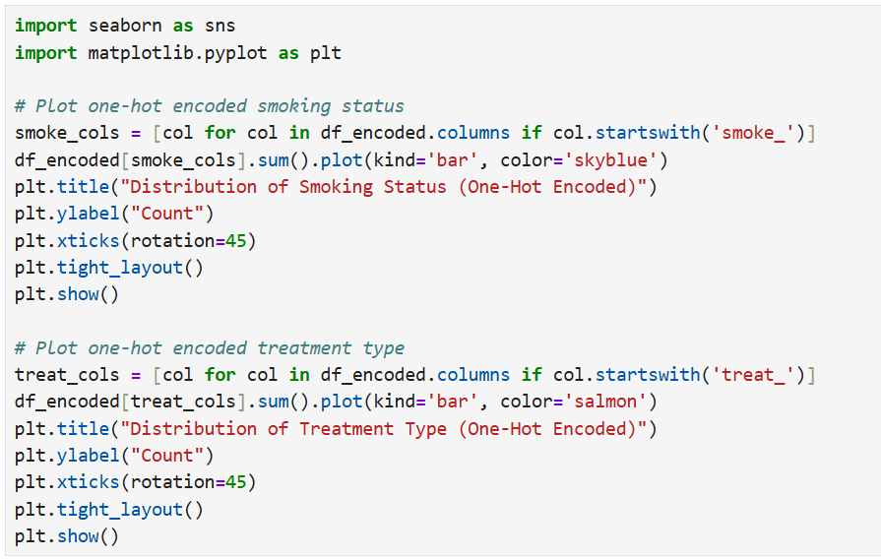

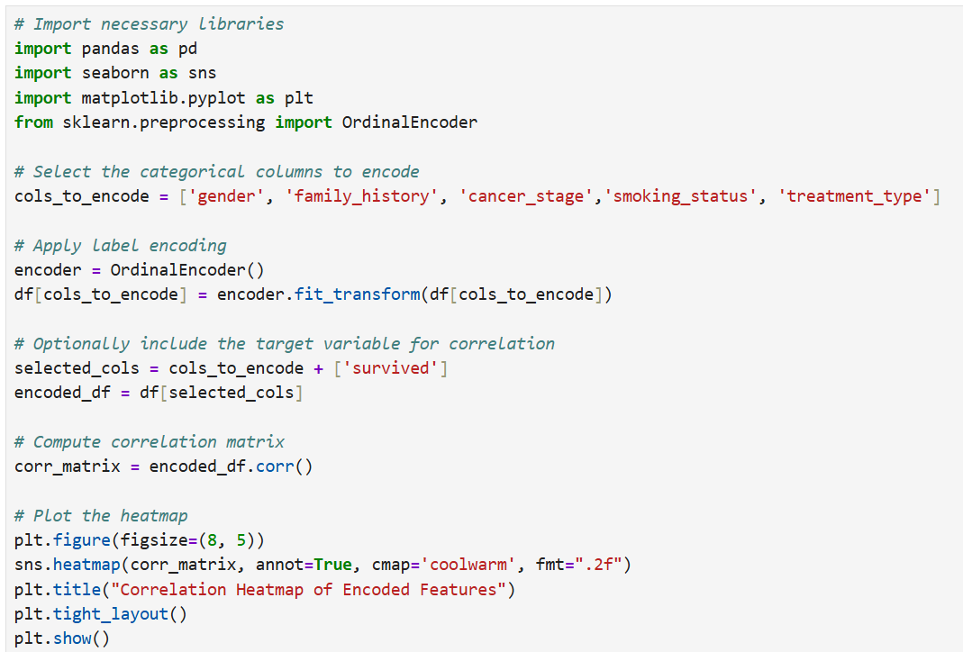

5.PCA (IT24100581-Praveesha M.D.S.)

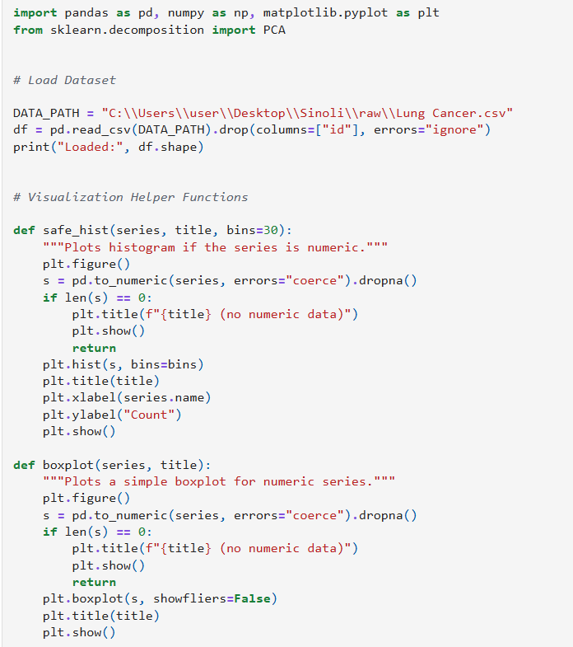

6.Scaling (IT24100640-Kasundhi W.V.)

