Sri Lanka Institute of Information
Technology

Lab Submission
< PS Lab sheet 09 >

< IT25100069 >
< Antony Sinthursan >

Probability and Statistics | IT2120
B.Sc. (Hons) in Information Technology
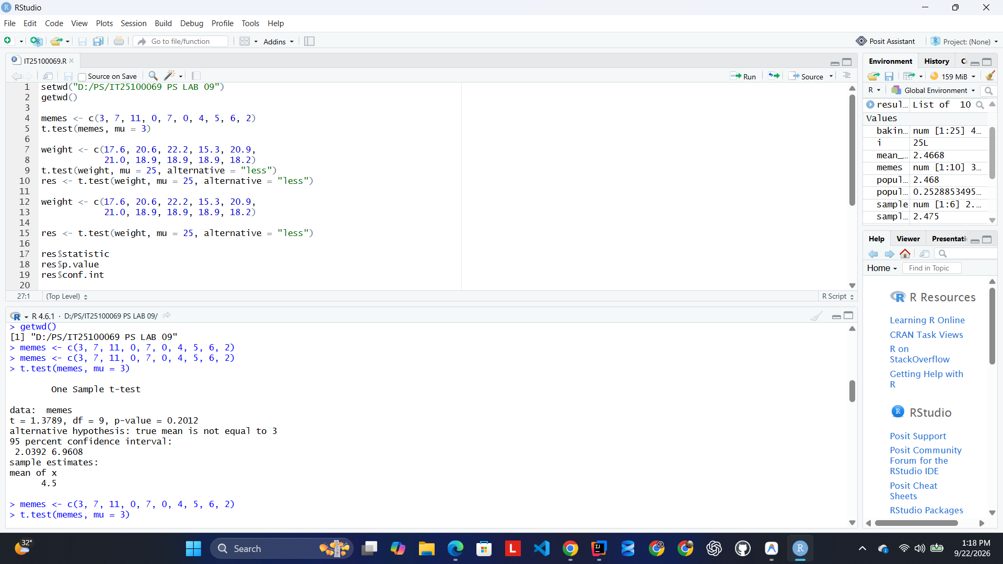

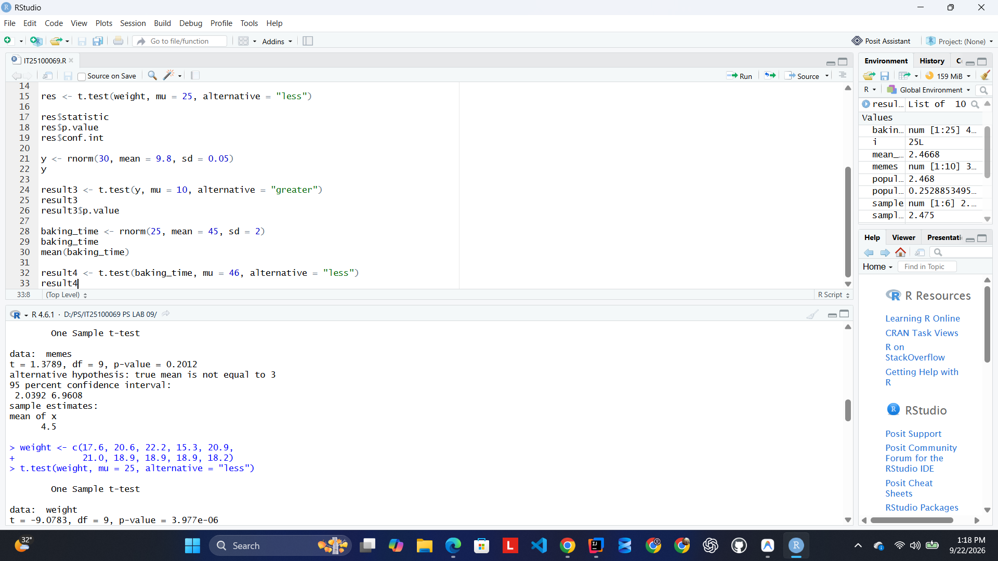

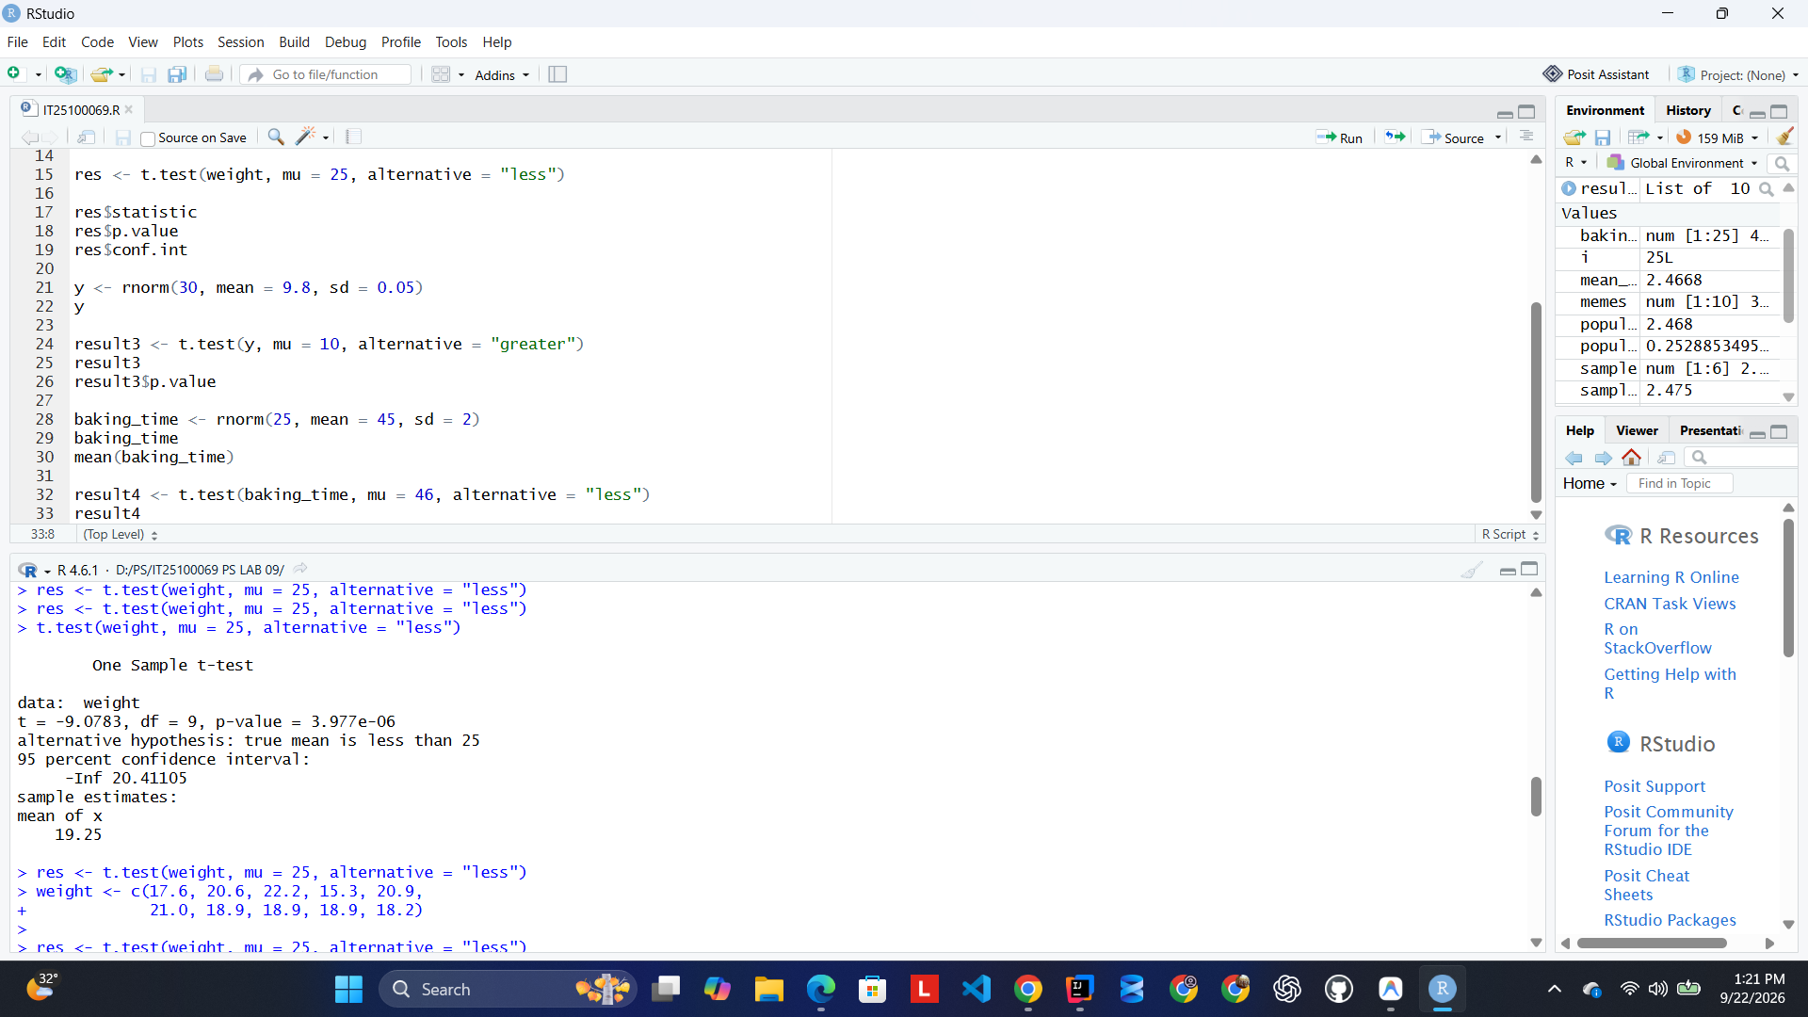

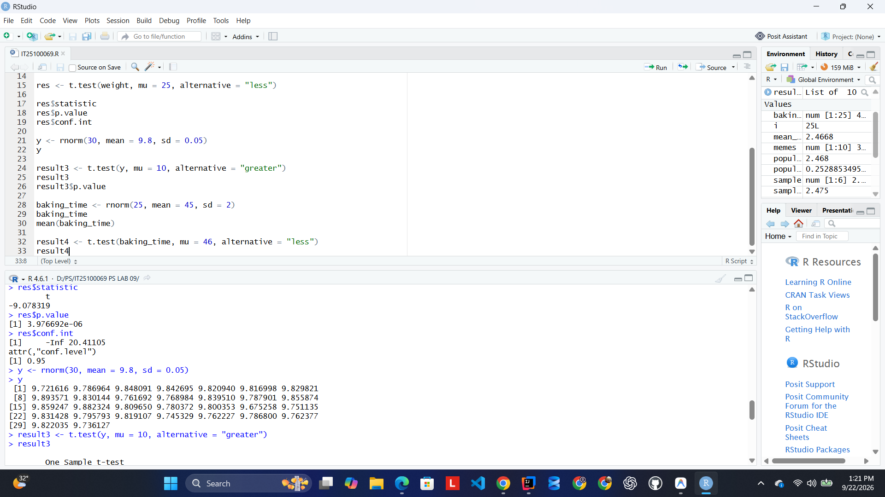

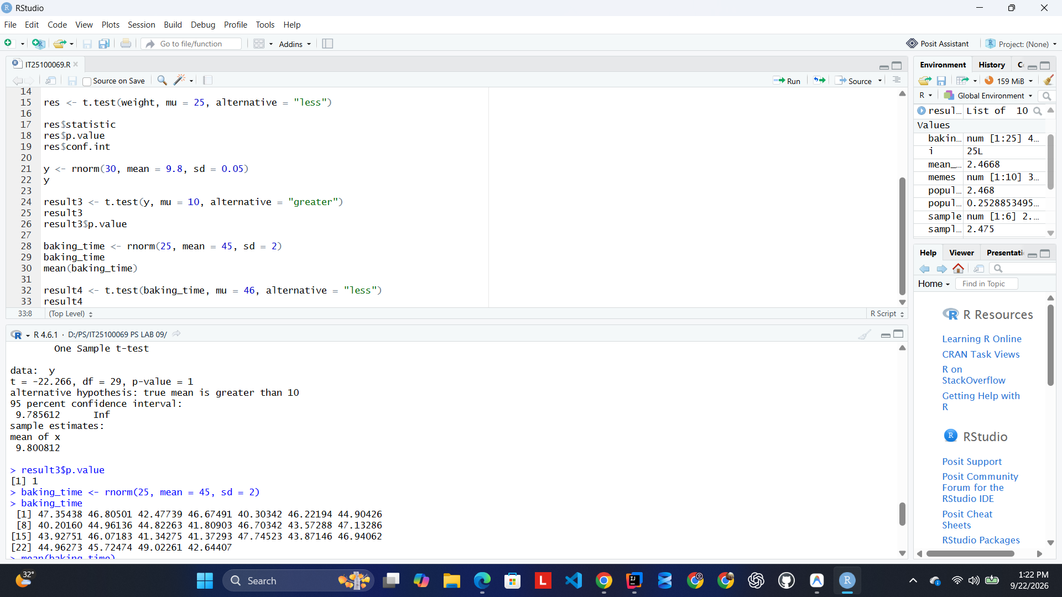

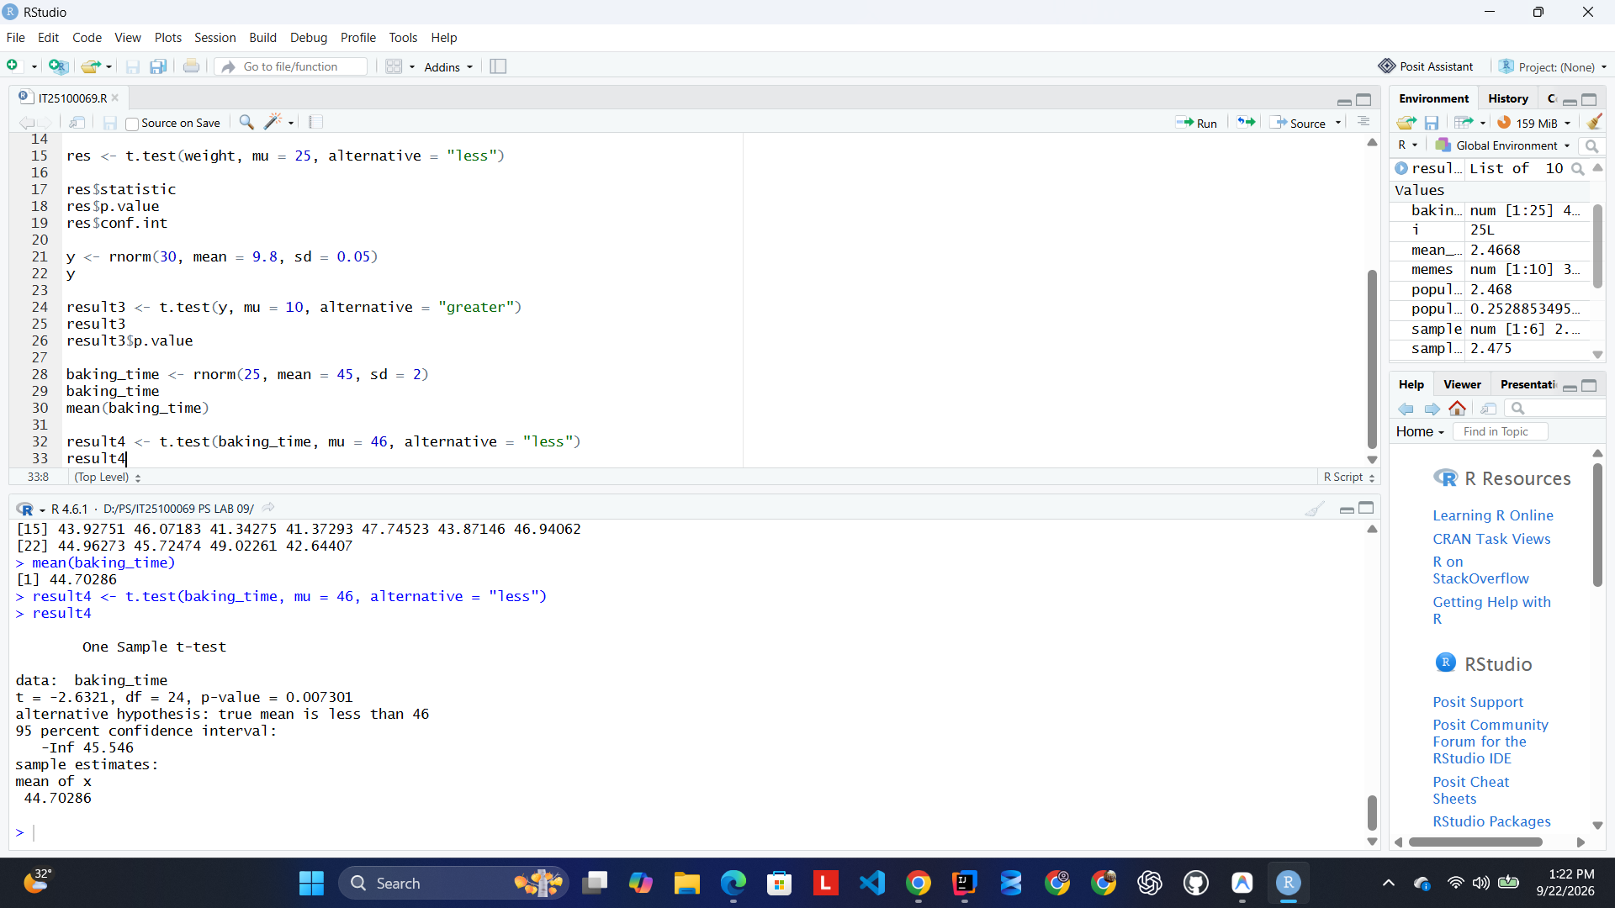

Conclusion:
Since the p-value (0.007301) is less than 0.05,
we reject H₀ at the 5% level of significance.
Therefore, there is sufficient evidence to conclude
that the average baking time is less than 46 minutes.

