dSri Lanka Institute of Information Technology



SE2030
Software Engineering

Web-based Medicine Ordering System
Proposal Report

Project Group - 2026-Y2-S1-MLB-B3G1-08
Group members
Student ID | Name
IT25101923 | Lakshan M.K.C.
IT25102867 | Karunathilaka W.V.R.D.T.Y.
IT25103946 | Vinogikan M.
IT25101882 | Widyawansa T.D.
IT25103725 | Hathoon.M.F.S.
IT25100979 | Kookulan E.

2. INTRODUCTION

2.1 Project Overview
The Web-Based Medicine Ordering System is an enterprise digital healthcare platform designed to streamline over the counter (OTC) and prescription medicine procurement for patients, healthcare providers, and pharmacy operational teams. Traditional pharmaceutical retail suffers from manual prescription validation, long customer waiting times, inefficient stock batch management, and potential delivery errors for sensitive drugs.
By incorporating role-segregated portals, automated clinical validation queues, First-Expired-First-Out (FEFO) inventory tracking, cold-chain safety tagging, and specialized subscription scheduling for chronic care patients, this application ensures convenient, efficient, and secure pharmaceutical distribution while upholding strict medical data confidentiality and regulatory compliance.

2.2 Objectives and Goals
- Multi-Device Accessibility: Deliver a responsive, cross-platform web interface for patients, pharmacists, administrative staff, and couriers accessible across mobile, tablet, and desktop devices.
- Automated Chronic Care Management: Eliminate friction for long-term patients (e.g., diabetes, hypertension) by providing automated time-based refill reminders and recurring order fulfillment.
- Streamlined Prescription Validation: Enable customers to upload high-resolution digital image/PDF prescriptions or scan QR codes for rapid clinical review before order processing.
- Unified Stakeholder Collaboration: Align doctors, patients, pharmacists, and logistics personnel within a single transparent ecosystem with real-time state tracking.
- Comprehensive Audit Logging: Enforce strict system-wide logging across all Create, Read, Update, and Delete (CRUD) operations for legal compliance and operational traceability.

2.3 Target Users & Stakeholders
- Patients & Chronic Care Customers: Ordering OTC products, uploading digital prescriptions, managing recurring refill schedules, and tracking live deliveries.
- Pharmacy Operations Team: Chief Pharmacist, Staff Pharmacists, and Pharmacy Assistants managing batch stock, validating prescriptions, and packaging items.
- Logistics & Delivery Operators: Field couriers and delivery coordinators executing zone dispatching and OTP-secured doorstep handovers.
- Administrative & Regulatory Teams: IT administrators, finance executives, operations managers, and compliance auditors from regulatory bodies (e.g., NMRA).

2.4 Scope and Limitations
- In-Scope: OTC drug ordering, digital prescription queue management, batch-level FEFO inventory control, cold-chain medication safety flags, automated chronic care refills, geofenced OTP delivery verification, partial order fulfillment, refund processing, and multi-channel alerts (SMS, Email, In-App).
- Out-of-Scope (Initial Release): In-app video telemedicine consultations, automated AI diagnostic prescriptions without pharmacist intervention, and physical robotic warehouse picking systems.

3. SYSTEM OVERVIEW DIAGRAM

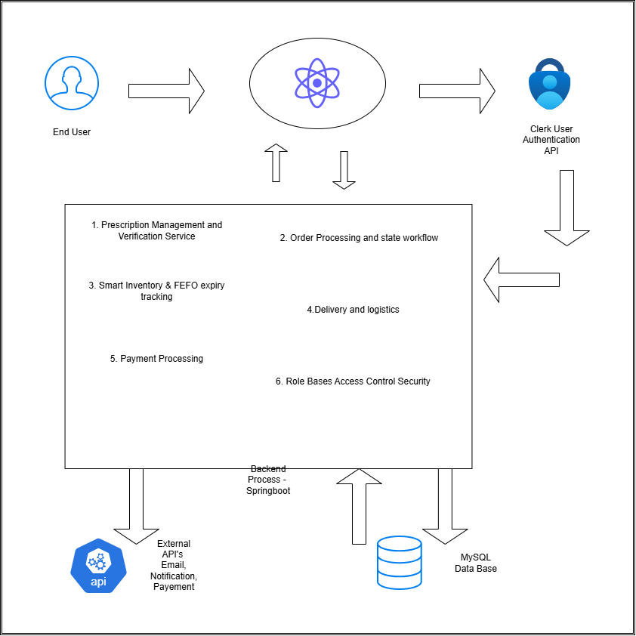
React Frontend

4. FUNCTIONAL REQUIREMENTS

4.1 Architectural Overview
- Backend Framework: Developed using Java Spring Boot, following structured layered architecture (Controller, Service, Repository, DTOs).
- Frontend Application: Built using React.js to deliver a responsive, single-page multi-portal user interface.
- Database Management: MySQL relational database utilizing normalized tables, indexing, foreign keys, and transaction management.
- Deployment & Infrastructure: Containerized using Docker and hosted on Render or Vercel cloud platforms.
- Authentication Infrastructure: Integrated with Clerk API for identity management, user onboarding, multi-factor authentication, and secure JWT session handling.
- External Integrations: RESTful API interfaces for notification channels (Twilio SMS / WhatsApp API, SendGrid Email) and payment gateways.

4.2 Core Functional Capabilities
- Identity & Role-Based Access Control: Strict role segregation preventing unauthorized cross-portal access.
- Catalog & FEFO Stock Management: Real-time inventory tracking, batch expiry date mapping, low-stock threshold triggers, and automatic locking of expired batches.
- Prescription Verification Pipeline: File validation (PDF/JPEG), QR code ingestion, SHA-256 file hashing to prevent duplicate uploads, and pharmacist approval/rejection workflows.
- Order Processing Engine: Cart management, status workflow state machine (Pending Validation → Approved → Packing → Dispatched → Delivered), and partial fulfillment support.
- Chronic Care Subscription Engine: Recurring schedule creation, automated interval reminders, and auto-generation of draft refill orders.
- Logistics & Multi-Channel Messaging: Delivery zone geofencing, dynamic OTP generation, and real-time alerts via Email, SMS, WhatsApp, and In-App channels.
- Audit & Compliance Logging: Event-driven logging for all critical system actions, failed login attempts, and sensitive medical data access.

5. NON-FUNCTIONAL REQUIREMENTS
Category | Technical Requirement & Standard
Scalability & Performance | Page load response times under 2.0 seconds for normal operations. Backend API throughput capable of handling concurrent user requests using connection pooling and caching strategies.
Availability & Fault Tolerance | Targeting 99.5% operational uptime during business hours with graceful error handling, automated database daily backups, and health-check monitoring endpoints.
Security & Privacy | TLS 1.3 encryption in transit, AES-256 encryption at rest for sensitive medical records, OWASP Top 10 protection, password hashing, and input sanitization to prevent injection attacks.
Legal & Compliance | Strict adherence to National Medicines Regulatory Authority (NMRA) guidelines for prescription handling and digital record retention policies for medical audit logs.
Usability & Accessibility | Responsive web UI compliant with WCAG 2.1 Level AA standards, intuitive navigation across desktop, tablet, and mobile browsers.
Maintainability & Extensibility | Modular monolithic code structure designed for future microservice decomposition, comprehensive API documentation, and clean code standards.

6. MAJOR STAKEHOLDERS / USERS

6.1 Client-Side Business Stakeholders
- Nuwan Perera (Operations Manager): Monitors operational efficiency, system bottlenecks, and delivery SLAs.
- Dilani Fernando (Chief Pharmacist): Supervises clinical compliance, prescription verification protocols, and restricted medicine safety.
- Kasun Jayasinghe (Customer Service Supervisor): Handles order escalations, cancellation disputes, missing items, and refund approvals.
- Tharindu Silva (Delivery Coordinator): Coordinates route assignments, field courier dispatches, and delivery exception management.
- Ishara Wickramasinghe (Finance Executive): Reviews financial logs, processes partial refunds, and performs daily cash flow reconciliations.
- Ramesh Gunawardena (IT Manager): Oversees system uptime, infrastructure security, Clerk API configurations, and platform maintenance.

6.2 End Users & Operational Roles
- Customers / Patients: Browse catalogue, upload prescriptions, configure chronic refills, and track delivery progress.
- Pharmacists: Review uploaded prescriptions, verify dosage instructions, approve/reject orders, and sign off on restricted drugs.
- Pharmacy Assistants: Pick items from stock based on FEFO recommendations, package orders, and update physical stock counts.
- Delivery Staff / Couriers: Receive assigned orders, navigate delivery routes, verify delivery via OTP, and complete doorstep handovers.
- Finance Staff: Audit incoming transactions and clear refund workflows.
- System Administrators: Manage role configurations, review security audit logs, and maintain system health parameters.

6.3 External Stakeholders
- NMRA & Health Authorities: Regulatory oversight on digital pharmaceutical distribution and prescription retention compliance.
- Payment & Messaging Service Providers: Third-party API services for financial payments, Twilio SMS/WhatsApp, and SendGrid email delivery.

Project Development Team
Student ID | Student Name | Assigned Core Function
IT25101923 | Lakshan M.K.C. | Function 01: Prescription Upload & Clinical Verification Engine
IT25102867 | Karunathilaka W.V.R.D.T.Y. | Function 02: Smart Inventory, Batch & FEFO Expiry Management System
IT25103946 | Vinogikan M. | Function 03: Real-Time Order Processing & State Workflow Tracking
IT25101882 | Widyawansa T.D. | Function 04: Cold-Chain Medication Tagging & Multi-Factor Logistics Security
IT25103725 | Hathoon M.F.S. | Function 05: Automated Chronic Care Refill & Subscription Management Engine
IT25100979 | Kookulan E. | Function 06: Geofenced Delivery Dispatch, OTP Handover & Multi-Channel Notification Engine

7. SIX MAJOR FUNCTIONS

Function 01: Prescription Upload & Clinical Verification Engine
Assigned Member: Lakshan M.K.C. (IT25101923)
Target Users: Customers, Pharmacists, Pharmacy Assistants.
Description: Provides a secure digital interface allowing customers to upload image/PDF prescriptions or scan doctor-issued QR codes. Utilizes SHA-256 cryptographic file hashing to detect duplicate or altered prescription uploads. Uploads enter a centralized clinical queue where licensed pharmacists review dosage instructions, customer history, and prescription validity. Pharmacists can approve, request clarification, or reject submissions with specific notes.
Expected Outcome: Eliminates illegal prescription reuse, guarantees NMRA compliance, and prevents unauthorized distribution of controlled medications.

Function 02: Smart Inventory, Batch & FEFO Expiry Management System
Assigned Member: Karunathilaka W.V.R.D.T.Y. (IT25102867)
Target Users: Pharmacists, Pharmacy Assistants, Operations Manager.
Description: Manages the complete lifecycle of pharmaceutical stocks using First-Expired-First-Out (FEFO) logic. Tracks batch numbers, manufacturing details, and expiration dates. Automatically locks expired or recalled batches to prevent picking. Generates real-time low-stock and upcoming-expiry alerts to operational staff.
Expected Outcome: Minimizes financial losses from expired inventory, ensures safe medication distribution, and automates stock replenishment planning.

Function 03: Real-Time Order Processing & State Workflow Tracking
Assigned Member: Vinogikan M. (IT25103946)
Target Users: Customers, Pharmacy Assistants, Delivery Coordinators, Customer Service.
Description: Powers the core order lifecycle via a deterministic state workflow engine (Pending Verification → Approved → Packing → Dispatched → Delivered / Cancelled). Manages partial fulfillment scenarios when specific items are out of stock and provides structured cancellation/refund request processing.
Expected Outcome: Delivers complete operational visibility, reduces customer support inquiries, and streamlines warehouse order picking workflows.

Function 04: Cold-Chain Tagging & Multi-Factor Logistics Security System
Assigned Member: Widyawansa T.D. (IT25101882)
Target Users: Pharmacists, Delivery Coordinators, Delivery Staff.
Description: Identifies temperature-sensitive medications (e.g., Insulin, Vaccines) and attaches mandatory cold-chain handling flags throughout packaging and transit. Enforces age-verification and identity security flags during packaging and final courier handover.
Expected Outcome: Guarantees temperature-sensitive medication integrity during transit and enforces strict legal age and identity compliance upon delivery.

Function 05: Automated Chronic Care Refill & Subscription Management Engine
Assigned Member: Hathoon M.F.S. (IT25103725)
Target Users: Chronic Care Patients (Diabetes, Hypertension), Pharmacists.
Description: Allows long-term patients to configure recurring medicine refill schedules based on standing prescriptions. The engine automatically calculates replenishment dates, dispatches proactive time-based reminders, and auto-generates pre-filled draft orders for one-click confirmation by both patient and pharmacist.
Expected Outcome: Significantly improves medication adherence for long-term care patients, secures predictable revenue, and automates repeat order processing.

Function 06: Geofenced Delivery Dispatch, OTP Verification & Multi-Channel Notification Engine
Assigned Member: Kookulan E. (IT25100979)
Target Users: Customers, Delivery Staff, Delivery Coordinator.
Description: Validates delivery addresses against active operational zones using geofencing. Upon dispatch, generates a dynamic single-use One-Time Password (OTP) sent to the customer via SMS/WhatsApp/Email. Couriers must input the valid OTP into their field application to confirm delivery completion. Centralizes all order status alerts across multiple channels.
Expected Outcome: Prevents fraudulent handovers, eliminates delivery location errors, and keeps stakeholders continuously updated in real time.

8. MINOR FUNCTIONS
- Customer Self-Service Utilities: User profile management, address book management, order history tracking, and downloadable PDF receipts.
- Clinical & Operational Helpers: Active ingredient and generic medicine search, automated digital picking list generation for warehouse staff, and manual inventory stock level adjustments.
- Logistics & Exception Handling Helpers: Failed delivery attempt logging, customer absence notes, driver re-routing requests, and escalation tagging.
- Financial Accounting Helpers: Transaction log exports, operational fee tracking, manual refund processing screens, and reconciliation summary reports.
- System Administration Helpers: Security audit log search tools, global configuration parameter controls, and notification template management.

9. SYSTEM LIMITATIONS / CONSTRAINTS
- Prescription Review Bottlenecks: Peak ordering hours may experience temporary delays due to the mandatory manual review required by licensed pharmacists.
- Database Synchronization Latency: In ultra-high traffic scenarios, micro-delays in database sync could briefly show dynamic stock updates before cart locking occurs.
- Customer Upload Quality: System processing relies on user-submitted file quality; blurry images or truncated PDFs require manual intervention, extending processing time.
- Field Connectivity Dependencies: Mobile delivery couriers operating in low-cellular network zones may encounter delayed real-time OTP confirmation syncs.
- Third-Party Service Reliance: Platform availability is dependent on external third-party API stability (Clerk Auth, Twilio SMS, SendGrid Email).
- Regulatory Overhead: Mandatory medical data retention and strict audit trails increase database storage footprint and backup maintenance requirements.

10. SIMPLE TIMELINE (14-WEEK SDLC PLAN)
Timeline Phase | Target Weeks | SDLC Phase & Key Milestones / Activities
Phase 1 | Weeks 3 – 4 | Requirements & Proposal: Gathering functional requirements, finalizing tech stack, writing proposal report, and establishing project architecture.
Phase 2 | Weeks 5 – 6 | System Design: ERD database modeling, API specification design, UX/UI wireframing, and setting up Spring Boot / React / Docker repositories.
Phase 3 | Weeks 7 – 8 | Sprint 1 Development: Database schema implementation, Clerk authentication setup, Function 01 (Prescription Engine) & Function 02 (FEFO Inventory) implementation.
Phase 4 | Weeks 9 – 10 | Sprint 2 Development: Implementation of Function 03 (Order Workflow), Function 04 (Cold-Chain Safety), Function 05 (Chronic Refills), and Function 06 (Geofenced OTP & Alerts).
Phase 5 | Weeks 11 – 12 | Integration & Testing: System integration, end-to-end API testing, role security validation, usability evaluation, and bug fixing.
Phase 6 | Weeks 13 – 14 | Deployment & Final Review: Docker containerization, cloud deployment to Render/Vercel, documentation completion, final project report, and system presentation.

11. CONCLUSION
The Web-Based Medicine Ordering System provides a secure, highly scalable, and structurally complete software solution designed to modernize online pharmaceutical distribution. By combining automated prescription validation, batch-level FEFO stock management, cold-chain safety tagging, chronic care refill automation, and geofenced OTP delivery handovers, the application directly solves the primary operational pain points of modern pharmacies while elevating patient convenience.
Guided by a disciplined 14-week SDLC roadmap, robust architecture (Java Spring Boot, React, MySQL, Clerk, Docker), and clear member function ownership, the development team is well-prepared to deliver a high-quality, regulatory-compliant, and production-ready system.

