Sri Lanka Institute of Information
Technology


SE2030 | Software Engineering
Lab Sheet 04 - Activity Diagram

Zentra Mart | Web-Based Marketplace Platform
Group ID: 2026-Y2-S1-KU-19

Member Name | Registration No. | Assigned Function
Jayawardena S.D.D.L. | IT25101719 | User Registration & Account Management
Madugalle E.W.M.W.W.S.A.K. | IT25101711 | Product Listing Management
Alahakoon A.R.S.S. | IT25101690 | Search & Browse / Product Catalog
Sooriyaarachchi A.G.S.T. | IT25101736 | Shopping Cart & Checkout
Jayasinghe J.M.N.R.N. | IT25101657 | Order Management & Tracking
Ahamed M. R. S. | IT25101678 | Admin Management Panel

Member 1
Registration No.: IT25101719
Use Case Scenario
Use Case: Register Account
Primary Actor: Guest / Visitor | pm,n Secondary Actor(s): Notification Service
Main flow:
1. Visitor selects “Sign Up” on the platform.
2. Visitor enters their name, email, mobile number, and password.
3. Visitor selects their role as Buyer or Seller.
4. System validates the submitted details.
5. System creates a new user account with the selected role.
6. System requests the Notification Service to send a confirmation OTP to the visitor's email or mobile.
7. Visitor enters the OTP to confirm the account.
8. System activates the account and displays the appropriate role-based dashboard.
Extensions:
2.a. If required fields are missing or invalid,
(a) Display a validation error message.
(b) Allow the visitor to correct and resubmit the form.
4.a. If the email is already registered,
(a) Display an “account already exists” message.
(b) Redirect the visitor to the Login use case.
7.a. If the OTP is incorrect or expired,
(a) Display an error message.
(b) Allow the visitor to request a new OTP.

Activity Diagram
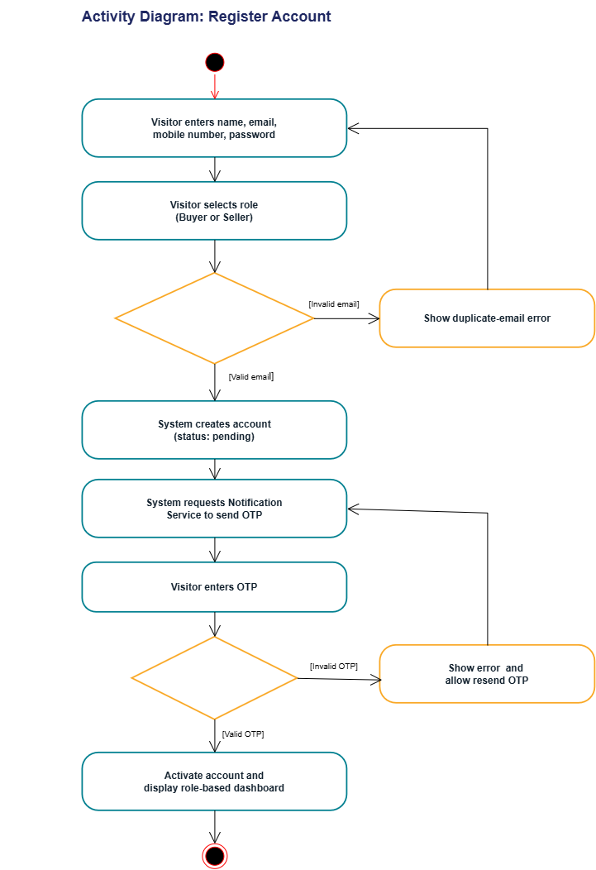
Member 2
Registration No.: IT25101711
Use Case Scenario
Use Case: Create Product Listing
Primary Actor: Seller | Secondary Actor: None
Main flow:
1. Logged-in seller selects “Add New Listing”.
2. Seller enters the product name, description, price, stock quantity, and category.
3. Seller uploads one or more product images.
4. System validates the listing details and images.
5. System saves the listing with status “Active”.
6. System publishes the active listing to the buyer-facing catalog.
Extensions:
2.a. If required fields are missing or invalid,
(a) Display a validation error message.
(b) Allow the seller to correct and resubmit the form.
3.a. If an uploaded image exceeds the size or format limit,
(a) Display an error message.
(b) Allow the seller to re-upload a valid image.

Activity Diagram:
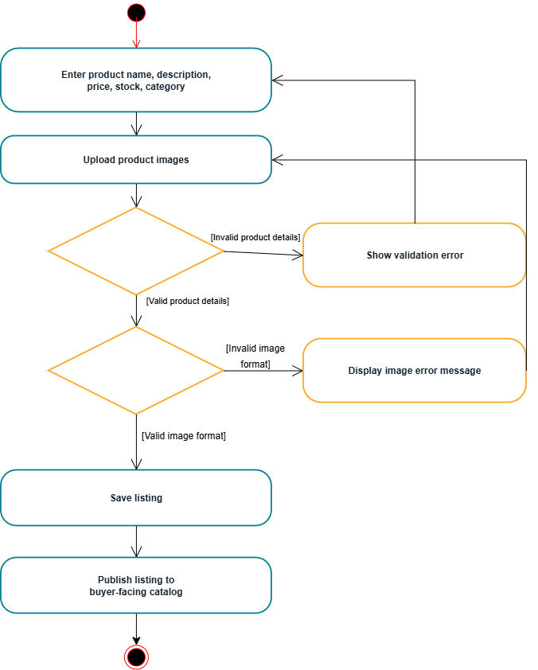

Member 3
Registration No.: IT25101690
Use Case Scenario
Use Case: Search & Filter Products
Primary Actor: Buyer | Secondary Actor: Guest / Visitor
Main flow:
1. Buyer or guest visitor enters a keyword in the search bar.
2. User applies optional filters such as category and price range.
3. System queries the product catalog for matching active listings.
4. System displays matching products with price and thumbnail.
5. User selects a sort order such as price, newest, or rating.
6. System re-orders the results accordingly.
7. Use case ends when the filtered and sorted results are displayed.
Extensions:
3.a. If no products match the search or filter criteria,
(a) Display a “no results found” message.
(b) Suggest that the user broaden the search.
5.a. If the user applies an invalid filter combination,
(a) Display a warning message.
(b) Reset the filters to their default values.

Activity Diagram
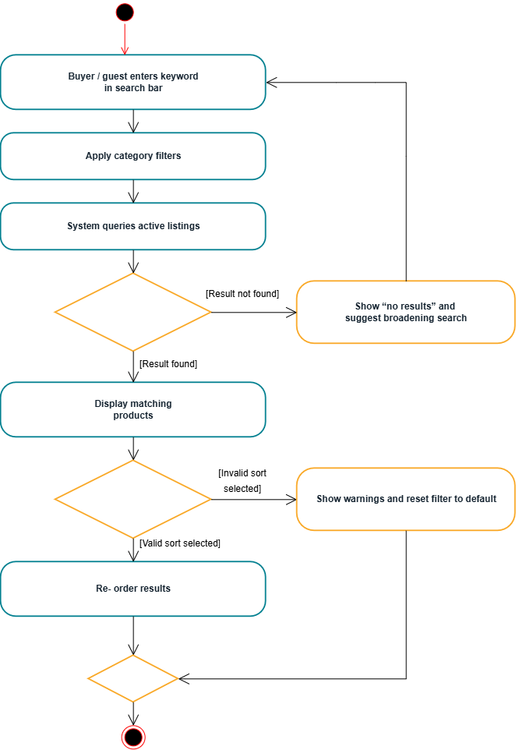Member 4
Registration No.: IT25101736
Use Case Scenario
Use Case: Checkout & Pay
Primary Actor: Buyer | Secondary Actor(s): Payment Gateway, Notification Service
Main flow:
1. Buyer selects “Checkout & Pay” from the shopping cart.
2. System displays the order summary with item prices and total.
3. Buyer confirms the delivery details.
4. Buyer optionally applies a valid discount code.
5. Buyer selects a payment method and submits payment.
6. System reserves stock and invokes the Process Payment use case.
7. Payment Gateway returns the payment result.
8. System creates the order, updates stock and requests the Notification Service to send an order confirmation.
9. Use case ends when the order confirmation is displayed to the buyer.
Extensions:
1.a. If the cart is empty,
(a) Display a message prompting the buyer to add items first.
4.a. If the discount code is invalid or expired,
(a) Display an error message.
(b) Continue checkout without applying the discount.
5.a. If required payment details are missing or invalid,
(a) Display a validation error message.
(b) Allow the buyer to correct and resubmit.
7.a. If payment verification fails,
(a) Display a payment failed message.
(b) Release the reserved stock.
(c) Allow the buyer to retry payment.
Activity Diagram: Checkout & pay
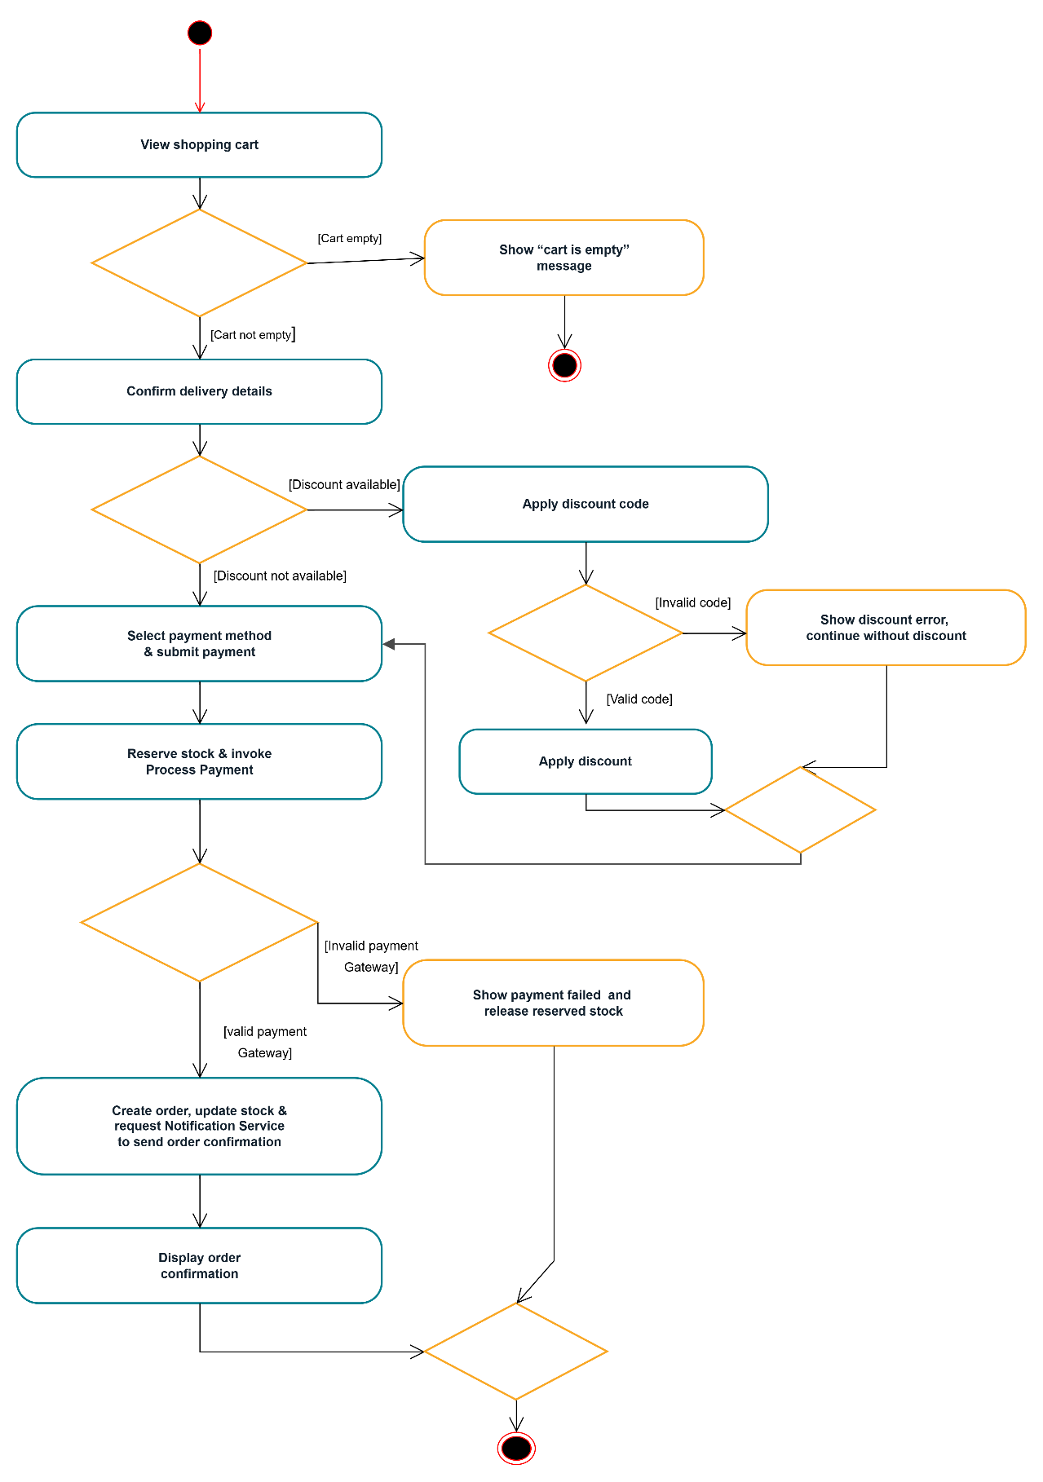
Member 5
Registration No.: IT25101657
Use Case Scenario
Use Case: Update Order Status
Primary Actor: Seller | Secondary Actor: Notification Service
Main flow:
1. Seller opens “Incoming Orders” on the seller dashboard.
2. System displays orders awaiting fulfilment.
3. Seller selects an order to process.
4. Seller updates the order status, for example to “Shipped”.
5. System validates and records the status change with a timestamp.
6. System requests the Notification Service to send the buyer an order-status notification.
7. Use case ends when the updated status is stored and the notification request is completed.
Extensions:
3.a. If the selected order has already been cancelled,
(a) Display a message indicating the order is no longer active.
4.a. If the seller attempts an invalid status transition, such as “Delivered” before “Shipped”,
(a) Display an error message.
(b) Keep the previous status unchanged.

Activity Diagram:
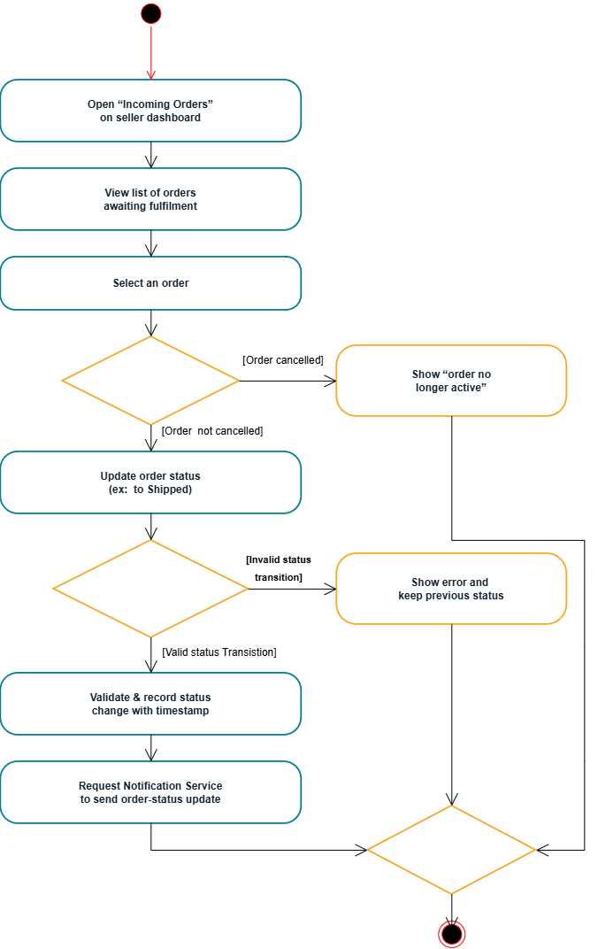
Member 6:
Registration No.: IT25101678
Use Case Scenario
Use Case: Admin Panel Management
Primary Actor: Administrator | Secondary Actor: Notification Service
Main flow:
- Administrator logs in and opens the Admin Panel.
- System displays the available management actions: Manage User Accounts, Moderate Listings, and Review Complaints.
- Administrator selects one action to perform.
- System executes the selected action, following one of the sub-flows below.
- Use case ends when the selected action is completed and the administrator may choose to perform another action or exit the panel.

Sub-flow A — Manage User Accounts
- System displays the list of user accounts.
- Administrator selects an account.
- Administrator chooses to suspend or reactivate the account.
- System updates the account status accordingly.
- System requests the Notification Service to notify the affected user.

Sub-flow B — Moderate Listings
- System displays listings flagged for review or reported by users.
- Administrator reviews a flagged listing's details.
- Administrator decides to approve or remove the listing.
- System updates the listing status accordingly.
- If required, system records the decision and requests the Notification Service to notify the relevant seller.

Sub-flow C — Review Complaints
- System displays the complaint queue.
- Administrator investigates a selected complaint.
- Administrator resolves the complaint or escalates it to the relevant department.
- System updates the complaint status accordingly.
- System requests the Notification Service to notify the complainant of the outcome.

Extensions:
3.a. If the administrator attempts an action without sufficient permissions,
(a) Display an access-denied message.
(b) Return to the action selection screen.
A3.a. If the selected account is already in the target status (e.g., already suspended),
(a) Display a message indicating no change is needed.
B3.a. If the listing was already removed by the seller,
(a) Display a message indicating that the listing no longer exists.
(b) Remove it from the review queue.
B4.a. If the administrator removes the listing,
(a) Record the reason for removal in the audit trail.
(b) Include the removal reason in the notification request to the Notification Service.
C3.a. If the complaint was already resolved by another support agent,
(a) Display a message indicating the complaint is already closed.

Activity Diagram

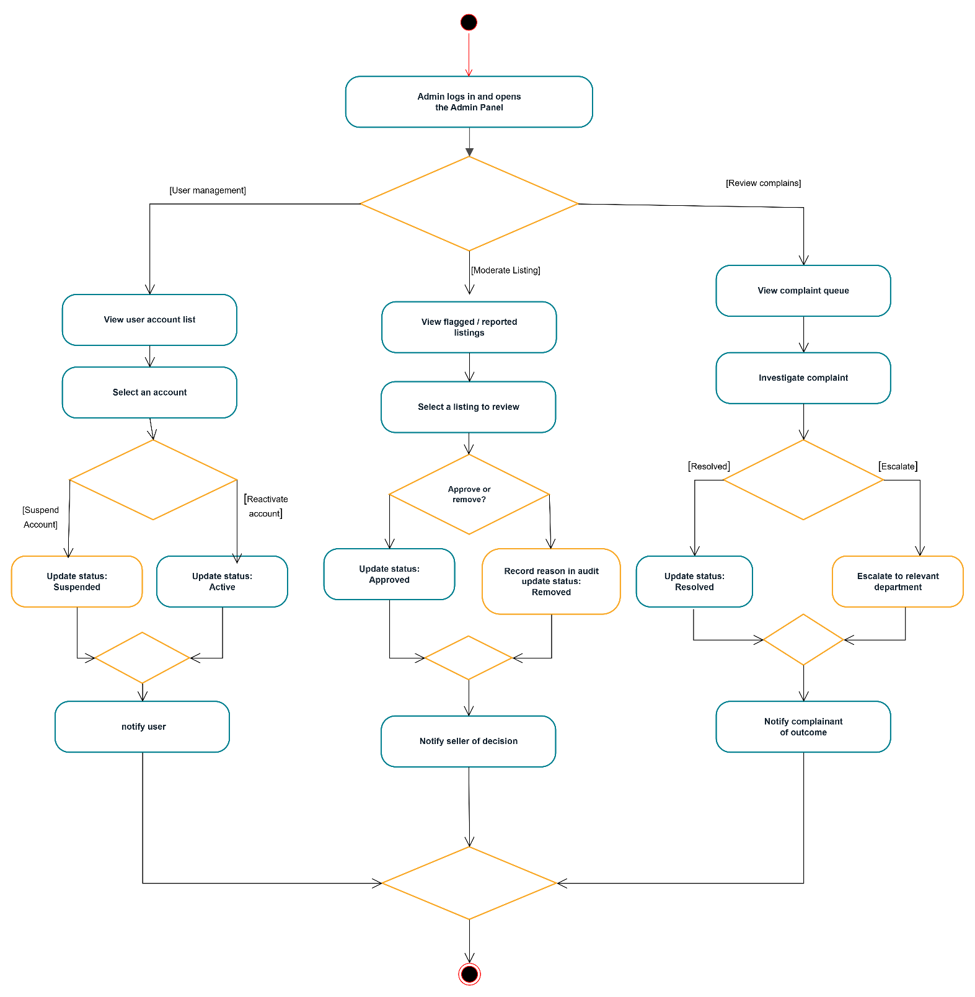

System Activity diagram
