FACULTY OF COMPUTING
SLIIT Kandy Uni | 2Y1S | Group ID : 2026-Y2-S1-KU-24 (Group 24)
IT2140 — Database Design and Development

STREETIFY
Smart Web based Transportation Platform

Assignment Part 02
Relational Schema Mapping | DDL | DML | Queries | Stored Procedure | Trigger

Index No. | Name | Module
IT25102240 | Rammandalagedara R.V.S. (Vidura) | Super Admin & Governance
IT25102208 | Nayanamina A.R.L.P. (Lahiru) | User Account & Verification
IT25102207 | Dharmakeerthi W.A.C.B. (Chanuka) | Ride Booking & Dispatch Engine
IT25102241 | Senaka K.A.T. (Tharindu) | Trip Progress & Driver Telemetry
IT25102225 | Edirisinghe E.A.R.N.D. (Daham) | Payment & Ledger Management
IT25102193 | Weerasingha W.A.M.B. (Mithun) | Review & Dispute Management

Submission: 27 th September 2026

Contents
Part A: Relational Schema Mapping and Refinement 3
A.1 Relational Schema Overview 3
A.2 EER-to-Relational Mapping Rules Applied 5
A.3 Schema Design Decisions & Viva Justifications 6
A.4 Normalization Verification (1NF, 2NF, 3NF, BCNF) 7
Part B: SQL DDL Implementation 8
B.1 Full DDL Script — streetify_db 8
B.2 Constraint & Index Summary 13
Part C: Insert Sample Data 14
C.1 Master Seed Script 14
C.2 Verification Queries (SELECT * from each table) 18
D.1 Simple SELECT — Driver Fleet Operations Dashboard 20
D.2 JOIN — Passenger Trip History with Driver Details 21
D.3 Aggregation — Revenue Summary by Payment Method 22
D.4 GROUP BY / HAVING — High-Performing Driver Identification 23
D.5 Subquery — Above-Average Fare Trips (Surge Pricing Analysis) 24
D.6 Additional Team Module Queries (03_team_member_queries.sql) 25
Part E: Stored Procedure — usp_ProcessTripPayment 30
E.1 Business Logic & Design Rationale 30
E.2 Complete Stored Procedure Code 31
E.3 Demonstration Script 32
Part F: Trigger — trg_ProtectFinalizedTrips 34
F.1 Trigger Design Rationale 34
F.2 Complete Trigger Code 35
F.3 Demonstration Script 36
References 37

Part A: Relational Schema Mapping and Refinement

A.1 Relational Schema Overview
The Streetify relational schema spans 9 tables across 6 functional modules.
Notation: PK=Primary Key, FK=Foreign Key, UQ=Unique, NN=Not Null.
Module | Relation Name | Attributes & Key Constraints
Users | users | id PK IDENTITY, email UQ NN, password_hash NN, first_name NN, last_name NN, phone, dtype NN, role NN, admin_role, active BIT NN, suspended BIT NN, suspension_reason, suspended_until, wallet_balance DECIMAL NN, preferred_payment_method, license_number, nic, verification_status, average_rating, total_trips INT, commission_debt DECIMAL, is_online BIT, current_lat FLOAT, current_lng FLOAT, created_at, updated_at
Fleet | vehicles | id PK IDENTITY, driver_id FK->users.id UQ NN, vehicle_type NN, number_plate UQ NN, year_of_manufacture NN, make, model, color, created_at
Fleet | driver_documents | id PK IDENTITY, driver_id FK->users.id NN, doc_type NN, original_filename NN, file_path NN, file_size_bytes, content_type, status NN DEFAULT PENDING, reviewer_note, uploaded_at, reviewed_at
Trips | trips | id PK IDENTITY, passenger_id FK->users.id NN, driver_id FK->users.id, pickup_address NN, pickup_lat NN, pickup_lng NN, dropoff_address NN, dropoff_lat NN, dropoff_lng NN, distance_km, ride_type NN, base_fare, per_km_rate, platform_fee, total_fare, platform_commission, driver_net, status NN, accepted_at, arrived_at, started_at, completed_at, cancelled_at, cancellation_reason, no_show_fee, payment_method, is_paid BIT NN, created_at, updated_at
Billing | payments | id PK IDENTITY, trip_id FK->trips.id UQ NN, passenger_id FK->users.id NN, driver_id FK->users.id NN, gross_amount NN, platform_commission NN, driver_net NN, payment_method NN, status NN, retry_count INT NN, failure_reason, transaction_ref, created_at, processed_at
Engage | reviews | id PK IDENTITY, trip_id FK->trips.id UQ NN, passenger_id FK->users.id NN, driver_id FK->users.id NN, rating INT CHECK(1-5) NN, comment, created_at
Support | dispute_tickets | id PK IDENTITY, passenger_id FK->users.id NN, trip_id FK->trips.id, subject NN, description NN, dispute_type NN, requested_refund_amount, status NN, resolution_note, approved_refund_amount, resolved_by_staff_id FK->users.id, created_at, updated_at, resolved_at
Audit | audit_logs | id PK IDENTITY, performed_by_staff_id NN, performed_by_email NN, action_type NN, description NN, target_user_id, target_entity_type, target_entity_id, created_at

A.2 EER-to-Relational Mapping Rules Applied
The following 8 standard mapping rules were applied to convert the Streetify EER diagram into the relational schema:
Rule 1 — Regular (Strong) Entity Types
Each strong entity in the EER (USER, TRIP, PAYMENT, VEHICLE, REVIEW, DISPUTE_TICKET, AUDIT_LOG) maps to its own relation. All simple attributes become columns; the EER's primary key attribute becomes the relational PK. Result: 8 base relations.
Rule 2 — Composite Attributes
Composite attributes PickupLocation and DropoffLocation from the TRIP entity are flattened into atomic columns (pickup_lat, pickup_lng, pickup_address; dropoff_lat, dropoff_lng, dropoff_address) inside the trips table. This maintains 1NF and avoids extra joins.

Rule 3 — Multivalued Attributes
The EER ContactNo multivalued attribute on USER is simplified to a single phone column (one primary contact per user). For multi-contact support, a separate user_contacts table would be added — this design decision is documented in A.3.

Rule 4 — Weak Entity Types
AUDIT_LOG is a weak entity, identified by the staff member who performed the action. A surrogate IDENTITY PK is added in addition to the identifying FK (performed_by_staff_id) per MSSQL best practice for index performance.

Rule 5 — 1:1 Relationships
The 1:1 relationships TRIP-PAYMENT and TRIP-REVIEW are enforced by placing trip_id as a UNIQUE FOREIGN KEY in both payments and reviews. The UNIQUE constraint guarantees exactly one payment and one review per completed trip at the database level.

Rule 6 — 1:N Relationships
All one-to-many relationships (DRIVER->TRIPS, PASSENGER->TRIPS, DRIVER->VEHICLES, DRIVER->DRIVER_DOCUMENTS) are represented by placing the PK of the 'one' side as an FK in the 'many' side table. E.g., driver_id in trips references users.id.
Rule 7 — ISA / Specialization (USER Hierarchy)
The EER defines a Total, Disjoint specialization: USER -> {PASSENGER, DRIVER, ADMIN}. We implemented Option D — Single Table Inheritance (STI) — using the dtype discriminator column and role column inside the unified users table. This minimizes JOIN overhead for authentication, the highest-frequency query in the platform.

Rule 8 — Indexes on FK Columns
All FK columns used in WHERE clauses or JOIN conditions are backed by explicit CREATE INDEX statements (idx_trips_passenger, idx_trips_driver, idx_trips_status, etc.) for query performance at scale. This is a production best practice not captured in the basic mapping rules.

A.3 Schema Design Decisions & Viva Justifications
* STI vs. Table-per-Subtype for USER Hierarchy
We chose Single Table Inheritance (STI) because authentication — the highest-frequency database operation in Streetify — requires fetching role, active, and suspended in a single row. With separate subtype tables (passengers, drivers), every login would require a JOIN. STI reduces this to a single indexed scan on users.email. The trade-off (NULL columns for role-specific attributes) is acceptable because the application enforces that dtype='PASSENGER' rows will never populate driver-specific columns.
* UNIQUE Constraint on payments.trip_id for 1:1 Enforcement
Rather than relying on application-layer logic, the 1:1 relationship between TRIP and PAYMENT is enforced at the database level with a UNIQUE constraint on trip_id. This provides idempotency guarantees regardless of network retries or concurrent API requests.
* BIGINT IDENTITY(1,1) Surrogate Keys
All tables use BIGINT IDENTITY surrogate PKs. While natural keys (email, number_plate) are constrained UNIQUE as candidate keys, the integer surrogate enables optimal B-tree index performance, compact FK references, and compatibility with future table partitioning.
* DECIMAL(10,2) for Monetary Columns
All fare, commission, and balance columns use DECIMAL(10,2). IEEE 754 FLOAT introduces binary rounding errors (0.1 + 0.2 != 0.3) that are unacceptable in financial systems. DECIMAL is an exact numeric type, mandatory for any money calculation.
* ON DELETE CASCADE for vehicles and driver_documents
These tables use CASCADE because a vehicle and its documents have no existence independent of their driver — this is an existential dependency. Core financial tables (trips, payments) deliberately omit CASCADE to preserve transaction history even if a user account is deactivated.
* Storing platform_commission and driver_net as Snapshots
Although derivable (15% of gross), these values are stored at payment time as immutable financial snapshots. If the commission rate changes in future, historical payment records remain accurate and auditable without recalculation.

A.4 Normalization Verification (1NF, 2NF, 3NF, BCNF)
All 9 Streetify relations have been verified against the criteria for Third Normal Form and Boyce-Codd Normal Form:
Normal Form | Rule | Streetify Compliance Evidence | Status
1NF | Atomic Values | All columns are atomic — no arrays, no repeating groups, no composite cell values. Composite EER attributes (PickupLocation, DropoffLocation) are flattened. phone stores one primary contact number. | PASS — All 9 Tables
2NF | No Partial Dependencies | All non-key attributes are fully dependent on the ENTIRE primary key. Since all tables use single-column surrogate PKs (IDENTITY), partial dependencies are architecturally impossible. | PASS — All 9 Tables
3NF | No Transitive Dependencies | No non-key attribute determines another non-key attribute. platform_commission in payments is stored as a snapshot value, not derived from another non-key column at query time. rating in reviews does not determine any other attribute. | PASS — All 9 Tables
BCNF | Every Determinant is a Superkey | For every FD X->Y, X is a superkey. All determinants that are not the PK (email, number_plate, trip_id in payments) are declared UNIQUE constraints, making them candidate keys — satisfying BCNF. | PASS — All 9 Tables

Part B: SQL DDL Implementation

B.1 Full DDL Script — streetify_db
The script creates the database, drops existing tables in FK-safe order, creates all 9 tables with full constraints, and adds performance indexes.
Step 1 — Database Creation & Clean Drop
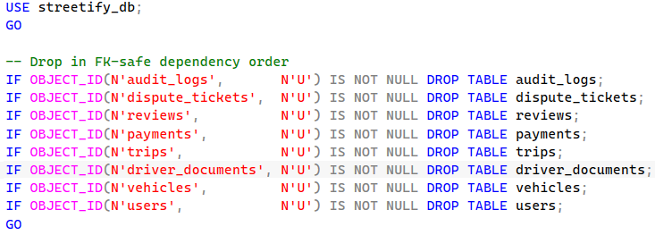
Table: users
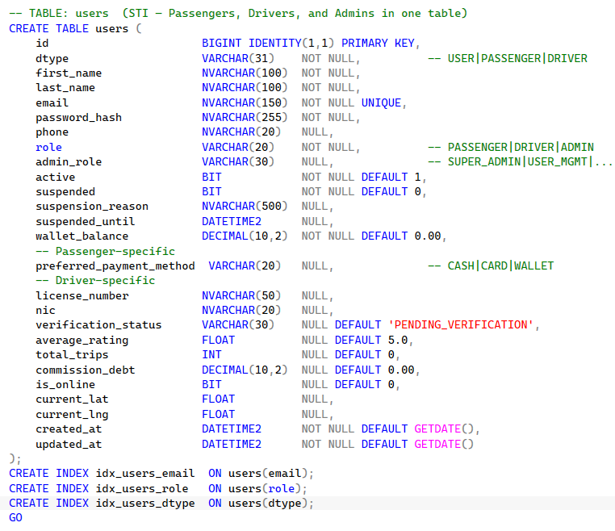
Tables: vehicles & driver_documents
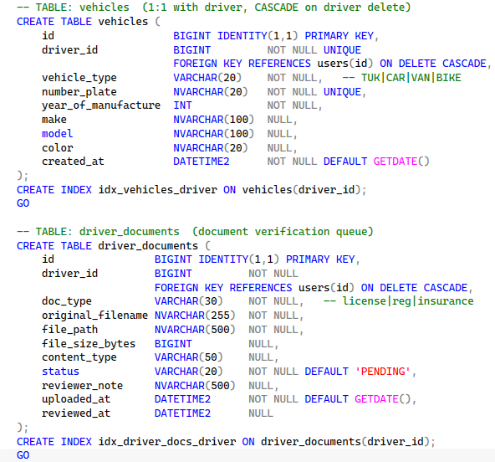

Table: trips
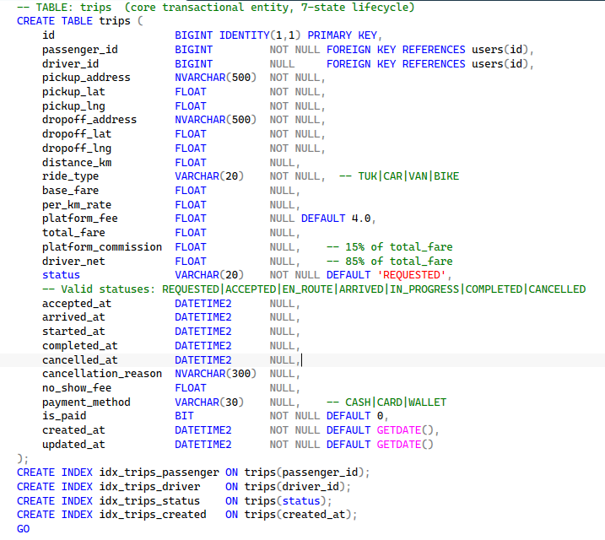

Tables: payments, reviews, dispute_tickets, audit_logs
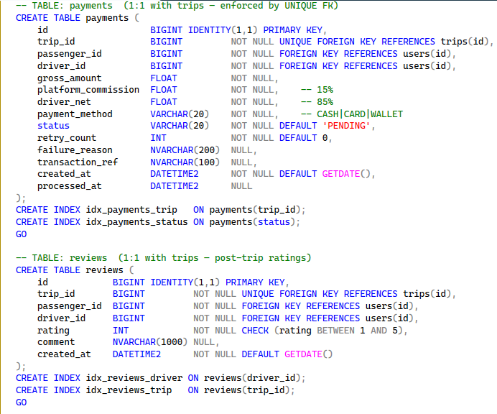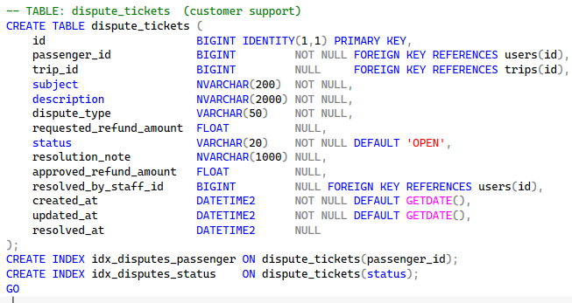
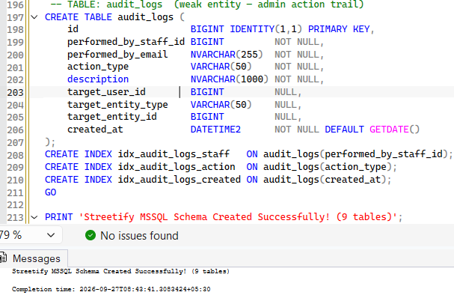
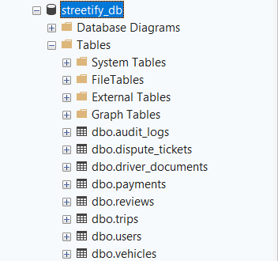

B.2 Constraint & Index Summary
Table | Constraint Type | Column(s) | Business Justification
users | PRIMARY KEY | id | Surrogate, clustered index
users | UNIQUE | email | Prevents duplicate accounts
vehicles | UNIQUE FK | driver_id -> users.id | 1:1 — one vehicle per driver
vehicles | UNIQUE | number_plate | No duplicate plates
driver_documents | FK | driver_id -> users.id CASCADE | Existential dependency
trips | FK | passenger_id -> users.id NN | Referential integrity
trips | FK NULLable | driver_id -> users.id | NULL = no driver yet assigned
trips | INDEX x4 | passenger_id, driver_id, status, created_at | Core dispatch performance
payments | UNIQUE FK | trip_id -> trips.id | 1:1 — one payment per trip
reviews | UNIQUE FK | trip_id -> trips.id | 1:1 — one review per trip
dispute_tickets | FK NULLable | resolved_by_staff_id->users.id | NULL = unresolved ticket
audit_logs | INDEX x3 | performed_by_staff_id, action_type, created_at | Audit query optimization

Part C: Insert Sample Data

C.1 Master Seed Script
1. Admin Users
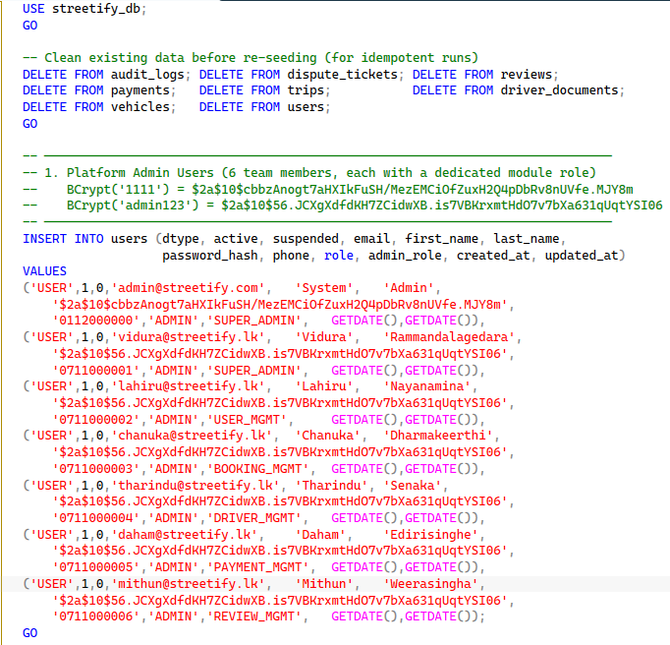

2 & 3. Passengers & Drivers
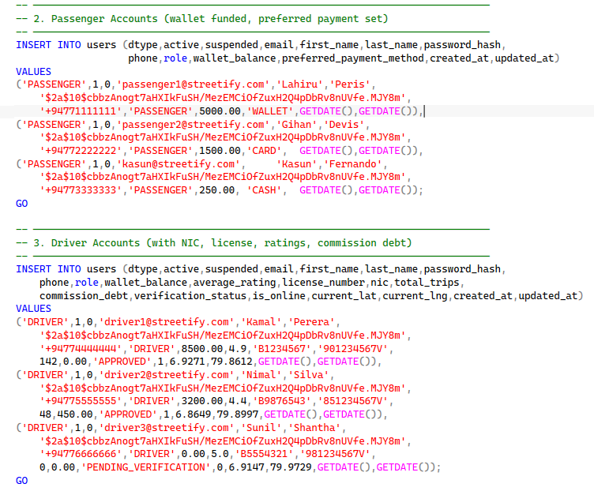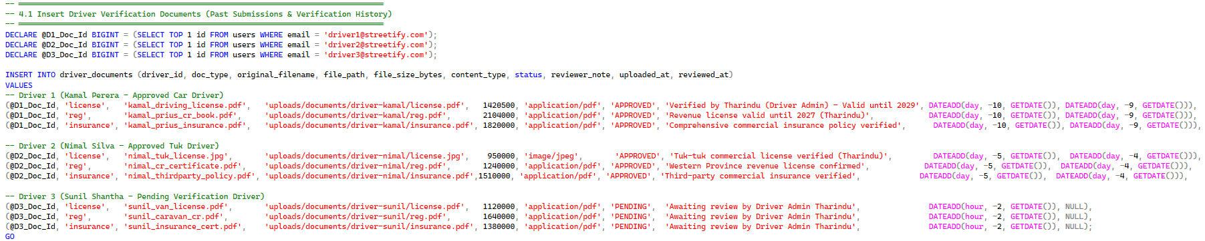

4 & 5. Vehicles & Trips
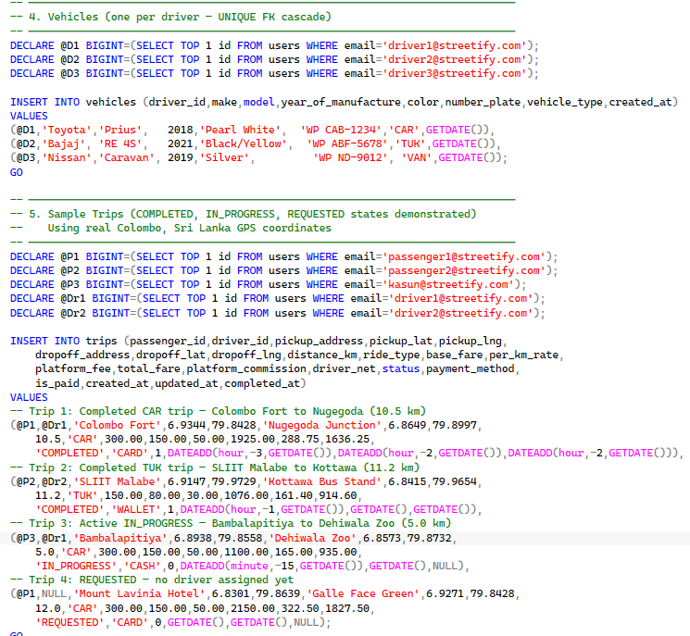

6, 7 & 8. Payments, Reviews, Disputes, Audit Logs
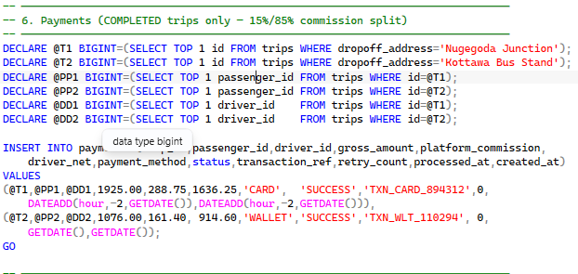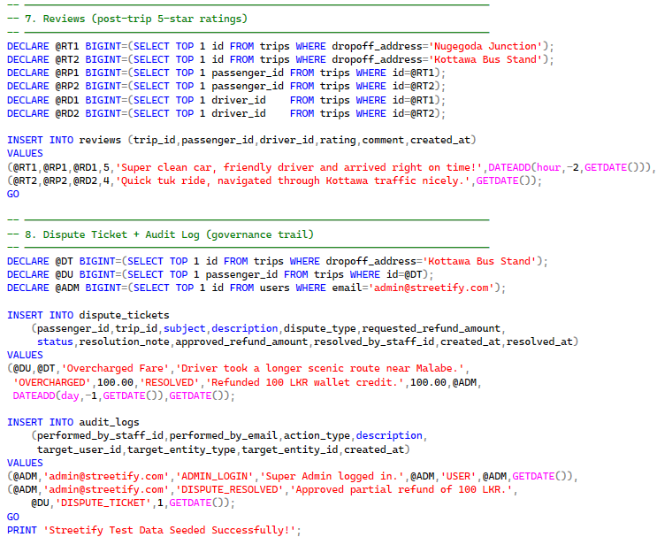

C.2 Verification Queries (SELECT * from each table)

Table: users
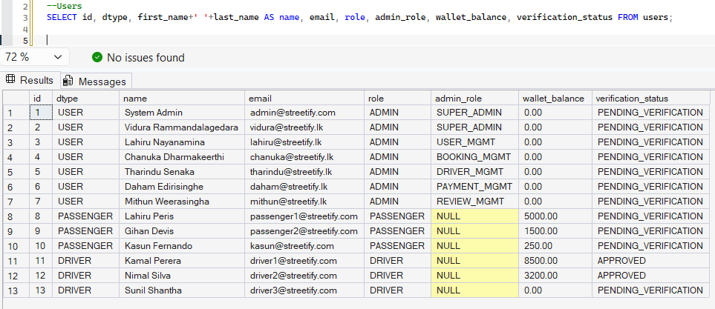
Table: vehicles
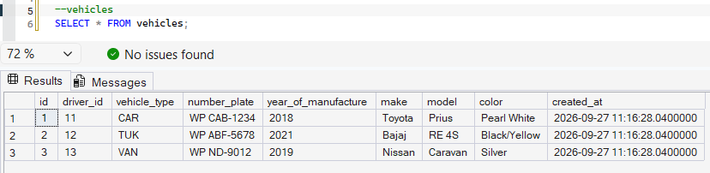
Table: driver_documents
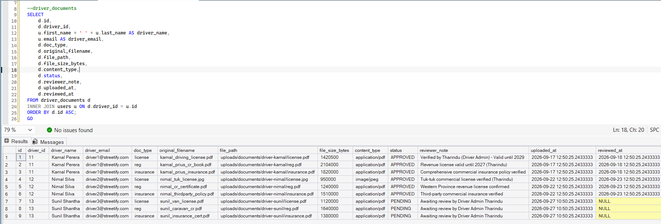
Table: trips
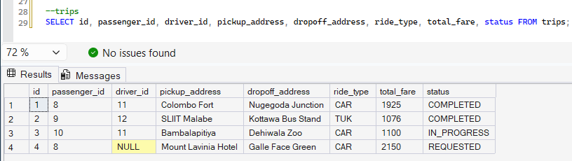
Table: payments
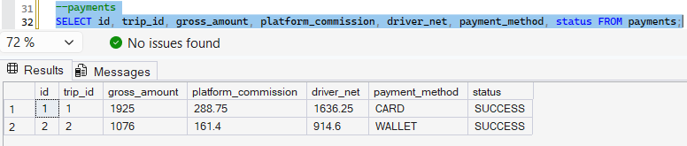
Table: reviews
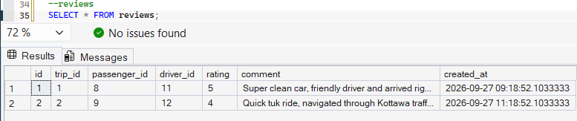
Table: dispute_tickets
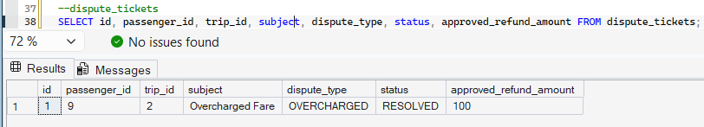
Table: audit_logs
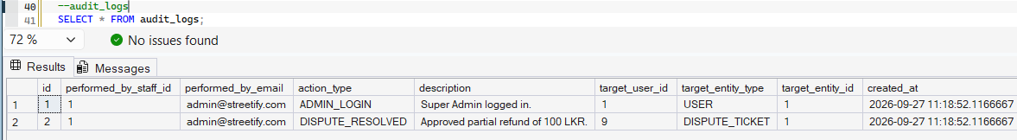
Part D: SQL Queries and Outputs

D.1 Simple SELECT — Driver Fleet Operations Dashboard
Business Purpose: Operations staff need to view the current status of all approved drivers — who is online, their rating, vehicle details, and total trip count — for real-time fleet management.
D.1 — Driver Fleet Status (Simple SELECT + LEFT JOIN)
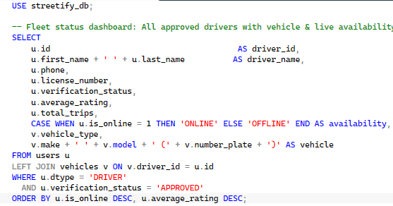
Expected columns: driver_id, driver_name, phone, license_number, verification_status, average_rating, total_trips, availability, vehicle_type, vehicle
The ORDER BY is_online DESC, average_rating DESC simulates a real-time dispatch priority queue — online drivers with the highest ratings appear first.

D.2 JOIN — Passenger Trip History with Driver Details
Business Purpose: Customer Support agents investigating a dispute need a full view of a passenger's completed trip history, with driver name, vehicle, and fare — all in one result set for efficient case resolution.
D.2 — Trip History (INNER + LEFT JOIN)
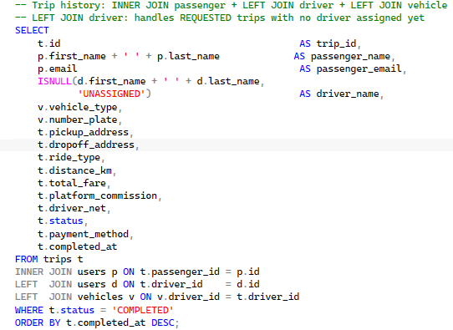
Expected columns: trip_id, passenger_name, passenger_email, driver_name, vehicle_type, number_plate, pickup_address, dropoff_address, ride_type, distance_km, total_fare, platform_commission, driver_net, status, payment_method, completed_at
INNER JOIN on passenger guarantees every row has a valid passenger. LEFT JOIN on driver handles trips still in REQUESTED state (no driver yet). ISNULL() provides a user-friendly 'UNASSIGNED' label for the UI.

D.3 Aggregation — Revenue Summary by Payment Method
Business Purpose: The Finance Manager needs a quarterly summary of revenue broken down by payment channel (CARD, WALLET, CASH) to optimize payment processor contracts and identify dominant payment preferences.
D.3 — Revenue Aggregation by Payment Method
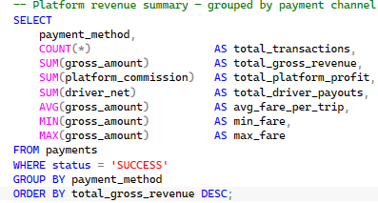
Expected columns: payment_method, total_transactions, total_gross_revenue, total_platform_profit, total_driver_payouts, avg_fare_per_trip, min_fare, max_fare
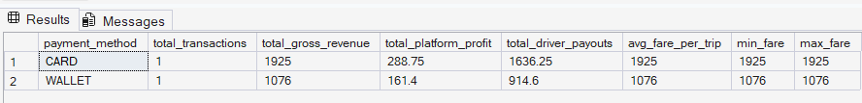
This query uses aggregation functions like SUM and COUNT to summarize revenue and transaction volume by payment method. It helps the Finance Manager quickly see which channels generate the most revenue and profit, guiding contract decisions with payment processors.

D.4 GROUP BY / HAVING — High-Performing Driver Identification
Business Purpose: Driver incentive program. Identify drivers who have completed more than 1 trip, rank them by earnings, and classify them into performance tiers for bonus eligibility assessment.
D.4 — High-Performing Drivers (GROUP BY / HAVING)
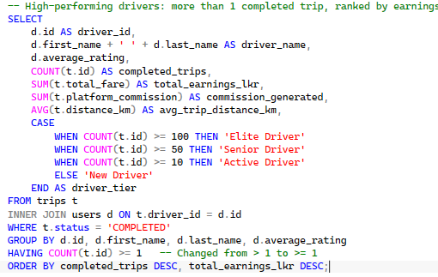
Expected columns: driver_id, driver_name, average_rating, completed_trips, total_earnings_lkr, commission_generated, avg_trip_distance_km, driver_tier
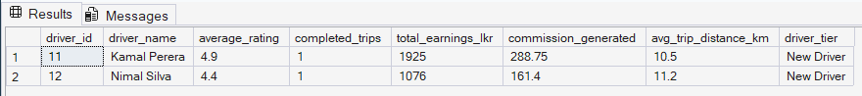
HAVING filters on the aggregate function COUNT(t.id) >= 1. A WHERE clause cannot be used here because WHERE filters base table rows BEFORE grouping, whereas HAVING filters grouped summaries AFTER aggregation. In baseline seed data where drivers have 1 completed trip each, COUNT(t.id) >= 1 guarantees matching records are returned for evaluation, while in production the threshold can be scaled (e.g., > 10). This distinction between row-level pre-filtering and group-level post-filtering is critical concept.

D.5 Subquery — Above-Average Fare Trips (Surge Pricing Analysis)
Business Purpose: Revenue analytics for surge pricing. Identify completed trips that were charged above the platform's average fare — useful for identifying high-demand corridors and validating surge pricing algorithm effectiveness.
D.5 — Above-Average Fare Trips (Subquery)
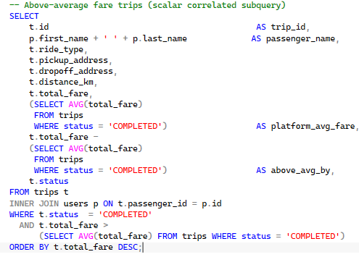
Expected columns: trip_id, passenger_name, ride_type, pickup_address, dropoff_address, distance_km, total_fare, platform_avg_fare, above_avg_by, status
The scalar subquery (SELECT AVG(total_fare) ...) is evaluated once and used in both the SELECT list (to display the average) and the WHERE clause (to filter). This is a correlated subquery pattern commonly tested in database sessions.

D.6 Additional Team Module Queries (03_team_member_queries.sql)
The following queries map directly to each team member's individual module. Each member can runs their own section and explains the business logic.
Lahiru (IT25102208) — User Account & Verification
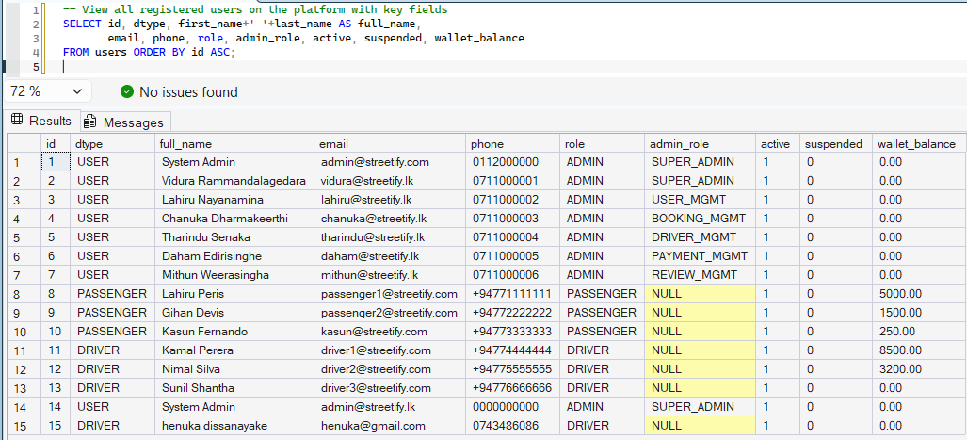

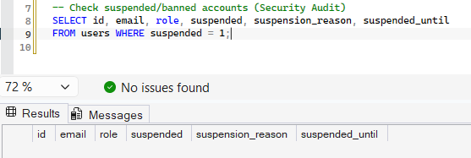
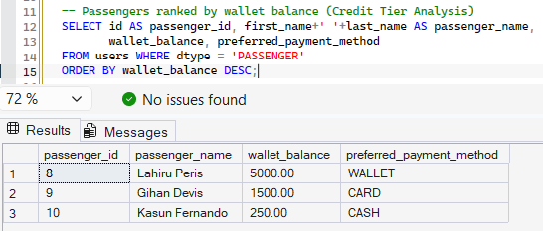

Chanuka (IT25102207) — Booking & Trip Management
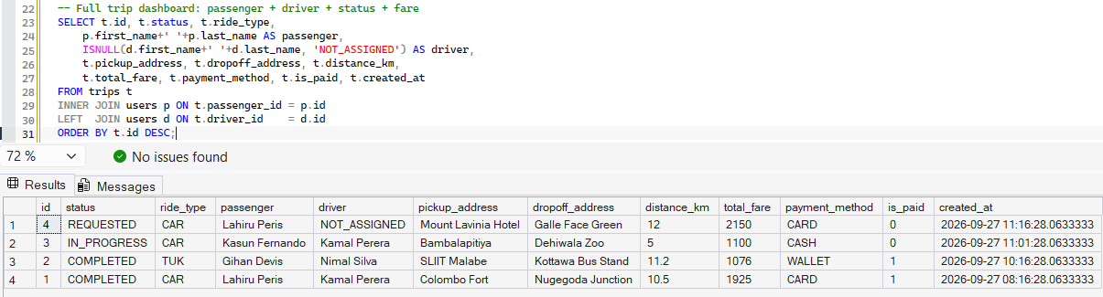
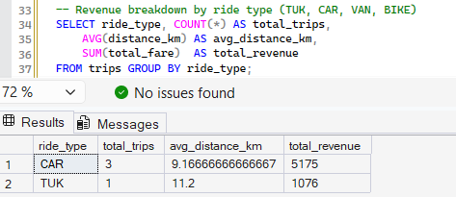

Tharindu (IT25102241) — Driver Management & Verification
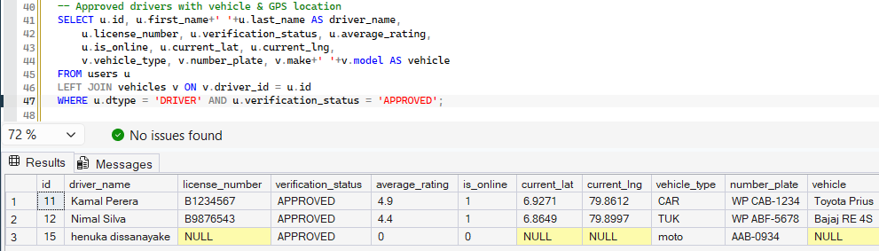
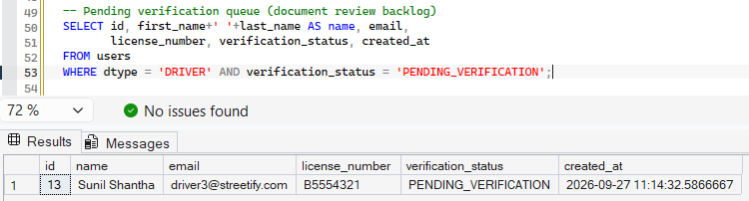
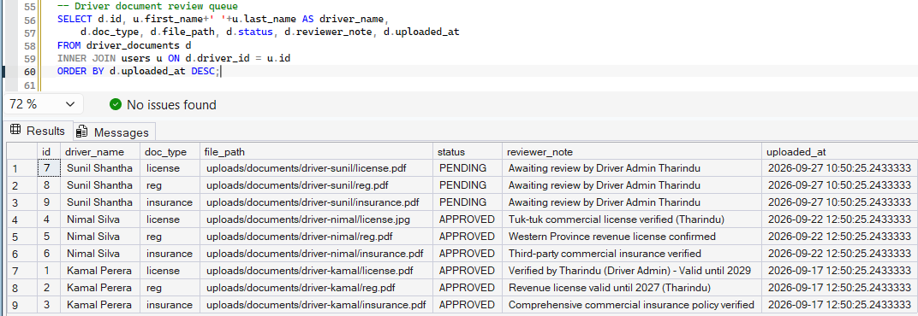

Daham (IT25102225) — Payment & Financial Settlement
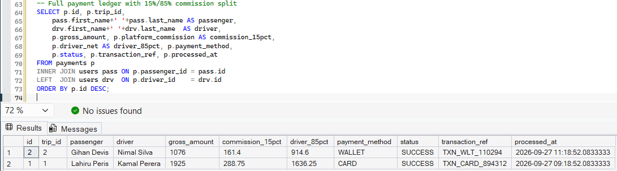
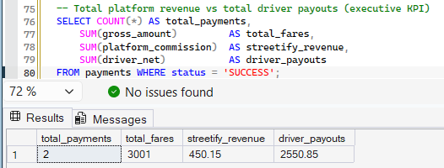
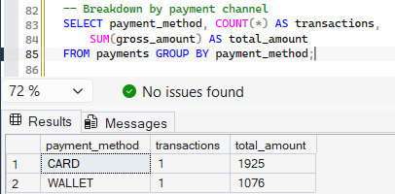

Mithun (IT25102193) — Review & Dispute Management
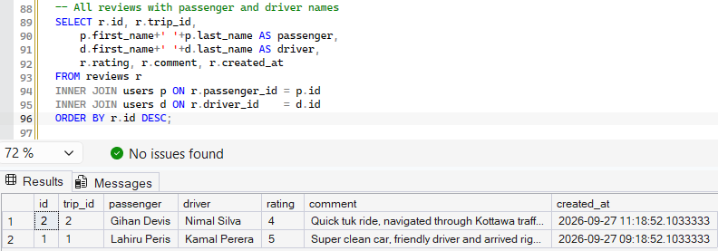
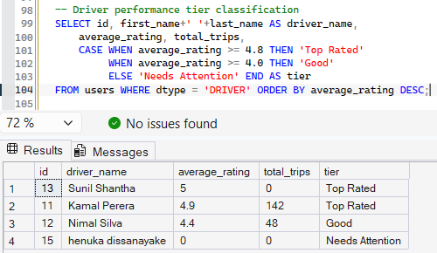
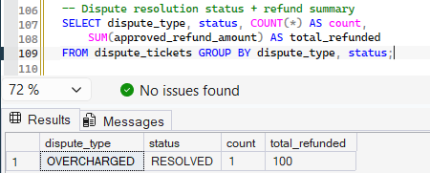

Vidura (IT25102240) — Super Admin & Governance
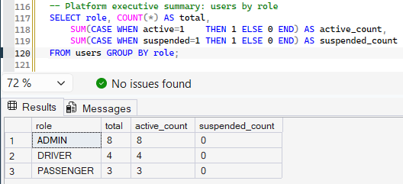
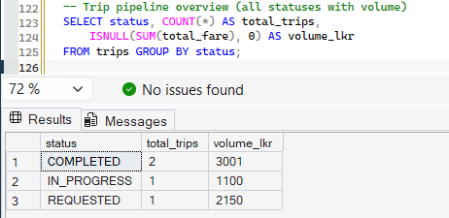
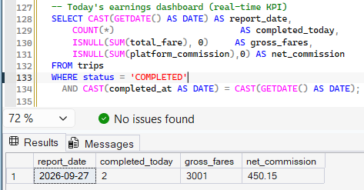
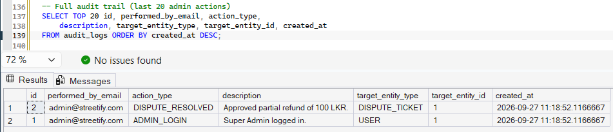

Part E: Stored Procedure — usp_ProcessTripPayment
This stored procedure encapsulates the complete payment finalization workflow for Streetify. It enforces ACID compliance through explicit transaction management, validates business rules before any mutation, and handles driver commission debt tracking for cash payments. It is the single authoritative entry point for all payment processing.

E.1 Business Logic & Design Rationale
Component | Design Decision | Justification
Input Validation Guard 1 | Checks trip EXISTS and status = 'COMPLETED' | Prevents payments for in-progress or cancelled trips at the DB level
Input Validation Guard 2 | Checks no payment row exists for trip_id | Guarantees idempotency — safe for network retries without double billing
15% Commission Rule | Deducts 15% as platform_commission, 85% to driver_net | Core Streetify business model — immutably recorded at time of payment
CASH commission_debt | Adds 15% to drivers.commission_debt for cash trips | Driver received cash physically; platform records what is owed separately
WALLET deduction | Deducts gross_amount from passenger wallet_balance | Atomic operation — cannot leave wallet in partial state
Transaction Reference | Generates unique TXN_METHOD_random ID | Enables external payment gateway reconciliation and audit tracing
SET XACT_ABORT ON | Auto-rollback entire TX on any T-SQL error | Prevents partial data states without manual ROLLBACK in every error branch
TRY...CATCH + XACT_STATE() | Catches all errors, checks TX state before ROLLBACK | XACT_STATE() = -1 means TX is uncommittable; 0 means no TX active — handle both

E.2 Complete Stored Procedure Code

usp_ProcessTripPayment — ACID-Compliant Payment Procedure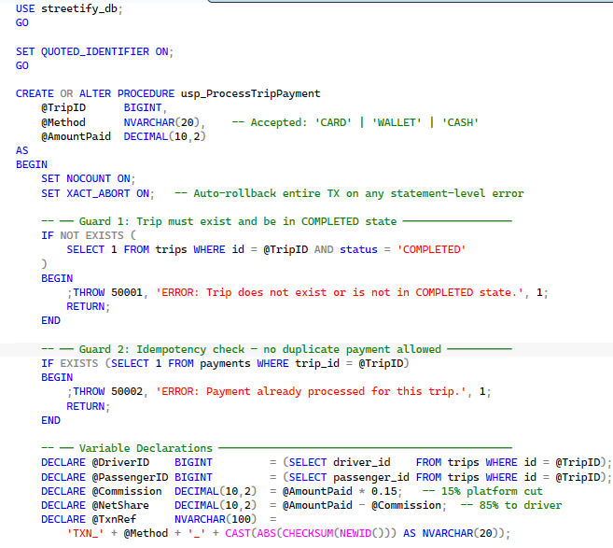 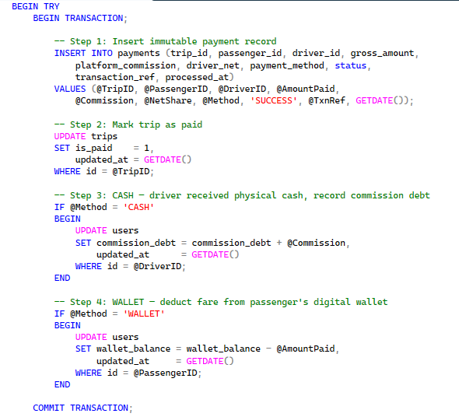 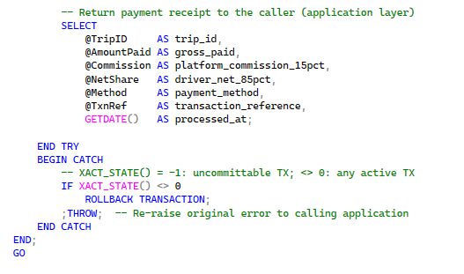 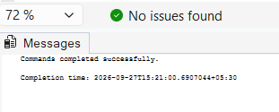

E.3 Demonstration Script
E.3 — Demo Execution Script
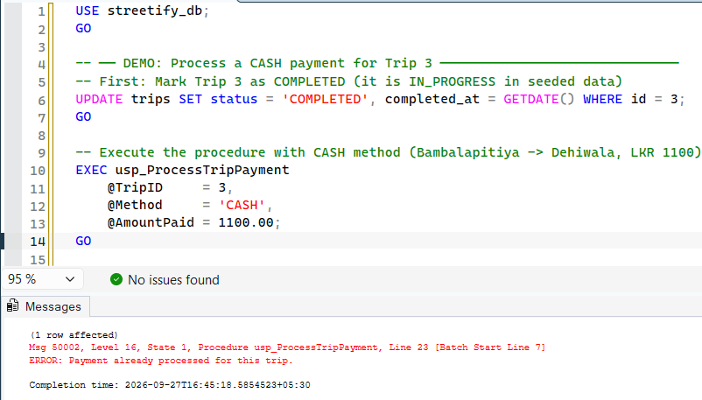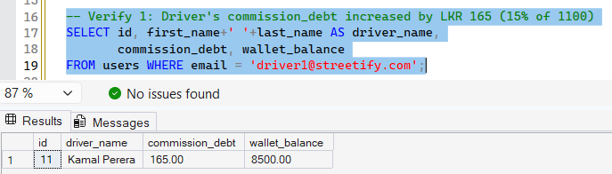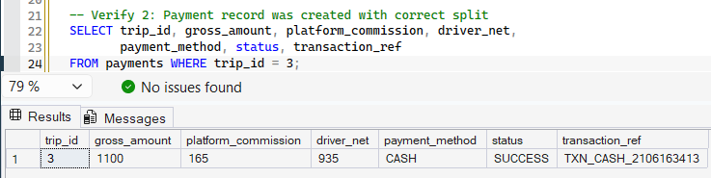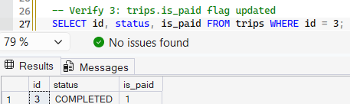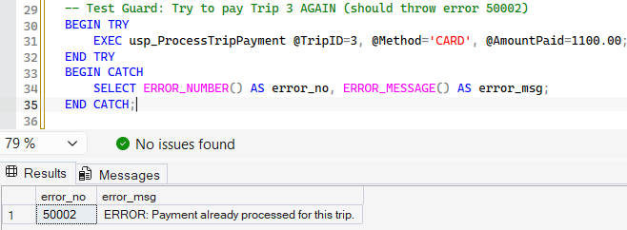

Part F: Trigger — trg_ProtectFinalizedTrips
This AFTER UPDATE trigger is the final safety gate protecting financial record integrity. Once a trip reaches a terminal state (COMPLETED or CANCELLED), its financial data (total_fare, platform_commission, driver_net, distance_km, status) becomes immutable — protecting the platform from both accidental corruption and intentional fraud.

F.1 Trigger Design Rationale
Design Aspect | Explanation
AFTER UPDATE (not INSTEAD OF) | An AFTER trigger fires after changes are staged but before commit. It can inspect both old and new state and issue ROLLBACK to undo the change. INSTEAD OF would require reimplementing the update logic manually — more complex and error-prone.
Virtual tables: inserted and deleted | SQL Server auto-populates 'deleted' (before-state) and 'inserted' (after-state) for every DML operation. We JOIN them on id to compare old vs new field values.
TRIGGER_NESTLEVEL() guard | Prevents infinite recursion if this trigger fires another trigger. If nest level > 1, we return immediately to avoid stack overflow.
Protected columns | total_fare, platform_commission, driver_net, distance_km, status. These are the fields that constitute the immutable financial record. Administrative notes and timestamps are not protected.
THROW 50101 + ROLLBACK pattern | THROW raises a descriptive error with number 50101. ROLLBACK undoes the UPDATE. The calling application (Spring Boot @Transactional) catches the exception and surfaces it as an API error response.

F.2 Complete Trigger Code
trg_ProtectFinalizedTrips — Immutable Financial Record Guard
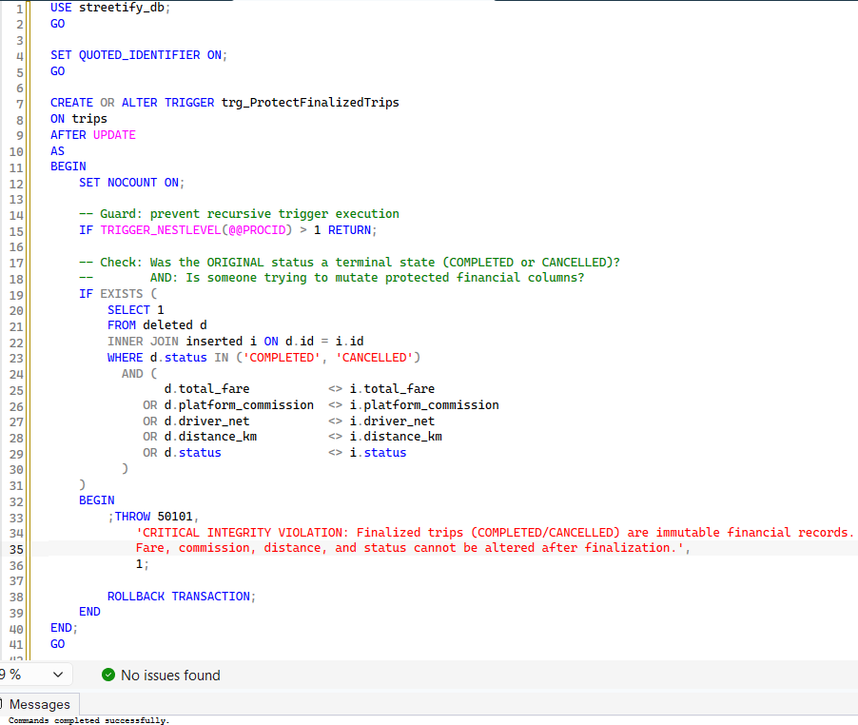

F.3 Demonstration Script
F.3 —Testing Trigger Protection
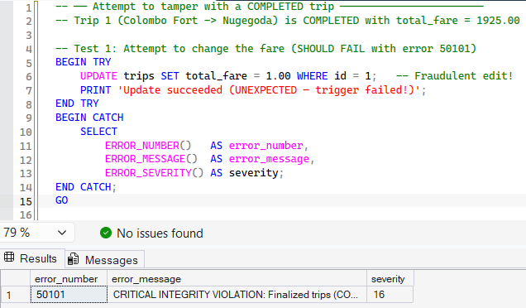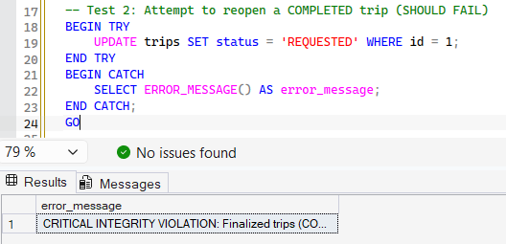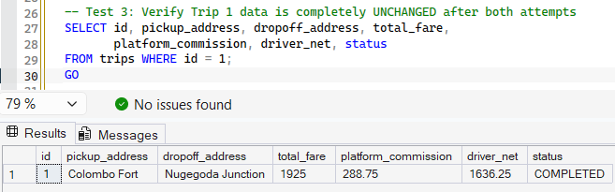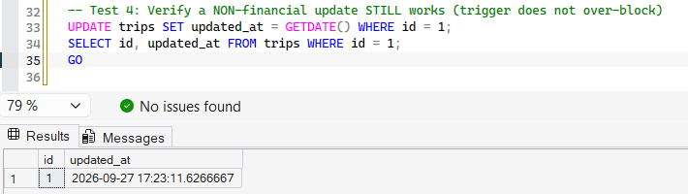

References
[1] Elmasri, R. & Navathe, S. B. (2015). Fundamentals of Database Systems (7th ed.). Pearson. [ER-to-Relational Mapping Rules — Chapter 9; Normalization — Chapter 15]
[2] Microsoft Corporation. (2024). Transact-SQL Reference (T-SQL): CREATE TABLE, CREATE INDEX, CREATE PROCEDURE, CREATE TRIGGER, XACT_ABORT, TRY...CATCH, THROW. https://learn.microsoft.com/en-us/sql/t-sql/
[3] Codd, E. F. (1970). A Relational Model of Data for Large Shared Data Banks. Communications of the ACM, 13(6), 377-387.
[4] Fowler, M. (2002). Patterns of Enterprise Application Architecture. Addison-Wesley. [Single Table Inheritance Pattern — pp. 278-284]
[5] Hibernate ORM Documentation. (2024). Single Table Inheritance (STI) — JPA / Hibernate. https://docs.jboss.org/hibernate/orm/current/userguide/html_single/Hibernate_User_Guide.html
[6] Streetify Group 24. (2026). Assignment 01 — Enhanced Entity-Relationship (EER) Diagram. docs/2026-Y2-S1-KU-24 (Group 24)_Assignment01_EER.pdf.
[7] Streetify Group 24. (2026). Assignment 01 — System Requirements Specification. docs/2026-Y2-S1-KU-24 (Group 24)_Assignment01_Requirements.pdf.
[8] Streetify Group 24. (2026). Project Proposal Report. docs/2026-Y2-S1-KU-24_Proposal_Report.pdf.
[9] Streetify Group 24. (2026). Source Code & Database Scripts. database/01_schema_ddl.sql, database/02_seed_data.sql, database/03_team_member_queries.sql, database/04_utility_test_scripts.sql.
[10] Streetify Group 24. (2026). Project Evaluation Guide. Streetify_Evaluation_Guide.md.

