

Student Preparation Program for the Semester 2

Programming Tutorial

Jayalath M.P.M.P.A
IT25102962

Sri Lanka Institute of Information Technology
Faculty of Computing
First Year Division
Question 01
(a) int miles, yards;
double kilometers;
(b) miles = 26;
yards = 385;
(c) (miles + yards / 1760.0) * 1.609
(d) kilometers = (miles + yards / 1760.0) * 1.609;
Question 02
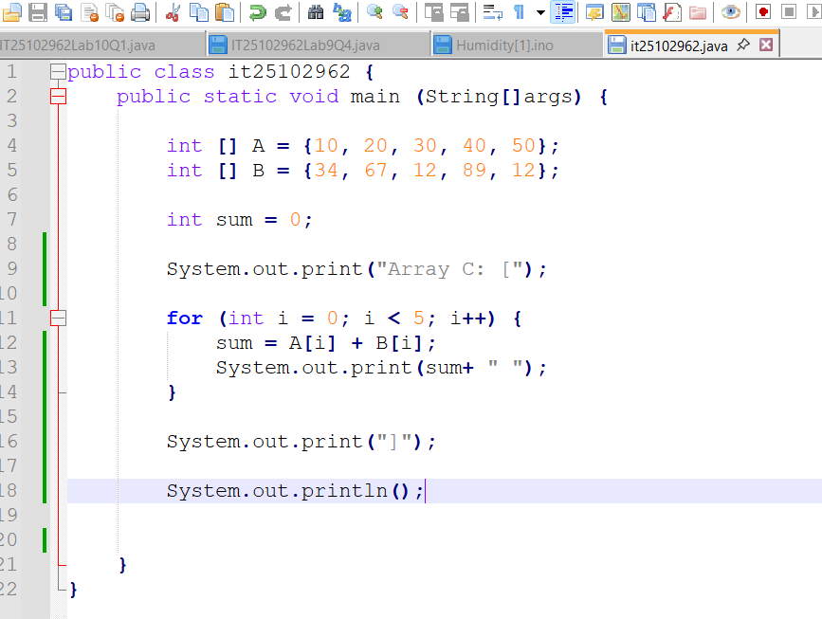
Question 03
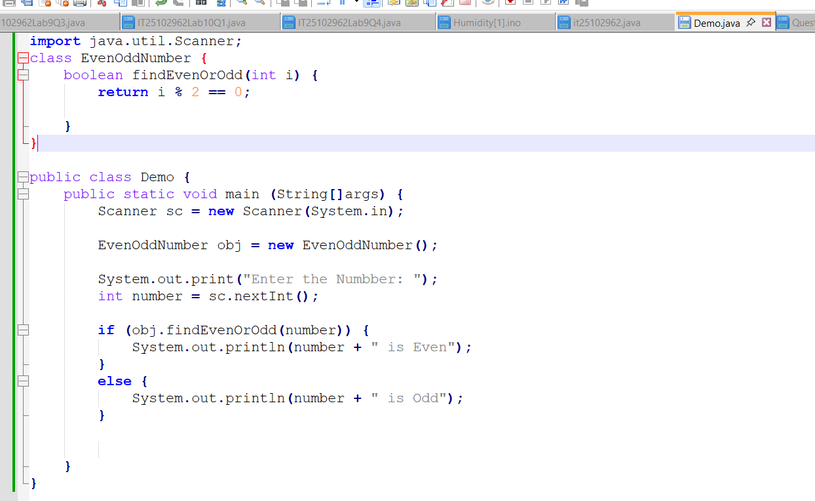
Question 04

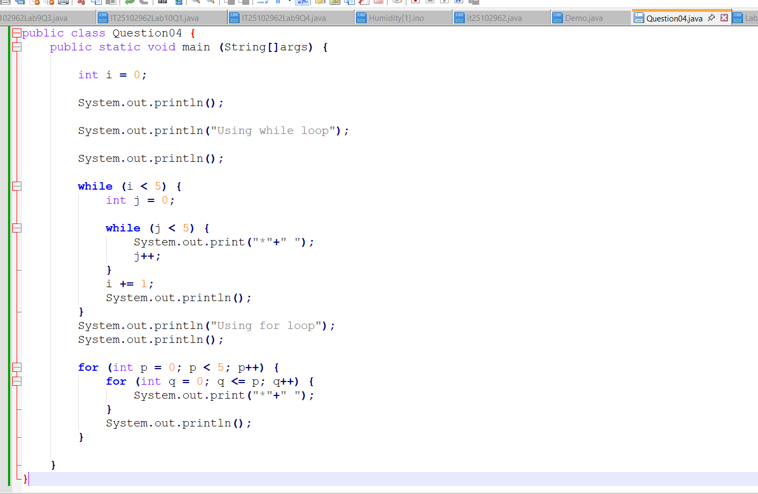
Question 05
