

VIETNAM – KOREA UNIVERSITY OF INFORMATION
TECHNOLOGY AND COMUNICATIONS
FACULTY OF COMPUTER SCIENCE
----------

SYSTEM PROGRAMMING
USER AND GROUP MANAGEMENT
WRITING A SHELL SCRIPT THAT COMPLETE THE TASKS IN THE GIVEN FILE

Members: Nguyen Quoc Vien - 23IT306
Nguyen Anh Tuan - 23IT297
Nguyen Van Trieu - 23IT286
Tran Viet Truong - 23IT292
Lecturer: PhD. Hoang Huu Duc



Da Nang, November 2025
VIETNAM – KOREA UNIVERSITY OF INFORMATION
TECHNOLOGY AND COMUNICATIONS
FACULTY OF COMPUTER SCIENCE
----------
SYSTEM PROGRAMMING
USER AND GROUP MANAGEMENT
WRITING A SHELL SCRIPT THAT COMPLETE THE TASKS IN THE GIVEN FILE

Members: Nguyen Quoc Vien - 23IT306
Nguyen Anh Tuan - 23IT297
Nguyen Van Trieu - 23IT286
Tran Viet Truong - 23IT292
Lecturer: PhD. Hoang Huu Duc

Da Nang, November 2025
INFORMER'S COMMENTS
-----------------------------------------------------------------------------------------------------------------------------------------------------------------------------------------------------------------------—------------------------------------------------------------------------------------------------—----------------------------------------------------------------------------------------------------------------—----------------------------------------------------------------------------------------------------------------—--------------------------------------------------------------------------------------------------------------------------------—--------------------------------------------------------------------------------------------------------------------------------—----------------------------------------------------------------------------------------------------------------—----------------------------------------------------------------------------------------------------------------—----------------------------------------------------------------------------------------------------------------—------------------------------------------------------------------------------------------------—------------------------------------------------------------------------------------------------—------------------------------------------------------------------------------------------------—------------------------------------------------------------------------------------------------—------------------------------------------------------------------------------------------------—------------------------------------------------------------------------------------------------—----------------------------------------------------------------------------------------------------------------------------

ACKNOWLEDGEMENTS
To achieve this project successfully, we have received support and assistance from the lecturers of The System Programming subject.
With deep and sincere feelings, please allow our group to express our deep gratitude to all the teachers who have created favorable conditions to help in the process of studying, researching and developing the topic.
First of all, we would like to send our respectful greetings, best wishes and deep thanks to the teachers of Vietnam - Korea University of Information Technology and Communications. With the care, teaching and dedicated guidance of the lecturers who have imparted the necessary skills, we have been able to complete this course project.
In particular, we would like to send our most sincere thanks to teacher - Hoang Huu Duc for his attention, help and wholehearted support in helping us complete this project successfully during the past time.
Due to the limited time and experience, this project cannot avoid shortcomings. We look forward to receiving guidance and comments from teachers so that we can supplement and improve our awareness, to better serve practical work in the future.

Group 12 students,

INDEX
ACKNOWLEDGEMENTS iii
INDEX iv
LIST OF FIGURE vi
CHAPTER 1. CHAPTER I PROJECT OVERVIEW 1
1.1. Introduction 1
1.2. Objectives and tasks of the topic 1
1.2.1. Main objectives: 1
1.2.2. Specific tasks: 1
1.3. Objects, scope and approach 1
1.3.1. Research subjects 1
1.3.2. Scope of research 2
1.3.3. Approach 2
1.4. Contribution of the topic 2
CHAPTER 2. THEORETICAL BASIS 3
2.1. Introduction to system programming 3
2.1.1. Concept 3
2.1.2. System programming applications 3
2.2. Overview of main technology 4
2.2.1. Virtualbox virtual machine 4
2.2.2. Overview of Ubuntu 4
2.2.3. Overview of Shell Script 5
2.3. Understanding Users and Groups in Linux 6
2.3.1. User management in Linux 6
2.3.1.1. What is a User? 6
2.3.1.2. File “/etc/passwd” 6
2.3.1.3. Create, edit, delete users 7
2.3.1.4. User conversion 11
2.3.2. Group management in Linux 11
2.3.2.1. What is a Group? 11
2.3.2.2. File “/etc/group 11
2.3.2.3. Group management commands 12
2.3.2.4. Management rights in Linux 14
CHAPTER 3. INSTALLATION AND DEMO 15
3.1. Program installation 15
3.1.1. Execution environment. 15
3.1.2. Prepare the program directory 15
3.1.3. Grant execution rights 16
3.1.4. Run the program 16
3.2. Implementation results 16
3.2.1. Zenity menu interface 16
3.2.2. Zenity menu User Management interface 17
3.2.3. Zenity menu Group Management interface 17
3.2.4. New User Creation Function 18
3.2.5. Delete User function 18
3.2.6. User List Display Function 19
3.2.7. Group Creation Function 20
3.2.8. Delete Group function 20
3.2.9. Group List Display Function 21
3.2.10. Add User to Group function 21
3.2.11. Remove User to Group function 22
3.2.12. Function to View User Details 23
3.2.13. Function to View Group Details 23
3.2.14. Run script from tasks.txt file 24
3.2.15. Log File Viewing Function 24
3.2.16. Main Log Viewing Function 25
3.2.17. Group Log Viewing Function 26
3.2.18. User Log Viewing Function 26
3.2.19. Automation Log Viewing Function 27
CONCLUDE 28
1. Results Achieved 28
1.1. Theoretical Knowledge 28
1.2. Practical Implementation 28
1.3. Personal Experience and Skills Development 28
2. Limitations 29
3. Future Research and Development Directions 29

LIST OF FIGURE
Figure 1 - Virtualbox virtual machine 4
Figure 2 - Ubuntu 5
Figure 3 - Shell Script 5
Figure 4 - File “/etc/passwd” 6
Figure 5 - Create users 7
Figure 6 - Delete user 8
Figure 7 - Add to group 9
Figure 8 - Change password 10
Figure 9 - File “/etc/group 12
Figure 10 - Create group 12
Figure 11 - Change password for group 13
Figure 12 - Delete group 14
Figure 13 - Management rights in Linux 14
Figure 14 - Main interface menu of the Zenity program 16
Figure 15 - Zenity interface – User management 17
Figure 16 - Zenity interface – Group management 17
Figure 17 - Function to create a new user 18
Figure 18 - Function to delete a user 18
Figure 19 - Displaying the list of users in the system 19
Figure 20 - Function to create a new group 20
Figure 21 - Function to delete a group 20
Figure 22 - Displaying the list of groups in the system 21
Figure 23 - Function to add a user to a group 22
Figure 24 - Remove User to Group function 22
Figure 25 - Function to view user details 23
Figure 26 - Function to view group details 23
Figure 27 - Running an automated script from the task.txt file 24
Figure 28 - System log viewing interface 25
Figure 29 - Main.log file content 25
Figure 30 - Group.log file content 26
Figure 31 - User.log file content 26
Figure 32 - Automation.log file content 27

- CHAPTER I PROJECT OVERVIEW
  - Introduction
In the 21st century, science, engineering, and technology play a key role in every aspect of life—from system administration, computer networks, to software development. User and Group Management (UGM) is an integral part of Unix/Linux system security and operation. Automating administrative tasks—creating users, setting passwords, assigning groups, deleting users, checking status—with shell scripts saves time, reduces manual errors, and standardizes operational processes.
The topic “User and Group Management — Writing a shell script that completes the tasks in the given file” focuses on analyzing requirements, designing and implementing a shell script that can read the command/input file (the given file) and then automatically perform user and group management tasks according to the correct policy.
  - Objectives and tasks of the topic
    - Main objectives:
Analyze the requirements and build a shell script running on Linux/Unix environment that automatically performs the user and group management tasks described in the input file.
    - Specific tasks:
The main tasks of the project include: defining the format and structure of the given file so that the script can parse it correctly; designing a secure processing flow, including permission checking (sudo), authentication and checking of input data, and error handling mechanisms; implementing basic functions such as creating/deleting users, creating/deleting groups, assigning/disabling groups to users, changing passwords, locking/unlocking accounts, and exporting results reports; and finally drafting user manuals, test scripts, and appendices containing the full script source code.
  - Objects, scope and approach
    - Research subjects
The main subject of this topic is user and group management operations on Ubuntu operating system (version 24.04 LTS), specifically:
- File structure /etc/passwd, /etc/shadow, /etc/group.
- System commands:
  - adduser, deluser – add or delete a user.
  - groupadd, delgroup – add or delete a group.
  - usermod – edit user attributes.
  - chpasswd, passwd – set and change passwords.
  - getent – check system information.
  - cat, grep, awk, cut – process data in shell.
    - Scope of research
The project was developed and tested on an Ubuntu 24.04 LTS virtual machine running in a VirtualBox environment.
The system focuses on local user and group management on Linux and does not extend to centralized authentication systems such as LDAP or Active Directory.
Although the core logic is implemented using Bash shell scripting, the program integrates a graphical user interface (GUI) built with Zenity.
This GUI allows users to interact with the system through dialog windows instead of traditional command-line input, improving usability and accessibility while still relying on standard Linux system commands in the background.
The automation input file (e.g., tasks.txt) is designed in a simple text-based format (CSV-style or line-by-line commands), enabling the program to easily parse and execute batch user and group management operations.
sily.
    - Approach
The process of implementing the topic includes the following main steps: studying the theory of user and group management mechanism on Ubuntu operating system; analyzing specific requirements from input file content to determine the types of operations that need to be supported and data formats; designing the shell script architecture with modules for reading files, validating, executing commands, handling errors and logging; installing the script using Bash and using sudo rights to perform administrative operations; conducting testing, calibration and evaluating operations on Ubuntu virtual machine; finally synthesizing the results, drafting instructions and a complete report.
  - Contribution of the topic
Based on research, analysis, design and practical implementation, the project has successfully built an automatic shell script capable of reading and analyzing input files, performing user and group management operations such as creating, deleting, editing accounts, setting passwords, locking/unlocking users, and simultaneously logging and reporting implementation results.
The project also standardized the input file format to make it easy for administrators to configure and use. The script is designed to be secure with execution permission checking ( sudo ), user/group verification, and automatic error handling.

- THEORETICAL BASIS
  - Introduction to system programming
    - Concept
Systems programming is the activity of programming software for computer systems. It involves designing and writing computer programs that allow computer hardware to intervene between programmers and users, resulting in the execution of application software on the computer system.
Systems programming differs from applications programming in that it focuses on creating software that meets the needs of end users. Instead, systems programming focuses on creating software that manages and controls computer hardware, such as operating systems and development environments.
    - System programming applications
Systems programming is used to develop system software that manages and controls the operations of a computer. Low-level code is very close to the hardware level and handles things like registers and memory allocation. Here are some of the main applications of systems programming:
- Driver
Drivers are programs that allow the operating system to communicate with the computer's hardware. They provide an interface between the operating system and the hardware, allowing the operating system to control the hardware and vice versa. Drivers are written in a system programming language and are usually provided by the hardware manufacturer.
- firmware
Firmware is software stored on a non-volatile memory chip in a hardware device. It provides instructions to the hardware and is used to control the operation of the device. Firmware is written in a system programming language and is periodically updated to fix bugs and add new features.
- Application software
Application software is software designed to perform specific tasks on a computer. It is written in high-level programming languages such as Java, C++, and Python. Application software typically runs on an operating system and uses features provided by the operating system, such as graphical user interfaces and file management.
System programming is essential for developing drivers, firmware, and application software. Without system programming, the computer would not be able to communicate with the hardware and perform specific tasks.

  - Overview of main technology
    - Virtualbox virtual machine
In the simplest terms, VirtualBox is a free, open-source virtualization manager developed by Oracle. A hypervisor manager (also known as a Virtual Machine Monitor or VMM) is software that creates and runs virtual machines (VMs). Think of it as a layer that sits between your computer hardware and the operating system you want to run.
With VirtualBox, you can install and run multiple operating systems—such as Windows, Linux, macOS, and even older versions of Windows—all on a single physical machine. The main computer running VirtualBox is called the host, and each operating system you install inside VirtualBox is called a guest, or guest operating system.

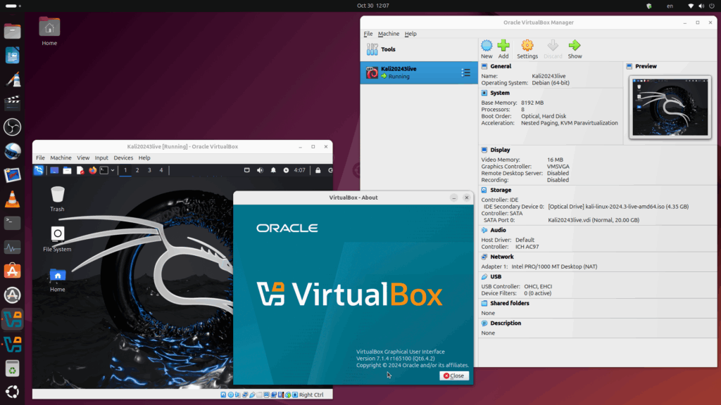
- Figure 1 - Virtualbox virtual machine

    - Overview of Ubuntu
Ubuntu is a desktop operating system developed based on Linux/Debian GNU. It was first introduced in 2004 and by 2007 Ubuntu was the version that accounted for 30% of Linux customizations installed on computers and was also considered the most popular Linux customization.
- Ubuntu Highlights
Free and Open Source: Ubuntu is free and open source software, which means you can download, use, modify, and redistribute it without paying any costs.
Easy to install and use: One of the biggest advantages of Ubuntu is that it is easy to install and use. You just need to download the ISO and install it on your computer. After installation, the interface of Ubuntu is very easy to approach even for those who are new to the Linux operating system.
Continuous updates and security: Ubuntu regularly releases updates to improve features and security. Updates are provided automatically and free of charge, helping to keep the operating system stable and secure.
Strong Community Support: Ubuntu has a large and active user community. You can easily find documentation, video tutorials, or join forums to solve problems.
Ubuntu also comes in different versions to suit different needs. The LTS (Long Term Support) version is the stable and long-term supported version, which is often recommended for users who want a secure and reliable system for many years. In addition, the annual releases of Ubuntu often come with new features and user interface improvements.
- Ubuntu and Linux operating systems
Ubuntu is one of many Linux distributions, but it stands out for its ease of use and good hardware support. While Linux is a flexible and powerful open source operating system, Ubuntu offers an easier experience for non-technical users. Ubuntu allows users to get familiar with Linux without having to worry about complicated configurations.
With Ubuntu, users can take advantage of the power of Linux in a friendly interface that does not require too much technical knowledge to use. This has made Ubuntu a popular choice for many individuals, businesses and organizations around the world.

- Figure 2 - Ubuntu

    - Overview of Shell Script
A shell script is a computer program designed to be run by the Unix shell, a command-line interpreter. Different dialects of shell scripts are considered scripting languages. Typical operations performed by shell scripts include file management, program execution, and text display.
Shell Script has a syntax similar to programming languages, which is very beneficial for those who already know and use Python or C/C++. Shell Script components include:
Keyword: else, if, break,…
Jaw
Commands: ls, pwd, cd, echo,…
Control: else…them…if

- Figure 3 - Shell Script
  - Understanding Users and Groups in Linux
    - User management in Linux
      - What is a User?
- User is the account that the user is provided to operate with the system.
- Each account will have permissions to do what and what not.
- The account with the highest privileges is root and root has the right to do everything.
      - File “/etc/passwd”
- Is a text file containing information about user accounts on the computer.
- Every user can read this file but only the root user has permission to change it.
- File structure: in the /etc/passwd file is divided into 4 main fields and environment separated by colons.
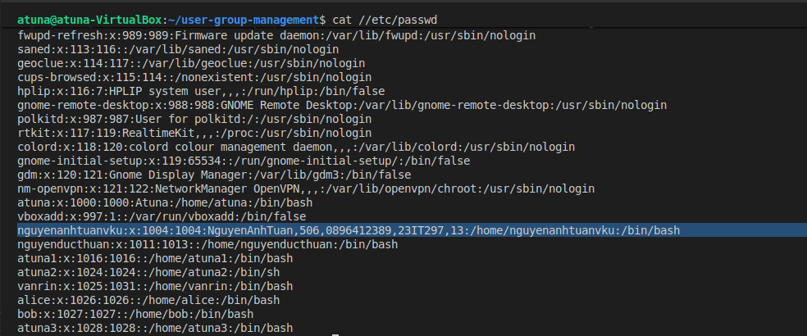
- Figure 4 - File “/etc/passwd”
- nguyenanhtuanvku- Username (login name)
- x - The group password is encrypted (because there is a /etc/shadow file), so the default here is x
- 1004 - User ID (uid)
- 1004 - Group ID (gid)
- NguyenAnhTuan - User description name (comment)
- home/nguyenanhtuanvku - User's home directory
- /bin/bash - The shell that will run when the user logs in

      - Create, edit, delete users
We can create user with command “useradd”
useradd [options] [username]
- Options:
  - -m: also create a directory at home
  - -d: directory name created at home
  - -c: add description about that directory
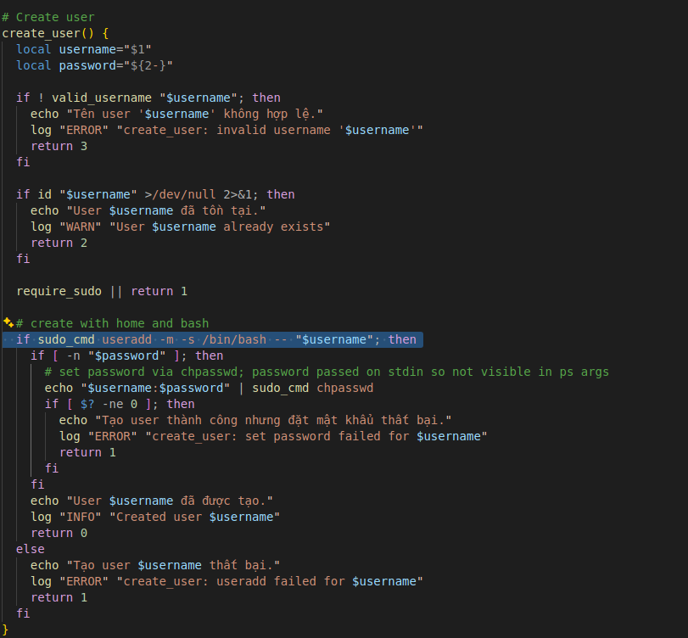
- Figure 5 - Create users

We can delete a user using the command” userdel”
userdel [options] [username]
- Options:
  - -m: used to delete user
  - -r: delete user and delete all files created by that user
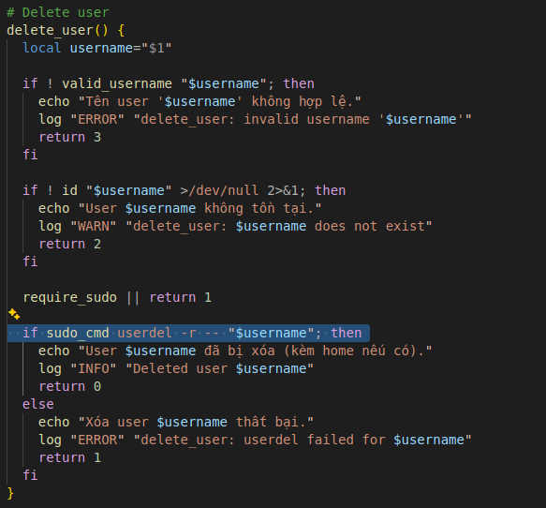
- Figure 6 - Delete user

We can edit users with the “usermod” command
usermod [options] [username]
- options
  - -G: Add user to group
  - -c: change user information
  - -e: set expiration date for user
  - -L: Lock account
  - -U: unlock account
  - -s: change shell script for user usermod -s
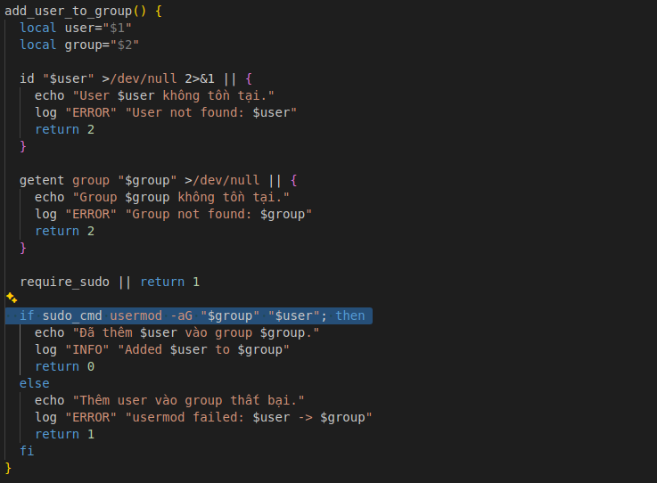
- Figure 7 - Add to group

We can create or change passwords for users using the “passwd” command. Only root privilege can do this.
chpasswd [username]
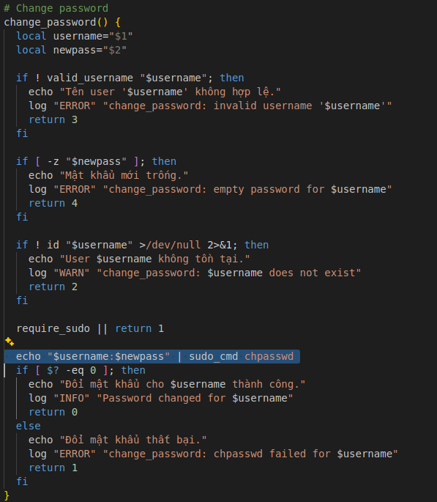
- Figure 8 - Change password

      - User conversion
When we want to switch from one user to another, we can use the command "su" or "sudo su"
sudo su [user-name]
But not all users have sudo rights to switch accounts. To have sudo rights, the user must be in the “wheel” group for centos and the “sudo” group for ubuntu. You can refer to the following command:
usermod -aG wheel atuna
or:
usermod -aG sudo atuna

    - Group management in Linux
      - What is a Group?
- Group is a collection of users.
- Each group has a unique name and a unique identifier (gid).
- When creating a user (without using the -g option), a group named user is created by default.
      - File “/etc/group
- Is a text file containing information about groups on the computer.
- Every user has read access to this file, but only the root user has changed access.
- File structure:
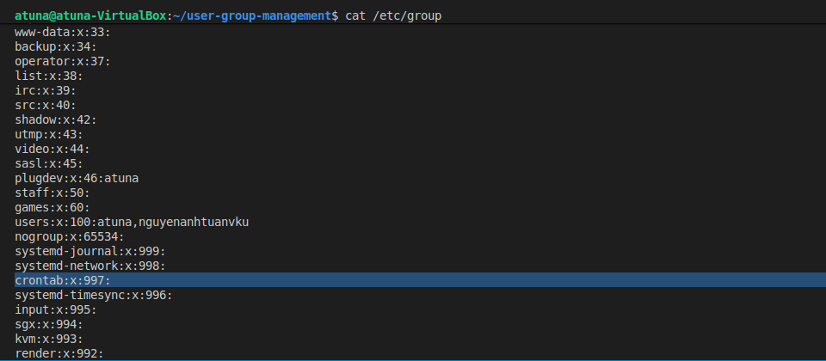
- Figure 9 - File “/etc/group
- users - Group name
- x- The group password is encrypted (because there is a /etc/gshadow file) so the default here is x
- 100 - Group code (gid)
- Atuna, nguyenanhtuanvku - List of users in the group
      - Group management commands
To create a group we use the command “groupadd”.
groupadd [group_name]

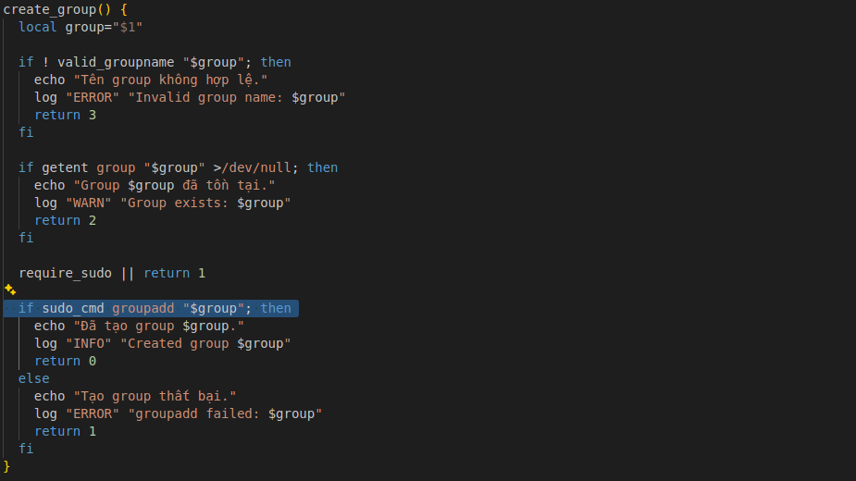
- Figure 10 - Create group
To change a password for a group, we use the “gpasswd” command.
gpasswd [group_name]
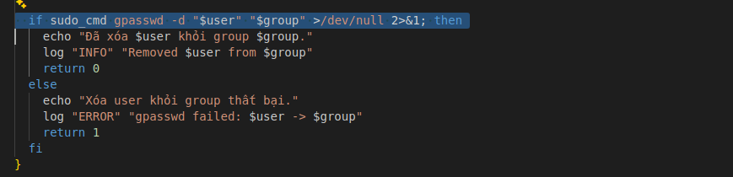
- Figure 11 - Change password for group
To edit group information, we use the "groupmod" command.
groupmod [options] [group_name]
- Options
  - g [gid] : edit group code ( gid )
  - n [group_name] : edit group name
To delete a group, use the “groupdel” command.
groupdel [group_name]
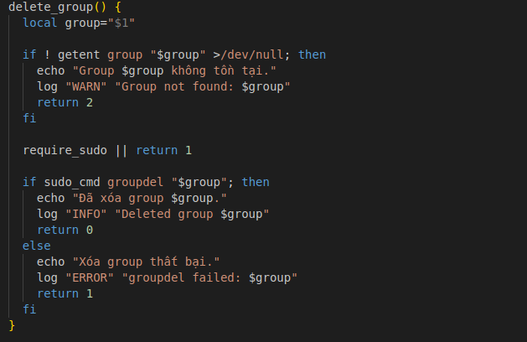
- Figure 12 - Delete group
      - Management rights in Linux
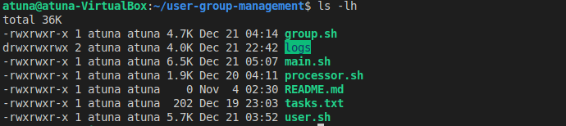
- Figure 13 - Management rights in Linux

Right name | value (decimal) | Intended use
r(read) | 4 | This is the permission to read the file. The cat command is an example of this permission.
w(write) | 2 | This is the editing permission. The vi command is an example of this permission.
x(execute) | 1 | This is the execution permission. When we run bash, we need this permission.

- INSTALLATION AND DEMO
  - Program installation
    - Execution environment.
The program is built and runs in the Linux (Ubuntu) environment. The shell scripts use Bash as the main interpreter. Therefore, the minimum requirements include:
Operating System: Ubuntu 24.04 or later or any equivalent Linux distribution
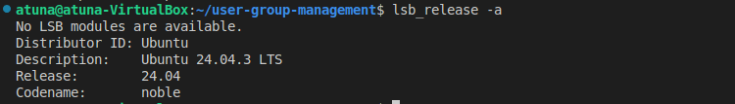
Bash Interpreter: version 4.0 or later
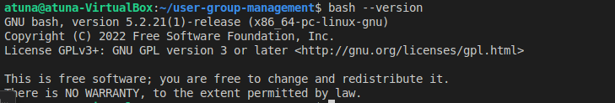
Verifying that Zenity is installed and available on the system
Terminal access and file execution permissions
All system tools used in the program (useradd, groupadd, id, grep, awk, …) are already available on Linux so no additional libraries need to be installed.
    - Prepare the program directory
To set up a working environment for the project, the user creates a directory containing all the source code using the command: mkdir user-group-management.
Then move into the newly created folder
Next, script files like main.sh, processor.sh, user.sh, group.sh, along with supporting files (tasks.txt, README.md) and the logs/ directory are created or copied inside.
In there:
- main.sh: the main executable file that controls the entire program
- processor.sh: processes and parses each line in the task file
- user.sh and group.sh: manipulate users and groups in the system
- logs/: directory to save the operation process and error messages (if any)
    - Grant execution rights
.sh files need to be given executable permission before running. This command allows scripts to be accepted by the system as standalone programs.
    - Run the program
The program is launched through the main.sh file:
  - Implementation results
    - Zenity menu interface
After running main.sh, the program displays a graphical menu interface using Zenity.Users select user and group management functions by choosing an item from the list and clicking OK, including User Management, Group Management, running scripts, viewing logs, and exiting the program.
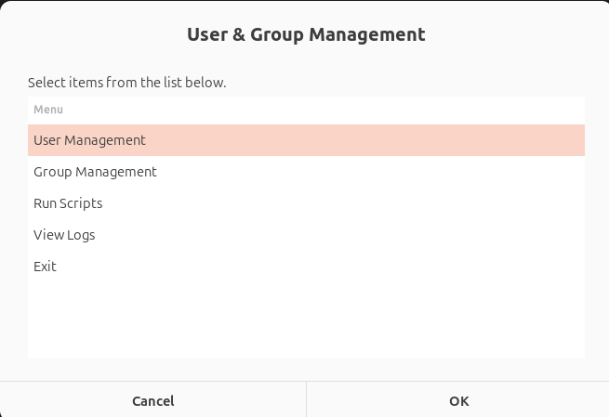
- Figure 14 - Main interface menu of the Zenity program

    - Zenity menu User Management interface
The User Management menu provides a graphical list of user-related operations, including creating users, deleting users, changing passwords, viewing the user list, and displaying detailed user information. Users select an action from the list and click OK to perform the corresponding operation.
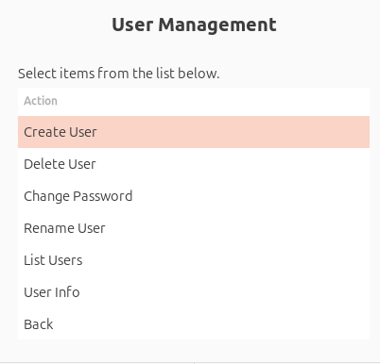
- Figure 15 - Zenity interface – User management
    - Zenity menu Group Management interface
The Group Management menu provides a graphical interface for managing systemgroups. It allows administrators to create and delete groups, view group lists and detailed group information, and manage user membership within groups by adding or removing users.
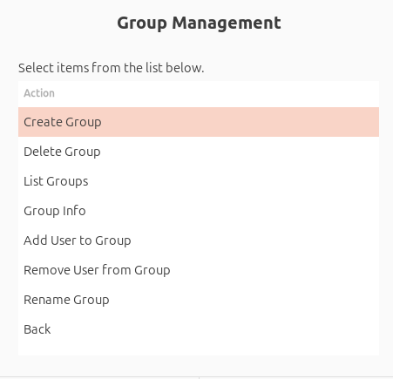
- Figure 16 - Zenity interface – Group management
    - New User Creation Function
Illustration of the user operation process using the “Create User” function in the program’s graphical menu interface. After selecting User Management → Create User, the program prompts the user to enter a username. If the operation is successful, a confirmation message is displayed.
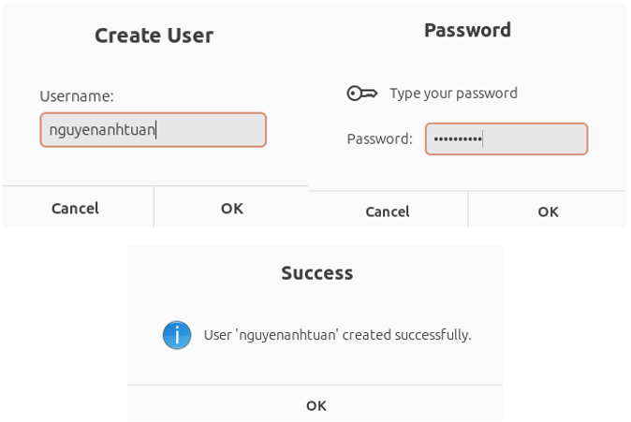
- Figure 17 - Function to create a new user
    - Delete User function
Illustration of the operation of using the “Delete user” function in the program’s command line menu interface. When the user selects item number 2 , the system asks for the account name to be deleted. After the user provides the username ( NguyenAnhTuan23IT297 ), the program executes the command to delete the account on the Linux system.
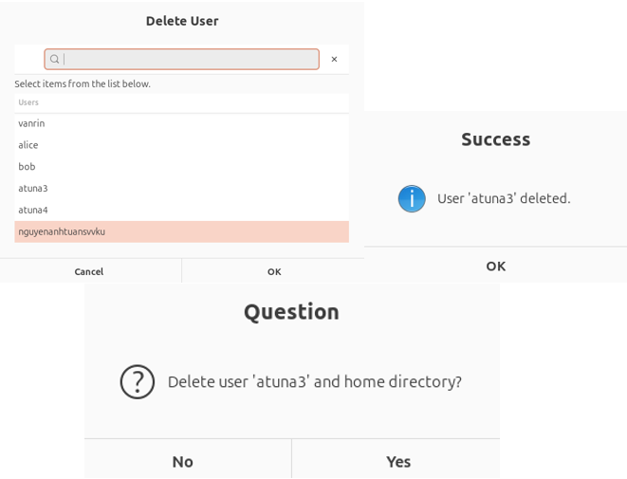
- Figure 18 - Function to delete a user
    - User List Display Function
Illustration of the program interface when the user selects the “Show User List” function from the graphical menu. After selecting this option, the program retrieves user information from the system and displays a list of all existing users.
Each user is displayed with the following information fields:
- Username
- UID (User ID)
- Home directory
The information is presented in a structured, table-like format, allowing users to easily view and manage user accounts. After reviewing the list, users can close the window and continue using other functions of the program.
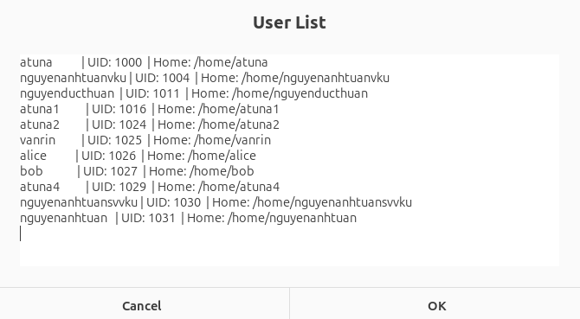
- Figure 19 - Displaying the list of users in the system

    - Group Creation Function
Describes the operation of creating a new group in the function “4. Create new group”. After entering the new group name (for example: Nhom12SP), the program proceeds to execute the groupadd command.
The results are displayed on the screen:
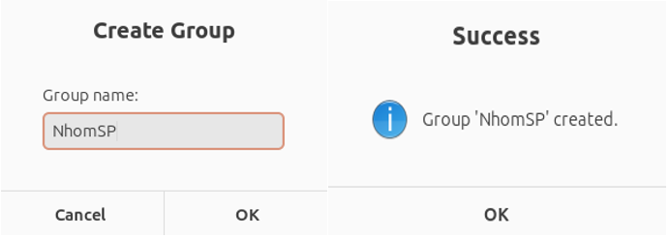
- Figure 20 - Function to create a new group

    - Delete Group function
When the user selects item 5. Delete group , the program asks for the group name and executes the groupdel command.
Illustrative result: Group ' Nhom12SP ' has been deleted.
The function works as expected.
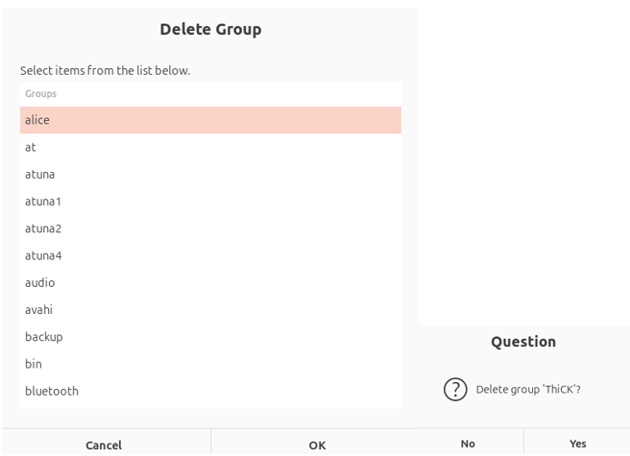
- Figure 21 - Function to delete a group

    - Group List Display Function
The “Display Group List” function shows all groups available in the system along with their associated members.
When this option is selected, the program retrieves group information from the system and displays each group in the following format:
Group name | Members: <list of users>
Groups that do not contain any users are clearly indicated as (None), making it easier for administrators to identify empty groups.
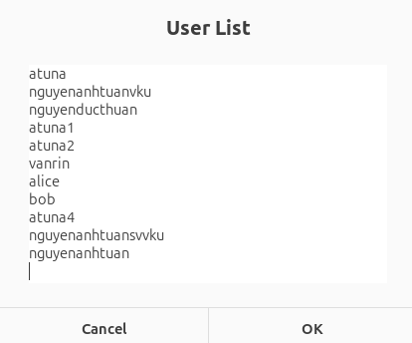
- Figure 22 - Displaying the list of groups in the system
    - Add User to Group function
The “Add User to Group” function allows the administrator to assign a user account to a specific group in the Linux system. This operation plays an important role in organizing users and managing access permissions based on functional groups.
When this function is selected from the Group Management menu, the program displays two selection dialogs:
- A list of existing users
- A list of available groups
After the administrator selects a user and a target group, the program verifies their existence in the system. If both are valid, the script executes the appropriate Linux command (such as usermod -aG) to add the user to the selected group. A confirmation message is then displayed upon successful completion.
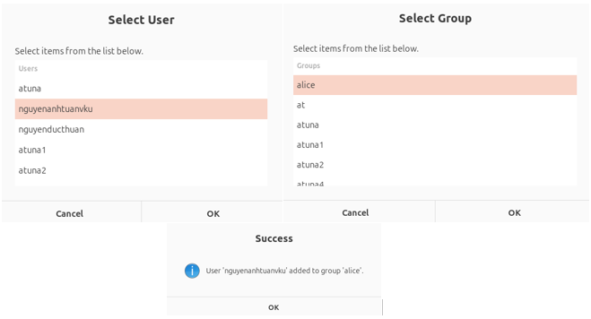
- Figure 23 - Function to add a user to a group
    - Remove User to Group function
The “Remove User from Group” function allows the administrator to remove a user from a specific group in the Linux system. This operation is useful for adjusting access permissions and reorganizing user groups.
When this function is selected from the Group Management menu, the program displays a list of users and a list of groups for selection.
After the administrator selects the appropriate user and group, the program executes the corresponding system administration command (such as gpasswd -d username groupname) to remove the user from the group. A confirmation message is displayed upon successful completion of the operation.

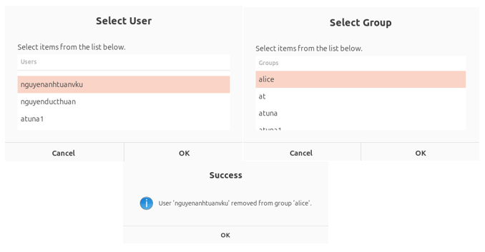
- Figure 24 - Remove User to Group function

    - Function to View User Details
This function displays all information of a user in the system, including UID, GID, group list, home directory, and shell in use. This function supports quick checking of the configuration of each account.

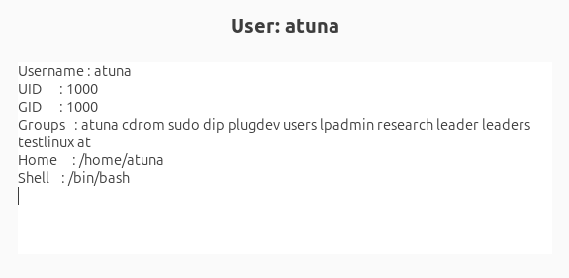
- Figure 25 - Function to view user details

    - Function to View Group Details
This function is used to view the structure of a group, including GID and list of members belonging to that group. The user just needs to enter the group name and the program will return detailed information.
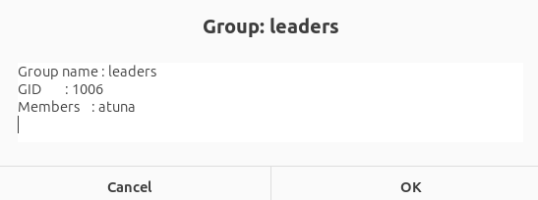
- Figure 26 - Function to view group details

    - Run script from tasks.txt file
This function automatically executes a series of commands described in the tasks.txt file. The program reads each line and executes accordingly (create user, create group, add user, delete user, ...). After completion, the system notifies:
“Done running tasks.txt file.”

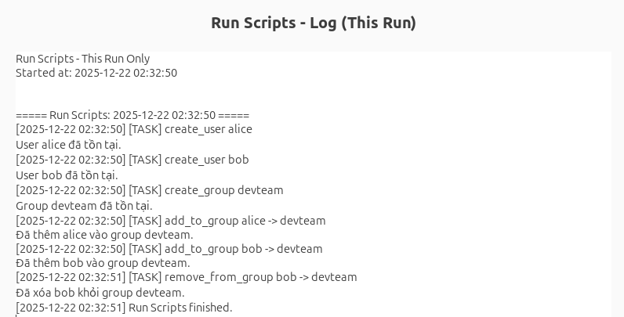
- Figure 27 - Running an automated script from the task.txt file

    - Log File Viewing Function
This function allows users to view the complete history of the program’s operations, including both successful actions and errors that occurred during execution.
When selecting “View Logs”, the program displays a graphical list of available log files stored in the logs/ directory.
Users can choose a specific log file to view its contents, including:
- Main Log (main.log): Records overall program activities and menu navigation.
- User Log (user.log): Stores user-related operations such as creating users, deleting users, and changing passwords.
- Error Log (error.log): Records errors that occur during execution, for example attempting to delete a non-existent user or create an existing group.
- Automation Log (automation.log): Saves the execution results of batch operations from the tasks.txt file.
The selected log file is then displayed in a readable text window, allowing users to easily review and trace system activities.

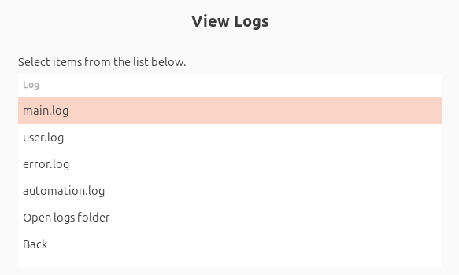
- Figure 28 - System log viewing interface

    - Main Log Viewing Function
The main log records the execution history of the program, including GUI start events and user/group management operations. Each entry is timestamped and labeled with execution status for easy tracking and debugging.

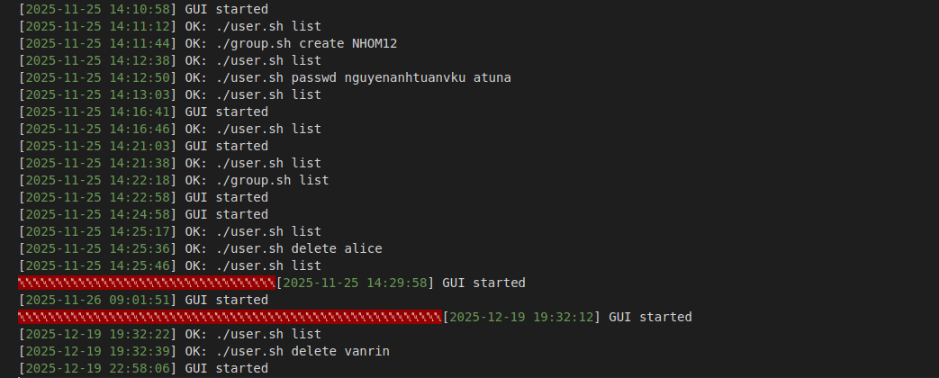
- Figure 29 - Main.log file content

    - Group Log Viewing Function
The group log records all group management activities with timestamps and severity levels, enabling effective tracking, monitoring, and troubleshooting of group-related operations.
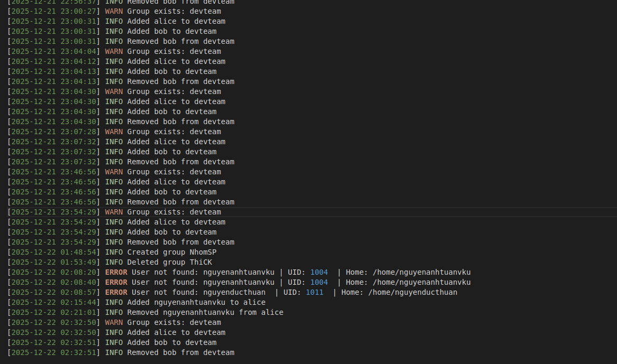
- Figure 30 - Group.log file content

    - User Log Viewing Function
The user log tracks all user management actions with timestamps and execution results, supporting monitoring and auditing of user-related activities.
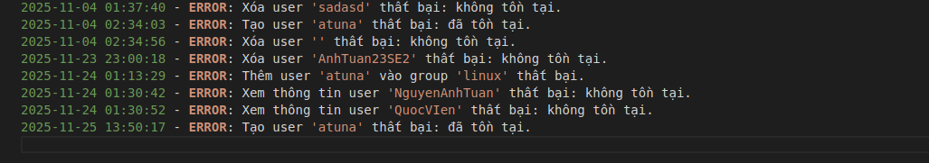
- Figure 31 - User.log file content

    - Automation Log Viewing Function
The automation log records all batch operations executed from the tasks.txt file. Each task is logged with a timestamp and action type, including user creation, group creation, adding users to groups, and removing users from groups. The log clearly distinguishes between successful actions, warnings (such as existing users or groups), and execution completion, helping administrators track and verify automated operations.

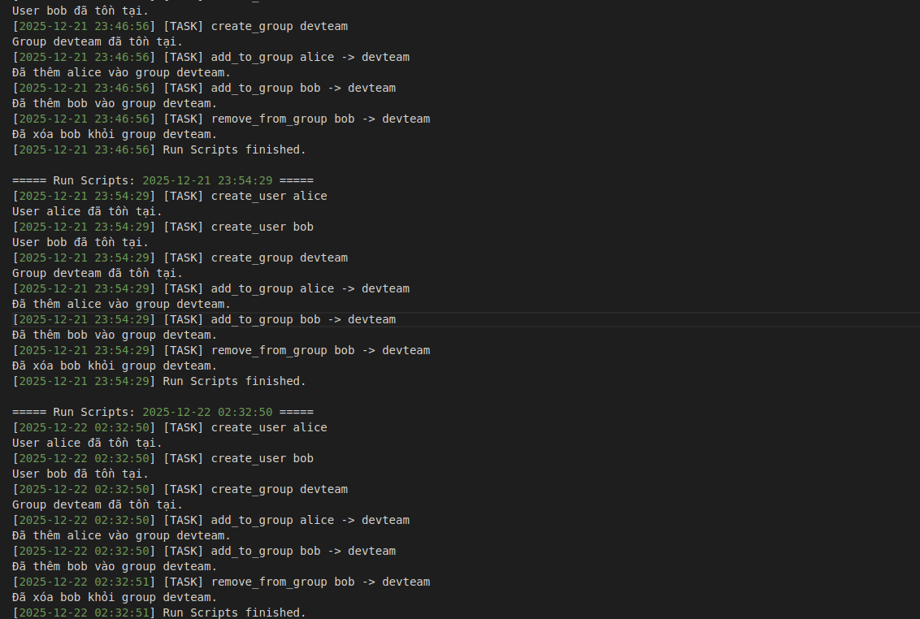
- Figure 32 - Automation.log file content

CONCLUDE
- Results Achieved
Through the implementation of the project “Building a Program to Manage Users and Groups on Linux Using Shell Script”, several significant results have been achieved in both theoretical understanding and practical application.
- Theoretical Knowledge
Gained a solid understanding of the user and group management model in Linux.
Understood the working principles of core system administration commands such as useradd, groupadd, usermod, passwd, id, and grep.
Learned how to design and organize command-line interface (CLI) programs, including menu-driven interaction.
Understood fundamental shell script design principles, including modularization, input validation, error handling, logging mechanisms, and conditional processing.
- Practical Implementation
Successfully built a fully functional user and group management program with features such as:
- Creating and deleting users
- Creating and deleting groups
- Viewing detailed user and group information
- Adding and removing users from groups
- Executing batch operations from a tasks.txt file
Implemented a comprehensive logging system, including:
- User operation logs
- Group operation logs
- Error logs
- Automation execution logs
Tested all functions directly on the Ubuntu Linux environment, effectively handling common system errors such as:
- Permission denied
- Invalid operations
- Non-existent users or groups
- Personal Experience and Skills Development
Improved skills in requirements analysis and program structure design.
Enhanced overall Linux system usage proficiency, particularly in Bash scripting.
Gained practical experience in real-world error handling and debugging techniques.

- Limitations
Although the program operates correctly and meets the core requirements, some limitations still exist:
The command-line interface remains relatively simple and lacks advanced input controls.
Certain features, such as automatic and secure password management, are not fully optimized.
Some special scenarios are not deeply handled, for example:
  - Deleting users who are currently logged in
  - Removing groups that are still actively in use

- Future Research and Development Directions
In the future, the project can be extended and improved in the following directions:
Further study of permission management and file system administration in Linux.
Integration of advanced monitoring tools such as auditd to track user and system activities.
Development of additional graphical user interfaces (GUI) or web-based management interfaces to enhance usability.
Full automation of task file parsing using CSV or JSON formats instead of plain text.
Implementation of backup and restore functionalities for users and groups.
Strengthening system security through improved input validation and protection against shell injection attacks.

REFERENCES
Books and Textbooks
[1] System Programming Practice Textbook: Focus on Assembly, Assembly Language Introduction, File Processing, BIN–HEX–DEC Input/Output (SinhVienCNTT, 2022).
Available at: https://sinhviencntt.net/giao-trinh-thuc-hanh-lap-trinh-he-thong-1055
[2] Embedded SystemProgramming (Lecture Slides, 2023)
Publisher: Faculty of Computer Engineering and Electronics. Available at:
http://elib.vku.udn.vn/handle/123456789/2608
Related Reports and Articles
[3] System Programming Project Report – 21IT – Building a Monitoring Application.
Available at:
https://www.studocu.vn/vn/document/truong-dai-hoc-cong-nghe-thong-tin-va-truyen-thong-viet-han/vku-lap-trinh-he-thong/bao-cao-lap-trinh-he-thong/103780765
[4] System Programming Project – Writing an Interactive Client Program.
Available at:
https://www.studocu.vn/vn/document/truong-dai-hoc-cong-nghe-thong-tin-va-truyen-thong-viet-han/vku-lap-trinh-he-thong/ltht-aaa/91476292
[5] System Programming Project Report – File and Directory Copying.
Available at:
https://www.studocu.vn/vn/document/truong-dai-hoc-cong-nghe-thong-tin-va-truyen-thong-viet-han/vku-lap-trinh-he-thong/bao-cao-mon-hoc-ltht-do-an/75877389

Web and Technical Resources
[6] How to Use the groups Command in Linux.
Available at: https://vietnix.vn/lenh-groups-trong-linux/
[7] How to Check and View the List of Users in Linux.
Available at: https://vietnix.vn/xem-danh-sach-user-trong-linux/
[8] Introduction to Permission Management in Linux.
Available at: https://123host.vn/community/tutorial/gioi-thieu-ve-phan-quyen-tren-linux.html
[9] User and Group Management: A Guide to Writing Shell Scripts. Available at:
https://www.studocu.vn/vn/document/truong-dai-hoc-cong-nghe-thong-tin-va-truyen-thong-viet-han/linux/quan-ly-nguoi-dung-va-nhom-huong-dan-viet-shell-script/143126460
[10] How to Add or Remove Users from Groups in Linux. Available at: https://www.tranvanbinh.vn/2023/07/cach-them-hoac-xoa-user-ra-khoi-group.html
[11] Zenity – Creating Graphical Dialog Boxes (GTK+) in Command-Line and Shell Scripts. Available at: https://vi.linux-console.net/?p=774
[12] Vietnamese User Guide for Ubuntu.
Available at: https://fr.slideshare.net/slideshow/ti-liu-hng-dn-s-dng-ubuntu-bng-ting-vit/3261436

