

Vectoria: Private, on-premise RAG for document question answering
User Manual



Funded by the European Union. This work has received funding from the European High Performance Computing Joint Undertaking (JU) and Germany, Bulgaria, Austria, Croatia, Cyprus, Czech Republic, Denmark, Estonia, Finland, Greece, Hungary, Ireland, Italy, Lithuania, Latvia, Poland, Portugal, Romania, Slovenia, Spain, Sweden, France, Netherlands, Belgium, Luxembourg, Slovakia, Norway, Türkiye, Republic of North Macedonia, Iceland, Montenegro, Serbia under grant agreement No 101101903.

This page intentionally blank

Summary
Introduction
Executive Summary
Service Description
Architectural Diagram
System Components
Operational Workflows
Self-Deployment Guide
Prerequisites
Local Installation with uv
Local Installation with Docker Compose
Leonardo / CINECA Deployment
Using Vectoria
Upload and Index Documents
Chat and OpenAI-Compatible Clients
Agent Tools
Configuration
Operations and Troubleshooting
Support, Ownership and Contributions
Table of Figures
Figure 1: Current Vectoria architecture
Figure 2: Document ingestion and tenant indexing workflow
Figure 3: Query, tool use, retrieval and answer generation workflow

Acronyms and Terminology
AI | Artificial Intelligence | Computer systems that perform tasks associated with human intelligence.
API | Application Programming Interface | A programmatic interface used by clients to interact with Vectoria.
BM25 | Best Matching 25 | A lexical ranking method used in Vectoria's hybrid retrieval.
CLI | Command-Line Interface | A text-based interface for operating the application.
GPU | Graphics Processing Unit | Hardware used to accelerate model inference, embedding and reranking.
HPC | High-Performance Computing | Large-scale computing infrastructure such as CINECA Leonardo.
LLM | Large Language Model | A model that interprets prompts and generates natural-language answers.
MMR | Maximal Marginal Relevance | A method for balancing retrieval relevance and diversity.
NER | Named Entity Recognition | Identification of entities used to construct the knowledge graph.
PMI | Pointwise Mutual Information | A statistical measure used to filter noisy graph relationships.
RAG | Retrieval-Augmented Generation | Generation grounded in evidence retrieved from private documents.
SLURM | Simple Linux Utility for Resource Management | The workload scheduler used on Leonardo.
Tenant | Isolated Vectoria workspace | A logical customer or organization selected with X-Tenant-ID.

Introduction
Vectoria is an on-premise Retrieval-Augmented Generation (RAG) service for asking questions over private organizational documents. It was built for the IT4LIA project and is designed to keep document processing, indexes, conversation history and model inference under the operator's control. The software can run directly with uv, as a Docker Compose service, or on CINECA's Leonardo supercomputer through an automated Ansible deployment.
This manual is intended for system administrators, technical operators and users who need to install, configure, run and use Vectoria. It describes the currently supported workflows and should be read together with the repository README files for deployment-specific troubleshooting and parameter details.
Privacy depends on the selected inference endpoint. When Vectoria is connected to a model hosted locally or on the organization's HPC infrastructure, documents and retrieved context remain on premises. Connecting an external OpenAI-compatible provider can transmit prompts and retrieved context to that provider and must therefore be evaluated against the organization's data-handling policy.

Executive Summary
Vectoria combines document ingestion, hybrid retrieval and an agentic question-answering interface in a multi-tenant service. Each answer is generated from retrieved evidence and cites its source files. The current application provides the following capabilities:
• Hybrid search that fuses BM25 lexical matches with semantic vector retrieval, followed by reranking and optional MMR diversity.
• PDF and DOCX ingestion with native extraction or Docling/OCR, recursive or semantic chunking, and persistent Chroma, FAISS or Qdrant indexes.
• A per-tenant Markdown wiki that synthesizes concepts from uploaded documents and a per-tenant entity graph for relational queries.
• A multi-turn ReAct agent with SQLite-backed history, tool-call limits and explicit human approval before document deletion.
• An OpenAI-compatible API for integration with OpenWebUI and other clients, plus a browser upload page and command-line workflows.
• Isolated tenant data selected with X-Tenant-ID; OpenAI-compatible model identifiers use vectoria-<tenant_id>.
• Support for OpenAI-compatible endpoints, Ollama, vLLM, llama.cpp/llama-server and Hugging Face inference engines.
• Local CPU-oriented defaults and an automated, GPU-optimized Leonardo deployment with vLLM, OpenWebUI, SLURM and SSH tunnels.
• Optional MLflow observability for local Docker deployments.

Service Description
Vectoria turns dispersed internal documents into a searchable, conversational knowledge service. Users upload documents for an isolated tenant, wait for background indexing to complete, and then query that tenant through OpenWebUI, the OpenAI-compatible API or the CLI. The agent selects the tools needed for each question, retrieves and ranks relevant evidence, and asks the configured LLM to produce a grounded response.
Key Objectives:
• Efficient knowledge access: make private documents available through a natural-language interface without requiring users to know their storage layout.
• Relevance and explainability: combine lexical and semantic evidence, rerank it, preserve metadata and cite source files in answers.
• Isolation and control: keep each tenant's indexes, wiki, graph and chat state separate and allow operators to choose the inference location.
• Operational flexibility: provide the same application through local Python, Docker Compose and Leonardo HPC deployment paths.

Architectural Diagram
The current architecture separates ingestion from retrieval and generation. During ingestion, files are extracted, cleaned and chunked before lexical and semantic indexes are built. Optional wiki and graph layers are updated from the same tenant-scoped content. During a conversation, the ReAct agent can call retrieval, wiki, graph and document-management tools. The configured LLM receives selected evidence rather than the entire document collection.
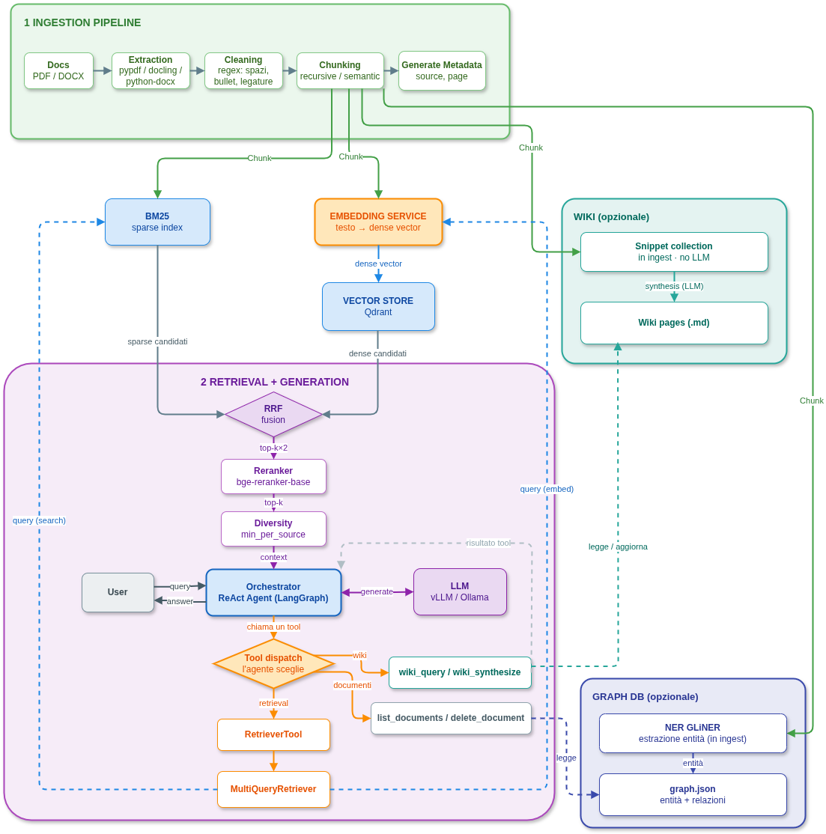
Figure 1: Current Vectoria architecture

System Components
Configuration: YAML configuration controls extraction, chunking, vector storage, retrieval, reranking, wiki, graph, history, guardrails and inference. Docker uses etc/docker/config.yaml; HPC renders its configuration from ansible/roles/vectoria/templates/default_config.j2.
Document preprocessing: Native extraction handles ordinary PDF and DOCX content; Docling can be enabled for layout-aware extraction and OCR. Text is cleaned and divided with recursive or semantic chunking while source metadata is retained.
Indexes: A tenant receives a semantic vector store and, when hybrid retrieval is enabled, a persisted BM25 index. Chroma, FAISS and Qdrant are supported.
Retrieval and reranking: Lexical and semantic candidates are fused, reranked and optionally filtered with minimum-per-source and MMR diversity rules.
Knowledge layers: The wiki stores synthesized Markdown pages. The graph uses GLiNER entity extraction, configurable PMI filtering, entity resolution and co-occurrence, spaCy or LLM relationships.
Agent and tools: A LangGraph ReAct agent manages the conversation and decides when to retrieve, inspect the wiki or graph, list documents, or request deletion. SQLite checkpoints maintain continuity between turns.
API and user interfaces: FastAPI exposes document operations and OpenAI-compatible /v1 endpoints. OpenWebUI provides chat, and /upload provides a browser-based upload interface.
Inference backend: The application can call any compatible remote or on-premise endpoint, or use supported local engines. The endpoint, key, model name and timeout are environment-driven in Docker.

Operational Workflows

Document ingestion and indexing
Users upload up to 20 PDF or DOCX files per request, with a maximum size of 200 MB per file. Indexing runs in the background and can be monitored or cancelled. Existing tenants are updated incrementally, and the agent is reloaded when the new index is ready.
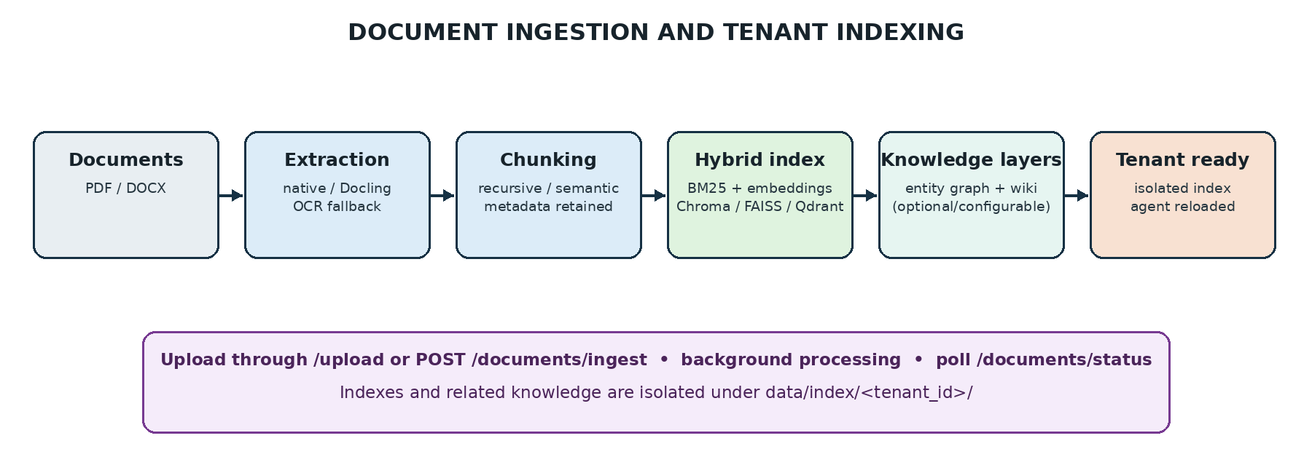
Figure 2: Document ingestion and tenant indexing workflow

Query and answer generation
A query enters through an OpenAI-compatible chat request or the CLI. Conversation identity is maintained through the client chat identifier or X-Thread-ID. The agent chooses one or more tools, collects evidence, and asks the configured LLM for an answer. Retrieved claims include [Source: file] citations. Destructive document deletion requires an explicit confirmation when the default guardrail is enabled.
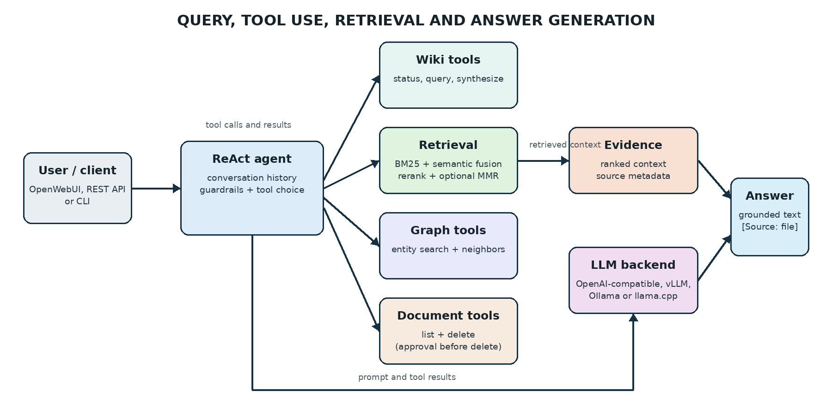
Figure 3: Query, tool use, retrieval and answer generation workflow

Self-Deployment Guide
Choose one deployment path. Docker Compose is the simplest local installation and includes OpenWebUI. Direct uv execution is useful for development or a minimal API service. The Ansible path is the supported deployment method for Leonardo.

Prerequisites
• Git and access to the Vectoria repository.
• For direct execution: Linux, Python 3.12 or 3.13, and uv.
• For Docker: Docker Engine with the Compose plugin and enough disk space for model caches and tenant indexes.
• A reachable LLM endpoint and its model name; an API key is required when the endpoint enforces authentication.
• For Leonardo: a CINECA account with a valid budget, SSH access and certificate, Ansible on the local workstation, and Hugging Face access for gated models when applicable.
CPU execution is suitable for functional use with the local defaults. GPU acceleration is recommended for Docling OCR, semantic chunking, large embedding/reranking models and high-throughput LLM inference. Actual memory requirements depend primarily on the selected model and quantization.

Get the Source Code
git clone https://github.com/Eurocc-Italy/Vectoria.git
cd Vectoria

Local Installation with uv
Install only the API extras for the smallest supported server, or include Docling and observability for the complete stack:
uv sync --extra api --no-dev
uv sync --extra api --extra docling --extra observability --no-dev
Copy the environment template, set LLM_BASE_URL, LLM_API_KEY and LLM_MODEL, and review etc/docker/config.yaml. When running directly on the host, use a host-reachable endpoint such as http://localhost:11434/v1 rather than Docker's host.docker.internal name.
cp .env.example .env
mkdir -p data/index data/uploads
set -a; source .env; set +a
Start the API and upload interface:
uv run bin/vectoria --config etc/docker/config.yaml serve --index-dir data/index --upload-dir data/uploads --host 0.0.0.0 --port 8000
Open http://localhost:8000/upload. The OpenAI-compatible base URL is http://localhost:8000/v1.

Local Installation with Docker Compose
cp .env.example .env
Edit .env. At minimum, provide the LLM endpoint and model. Set PERMITTED_KEYS for any deployment that is not restricted to a trusted local environment. DATA_DIR, HF_CACHE_DIR and OPENWEBUI_DATA_DIR control persistent host storage.
docker compose up -d
• Vectoria API and upload page: http://localhost:8000 and http://localhost:8000/upload
• OpenWebUI: http://localhost:8080
• OpenAI-compatible base URL: http://localhost:8000/v1
The data-init service creates data/index and data/uploads with the correct ownership on first start. Inspect service output with docker compose logs -f. Stop the services without deleting persisted data with docker compose down.
Optional MLflow observability is available on http://localhost:5000:
docker compose --profile observability up -d

Leonardo / CINECA Deployment
Deployment to Leonardo is automated and Ansible-only. The playbook synchronizes the repository, installs dependencies, caches required assets, builds or reuses Singularity containers, downloads the LLM, renders the GPU configuration and SLURM launcher, submits the job, waits for it to run, and opens local SSH tunnels.
Create .env from the template and provide the CINECA user and SSH key, the SLURM account, repository URL and Vectoria API token. Review ansible/inventory/hosts and ansible/roles/vectoria/vars/config.yml for the target account, model, ports and GPU allocation.
set -a; source .env; set +a
cd ansible
uv pip install -r requirements.txt
ansible-playbook -i inventory deploy.yml
When the playbook completes, the default tunnels expose the upload page at http://localhost:8081/upload and OpenWebUI at http://localhost:8082. If the tunnels are lost while the SLURM job is still running, reconnect without redeploying:
cd ansible
ansible-playbook -i inventory connect.yml
The default job uses one Leonardo node: vLLM on GPUs 0-1, Vectoria on GPUs 2-3 and OpenWebUI on CPU. Multi-node execution starts a Ray cluster and uses pipeline parallelism. Operators should consult ansible/README.md and etc/hpc/README.md before changing node counts, tensor parallelism, GPU memory utilization or NCCL settings.

Using Vectoria

Upload and Index Documents
The browser workflow is available at /upload. For API automation, send the tenant identifier with every document request. Authentication can use Authorization: Bearer <token> or x-token: <token> when PERMITTED_KEYS is configured.
curl -X POST http://localhost:8000/documents/ingest \
-H "X-Tenant-ID: company-a" \
-H "Authorization: Bearer <token>" \
-F "files=@document.pdf"
Ingestion returns immediately. Poll status until it reports ready:
curl http://localhost:8000/documents/status \
-H "X-Tenant-ID: company-a" \
-H "Authorization: Bearer <token>"

Chat and OpenAI-Compatible Clients
In OpenWebUI, choose the model vectoria-company-a for the tenant named company-a. Other OpenAI-compatible clients can list models at /v1/models and send standard chat completion requests. Provide X-Tenant-ID or select the corresponding vectoria-<tenant_id> model.
curl http://localhost:8000/v1/chat/completions \
-H "Content-Type: application/json" \
-H "X-Tenant-ID: company-a" \
-H "Authorization: Bearer <token>" \
-d '{"model":"vectoria-company-a","messages":[{"role":"user","content":"What are the approval steps?"}]}'
Use a stable X-Thread-ID when a client does not provide its own persistent chat identifier. This preserves multi-turn context in the SQLite checkpoint database.

Agent Tools
Tool | Availability | Purpose
retriever | Always | Hybrid search over indexed documents, followed by configured reranking and diversity controls.
list_documents | Always | Lists the source files indexed for the active tenant.
delete_document | Always | Removes a source document and its indexed content; the default configuration requests human approval.
wiki_status | wiki.enabled | Reports wiki pages and concepts waiting for synthesis when the wiki is enabled.
wiki_query | wiki.enabled | Searches synthesized Markdown knowledge by topic.
wiki_synthesize | wiki.enabled | Uses the LLM to turn pending concepts into wiki pages.
graph_search | graph extra/config | Searches the optional tenant entity graph.
graph_neighbors | graph extra/config | Returns entities directly related to a known graph entity.

Command-Line Indexing and Inference
The API workflow is recommended for normal operation. The CLI remains available for batch or diagnostic use. Build an index from a folder and then query it as follows:
uv run bin/vectoria --config etc/docker/config.yaml build_index --input-docs-dir ./docs --output-dir ./data/index/manual
uv run bin/vectoria --config etc/docker/config.yaml inference --index-path ./data/index/manual --output-dir ./output --questions "Your question"

Configuration
Use etc/docker/config.yaml for local and Docker deployments. For HPC, edit the Ansible variables and template, then re-run the playbook; generated files under etc/hpc are remote runtime artifacts and are not the source of truth. Important settings are summarized below.
Setting | Typical values | Purpose
data_ingestion.extraction.backend | native/pypdf, docling or auto | Choose fast text extraction or OCR-capable extraction.
data_ingestion.chunking.method | recursive or semantic | Choose CPU-friendly splitting or topic-aware GPU splitting.
vector_store.name | chroma, faiss or qdrant | Select the persistent semantic index.
vector_store.device | cpu or cuda | Select the embedding device.
retriever.search_type | similarity, mmr or hybrid | Select the primary retrieval strategy.
retriever.top_k | integer | Control the initial candidate count.
retriever.multi_query | true/false | Generate alternative queries to improve recall.
retriever.min_per_source | integer | Preserve evidence diversity across source files.
retriever.mmr_* | enabled, lambda, top_k | Balance relevance and semantic diversity after reranking.
reranker.* | enabled, model, device, top_k | Control cross-encoder reranking.
wiki.* | enabled and synthesis controls | Configure the tenant Markdown knowledge layer.
graph_store.* | enabled and extraction controls | Configure entity extraction, PMI filtering and relation labels.
chat_history.* | enabled and retention controls | Configure SQLite checkpoints and conversation summarization.
agent_guardrails.* | tool limits and approvals | Bound tool use and protect destructive operations.
inference_engine.* | backend, URL, model, timeout | Configure the LLM used for answer generation.
Local defaults are intentionally CPU-oriented. The HPC template enables GPU extraction, semantic chunking, CUDA embeddings and reranking, MMR, wiki and graph features. Configuration values should be changed as a coherent set; in particular, model names, devices, endpoint URLs and available extras must agree.

Operations and Troubleshooting
No answer or endpoint timeout: Verify LLM_BASE_URL, LLM_API_KEY and LLM_MODEL from the same environment that starts Vectoria. Increase LLM_TIMEOUT for large or slow models.
No text extracted: For scanned or image-only PDFs, install the docling extra and select docling or auto extraction. Check that the file is PDF or DOCX and within the upload limits.
Indexing is still running: Poll /documents/status. The chat endpoint deliberately remains unavailable for that tenant until the agent has reloaded. Use /documents/cancel only when necessary.
Authentication fails: Ensure the submitted bearer or x-token value exactly matches one of PERMITTED_KEYS. An empty value disables authentication and is appropriate only for trusted local/private use.
Docker data permissions: The data-init container normally creates and owns the data directories. Confirm the DATA_DIR mount and inspect docker compose logs if startup fails.
HPC tunnel lost: Run ansible-playbook -i inventory connect.yml. Redeploy only if the SLURM job ended or the application itself must be updated.
HPC out of memory: Reduce model size or parallelism, or tune vllm_gpu_memory_utilization in the Ansible variables. Keep headroom for CUDA graph capture.
Backups: Back up DATA_DIR, including tenant indexes, uploaded source metadata, wiki/graph data and chat_history.db. OpenWebUI data is stored separately under OPENWEBUI_DATA_DIR.

Support, Ownership and Contributions
For bugs, feature requests or questions, use the issue tracker linked from README.md. For access problems or general support in the IT4LIA organization, contact support-it4lia@cineca.it. Security vulnerabilities should be reported privately to superc@cineca.it rather than disclosed in a public issue.
• Owner: Michele Visciarelli
• Maintainer: Mattia Buzzoni
The Vectoria application and this manual are released under the MIT License. The complete license text is available in the repository LICENSE file. Copyright © 2025 EuroCC Italy.
Repository documentation: README.md, ansible/README.md and etc/hpc/README.md.

