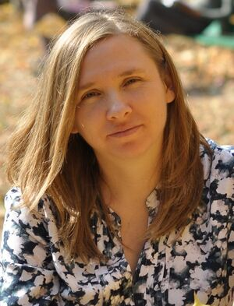 | Lesia Bulatetska  PhD, Associate Professor,  Associate Professor at the Department of Computer Science and Cybersecurity  Lesya Ukrainka Volyn National University, Lutsk, Ukraine
Contact Information | Bulatetska.Lesya@vnu.edu.ua (corp)  tl1@ukr.net (personal)
Work experience | 18 years
Teaching Disciplines | - Organization of Databases and Knowledge  - Databases and distributed information analytical systems  - Programming (Java)
Skills | - Programming Languages/ Technologies  - Java  - PL\SQL  - SQL  - Database systems  - Oracle | - Development Tools  - Logisim  - Oracle SQL Developer  - Oracle Application Express  - Oracle VirtualBox  - Moodle
- Operating Systems
- Windows
Certificatios | - Database Design and Programming with SQL (Oracle Academy)  - Database Foundations (Oracle Academy) | - 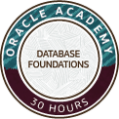
Education | Lesya Ukrainka Volyn National University  Faculty of Physics  Master of Physics  Graduated in 2000  Ph.D. in Physical and Mathematics, majoring in the physics of semiconductors and dielectrics (2009)

