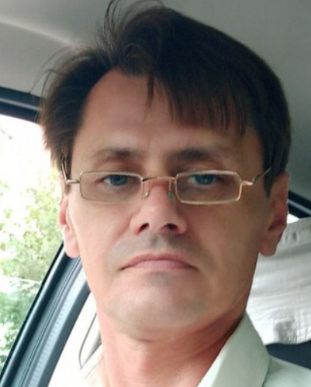

Vitaly Bulatetsky |  |  |  | Assoc., Ph.D.
Contact Information | Bulatetsky.Vitaly@vnu.edu.ua (corp)  nomadcat@ukr.net (personal)
Summary of Qualifications | At the university, I teach subjects related to the administration of operating systems and networks, the architecture of computer systems and circuit engineering, partly - with databases and system programming. I will administer the faculty's servers and network at the level of the operating system, hosting and services. By my first higher education and scientific degree, I am a physicist specializing in experimental research of semiconductors. I have been working at the university as a teacher for more than 20 years.
Skills | - Programming Languages/ Technologies  - Shell/Batch scripting  - RDBMS  - My SQL  - Methodologies  - LMS  - Testing Tools |  | - Frameworks  - Application/Web Servers  - LAMP  - Development Tools  - Logisim  - Visual C# 2010  - Oracle VirtualBox, Qemu  - Moodle  - CMD  - PowerShell
 |  | - Operating Systems  - Microsoft DOS, Windows 3.1/…/10/11  - Microsoft Windows Server 2003, 2008  - Ubuntu Server 14, 18, 22  - Mandriva Desktop  - And other… |  |  | - Hardware  - Physical (Dell, Intel) servers  - RAID (soft and hard)  - Network  - TCP/IP, DNS, VPN, Routing  - Active Directory

