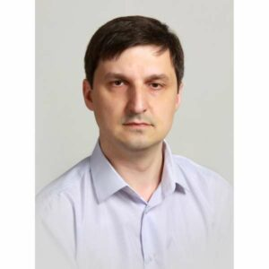
Ruslan Bahrii
Data Engineer/Analyst
Contact Information | bahriiro@khmnu.edu.ua
Summary of Qualifications | I have experience in data engineering: collecting, managing and converting raw data into clean data. In addition, I have basic skills to interpret data using data analysis and visualization tools.  I have math skills, programming skills, basics of data warehouse skills and data visualization skills.  Smart, self-motivated, flexible, adjustable to different situations. Opened for learning new technologies and practices.
Skills | - Programming Languages/ Technologies  - C# / PHP  - HTML / CSS  - SQL / Transact-SQL  - Basics of Python  - RDBMS  - MS SQL Server  - My SQL  - SQLite  - Firebird  - PostgreSQL  - Methodologies  - Basics of SCRUM |  | - Frameworks  - Laravel  - .Net Framework  - Application/Web Servers  - Apache  - Open Server Panel  - Development Tools  - VisualStudio  - VSCode  - SQL Server Management Studio  - MS SQL Server Analysis Services  - Power BI
 |  | - Operating Systems  - Microsoft Windows 7/8/10  - Microsoft Windows Server |  |  | - Network  - Basics of TCP/IP, DNS, VPN, Routing  - Basics of Active Directory
Education | 1996 – 2001 Technological University of Podillya (Khmelnytskiy)  Faculty: Engineering Mechanics  Specialization: Mechanical Engineering Technology  Qualification: Master of Mechanical Engineering Technology (diploma with distinction).  2018 Obtained a Candidate of Technical Science degree (PhD) in Computer Science

