wAsset Management

Execution Plan
Ver 1.0

Table of Contents
Execution Plan 4
1. Project Overview 4
1.1. Project Objectives 4
2. Technology Architecture 4
2.1. Technology Stack 4
2.2. System Architecture 5
2.3. Directory Structure 6
3. Implementation Phases 6
Phase 1: Foundation Setup (Weeks 1-2) 6
Phase 2: Authentication & Authorization (Weeks 3-4) 7
Phase 3: Core Asset Management (Weeks 5-8) 8
Phase 4: Asset Operations (Weeks 9-12) 8
Phase 5: Maintenance & Support (Weeks 13-16) 9
Phase 6: Analytics & Reporting (Weeks 17-18) 9
4. Feature Modules 10
4.1. User Management 10
4.2. Asset Management 11
4.3. Asset Operations 11
4.4. Maintenance and Disposal 11
4.5. Report and Analytics 11
5. API Endpoints Overview 12
Authentication 12
Assets 12
Asset Operations 12
Asset Assignment Flow Sequence Diagram 13
Data Flow Diagrams 14
Users 15
6. Database Schema 16
Entity Relationships Diagram 16
Core Tables 17
7. Security Implementation 17
Authentication 17
Authorization 17
Data Security 18
8. Deployment Configuration 18
Development Environment 18
Production Environment 18
9. Quality Assurance 18
Testing Strategies 18
Testing Tools Specified: 18
Code Quality 19
10. Logging and Monitoring 19
Winston Logging 19
Logger Configuration: 19
Log Categories 19
11. Database Operations 20
Index Types Used: 20
API Pagination 20
12. Database Backup and Recovery 21
Curent Implementation 21
Daily Backup Procedure 21
Backup Types 21
Restore Procedure 21
13. Version Control 22
Github Repository 22
Versioning Strategy 22
Release Process 22
14. Deployment Strategy 23
Current Status: Planning 23
Deployment Options Considered 23
Planned Deployment Steps 23
15. Success Criteria 24

Execution Plan

Technology Architecture

Technology Stack
Layer | Technology | Version
Frontend | React | 19.x
Frontend Framework | Vite | Latest
Language | TypeScript | 5.x
Styling | Tailwind CSS | 3.x
UI Components | Shadcn UI | Latest
Backend | Node.js | 18+
Backend Framework | Express | 4.x
Database | MySQL | 8.x
Authentication | JWT + Refresh Tokens | -
Real-time | Socket.io | 4.x

System Architecture
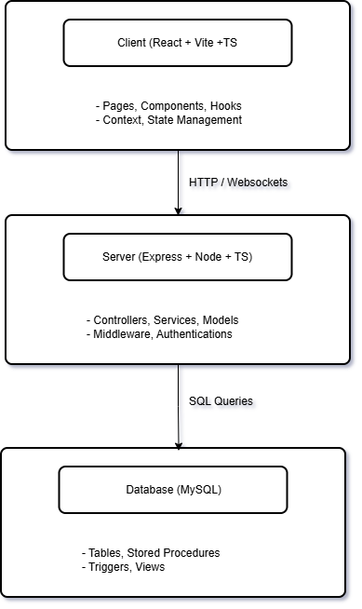
(Diagram 1)

Directory Structure
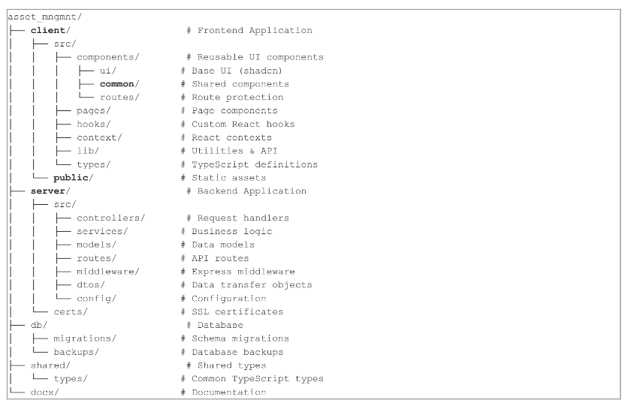
(Diagram 2)

Feature Modules

User Management
Feature | Description | Status
User Registration | Self-service user registration | Complete
User Login | Secure authentication with JWT | Complete
Password Reset | OTP-based password recovery | Complete
Profile Management | User profile viewing and editing | Complete
Role Management | Admin role assignment | Complete
Department Assignment | User department association | Complete

Asset Management
Feature | Description | Status
Asset Creation | Add new assets to system | Complete; with minor improvement in UI / UX
Asset Editing | Modify asset details | Complete; with minor improvement in UI / UX
Asset Deletion | Archive/remove assets | Complete; with minor improvement in UI / UX
Asset Search | Search and filter assets | Complete; with minor improvement in UI / UX
Asset Tagging | QR/barcode tagging | Complete; with minor improvement in UI / UX
Asset Import | Bulk asset import | Complete; with minor improvement in UI / UX
Asset Export | Export to CSV/Excel | Complete; with minor improvement in UI / UX

Asset Operations
Feature | Description | Status
Asset Issuance | Assign assets to users | Complete; with minor improvement in UI / UX
Return Requests | Process asset returns | Complete; with minor improvement in UI / UX
Transfer Requests | Transfer between users | Complete; with minor improvement in UI / UX
Approval Workflow | Multi-level approvals | Complete; with minor improvement in UI / UX
Digital Forms | Electronic signatures | Complete; with minor improvement in UI / UX
Condition Assessment | Return condition checking | Complete; with minor improvement in UI / UX

Maintenance and Disposal
Feature | Description | Status
Maintenance Records | Track maintenance history | OnQue
Repair Requests | Submit repair requests | OnQue
Disposal Requests | Request asset disposal | OnQue
Service Scheduling | Schedule maintenance | OnQue

Report and Analytics
Feature | Description | Status
Dashboard | Overview statistics | Complete; with minor improvement in UI / UX
Asset Status | Status distribution | Complete; with minor improvement in UI / UX
Recent Activity | Activity timeline | Complete; with minor improvement in UI / UX
Audit Trail | Complete history log | Complete; with minor improvement in UI / UX
PDF Reports | Generate printable forms | Complete; with minor improvement in UI / UX

API Endpoints Overview

Authentication
- POST /api/auth/register - User registration
- POST /api/auth/login - User login
- POST /api/auth/refresh - Token refresh
- POST /api/auth/logout - User logout
- POST /api/auth/forgot-password - Request password reset
- POST /api/auth/reset-password - Reset password with OTP

Assets
- GET /api/assets - List assets
- POST /api/assets - Create asset
- GET /api/assets/:id - Get asset details
- PATCH /api/assets/:id - Update asset
- DELETE /api/assets/:id - Delete asset

Asset Operations
- POST /api/assets/issuance - Issue assets
- POST /api/assets/return - Return assets
- POST /api/assets/transfer - Transfer assets
- GET /api/assets/my-assets - User's assigned assets

Asset Assignment Flow Sequence Diagram
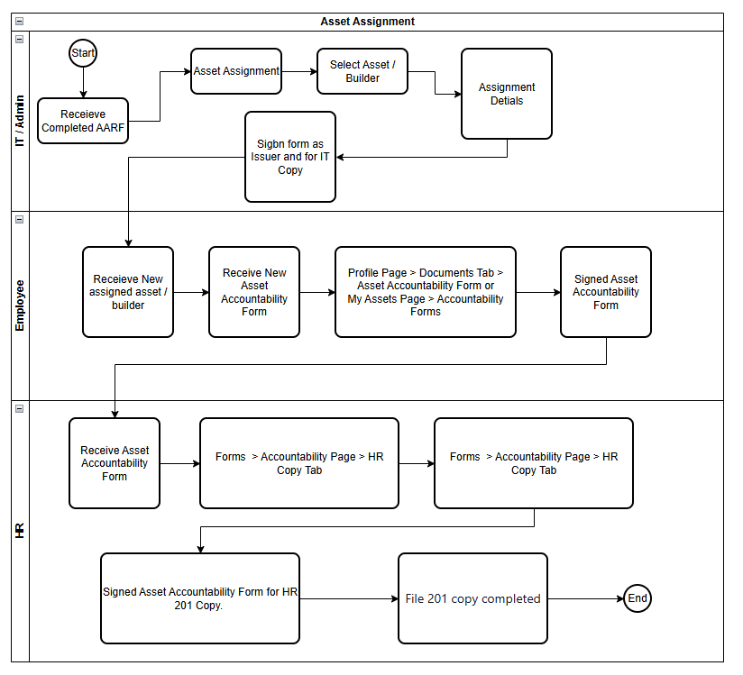
(Diagram 3)

Data Flow Diagrams
DFD Level 0 – Context Diagram
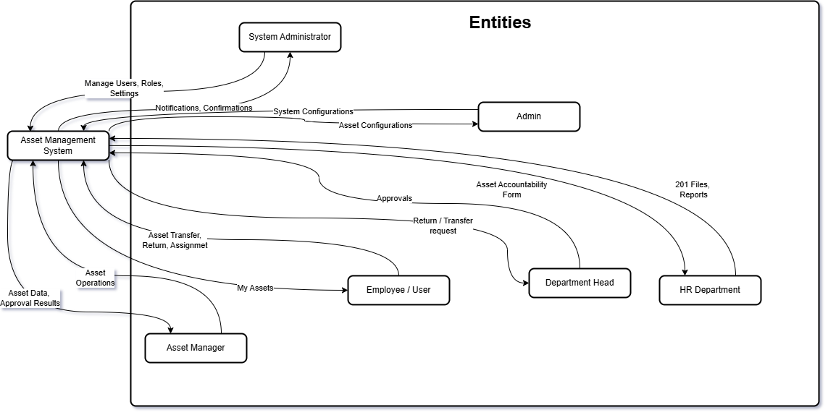
(Diagram 4)
DFD Level 1 – Main Process
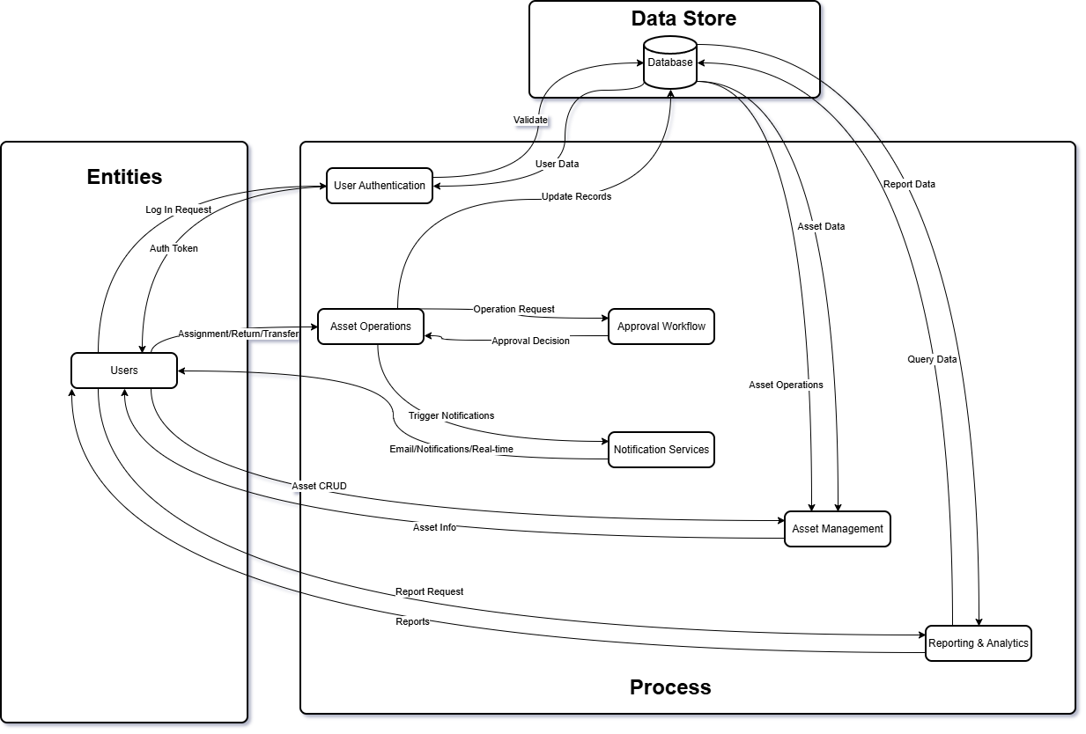
(Diagram 5)

- GET /api/maintenance - List maintenance records
- POST /api/maintenance - Create maintenance record
- POST /api/repair-requests - Submit repair request

Users
- GET /api/users - List users
- GET /api/users/:id - Get user details
- PATCH /api/users/:id - Update user

Database Schema

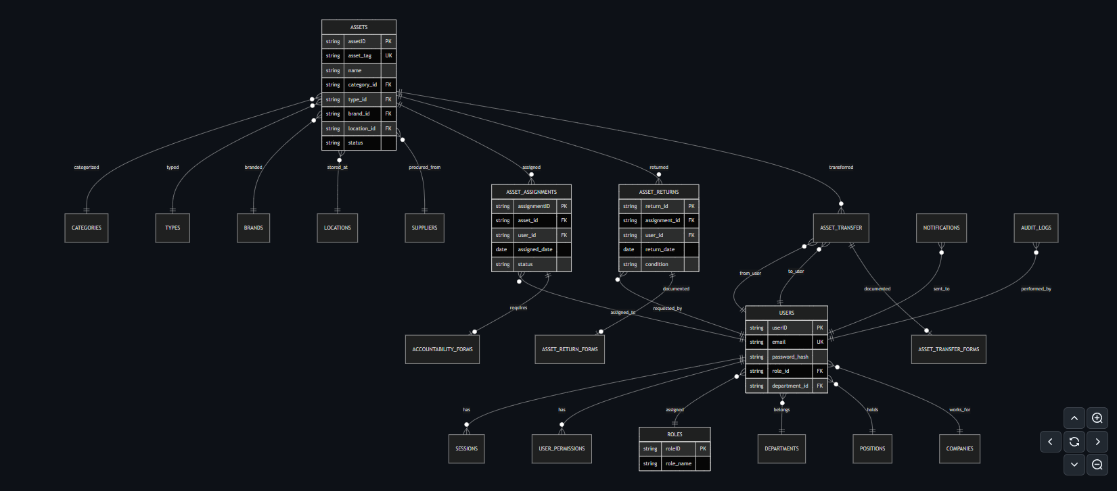
Entity Relationships Diagram

Core Tables
Table | Purpose
users | System users
roles | User roles
permissions | Access permissions
departments | Organizational departments
positions | Job positions
assets | Asset records
categories | Asset categories
types | Asset types
brands | Asset brands
locations | Storage locations
suppliers | Vendor information
asset_assignments | Asset assignment records
asset_return_requests | Return requests
asset_transfer_requests | Transfer requests
accountability_forms | Digital signature forms
notifications | System notifications
audit_logs | Activity history

Security Implementation

Authentication
- JWT access tokens (15-minute expiry)
- Refresh tokens (7-day expiry)
- Secure HTTP-only cookies
- Session management in database

Authorization
- Role-based access control (RBAC)
- Permission-based route protection
- Middleware-level authorization checks
- API endpoint protection

Data Security
- Input validation with Zod schemas
- SQL injection prevention (parameterized queries)
- CORS configuration with allowed origins
- Secure password hashing with bcrypt

Deployment Configuration

Development Environment
- Client: http://localhost:9669
- Server: http://localhost:6996
- Database: MySQL localhost

Production Environment
- Client: https://assetmanagement.sys
- Server: Port 6996 (HTTP)

Quality Assurance

Testing Strategies
Level | Tool | Coverage Target
Unit Tests | Jest | 70%+
Component Tests | React Testing Library | 60%+
Integration Tests | Jest + Supertest | Key workflows
E2E Tests | Playwright (Future) | Critical paths

Testing Tools Specified:
- Jest: Backend unit tests and frontend component tests
- React Testing Library: Frontend component testing
- Supertest: API endpoint integration testing
- Playwright (Future): End-to-end testing for critical user flows

Code Quality
- ESLint for code linting
- Prettier for code formatting
- TypeScript strict mode
- Husky pre-commit hooks

Logging and Monitoring

Winston Logging
The system implements comprehensive logging using Winston:
Feature | Implementation
Log Levels | error, warn, info, http, debug
Log Format | JSON with timestamp, level, message, metadata
Transports | Console, File (daily rotation), Database
Error Tracking | Stack traces with context
Log Retention | 30 days (configurable)

Logger Configuration:
- Console: Development debugging
- File: Production error tracking (logs/error.log)
- Combined: All info logs (logs/combined.log)

Log Categories
- Application logs
- API request/response logs
- Database query logs
- Authentication logs
- Error logs with stack traces

Database Operations
Index Strategy (MySQL)
Proper indexing is critical for performance. The following indexes are implemented:
Table | Index Columns | Purpose
assets | asset_tag, status, category_id | Fast asset lookups
users | email, department_id | User authentication
asset_assignments | user_id, asset_id, status | Assignment queries
asset_return_requests | user_id, status, created_at | Return processing
asset_transfer_requests | from_user_id, to_user_id, status | Transfer tracking
audit_logs | user_id, action, created_at | Audit trail queries
notifications | user_id, is_read, created_at | Notification retrieval

Index Types Used:
- PRIMARY KEY indexes on all tables
- UNIQUE indexes on business keys (email, asset_tag)
- FOREIGN KEY indexes for relationship queries
- COMPOSITE indexes for complex queries
- FULLTEXT indexes for search operations

API Pagination
All list endpoints implement pagination for optimal performance:
Parameter | Type | Default
page | integer | 1
limit | integer | 20
sortBy | string | created_at
sortOrder | string | DESC

Response Format:
- data: Array of results
- meta: Pagination metadata (page, limit, total, totalPages)

Database Backup and Recovery

Current Implementation
The system already includes database backup infrastructure:
- Backup files stored in db/backups/ directory
- Migration scripts in db/migrations/

Daily Backup Procedure
Component | Schedule | Retention
Full Database Backup | Daily at 2:00 AM | 30 days
Incremental Backup | Every 6 hours | 7 days
Transaction Logs | Continuous | 24 hours

Backup Types
- Full Back up: Complete database dump
- Differential: Changes since last full backup
- Point-in-Time: Recovery to specific timestamp

Restore Procedure
Step 1: Assess Recovery Need
- Identify failure type (logical, physical, user error)
- Determine RPO (Recovery Point Objective): 24 hours
- Determine RTO (Recovery Time Objective): 4 hours
Step 2: Restore Process
- Stop application services
- Select appropriate backup (full + incremental)
- Restore database from backup
- Apply transaction logs if point-in-time needed
- Verify data integrity
- Start application services
Step 3: Verification
- Run database integrity checks
- Validate critical table counts
- Test application connectivity
- Verifying recent transactions

Version Control

Github Repository
Aspect | Configuration
Platform | GitHub
Branch Strategy | Git Flow
Main Branches | main (production), develop (integration)
Feature Branches | feature, bugfix, hotfix
Commit Messages | Conventional commits

Versioning Strategy
Version Type | Format
Major | X.0.0
Minor | X.Y.0
Patch | X.Y.Z

Release Process
- Feature freeze on develop branch
- Create release branch
- Run all tests
- Update version numbers
- Merge to main
- Create Git tag
- Deploy to production

Deployment Strategy

Current Status: Planning
Environment | Purpose | Status
Development | Local development | Complete
Staging | Pre-production testing | Planning
Production | Live environment | Planning

Deployment Options Considered
Option | Pros | Cons
Traditional (VM) | Full control | Manual scaling
Container (Docker) | Consistent | More complex
Platform (Render/Heroku) | Easy setup | Less control
Vercel | Zero-config frontend, global CDN | Backend limited
Railway | Full-stack (Node + DB), easy scaling | Smaller ecosystem

Planned Deployment Steps
Option A: Vercel + Railway
- Deploy client to Vercel
- Deploy server and MySQL to Railway
- Connect via environment variables
Option B: Containerization
- Dockerfile for client
- Dockerfile for server
- Docker Compose for local development
Phase 1: Containerization
- Dockerfile for client
- Dockerfile for server
- Docker Compose for local development
Phase 2: CI/CD Pipeline
- GitHub Actions workflow
- Automated testing
- Automated deployment
Phase 3: Production
- Cloud hosting setup
- SSL configuration
- Monitoring and alerts

Success Criteria
The execution plan aims to deliver:
- Functional Requirements
  - Complete asset lifecycle management
  - Streamlined approval workflows
  - Comprehensive reporting capabilities
- Non-Functional Requirements
  - Responsive user interface
  - Secure authentication
  - Real-time updates
  - Audit trail compliance
- Business Objectives
  - Centralized asset visibility
  - Reduced manual processing
  - Improved asset utilization
  - Enhanced accountability tracking
Prepared by:

Ryan Rey D. Magdalita
(Jr. Full Stack Developer)

Checked By:

Ralph Padilla
(IT Manager)

