Asset Management

Project Proposal

Ver 1.0

Table of Contents
Project Proposal 4
1. Summary 4
2. Problem Statement 4
2.1. Current Challenges 4
2.2. Business Pain Points 4
3. Proposed Solution 5
3.1. Solution Overview 5
3.2. Core Capabilities 5
3.3. Use Case Diagram 6
3.4. Data Flow Diagrams 7
3.5. In Scope 8
4. Functional Requirements 10
4.1. In Scope 10
4.2. Asset Management 10
4.3. Asset Operations 10
4.4. Maintenance 11
4.5. Report 11
5. Non-Functional Requirements 12
5.1. Performance 12
5.2. Security 12
5.3. Usability 12
5.4. Reliability 12
6. Technology Stack 13
6.1. Frontend 13
6.2. Backend 13
7. Implementation Timeline 13
Phase 1: Data Gathering / Data Collection 13
Phase 2: Software Development 14
Phase 3: Software Testing & Debugging 15
Phase 4: Data Migration 15
Phase 5: Documentation 15
Phase 6: Management Presentation 16
Phase 7: Executive Approval 16
Phase 8: Deployment 16
8. Resource Requirements 16
8.1. Human Resources 16
8.2. Technical Resources 16
9. Expected Benefits 16
9.1. Quantitative Benefits 16
10.2 Qualitative Benefits 17
10. Risk Assessment 17
11. Success Metrics 17
12. Budget 18
13. Conclusions 18
14. Additional System Diagrams 19
14.1. Asset Assignment Flow Diagram 19
14.2. Asset Return Request Flow Diagram 20
14.3. Asset Transfer Request Flow Diagram 21
14.4. Asset Diagram Descrioptions 22

Project Proposal

Summary

The Asset Management System is a comprehensive web-based platform designed to transform how organizations track, manage, and optimize their physical and digital assets. This proposal outlines the development of a centralized solution that provides complete visibility into asset lifecycle management, from acquisition to disposal.

The system addresses critical business needs including inventory control, accountability tracking, maintenance scheduling, and compliance documentation. By implementing this solution, organizations can expect significant improvements in asset utilization, reduced losses, and streamlined operational processes.

Problem Statement

Current Challenges
Organizations face significant challenges in managing their assets effectively:
Challenge | Impact | Root Cause
Manual Tracking | Inefficient, Error-prone | Spreadsheet -based tracking
Poor Visibility | Lost or underutilized | No centralized system
Accountability Gaps | Asset loss, misuse | No assignment tracking
Compliance Risk | Audit failures | Incomplete documentation
Delayed Maintenance | Increased costs | No scheduled maintenance
Slow Process | Productivity loss | Manual Approval

Business Pain Points
- Asset Loss: Inability to locate assets results in unnecessary purchases.
- Duplicate Purchases: No visibility into existing inventory.
- Compliance Failures: Missing documentation for audits.
- Maintenance Backlogs: Unscheduled equipment failures.
- Inefficient Allocations: Assets not optimally distributed
- Reporting Delays: Manual data compilation takes days

Proposed Solution

Solution Overview
We propose developing a full- featured Asset Management System that provides:
- Centralized Asset Repository: Single source of truth for all assets
- Automated Workflows: Streamlined approval and assignment processes
- Real-time Tracking: Live visibility into asset location and status
- Comprehensive Auditing: Complete history for compliance
- Analytics Dashboard: Data-driven insights for decision-making

Core Capabilities
Asset Management System
- Asset Catalog:
  - Create
  - Search
  - Categorize
  - Tag
- Asset Tracking:
  - Location
  - Status
  - History
  - Transfer
- Asset Lifecycle:
  - Acquire
  - Assign
  - Maintain
  - Dispose
- Workflow Automation:
  - Approvals
  - Issuance
  - Returns
  - Transfer
- Reporting and Analytics:
  - Dashboard
  - Charts
  - Exports
  - Alerts
- Security and Compliance
  - Role Based Access Control (RBAC)
  - Audit
  - Logging
  - Encryption
- Multi Company Support
- Manage assets across multiple subsidiaries or organizations
- Logical data separation
- Centralized monitoring and reporting across all companies

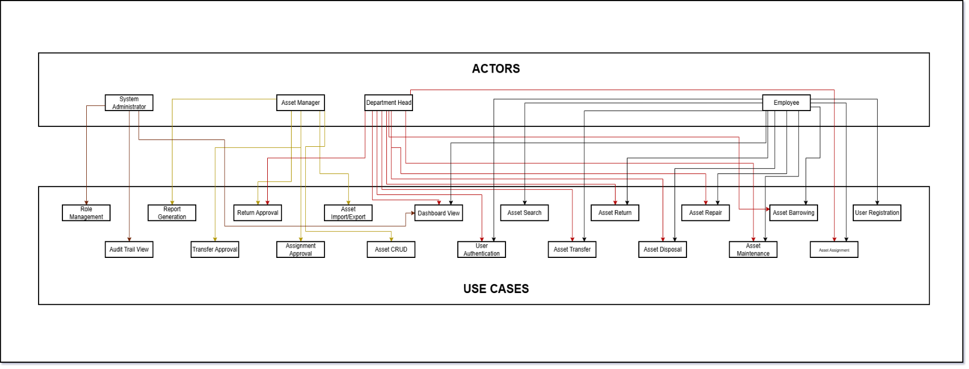
Use Case Diagram
(Diagram 1)
Use Case Descriptions
ID | Use Case | Actor | Description
UC1 | User Authentication | All | Login, logout, session management
UC2 | User Registration | User | Self-service user registration
UC3 | Role Management | Admin | Assign and manage user roles
UC4 | Asset CRUD | Manager | Create, read, update, delete assets
UC5 | Asset Search | All | Search and filter assets
UC6 | Import/Export | Manager | Bulk import and export assets
UC7 | Asset Assignment | User/Dept Head | Request asset assignment
UC8 | Assignment Approval | Manager | Approve or reject assignments
UC9 | Asset Return | User | Request asset return
UC10 | Return Approval | Manager | Approve or reject returns
UC11 | Asset Transfer | User/Dept Head | Request asset transfer
UC12 | Transfer Approval | Manager | Approve or reject transfers
UC13 | Maintenance Request | User | Submit maintenance requests
UC14 | Disposal Request | Manager | Request asset disposal
UC15 | Dashboard View | All | View dashboard and statistics
UC16 | Report Generation | Manager | Generate reports and exports
UC17 | Audit Trail View | Admin | View complete audit history

Data Flow Diagrams
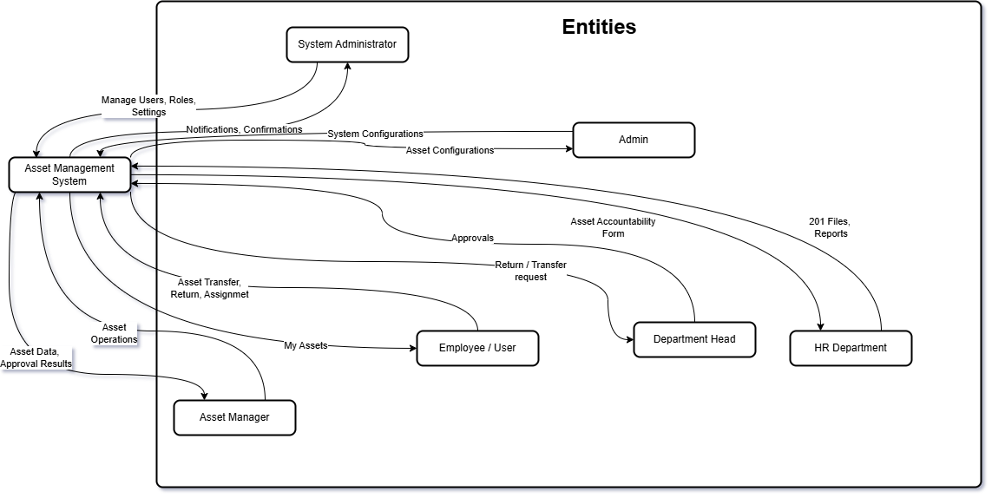
DFD Level 0 – Context Diagram
(Diagram 2)

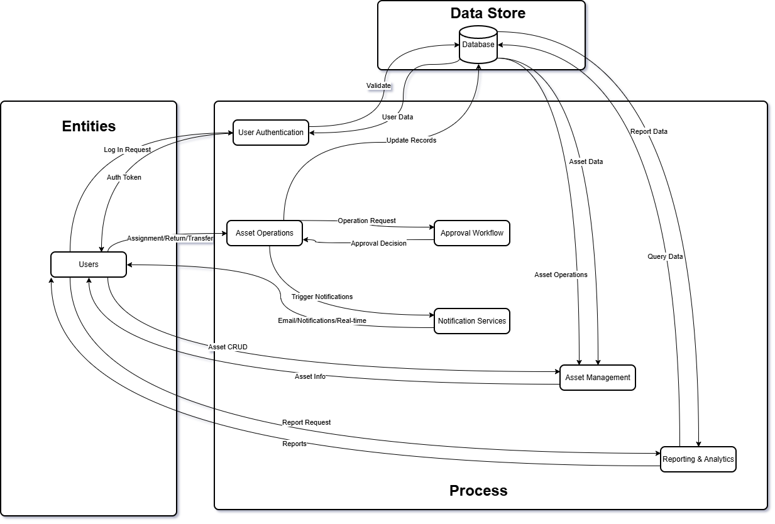
DFD Level 1 – Main Process
(Diagram 3)

In Scope
User Management
- User registration and authentication
- Role-based access control (Admin, Manager, User)
- Department and position management
- Profile management
Asset Management
- Asset creation, editing, and deletion
- Asset categorization (categories, types, brands)
- Asset tagging with unique identifiers
- Asset search and advanced filtering
- Bulk import and export capabilities
- Asset history and timeline tracking
Asset Operations
- Asset issuance to users
- Return request and approval workflow
- Transfer requests between users/departments
- Multi-level approval processes
- Digital signature capture for accountability
Maintenance & Support
- Maintenance record keeping
- Repair request submission and tracking
- Scheduled maintenance reminders
- Asset disposal workflow
Reporting & Analytics
- Interactive dashboard with key metrics
- Asset status distribution charts
- Recent activity timeline
- Comprehensive audit trail
- PDF report generation
- Data export (CSV, Excel)
Multi-company / Subsidiary support
- Company based data segregation for users and assets

Functional Requirements

In Scope
ID | Requirement | Priority
AUTH-001 | User registration with email verification | High
AUTH-002 | Secure login with JWT tokens | High
AUTH-003 | Password reset with OTP | High
AUTH-004 | Role-based access control | High
AUTH-005 | Session management | High

Asset Management
ID | Requirement | Priority
ASSET-001 | Create new assets with all attributes | High
ASSET-002 | Edit asset information | High
ASSET-003 | Soft Delete/archive assets | High
ASSET-004 | Search assets by multiple criteria | High
ASSET-005 | Filter assets by category, status, location | High
ASSET-006 | Asset tagging with unique identifiers | High
ASSET-007 | Bulk assets import from CSV | Medium
ASSET-008 | Export assets to CSV/Excel | Medium
ASSET-009 | Asset image upload and display | Medium
ASSET-010 | Asset assignment history | High

Asset Operations
ID | Requirement | Priority
OP-001 | Issue assets to users | High
OP-002 | Request asset return | High
OP-003 | Approve/reject return requests | High
OP-004 | Request asset transfer | High
OP-005 | Approve/reject transfer requests | High
OP-006 | Multi-level approval workflow | High
OP-007 | Digital accountability forms | High
OP-008 | Condition assessment on return | High
OP-009 | Email notifications for operations | Medium

Maintenance
ID | Requirement | Priority
MAINT-001 | Create maintenance records | Medium
MAINT-002 | Submit repair requests | Medium
MAINT-003 | Track repair status | Medium
MAINT-004 | Schedule maintenance | Medium
MAINT-005 | View maintenance history | Medium
MAINT-006 | Request asset disposal | Medium

Report
ID | Requirement | Priority
RPT-001 | Dashboard with summary statistics | High
RPT-002 | Asset status distribution chart | High
RPT-003 | Recent activity timeline | High
RPT-004 | Complete audit trail | High
RPT-005 | Generate PDF reports | Medium
RPT-006 | Export data to CSV | Medium

Non-Functional Requirements

Performance
Metric | Target
Page Load Time | >= 1 minute
API Response Time | >= 500ms
Concurrent Users | 100+
Database Queries | >= 100ms

Security
Requirement | Implementation
Authentication | JWT with refresh tokens
Password Storage | bcrypt hashing
Data Validation | Zod schemas
SQL Injection | Parameterized queries
CORS | Whitelist allowed origins
HTTPS | SSL/TLS encryption

Usability
Requirement | Target
Browser Support | Chrome, Firefox, Edge, Safari
Mobile Responsive | Yes
Accessibility | WCAG 2.1 AA
User Training | >= 2 hours

Reliability
Metric | Target
Uptime | 99.5%
Backup Frequency | Daily
Error Rate | < 1%

Technology Stack

Frontend
Technology | Purpose
React 19 | UI Framework
TypeScript | Type Safety
Vite | Build Tool
Tailwind CSS | Styling
Shadcn UI | Component Library
React Router | Navigation
Socket.io Client | Real-time Updates

Backend
Technology | Purpose
Node.js | Runtime
Express | Web Framework
TypeScript | Type Safety
MySQL | Database
Socket.io | Real-time Communication
JWT | Authentication
bcrypt | Password Hashing
Zod | Validation

Infrastructure
Component | Configuration
Web Server | Node.js + Express
Database | MySQL 8.x
Client Hosting | Vite (Static)

Implementation Timeline

Phase 1: Data Gathering / Data Collection
- Week 1-2
  - Existing Workflow

Phase 2: Software Development
- Week 3
  - Project setup and configuration
- Week 4
  - Database schema design
  - Authentication system
  - Basic user management
- Week 5
  - Assessment
  - Asset CRUD operations
- Week 6
  - Asset categorization
  - Search and filtering
- Week 7
- Asset tagging
  - Issuance workflow
- Week 8
  - Return Process
  - Transfer process
- Week 9
  - Approval workflows
  - Reporting dashboard
- Week 10
  - Return workflow
  - Transfer workflow
- Week 11
  - Asset Assignment
  - Asset Accountability Form
- Week 12
  - Return Form
  - Transfer Form
- Week 13
  - Testing and bug fixes
  - Performance optimization
- Week 14
  - Documentation

Phase 3: Software Testing & Debugging
- Week 15
  - Testing of Core Functionality
  - Security Testing
  - Initial Regression Testing

Phase 4: Data Migration
- Week 16
  - Cleansing & Standardization of Asset Records
  - Initial/Partial Load, Validation & Basic Functional Testing of Migrated Assets
  - Post-Load Updates/Corrections, Issue Documentation & Quick Regression Check

Phase 5: Documentation
- Week 17
  - UAT Deployment
  - Compilation of User Manual & Quick-Start Guides

Phase 6: Management Presentation
- PowerPoint Presentation

Phase 7: Executive Approval
- Executive signing

Phase 8: Deployment
- Cloud deployment of system

Total Estimated Duration: 24 weeks

Resource Requirements

Human Resources
Role | Quantity | Responsibilities
Project Manager | 1 | Overall coordination
Senior Full Stack Developer | 1 | Implementation and guide
Full-stack Developer | 1 | Implementation
UI/UX Designer | 1 | Interface design
QA Tester | 1 | Testing

Technical Resources
Resource | Specification
Development Server | Local or cloud VM
Database Server | MySQL 8.x
Testing Environment | Staging server
Version Control | Git repository

Expected Benefits

Quantitative Benefits
Benefit | Metric | Expected Improvement
Asset Visibility | % of assets tracked | 0% → 100%
Search Time | Time to find asset | Hours → Seconds
Processing Time | Approval cycle | Days → Hours
Reporting | Report generation | Days → Minutes
Asset Utilization | Usage rate | Unknown → 85%+

Qualitative Benefits
- Improved Accountability: Clear assignment tracking
- Better Decision Making: Real-time data and analytics
- Reduced Losses: Better asset visibility
- Compliance Ready: Complete audit trails
- Operational Efficiency: Automated workflows

Risk Assessment
Risk | Probability | Impact | Mitigation
Scope Creep | Medium | High | Clear requirements, change control
Technical Debt | Low | Medium | Code reviews, testing
Performance Issues | Low | Medium | Load testing, optimization
User Adoption | Medium | High | Training, UX improvements
Data Migration | Medium | Medium | Careful planning, validation

Success Metrics
The project will be considered successful when:
- User Adoption: 100% of target users actively use the system
- Asset Coverage: 100% of assets registered in the system
- Process Automation: 90% of asset operations through the system
- Performance: All response times within targets
- User Satisfaction: Positive feedback from end users

Project Budget
# | Manpower / Application | Budget | Amount | Remarks
1 | Sr Software Developer | 0.00 * 3 | - | Sr. Developer Salary
2 | Software Developer | 20,000.00 * 3 | 60,000 | Developer Salary
3 | UI/UX | 0.00 * 2 | - | UI/UX Salary + Project Designs/Layout Artifacts
4 | Quality Assurance | 0.00 * 1 | - | Quality Assurance + Project Documentation Artifacts
5 | Software Tools | 28.55% | 22,900 | Software Tools utilize per Affiliate per Year
6 | Electrical & IT Equipment | 10,000 * 3 | 30,000 | Admin Fee
Total |  |  | Php 112,960.00

Conclusions
The Asset Management System represents a significant opportunity to transform how the organization manages its assets. By implementing this comprehensive solution, we will achieve:
- Complete visibility into asset inventory
- Streamlined operational workflows
- Enhanced accountability and compliance
- Data-driven decision making
- Improved operational efficiency
The proposed solution is technically feasible, aligned with business objectives, and provides measurable value to the organization. We recommend proceeding with implementation as outlined in this proposal.

Additional System Diagrams

Asset Assignment Flow Diagram
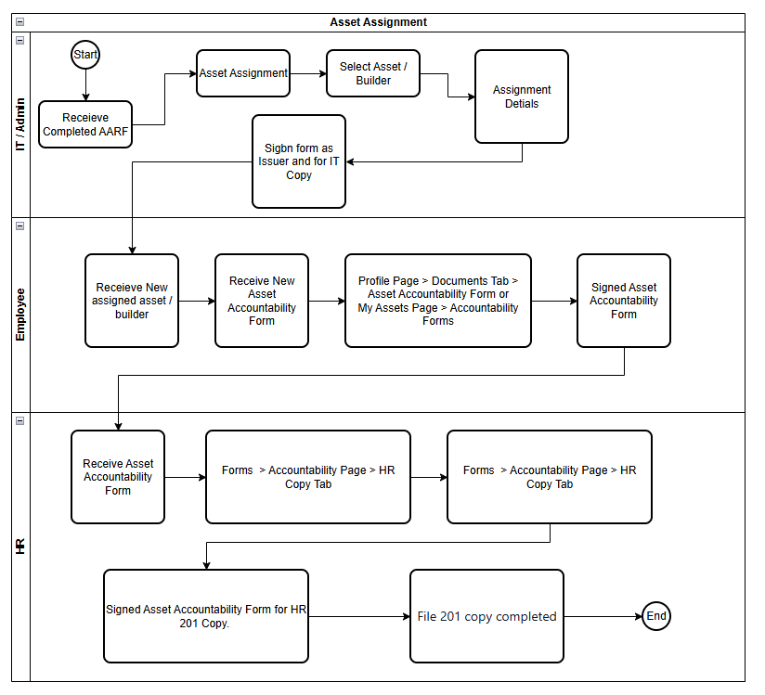
(Diagram 4)

Asset Return Request Flow Diagram
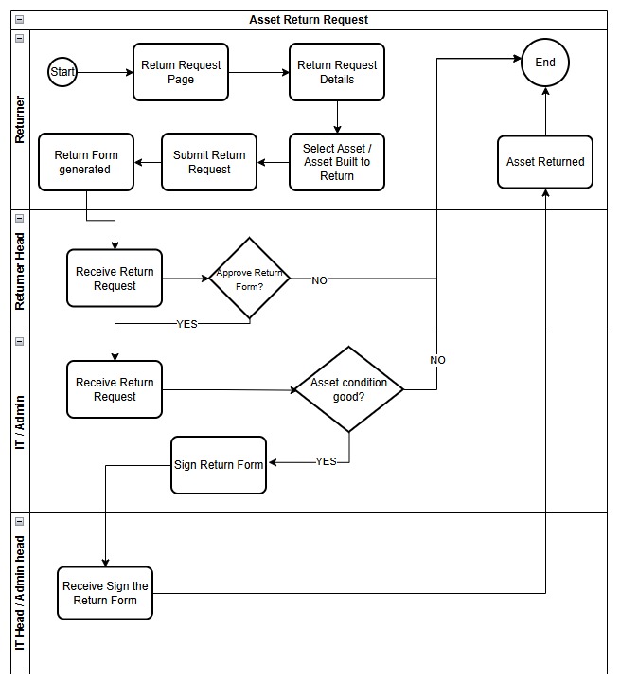
(Diagram 5)

Asset Transfer Request Flow Diagram
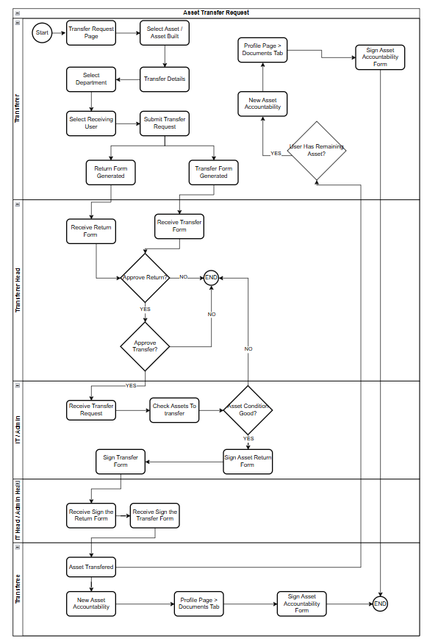
(Diagram 6)

Asset Diagram Descriptions
Diagram | Description
Asset Assignment Flow | Complete flowchart showing IT Admin, Employee, and HR roles in asset assignment process with accountability form signing
Asset Transfer Request Flow | Complete transfer request process from Returner through approval to IT Head
Asset Return Request Flow | Complete return request process from Returner through approval to Asset manager

Prepared by:

Ryan Rey D. Magdalita
(Jr. Full Stack Developer)

Checked By:

Ralph Padilla
(IT Head)

