CloneVision

A smart glass for the visually challenged

M. Vignesh1, D. Vignesh2, R. Shanmugapriyan3, Final year CSE (UG)

Guided by Dr. R. Deepalakshmi, Professor, CSE Department

Velammal College of Engineering and Technology, Madurai

***Abstract***—*Blindness is a vision impairment. Such visually challenged people need some external assistance from others to help them with their daily chores. A solution to this problem has been addressed in this paper as a product, a wearable smart glasses called ‘CloneVision’. The paper presents the necessity, functionality, modules and working of the product in detail. The CloneVision smart glass helps to know any obstacle in-front of the user and alerts them of the same. It detects and recognizes the objects and faces of persons as they come across. The smartglass uses haarcascade classifier for object detection and LPBH (Local Binary Patterns Histograms) for face recognition. The information about the object or person recognized reaches the user through voice output. The user can add new person’s data to the database. In such case, the product stores multiple pictures of the person’s face and adds additional data about the person fed by the user through voice input and updates the existing model. Thus, the proposed solution is dealt in-depth in the full paper.*

***Keywords***— Blindness, smart glass, detection, recognition, voice input and output.

1. **INTRODUCTION**

Blindness is the lack of vision that can’t be improved, or loss of vision that can be corrected with power glasses or contact lenses. Complete vision loss does not allow the person to see anything. Blindness may be by birth for some people or on due course with the leading causes like, cataract, glaucoma, age related macular degeneration (AMD), corneal opacities, uncorrected refractive errors, trachoma and diabetic retinopathy with the remaining internal health issues undetermined. It can also be due to external injuries to the surface of eyes due to accidents or even sports injuries. Partial vision loss or vision impairment is often defined with the clarity of vision of about 20/40 or worse on scale. Globally the principal causes of visual impairment are uncorrected refractive errors and cataracts. Other causes are glaucoma, age related macular degeneration (AMD), diabetic retinopathy, trachoma, corneal opacities, problems in the brain due to stroke and premature birth, where such cases are termed as cortical visual impairment. Complete blindness is defined with zero perception of objects and no projection of light on the lens of the patient. People with complete blindness can’t see any object in any level of visual acuity and thus completely blind. Irrecoverable blindness defines people with visual challenges for which there is no definite treatment of cure. Such complete blindness and irrecoverable blindness are the major issues can’t seem to be addressed by technologies effectively so far and thus addressed in this paper by providing a generalized approach independent of the vision impairments or any other visual challenges. The end product is a wearable smart glasses that helps people with any kind of visual challenges in their daily life, to recognize objects or people in-front of them and to avoid any obstacles to a certain extent. This helps the people to be independent of other people for their most general day-to-day works and basically know anything or any-being in-front of them. The database can also updated upon use and the smart glasses can be trained for better performance as they use upon time.

**2. LITERATURE SURVEY:**

A study has been made on some of the few journals published, more relevant to the subject taken under consideration, with the description of each paper as follows.

As in paper [2], there are two components, a smart glass and a biochip. The smart glass captures a live video stream, processes it and sends the information through wireless medium to the biochip, implanted behind the eyes of the user by microsurgery. This chip converts the input signal into points of light called phosphenes that is understood by the brain. Since the concept requires microsurgery, it is complex and an expensive solution.

The paper as in [3], presents the concept of helping the blind to recognise traffic signal patterns and the obstacles around, to cross roads without any help. It uses template matching technique to achieve the same. But, it is limited to only the traffic signals and road crossing.

The paper as in [4], says about how to help the visually challenged to avoid obstacles with multiple ultrasonic sensors. But, the concept includes many accessories to be used by the people for the product to work as intended, which is quite frustrating to follow.

A smartglass called eSight has been developed and is on sale by a corporate company eSight Corporation. The smart glass features a high-definition camera to capture live video stream, processes it and projects the visuals on two OLED screens in-front of the user’s eye. It also supports Bioptic Tilt capability to adjust the angle of the screen based on the user convenience. The smartglass is sold for 10000 USD (6,34,000 INR), which is considered to be a major drawback. It is also limited to low vision and legally blind.

**3. PROPOSED SYSTEM**

The proposed system captures a live video stream, processes it, detects objects and faces, recognizes them and provide audio output to the user, through a headphone. The device also detects some obstacles in-front of them and alerts the user through audio output. Hence, in this methodology we have 3 sections namely,

1. Object recognition
2. Face Recognition
3. Obstacle avoidance

***A. Object Recognition***

The first module works on object recognition. The product carries a 5 Megapixel PiCamera that captures a live video stream. Each frame is processed in grayscale. The algorithm uses Tensorflow framework for object recognition. Tensorflow is an opensource and easy to use algorithm with good community support. Compared to other algorithms and frameworks, Tensorflow is 3.17 times faster than Haarcascade classifier, 2.42times faster than Caffe framework and 1.31times faster than Torch framework. The working of tensorflow can be described in few steps as follows,

1. Takes an image and locate landmarks.
2. Calculates and concatenates tensors (Organized multi-dimensional array of numerical values).
3. Flips the image horizontally from left to right.
4. Computes distance between sequences.
5. Saves a list of tensors to a file.
6. Extracts a slice from a tensor and recognizes the image.

The algorithm detects for any objects in the frame. If any object detected, it ensures if there is any corresponding predefined match in the database with a threshold level of confidence. If the condition is satisfied, the information stored about that matched predefined model is given as an audio output to the user. If no match found, the output message is ‘unknown’. The product has been trained with a large set of predefined models in the database, to make the product work out of the box. A sample output is given below in Fig.1.

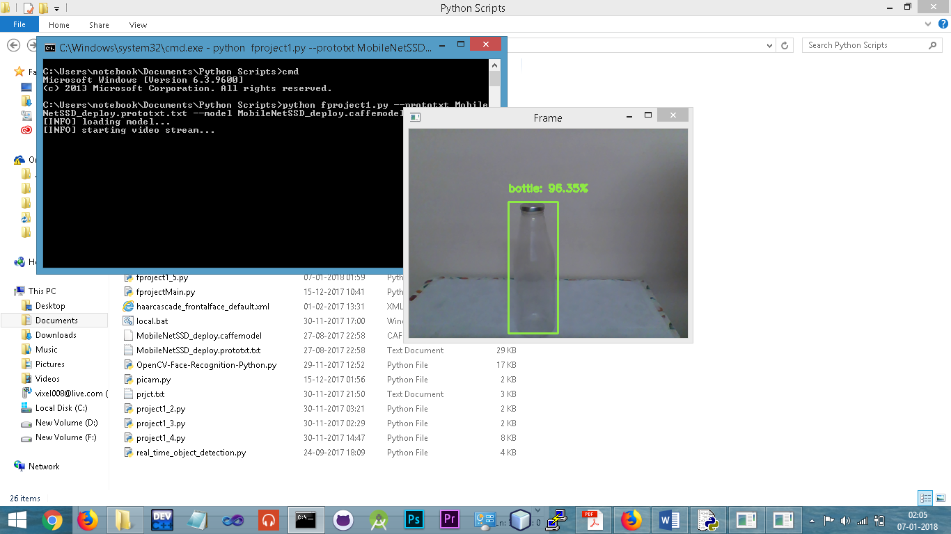

*Fig.1. Simulated output for object recognition module.*

***B. Face Recognition***

The second module helps the users to know the person in-front of them. Thus the second module is face recognition. This module is more or less similar to the first module, except that the second module detects and recognizes faces and not objects as in first module. A live video stream is captured. Each frame in the video stream is converted to grayscale for processing. Then, the algorithm detects any faces available in the frame by locating some common landmarks on the face like, eyes, nose and mouth. After face detection, it is ensured if there is any corresponding predefined match in the database with a threshold level of confidence. If there any match exist, the corresponding information of the predefined model is given as an audio output to the user. If there is no match found, the product outputs as ‘unknown person’.

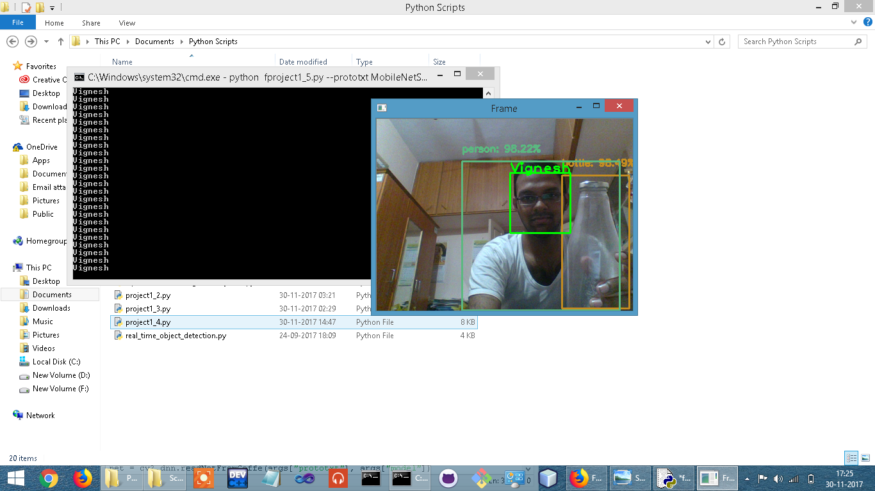

Fig.2. Simulated output of face recognition and object recognition.

Unlike object recognition, there will be no predefined models available in the database for face recognition. Thus, in each occasion when the user come across a new person, the user can store the data about the person, like the image of the person and an additional information. This feature can be triggered by a button press on the device. This action triggers the product to detect the person’s face, capture rapid shots of the person and save the images in the ‘imagesdb’. The user is allowed to input the additional information in the form of a voice note. The information about the person is converted to an YML (Why a Mark-up language – XML generated) file, stored and loaded for future use of the product. Thus, the database can be updated and the product can be trained upon use for better performance.

***C. Obstacle avoidance***

The smartglass contains an ultrasonic sensor for obstacle avoidance. The sensor detects any obstacle in-front of the person to a certain extent. For instance, if the user is about to hit a wall, the smartglass detects the wall in its proximity and alerts the user through audio output. The ultrasonic sensor works on the same principle as a radar or sonar, which evaluates the distance of the object from the sensor. The ultrasonic sensor has a transmitter for transmitting the ultrasonic signals and the receiver receives the signals echoed by the targeting object in-front of the smartglass, evaluates the distance of the obstacle, if the distance reaches a threshold value, the system alerts the user through an audio output.

1. **BLOCK DIAGRAM**

Ultrasonic sensor

Micro-processor

PiCamera

Microphone

Speaker

*Fig. 1. Block diagram of the system*

**Block diagram Description:**

***PiCamera***

This block consists of a 5 Megapixel camera that records a constant live video stream of the environment in-front of the camera.The PICAMERA is exclusively built for Raspberri Pi. It is compatible with Raspberry Pi Zero W microprocessor module. The PiCamera is connected with the Raspberry Pi through a flex ribbon cable. The PiCamera has an LED notification light that turns ON when the camera module starts recording.

***Microphone***

This block consists of a MICROPHONE. The microphone is active only when the user desires to update the database by adding the data of a new person. The microphone is actually a transducer that converts the audio signal to electrical signal that can be processed by the microprocessor. The electrical signal is passed to the microprocessor module for further processing and stored. Preferably, the microphone will be a part of the headphones.

***Ultrasonic sensor***

This block consists of an ultrasonic sensor HC-SR04. The sensor module consists of a transmitter and a receiver. The transmitter emits a sound wave at specific higher frequency. When the sound wave touches any surface, it bounces back. The receiver picks up the sound wave at the same frequency. Then, the distance between the sensor and the object or any obstacle is calculated and sent to the microprocessor block. The sensor used in this product can sense any object within 400cm.

***Microprocessor***

The microprocessor used in this block is Raspberry Pi Zero W. It is a 32-bit ARM based processor. The microprocessor board hosts a Broadcom BCM2835 System-On-Chip powered by ARM11 CPU running at 1GHz with 512MB of RAM. The module also supports 2.4GHz 802.11n wireless LAN, Bluetooth Classic 4.1 and Bluetooth LE. The module consists of two Micro USB ports for power and data syncing, one Mini HDMI port, a Camera Serial Interface, a Micro SD card slot and 40 GPIO pins for external connections. It processes the data gathered from the input blocks, stored in the SD card. The output is sent to the speaker block.

***Speaker***

This block consists of a speaker for audio output. In this product, a headphone is used in place of a speaker. The electrical signal sent by the microprocessor passes though the wire, causes vibration in air to make sound that is heard through the scuffs or plastic cover of earphones. Thus, the output of the system is heard through a headphone / earphone by the user.

**5. CONCLUSION**

The **CloneVision smartglass for the visually challenged** is made targeting the people with complete blindness and irrecoverable blindness and can also be used by people with low-vision, visual impairments and legally blind. The smartglass has been made with care and aid the people to a greater extent in their daily life. The product has been designed with utmost care to ensure the usability and easy access of all features by the user. The smartglass especially helps the user to know anything or any-being in-front of the user. Research is in-progress to include the GPS module for real-time navigation and to increase the performance of the smartglass, make the user feel comfortable with ergonomic designs and thus improving the overall product.

**6. REFERENCES**

1. Smart guiding glasses for visually impaired people in indoor environment, Jinqiang Bai, Shiguo Lian, Zhaoxiang Liu, Kai Wang and Dijun Liu. (published in The Institute of Electrical and Electronics Engineers IEEE 2017)
2. Smart Eye Implementation using Smart Glass and Bio Chip, Akshay Vartak, Saurabh Ranjane and Dr.Suhasini Vijaykumar (published in International organization of Scientific Research Journal of Computer Engineering IOSR-JCE 2017)
3. Smart vision for the blind people, R.Mohanapriya,U.Nirmala,C.Pearlin Priscilla (published in International Journal of Advanced Research in Electronics and Communication Engineering IJARECE 2016)
4. Smart navigation system for visually challenged people, Ramamurthy.N and P.N.Sudha (published in International Journal of Industrial Electronics and Electrical Engineering IJIEEE 2016)
5. http://ieeexplore.ieee.org/document/7372720/
6. http://ieeexplore.ieee.org/document/8103374/
7. https://www.esighteyewear.com/technology
8. https://aira.io/#why_choose_aira
9. https://www.orcam.com/en/myeye2/

http://www.rnib.org.uk/sites/default/files/Smart%20glasses%20transcript.docx

https://www.pyimagesearch.com/2015/12/14/installing-opencv-on-your-raspberry-pi-zero/#comment-442963

https://www.pyimagesearch.com/2015/10/26/how-to-install-opencv-3-on-raspbian-jessie/

https://www.pyimagesearch.com/2017/10/09/optimizing-opencv-on-the-raspberry-pi/#comment-443021

https://www.pyimagesearch.com/2015/03/30/accessing-the-raspberry-pi-camera-with-opencv-and-python/

https://www.pyimagesearch.com/2017/09/18/real-time-object-detection-with-deep-learning-and-opencv/

https://nueyes.com/wp-content/uploads/2017/12/nueyes-electronic-magnification-glasses-low-vision1200x800.jpg