Auto Parts Price Outlook
Next 6 months: what moves, why, and who to call
Prepared for Leadership Review. Generated by Radar from the connected knowledge base.

1. Executive summary
The forecast basket rises 1.29% over the next six months, from ₹17.56 lakh today to ₹17.78 lakh in December 2026. The move is small overall but uneven: Electrical and Lighting rise sharply while HVAC and Powertrain ease.
- Prices peak at ₹17.93 lakh in October, then soften through December.
- ₹2.83 lakh of spend (16.1% of the basket, 73 parts) is exposed to increases above 5%.
- Four vendors account for 62% of that risk, led by Minda Industries at 23.6%.
- The best model (XGBoost) reaches 96.7% accuracy on a 60-part backtest.

2. Price forecast
The basket climbs through October and then eases. The confidence band widens to about ±₹0.7 lakh by August, so early buys carry less risk than late ones.
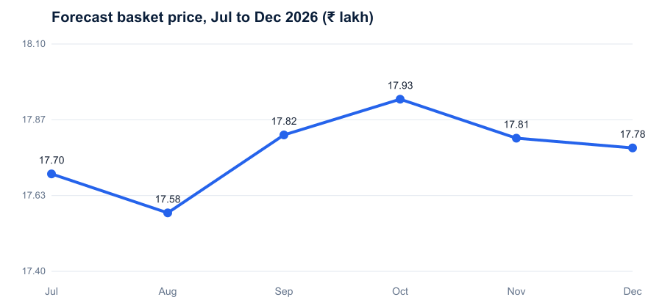
Figure 1. Forecast basket price, July to December 2026. Source: Pricing Models.

3. Category movement
Electrical (+6.8%) and Lighting (+5.1%) lead the increases. HVAC is the only category with a meaningful decline (-2.9%).
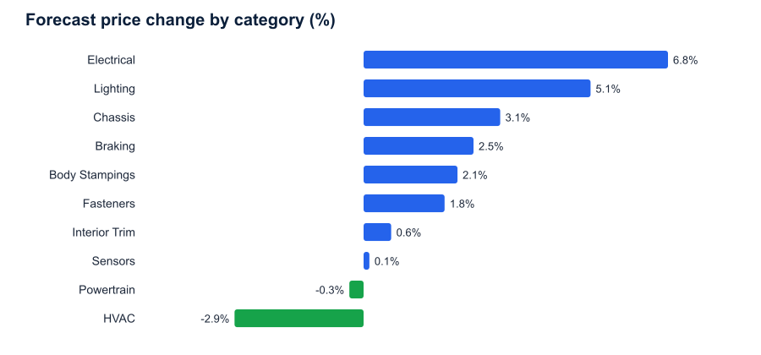
Figure 2. Forecast price change by category over six months. Source: Category Cost Reports.
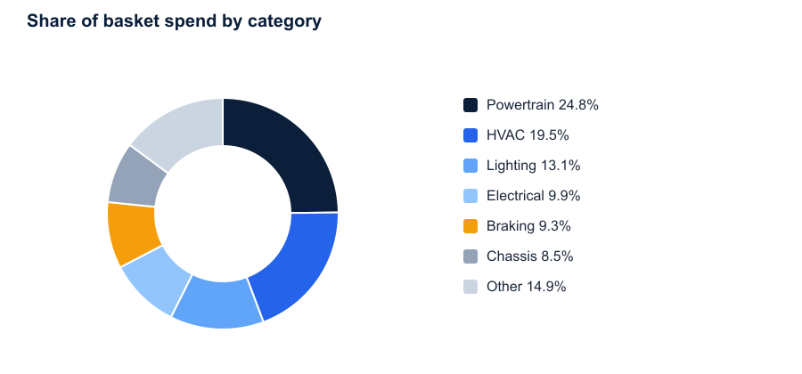
Figure 3. Share of basket spend. Powertrain and HVAC together hold 44.3% of spend. Source: Category Cost Reports.

4. Drivers
- Currency: a 10% FX rise lifts the basket about 1.6%, mostly through imported electronics.
- Raw materials: copper and aluminium contracts reprice in Q4 and feed wiring and lighting.
- Logistics and duty: freight and duty shocks move the basket by less than 0.4% in every scenario tested.

5. Supplier risk
Risk is concentrated. Minda Industries, Varroc Engineering, Valeo India and Bosch India hold 62.2% of spend at risk.
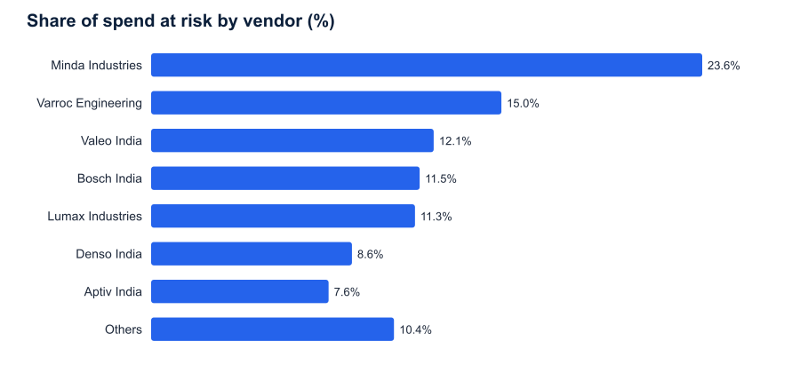
Figure 4. Share of spend at risk by vendor. Source: Supplier Master.
Vendor | Share of risk | Suggested action
Minda Industries | 23.6% | Open price review, lock Q4 volume
Varroc Engineering | 15.0% | Request cost breakdown
Valeo India | 12.1% | Negotiate index-linked clause
Bosch India | 11.5% | Confirm Q4 pricing validity

6. Recommended next steps
- Approve early buys for Electrical and Lighting before the October peak.
- Open price reviews with Minda, Varroc, Valeo and Bosch this month.
- Review the FX hedge position against the 10% scenario.
- Re-run this outlook after the November contract repricing.

