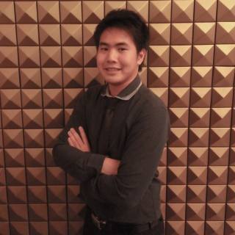

**Ratchanon Chompuboot**

Full Stack .NET Developer

Tel:  090-030-3314

Email: it.sunday.develop@gmail.com

GitHub: https://github.com/ITCSsDevloper

Facebook: https://www.facebook.com/GmtanBeartai2010

Objective

* Design and Develop Software from user requirement.
* Looking for an innovative and challenging.
* Looking for enjoy community.
* Looking for progress in the job
* Expect Salary 32,000 - 35,000 (Negotiable)

Personal Details

|  |  |
| --- | --- |
| **Name** | : Ratchanon Chompuboot |
| **Nickname** | : TAN |
| **Age** | : 23 years |
| **Date of Birth** | : 23 Apr 1994 |
| **Nationality** | : Thai |
| **Religion** | : Buddhism |

Education

* Khon Kaen University 2012 - 2016
  + Faculty of science, Department of Computer Science (ICT)
  + GPA 2.57
* Roi Et Wittayalai School

Skills

* **Programming Languages :**C#, JavaScript, SQL, NodeJS
* **Web technologies :**HTML, JavaScript, CSS, jQuery, Bootstrap, Json and VueJs
* **Frameworks :**ASP.NET MVC, ASP.NET API, Windows From, Windows Service, Entity Framework, LINQ, Nlog, Crystal Report, EPPlus, Docx, Express.js, Mongo DB
* **Tools :**Visual Studio, Visual Code, MSSQL, IIS, Windows Server, MongoDB, SourceTree, GitExtension, Kdiff3, ArduinoIDE, Android Studio
* **Testing :**NUnit, Selenium

Experience

* **OneCall CO., LTD.**(October 16, 2017 to present)
  + **Position** : Full-stack .NET Developer
  + **Developing software for**: Siam Commercial Bank (SCB)
  + **Responsibilities :**
    - Get Requirement.
    - Systems design.
    - Databases design.
    - Development & Deployment on the server.
    - Documentation.
    - Investigate defect & Find solution.
    - Support & Maintenance.
    - Take care customer.
* **iCONEXT CO., LTD.**(May 31, 2016 to October 13, 2017)
  + **Position :**C# .NET Developer
  + **Onsite:**AEON Thana Sinsap (Thailand) PCL.
  + **Responsibilities :**
    - Producing Windows Applications.
    - Producing Web Applications ASP.NET MVC.
    - Producing Socket Service for communicate with AS400.
    - Participate in requirements analysis.
    - Technical support.

Thank you.