Section 4: Design Control

Purpose and scope

This document describes the responsibilities and activities related to the quality-minded design of products.

Much of the work undertaken by Scientific Analytical Waterloo contains an element of design, which is performed under the direction of the Design and Development Department. Through specific procedures SAW ensures adequate control of design work which results in products that meet our quality specifications, including:

- Establishing the design requirements of our customers (P04-1).
- Planning the design work and assigning responsibility for it to qualified staff (P04-2).
- Checking that completed designs meet our customers requirements (P04-3, P04-4, P04-5).
- Appropriately documenting and archiving the completed design, and carefully implementing and tracking changes to such documentation (P04-6).

Reference documents
Ref # | Title | Document #
[1] | ISO 9001:1994(E) | N/A
[2] | Quality Systems Section 3: Contract Review | DQM03
[3] | Product Documentation Archiving & Item Number Assignment | WI04-1
[4] | Phasing of SAW Regular Innovation Projects | WI04-4
[5] | Electronic Hardware Documentation Archiving | WI04-2
[6] | Software Archiving and Releases | WI04-3
[7] | Control of Quality Records | DQM16

Revision history
Date | Version | Prepared by | Change
99/04/07 | DQM04/3 | J. Cole | Changes per CAR 042
99/06/03 | DQM04/4 | J. Cole | CAR 083: Validation milestone, dept. heads review archives
99/07/30 | DQM04/5 | J. Cole | Results of first external audit (CAR141); major changes. Added Design Checklist, Design Specification Form; Innovation Procedure; tiny, strategic projects (CAR147). Also addresses CAR125-CAR127 improvements, many resulting from new forms, some cosmetic. Change project size definitions. BOM changes defined for ECR (CAR152)
00/01/11 | DQM04/6 | J. Cole | CAR 166 and other changes due to internal audit from Aug / 99. Changes to F04-6 and 7. CAR 190 (large project reports).

Acronyms and definitions
Acronym | Meaning
D&D | The Design and Development department.
ECR | Engineering Change Request
ECN | Engineering Change Notice
SAW | Scientific Analytical Waterloo

Design Initiator Originator and proponent of a design request (or delegate).

Engineering Manager The manager of one of the D&D departments (or delegate).

Design Heads Managers or other qualified senior staff members (or delegates) appropriate to the design project at hand. In general these are D&D department managers, but other SAW departments may be represented as deemed appropriate by the D&D Manager.

Team Leader A qualified person, selected to direct the design project (or delegate).

Design Exception A dilemma in the design process that requires decisions at the senior management level, and may result in the project being cancelled.

Standard production product A product that is built entirely from archived design documents without any involvement from D&D.

Strategic project A large project that requires use of the SAW Innovation Procedure. Strategic projects are typically those that require extensive involvement from Front Line for product launch and support, and therefore a broader and higher profile within the company.

ECR Committee A group made up of qualified representatives of the D&D, Production and Front-line Departments, for assessing and directing the implementation of Engineering Change Requests (ECRs).

BOM Change An ECR that affects only the Bill of Materials, not the design per se.

Milestone A well-defined point in the development process at which some goal has been achieved, a capability demonstrated etc. Milestones are decided in advance by the Team Leader and D&D Manager, and are tied to design reviews.

Design Inputs Requirements, in writing, of the product being designed. Design inputs may include: throughput requirements, product "look and feel", quality performance, principles of operations, regulatory requirements and targeted manufacturing cost. Design inputs are anything that is needed to define the product requirements and goals. Inputs for a given project (along with other project documentation) are kept in a project folder in the Design Documents cabinet in the D&D area.

Design Outputs Design outputs are anything that result from the process, that are required to manufacture the product. These may include schematics, engineering drawings, assembly instructions, software and written documentation. Design outputs are typically kept in an archive. Design outputs that are out of the ordinary should be identified when the project is planned.

Specifications Design Inputs. The requirement for Design Outputs is also part of the specifications.

Responsibilities
- Design Initiator (or delegate)
- Provide specifications and develop, refine and/or clarify them as required.
- Interface to the customer of the design if necessary.
- Perform design validation.

- Management Team
- If required, assist the D&D Manager in resolving time and budget conflicts.
- If required, assist in resolving design exceptions.

- Design and Development Manager (or delegate)
- Appoint the Design Heads for each design project.
- Assist in determination and approval of required resources.
- Integrate the project’s timeline with other D&D projects.
- Review the project milestone reports.
- Identify strategic projects.
- Declare a design exception if the design project fails.
- Authorize changes once the design has been archived.

- Design Heads (or delegates)
- Identify design inputs and outputs.
- Assess design specifications for completeness and reasonableness.
- Select the Team Leader and direct Team Leader to gather information.
- Assist in determination of required resources.

- Team Leader (or delegate)
- Research regulatory issues.
- Resolve conflicts in requirements.
- Assist in determination of required resources and project timeline, and maintain same.
- Co-ordinate with other departments and outside resources.
- Define milestones at which the design must be reviewed.
- Direct the development of the design.
- Conduct Design Review meetings.
- Perform Design Verification.
- Approve changes until the design is archived.
- Consider safe and proper functioning of the product

- Design Team
- Develop the product.
- Ensure that product documentation is archived, and request part numbers in anticipation of production.
- Assist in Design Verification.

- Engineering Managers (or delegates)
- Review Design Outputs prior to release for Production (or other use).

Procedure Flowcharts

- The Design Process
This flowchart depicts the flow of a design, from the gathering of information through to the tracking of changes. There is no matching procedure.

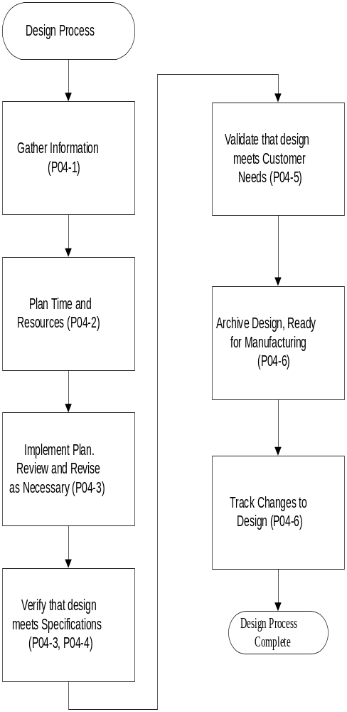
6.2 Information Assessment (P04-1)

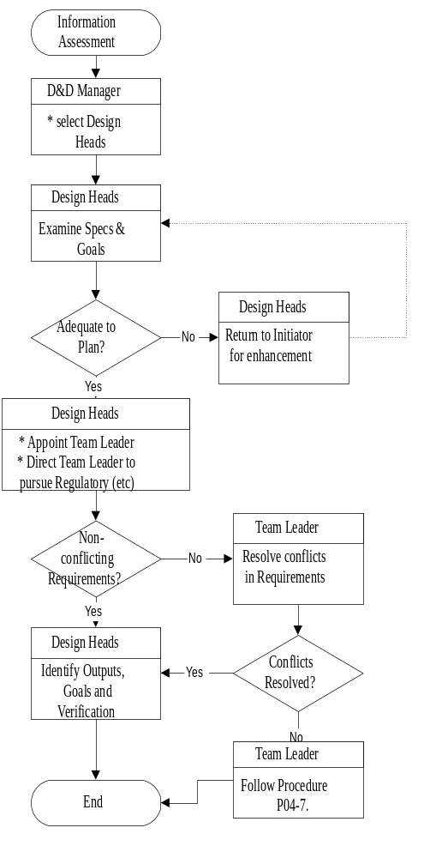
6.3 Planning (P04-2)

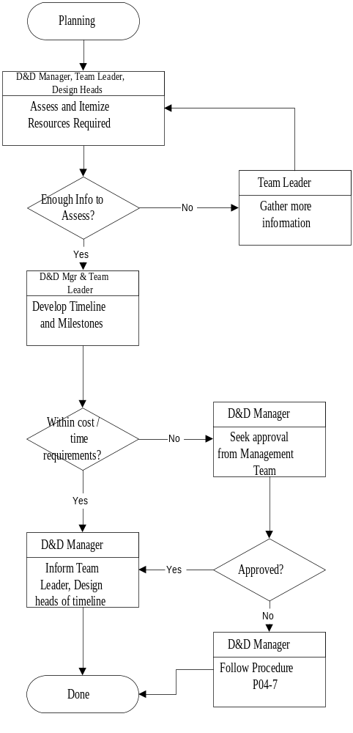
6.4 Design Review (P04-3)

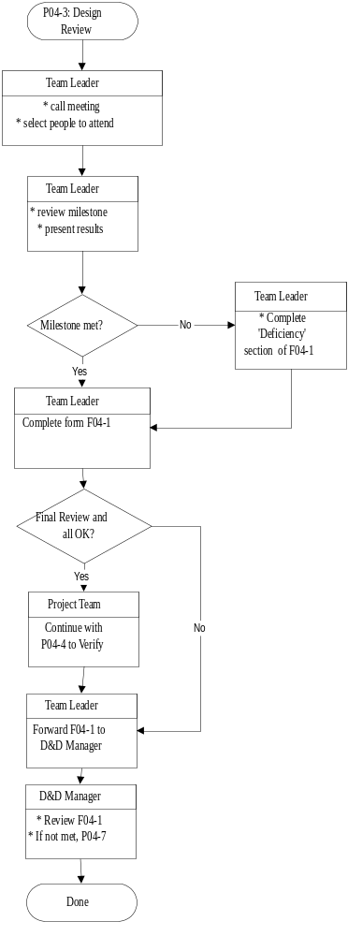
6.4b Design Verification (P04-4)

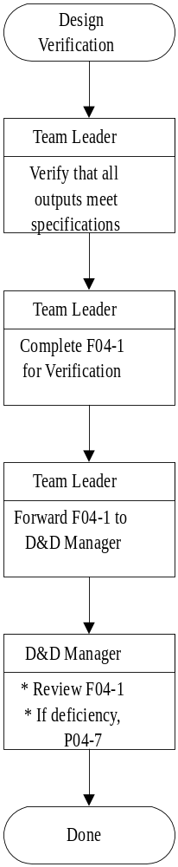

6.5 Design Validation (P04-5)

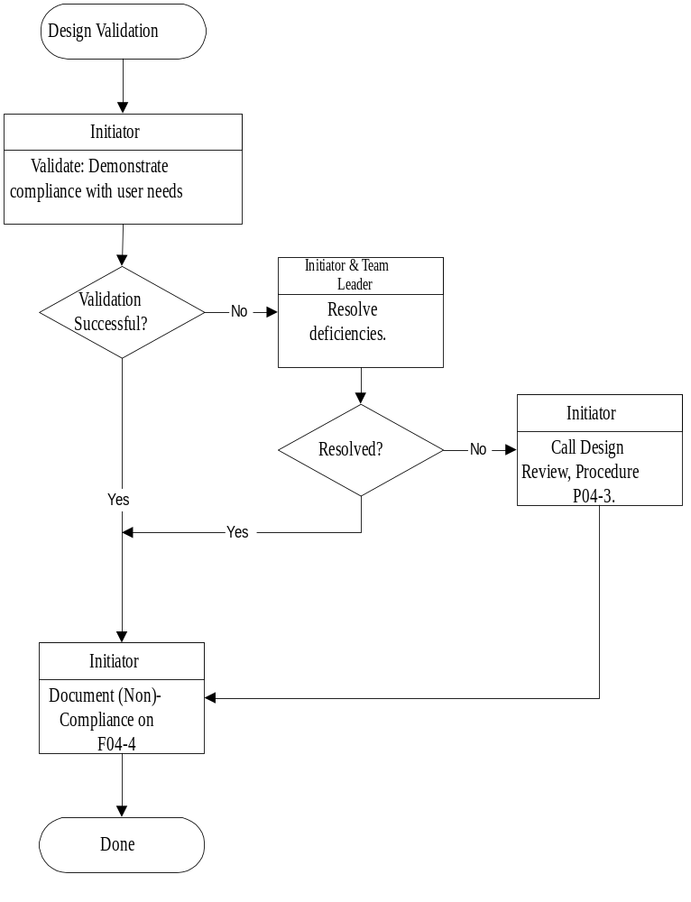
6.6 Design Changes (P04-6)
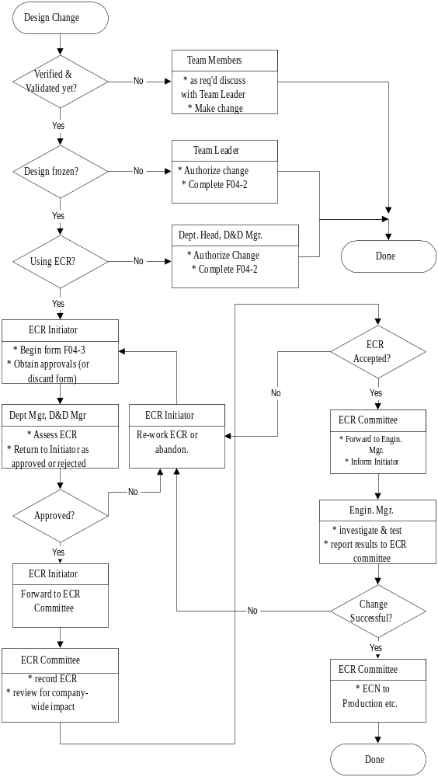

Procedures

General

7.1.1 Specifications. Products are designed according to product specifications, which must clearly identify the requirements, restrictions and goals of the resulting design.

Specifications will include the following, as applicable:
- Certifications and safety regulations
- Requirements related to safe and proper operation
- Manufacturing cost required for specified quantity

Specifications come from two sources:

- Contract Review [Reference 2], in which specifications result from a product sale to, and/or communication with, a customer. A person from the contract review process (usually a member of the Front-Line Department) must act as the Design Initiator (see below).

- Internal requests, in which specifications come from an internal “customer”, that is a department of SAW. A person from the originating department must assume the role of the Design Initiator.

    - Design Initiator. The Design Initiator is the interface to the customer, and must be qualified to make decisions about product specifications and to perform final design validation. Ensuring that the Design Initiator is qualified is the responsibility of the department that he or she represents.

    - Design Documents. The Design Documents (and blank forms referred to in this document) are kept in the Design Documents filing cabinet, located in the D&D area. Each project is assigned a project file, and this file must contain the specifications and project plan, and may contain any other relevant information about the project.

    - Part Numbers. It is the responsibility of all members of the design team to ensure that parts are assigned proper part numbers (using Reference [3]) as soon as they are identified as likely candidates for the final product. Part numbers must be assigned to all parts before designs are archived.

7.1.5 Project size. Projects at SAW range in size from a day or two up to several years of effort. Section 7.3.2 uses the number of team members and the anticipated time invested to categorize projects for the purpose of establishing milestones, as being Tiny, Small, Medium and Large.

In addition, some projects may be declared (by the D&D Manager) to be strategic. Strategic projects are those which require significant co-ordination from other departments within SAW, or from outside, for things like product launch plans, return on investment calculations, service training plans, spare parts plans and so on. The document "Phasing of SAW Regular Innovation Projects" [ Reference 4 ] provides an additional checklist of activities, specifies three project phases, and requires signoff by the SAW General Manager. Strategic projects are automatically also defined as Large projects.

The D&D Manager decides when a very small task warrants being identified as a "project" for the purposes of this document. Those that do are likely to end up as Tiny projects. Tiny projects must clearly represent no more than two weeks of effort between at most 2 developers. They are allowed a special streamlined version of the development procedure:
- A single Design Head is chosen, and is also the Team Leader. This person can act as the delegate of the D&D Manager for all information assessment and planning activities.
- A timeline does not need to be developed.
- Milestones (and Design Reviews) beyond Verification and Validation are not required.

All Large projects also require a monthly written progress report to the D&D Manager and Management Team.

Procedure P04-1 Information Assessment

7.2.1 Upon receipt of specifications for a product design, the D&D Manager will:
- Select Design Heads appropriate for the design project.
- Begin new forms F04-4, F04-6, and F04-7 to track the project.
- Convene a meeting with the Design Heads to assess the information available.

7.2.2 The Design Heads will:
- Assess the specifications and other information available to determine if the material is sufficient to plan the project.
- If the information is not sufficient, return it to the Design Initiator for augmentation and clarification, and schedule a date to reconvene.
- When the information is adequate, appoint a qualified Team Leader to guide the project. Qualified in this context means that the Team Leader has the necessary experience and either has, can be trained in, or can access the required knowledge.
- Assess the specifications to ensure that they are reasonable and do not contain conflicts.
- If further research is required (such as investigation of regulatory requirements), the Design Heads will direct the Team Leader to perform that investigation, and schedule a date to reconvene.
- If the specifications contain conflicts, direct the Team Leader to resolve them and schedule a date to reconvene.
- Identify and specify the design outputs and design verification criteria. This is a critical step; the outputs and verification criteria are used to determine completeness of the project. In many cases the design specifications are sufficient as verification criteria, as determined by the Design Heads.
- Notify the D&D Manager that the project is ready for the planning stage.

7.2.3 The Team Leader will:
- Perform research to identify statutory and regulatory requirements, and to supplement the information as required in order to understand the design requirements, as directed by the Design Heads
- Resolve conflicts in the design requirements, as directed by the Design Heads.
- If conflicts cannot be resolved, follow procedure P04-7 to cause a Design Exception.
- Itemize all specifications on form F04-6.
- Identify characteristics of the design that are crucial to the safe and proper functioning of the product, and identify safety outputs that may be required.
- File all specification documents (including any feedback and history of discussions) with forms F04-4, F04-6 and F04-7 in the D&D Design Documents cabinet.

Procedure P04-2 Planning
The Planning procedure determines the resources that are necessary for a design project, schedules the resources in consideration of other activities, ensures that milestones are included with the schedule, and seeks approval for the resulting resource cost and timeline. This planning must be updated during the project, at the discretion of the Team Leader.

7.3.1 The D&D Manager will:
- Meet with the Team Leader and Design Heads to determine resources (people and equipment) that are required, and assign a cost to these resources. If required, set up a budget for the project.
- With the Team Leader, select the members of the design team, by department. The D&D Manager and Team Leader will ensure that all members of the team are qualified and equipped to perform their functions. They will also make sure that the design team includes a representative of all departments that must be involved, to ensure an interface to their departments.
- Request a job number from Accounting to track costs, if deemed appropriate.
- If the information is not sufficient to determine resources, direct the Team Leader to gather more information and to re-convene the meeting within a reasonable time period
- With the Team Leader, develop a project timeline, integrated with other D&D activities. See sections 7.3.2 and 7.3.3.
- Seek approval from the Management Team if the timeline or cost estimate is outside of budgetary limits or project requirements.
- If approval is denied, follow procedure P04-7 to cause a Design Exception.
- Inform Team Leader and Design Heads of the project start date.

The Team Leader will:
- Assist in the determination of resource requirements.
- Gather additional information as directed by the D&D Manager.
- With the D&D Manager, prepare a project timeline. The schedule will contain an appropriate number of milestones, including a milestone marking the project completion. See sections 7.3.2 and 7.3.2.
- Co-ordinate resources from other departments or outside of SAW.

7.3.2 About Timelines. Project timelines must follow some rules in order to be useable and understandable by all members of the team. Timelines must:
- be clearly legible. Printouts from Microsoft Excel or Project are preferred.
- show time elapsed on the horizontal axis, and tasks and/or resources on the vertical axis
- clearly identify all milestones (and therefore Design Reviews), and especially verification and validation.
- be kept current. A timeline should be viewed as a living document, that reflects the present status of the project.

7.3.3 About Milestones. Milestones are the triggers that cause design reviews to happen, and are essential parts of the design process. Verification and Validation are (special) implicit milestones for all projects (see below).

- The number of milestones will depend on the size of the project, as follows:
- Tiny: Less than 2 weeks of work, and 1 or 2 people on the project team: 0-1 milestone
- Small: Less than 2 months of work, and 1 - 4 people on the project team: 1-2 milestones
- Medium: Less than 10 months of work, and 1 to 5 people on the project team: 2-4 milestones
- Large: 10 months or more of work, or more than 5 people on the project team, or a Strategic project: 3-5 milestones
More milestones are permitted, but not encouraged.

- Milestones may correspond to major achievements in the development process, or may instead correspond to the completion of a phase in the process. The choice of milestones is at the discretion of the Team Leader and D&D Manager, but a mixture of achievements and phase completions is recommended. Some examples of the former: first data collected; first power up of new component; successful integration of electronics and cabinet. Some examples of the latter: completion of research; design is capable of being reproduced.

- Verification is an implicit milestone that marks the completion of the project, meaning that the entire design is verifiable (see P04-4). It automatically causes a Design Review.

- Design validation is an implicit milestone. In this case, the Initiator's sign off on F04-4 and F04-6 are sufficient if the validation is successful, but a validation that cannot be easily resolved must trigger the Design Review procedure.

Procedure P04-3 Design Review

The Design Review is a mechanism for:
- documenting the progress of a project,
- resolving deficiencies in the design, and
- performing design verification.
- Reviewing information from other groups, which may have changed during the project.

Design Reviews are called:
- automatically by the Team Leader when he or she determines that a project milestone has been achieved.
- by any member of the Team or by the D&D Manager when it becomes clear that a milestone may not be achievable.

A Design Review must include the person who instigated the review, the Team Leader and other members of the Design Team as appropriate, as determined by the Team Leader.

The Team Leader will:
- complete sections 2 and 3 of Form F04-1 in advance of the Review Meeting.
- present the milestone under discussion and the design results to the group.
- complete section 4 of F04-1 in one of three ways:
- if the milestone was not met but additional action is possible, schedule the action and a follow up meeting. This procedure then continues at the follow up meeting.
- if the milestone cannot be met, document the deficiencies
- if the milestone is met, list design results that have been verified.
- complete form F04-1 and forward it to the D&D Manager
- if this is the final design review for this project and all milestones have been deemed met, follow Procedure P04-4 to perform design verification

Upon receipt of a completed form F04-1, the D&D Manager will:
- Review the completed form F04-1
- If the milestone was not met, follow procedure P04-7 To cause a Design Exception.
- File the completed form F04-1 in the D&D Design Documents cabinet.

Procedure P04-4 Design Verification

The purpose of design verification is to ensure that the final design performs according to the specifications that were filed on form F04-6. Design verification is performed as part of the final design review.

The Team Leader will:
- Ensure that the final design review meeting is attended by all Team Members required to verify the design.
- Verify that all specifications have been met. Especially, verify that the design outputs (that is, the results of the design) have been achieved. Specifications that have already been verified at previous design reviews (and as recorded on forms F04-1) may not need to be verified again, at the discretion of the Team Leader.
- Ensure that test results that demonstrate verification are filed with the design documentation.
- If the design is not verified successfully…
- but additional action is possible, schedule the action and a follow up meeting. This procedure then continues at the follow up meeting.
- and no other action is envisioned, document the deficiencies.
- Prepare and forward a completed form F04-1 to the D&D Manager

Upon receipt of a completed form F04-1, the D&D Manager will:
- Review the completed form F04-1
- If the verification failed, follow procedure P04-7 To cause a Design Exception.
- File the completed form F04-1 in the D&D Design Documents cabinet.

Procedure P04-5: Design Validation
Design validation ensures that the product as designed meets the needs of the intended user. 'Needs' in this case includes "soft" issues that might go beyond the original specification. As such, it is the responsibility of the Design Initiator, who must have good knowledge of the user’s requirements.

The Design Initiator will:
- Satisfy himself / herself that the design meets the user’s needs, including any special recommendations from form F04-6.
- Complete the Validation section of form F04-4 and F04-7.
- If validation fails, convene a meeting with the Team Leader to resolve the issues. If no resolution is possible, the Initiator or Team Leader must follow Procedure P04-3 to cause a Design Review, which may result in Procedure P04-7 declaring a Design Exception.

Procedure P04-6: Design Changes
7.7.1 General

The procedure for handling design changes depends on the stage of the design project. There are four possible procedures, corresponding to:
- During development and before verification and validation. (See 7.7.3.1)
- After verification but before validation. (See 7.7.3.2)
- After validation, for non-production products. (See 7.7.3.3)
- After validation, for standard production products. (See 7.7.3.4)

7.7.2 Archiving

Design archiving is fundamental to ensuring that a product can be maintained and reliably reproduced.

Archiving means removing (or copying) the design documents from the developers and placing them in a secure location, after which changes must undergo increased scrutiny. Copies of design documents filed earlier in the process (for security or other reasons) are not archives by this definition.

Designs may be archived before validation has been performed, in order, for example, that Production can place parts on order. However, once a design has been validated documents must be archived as soon as possible (see next section). The design cannot then be changed except through the defined procedures. (Designs based on these documents may evolve, but they are new designs).

The outputs of the design process (for example, mechanical drawings, electronic schematics, design notes and software source code) must be archived according to the practice and work instructions of the departments involved [References 3, 5, 6]. For some standard production products (notably software) archiving may be delayed until a planned product release. The Engineering Manager in charge of the appropriate department is responsible for the review of design outputs, to ensure their adequacy for release.

Refer to the work instructions in Reference [3] for details of the archiving process and part number assignment.

7.7.3 P04-6: The Design Change Procedure

7.7.3.1 Design evolution is part of the active development process, and as such, resulting design changes are not part of our Design Change Procedure and are the responsibility of the developers involved. However, any such changes that might negatively impact the design goals (and therefore the ability to meet milestones) must be reviewed with the Team Leader. In making this determination, and in assessing the suitability of all design changes, developers are expected to use their professional judgement. No additional authorization is required.

If in so doing (or at any other time) the Team Leader determines that a design goal is in jeopardy, a Design Review must be called to resolve the situation.

7.7.3.2 Once any design verification has taken place and before validation, design changes are the responsibility of, and must be authorized by, the Team Leader. The Team Leader must complete form F04-2, and decide if such changes invalidate all or part of the verification process. If so, all or part of the verification must be repeated.

      - Once a design has been validated it can only be changed with the authorization of the department head and the D&D Manager. If the design is part of a standard production product, the ECR/ECN procedure (see next section) must be used; otherwise form F04-2 can be used.

7.7.3.4 The ECR/ECN process ensures that all changes to standard production products have full visibility by all departments of SAW and the authorization of the appropriate engineering department head, the D&D Manager, and the ECR committee. See the procedure which follows.

Exception: In the manufacturing process, there often arise requests for a part substitution or notifications of a manufacturer part number change. These are not truly design changes, but will result in changes to design outputs such as Bills of Materials. These must be approved by the appropriate D&D Engineering Manager. If the Manager determines that the part specification is clearly unchanged a streamlined version of the ECR procedure (identified as a "BOM change", and described on the form) may be used.

7.7.4 The Engineering Change Request (ECR) Procedure

Any person may initiate an ECR.

The ECR initiator will:
- Complete the Initiator section of ECR form F04-3, including obtaining the approval of the required managers, as described on the form.
- Forward the form to the ECR committee.

The Department Manager and D&D Manager will, before signing approval:
- Assess the ECR to verify the problem and consider the reasonableness of the change request.
- If the ECR is rejected, return it to the initiator for possible rework.
- If the ECR is accepted, return it to the initiator for submission to the ECR committee.
- For a BOM change, the Department Manager completes Section 3 before sending the ECR to the ECR committee.

The ECR committee (or delegate) will:
- Record the ECR and assign it a number.
- Inform the initiator of the date of the next ECR Committee meeting.
- At the next ECR meeting, review the ECR for overall, company-wide impact.
- If the ECR is rejected, return it to the initiator for possible rework.
- If the ECR is accepted, forward it to the appropriate Engineering Manager for investigation and possible implementation and testing, and inform initiator.

The Engineering Manager (or delegate) will:
- Plan and schedule the investigation and possible implementation and testing of a solution.
- Obtain approval for resources if necessary. This may result in the creation of a new D&D project, at the discretion of the D&D Manager.
- Report the results (success or failure) back to the ECR committee. Results include not only the resolution of the original problem, but also issues of serviceability and cost.
- If this process cannot be timely, the Manager will explain the difficulties to the ECR Committee.
- Ensure that design documents are updated and archived as appropriate, to reflect the change.

The ECR committee (or delegate) will:
- If the engineering was successful, cause the appropriate Engineering Change Notices to be sent to the Production, Service and Engineering departments (see 7.7.5)
- If the Engineering was not successful, return the ECR to the initiator for possible rework.

7.7.5 The Engineering Change Notice (ECN) Process

An ECN is initiated by the ECR Committee. The Committee may, at its discretion, group several ECRs into a single ECN form (F04-5), but not if unreasonable delays would be introduced. The Committee may also produce an ECN by checking the box on the ECR form:

Copy of ECR sent to Production, Service and D&D Managers as Change Notice. No ECN form will be issued!

. In either case, the document is henceforth called an ECN.

The ECR committee will:
- Create form F04-5 to describe the ECN and stamp it ORIGINAL, in red or check the appropriate box on the ECR form.
- Distribute the ECN and all relevant ECR information to the Production, Service and D&D department managers (or their delegates). The Production Manager receives the original.
- File the ECN upon completion.

The Production Manager (or delegate) will:
- Review the ECN, and either
- implement the ECN, updating version numbers of the affected parts, or
- advise the ECR Committee of a reason to not implement the ECN and participate in a follow-up meeting if so requested
- Sign and return the ECN to the ECR Committee. Form F04-5 (ECN form) should be signed in the space provided. F04-3 (ECR form) should be 'checked' and initialed beside the line described above.

Procedure P04-7 Design Exceptions

A design exception may be declared by the Team Leader or the D&D Manager whenever a situation is noticed that might result in the failure of the design process to achieve the design goals. Examples of a design exception situation include:

- The inability of the Team Leader to resolve conflicts in the design specifications.
- The seeming inability of the design team to reach a milestone.
- Failure of design validation.

7.8.1. When a design exception is declared, the D&D Manager will convene a meeting with the Team Leader, Design Initiator, the Design Heads and any other required persons.

The Team Leader will explain the exception condition.

The group will resolve the design exception in a timely manner in one of the following ways:

- Change one or more of the design specifications. The revised specifications must be signed off by the entire group and filed with F04-4. F04-6 must be amended.
- Devise a solution that will allow the design to achieve the specifications. A follow-up meeting must be scheduled by the Team Leader when the solution has been confirmed.
- Suspend the project. The project will receive minimal attention while it is suspended. A suspended project must be reported to the Management Team and re-assessed by the D&D Manager at 6 month intervals until the Management Team agrees to cancel it.
- Abandon the project. The entire group must sign off on this decision, which must then be relayed to the Management Team and recorded in section 4 of F4-4.

Forms and Instructions

8.1 F04-1 : Design Review Report

8.2 F04-2 : Design Change Report

8.3 F04-3 : Engineering Change Request

8.4 F04-4 : Design Summary Form

F04-5 : Engineering Change Notice

8.6 F04-6 : Specification Form

8.7 F04-7 : Design Checklist

(forms begin on following page)
F04-1/3 Design Review Report Project ID: ________________ Milestone ID: ____________
Team Leader: __________________ Meeting called by: ____________________ Date: ____________
Instructions: Complete header and sections 1-5 before and during Design Review Meeting. If no follow up required, forward to D&D Manager.

1. Review Participants (sign in by all attendees):

2. Description of Milestone (attach relevant design documents):

Final Verification? □
3. Results (include / attach test procedures and results):

4. Assessment (check one and list additional information as directed):
□ Milestone Achieved (List design results that have been verified by this milestone.)
□ Milestone Cannot Be Achieved (Detail deficiencies.)
□ Additional Action Required (Document action, schedule follow up, attach this form to follow up.)

5. Additional Comments (eg. effectiveness of the design, recommendations for design or test improvements):

Any new information from other groups? ______________________________________________
6. Reviewed/Approved by D&D Manager on _____________ Signature: ________________________
F04-2/1 Design Change Report Project ID: ________________ Change ID: _______________
Team Leader: __________________ Date: ____________
Instructions: Use this form for changes after verification and before validation, and for non-production products that are not under ECR control.

1. Description of Change (attach relevant design documents):

2. Impact of Change (include results of testing, if any):

3. Assessment (check one or more and list additional information as directed):
□ No Additional Action Required.
□ Verification must be repeated (List design results that should be re-verified.)
□ Validation must be repeated (Non-production products only! List design results that should be re-validated.)

4. Additional Comments (eg. Reason for the change, recommendations for design or test improvements):

5. Authorization (Team Leader (line 1) before validation; Department Head (1) and D&D Manager (2) after validation)
1. Authorized by _____________________ on ________________ Signature: ____________________
2. Authorized by _____________________ on ________________ Signature: ____________________
Scientific Analytical Waterloo
F04-3/3 Engineering Change Request ECR #:
Instructions: Use this form for changes to products that are under ECR control. Initiator completes section 1.

1. Originator: _________________ Date: _______________ Change required by: ________________
Reason For Request (problem to solve):

Approval: (Department Manager) (D&D Manager) (Comments)
Approved by: ______________________ ________________________
Approved on: ______________________ ________________________
BOM Change only. D&D Manager signature and Section 2 not required. Dept. Manager: Complete Section 3 and submit to ECR committee.
Suggested Solution(s) (Attach documents. May be completed by Initiator or Engineering Department)

2. ECR Committee: Date Received: _________________ Date Reviewed: ____________________
□ Rejected. (Explain reasons in this box.. Return to Initiator.) Rejected by: ______________
□ Forwarded to ________________ for investigation. (Assign Engineering Manager. Inform Initiator.)
Comments/Reasons:

3. Engineering Manager: (consider issues such as practicality, serviceability, cost)
Results of investigation: □ Change successful. □ Change not successful . □ Change not feasible.
Comments:

Recommendations:
Stop Production WIP? Rework Stock? Field Units Affected? Interchangeability Affected?
Release Level Change? NOTE: Attach list of part numbers affected!!! Effective Date: _____________
4. ECR Committee: Date Solution was Reviewed: ____________________
Comments:

Copy of ECR sent to Production, Service and D&D Managers as Change Notice. No ECN form will be issued! Implemented ______ (Prod. Mgr)
F04-4/3 Design Summary Form Design Name: _______________ Project ID: ______________
Internal Job Code: ________ Team Leader: ________________ Initial Date: ____________
Instructions: Use this form to track the progress of a Design project. The Initial Date should indicate start of this form. File this form (and all relevant documents) in the “D&D Design Documents” cabinet.

1. Brief Description of Project D&D Manager; attach relevant design documents

2. Design Approach Summary Team Leader; Describe intended design activities and general approach to solution;
Circulate to other department managers that may need visibility, and obtain signatures.

Read and understood by (Signatures): _____________________________________________________
3. Validation Comments Initiator: describe validation performed, observations, suggestions.

4. Final Closeout (Project is no longer receiving significant attention. Comment on success of project, delays etc.)
- Design docs OK for production _______________ Mfg Manager: _____________________
(Date, or N/A)

Recorded by _____________________ on _________________ Signature: ____________________
Scientific Analytical Waterloo
F04-5/2 Engineering Change Notice ECN #:
Instructions: Use this form for distributing ECRs to Production, Service and D&D for implementation.

1. ECR Committee (fill in ECR information, stamp Original, forward to Managers)
Date Issued: _________________ □ Original to Production Mgr. □ Copies to Service & D&D Mgrs.

ECR Number Brief Description Implemented? Date

___________ ____________________________________________________ □ ___________

___________ ____________________________________________________ □ ___________

___________ ____________________________________________________ □ ___________

___________ ____________________________________________________ □ ___________

___________ ____________________________________________________ □ ___________

___________ ____________________________________________________ □ ___________

___________ ____________________________________________________ □ ___________

___________ ____________________________________________________ □ ___________

___________ ____________________________________________________ □ ___________

___________ ____________________________________________________ □ ___________

2. Production Manager: (complete right hand columns in previous box, sign below and return to ECR Committee)
Comments:

Completed by Production Manager on _____________ Signature: __________________________

3. ECR Committee: Date form returned: ____________________
(If not all ECRs were implemented, schedule follow-up meeting and resubmit ECRs)
Comments:

F04-6/2 Specification Form Design Name: _______________Project ID: ________ Page __ of __
Instructions: Use this form to record design specifications and signoffs from verification and validation. Attach additional documentation and comments on the specs. Keep all documents and revision. Stroke & replace changed specs.
Design Originator: __________________________________________________________________________
1. Brief Description of Specification (in Notes fields insert note # (or √ if attachment) for additional details):
Specification | Note # | Verification |  |  | Validation
Use N/A if not applicable Verification and validation must be initialed. |  | Date | Init. | Note | Date | Init. | Note
1. Target manufacturing cost: _______________
2. Target SAW instruments: _______________
3. Must be field installable? _______________
4. Regulatory/standards required: ____________
5.
6.
7.
8.
9.
10.
11.
12.
13.
14.
15.
16.

2. Notes (Each Note should be referenced from the table above. Use another page for more notes):
Note 1.

Note 2.

Note 3.

Note 4.

Note 5.

Note 6.

Note 7.

Note 8.

3. Special Recommendations for Validation and/or Verification:

F04-7/3 Design Checklist Design Name: _______________________ Project ID: _____________
This checklist is used to record steps in the design process. DM=D&D Manager, DH=Design Heads, TL=Team Leader Date & Sign

1. Select Design Heads Electronics ________________ Software __________________
Information Assessment
Check when notified. Mechanical ________________ Scientific __________________
N/A if not applicable. Front Line ________________ Other __________________
2. F04-4 (Design summary form) started. Design Originator: __________________________
3. Information assessment meeting with Design Heads? First meeting date: ___________ Final:
4. Adequate information to plan project . . . . . . . . . . . . . . . . . . . . . . . . . . . . . . . . . . . . . . . . . . . .
5. Team leader appointed: _____________________ Training requests required? No Yes
6. Specifications defined and believed adequate (F04-6). . . . . . . . . . . . . . . . . . . . . . . . . . . . . . . . .
7. Regulatory & safety requirements considered. Same as _______ or New __________
8. Design outputs, verification & validation criteria defined (on F04-6 or attached) . . . . . . . . . . . . .
9. Signoff of information assessment by all Design Heads: __________________________________
D&D Manager informed that project is ready for planning.
10. Resource assessment done. Record below months required and name(s) of person(s) recommended.
Planning

11. Design Team Electronics ___mon. _________________ Front Line ___mon. _____________
Check if training Mechanical ___ ___________________ Scientific ___ _________________
is required. Software ___ ___________________ Other ___ _________________
12. Total number of months effort (from step 11): E=_____ Number of people: P=_____
13. Project Size: Tiny (E< .5, P= 1 or 2) Small (E< 2, P= 1-4) Medium (E< 10, P= 1-5) Large (others)
14. StrateGic Project? Decided by D&D Manager, and must then include SAW Innovation Procedure (WI04-4).
15. Additional Budget Required? No Yes → Budget received?
16. Job number required? No Yes → Job number: _____________
17. Timeline developed. Planned Start date: ____________ Planned completion: _____________
18. Milestones (plus Verification + Validation): Tiny: 0 Small: 1-2 Medium: 2-4 Large: 3-5 StrateGic: Large+ A,B,C
Size | Milestone Name | Expected Date |  | Actual Date | Reviewed? Results of Review | Initials
1 S M L |  |  |  |  |  | (DM)
2 S M L |  |  |  |  |  | (DM)
3 M L |  |  |  |  |  | (DM)
4 M L |  |  |  |  |  | (DM)
5 L |  |  |  |  |  | (DM)
+ S M L | Final Verification |  |  |  |  | (DM)
+ S M L | Final Validation |  |  |  |  | (Initiator)
G only | Checkpoint A (end of Study) |  |  |  |  | (DM)
G only | Checkpoint B (end of Devel.) |  |  |  |  | (DM)
G only | Checkpoint C (in Production) |  |  |  |  | (DM)
19. Design Archived: (Record date of archiving and/or entering ECR for each area) Total Design:
Electronics _______ In ECR? ________ Software __________ In ECR? ________
Mechanical _______ In ECR?_________ Other _____________ In ECR? ________
_________
(DM)

_________
(DM)
____________
(DM)
____________
(DH)

___________________
(DH)
______________
(DH)

____________
(TL)
____________
(DH)

___________________
(DM)

___________________
(DM)

______________
(DM)

________________
(DM)
________________
(TL)

___________________
(TL)

Design Reviews

___________________
(TL)

