Download the CleanDatabaseStoredProcedure file from the Course Content menu

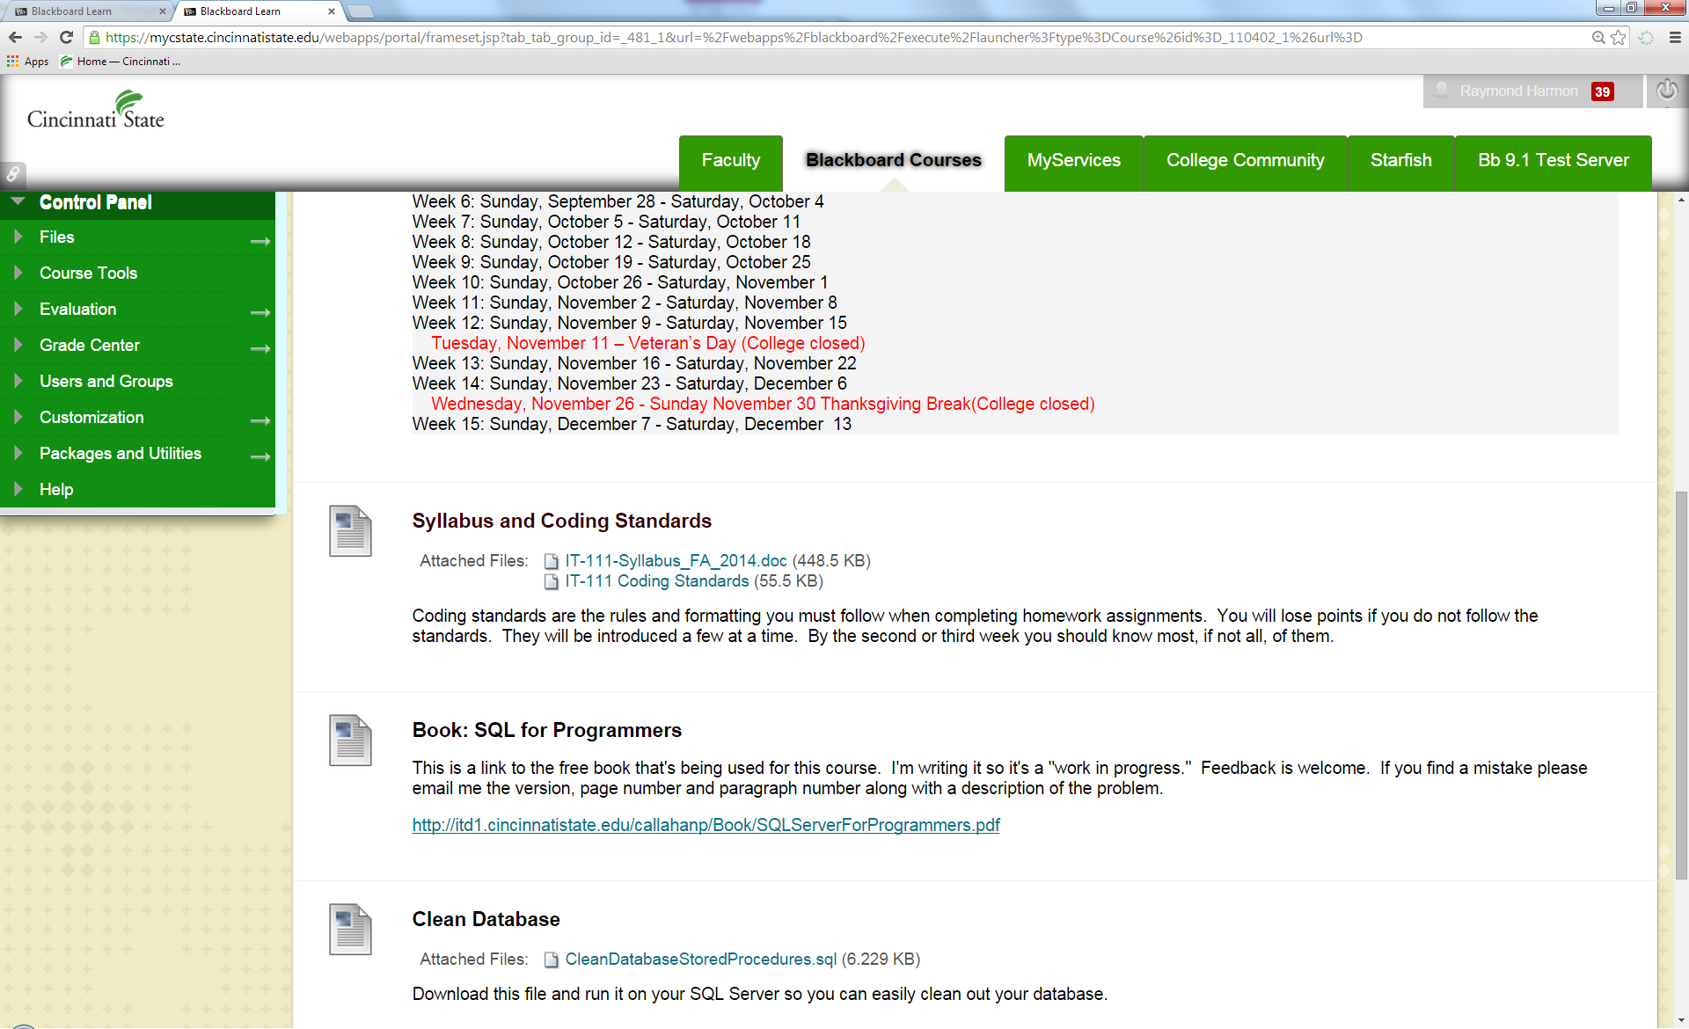

Open SQL server and click the “+” sign next to Databases

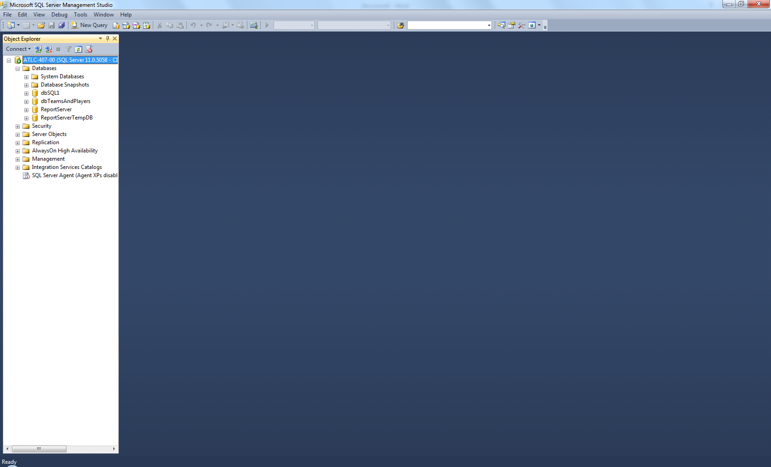

Then click the “+” next to dbSQL1

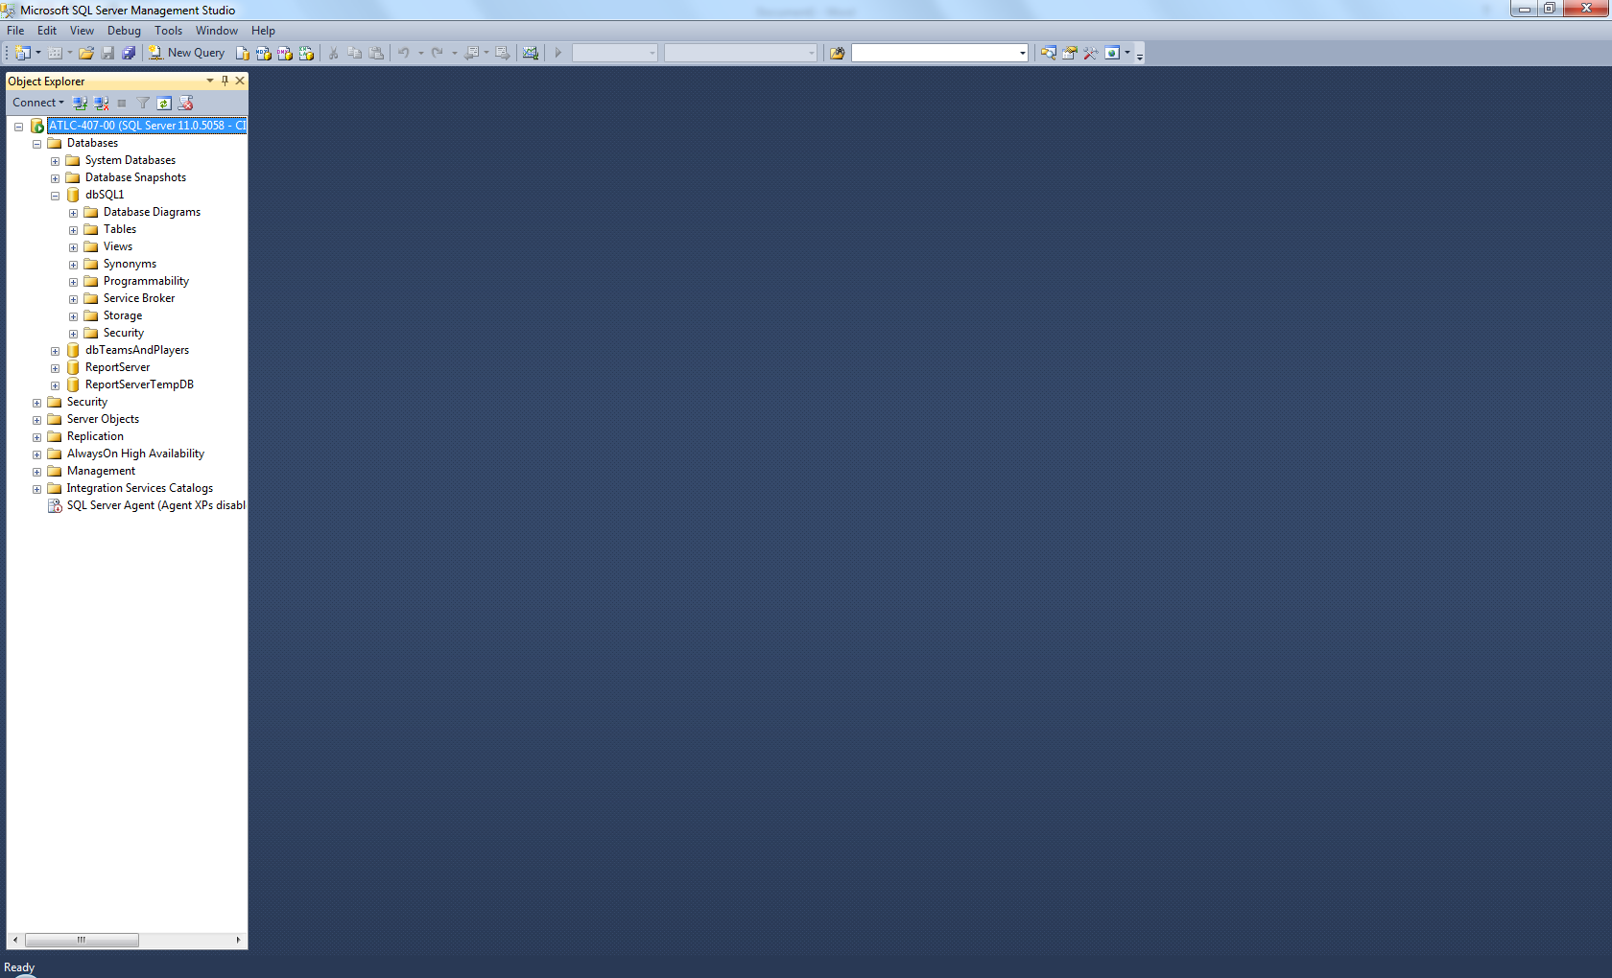

Then click the “+” next to Programmability

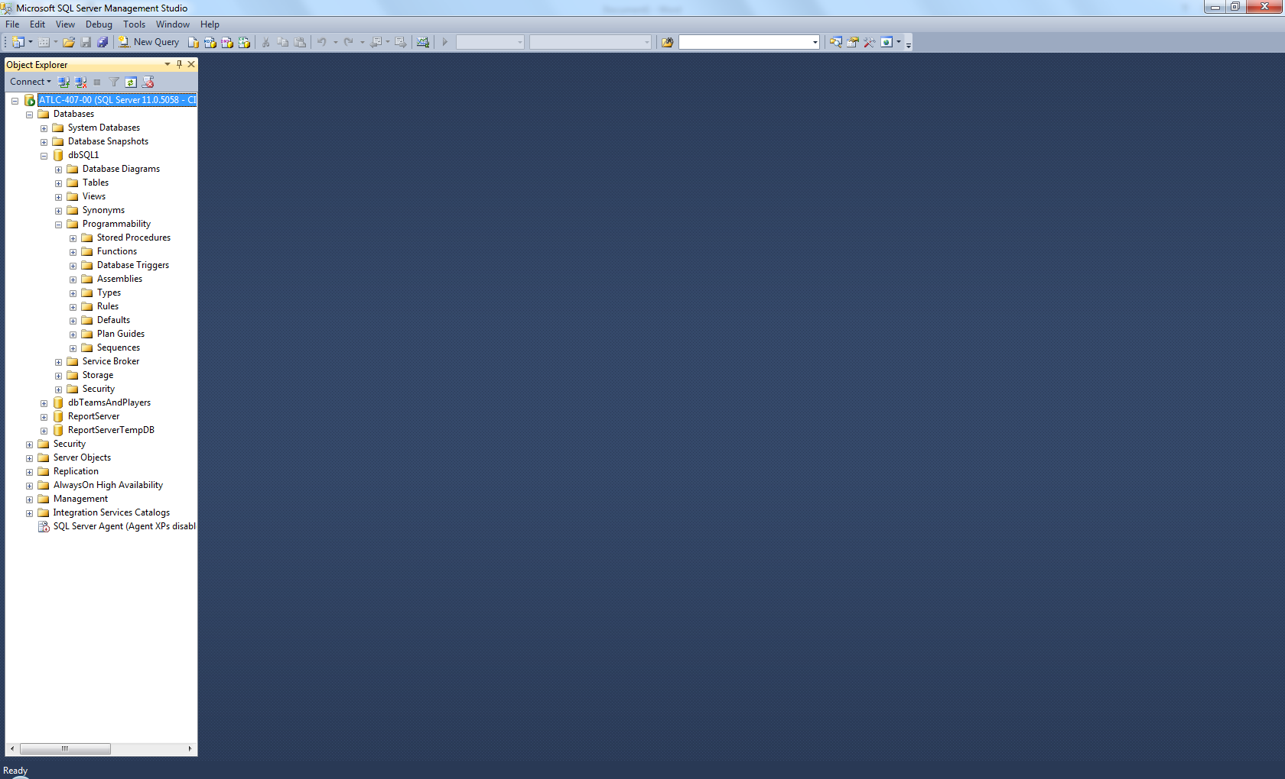

Then click the “+” next to Stored Procedures

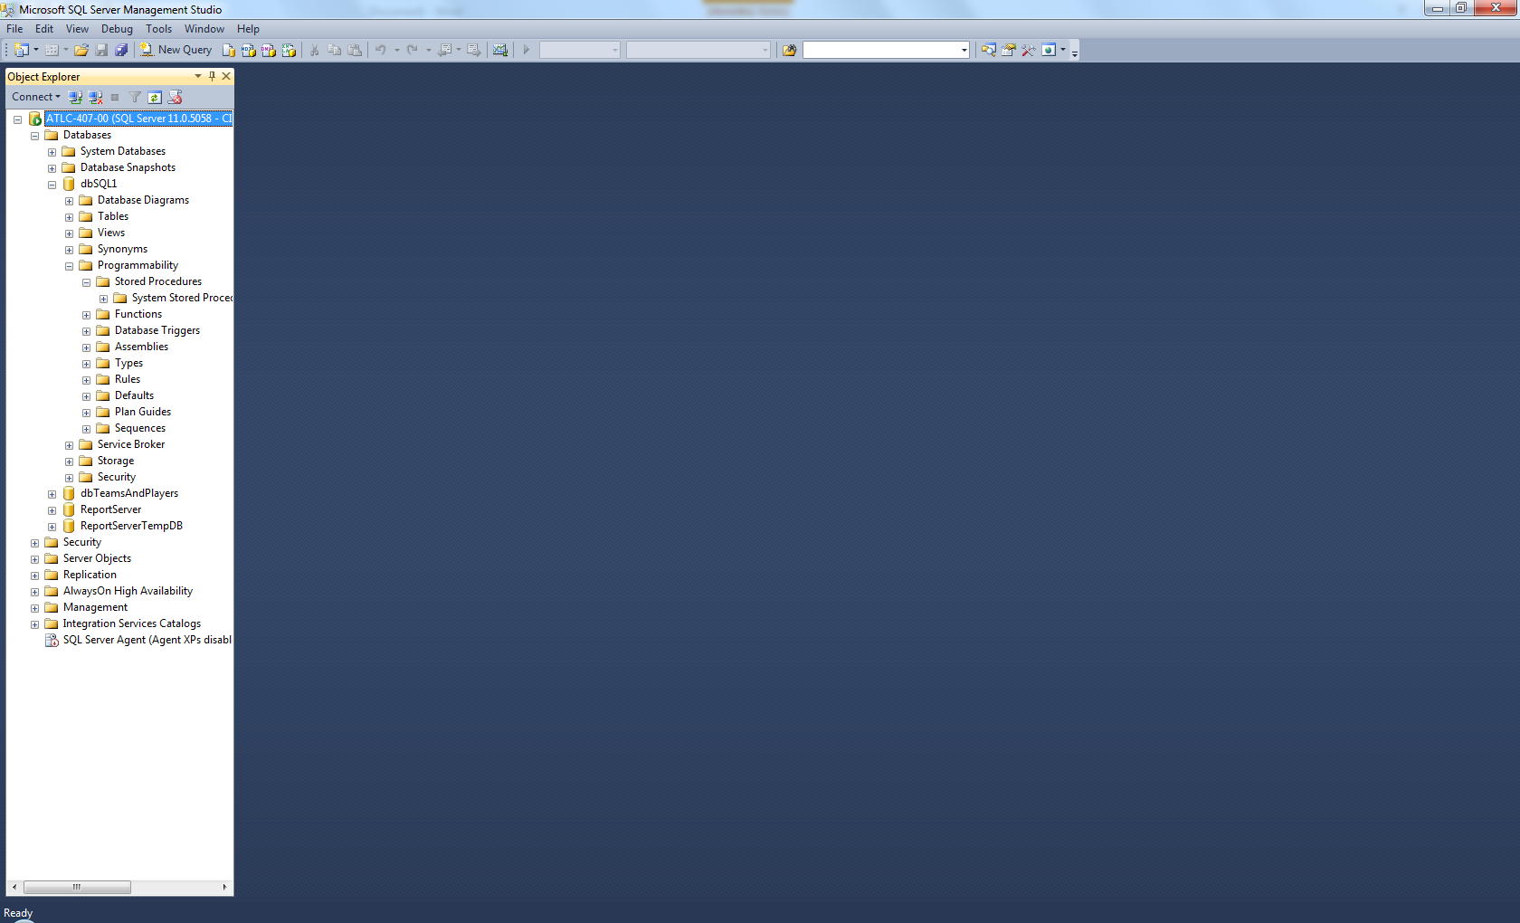

Notice there are no stored procedures listed. Now click File🡪Open🡪File..

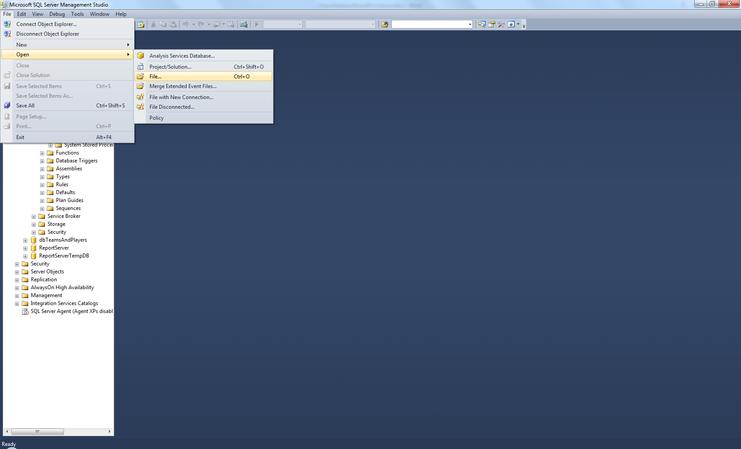

Browse to where you downloaded the file

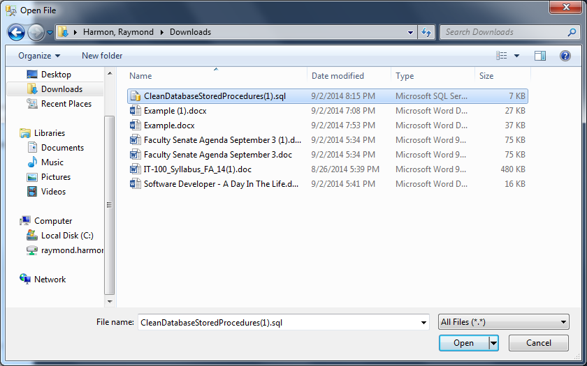

Double click the file or click once and click “Open”. The file opens in SQL Server. Make sure you are in dbSQL1 then click Execute

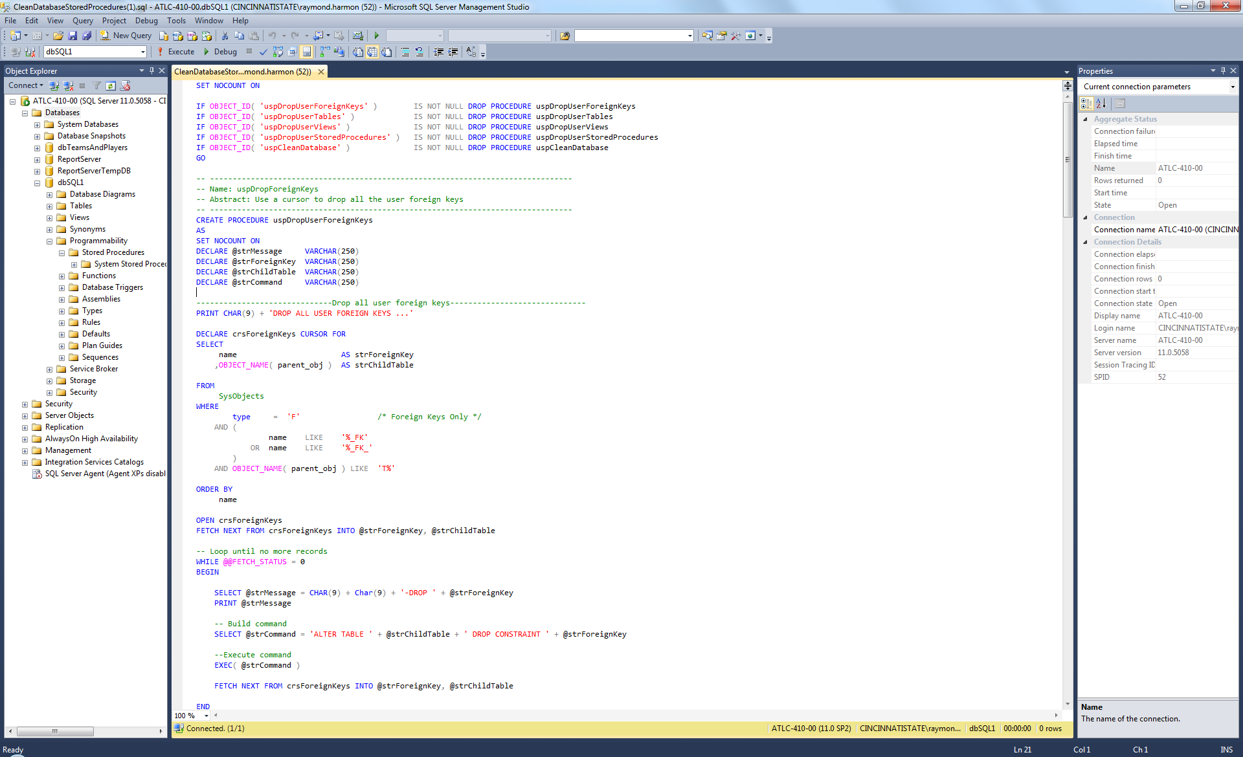

The success message shows up

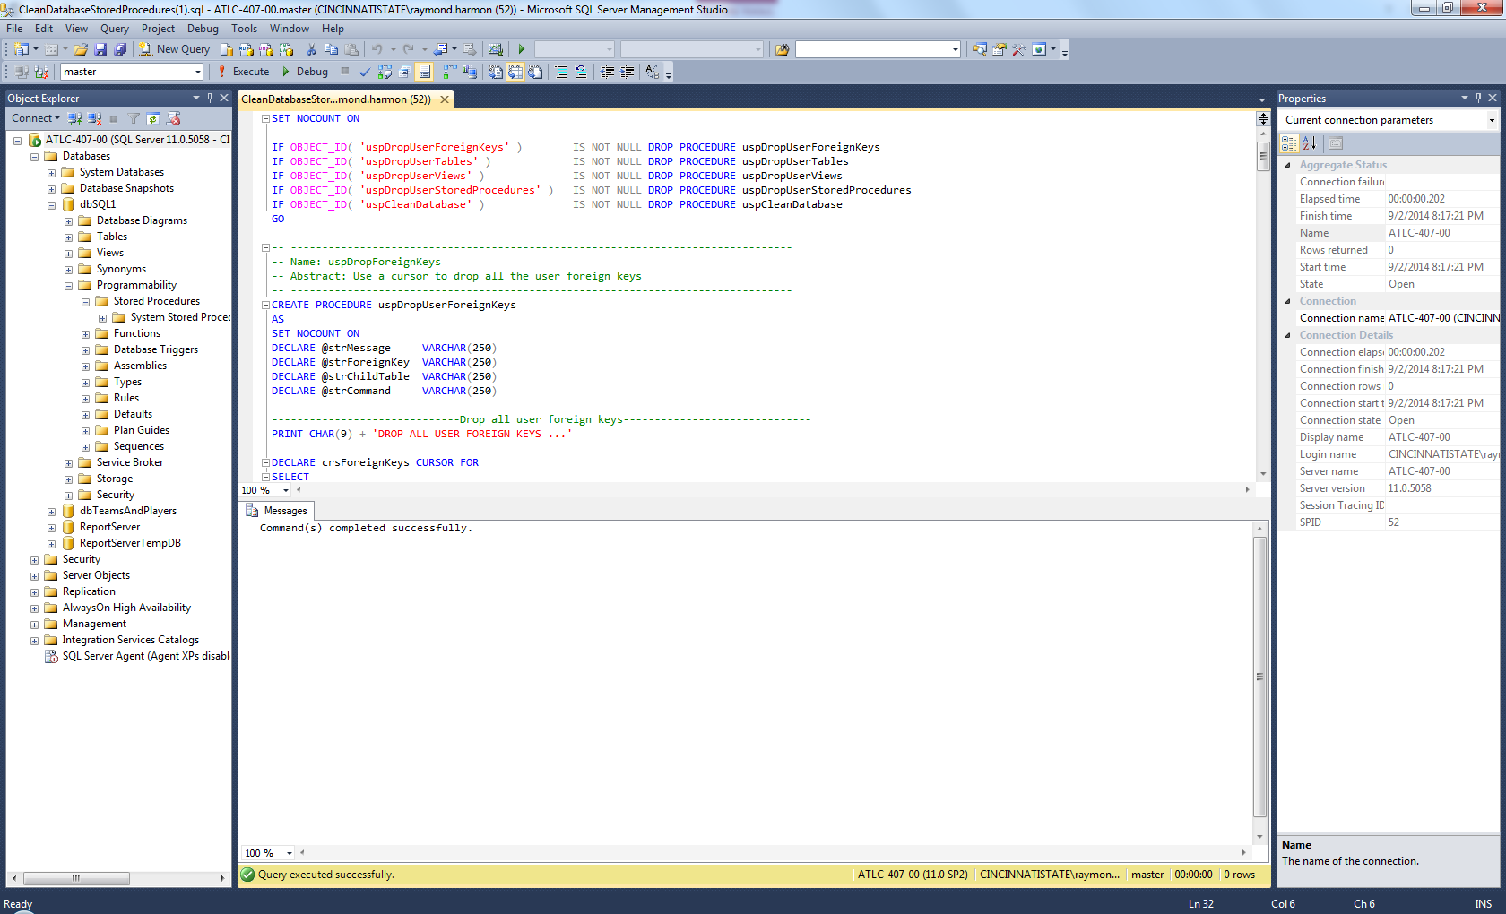

Click on Stored Procedures and then Right Click and click Refresh.

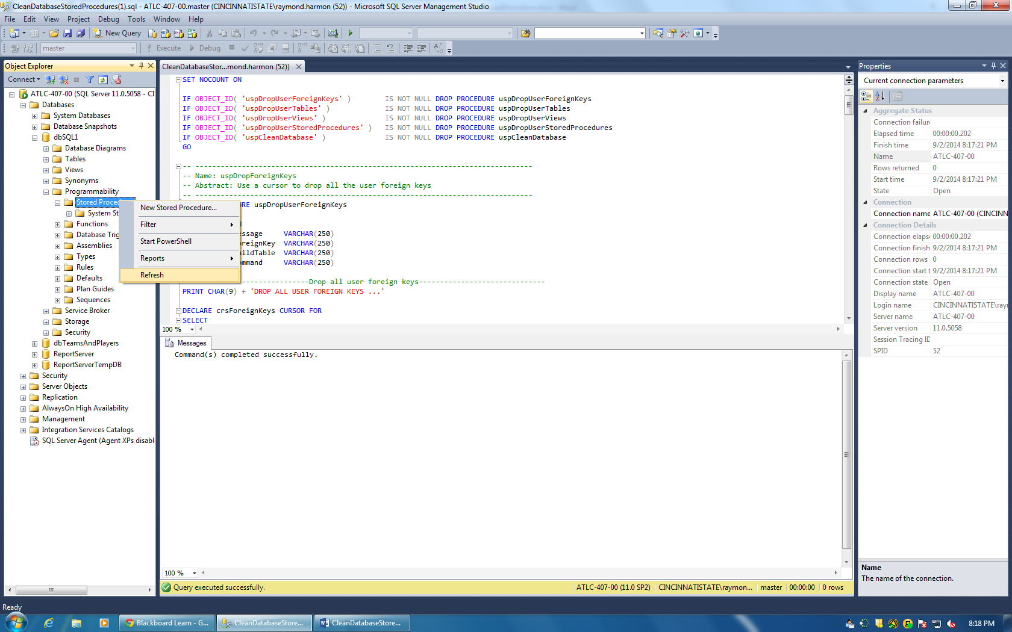

You will now see the stored procedures listed.

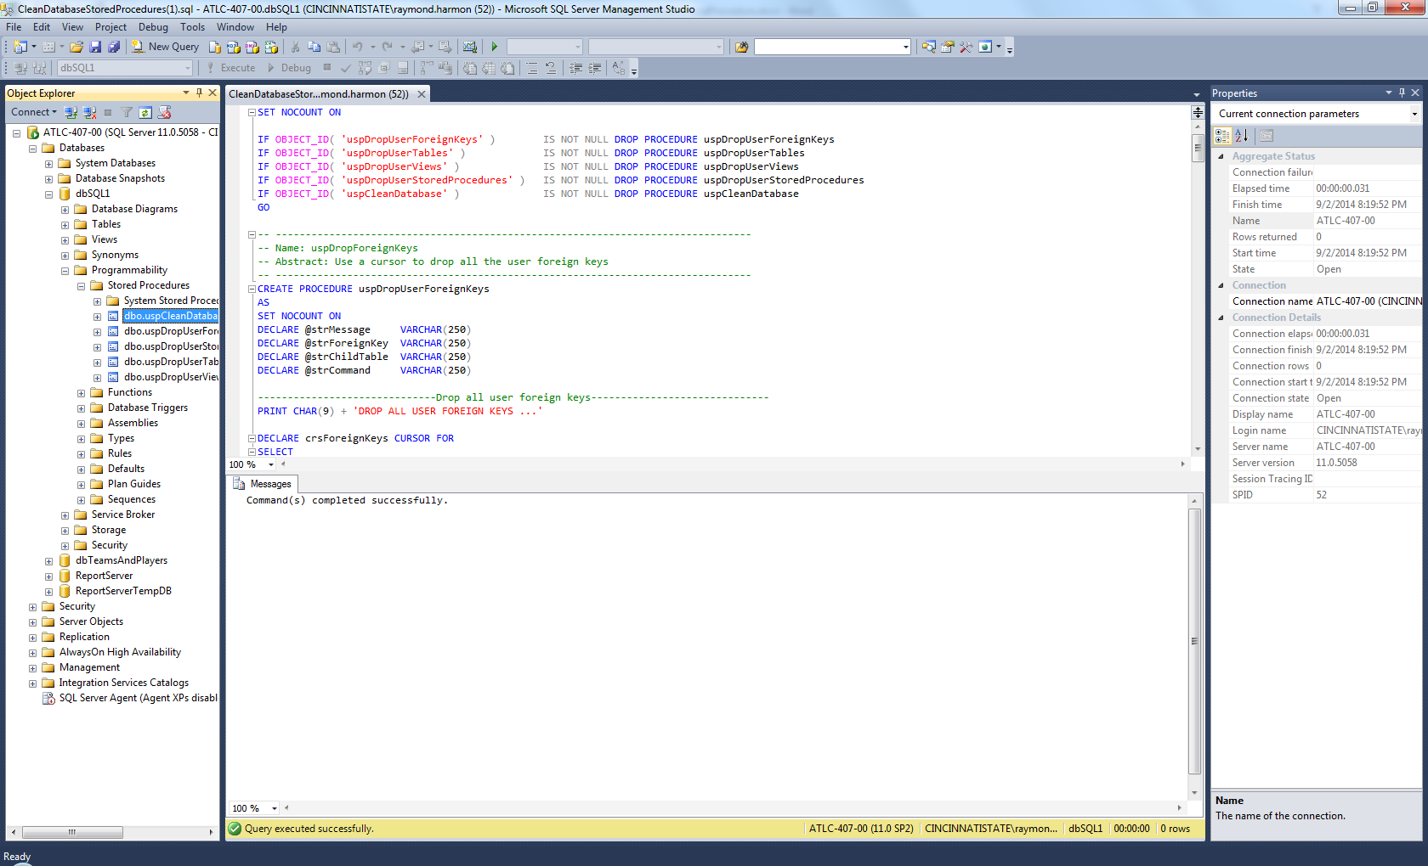

Right Click on the dbo.uspCleanDatabase file and click Execute Stored Procedure

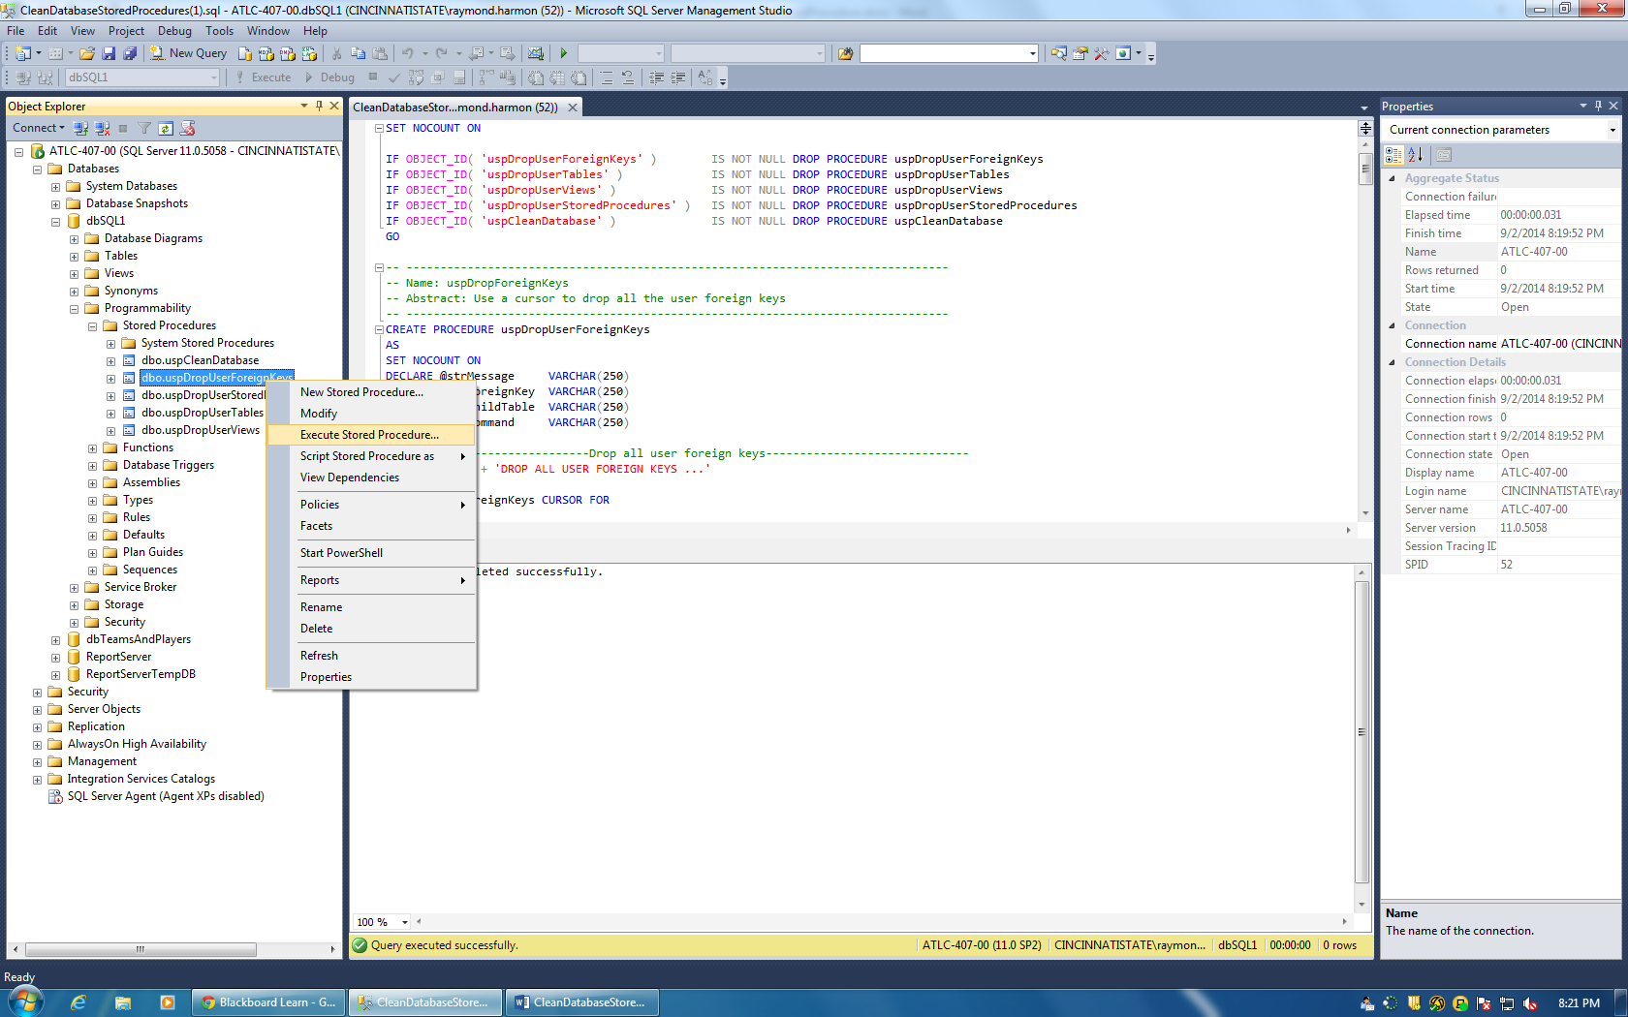

Click Ok

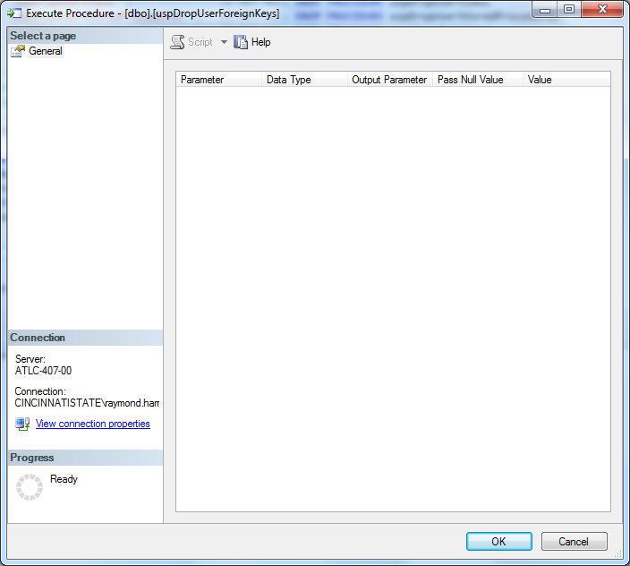

You should then see a Return of 0 and a success message in the bottom window.

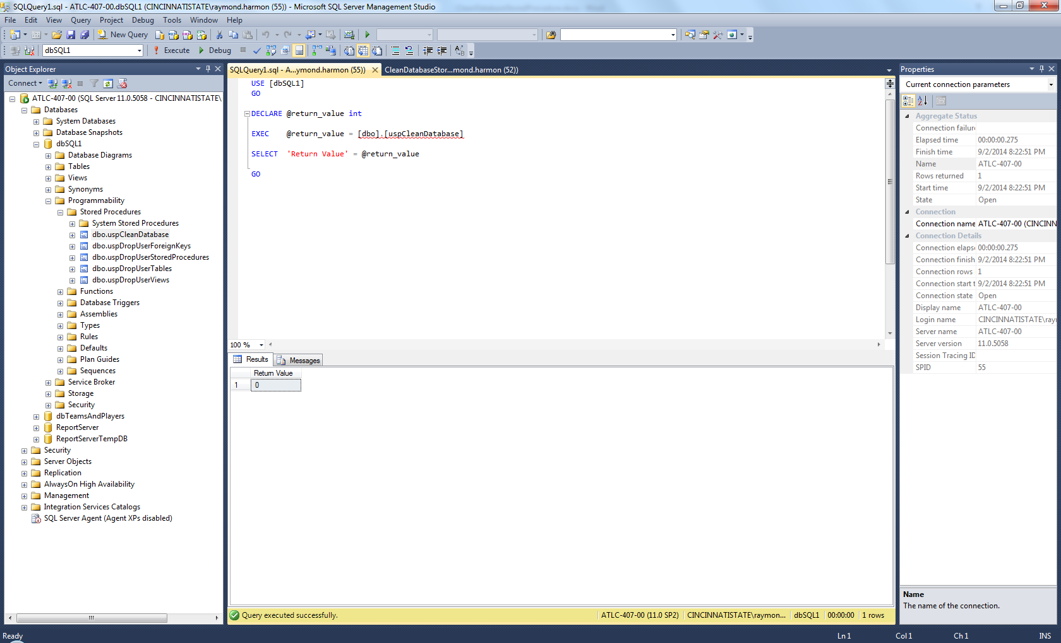

Your database should be clean. You can Right Click on Tables and Refresh to make sure your tables are gone.