Software Requirements Specification

REVISION HISTORY

VERSION | DATE | DESCRIPTION | AUTHOR
1.0 | 22.09.2025 | Initial Version

CONTENTS

1 SW System Overview 4
1.1 Purpose 4
1.2 Scope 4
1.3 Use-Case Diagram 4
1.4 General Constraints 4
1.5 Assumptions and Dependencies 4
1.6 Acronyms and Abbreviations 4
2 SW Functional Requirements 5
2.1 Features / Functions to be Implemented 5
2.1 Acceptance Criteria 5
2.2 Implementation Requirements 5
3 SW Non-Functional Requirements 6
3.1 Resource Consumption 6
3.2 License Issues 6
3.3 Coding Standard 6
3.4 Modular Design 6
3.5 Reliability 6
3.6 Portability 6
3.7 General Operational Guidelines 6
4 SW Design Artifacts 7
4.1 CRC Cards (Class–Responsibility–Collaboration) 7
4.2 Conceptual UML Diagram (entities & relationships) 7

SW System Overview
Specify the purpose and the overview of the SRS.

Purpose
This project simulates the operation of a small photo studio. The system manages orders placed by clients, records customer details, processes photos, tracks material consumption, and generates reports. It supports three main roles: receptionist, photographer, and administrator.

Scope
The system will include: order management, pricing, reporting, consumables tracking.
The system will not handle direct payment processing, employee payroll, or scheduling.
Benefits: The software will increase order processing speed, will lead to less manual errors in pricing and reporting.
Key-features: Digital order tracking, automated pricing, daily report generation

Use-Case Diagram
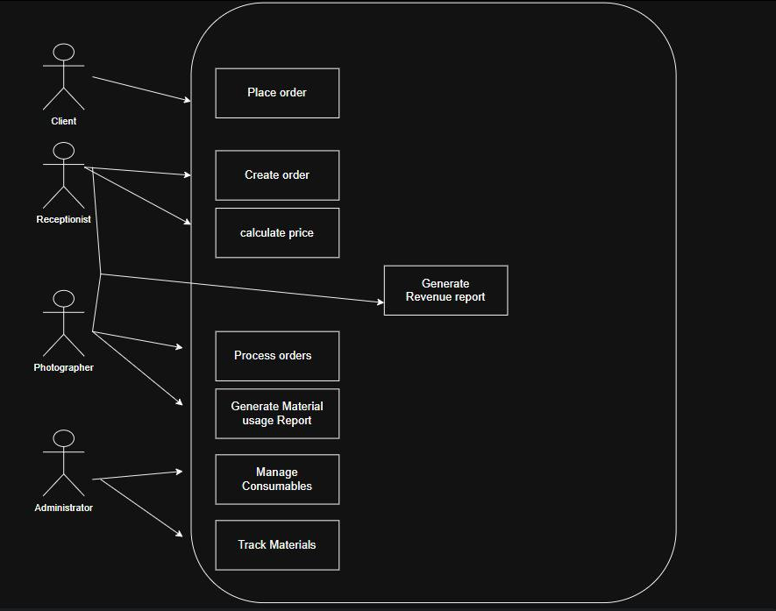

General Constraints

1. Implementation language: C++

2. Platform: Windows/Linux desktop

3. Data storage: file system (text or CSV files)

4. Standards: UML notation for diagrams

5. Performance: each exchange transaction must complete in ≤ 2 seconds
6. User interface: console only (CLI)

Assumptions and Dependencies
- The studio has a stable internet connection and a reliable power source.
- All users (receptionist, photographer, and administrator) have access to a computer running the program.
- The system depends on the local file system being accessible for storing transactions and reports
- No internet connection or external APIs are required.

Acronyms and Abbreviations
List all acronyms and abbreviations used in the document along with their explanations.
Terms Used | Description of terms
cli | Command Line Interface
API | Application Programming Interface
CSV | Comma-separated Values

SW Functional Requirements

2.1 Features / Functions to be Implemented
User stories:
- As a Client, I want to place an order so that I can get my photos printed or film developed.
- As a Receptionist, I want to record client details (surname) and desired completion time when taking an order so that the order is accurately registered.
- As a Receptionist, I want to specify if an order is "express" so that the correct surcharge is applied.
- As a Receptionist, I want to print an order form for the client and for the photographer so that both parties have a physical record.
- As a Receptionist, I want to view active orders so that I can monitor their status and manage client expectations.
- As a Receptionist, I want to mark an order as completed and record payment so that the order lifecycle is correctly updated and revenue is accounted for.
- As a Receptionist, I want to generate a daily report on completed orders and revenue so that I can submit it to management.
- As a Photographer, I want to view my assigned orders so that I know what tasks I need to complete.
- As a Photographer, I want to update the status of an order (e.g., in progress, ready for pickup) so that the receptionist is aware of the progress.
- As a Photographer, I want to report the consumables (paper, developer, etc.) used for my tasks so that stock levels can be accurately tracked.
- As a Studio Administrator, I want to manage consumables stock levels so that I can ensure the studio is always supplied.
- As a Studio Administrator, I want to review reports on consumed materials so that I can make informed purchasing decisions.

Acceptance Criteria
FR1: The system must allow the receptionist to register new client orders.
Validation: Acceptance test – create an order with client surname, order type, urgency, and completion time; verify it is stored correctly.

FR2: The system must calculate prices, applying a 25% surcharge for express orders.
Validation: Test case – register two identical orders (one urgent, one normal); check that urgent price = normal price × 1.25.

FR3: The system must allow the photographer to process orders.
Validation: Test case – after registering an order, pass it to the photographer; system should display “Processing order for [surname].”

FR4: The system must track consumables usage per processed order.
Validation: Test case – process at least one order of each type (photo printing, film developing); system should output consumables used.

FR5: The system must generate a daily report of completed orders and revenue.
Validation: Acceptance test – process multiple orders, run generateRevenueReport(), and verify total revenue equals sum of all order prices.

FR6: The system must generate a daily report of consumed materials.
Validation: Acceptance test – after processing orders, run generateMaterialReport(); verify materials are reported correctly.

Non-Functional Requirements

NFR1: The system should be simple and console-based.
Validation: Quality metric – program runs entirely in the console without GUI.

NFR2: The system should provide readable text output for reports.
Validation: Acceptance test – reports are generated with clear formatting (totals, client names, order types).

NFR3: The system should be modular, with classes representing roles.
Validation: Code inspection – confirm that Receptionist, Photographer, Client, Administrator are implemented separately.

NFR4: The system should allow easy extension (e.g., adding new services).
Validation: Code review – confirm that new order types can be added by extending OrderType enum without modifying core logic.

Implementation Requirements
- The system must be implemented in C++11.
- Standard library (iostream, string, vector) must be used for input/output and data structures.
- The code should follow object-oriented design principles (encapsulation, inheritance, separation of concerns).
- Each class should implement only its assigned responsibilities from the CRC cards.
- Methods should be simple, with clear console output demonstrating system behavior.

SW Non-Functional Requirements

Resource Consumption
- Response time for any operation: ≤ 1 second
- Maximum memory usage: ≤ 100 MB
- Maximum file size for daily logs: ≤ 5 MB

License Issues
- Only standard C++ STL libraries are allowed
- No proprietary third-party libraries are permitted.
- External libraries may only be used if they have permissive open-source licenses (MIT, Apache-
2.0).

Coding Standard
- Each function and class must include descriptive comments.
- Unit tests must cover all critical components (e.g., calculation of exchanged amount).

Modular Design
Modularity:
- The system must be organized into separate classes with clear responsibilities
- Modules should interact through well-defined interfaces
- Business logic must be separated from data storage structures
Extensibility:
- The initial architecture should allow possibilities to extend services in future (adding digital scanning service)
- Enums (like OrderType) should support adding more order types without breaking existing code.
Maintainability:
- The code should be easy to read and follow standard naming conventions, so future developers (or students) can understand responsibilities quickly.
- By keeping classes loosely coupled (e.g., Receptionist doesn’t need to know how the photographer processes orders, only that it does), changes in one module won’t break others.

Reliability
- The system must reject invalid input without crashing.
- File writes must be atomic to avoid corruption.
- Error messages must be logged in a text file for troubleshooting.

Portability
- The system must compile and run on Windows 10+ and Ubuntu Linux.
- Identical inputs must produce identical outputs on both platforms.

General Operational Guidelines
- The system must be robust, easy to maintain, and simple to use.
- Daily reset functionality must be provided to start each workday with a clean state.

SW Design Artifacts

CRC Cards (Class–Responsibility–Collaboration)

Class: Client
Responsibilities | Collaborators
- Provide surname and order details  - Place orders for services | - Receptionist  - Order

Class: Receptionist (inherits Employee)
Responsibilities | Collaborators
- Register new client orders  - Pass orders to the photographer  - Generate revenue report | - Client  - Order  - Photographer  - Report

Class: Photographer (inherits Employee)
Responsibilities | Collaborators
- Process orders  - Track consumables used  - Generate material usage report | - Order  - ConsumableUsage  - Administrator  - Receptionist

Class: Administrator
Responsibilities | Collaborators
- Manage consumable inventory  - Account for materials reported by the photographer | - Photographer  - Consumable  - ConsumableUsage

Class: Consumable
Responsibility | Collaborators
- Represent a consumable material  - Store available quantity | - ConsumableUsage  - Administrator

Class: ConsumableUsage
Responsibility | Collaborators
- Record how much of each consumable was used for a given service/order | - Consumable  - Photographer  - Order

Class: Employee (abstract / parent)
Responsibility | Collaborators
- Represent shared attributes of employees (name, ID)  - Define base responsibilities for staff roles | - Receptionist  - Photograpgher  - Administrator

Class: ExpressOrder (inherits Order)
Responsibility | Collaborators
- Represent urgent orders  - Apply 25% surcharge to base price | - Order  - Receptionist

Class: Order
Responsibility | Collaborators
- Represent a customer’s request  - Stores client’s information  - Contain order status  - Calculate the final price  - Contain a list of order items | - Client  - Receptionist  - Photographer  - OrderItem

Class: OrderItem
Responsibility | Collaborators
- Represent a single service request within an order  - Store service type and cost | - Order  - Service

Class: Report
Responsibility | Collaborators
- Represent reports  - Store report content and allow output/printing | - Receptionist  - Photographer  - Administrator

Class: Service
Responsibility | Collaborators
- Represent a service offered by the studio  - Define base price and consumables required | - OrderItem  - Photographer  - ConsumableUsage

Conceptual UML Diagram (entities & relationships)
