SRS-DLD

S/W Detailed Level Design

Project Name
Block Name
Author |  | Approver
Team

Contents

1. Overview 4
2. System Overview / Architectural Context 5
3. UML Class Diagram (Technical Design) 6
4. Class Specifications 6
5. Interfaces and Abstractions 6
6. Function Responsibilities 6
7. Operation Flow 7
8. Enumerations & Constants 7
9. Validation Rules & Future Work 7
10. Traceability Matrix 7
11. Code Structure and File Mapping 7
12. Revision History 8

- Revision History
Version | Date | Revised contents | Author | Approver
1.0 | 27.10.2025 | Chapters 1-4 | Günther Miklas
1.1 | 27.10.2025 | Chapters 5-11 | Klaus Jesper Zaletajev
1.2 | 24.11 | Chapters 13-16 | Klaus Jesper Zaletajev
- Terms and Abbreviations
Term | Description
UI (User Interface) | The component layer responsible for interaction between the user and the system. In this project, implemented through the ConsoleUI class.
CSV (Comma-Separated Values) | A simple text format used to store tabular data such as reserves, rates, and people in the DataStore class.
ID (Identifier) | A unique integer assigned to entities like employees, clients, and receipts to distinguish records across files and sessions.
ExchangeOffice | The core business logic class managing currency exchanges, reserves, profits, and reports.
Reserve | Represents the balance of currencies available for exchange, enforcing nonnegative constraints.
RateTable | Data structure maintaining conversion rates between currencies, including base-currency fallbacks.
Receipt | A transaction record issued after an exchange, containing details such as client, cashier, source amount, payouts, and profit.
DailyReport | The end-of-day summary generated by a manager, containing reserves, thresholds, transactions, and total profit.
Commission | The fee percentage applied to each transaction, representing the system’s profit margin (e.g., 3% in this implementation).
Critical Minimum | The minimum balance level for each currency reserve, below which a warning is triggered to prevent liquidity issues.

- References
- SW Requirements Specification

Overview

This document describes a terminal-based Currency Exchange Management System. The system supports day-to-day exchange operations (cashier-handled client transactions), management controls (rates, reserves, end-of-day reporting), and simple file-based persistence (CSV/log/text reports).
Scope and objectives
- Execute currency exchanges with commission.
- Maintain reserve balances per currency with critical thresholds.
- Manage exchange rates.
- Produce end-of-day reports and append transaction logs.
- Persist rates, reserves, people, thresholds, and reports to files.
Context
- Runs as a console application (main.cpp) invoking ConsoleUI.
- No network/database; uses filesystem (CSV/log/text) for persistence.
- Business logic encapsulated in ExchangeOffice.
- Errors are signaled via domain exceptions
Stakeholders & Roles
- Client: Requests currency exchange.
- Cashier: Executes client exchanges and prints receipts.
- Manager: Adjusts rates/thresholds, inspects reserves, generates reports, resets daily cycle.
- Operations: Reads logs/reports, audits data.
- System: Filesystem for persistence; terminal for interaction.

System Overview / Architectural Context

Design
- Clear separation of concerns:
  - UI Layer: Console I/O, input validation and flows.
  - Domain/Logic Layer: Currencies, requests, exchange rules, receipts, reporting.
  - Persistence Layer: File I/O for rates/reserves/people/thresholds/transactions/reports.
Layers:
Presentation Layer
- ConsoleUI (menu flows for Cashier/Manager)
Logic Layer
- ExchangeOffice, RateTable, Reserve, Receipt, DailyReport, BonusPolicy/PercentageBonusPolicy, domain models (ExchangeRequest, ExchangePortion, PayoutDetail)
Data Layer
- DataStorage (+ PersonEntry) for CSV/log/text files

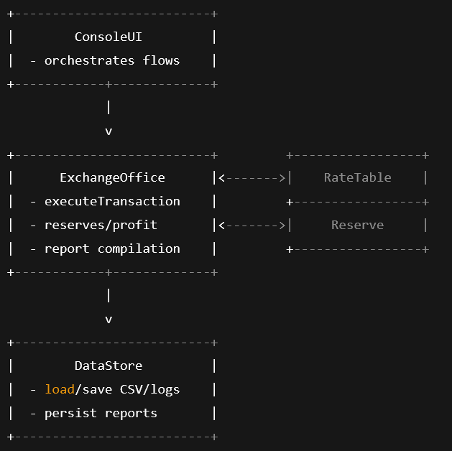

UML Class Diagram (Technical Design)

Fully visible here: https://online.visual-paradigm.com/share.jsp?id=343332323535372d31#diagram:workspace=gssyroho&proj=0&id=1
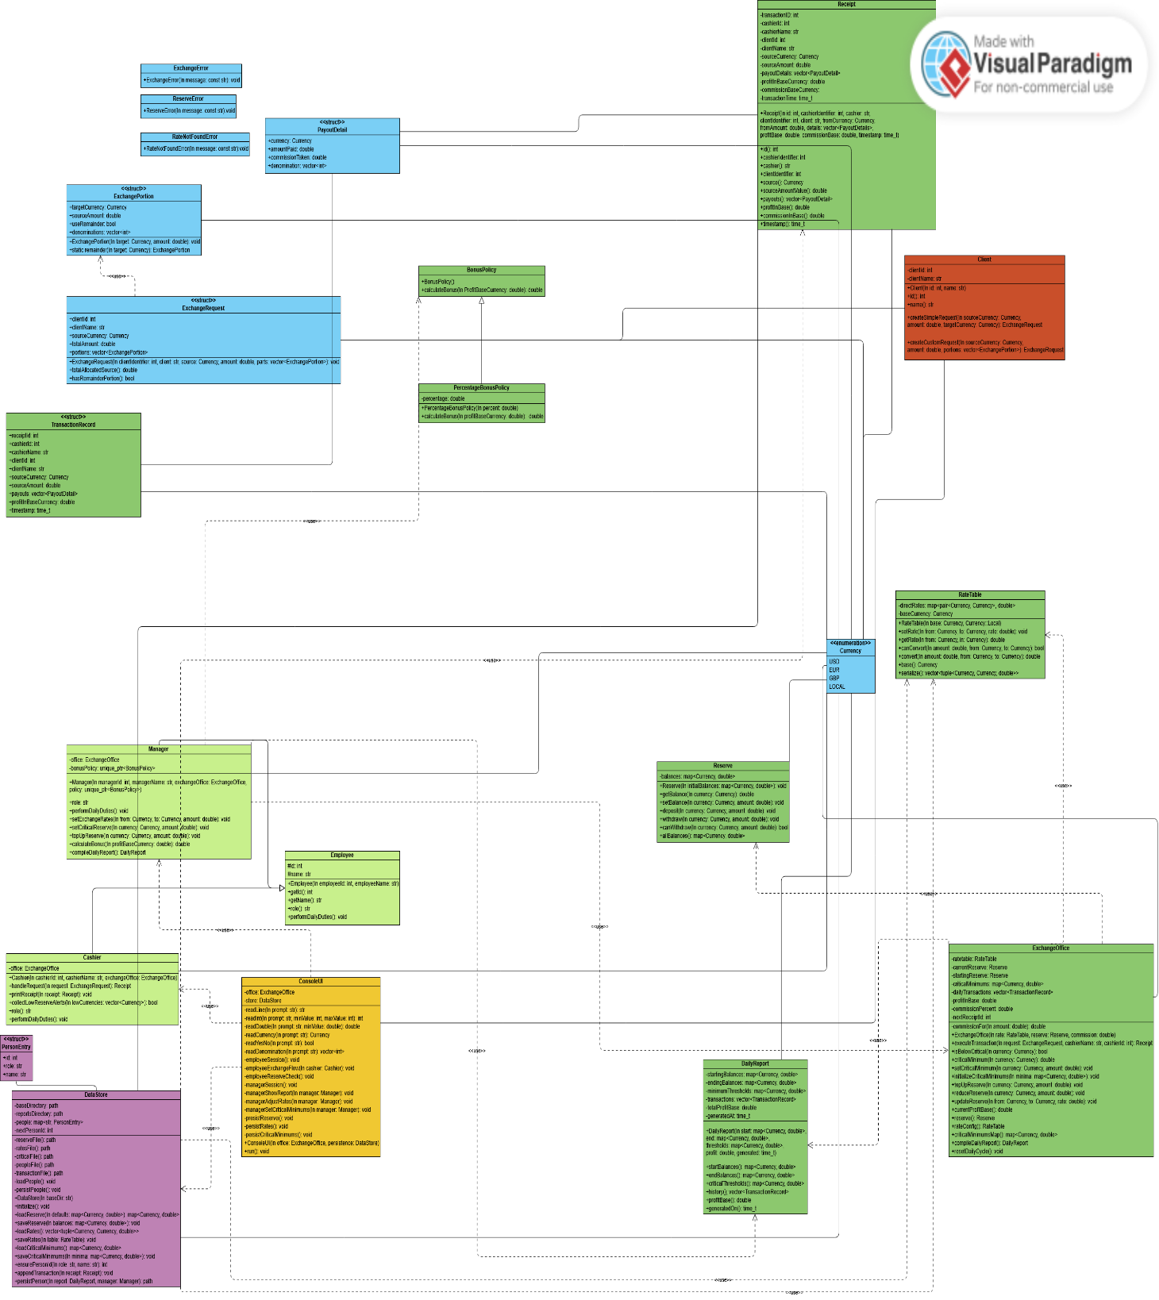

Class Specifications

Core Utilities (utils.*)
Class | Type | Description | Attributes | Methods
Currency | Enum class | Supported currency codes. | USD, EUR, GBP, LOCAL | ---
to_string(Currency) | function | Stringify currency enum. | --- | std::string to_string(Currency)
currency_from_string | function | Parse currency symbol (case-insensitive). | --- | Currency currency_from_string(const std::string&)
ExchangePortion | struct | Portion of a request allocated to a target currency. | Currency targetCurrency; double sourceAmount; bool useRemainder; std::vector<int> denominations; | ExchangePortion(Currency,double),  static ExchangePortion remainder(Currency)
ExchangeRequest | struct | A client’s exchange intent. | int clientId; std::string clientName; Currency sourceCurrency; double totalAmount; std::vector<ExchangePortion> portions; | ExchangeRequest(int,std::string,Currency,double,std::vector<ExchangePortion>),  double totalAllocatedSource() const, bool hasRemainderPortion() const

Exchange Management (exchange_manager.*)
Class | Type | Description | Attributes | Methods
Reserve | class | Tracks per-currency reserves with safety checks. | std::map<Currency,double> balances | Reserve(), explicit Reserve(map), double getBalance(Currency) const, void setBalance(Currency,double), void deposit(Currency,double), void withdraw(Currency,double), bool canWithdraw(Currency,double) const, const map& allBalances() const
RateTable | class | Manages direct rates and conversion via base currency. | map<pair<Currency,Currency>,double> directRates; Currency baseCurrency; | explicit RateTable(Currency base=LOCAL), void setRate(Currency, Currency, double), double getRate(Currency,Currency) const, bool canConvert(Currency,Currency) const, double convert(double, Currency, Currency) const, Currency base() const, vector<tuple<Currency,Currency,double>> serialize() const
TransactionRecord | struct | Immutable snapshot stored in report history. | int receiptId,cashierId,clientId; std::string cashierName,clientName; Currency sourceCurrency; double sourceAmount; vector<PayoutDetail> payouts; double profitInBaseCurrency; time_t timestamp; | ---
Receipt | class | Client-visible result of a transaction. | IDs, names, Currency sourceCurrency; double sourceAmount; vector<PayoutDetail> payoutDetails; double profitBaseCurrency; double commissionBaseCurrency; time_t transactionTime; | Ctor with all fields; accessors: id(), cashierIdentifier(), cashier(), clientIdentifier(), client(), source(), sourceAmountValue(), payouts(), profitInBase(), commissionInBase(), timestamp()
DailyReport | class | End-of-day summary (balances, thresholds, transactions, profit). | map start,end,thresholds; vector<TransactionRecord> transactions; double totalProfitBase; time_t generatedAt; | Ctor; accessors: startBalances(), endBalances(), criticalThresholds(), history(), profitInBase(), generatedOn()
BonusPolicy | interface | Strategy for computing bonuses. | --- | virtual double calculateBonus(double) const = 0
PercentageBonusPolicy | class | Percentage-based bonus strategy. | double percentage; | explicit PercentageBonusPolicy(double), double calculateBonus(double) const

Employees & Client (employee.*, client.*)
Class | Type | Description | Attributes | Methods
Employee | abstract class | Base type for system users with duties. | int id; std::string name; | Employee(int,std::string), virtual ~Employee(), int getId() const, const std::string& getName() const, virtual std::string role() const = 0, virtual void performDailyDuties() = 0
Cashier | class | Executes exchanges and prints receipts; monitors critical reserves. | ExchangeOffice& office (+ inherited) | Cashier(int,std::string,ExchangeOffice&), Receipt handleRequest(const ExchangeRequest&), void printReceipt(const Receipt&) const, bool collectLowReserveAlerts(std::vector<Currency>&) const, overrides: role(), performDailyDuties()
Manager | class | Manages configuration, generates reports, computes bonuses. | ExchangeOffice& office; std::unique_ptr<BonusPolicy> bonusPolicy; | Manager(int,std::string,ExchangeOffice&, std::unique_ptr<BonusPolicy>=std::make_unique<PercentageBonusPolicy>(0.05)), overrides: role(), performDailyDuties(), mgmt ops: setExchangeRate, setCriticalReserve, topUpReserve, double calculateBonus(double) const, DailyReport compileDailyReport() const
Client | class | Represents a customer initiating exchange. | int clientId; std::string clientName; | Client(int,std::string), int id() const, const std::string& name() const, ExchangeRequest createSimpleRequest(Currency,double,Currency) const, ExchangeRequest createCustomRequest(Currency,double,std::vector<ExchangePortion>) const
Persistence and UI (persistence.*, console_ui.*, main.cpp)
Class | Type | Description | Attributes | Methods
PersonEntry | struct | Stored identity for people. | int id; std::string role; std::string name; | ---
DataStore | class | File-backed repositories for reserves, rates, people, thresholds, transactions, and reports directory. | Paths: baseDirectory, reportsDirectory; map<std::string,PersonEntry> people; int nextPersonId; | explicit DataStore(const std::string& baseDir="data"), void initialize(), Reserves: map loadReserve(const map& defaults) const, void saveReserve(const map&) const; Rates: vector<tuple<Currency,Currency,double>> loadRates() const, void saveRates(const RateTable&) const; Criticals: map loadCriticalMinimums() const, void saveCriticalMinimums(const map&) const; People: int ensurePersonId(const std::string& role, const std::string& name); Audit: void appendTransaction(const Receipt&) const, std::filesystem::path persistReport(const DailyReport&, const Manager&) const
ConsoleUI | class | CLI workflows for employees and managers; input validation and persistence hooks. | ExchangeOffice& office; DataStore& store; | ConsoleUI(ExchangeOffice&, DataStore&), void run(), (private helpers) readLine, readInt, readDouble, readCurrency, readYesNo, readDenominations; flows: employeeSession, employeeExchangeFlow(Cashier&), employeeReserveCheck() const, managerSession, managerShowReport(Manager&), managerAdjustRates(Manager&), managerSetCriticalReserve(Manager&); persistence: persistReserve() const, persistRates() const, persistCriticalMinimums() const
main.cpp | program | Entry point: validates args, boots DataStore, seeds defaults, wires objects, runs UI, persists on exit.

5. Interfaces and Abstractions

Interface | Purpose | Key Methods | Planned For (Release)
BonusPolicy | Enable polymorphic bonus calculation strategies. | calculateBonus(double profitBaseCurrency) double | 2
Employee | Provide polymorphic behavior for all personnel types. | (employee)::performDailyDuties | 2
IRepository | Abstract data access for persistence later. | get(id)->T; save(T)->void; list()->vector | 3
IReportable | Uniform report generation. | generate() -> Report | 3

6. Function Responsibilities

Class | Method | Purpose | Input | Output | Notes
ExchangeOffice | executeTransaction | Coordinate complete exchange transaction with multi-currency payout. | From currency, to currency, currency ammount | Receipt | Validates allocations, processes each portion, applies commission, updates reserves
ExchangeOffice | compileDailyReport | Generates end-of-day report | Stats | DailyReport | Aggregates all daily data into DTO
ExchangeOffice | resetDailyCycle | Clear daily transactions | none | void | Snapshots current reserves as new starting balances
RateTable | setRate | Store exchange rate | Curreny ID, Currency rate | void | Validates rate > 0.
RateTable | getRate | Gets the rate | rate of the desired currency | Rate | Returns direct rate or RateNotFoundError
RateTable | convert | Perform currency converts | Currency ID from, Currency ID To | void | Uses direct rate if available
Reserve | getBalance | Gets the balance of a user | User ID | Balance
Reserve | deposit | Add currency to reserve | Currency Id, Ammount of currency | void
Reserve | witdhdraw | Remove currency from reserve | Currency ID, Ammount of currency | void
ConsoleUI | run | Main application loop with menu navigation |  |  | Displays main menu, handles employee/manager login
ConsoleUI | managerShowReport | Generates and displays dailiy report | Manager ID | Dailiy report

7. Operation Flow
Step 1 – User interaction
The user (cashier) starts the process by:
- Logging in with employee name
- Selecting "Perform exchange" from menu
- Entering client name
- Entering source currency (USD, EUR, GBP, or LOCAL)
- Entering total amount to exchange
- Choosing simple or split payout
It performs basic syntactic validation (non-empty, valid format, positive numbers)

Step 2 – Delegation to Logic Layer
ConsoleUI transfers control to:
Cashier::handleRequest(request)
ExchangeOffice::executeTransaction(request, cashierName, cashierId)
This marks the transition from Presentation layer to Logic layer.
Step 3 – Validation and Initialization (Logic Layer)

ExchangeOffice validates:
- Total allocated source ≤ request.totalAmount
- All amounts are positive
- Request has at most one remainder portion

Initializes tracking variables:
- remainingSource = request.totalAmount
- payoutDetails = [] (empty vector)
- profitBase = 0.0

Step 4 – Process Each Portion (Logic Layer)

Determine Source Amount:
- If portion.useRemainder == true: use remainingSource
- Else: use `portion.sourceAmount`
- Skip if amount < epsilon (very small/zero)

Rate Retrieval:
- ExchangeOffice requests rate from RateTable
- rate = rateTable.getRate(sourceCurrency, portion.targetCurrency)

RateProvider logic:
- If from == to: return 1.0
- Check direct rate map: if exists, return rate
- Try indirect via base: convert to base, then to target
- If no path: throw RateNotFoundError

Principle: Polymorphism - RateTable encapsulates conversion logic.

Conversion and Commission:

- convertedAmount = sourceAmount * rate
- commission = convertedAmount * commissionPercent (e.g., 3%)
- payoutAmount = convertedAmount - commission

Reserve Validation:
- Check if sufficient reserve:
- if (!reserve.canWithdraw(targetCurrency, convertedAmount)) throw ReserveError

Principle: Encapsulation - Reserve manages balance validation internally.

Reserve Update:
- reserve.withdraw(targetCurrency, convertedAmount) - Remove full converted amount
- reserve.deposit(targetCurrency, commission) - Return commission portion
- reserve.deposit(sourceCurrency, sourceAmount) - Add received source currency
Profit Tracking:
Convert commission to base currency for centralized accounting:
- commissionInBase = rateTable.convert(commission, targetCurrency, baseCurrency)
- profitBase += commissionInBase

Record Payout Detail:
- PayoutDetail {
currency: targetCurrency,
amountPaid: payoutAmount,
commissionTaken: commission,
denominations: portion.denominations
}
Add to `payoutDetails` vector.

Update Remaining:
- remainingSource -= sourceAmount`

Principle: Single Responsibility - Each step performs one clear task.
Step 5 – Generate Receipt (Logic Layer)
After processing all portions, ExchangeOffice creates immutable Receipt:

- Receipt {
id: nextReceiptId++ (auto-increment)
cashierId, cashierName
clientId, clientName
sourceCurrency, sourceAmount (total used)
payoutDetails (all portions)
profitBaseCurrency (accumulated)
commissionBaseCurrency (total commission)
transactionTime (current timestamp)
}
Record transaction:
- Create TransactionRecord and add to dailyTransactions vector.
Step 6 – Display Result (UI Layer)

ConsoleUI receives Receipt and formats output:
- Receipt #1 for client John Doe (ID 5) handled by Bob Smith (ID 1)
Source: USD amount 1000.00
-> GBP amount: 243.90 (denominations: 50, 20)
-> EUR amount: 368.00 (denominations: 100, 50)
-> LOCAL amount: 291.60 (denominations: 20, 10)
Profit (base): 29.16

Error Handling:
- If exception thrown (RateNotFoundError, ReserveError, ExchangeError):
- Catch at UI layer
- Display user-friendly message
- Transaction aborted (no reserves modified)

Principle: UI handles presentation, Logic handles errors semantically.

Step 7 - Manager Daily Report Flow

Report Request:
- Manager selects "Generate end-of-day report" from menu.

Compile Report (Logic Layer):
- Manager calls compileDailyReport() → ExchangeOffice creates DailyReport with:
- Starting balances (snapshot from cycle start)
- Ending balances (current reserves)
- Critical thresholds
- All transactions from dailyTransactions
- Total profit in base currency
- Current timestamp

Calculate Bonus (Logic Layer):
- Manager calls calculateBonus(report.profitInBase())
- Delegates to bonusPolicy->calculateBonus(profit)
- PercentageBonusPolicy: `return profit * 0.05` (5%)

Display Report, consoleUI formats comprehensive report with:
- Generation timestamp
- Profit summary
- Ending reserves with critical threshold indicators
- Transaction list
- Calculated bonus

8. Enumerations & Constants
enum class Currency | {USD, EUR, GBP, Local} | Supported currencies for exchange operations
Const double commissionPercent | 0.03 | 3 % commission applied to all exchanges
Const double kEpsilon | 1e-8 | Floating-point comparison tolerance
Const double Default bonus rate | 0.05 | 5% bonus from dailiy profit

9. Validation Rules & Future Work

Rule / Planned Feature | Description | Target Release
Denomination preferences (Coins) | Users can ask for coins also | Release 3
Transaction rollback | Managers can initiate rollbacks for transactions | Release 3

10. Traceability Matrix
Requirement (SRS) | Class/ Method (DLD) | Notes
Convert Money between currencies | ExchangeOffice::executeTransaction | Suports direct conversions
Apply commission to exchanges | ExchangeOffice::commissionFor() | Applies a 3% commision
Present result | Cashier::printReceipt()
Reset daily cycle | ExchangeOffice::resetDailyCycle() | Clears transactions
Low-reserve alerts | Cashier::collectLowReserveAlerts() | Checks currencies against thresholds, displays console alerts

11. Code Structure and File Mapping

Class | File
ConsoleUI | Console_ui.h / Console_ui.cpp
Cashier | Employee.h /employee.cpp
Manager | Employee.h/ employee.cpp
Client | Client.h /client.cpp
Receipt | Exchange_manager.h/ Exchange_manager.cpp
DailyReport | Exchange_manager.h/ Exchange_manager.cpp
RateTable | Exchange_manager.h/ Exchange_manager.cpp
DataStore | Persistence.h/ Persistence.cpp
Reserve | Exchange_manager.h/ Exchange_manager.cpp
ProsentageBonusPolicy | Exchange_manager.h/ Exchange_manager.cpp

12. Revision History

Date | Version | Change Summary | Author
28.10.2025 | 1.1 | Release 2 DLD example for Currency Exchange System. | Klaus Jesper Zaletajev

Release 3

13. Validation Rules & Preconditions/Postconditions
Class | Method | Preconditions | Postconditions | Validation Level (UI/Logic/Repository) | Explanation
ConsoleUI | managerAdjustRates | Valid manager session active | Rate updated and persisted | Rate updated and persisted | UI | UI validates currencies differ before delegating
Manager | setExchangeRate | from ≠ to, rate ≥ 0.0001 | Rate stored bidirectionally | Logic | Logic layer enforces rate positivity
RateTable | setRate | rate > 0 | directRates[from,to] and [to,fro}] set | Logic | Throws ExchangeError if rate ≤ 0
ConsoleUI | employeeExchangeFlow | Valid cashier session, valid client data | Receipt generated and persisted | UI | UI validates all inputs before creating request
ExchangeOffice | executeTransaction | Valid request, sufficient reserves | Receipt created, reserves updated, profit tracked | Logic | Checks reserve availability per portion
Reserve | withdraw | amount ≥ 0, balance ≥ amount | balance reduced by amount | Repository | Throws ReserveError if insufficient
Reserve | deposit | amount ≥ 0 | balance increased by amount | Repository | Throws ReserveError if negative
ExchangeRequest | constructor | totalAmount > 0, at most one remainder | Request object created | Logic | Validates allocation doesn't exceed total
RateTable | convert | Rate exists for from→to | Converted amount returned | Logic | Throws RateNotFoundError if rate missing

14. Behavioral Models
Activity Diagram
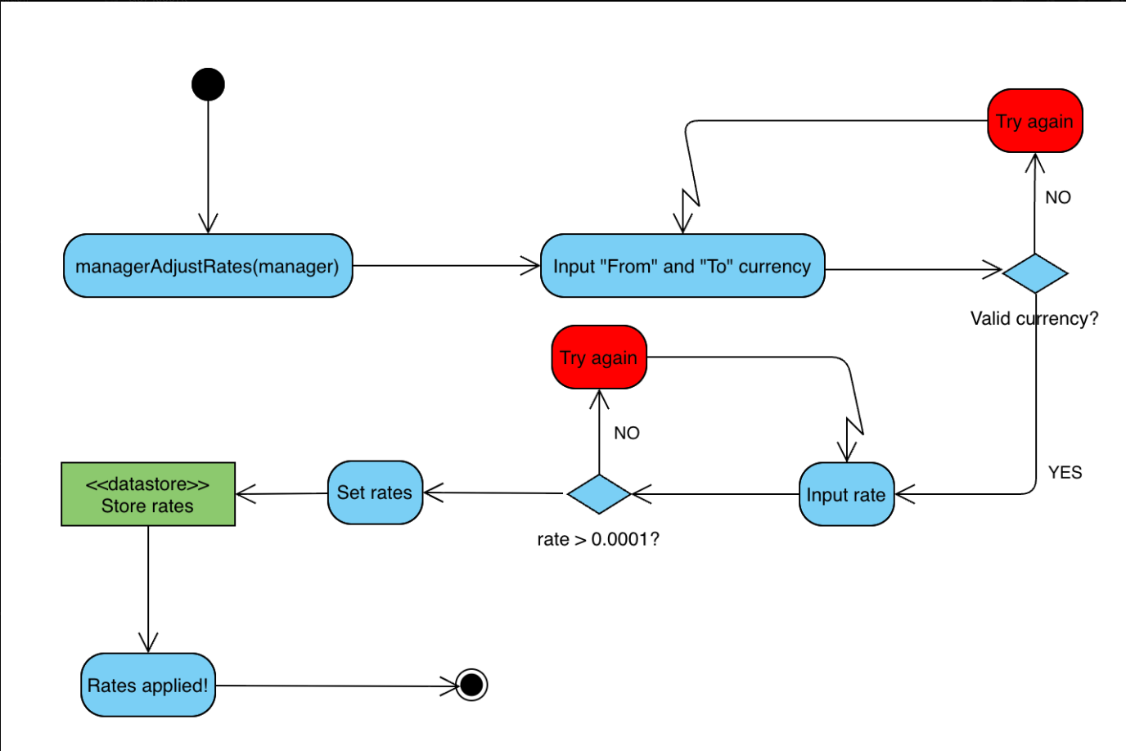
Sequence Diagram
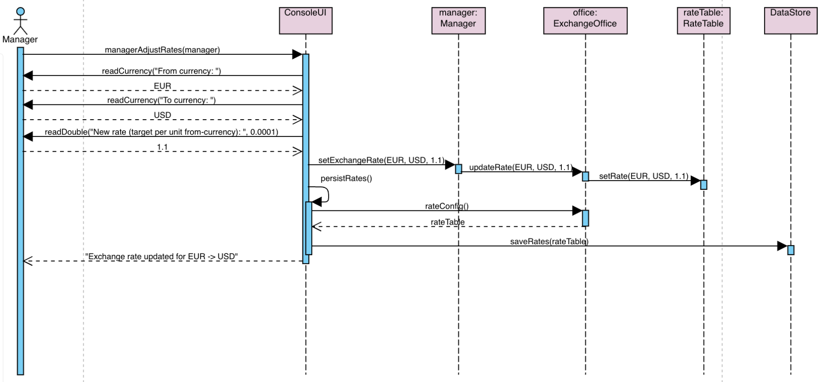
Sequence problem

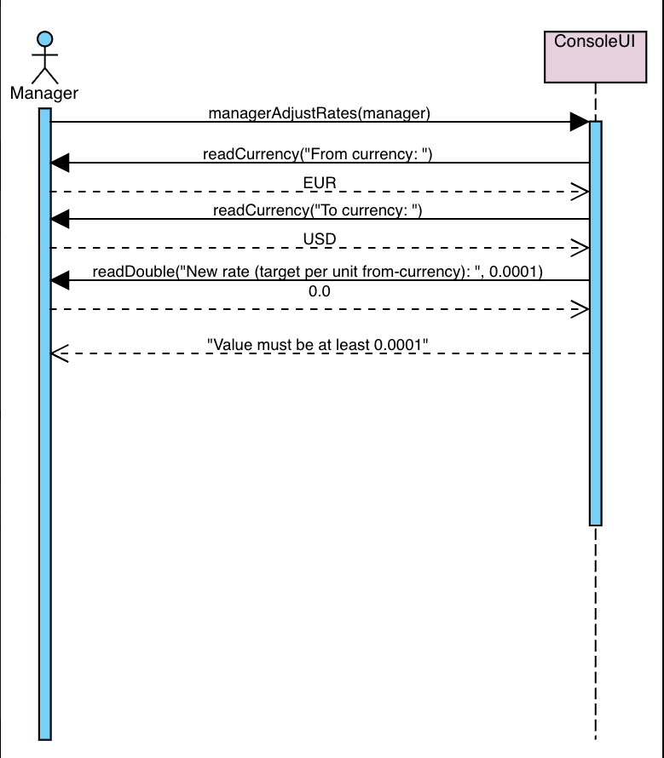

15. Error & Exception Handling Policy

Exception Type | Thrown By (Layer / Class) | Caught At (Layer) | Message / what() | Default Action (message / stop / retry)
ExchangeError | Logic RateTable::setRate | UI | "Exchange rate must be positive" | Display error, return to menu
ExchangeError | UI ConsoleUI::managerAdjustRates | UI | "From and to currencies must be different" | Display error, return to menu
RateNotFoundError | Logic RateTable::getRate | UI | "Rate not configured for conversion from X to Y" | Display error, abort transaction
RateNotFoundError | Logic RateTable::convert | UI | Unable to convert from X to Y | Display error, abort transaction
ExchangeError | Logic ExchangeOffice constructor | UI | "Commission percentage must be between 0 and 1" | Display error, exit program
ExchangeError | Logic ExchangeRequest constructor | UI | Requested exchange amount must be positive | Display error, retry input
ExchangeError | Logic ExchangeOffice::executeTransaction | UI | Requested source allocation exceeds available  amount | Display error, abort transaction
ExchangeError | Logic ExchangeOffice::executeTransaction | UI | Portion exceeds remaining source amount | Display error, abort transaction

16. Revision History

Date | Version | Change Summary | Author
28.10.2025 | 1.1 | Release 2 DLD example for Currency Exchange System. | Klaus Jesper Zaletajev
24.11.2025 | 1.2 | Realese 3 DLD | Klaus Jesper Zaletajev

