SEC-TMP-DLD

S/W Detailed Level Design

Project Name | Railway Ticket Sales System
Block Name | Release 4
Author | Kamil Błasiak | Approver | Anna Kyselova
Team | Group 7

Contents
1. Overview 3
2. System Overview / Architectural Context 4
3. UML Class Diagram (Technical Design) 4
4. Class Specifications 4
5. Interfaces and Abstractions 6
6. Function Responsibilities 6
7. Operation Flow 7
8. Enumerations & Constants 7
9. Validation Rules & Future Work 8
10. Traceability Matrix 8
11. Code Structure and File Mapping 9
12. Validation Rules & Preconditions/Postconditions 9
13. Error & Exception Handling Policy 10

- Revision History
Version | Date | Revised contents | Author | Approver
1.0 | 2025-09-22 | Prepared initial prototype. | Kamil Błasiak | Anna Kyselova
2.0 | 2025-10-27 | Improved structure and divided responsibilities. | Kamil Błasiak | Anna Kyselova
3.0 | 2025-11-25 | Added quality and robustness. | Kamil Błasiak | Anna Kyselova
4.0 | 2025-12-14 | Added persistent storage (loadAll/saveAll) and updated design for railway ticket sales. | Kamil Błasiak | Anna Kyselova
- Terms and Abbreviations
Term | Description
UI | Console user interface layer (ConsoleUI).
Logic | Business rules orchestration (Cashier).
Repository | In-memory ticket storage + file persistence (RailwayConnectionDatabase).
CoachType | Type of coach: SEATER, COMPARTMENT, SLEEPER.
TicketStatus | Ticket state: AVAILABLE, BLOCKED, SOLD.

Overview
All railway tickets and their sale state are stored in a text file and reconstructed into dynamic memory at program start.
- In-memory data (dynamic array of Ticket objects)
- Persistent data (text file: data.txt)
Data transfer model:
- File → loadAll() → RailwayConnectionDatabase
- RailwayConnectionDatabase → saveAll() → File

System Overview / Architectural Context
The system follows a strict layered architecture: UI → Logic → Repository → File. ConsoleUI is responsible only for input/output. Cashier contains validation rules, ticket state transitions (AVAILABLE → BLOCKED → SOLD), and return/refund policy. RailwayConnectionDatabase is the central repository that manages a dynamic array of Ticket objects during execution and synchronises them with a persistent text file at startup/shutdown.

UML Class Diagram (Technical Design)

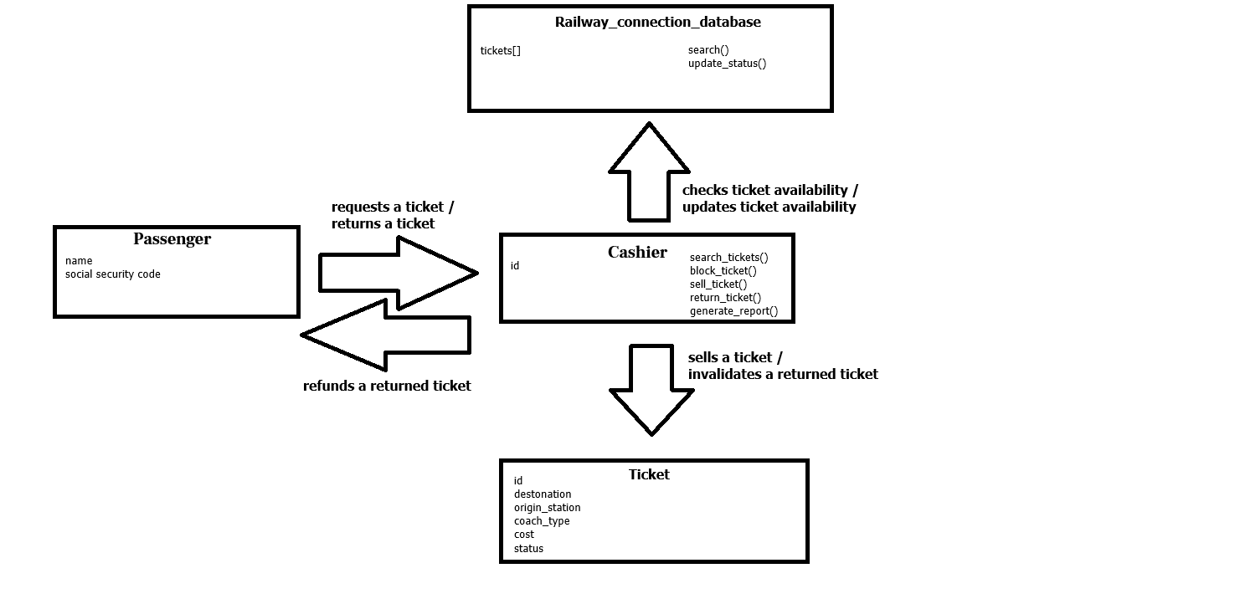

Class Specifications
Class | Type | Description | Attributes | Methods
Ticket | Struct | Represents one ticket offer in the central database. | id:int; originStation:string; destination:string; travelDate:time_t; coachType:CoachType; cost:double; status:TicketStatus; passenger:Passenger | N/A (plain data object)
Passenger | Struct | Minimal passenger passport data provided during purchase. | surname:string; passportNumber:string | N/A (plain data object)
RailwayConnectionDatabase | Class (Repository) | Stores all tickets in a dynamic array and provides search/lookup. Synchronises with data.txt. | data:Ticket*; count:int; capacity:int; filePath:string | ensureCapacity(), addTicket(), size(), getByIndex(), getTicketById(), requireTicketById(), search(), updateTicketStatus(), loadAll(), saveAll(), parseLine(), toLine()
Cashier | Class (Logic) | Implements ticket sales workflow: search, block, sell, return and daily reporting. | db:RailwayConnectionDatabase*; clock:IClock*; soldTickets:vector<int>; returnedTickets:vector<int>; totalSales:double; totalRefunds:double | searchTickets(), blockTicket(), sellTicket(), returnTicket(), generateDailyReport(), computePenaltyRate()
ConsoleUI | Utility (UI) | Handles console output and basic prompts (no business logic). | N/A (stateless) | showTicket(), showMessage(), showError()
IClock | Interface | Abstracts current time for return penalty calculation and report timestamps. | N/A | now(), now_str()
SystemClock | Class | System implementation of IClock. | N/A | now(), now_str()
Employee | Class | Base class containing employee identifier. | id:string | getId()
Repository Behavioral Constraints
- capacity ≥ count
- data always refers to a valid dynamic array or nullptr
- loadAll reconstructs Repository state from the file without terminating execution
- saveAll rewrites the file completely
- parseLine skips invalid lines
- toLine always produces valid output

5. Interfaces and Abstractions
Interface | Purpose | Key Methods | Planned For (Release)
IClock | Time abstraction to decouple logic from system time. | now(), now_str() | R3 (used in R4)

6. Function Responsibilities
Class | Method | Purpose | Input | Output | Notes
RailwayConnectionDatabase | loadAll() | Loads tickets from data.txt into dynamic memory. | data.txt | Repository state updated | Invalid lines skipped; no exception due to file content.
RailwayConnectionDatabase | saveAll() | Writes all in-memory tickets back to data.txt. | Repository state | data.txt rewritten | Full rewrite; stable format via toLine().
RailwayConnectionDatabase | parseLine() | Parses one line into a Ticket object. | string line | Ticket or invalid | Validates field count and conversions.
RailwayConnectionDatabase | toLine() | Formats Ticket into one file line. | Ticket | string line | Fixed precision for cost; 9 fields separated by ';'.
Cashier | blockTicket() | Temporarily reserves a ticket for purchase. | ticketId | status updated | Only AVAILABLE can be blocked.
Cashier | sellTicket() | Finalises purchase, stores passport data, takes payment. | ticketId, Passenger | status updated | Only BLOCKED can be sold.
Cashier | returnTicket() | Returns a sold ticket, computes refund with penalty. | ticketId | status becomes AVAILABLE | Penalty based on days before departure.

7. Operation Flow
Startup Flow
Program begins.
Repository calls loadAll().
File is read line by line.
Each line is processed through parseLine().
Valid objects are added to dynamic memory through add().
Shutdown Flow
Program ends.
Repository calls saveAll().
All objects are transformed into text using toLine().
File is completely rewritten.
This establishes full persistence across program runs.

8. Enumerations & Constants

Name | Value / Type | Description
FILE_FORMAT_FIELDS | 9 (int) | Number of fields in one line of data.txt.
DELIMITER | ';' (char) | Field delimiter for persistence format.
PENALTY_30D | 0.01 (double) | Penalty if returned >= 30 days before departure.
PENALTY_15D | 0.05 (double) | Penalty if returned >= 15 days before departure.
PENALTY_3D | 0.10 (double) | Penalty if returned >= 3 days before departure.
PENALTY_SAME_DAY | 0.30 (double) | Penalty if returned on travel day.

9. Validation Rules & Future Work
Rule | Description | Release
Ticket id must be positive and unique. | Prevents double sales and ensures stable lookup. | R2-R4
Only AVAILABLE tickets are returned in search(). | Client can only buy unsold tickets. | R3-R4
State transitions must follow AVAILABLE→BLOCKED→SOLD. | Prevents illegal operations and double sales. | R3-R4
Return allowed only for SOLD tickets before departure. | Refund is computed by penalty ladder. | R3-R4
File line must contain exactly 9 fields separated by ';'. | Ensures correct reconstruction during loadAll. | R4
Invalid file lines are ignored and do not terminate the program. | Repository resilience against corrupted file input. | R4

10. Traceability Matrix
Requirement (SRS) | Class / Method (DLD)
Search availability by destination (SRS). | Cashier::searchTickets(), RailwayConnectionDatabase::search()
Temporarily block a ticket during purchase (SRS). | Cashier::blockTicket(), TicketStatus::BLOCKED
Store passport data and prevent double sales (SRS). | Cashier::sellTicket(), RailwayConnectionDatabase (unique id + SOLD state)
Ticket return with time-based penalty (SRS). | Cashier::returnTicket(), Cashier::computePenaltyRate(), IClock::now()
Persist central database between runs (R4 requirement). | RailwayConnectionDatabase::loadAll(), saveAll(), parseLine(), toLine()

11. Code Structure and File Mapping
Component | File
Entry point / UI menu | main.cpp
Console UI helper | ConsoleUI.hpp, ConsoleUI.cpp
Domain entities + enums | Types.hpp
Logic layer (sales workflow) | Cashier.hpp, Cashier.cpp
Repository + persistence | RailwayConnectionDatabase.hpp, RailwayConnectionDatabase.cpp
Clock abstraction | IClock.hpp, SystemClock.hpp
Exceptions | exceptions.hpp

12. Validation Rules & Preconditions/Postconditions

Class | Method | Preconditions | Postconditions | Validation Level (UI/Logic/Repository) | Explanation
RailwayConnectionDatabase | loadAll | Repository initialised; file may or may not exist. | Repository contains one object per valid line; invalid lines ignored; capacity>=count. | Repository | Skips malformed lines; starts empty if file missing.
RailwayConnectionDatabase | saveAll | Repository initialised; all tickets in memory are valid. | data.txt fully rewritten; one line per ticket in stable format. | Repository | Throws DataSourceException only if file cannot be opened for writing.
Cashier | sellTicket | Ticket exists and is BLOCKED; passport data provided. | Ticket becomes SOLD; passenger data stored. | Logic | Prevents selling AVAILABLE/SOLD tickets.
Cashier | returnTicket | Ticket exists and is SOLD; current time < travelDate. | Ticket becomes AVAILABLE; refund computed by penalty ladder; passenger cleared. | Logic | Penalty ladder: 1%/5%/10%/30% depending on days before departure.

13. Error & Exception Handling Policy
Exception Type | Thrown By | Caught At | Message | Default Action
InvalidInputException | UI/Logic | UI | Readable validation message | Show error and continue.
TicketNotFoundException | Repository | UI | Ticket with id X not found. | Show error and continue.
InvalidOperationException | Logic/Repository | UI | Operation not allowed in current state. | Show error and continue.
DataSourceException | Repository | UI | Cannot open data file for writing. | Show error; exit without saving.
NoExceptionDuringLoadAll (design rule) | Repository | N/A | None | Malformed file lines are skipped silently.

