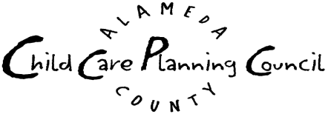CEL Collaborative
of the Alameda County Child Care Planning Council
Wednesday, September 20, 2006 9:30 a.m. – 11:30 a.m.
BANANAS, Inc. 5232 Claremont Avenue, Oakland, CA 94618

A G E N D A

- Introductions/Check-In/Announcements
- CEL Contractor Update
Introduction of new CEL Administrator

- Review Draft Committee Statement of Purpose
- Discuss Chair and Co-Chair Positions
- Continue Membership Discussion
- Plan Agenda for Next Meeting
- Adjourn
Next Meeting: December 20

Decision Making By Consensus

Consensus means that general agreement is reached on an issue. Consensus does not mean that every participant agrees in full, but it does mean that every member of the group is heard, and in the end, for none to believe that the decision violates his or her convictions. The decision may not represent everyone’s first choice, but those who remain doubtful nevertheless understand the decision and agree not to obstruct its implementation.

Consensus decision making shall be operationalized as follows:

When an agenda or discussion item requires a final decision, a member of the group will call for a vote and must verbalize the item to be voted on (much like proposing a motion). Each member will then vote by expressing one of the following choices:

- Total agreement; best solution; complete support
- Agree, good solution, support
- Ok with me, willing to support
- Not my choice, but I can live with it
- No way; must think of an alternative
The facilitator will record each number and if there are no “5‘s”, the decision is finalized. If there is a “5”, the decision is tabled and returned for further discussion.

Adapted from Circle of Influence, Paula Jorde Bloom, 2000 /tmp/lo/0000.doc

