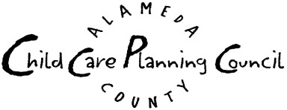
The Coalition of Alameda County Licensed
Family Child Care Providers

October Event Planning Meeting
AGENDA

Tuesday, October 5, 2004 7:00 p.m. – 8:30 p.m.

Every Child Counts, 1100 San Leandro Blvd. Conference Room A, San Leandro, CA 94577

Co-Chairs: Barbara Terrell and Muriel Sterling Staff: Rosemary Obeid, Tracy Park

- Welcome, Introductions

- Countdown to Event!
  - Review Talking Points for Experts
  - Distribute and Review Packets
  - Update on RSVPs
Review RSVP List
Review Tour Information Sheet
  - Update on Publicity
Review Press Advisory (faxed and emailed 9/30)
Review Draft Press Release (will be faxed 10/7)
  - Confirm Transportation

- Next Steps, last minute details

- Adjourn

Proposed Post Event Meeting: Tuesday, October 19, 7pm, Every Child Counts **Need to Confirm

