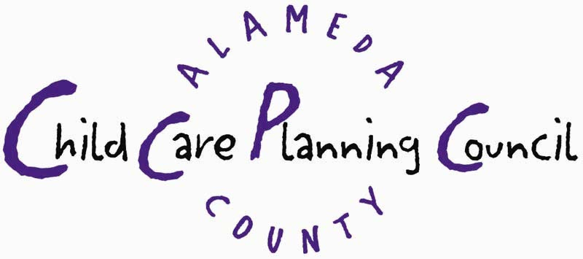
CHILD CARE PLANNING COUNCIL MEETING AGENDA
Friday, January 30, 2004 9:00 a.m. – 12:00 p.m.

Every Child Counts, 1100 San Leandro Blvd., Conference Room A, San Leandro, CA
In compliance with the Americans with Disabilities Act, those requiring accommodation for this meeting should notify
Angie Garling 24 hours prior to the meeting at (510) 208-9675.

Chaired by: Rosemary Obeid Staff: Angie Garling

- Call to Order (Chair and Staff)
Welcome, Introductions and Announcements
- Review of Planning Council Binders and 2004 Calendar

- Consent Calendar (Chair) ACTION

Review and Approve Agenda and November 2003 Minutes

- Planning Council Business ACTION
- Approve letter and policy statement to Governor and State (Chair or designee)
Legislators re the Effect of Budget Proposals on Child Care
- Approve Strategic Planning Facilitator, Timeline and Calendar (Chair or designee)
- Approve Preschool For All Principles and Proposed (Chair or designee)
Outreach and Dissemination Plan
- Approve Formation of Ad-hoc Committee to Develop Voter (Staff)
Registration and Education Plan

- Planning Council Correspondence (Staff) INFORMATION
- Copy of 12/2/04 letter to state elected officials regarding cuts to
Community Care Licensing
- Copy of 12/2/04 letter to federal elected officials opposing
Head Start’s National Reporting System
- Copy of 12/19/03 letter from Assemblywoman Chan in response
to the LPC’s 12/2 letter regarding cuts to Community Care Licensing

- Committee Reports (verbal and/or written)
Local Investment in Child Care (LINCC) (Staff)
CEL/UASCC Advisory Committee (Staff/Chair)
Early Care and Education Committee (Staff/Chair)
School-Age Care/After-school Workgroup (Staff)

- Community and Staff Reports (verbal and/or written) REPORTS
Federal and State Legislative Issues (Staff)
ECMH Systems Group (Margie Padilla)
CalWORKS Workgroup (Carol Thompson)
Community Care Licensing (Fred Gill)
Parent Voices Update (Erica Sorrells)

- Public Comment

Adjournment to: Child Care Planning Council Meeting, Friday, March 19, 2004, 9:00a.m. – 12:00p.m.
Alameda County Office of Education, 313 W. Winton Avenue, Hayward, CA

The Planning Council welcomes you to its meetings and your interest is appreciated. If you wish to speak on a matter on the agenda, please give your name for the record prior to your presentation. If you wish to speak on a matter not on the agenda, please wait until the Chair calls for public input at the end of the regular meeting. NOTE: Action can only be taken on items currently on the agenda. Time limitations shall be at the discretion of the Chair: The Council may take action related to any subject listed on the Agenda.

