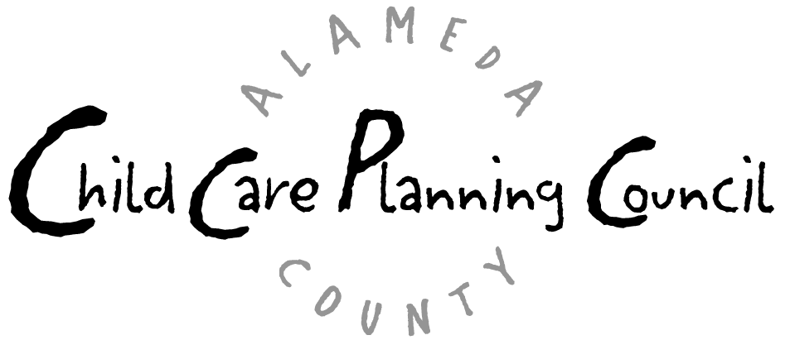

School-Age Care Afterschool Workgroup Meeting
Wednesday, May 5, 2004
9:30 a.m. – 11:00 a.m.
Every Child Counts, Conference Room B
(in the back conference room)
1100 San Leandro Blvd., San Leandro, CA 94577

Agenda

- Welcome/Introductions/Announcements

- Update on 21st Century CCLC Funding/Applications

- Update on AB1949 (Hancock)

- Other Legislative/Program Updates

- Future Agenda

- Adjourn

***Next Meeting: Tuesday, June 15, 9:30-11am, Every Child Counts Room B, San Leandro***

