The following JavaScript libraries were used within the project:

* jQuery & jQuery-ui (https://jquery.com & https://jqueryui.com)
* velocity & velocity-ui (https://github.com/julianshapiro/velocity)
* spin (<http://fgnass.github.io/spin.js)>

As well as this, the algorithm for smooth CSS rotation animation has been written by

Stackoverflow user yckart on the question <http://stackoverflow.com/questions/15191058/css-rotation-cross-browser-with-jquery-animate>

This is accredited in the source code.

f454/html/ca/gameComponents/enemies/attackShip.pngf454/html/ca/gameComponents/enemies/heavyFighter.pngf454/html/ca/gameComponents/enemies/attackFighter.pngThe parts of the following images were originally produced by opengameart user Skorpio, and published under CC-BY-SA 3.0 and GPL licenses on the site <http://opengameart.org>. They have been modified from their original creations by Ignacy Debicki

The following images were originally produced by opengameart user Scrittl and published under the CC0 license on the site <http://opengameart.org>. They have been modified from their original creations by Ignacy Debicki

f454/html/ca/gameComponents/enemies/scoutDroid.pngf454/html/ca/gameComponents/enemies/swarmShip.png

The following image was originally produced by opengameart user wuhu and released under the CC-BY 3.0 license on the site <http://opengameart.org>.

f454/html/ca/gameComponents/enemies/transporter.png

The following image was originally produced by opengameart user SpriteAttackand published under the CC0 license on the site <http://opengameart.org>. It has been modified from their original creation by Ignacy Debicki and Joanna Debicka

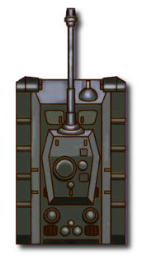

The following images were originally produced by opengameart user mauriku published under the CC-BY 3.0 license on the site <http://opengameart.org>.

f454/html/ca/gameComponents/towers/repeater.pngf454/html/ca/gameComponents/towers/repeater2.pngf454/html/ca/gameComponents/towers/repeater3.png

The following images were originally produced by opengameart user clayster2012 published under the OGA-BY 3.0 license on the site <http://opengameart.org>.

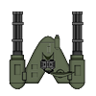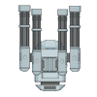

The following image was originally produced by opengameart user Xavier4321 who used parts of a work by opengameart user Skorpio. The work has been published under the CC-BY 3.0 license on the site <http://opengameart.org>. It has been modified from their original creation by Ignacy Debicki

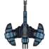

The following images have been produced by Joanna Debicka specifically for this project.

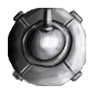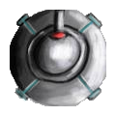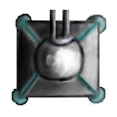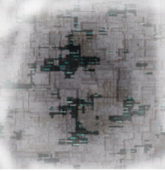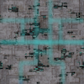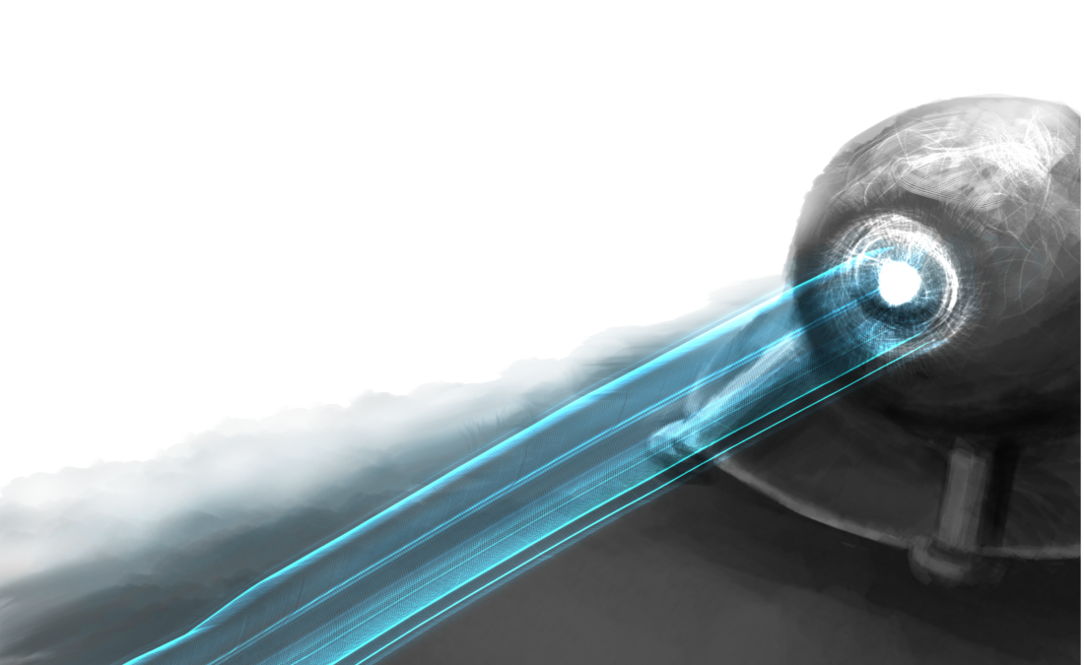

The following image has been produced by user JOEY600 on the site clker.com. It has been published under the CC0 license.

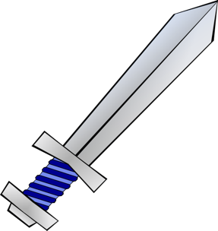

The following image has been produced by user Ranks on the site github.com and published under the Creative Commons Attribution-ShareAlike 4.0 International license.



The following image has been produced by user GCS on the site clker.com. It has been published under the CC0 license.



The following image has been produced by user Mlampret on the site openclipart.org. It has been published under the CC0 license.



The following image has been produced by user Ocal on the site clker.com. It has been published under the CC0 license.

f454/html/ca/gameComponents/images/resources.png

The following image has been produced by user dannya on the site openclipart.org. It has been published under the CC0 license.



The following image has been produced by user Terraformer_Author on the site forum.profantasy.org. It has been published under the CC0 license.

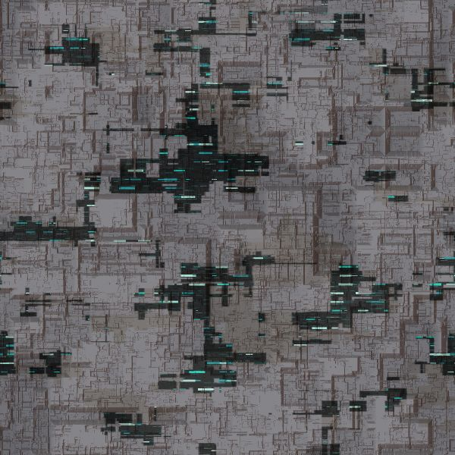

The original creators for these images could not be traced:

f454/html/ca/gameComponents/enemies/cruiser.png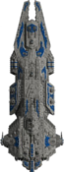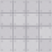

The following has an unknown original creator, however has been modified by Ignacy Debicki:



All images which have not been mentioned here have been created specifically for this project by Ignacy Debicki