電通二甲微處理器實驗 實驗結報

實驗名稱 | Lab06-音樂教室
組別 | 32 | 組員 | 楊峻03050175 李仕如03050574

- 實驗目的
如何使 Arduino 發出特定旋律的聲音?
Arduino 接喇叭如何接線?
如何使用 tone library?
如何演奏一段音樂?
如何使用 4x4 鍵盤演奏音樂?
如何發報摩斯電碼?
- 實驗步驟
* Arduino 演奏一段特定的音樂, 旋律不得是小蜜蜂
* 使用 4x4 鍵盤演奏音樂
* 發報摩斯電碼
- 程式碼
1.
#include "pitches.h"
const byte Buzzer = 2;
const int rhythm = 500;
char index;
int SoundLeng;
char song_tone;

int pitch[] = { 0,
NOTE_C4,NOTE_D4,NOTE_E4,NOTE_F4,NOTE_G4,NOTE_A4,NOTE_B4,
NOTE_C5,NOTE_D5,NOTE_E5,NOTE_F5,NOTE_G5,NOTE_A5,NOTE_B5 };

float song[] = {5,1,
3+7,1.5, 6,0.5, 6,1, 6,0.33, 7,0.33, 1+7,0.33,
2+7,0.75, 3+7,0.75, 2+7,0.25, 5,0.25, 1+7,1.5, 6,0.25, 7,0.25,
1+7,1.5, 4,0.5, 4,1, 1+7,0.33, 7,0.33, 6,0.33,
6,1, 5,1, 4+7,1, 3+7,1,
5+7,0.75, 3+7,0.75, 6,0.25, 6,1.25, 0,1,
3+7,0.33, 2+7,0.33, 1+7,0.33, 2+7,1, 5,0.33, 5,0.33, 2+7,0.33, 1+7,2,
0,2, 6,0.5, 7,0.5,
1+7,4,
6,2, 7,2,
1+7,4 -1,-1 };

void setup() {
pinMode(Buzzer,OUTPUT);
}

void loop() {
index=0;
while (1) {
song_tone = char(song[index]);
index++;
SoundLeng = int(song[index]*rhythm);
index++;
if (song_tone==-1)
break;
else if (song_tone==0)
delay(SoundLeng*1.3);
else {
tone(Buzzer, pitch[song_tone], SoundLeng);
delay(SoundLeng*1.3);
}
}
}

2.
#include <Keypad.h>
#include "pitches.h"
const byte ROWS=4;
const byte COLS=4;
int duration=200;
const byte Buzzer=2;
const int rhythm=500;
char index;
int SoundLeng;
char song_tone;
char ch;
char keys[ROWS][COLS]={
{'0','1','2','3'},
{'4','5','6','7'},
{'8','9','A','B'},
{'C','D','E','F'}
};
byte rowPins[ROWS]={10,11,12,13};
byte colPins[COLS]={6,7,8,9};
int
pitch[]={0,NOTE_C4,NOTE_D4,NOTE_E4,NOTE_F4,NOTE_G4,NOTE_A4,NOTE_B4,
NOTE_C5,NOTE_D5,NOTE_E5,NOTE_F5,NOTE_G5,NOTE_A5,NOTE_B5};

float song[] = {5,0.5, 1+7,0.5, 2+7,0.5, 3+7,0.5, 2+7,0.5, 3+7,0.5,
4+7,0.5, 5+7,0.5, 5+7,0.5, 5+7,0.5, 4+7,0.5,
3+7,0.5,
2+7,0.5, 2+7,1, 0,0.5, 5,0.5, 1+7,0.5, 2+7,0.5,
3+7,0.5,
2+7,0.5, 3+7,0.5, 4+7,0.5, 5+7,0.5, 5+7,0.5,
5+7,0.5,
6+7,0.5, 5+7,1, 2+7,0.5, 3+7,0.5, 1+7,1, 1+7,0.5,
6,0.5,
2+7,0.5, 2+7,0.5, 3+7,0.5, 3+7,0.5, 1+7,1, 5+7,0.5,
1+7,0.5, 5,0.5, 1+7,0.5, 7,0.5, 1+7,0.5, 0,1,
1+7,0.5,
6,0.5, 2+7,0.5, 2+7,0.5, 3+7,0.5, 3+7,0.5, 4+7,0.5,
4+7,0.5,
4+7,0.5, 3+7,0.5, 2+7,0.5, 1+7,0.5, 1+7,1, -1};

Keypad keypad = Keypad(makeKeymap(keys), rowPins, colPins, ROWS,
COLS);

void setup() {
pinMode(Buzzer,OUTPUT);
Serial.begin(9600);
}
void loop() {
char key = keypad.getKey();
if(key!=NO_KEY){
switch(key){
case '0':
tone(Buzzer,NOTE_C4,duration);
break;
case '1':
tone(Buzzer,NOTE_D4,duration);
break;
case '2':
tone(Buzzer,NOTE_E4,duration);
break;
case '3':
tone(Buzzer,NOTE_F4,duration);
break;
case '4':
tone(Buzzer,NOTE_G4,duration);
break;
case '5':
tone(Buzzer,NOTE_A4,duration);
break;
case '6':
tone(Buzzer,NOTE_B4,duration);
break;
case '7':
tone(Buzzer,NOTE_C5,duration);
break;
case '8':
tone(Buzzer,NOTE_D5,duration);
break;
case '9':
tone(Buzzer,NOTE_E5,duration);
break;
case 'A':
tone(Buzzer,NOTE_F5,duration);
break;
case 'B':
tone(Buzzer,NOTE_G5,duration);
break;
case 'C':
tone(Buzzer,NOTE_A5,duration);
break;
case 'D':
tone(Buzzer,NOTE_B5,duration);
break;
case 'E':
tone(Buzzer,NOTE_C6,duration);
break;
case 'F':
tone(Buzzer,NOTE_D6,duration);
break;
}
}

if(Serial.read()=='S')
{
ch=Serial.read();
Serial.println("Sing");
index=0;
while (1) {
song_tone = char(song[index]);
index++;
SoundLeng = int(song[index]*rhythm);
index++;
if (song_tone==-1)
break;
else if (song_tone==0)
delay(SoundLeng*1.3);
else {
tone(Buzzer, pitch[song_tone], SoundLeng);
delay(SoundLeng*1.3);
}
}
}
}

3.
char *morse[]={ "01", "1000", "1010", "100", // A~D
"0", "0010", "110", "0000", // E~H
"00", "0111", "101", "0100", // I~L
"11", "10", "111", "0110", // M~P
"1101", "010", "000", "1", // Q~T
"001", "0001", "011", "1001", // U~X
"1011", "1100" }; // Y~Z
const byte Buzzer = 2;
char chr, index;
char *ptr;

void setup() {
pinMode(Buzzer,OUTPUT);
Serial.begin(9600);
}

void loop() {

if (Serial.available()) {
chr=Serial.read();
Serial.println(chr);
if ((chr-'A')>=0 && (chr-'Z')<=0) {
index=chr-'A';
ptr=morse[index];
while (*ptr!='\0') {
if (*ptr=='0') {
tone(Buzzer, 440, 100);
delay(100);
}
else {
tone(Buzzer, 440, 300);
delay(300);
}
ptr++;
delay(100);
}
delay(300);
}
}
}

- 電路圖
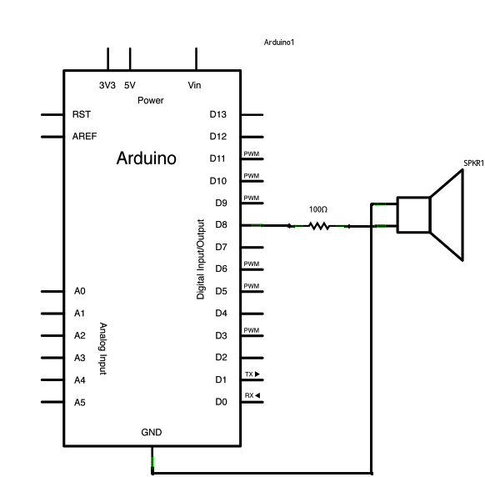

心得討論:
這次的實驗滿有趣的，因為有聲音的東西大家都喜歡這是不變的道理，不過喜歡歸喜歡這實驗還是不太容易，喇叭的實驗程式碼都不太容易比較長且複雜，而且這次程式還有三個，實驗是不容易又多，我們做實驗做到下課才好不容易做完，不過能聽到自己實驗做出來的音樂還是很開心，謝謝組員的幫忙。

