電通二乙微處理器實驗 實驗預報

實驗名稱 | Lab05結報作業
組別 |  | 組員 | 01053056許博凱

- 了解4x4 鍵盤的工作原理
  - 4x4 鍵盤如何接線?
  - 如何使用 Arduino keyboard library?
  - 如何讀取鍵盤的顯示數值?
  - 如何讓四合一七段顯示器顯示鍵盤的輸入值?

- 實驗步驟
4x4 鍵盤之按鍵值經由串列傳輸，顯示在 PC 上 （60 分)
4x4 鍵盤之按鍵值顯示在七段顯示器上 (40 分)

- 程式碼
const byte ROWS = 4;
const byte COLS = 4;
char keys[ROWS][COLS] = {
{'7','4','1','0'},
{'8','5','2','A'},
{'9','6','3','B'},
{'C','D','E','F'}
};
byte rowPins[ROWS] = {2,3,4,5};
byte colPins[COLS] = {6,7,8,9};
Keypad keypad = Keypad( makeKeymap(keys), rowPins, colPins, ROWS, COLS );

void setup(){
Serial.begin(9600);
}

void loop(){
char key = keypad.getKey();
if (key != NO_KEY){
Serial.println(key);
}
}

四合一七段顯示程式碼：
#include <SevSeg.h>
#include <Keypad.h> //installtation

#define PIN_g A2
#define PIN_f A3
#define PIN_a 10
#define PIN_b 11
#define PIN_e A1
#define PIN_d A4
#define PIN_c 12
const byte seg_pins[7]={PIN_a, PIN_b, PIN_c, PIN_d, PIN_e, PIN_f, PIN_g};
const boolean data[16][7] = {
{1, 1, 1, 1, 1, 1, 0},
{0, 1, 1, 0, 0, 0, 0},
{1, 1, 0, 1, 1, 0, 1},
{1, 1, 1, 1, 0, 0, 1},
{0, 1, 1, 0, 0, 1, 1},
{1, 0, 1, 1, 0, 1, 1},
{1, 0, 1, 1, 1, 1, 1},
{1, 1, 1, 0, 0, 0, 0},
{1, 1, 1, 1, 1, 1, 1},
{1, 1, 1, 1, 0, 1, 1},
{1, 1, 1, 0, 1, 1, 1},
{0, 0, 1, 1, 1, 1, 1},
{1, 0, 0, 1, 1, 1, 0},
{0, 1, 1, 1, 1, 0, 1},
{1, 0, 0, 1, 1, 1, 1},
{1, 0, 0, 0, 1, 1, 1},
};
const byte ROWS = 4;
const byte COLS = 4;
char keys[ROWS][COLS] = {
{'7','4','1','0'},
{'8','5','2','A'},
{'9','6','3','B'},
{'C','D','E','F'}
};
byte rowPins[ROWS] = {2,3,4,5};
byte colPins[COLS] = {6,7,8,9};
Keypad keypad = Keypad( makeKeymap(keys), rowPins, colPins, ROWS, COLS );

void setup(){
Serial.begin(9600);
for(int i=1;i<=12;i++)
{
pinMode(i,OUTPUT);
}
pinMode(A1,OUTPUT);
pinMode(A2,OUTPUT);
pinMode(A3,OUTPUT);
}

void loop(){
char key = keypad.getKey();
int key_num = chang_key(key);
if (key != NO_KEY){
for(int i = 0;i < 7;i++)
{
digitalWrite(seg_pins[i], data[key_num][i]);
}
Serial.println(key);
}
}

int chang_key(char key)
{
int key_num;
if(key =='0')
key_num = 0;
if(key =='1')
key_num = 1;
if(key =='2')
key_num = 2;
if(key =='3')
key_num = 3;
if(key =='4')
key_num = 4;
if(key =='5')
key_num = 5;
if(key =='6')
key_num = 6;
if(key =='7')
key_num = 7;
if(key =='8')
key_num = 8;
if(key =='9')
key_num = 9;
if(key =='A')
key_num = 10;
if(key =='B')
key_num = 11;
if(key =='C')
key_num = 12;
if(key =='D')
key_num = 13;
if(key =='E')
key_num = 14;
if(key =='F')
key_num = 15;
return key_num;
}

- 實驗結果及分析

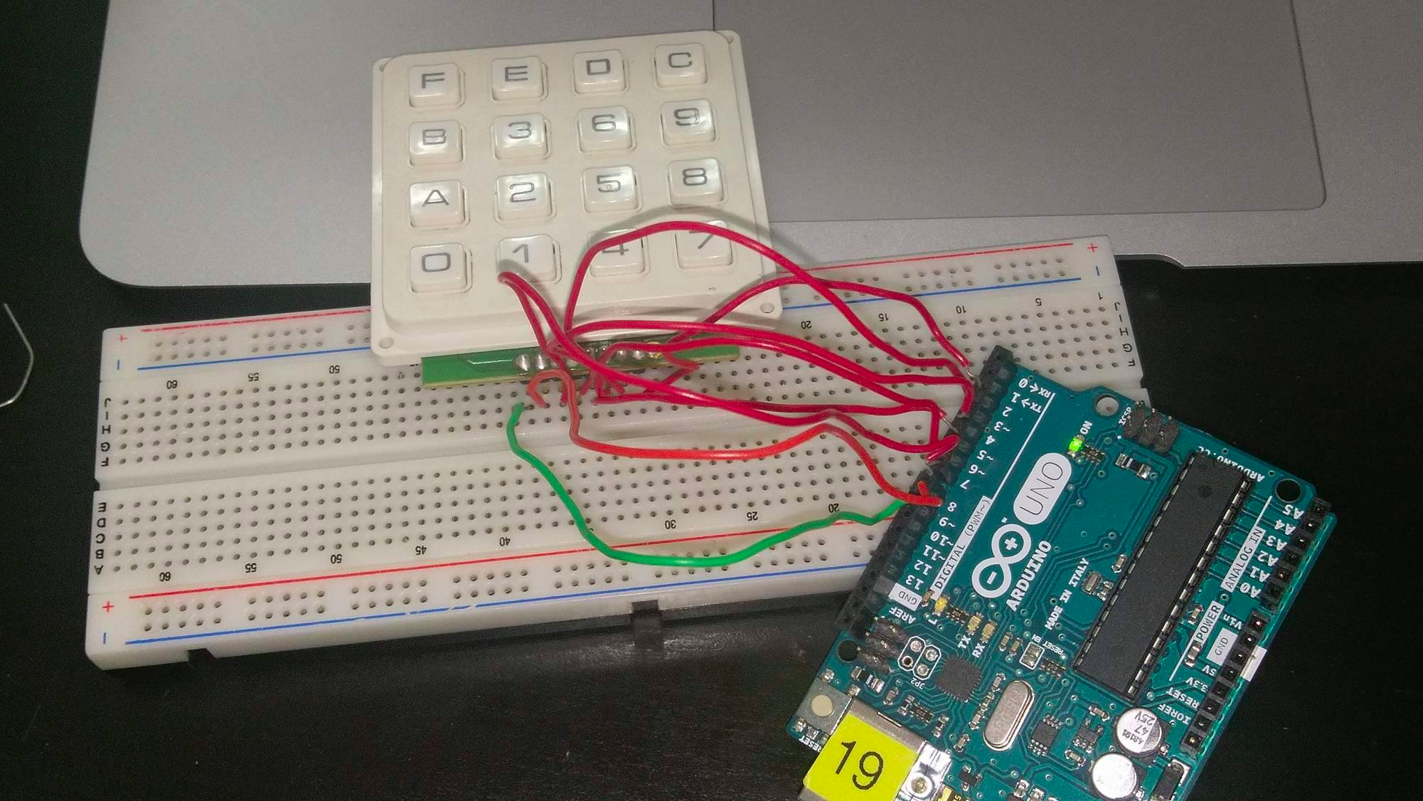
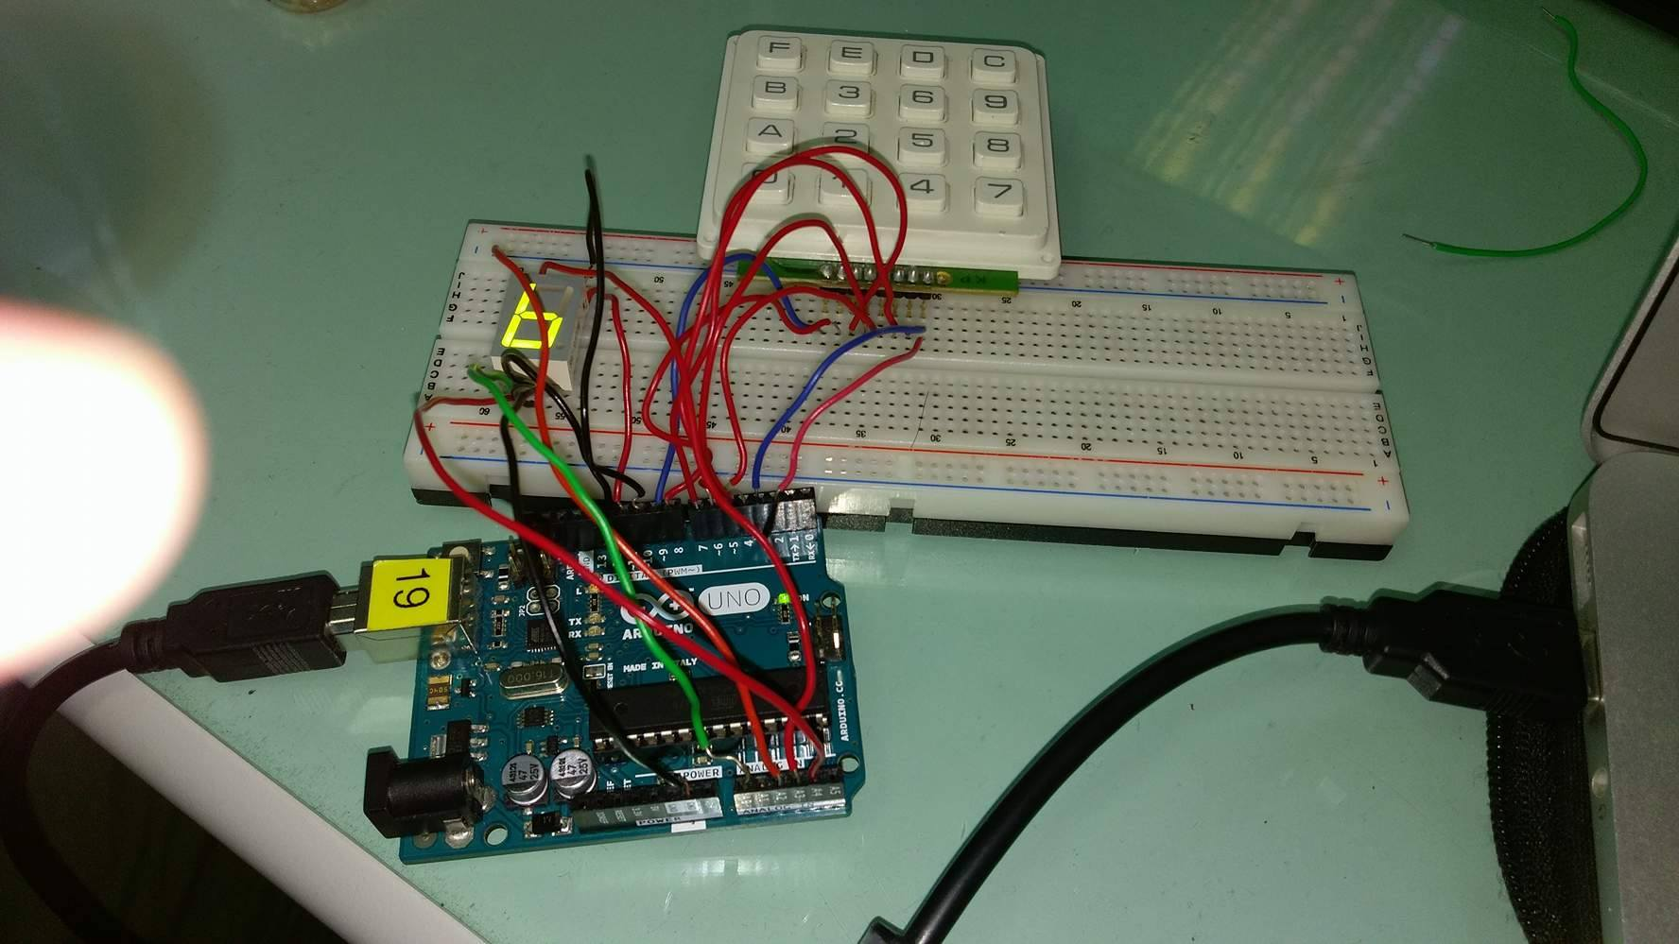
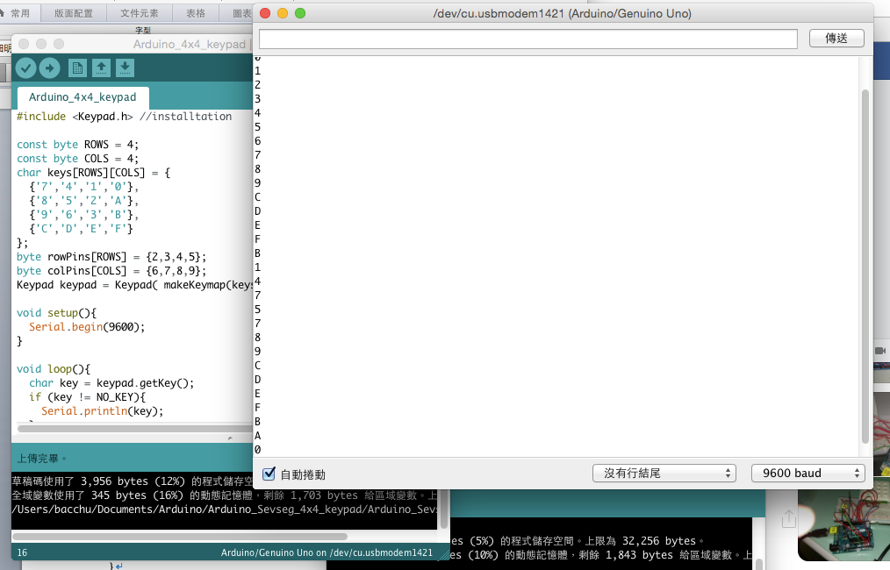

5.這次的實驗十分的艱辛，真的都靠TA的開導 使得我們實驗作業做起來。

