電通二乙微處理器實驗 實驗結報

實驗名稱 | Lab 08 –I 2C通訊
組別 | 24 | 組員 | 01053056許博凱 99050375 鄭宗欽

- 實驗目的
使用 Arduino wire 程式庫, 實現多台 Arduino 透過 I2C 介面 通訊. 1. 一台 Arduino, 作為 Master 端，讀取 slave 端之溫濕度 感測器讀值, 顯示在 LCD 螢幕上 2. 一台 Arduino, 作為 Slave 端，將溫濕度感測器之讀值， 傳送到 Master 及 PC
- 實驗步驟
1. Slave 端, 可透過 I2C 傳出溫濕度感測器之讀值 50%
2. Master 端, 可透過 I2C 讀取溫濕度感測器之讀值 50%
- 程式碼
- 從:
- // slave_receiver.ino // Refer to the "master_sender" example for use with this #include <Wire.h> #include <string.h> #include "DHT.h" #define dht_dpin A0 //定義訊號要從Pin A0 進來 dht DHT; const int SLAVE_ADDRESS = 1; const int MASTER_ADDRESS = 2; char incomingByte = 0; char test[20]; void setup() { Wire.begin(SLAVE_ADDRESS); // join I2C bus as a slave with address 1 Wire.onReceive(receiveEvent); // register event Serial.begin(9600); Serial.println("Received data:"); } void loop() { postDataToMaster(); delay(1000); //每1000ms更新一次 } void receiveEvent(int howMany) { while (Wire.available()) { // receive one byte from Master incomingByte = Wire.read(); Serial.print(incomingByte); } } void serialEvent() { // send the received data to slave Wire.beginTransmission(MASTER_ADDRESS); Wire.write(Serial.read()); Wire.endTransmission(); } void postDataToMaster(){ //去library裡面找DHT.read11 DHT.read11(dht_dpin); Wire.beginTransmission(MASTER_ADDRESS); float h = DHT.humidity; float t = DHT.temperature; Wire.write("H="); Wire.write(floatToString(test, DHT.humidity, 2, 6)); Wire.write("%,T="); Wire.write(floatToString(test, DHT.temperature, 2, 6)); Wire.write("C\n"); Wire.endTransmission(); } char * floatToString(char * outstr, double val, byte precision, byte widthp){ char temp[16]; byte i; // compute the rounding factor and fractional multiplier double roundingFactor = 0.5; unsigned long mult = 1; for (i = 0; i < precision; i++) { roundingFactor /= 10.0; mult *= 10; } temp[0]='\0'; outstr[0]='\0'; if(val < 0.0){ strcpy(outstr,"-\0"); val = -val; } val += roundingFactor; strcat(outstr, itoa(int(val),temp,10)); //prints the int part if( precision > 0) { strcat(outstr, ".\0"); // print the decimal point unsigned long frac; unsigned long mult = 1; byte padding = precision -1; while(precision--) mult *=10; if(val >= 0) frac = (val - int(val)) * mult; else frac = (int(val)- val ) * mult; unsigned long frac1 = frac; while(frac1 /= 10) padding--; while(padding--) strcat(outstr,"0\0"); strcat(outstr,itoa(frac,temp,10)); } // generate space padding if ((widthp != 0)&&(widthp >= strlen(outstr))){ byte J=0; J = widthp - strlen(outstr); for (i=0; i< J; i++) { temp[i] = ' '; } temp[i++] = '\0'; strcat(temp,outstr); strcpy(outstr,temp); } return outstr; }
- 主:
- // master_sender.ino // Refer to the "slave_receiver" example for use with this #include <Wire.h> // 引用 LiquidCrystal Library #include <LiquidCrystal.h> // 建立 LiquidCrystal 的變數 lcd // LCD 接腳: rs, enable, d4, d5, d6, d7 // 對應到 Arduino 接腳: 12, 11, 5, 4, 3, 2 LiquidCrystal lcd(12, 11, 5, 4, 3, 2); const int SLAVE_ADDRESS = 1; const int MASTER_ADDRESS = 2; char incomingByte = 0; void setup() { Wire.begin(MASTER_ADDRESS); // join I2C bus as a Master Wire.onReceive(receiveEvent); Serial.begin(9600); Serial.println("Type something to send:"); //LCD // 設定 LCD 的行列數目 (2 x 16) lcd.begin(16, 2); // 列印 "Hello World" 訊息到 LCD 上 // lcd.print("03050485"); // 將游標設到 column 0, line 1 // (注意: line 1 是第二行(row)，因為是從 0 開始數起): // lcd.setCursor(0, 1); // lcd.print("Hana Sun"); } void loop() { // // 列印 Arduino 重開之後經過的秒數 // lcd.print(millis()/1000); /* while(Serial.available()){ lcd.write(Serial.read()); } */ } void serialEvent() { // read one byte from serial port incomingByte = Serial.read(); // send the received data to slave Wire.beginTransmission(SLAVE_ADDRESS); Wire.write(incomingByte); Wire.endTransmission(); } void receiveEvent(int howMany) { while (Wire.available()) { // receive one byte from Master incomingByte = Wire.read(); Serial.print(incomingByte); lcd.write(incomingByte); // lcd.setCursor(10, 1); } }

- 實驗結果及分析

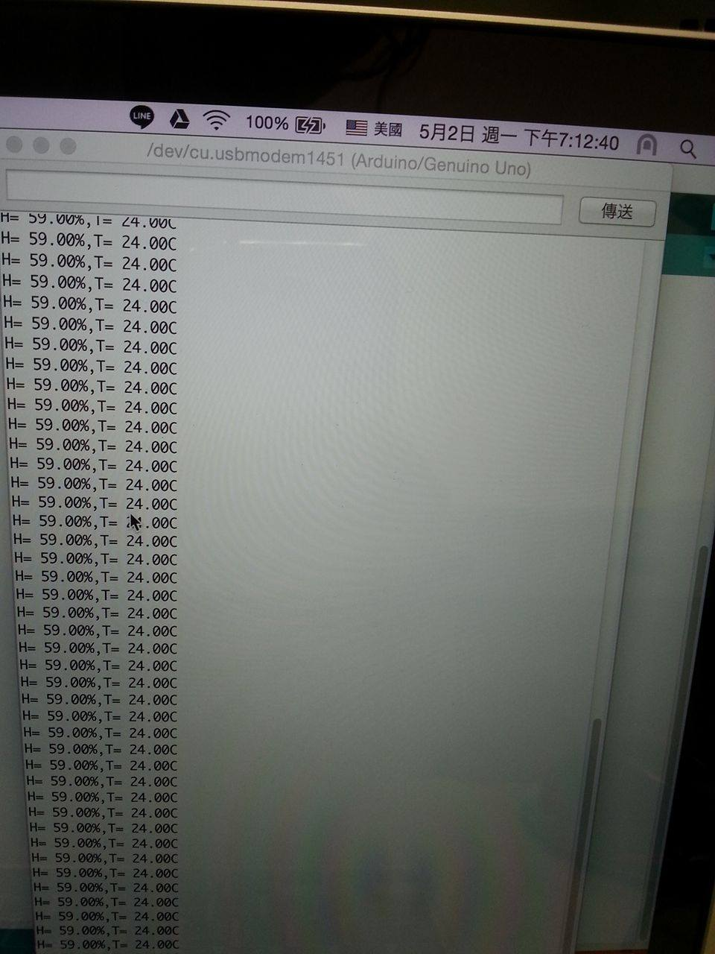

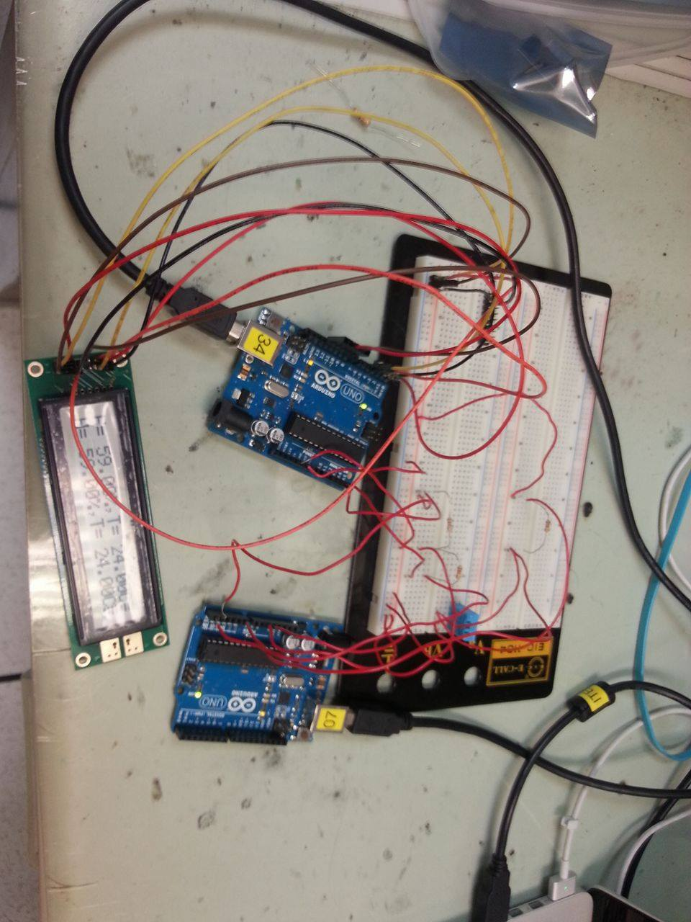

- 心得討論:
這次差點沒被LCD接腳搞瘋了,還有數值一直輸不進去,在濕度那方面就比較還好

