Wireframing; Career Assessment Tools

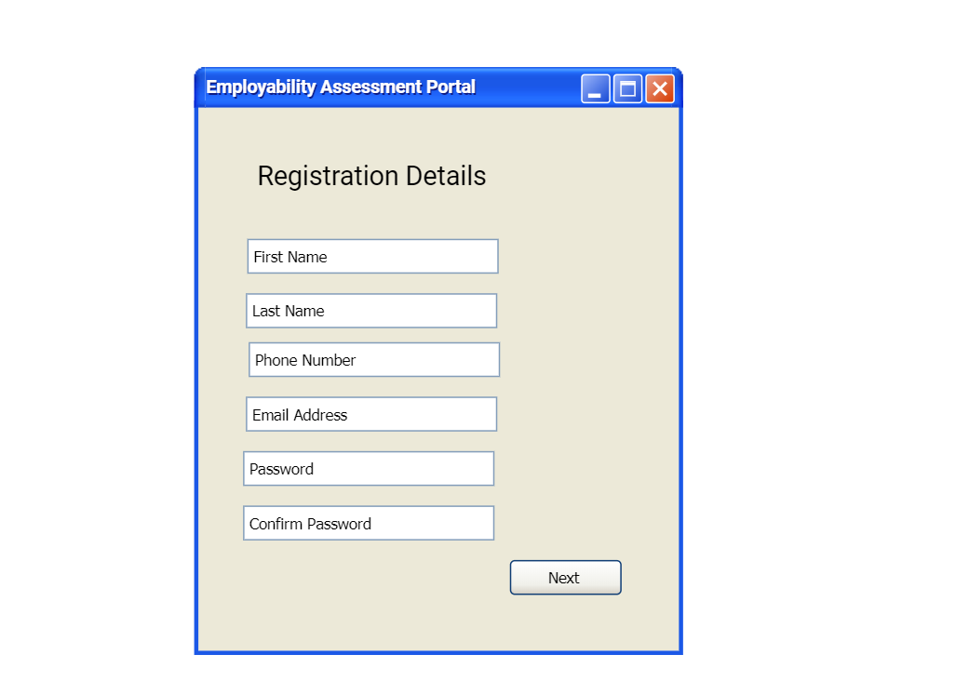

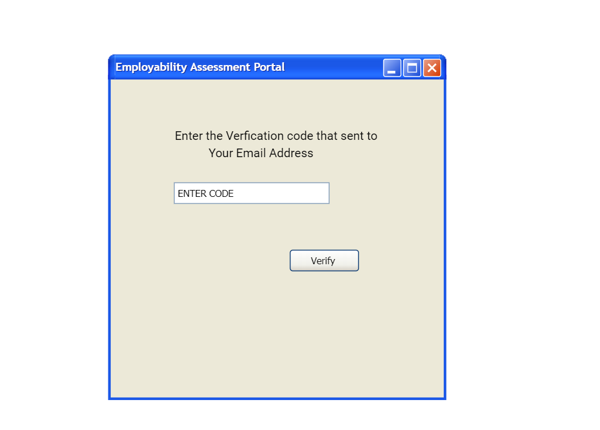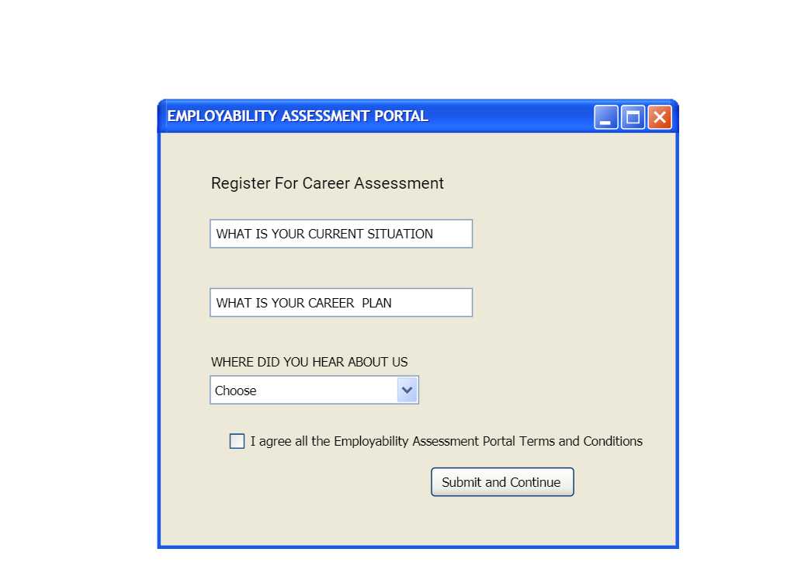

Findings:

When you enter the career assessment tools, you will be able to register your details, then giving all the details, you will receive the verification code to verify. After entering the verification code, you will be able to submit and continue giving the answer on what is your current situation and career plan.

By Clicking the submit and continue buttons.

You will be asked different specific career question, to identify your strength and skillsets.

You need to choose the answer to the following question?

Q1. Which one of the skills will be suited role for you?

* Providing the information and helping to the people to understand and interpret it, in every field like business, teaching, advisory and others
* Design, create and create things by using the skills like science, engineering, and math
* Solving the challenge by using different kind if technology and digital program
* Finished the different series of task in proper plan step by step each day

Q2. Which of the role would you like to enjoy?

* Working as the sound engineering, audio engineering and making a suitable sound the shows
* As teaching actors and working as a language coach
* Playing as a role of the character on the stage or screen

Q3. What your friend mentioned you are most interested in?

* Making new connection and bringing people together
* Having interested on the houses and design how it looks like stylish and other

Q4. On what things you want a invest your time?

* Playing with Pets like cat, dog and others
* Exploring the new sites and location
* Filming and editing

Q5. What’s your strongest skillsets is mostly related to?

* Coaching or motivating others
* Learning about the interesting new development in culture, politics, and every daily life
* Talking and entertaining to other arranging get together with friends
* Keeping your hand busy on the something to build rather than buying

Q6. Which types of the work you like the most?

* Working in lab experimenting where you must be very careful with the different chemical and create something meaningful
* Working in an animal care and plan for the conservation setting
* Being a part of the working in a office which is growing business

Q7. What subject will you find interesting and play your strength?

* Math, science, and engineering
* Health, community studies, Early childhood, environmental studies
* Retail studies, Hospitality, and business administration
* Commerce and legal studies

Q8. What you see in yourself?

* Designer
* Handcrafter
* Technician

Q9. If you get chance to work in the match, what would you prefer to

* Work with the team as healthcare team and providing the health fitness
* Working with the technician team help to stream the match
* Working with organizer to assembling the tents and stalls
* Watch and enjoy with your friends

After answering all the questions,

The results will publish in the two categories with the percentage.

1. The Do-er
2. The Career

Everyone has their own skillsets; the result will show the targeted job or career based on the personality on the screen as a careers to consider.