# Test Cases

I have provided the evidences of the test cases which I have run in order to check functionalities of the tools.

Tool used: TESTINY

Below are the test scenarios which I have completed:

* Check the login functionalities
* Check the registration functionalities
* Check the enquire chat pop-up functionalities

# Test cases to check the registration functionalities

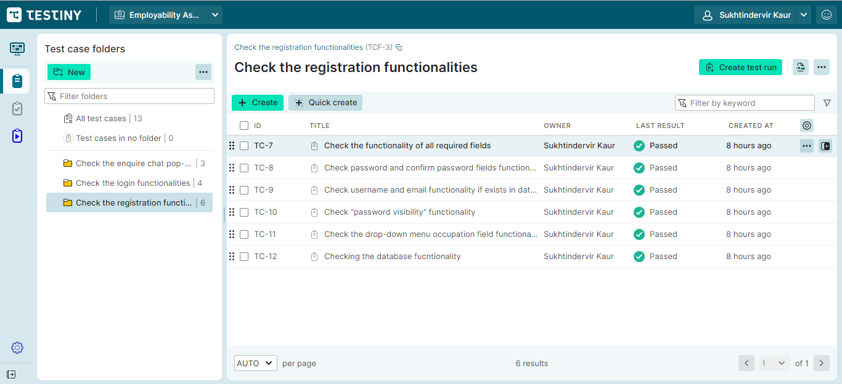

## Check the functionality of all required fields

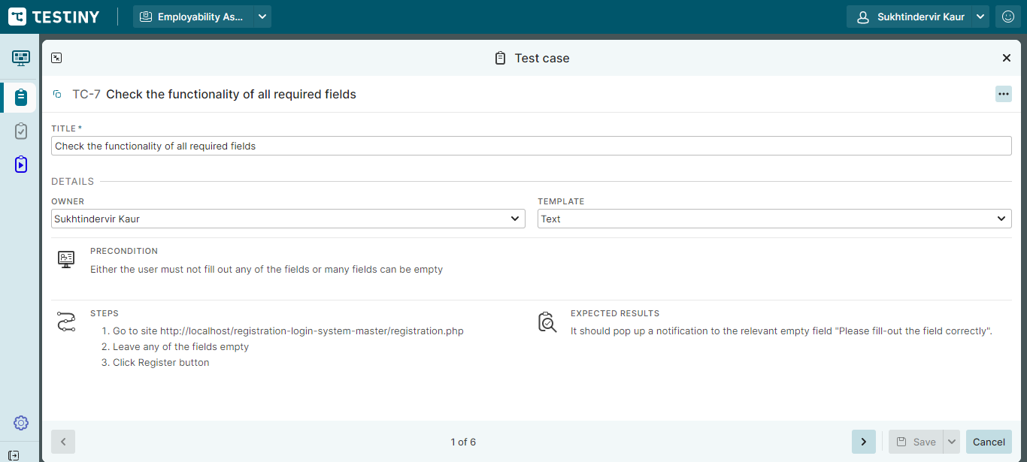

## Check password and confirm password fields functionalities

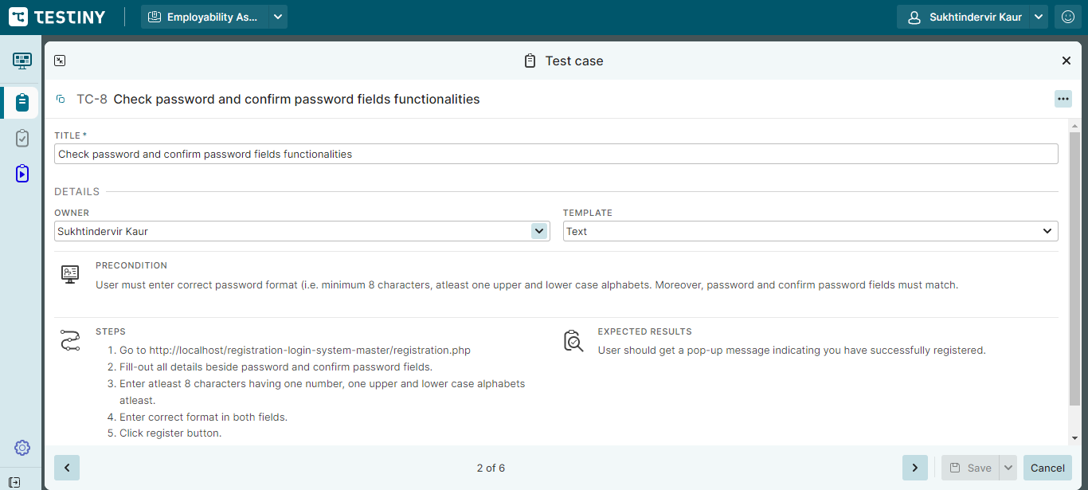

## Check username and email functionality if exists in database or not

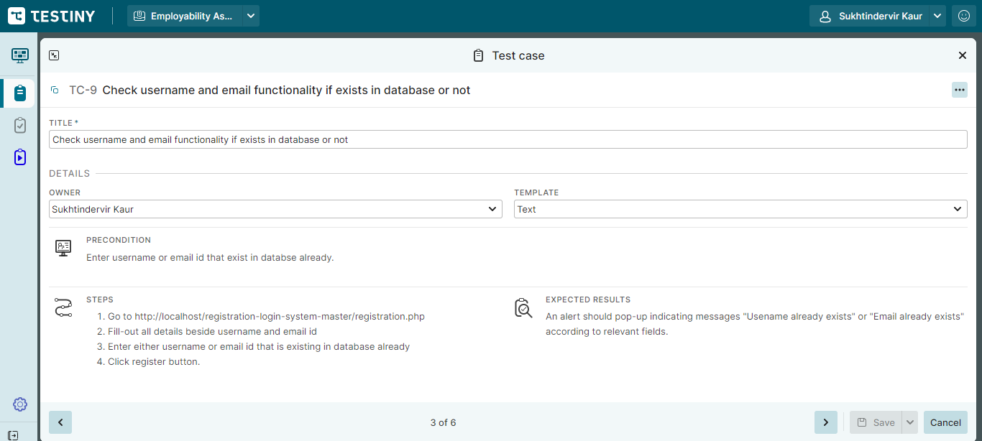

## Check password visibility functionality

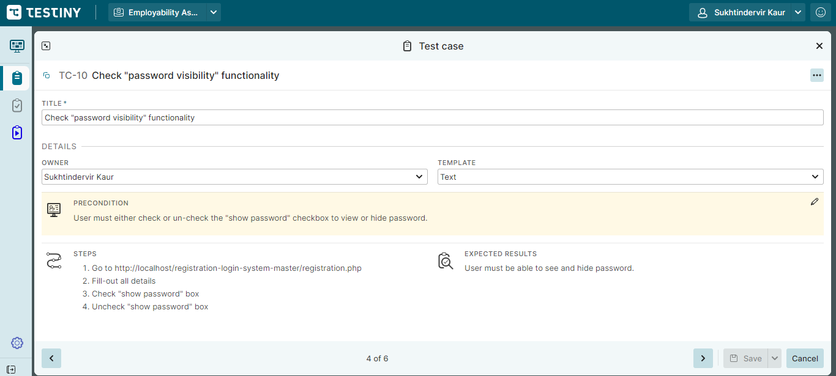

## Check the drop-down menu occupation field functionality

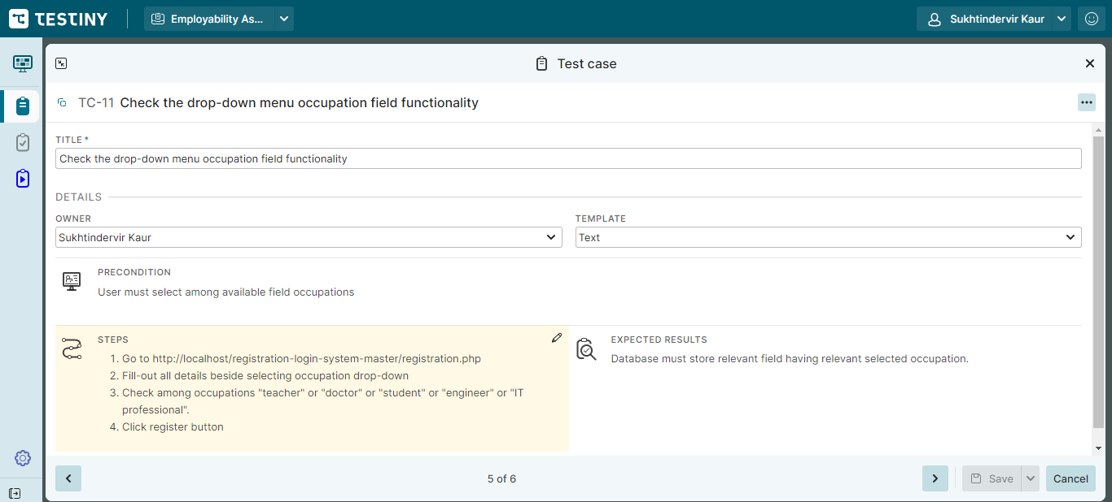

## Check the database functionality

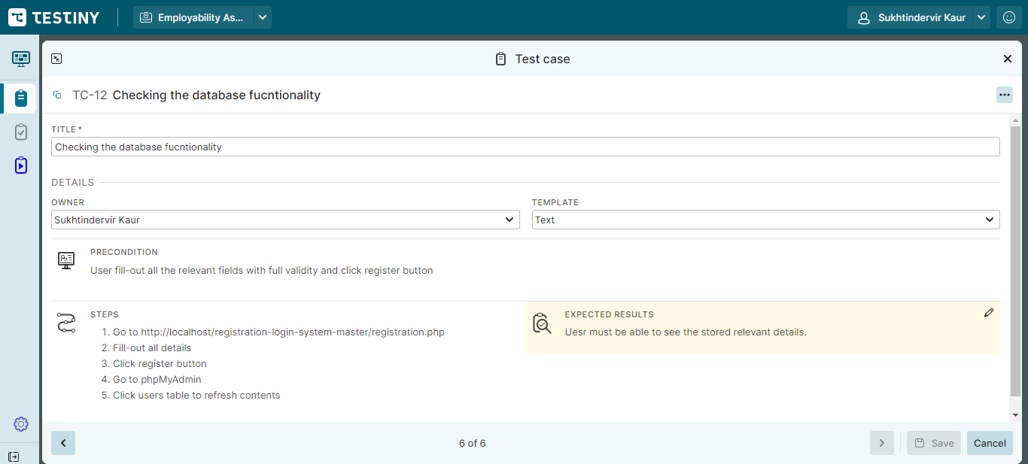

# Result report of the registration functionalities

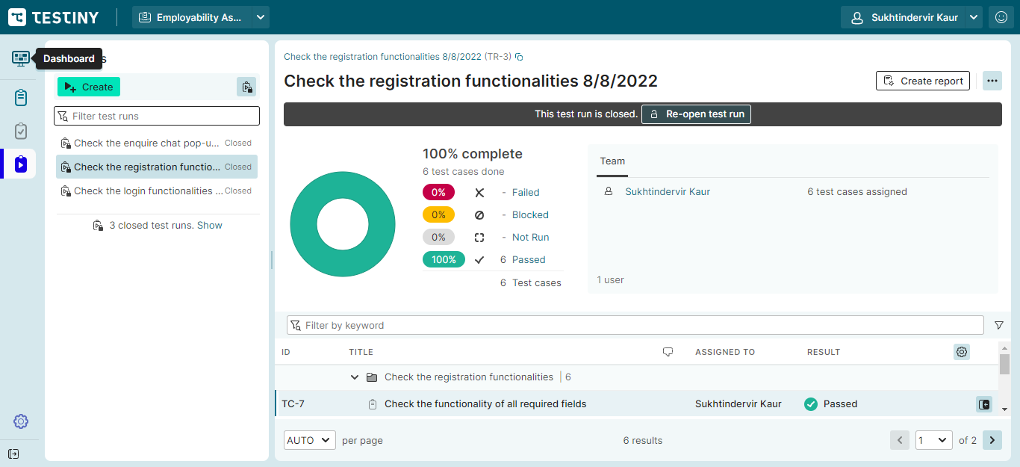

# Test cases to check the login functionalities

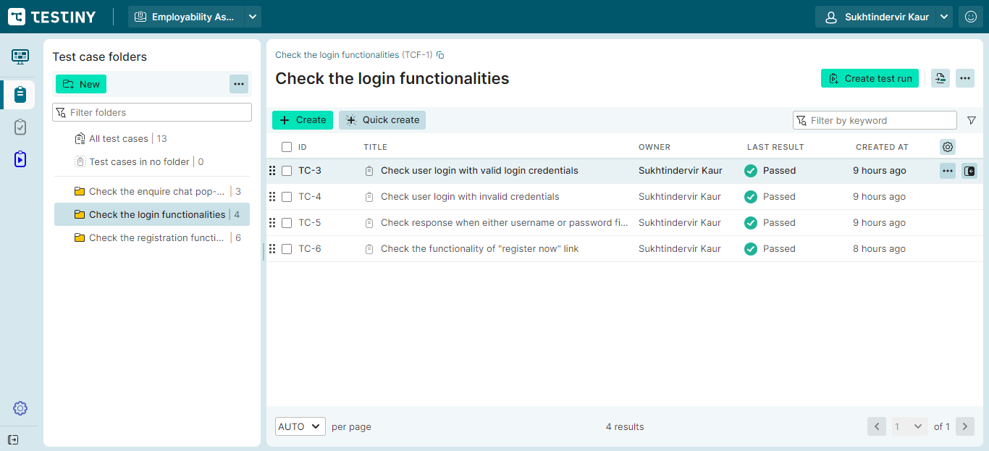

## Check user login with valid credentials

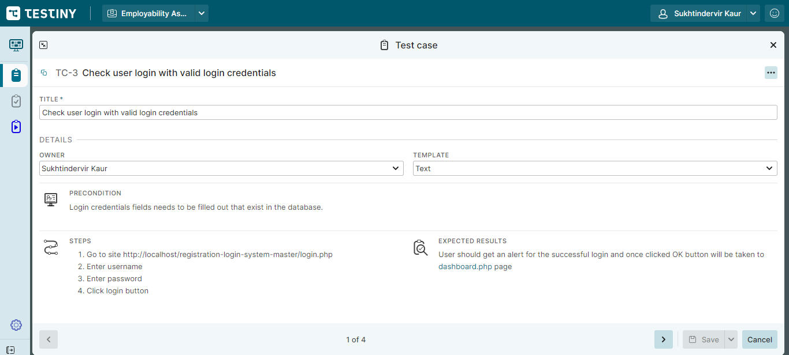

## Check user login with invalid credentials

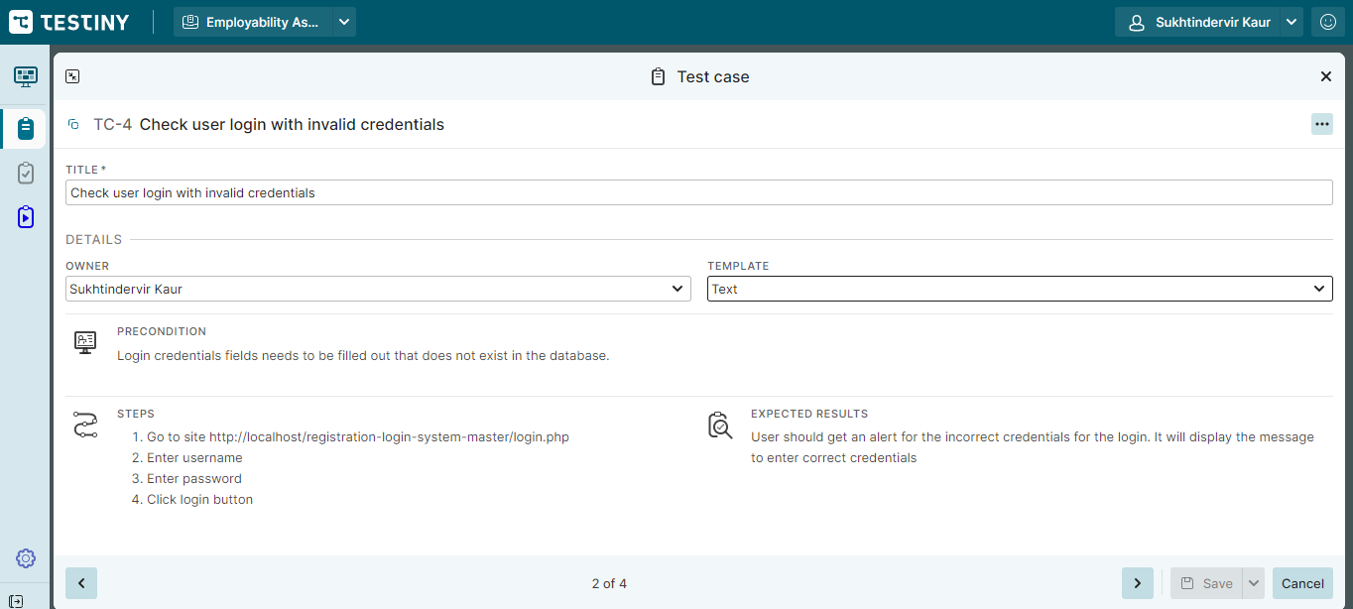

## Check response when either username or password fields are empty or both are empty

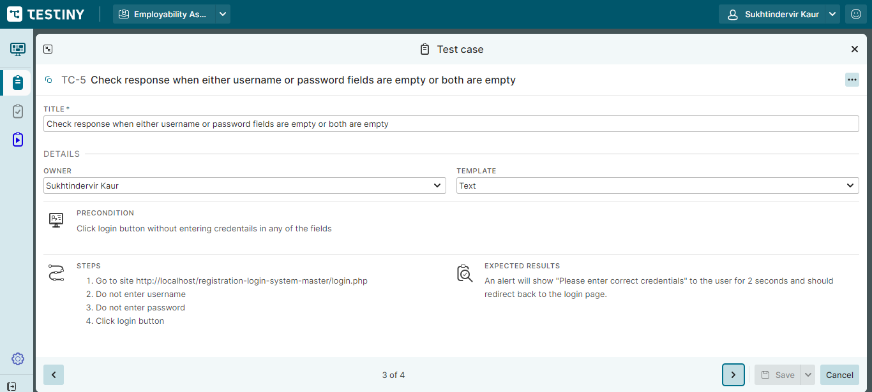

## Check the functionality of registration now link

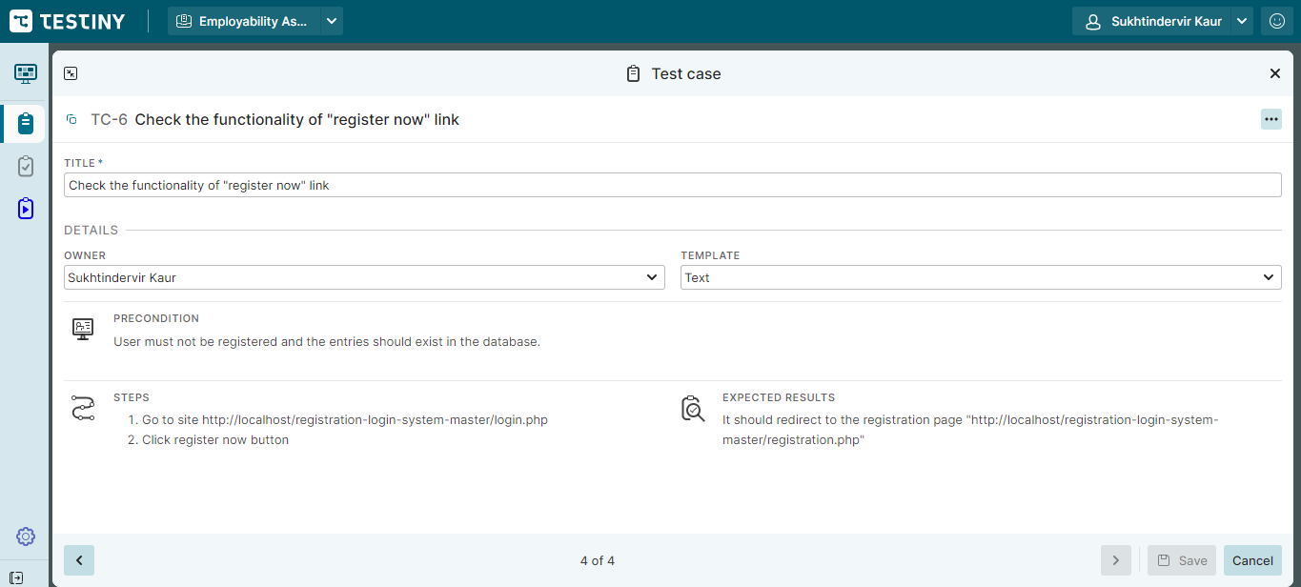

# Result report of login functionalities

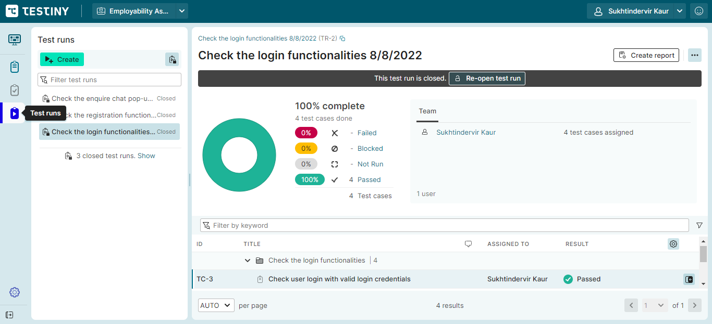

# Test cases to check the enquire chat pop-up functionality

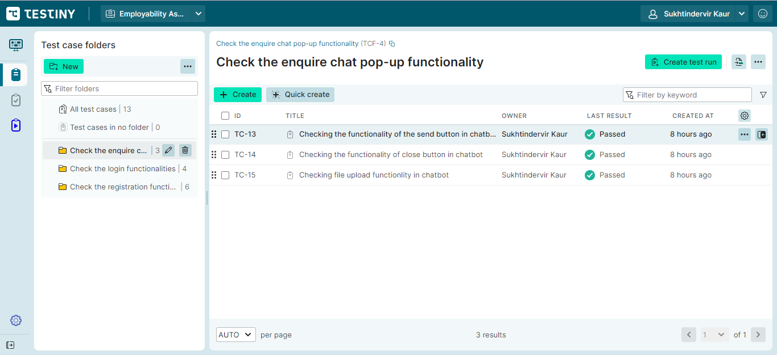

## Check the functionality of the send button in Chatbot

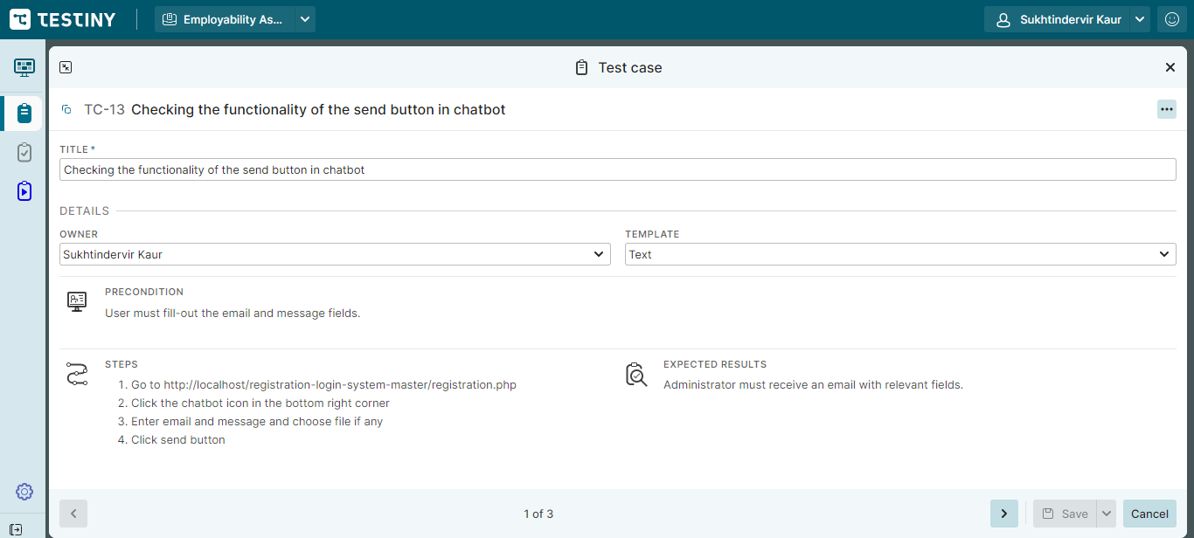

## Check the functionality of close button in chatbot

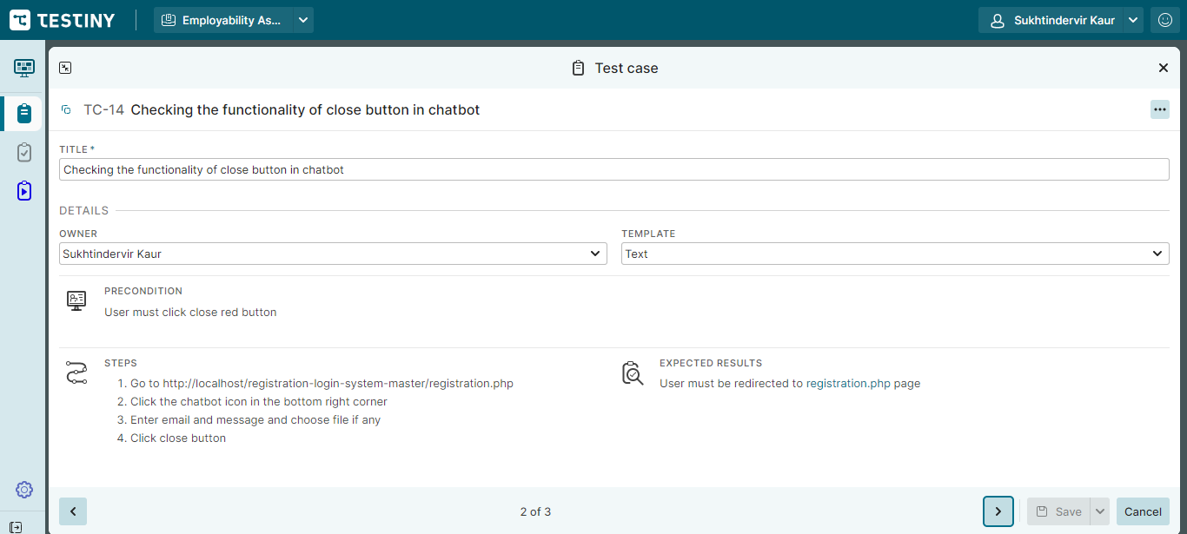

## Check the file upload functionality in chatbot

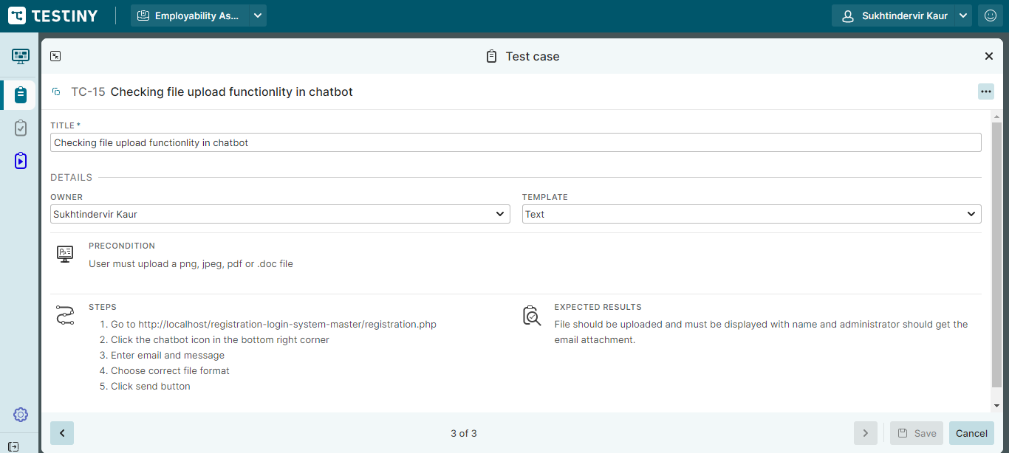

# Result report of chat pop-up functionality

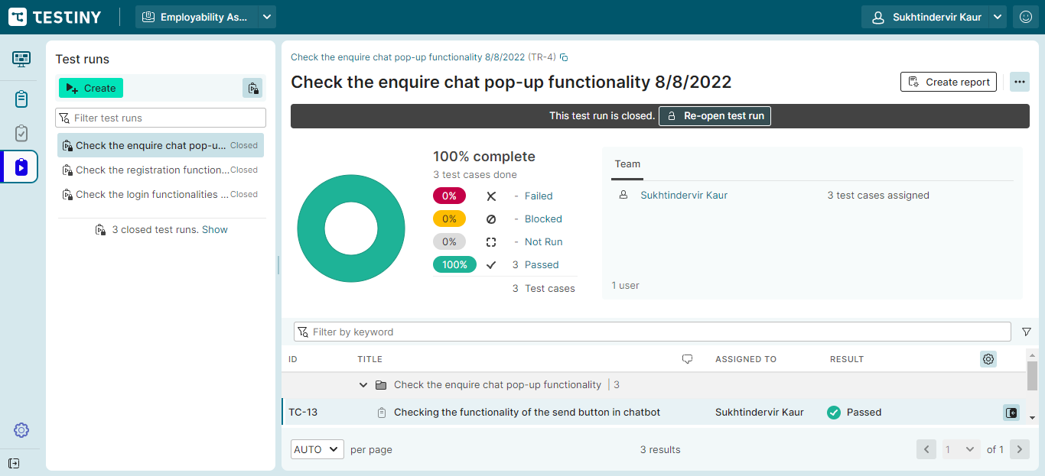

# Result report of all test cases

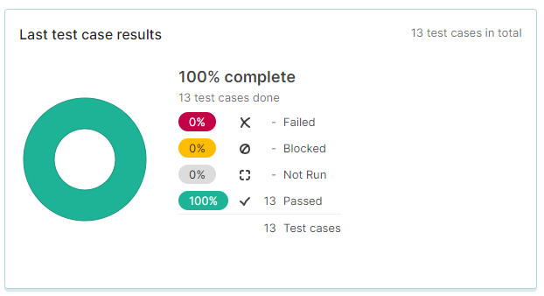

# Graphical representation of the test cases

