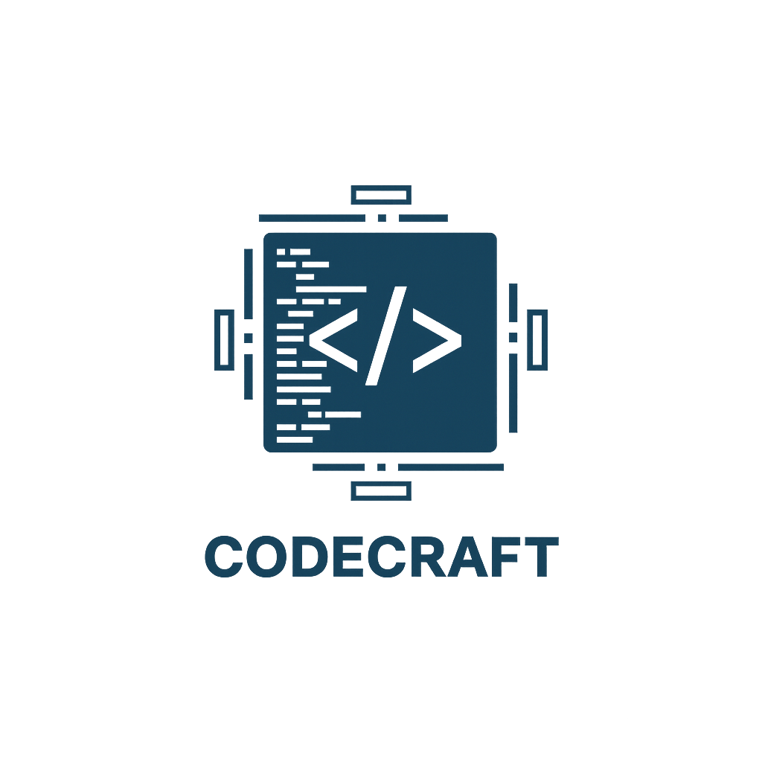
CodeCraft

Contents
1.About us 2
2.Idea of the project 2
3.Stages of working 3
4.Used technologies 3
5. Block diagram 4
6. Functions 5

1.About us
Name | Role | Grade
Ivaylo Georgiev | Scrum trainer | 9B
Toma Ivanov | Back-End Developer | 9A
Dimitar Bornusuzov | Back-End Developer | 9G
Ioan-Aleksandur Georgiev | Quality Engineer | 9A

2.Idea of the project
EduRise is an innovative math learning app designed to make problem-solving faster and more intuitive. With its clean interface and smart features, it helps students understand concepts step by step rather than just memorizing answers. The app offers interactive exercises and personalized learning paths that adapt to each user’s level.
What makes EduRise stand out is its focus on clarity and engagement—complex topics are broken down into simple, easy-to-follow explanations. Whether you're preparing for exams or just improving your skills, EduRise provides a smooth and effective learning experience.
Overall, EduRise is a promising tool for students who want to build confidence in math while learning in a modern, digital way.

3.Stages of working
№ | Stages
First Week | We created the idea and the working environment.
Second Week | We created the Main Menu, Login and Register.
Third Week | In the third week we created the lessons, the tests and also the statistics menu.
Fourth Week | In the fourth week we made the presentation and documentation and now the project is ready to be presented.

4.Used technologies
1. C++ - for creating the game.
2. Github – for the synchronization.
3. MS PowerPoint – for creating presentation.
4. MS Word – for creating documentation.
5. Visual Studio 2022 – for writing the code.

5. Block diagram

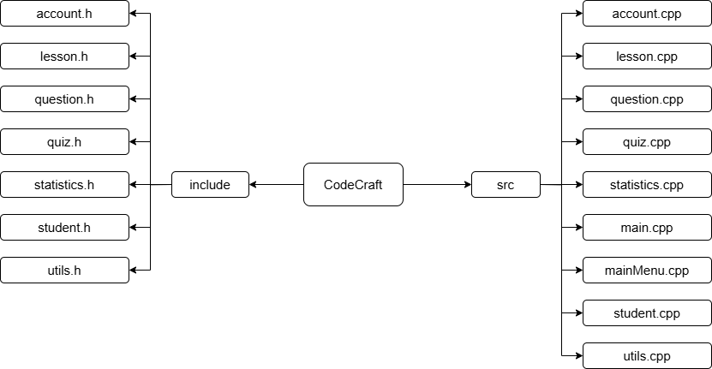

6. Functions

Type | Name
bool | saveAccounts()
bool | userExists()
bool | empty()
string | toCsv()
void | lessonMenu()
string | catName()
void | practiceMode()
void | showStats()
static | fromCsv()
void | display()
bool | saveResult()
void | cls()
void | waitEnter()
void | void bTop()
void | bDiv()
void | bBot()
void | bBlank()
void | bRow()
void | bBanner()
bool | showBanner()
string | inputLine()
string | cen()
string | hashPwd()
double | calcPct()
int | toGrade()
string | gradeStr()
string | gradeMsg()
void | mainMenu()

