DESKII
Design & UX Quality Assessment
Developer Implementation Guide v2.0 — Gap-Corrected Full Edition Savage LLC · June 2026 · Confidential

Product | Deskii — Internal Workforce Management Portal
Company | Savage LLC
Portal URL | internal-company-portal-savage-llc.vercel.app
Review Date | June 2026
Document Version | v2.0 — Gap-Corrected (replaces v1.0)
Total Issues | 47 issues (16 Bugs · 24 Visual · 6 UX · 1 Copy)
Gap Fixes in v2 | 6 previously-missing issues added; 3 wrong module attributions corrected; cover count corrected
Implementation Tool | OpenAI Codex (AI-assisted development)
Tech Stack | Next.js · Tailwind CSS · Supabase · Vercel

What Changed in v2 (Gap Sweep)
This is a gap-corrected edition of the original Design QA report. The following discrepancies were found in v1 and have been resolved in this version:
v1 Errors Corrected in v2
- COVER COUNT WRONG: v1 cover said '29 issues' but the table contained 40 rows. v2 cover correctly states 47 issues.
- MISSING ISSUE #33 (now #33): Payroll Scheduler 'Run Now' buttons are completely non-functional. v1 covered 'This Week' nav arrows but missed the Scheduler tab entirely.
- MISSING ISSUE #47 (new): Time Entry Audit view (/payroll-calendar → audit tab) has low-contrast icons in light mode. Entire view was absent from v1.
- WRONG MODULE — #32 in v1: Was labeled 'Onboarding' with 'All Statuses / All Departments' dropdowns. Those dropdowns are in Payslips Management, not Onboarding. Now correctly split into two issues: #36 (Payslips) and #37 (Employee Overview).
- WRONG DESCRIPTION — #7 in v1: Described as 'Calendar icon style inconsistent' but QA pg.4 shows the textarea/input focus ring being too thick. Now correctly described as focus ring issue.
- MISSING DATE PICKER UX NOTE (now #8): Designer explicitly showed a scroll-style date picker as a design reference. v1 only captured the 'remove blue box' fix and missed the picker style suggestion.
- INCOMPLETE — Profile birthday date icon: v1 merged this into issue #22 (profile layout) without a specific fix. Now issue #44 with its own Codex hint.
- INCOMPLETE — Light Mode issues: v1 had a thin single section; v2 breaks out each specific component (header icons #45, dashboard gradient #46, Time Entry Audit #47) with targeted fixes.
- PHASE TABLE FIXED: v1 phase table referenced issue numbers that didn't align with the 40-row table. v2 phase table uses updated, correct issue numbers.

Overview & Purpose
This document is the official Design & UX Quality Assessment for the Deskii internal portal (v2, gap-corrected). It is compiled from a comprehensive designer-led audit of the live portal and is the primary implementation guide for the development team working with Codex.

Deskii is Savage LLC's all-in-one workforce management platform — combining task management, payroll, time tracking, EOD daily logs, announcements, team chat, and file storage into a single workspace at internal-company-portal-savage-llc.vercel.app. The product's promise is simplicity and unification. The visual design must reflect that same clarity and consistency.
How to Use This Document
- Each issue is numbered 1–47, tagged by type (BUG / VISUAL / UX / COPY), and includes the affected module.
- Screenshots from the designer's original QA are embedded under each relevant section for direct visual reference.
- Codex-ready code snippets are provided under every issue with a non-trivial implementation.
- Section 3 covers Global Principles — apply these as a sweep first before individual page fixes.
- Section 6 provides a phase-ordered implementation guide and a dark/light mode testing checklist.
- PRIORITY ORDER: Phase 1 (critical bugs that break features) → Phase 2 (global design sweep) → Phase 3+ (per-page fixes).

Issue Summary Table
All 47 issues identified in the designer QA. Corrected from v1 (which incorrectly listed 29 issues on the cover despite containing 40).

# | Type | Module | Issue | Fix Focus
1 | VISUAL | Login Page | Negative space in center column — layout not centered on wide screens | Use 12-col grid; two-col or single centered card
2 | VISUAL | Login Page | No grid/column structure — layout ignores 12-column standard | Apply 12-col grid system (e.g. Tailwind grid-cols-12)
3 | VISUAL | Nav Header (Global) | Profile icon uses filled variant — inconsistent with outline notification + moon icons | Replace with outline UserCircle icon
4 | VISUAL | Nav Header (Light Mode) | Profile icon is white — invisible in day/light mode | Apply --icon-color token (dark in light, light in dark)
5 | VISUAL | Search Bar | Blue box outline on search bar Ctrl+K focus is unpolished | Remove default outline; apply custom 2px cyan ring
6 | VISUAL | Task Tracking | Button focus ring (blue outline) is too thick vs all other elements | Standardize to 2px outline with 2px offset globally
7 | VISUAL | Create Task Modal | Textarea/input focus blue box too thick; same ring issue on description field | Apply global focus ring fix; box-shadow: none on inputs
8 | UX | Create Task Modal | Date picker UI style: designer suggests scroll-picker style (dd / mm / yyyy) | Consider native  scroll-type date input or custom picker
9 | VISUAL | Create Task Modal | Calendar icon in date field uses wrong (filled/thick) style | Use outline calendar icon; apply  --icon-color token
10 | VISUAL | Create Task Modal | dd/mm/yyyy placeholder at full opacity — should be muted like other placeholders | Set color:  var(--placeholder-colo r) on date input
11 | BUG | Task Filters | Filter toggles low contrast in dark mode — light text on light bg | Fix color tokens: use CSS dark/light mode variants
12 | BUG | Task Filters | Filter panel bottom clipped — 'All Projects' section cut off | Add overflow-y: auto + padding-bottom: 16px to panel
13 | BUG | EOD Report Popup | Low contrast text in Generate Daily EOD Report popup (dark mode) | Use --text-primary token; test all text in both modes
14 | VISUAL | Task Tracking Toolbar | Generate EOD Report button is red — red signals urgency/danger not a report action | Change to cyan primary button variant
15 | VISUAL | Announcements | Update Announcement button uses pastel mint — fails contrast on dark bg | Apply standard cyan primary button style
16 | BUG | Announcements — Events | Event Date & Time combined in one input — should be two separate fields | Split into <input type=date> + <input type=time>
17 | BUG | Announcements — Events | Calendar icon in Edit Announcement date field has low contrast | Apply --icon-color token; use outline icon
18 | VISUAL | Calendar Toggle | Month/Week/Day toggle has inconsistent border-radius between items and container | border-radius: 6px on container, 0 on inner items
19 | BUG | Company Chat | Cannot type in Company Chat — input field is completely non-functional | Fix onChange handler; check pointer-events, z-index

# | Type | Module | Issue | Fix Focus
20 | VISUAL | Chat + Comments | Send button style doesn't match app theme (appears as plain box) | Restyle: bg-cyan, white icon, rounded-md, hover state
21 | BUG | Chat + Comments | Pressing Enter repeatedly duplicates messages/comments | Add isSending guard; preventDefault on Enter keydown
22 | UX | Announcements — Events | Going button: no hover state and no way to toggle back to Not Going | Add hover CSS + toggle state logic
23 | UX | Announcements — Events | Calendar icon at top-left of event card is redundant | Remove icon; event card context is self-evident
24 | UX | Quick Actions Modal | Shortcuts description text is an input/textarea  — not editable but reads as one | Change to <p> or  <span> element
25 | VISUAL | Daily Logs — Add Modal | Add Daily Log modal layout is asymmetrical (Date and Hours columns misaligned) | Use grid-cols-2 gap-4 to align date and hours fields
26 | COPY | Daily Logs | Log Type dropdown option reads 'Daily / EOD' — should read 'End of Day' | Rename string in LOG_TYPES options array
27 | BUG | Daily Logs | Saving a daily log fails — process is confusing and non-functional | Debug Supabase insert  + RLS on daily_logs; simplify UI
28 | VISUAL | Filters (Global) | Reset button appears as plain text, not a button — no visual affordance | Add border, bg, padding, cursor: pointer styling
29 | BUG | Payroll Calendar | Calendar/date icons low contrast throughout Payroll Calendar | Apply --icon-color token globally to all date icons
30 | BUG | Payroll Calendar | Clock in/out state not synced — 'Not clocked in' error on Clock Out click | Refetch clock status from DB on component mount
31 | VISUAL | Global | Capsule/pill border-radius used on elements; mismatched with slightly-angular theme | Cap all border-radius at 8px; remove rounded-full from  non-dot elements
32 | BUG | Onboarding | Cannot add new employee — Internal Server Error | Debug POST  /api/employees; check Supabase RLS on employees table
33 | BUG | Payroll Scheduler | Payroll Scheduler 'Run Now' buttons  non-functional — entire Scheduler tab broken | Debug Vercel Cron / scheduler API endpoint; log response
34 | BUG | Payslips Management | 'This Week' button and < > period arrows do not work on click | Fix click handlers; update selectedPeriod state on click
35 | VISUAL | Payslips Management | Summary/Detailed/Payslip Archive tab buttons low contrast (light on light) | Apply contrast-aware token; dark text on light bg in light mode
36 | VISUAL | Payslips Management | Dropdown buttons ('All Statuses', 'All Departments') too tight — text may clip | min-width: 160px; white-space: nowrap on dropdown triggers
37 | VISUAL | Employee Overview | Dropdowns ('Website Developers', 'Sort by Department') too tight — text clips | min-width: 180px; text-overflow: ellipsis on trigger
38 | BUG | File Directory | Cannot upload files — 'Failed to upload file' error | Fix Supabase Storage bucket name + RLS upload policy
39 | VISUAL | Onboarding / Roles | Red delete icon dominates role cards — visually overpowers the role name | Default gray icon; red only on hover
40 | UX | Onboarding / Roles | Roles are pre-fabricated — admins cannot create custom role names | Add Create Role flow; store roles in Supabase roles table

# | Type | Module | Issue | Fix Focus
41 | UX | Onboarding / Roles | Redundant auto-generated description under Role selector | Remove the 'This assigns X in Y' sentence
42 | BUG | Clients | Client details fail to load — multiple 'Failed to load' errors on click | Fix client fetch + RLS on clients/client_members tables
43 | VISUAL | Profile — Edit Modal | Profile page splits info + edit into two panels with awkward empty left column | Consolidate into single edit-in-place panel
44 | VISUAL | Profile — Edit Modal | Calendar icon in Birthday date field low contrast (both modes) | Apply --icon-color token to Birthday date field icon
45 | VISUAL | Global (Light Mode) | Header action icons (Clock Out, sun, bell, profile) low contrast in light mode | Apply --icon-color token; verify against light bg
46 | VISUAL | Dashboard (Light Mode) | Gradient separator line between header and Team Command Center | Remove decorative gradient divider element
47 | BUG | Time Entry Audit | Time Entry Audit view (Payroll Calendar → audit tab): low contrast icons in light mode | Apply --icon-color token; audit all icons in this view

Global Design Principles (Apply Site-Wide)
Apply these five principles as a single global sweep before touching individual page issues. They are recurring patterns that, once fixed at the token/component level, will resolve many of the individual issues listed above simultaneously.

Corner Radius Consistency
The Deskii brand is slightly angular — not pill/capsule, not sharp. The current build inconsistently mixes capsule (border-radius: 9999px) on some elements with the correct slight-radius on others.
Rule: No capsule borders on interactive elements
- Buttons, inputs, dropdowns, filter toggles: border-radius: 6px
- Cards, panels, modals: border-radius: 8px
- Toggle groups (Month/Week/Day, Summary/Detailed): outer 6px, inner items 0 (clipped by parent)
- Status indicator dots (●): may remain border-radius: 50% — these are intentionally circular
- Payroll Calendar header tag: currently capsule — fix to 6px
- NEVER: border-radius: 9999px / rounded-full on buttons, dropdowns, or input fields
/* Codex: Global border-radius sweep */
button, .btn { border-radius: 6px !important; }
input, select, textarea { border-radius: 6px !important; }
.card, .panel, .modal, [role='dialog'] { border-radius: 8px !important; }
.toggle-group { border-radius: 6px; overflow: hidden; }
.toggle-group > * { border-radius: 0 !important; }
.toggle-group > *:first-child { border-radius: 6px 0 0 6px !important; }
.toggle-group > *:last-child { border-radius: 0 6px 6px 0 !important; }
/* Remove any rounded-full from non-dot elements */
.rounded-full:not(.status-dot):not(.avatar) { border-radius: 6px !important; }

Contrast — Dark Mode & Light Mode
Multiple elements fail contrast in both modes. The root cause is missing or incorrectly applied CSS custom properties. A single token fix resolves all calendar icons, nav icons, and form label contrast globally.
Contrast Rules
- Dark background (#0D1117) → icons and text must be light (#CBD5E0 minimum)
- Light background (white/off-white) → icons and text must be dark (#4A5568 minimum)
- Minimum ratio: 4.5:1 (WCAG AA) for all body text and UI labels
- All calendar/date picker icons must use --icon-color (not hardcoded white or dark)
- Profile icon (white in light mode) → FAILS. Must adapt per mode
- Clock Out, bell, sun/moon icons in light mode: currently too light → FAILS
- Filter toggle text in dark mode: too light on light chip bg → FAILS

/* Codex: Add icon color tokens to globals.css or tailwind config */
:root {
--icon-color: #4A5568; /* visible on white/light */
--icon-color-muted: #9BA8B5;
--placeholder-color: rgba(155,168,181,0.6);
--text-primary: #1A1A1A;
--text-secondary: #4A5568;
}
.dark {
--icon-color: #CBD5E0; /* visible on dark navy */
--icon-color-muted: #718096;
--placeholder-color: rgba(155,168,181,0.5);
--text-primary: #FFFFFF;
--text-secondary: #9BA8B5;
}
/* Apply to ALL icons: */
svg.icon, .nav-icon, [data-icon] { color: var(--icon-color); }

Focus Ring Standardization
The blue focus ring appears with inconsistent thickness (1px to 4px+) across elements. All interactive elements must share the same 2px cyan ring.
/* Codex: Standardize all focus rings globally */
*:focus { outline: none; }
*:focus-visible {
outline: 2px solid #00BCD4; outline-offset: 2px;
box-shadow: none;
}
/* Remove browser default on date/time inputs specifically */ input[type='date']:focus,
input[type='time']:focus, input[type='datetime-local']:focus {
outline: 2px solid #00BCD4; outline-offset: 2px;
box-shadow: none;
}
input[type='date']::-webkit-calendar-picker-indicator { color: var(--icon-color);
opacity: 0.7; cursor: pointer;
}

  - Icon Style — Outline Only
Icon Standard (Global)
- All icons: outline/stroke variants ONLY — no filled icons
- Recommended: Heroicons (outline), Lucide React (default strokeWidth 1.5–2), or Phosphor (Regular weight)
- Profile/user icon: UserCircle (outline) — NOT UserSolid
- Calendar icons: CalendarDays (outline) — apply --icon-color token

- Send/paper-plane: PaperAirplane (outline)
- Delete/trash: TrashIcon (outline) — gray default, red on hover only
- Do NOT mix filled and outline icons on the same page

  - Color Semantics — Reserve Red for Danger Only
Color Usage Rules
- Cyan #00BCD4 → Primary CTAs: Save, Create, Submit, Generate, Update, Send
- Gray #4A5568 → Secondary/neutral: Cancel, Reset, Filters, secondary nav
- Red #E53E3E → ONLY: delete confirmations, error states, destructive irreversible actions
- Orange #ED8936 → warnings, caution states only
- Green #38A169 → success, confirmed, active states
- NEVER use red for: report generation, announcements, routine task actions
- NEVER use pastel colors on dark backgrounds — they fail contrast

Page-by-Page Issue Details
Each subsection includes the original QA screenshot, issue description, and Codex-ready implementation guidance. Issues are grouped by page/module.

Login Page — /login

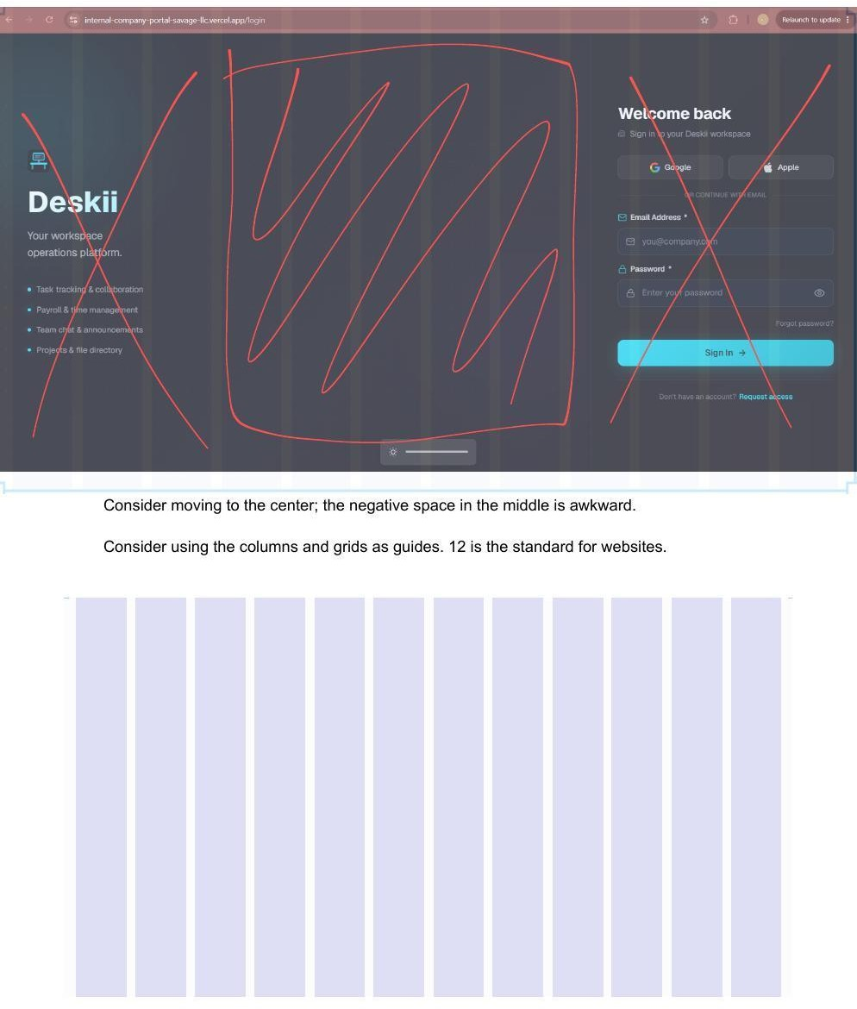

#1–2 Layout: Centered design + 12-column grid | VISUAL | pg. 1

The login page has significant dead space in the center column. The Deskii branding sits left-anchored and the form right-anchored with an empty middle third. Additionally, the layout does not follow a
12-column grid, which is the standard for web interfaces.

/* Codex: Fix login page — two-column centered 12-col grid */
<div className='min-h-screen flex items-center justify-center bg-[#0D1117]'>
<div className='grid grid-cols-12 gap-8 max-w-5xl w-full px-8'>
{/* Branding: cols 1-5 */}
<div className='col-span-5 flex flex-col justify-center'>
<Logo /><Tagline /><FeatureList />
</div>
{/* Gutter: col 6 */}
<div className='col-span-1' />
{/* Login Form: cols 7-12 */}
<div className='col-span-6'>
<LoginCard />
</div>
</div>
</div>

Navigation Header — Global

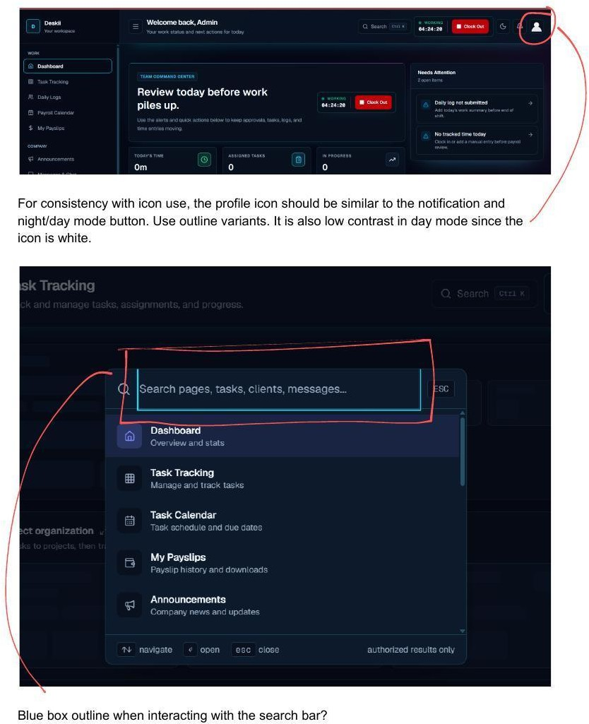

#3–4 Profile Icon — Style & Contrast | VISUAL | pg. 2

The profile icon uses a filled variant, inconsistent with the outline notification bell and day/night toggle. In light/day mode, the white icon becomes invisible against the light navigation background.

// Codex: Replace profile icon — outline + contrast-aware color import { UserCircle } from 'lucide-react' // outline by default

<button className='nav-action-btn'>
<UserCircle size={24} strokeWidth={1.5}
className='text-[var(--icon-color)] hover:text-[#00BCD4] transition-colors'
/>
</button>

/* Ensure --icon-color is set: dark in light mode, light in dark mode */
/* See Section 3.2 token definition */

#5 Search Bar — Blue Box Outline on Focus | VISUAL | pg. 2

When the Ctrl+K search modal opens, a thick browser-default blue outline appears around the search input. This is an un-overridden browser focus style.
/* Codex: Style search modal input */
.search-modal-input:focus { outline: none;
border: 1px solid #00BCD4;
box-shadow: 0 0 0 2px rgba(0, 188, 212, 0.15);
}

Task Tracking — /task-tracking

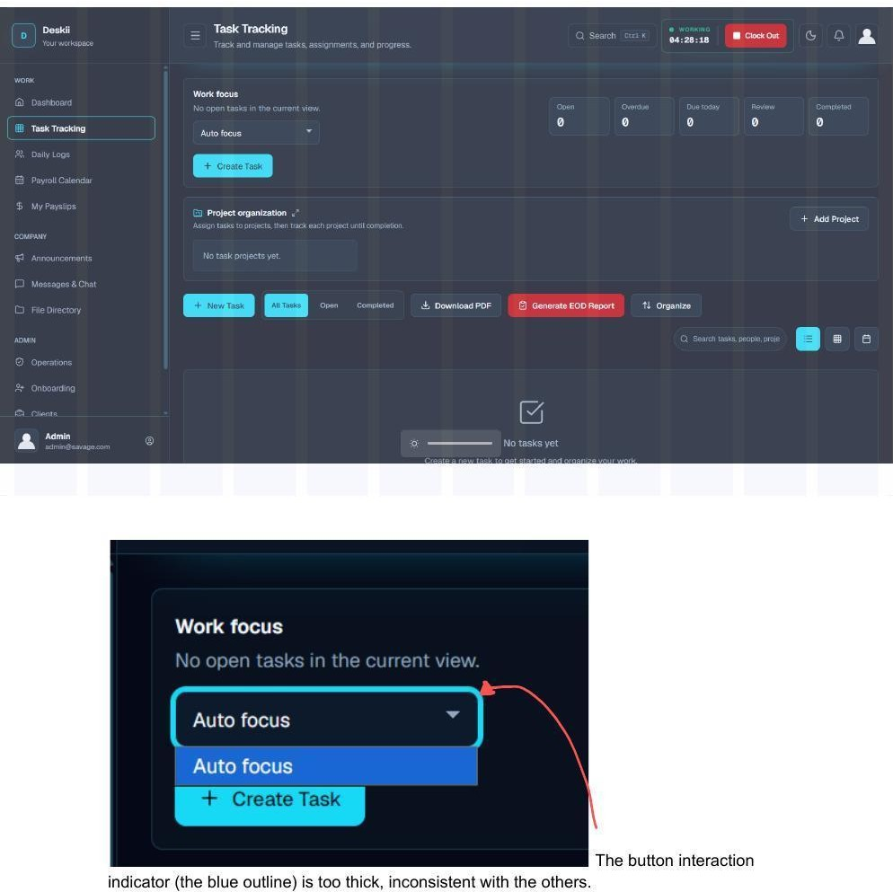

#6 Button Focus Ring Too Thick | VISUAL | pg. 3

The Auto Focus dropdown and task action buttons display a 3–4px thick blue focus ring when selected, inconsistent with the 1–2px rings on other elements. Apply the global focus ring fix from Section 3.3.

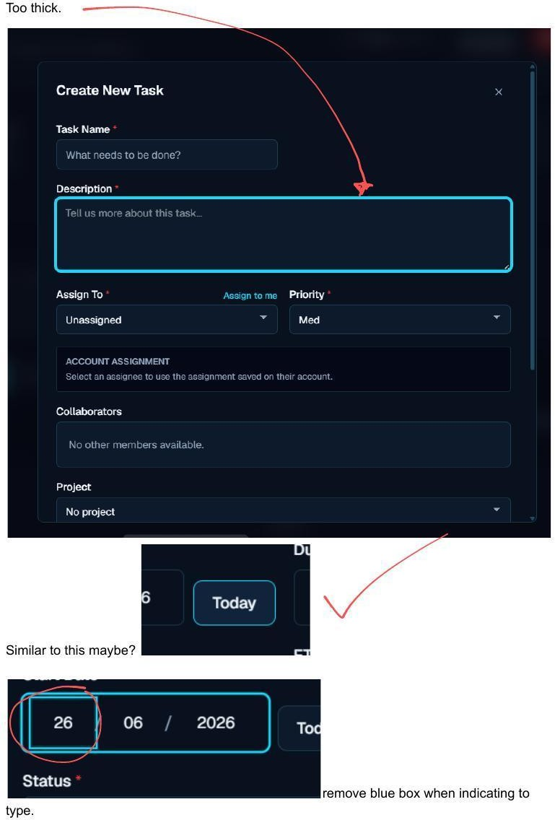

#7–10 Create Task Modal — Focus Ring, Date Picker, Icon, Placeholder | VISUAL | pg. 4

Four compounding issues in the Create New Task modal:
    - Issue #7: The description textarea shows the same oversized blue focus ring — apply global fix.

    - Issue #8: Designer suggests a scroll-picker style for the date field (shows circular day/month/year scroll). Consider replacing the flat date input with a segmented or scroll-style date picker.
    - Issue #9: Calendar icon in the date field uses the wrong (filled) style — replace with outline variant and apply --icon-color token.
    - Issue #10: The dd/mm/yyyy placeholder text appears at full opacity. It must be muted to match the placeholder style of all other inputs.
/* Codex: Fix Create Task date input — all four issues */

/* #7 & Global: focus ring */
input:focus-visible, textarea:focus-visible, select:focus-visible { outline: 2px solid #00BCD4;
outline-offset: 2px; box-shadow: none;
}

/* #9: Calendar icon color */
input[type='date']::-webkit-calendar-picker-indicator { opacity: 0.65;
filter: var(--calendar-icon-filter); /* define per mode */
}

/* #10: Muted placeholder on date inputs */ input[type='date']:not([value]):not(:focus) {
color: var(--placeholder-color);
}

/* #8: If using a custom date picker component, use segmented input: */
/* <DateInput segments={['dd','mm','yyyy']} /> */
/* or use @internationalized/date with a scroll-picker UI */

Task Filters & EOD Report — /task-tracking

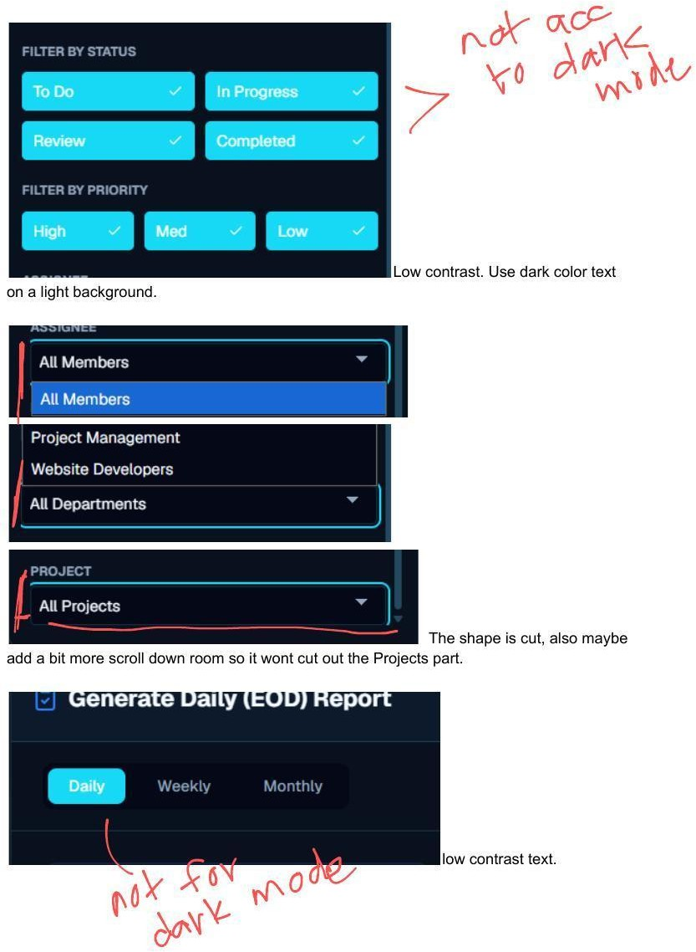

#11 Filter Panel — Low Contrast in Dark Mode | BUG | pg. 5

The Filter By Status / Filter By Priority toggle chips show light-colored text on a light chip background in dark mode. The color tokens are not theme-aware.
/* Codex: Fix filter toggle contrast */

.filter-chip {
background: transparent;
border: 1px solid var(--border-color); color: var(--text-primary);
}
.filter-chip.active { background: #00BCD4; border-color: #00BCD4; color: #FFFFFF;
}
.dark .filter-chip { color: #CBD5E0; border-color: #2D3748; }

#12 Filter Panel Clipped — Projects Section Cut Off | BUG | pg. 5

The filter dropdown panel's bottom edge is cropped, hiding the 'All Projects' section. Add scroll and bottom padding.
/* Codex: Fix filter panel overflow */
.filter-dropdown-panel { max-height: 75vh; overflow-y: auto; padding-bottom: 20px;
}

#13–14 EOD Report — Low Contrast Popup & Red Button | BUG | pg. 5–6

Issue #13: The Generate Daily EOD Report popup has low-contrast text in dark mode — color tokens not applied. Issue #14: The Generate EOD Report toolbar button is red, signaling urgency or danger for what is a routine action.
// Codex: Fix EOD Report button color
// Before: variant='danger' or custom red class
// After:
<Button className='bg-[#00BCD4] hover:bg-[#0097A7] text-white font-medium'>
<CheckIcon size={16} className='mr-1.5' /> Generate EOD Report
</Button>

/* Fix popup text contrast: */
.eod-report-popup * { color: var(--text-primary); }
.eod-report-popup .muted { color: var(--text-secondary); }

Announcements — /announcements

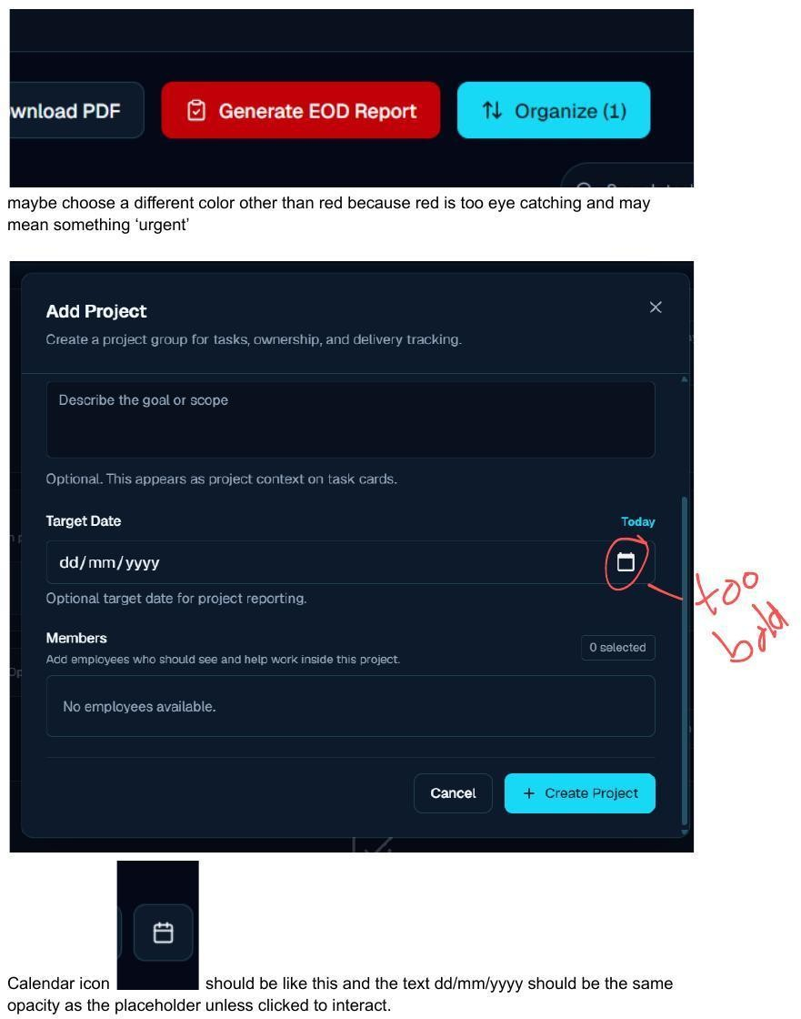

#15 Add Project — Calendar Icon Low Contrast | BUG | pg. 6

The calendar icon in the Add Project Target Date field is nearly invisible. Apply the --icon-color token to the date picker indicator. This is one of many instances of the same issue — the Section 3.2 global token fix will resolve all simultaneously.

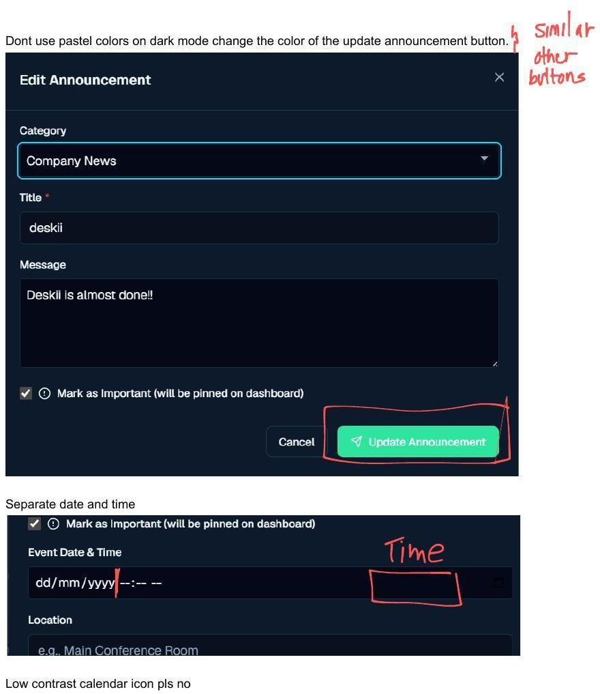

#15–17 Announcements Edit — Pastel Button, Combined Date/Time, Low-Contrast Icon | VISUAL/BU G | pg. 9

- Issue #15: Update Announcement button uses pastel mint — fails contrast on dark. Change to cyan primary button.
- Issue #16: Event Date & Time are combined in one field (datetime-local). Split into a date field and a time field.
- Issue #17: Calendar icon in the Edit Announcement date field is low contrast. Apply --icon-color token.
// Codex: Split Event Date & Time + fix button color

// 1. Split datetime into two fields:
<div className='grid grid-cols-2 gap-4'>
<div>
<label className='text-sm font-medium'>Date</label>
<input type='date' name='eventDate' className='input-base' />
</div>
<div>
<label className='text-sm font-medium'>Time</label>
<input type='time' name='eventTime' className='input-base' />
</div>
</div>

// 2. Fix Update Announcement button:
<Button variant='primary'> {/* primary = cyan */}
<PaperAirplaneIcon size={16} className='mr-1.5' /> Update Announcement
</Button>

Calendar Toggle — Month / Week / Day

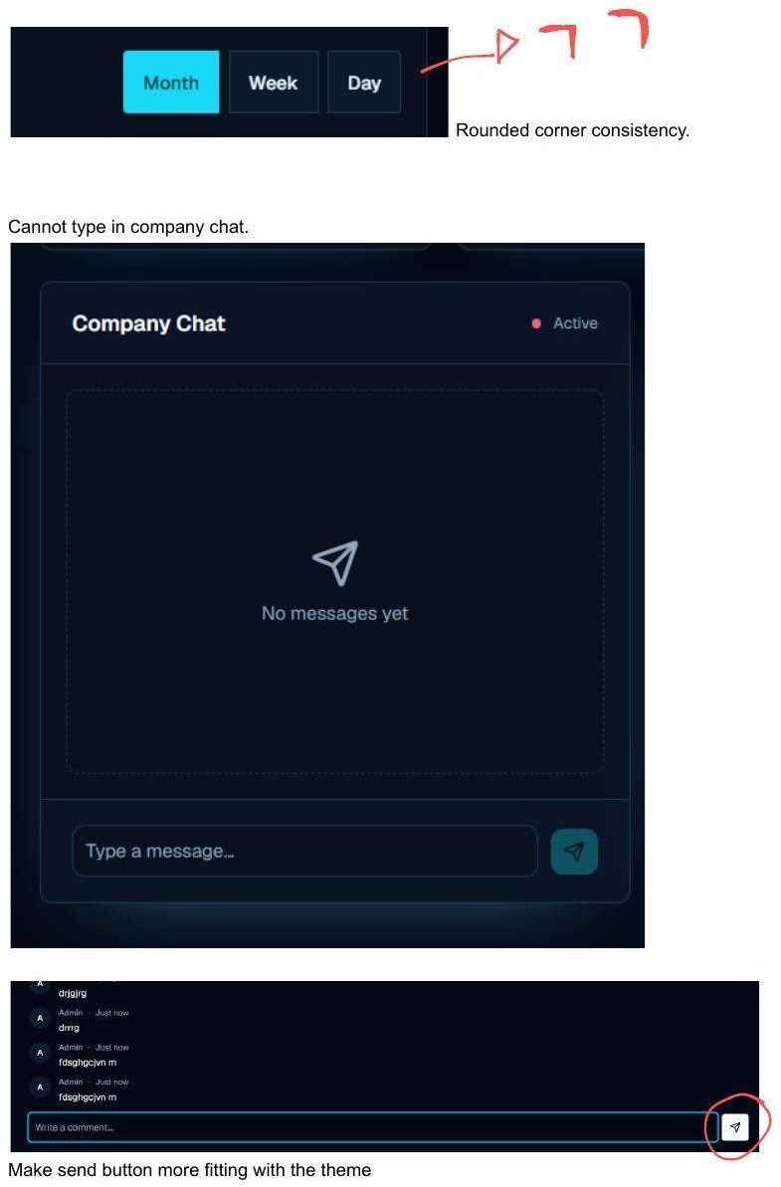

#18 Calendar Toggle — Inconsistent Rounded Corners | VISUAL | pg. 7

The Month/Week/Day toggle buttons have mismatched corner radii — the container and individual buttons do not share a consistent rounding pattern. The active 'Month' button appears more rounded than the inactive ones.
/* Codex: Fix calendar toggle border-radius */
.calendar-toggle-group {

display: inline-flex; border-radius: 6px;
overflow: hidden; /* clips children to group radius */ border: 1px solid var(--border-color);
}
.calendar-toggle-group button {
border-radius: 0; /* no individual radius */ border: none;
padding: 6px 16px;
transition: background 0.15s, color 0.15s;
}
.calendar-toggle-group button.active { background: #00BCD4;
color: #FFFFFF;
}

Messages & Company Chat — /messages



#19 Company Chat — Input Field Non-Functional | BUG | pg. 7

Clicking the 'Type a message...' input in Company Chat does not focus it — keyboard input is not captured. This is a critical bug that makes the entire chat module unusable. Likely causes: z-index overlay, pointer-events: none on the input, or a missing state handler.

// Codex: Debug and fix Company Chat input
// 1. Check for pointer-events: none on input or parent
// 2. Check for overlapping div with higher z-index
// 3. Verify state binding:
const [message, setMessage] = useState('')
const [isSending, setIsSending] = useState(false)

<textarea value={message}
onChange={(e) => setMessage(e.target.value)} onKeyDown={(e) => {
if (e.key === 'Enter' && !e.shiftKey) { e.preventDefault()
handleSend()
}
}}
placeholder='Type a message...'
className='w-full resize-none bg-transparent' // ensure no pointer-events-none style={{ pointerEvents: 'auto' }} // explicit override if needed
/>

#20 Send Button — Off-Theme Styling | VISUAL | pg. 7

The send button in both Company Chat and the announcement comment section appears as a plain box or unstyled square. It must match the application's cyan action button style.
// Codex: Restyle send button in chat and comments
<button onClick={handleSend}
disabled={isSending || !message.trim()} className='w-9 h-9 flex items-center justify-center
bg-[#00BCD4] hover:bg-[#0097A7] text-white rounded-md transition-colors
disabled:opacity-40 disabled:cursor-not-allowed'
>
<PaperAirplaneIcon size={16} />
</button>

Announcement Events — Interaction Bugs

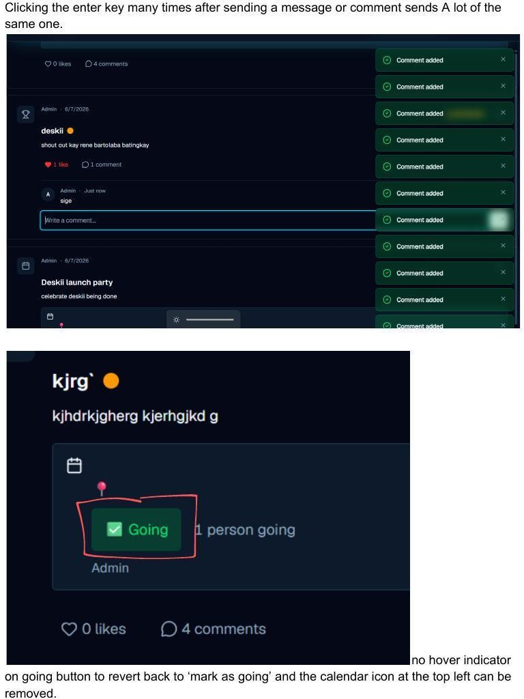

#21 Duplicate Messages on Enter Key Hold | BUG | pg. 8

Pressing and holding Enter (or pressing it multiple times rapidly) after submitting a comment or message creates duplicate entries. The submit handler has no guard against concurrent sends.
// Codex: Prevent duplicate message submission

const [isSending, setIsSending] = useState(false)

const handleSend = async () => {
if (isSending || !message.trim()) return // guard setIsSending(true)
try {
await submitMessage({ content: message, ... }) setMessage('')
} catch (err) {
console.error('Send failed:', err)
} finally {
setIsSending(false) // always re-enable
}
}

// In the input onKeyDown:
if (e.key === 'Enter' && !e.shiftKey) { e.preventDefault() // prevent newline AND repeat fire handleSend()
}

#22–23 Going Button — No Hover, No Toggle + Redundant Calendar Icon | UX | pg. 8

Issue #22: The 'Going' button on event cards has no hover state (users can't tell it's interactive) and no way to revert back to 'Not Going' once clicked. Issue #23: The calendar icon at the top-left of event cards is redundant — the event card format already makes context clear. Remove it.
// Codex: Going button — add hover + toggle const [isGoing, setIsGoing] = useState(false)

<button
onClick={() => toggleGoing(eventId)} className={`
px-3 py-1.5 text-sm font-medium rounded-md transition-all duration-150
${isGoing
? 'bg-[#00BCD4] text-white hover:bg-red-500'
: 'border border-[#00BCD4] text-[#00BCD4] hover:bg-[#00BCD4] hover:text-white'
}
`}
title={isGoing ? 'Click to cancel' : 'Mark as going'}
>
{isGoing ? '✓ Going' : 'Mark as Going'}
</button>

// Remove calendar icon from event card header:
// Delete or comment out the <CalendarIcon /> at top-left of EventCard component

Quick Actions — Dashboard Shortcut Modal

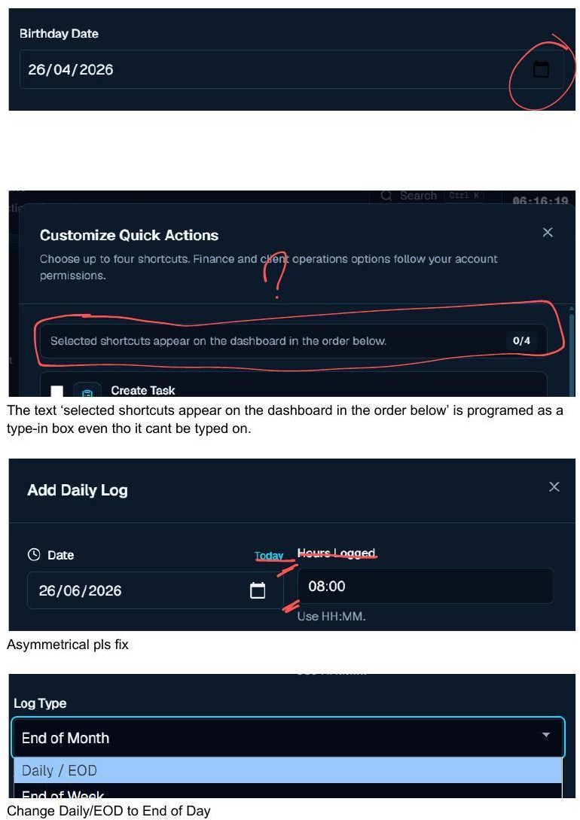

#24 Shortcuts Description Rendered as Editable Input | UX | pg. 10

The text 'Selected shortcuts appear on the dashboard in the order below.' is wrapped in an input or textarea element. It receives focus and shows a cursor when clicked, despite being read-only. This confuses users and implies it can be edited.
// Codex: Change shortcuts description from input to plain text

// REMOVE:

<input
value='Selected shortcuts appear on the dashboard in the order below.' readOnly
className='...'
/>

// REPLACE WITH:
<p className='text-sm text-[var(--text-secondary)] px-3 py-2 bg-[var(--surface-muted)] rounded-md'>
Selected shortcuts appear on the dashboard in the order below.
</p>

Daily Logs — /daily-logs



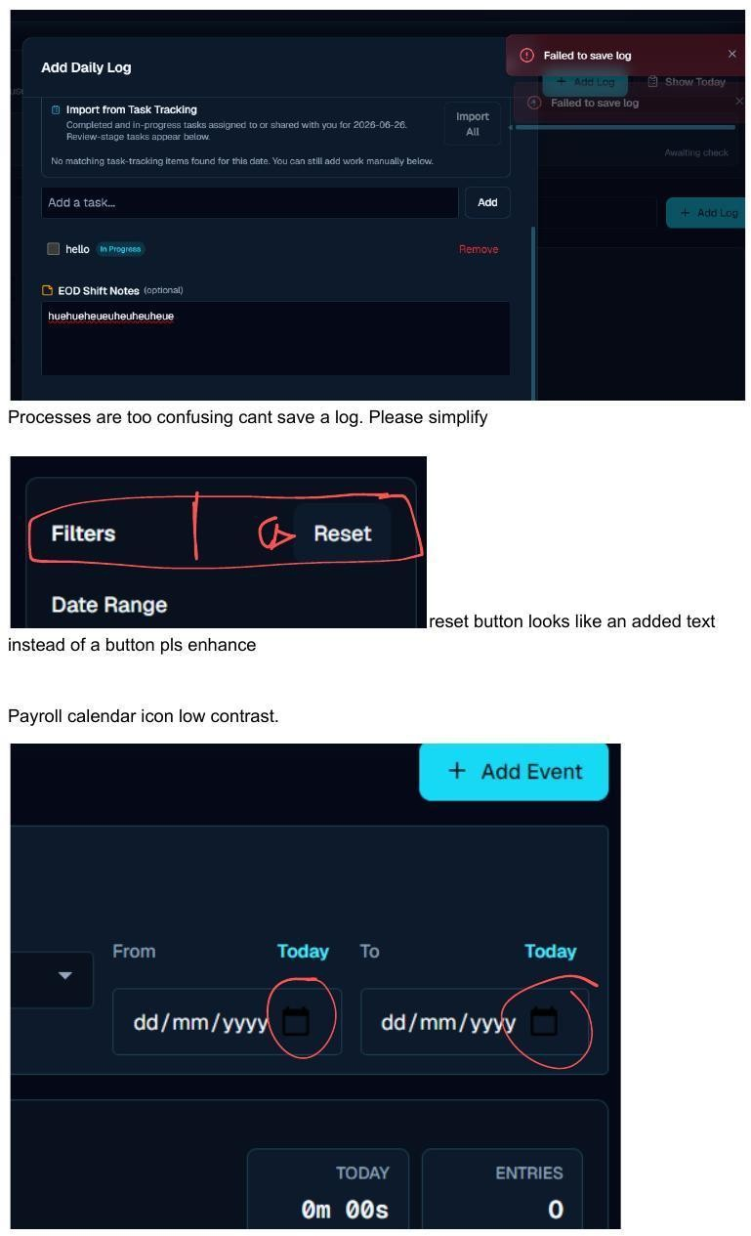

#25 Add Daily Log Modal — Asymmetrical Layout | VISUAL | pg. 10

The Date and Hours Logged columns in the Add Daily Log modal are visibly misaligned — the calendar icon and hours input are not in the same vertical rhythm.
/* Codex: Fix Add Daily Log grid alignment */

.daily-log-row { display: grid;
grid-template-columns: 1fr 1fr; gap: 16px;
align-items: center;
}
/* Ensure Date and Hours columns share same input height */
.daily-log-row input, .daily-log-row .date-display { height: 40px; line-height: 40px;
}

#26 Log Type Label — 'Daily / EOD' → 'End of Day' | COPY | pg. 10

The Log Type dropdown option reads 'Daily / EOD'. This should be 'End of Day' — consistent with how the feature is described throughout the product and documentation.
// Codex: Rename log type option in the options array const LOG_TYPE_OPTIONS = [
{ value: 'eod', label: 'End of Day' }, // was: 'Daily / EOD'
{ value: 'end_of_week', label: 'End of Week' },
{ value: 'end_of_month', label: 'End of Month' },
]

#27 Daily Log Save Fails — Process Too Confusing | BUG | pg. 11

Saving a daily log shows a 'Failed to save log' error. The multi-step flow (Import All → Add → Save) is also confusing and non-obvious. Both the UX and the underlying save must be fixed.
- Debug the daily_logs Supabase insert — check RLS policy allows the authenticated user to INSERT for their own employee record.
- Check that employee_id, date, and log_type are included in the insert payload.
- Simplify the UI: a single 'Save Log' button should submit all entries at once with a loading/success state.
- The Import from Task Tracking step can remain but should be clearly labeled as optional.
// Codex: Fix daily log save
const saveDailyLog = async (logData) => { const { data, error } = await supabase
.from('daily_logs')
.insert({
employee_id: currentUser.id, // REQUIRED — check this is included date: format(new Date(), 'yyyy-MM-dd'),
log_type: logData.logType, notes: logData.notes, tasks: logData.tasks,
})
if (error) {
console.error('Log save error:', error.message, error.hint) throw error
}
return data
}

#28 Reset Filters Button Looks Like Plain Text | VISUAL | pg. 11

The 'Reset' label next to the Filters heading has no visual affordance — no border, no background, no cursor — making it look like static text rather than a clickable button.
/* Codex: Add button affordance to Reset */
.reset-filters-btn { display: inline-flex; align-items: center; gap: 6px;
padding: 3px 10px;
border: 1px solid var(--border-color); border-radius: 6px;
font-size: 13px;
color: var(--text-secondary); cursor: pointer;
background: transparent; transition: all 0.15s;
}
.reset-filters-btn:hover { background: var(--surface-hover); color: var(--text-primary);
}

Payroll Calendar — /payroll-calendar



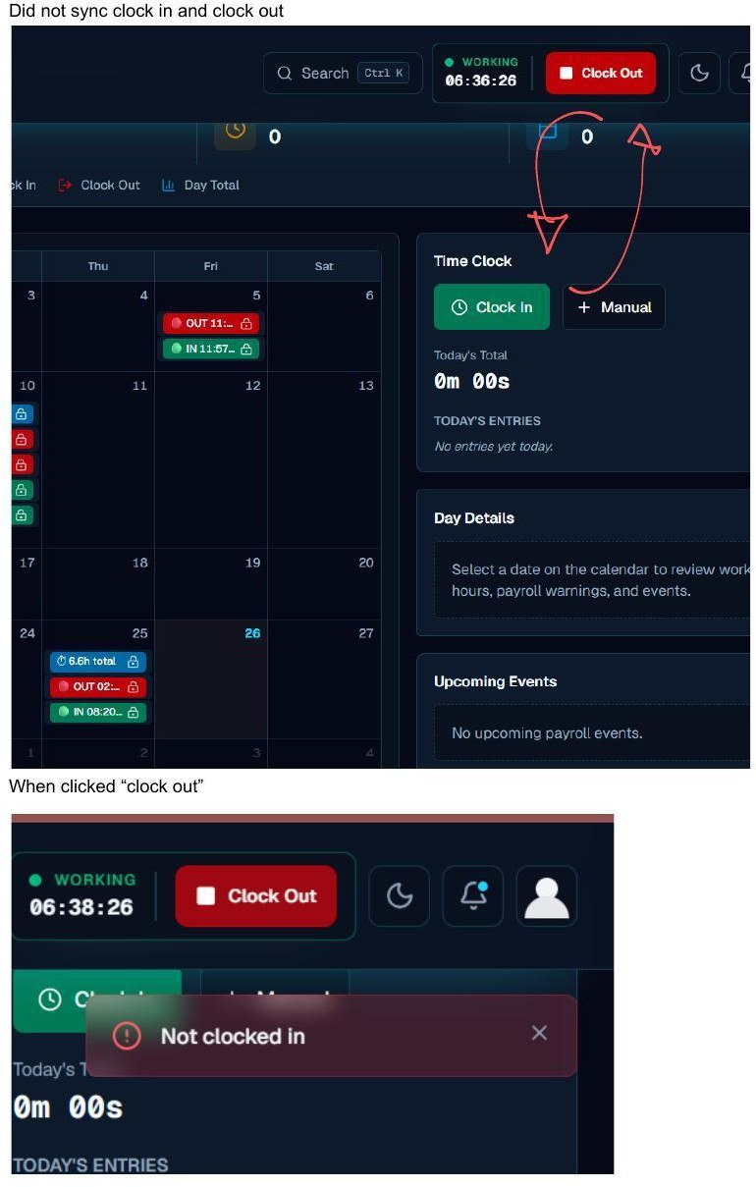

#29 Calendar Icons — Low Contrast Throughout Payroll Calendar | BUG | pg. 11–12

The calendar/date picker icons in the Payroll Calendar (date range filters, payroll period fields) are nearly invisible in both modes. This is the same root cause as all other calendar icon contrast issues — the Section 3.2 global token fix resolves it here too.

#30 Clock In / Out State Not Syncing | BUG | pg. 12

Clicking 'Clock Out' from the header bar while on the Payroll Calendar page throws a 'Not clocked in' error in the Time Clock panel, even though the header shows WORKING status. The clock-in state is read from different sources in the header vs the Time Clock component.
// Codex: Fix clock-in/out state sync
// Root cause: header reads clock state from context/local state;
// TimeClock component reads independently from DB.
// Fix: both must read from the same source (Supabase).

// In TimeClock component, fetch on mount: useEffect(() => {
const fetchClockStatus = async () => { const { data } = await supabase
.from('time_entries')
.select('*')
.eq('employee_id', currentUser.id)
.is('clock_out_time', null)
.single()
setCurrentEntry(data) // null = not clocked in
}
fetchClockStatus()
}, [])

// Clock Out should reference currentEntry.id, not header context

Payroll Scheduler — /payroll-calendar → Scheduler Tab

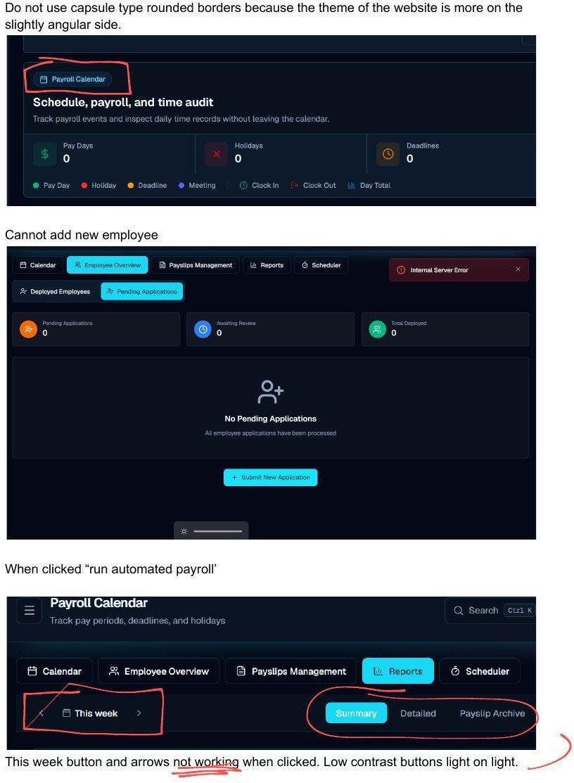

#33 Payroll Scheduler 'Run Now' Buttons Non-Functional | BUG | pg. 13

NEW in v2 — Missing from v1. The Payroll Scheduler tab contains four automated job triggers: Period Advance, Auto Payslip Generation, Department Cost Report, and Client Invoice Generation. Each has

a 'Run Now' button. None of them respond to clicks. The 'Recent Job Runs' section remains empty after triggering.
    - This is likely a Vercel Cron job configuration issue OR the manual trigger API endpoint is broken.
    - Check the /api/payroll/scheduler or equivalent endpoint — verify it exists and returns correctly.
    - Add loading state to each 'Run Now' button while the job is triggering.
    - Surface a success or error toast after each trigger attempt.
// Codex: Fix Payroll Scheduler 'Run Now' buttons const runSchedulerJob = async (jobType) => {
setRunning(jobType) try {
const res = await fetch('/api/payroll/run-job', { method: 'POST',
headers: { 'Content-Type': 'application/json' }, body: JSON.stringify({ job: jobType }),
})
const data = await res.json()
if (!res.ok) throw new Error(data.error || 'Job failed') toast.success(`${jobType} completed successfully`) refetchJobHistory()
} catch (err) {
console.error('Scheduler error:', err) toast.error(err.message)
} finally { setRunning(null)
}
}

Payslips Management — /payroll-calendar → Payslips Tab



#34 'This Week' Button & Period Arrows Non-Functional | BUG | pg. 13

The 'This Week' button and the left/right navigation arrows for period selection in Payslips Management do not respond to clicks. Period navigation is completely broken.

// Codex: Fix period navigation in Payslips Management const [period, setPeriod] = useState(getCurrentWeek())
const goBack
= () => setPeriod(prev => subWeeks(prev, 1))
const goForward = () => setPeriod(prev => addWeeks(prev, 1)) const goToToday = () => setPeriod(getCurrentWeek())

// Verify onClick is attached and not swallowed by a parent element:
<button onClick={goBack} aria-label='Previous period'> ← </button>
<button onClick={goToToday} className='btn-secondary'>This Week</button>
<button onClick={goForward} aria-label='Next period'> → </button>

// Also ensure period state change triggers a data refetch: useEffect(() => { fetchPayslips(period) }, [period])

#35 Payslips Tabs Low Contrast in Light Mode | VISUAL | pg. 13

The Summary / Detailed / Payslip Archive tab selector buttons in Payslips Management are low contrast in light mode — light text on a light background. The active tab is also hard to distinguish.
/* Codex: Fix Payslips tab contrast */
.payslips-tab {
color: var(--text-secondary);
border-bottom: 2px solid transparent; padding: 8px 16px;
font-size: 14px; transition: all 0.15s;
}
.payslips-tab:hover { color: var(--text-primary); }
.payslips-tab.active { color: #00BCD4;
border-bottom-color: #00BCD4; font-weight: 600;
}

#36 Payslips Dropdowns Too Tight — Text Clips | VISUAL | pg. 14

The 'All Statuses' and 'All Departments' filter dropdowns in Payslips Management are too narrow. The label text is clipped or overflows the button.
/* Codex: Fix Payslips filter dropdown sizing */
.payslips-filter-dropdown { min-width: 150px;
white-space: nowrap; overflow: hidden;
text-overflow: ellipsis; padding: 6px 12px 6px 10px;
}

Employee Overview — /onboarding → Employee Overview

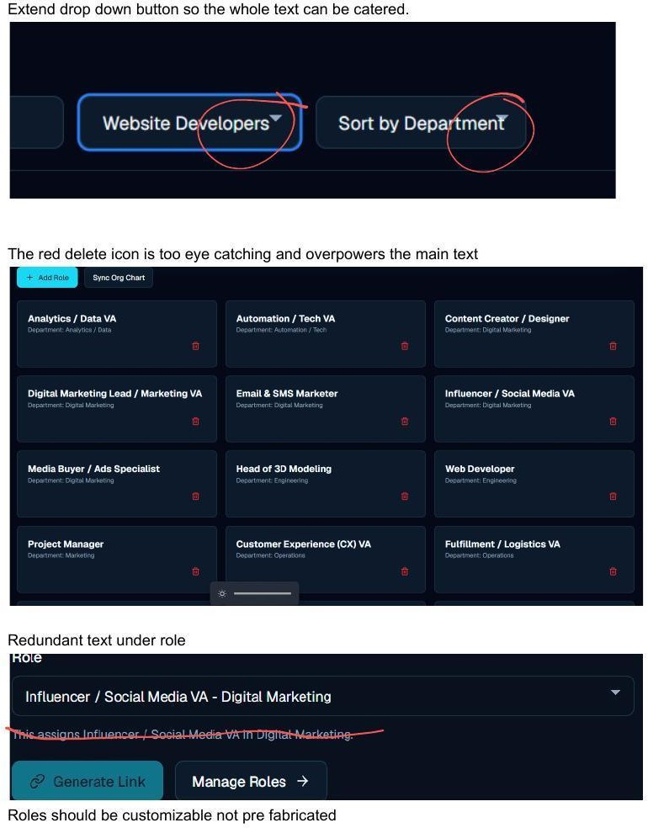

#37 Employee Overview Dropdowns Too Tight | VISUAL | pg. 15

NEW precise attribution in v2 — v1 incorrectly attributed this to Payslips. The 'Website Developers' and 'Sort by Department' dropdowns on the Employee Overview page are too narrow, causing text to overflow or be truncated.
/* Codex: Fix Employee Overview dropdown widths */
.employee-filter-dropdown {
min-width: 180px; /* wider — 'Website Developers' is long */ white-space: nowrap;
padding: 6px 32px 6px 12px; /* extra right padding for the arrow */ text-overflow: ellipsis;
overflow: hidden;
}

Onboarding — /onboarding



#32 Cannot Add New Employee — Internal Server Error | BUG | pg. 13

Submitting a new employee application results in an Internal Server Error toast. The employee creation flow is completely broken. Diagnose as follows:
    - Check the API route handling POST /api/employees or the equivalent Supabase direct insert.
    - Verify RLS policy: does the authenticated admin have INSERT permission on the employees table?

    - Check if required fields (department_id, role_id) are missing from the payload and failing server-side validation.
    - Review Vercel function logs for the full error trace and stack.
// Codex: Add error logging to employee creation const createEmployee = async (formData) => {
const { data, error } = await supabase
.from('employees')
.insert({
full_name: formData.name, email: formData.email,
department_id: formData.departmentId, role_id: formData.roleId,
status: 'pending',
})
if (error) {
console.error('Employee creation failed:', { message: error.message,
details: error.details, hint: error.hint,
code: error.code,
})
throw error
}
}

Roles Management — /onboarding → Roles



#39 Red Delete Icon Dominates Role Cards | VISUAL | pg. 15

The trash icon on each role card is bright red at full intensity at all times. This makes the delete action the most visually prominent element on every card, overpowering the role name and department text.
/* Codex: Mute delete icon; reveal red only on hover */

.role-card .delete-btn {
color: var(--icon-color-muted); /* gray default */ opacity: 0.6;
transition: color 0.15s, opacity 0.15s;
}
.role-card:hover .delete-btn { opacity: 1; }
.role-card .delete-btn:hover { color: #E53E3E; }

#40–41 Roles Pre-Fabricated + Redundant Description Text | UX | pg. 15

Issue #40: Roles are hardcoded (Analytics/Data VA, Web Developer, etc.) rather than admin-creatable. For Deskii's diverse target market (agencies, retail, healthcare, logistics), pre-built role names are too niche. Issue #41: Selecting a role auto-generates redundant helper text: 'This assigns [Role] in [Department]' — this is self-evident from the selection and adds noise.
    - Add a '+ Create Role' button that opens a simple name + department modal and saves to the Supabase roles table.
    - Allow existing roles to be renamed and re-departmented by admins.
    - Remove the auto-generated description sentence from below the role selector.
// Codex: Remove redundant role description
// Find where role selector renders the description and delete it:

// REMOVE:
{selectedRole &&
<p className='text-xs text-muted'>
This assigns {selectedRole.name} in {selectedRole.department}.
</p>
}

// Roles should come from DB, not a hardcoded array:
const { data: roles } = await supabase.from('roles').select('*').order('name')

File Directory — /file-directory

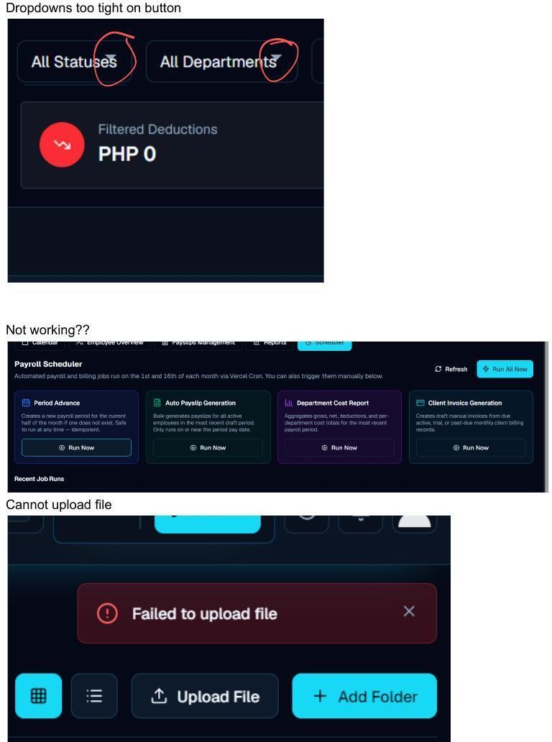

#38 File Upload Fails — 'Failed to Upload File' | BUG | pg. 14

All file uploads fail with a 'Failed to upload file' error toast. The Supabase Storage integration is broken.
    - Verify the storage bucket name in env variables matches the actual Supabase Storage bucket name.

    - Check the bucket's RLS policy: authenticated users must have INSERT (upload) permission.
    - Confirm CORS settings on the Supabase project allow uploads from the Vercel deployment domain.
    - Check file size: Supabase Storage Pro has a default 50MB per-file limit.
// Codex: Fix Supabase Storage file upload
const uploadFile = async (file, folder = 'general') => { const ext = file.name.split('.').pop()
const filePath = `${folder}/${currentUser.id}/${Date.now()}.${ext}`

const { data, error } = await supabase.storage
.from(process.env.NEXT_PUBLIC_STORAGE_BUCKET) // use env var, not hardcoded
.upload(filePath, file, { contentType: file.type, upsert: false,
})

if (error) {
console.error('Upload error:', error.message, error.statusCode) throw error
}
return data
}

Clients — /clients

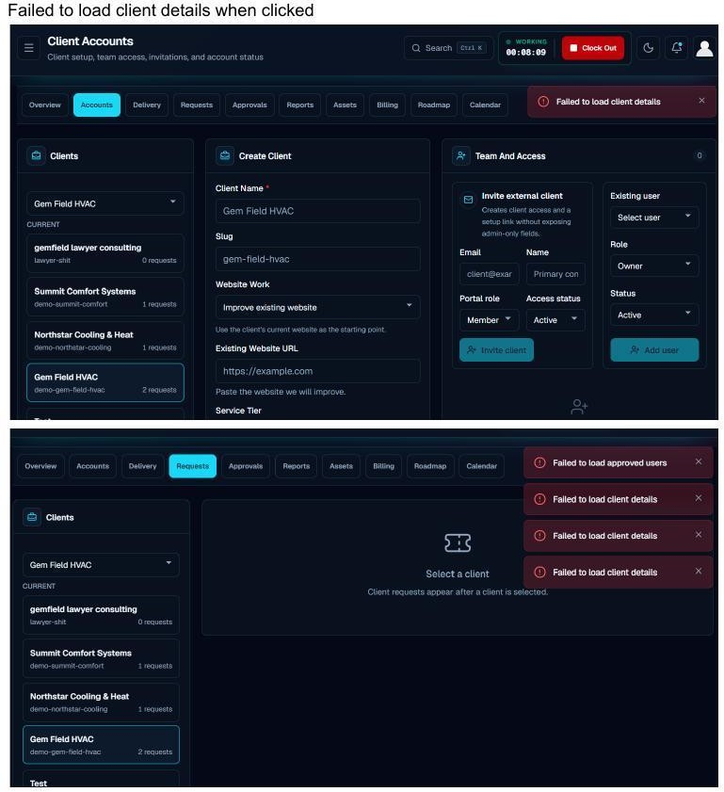

#42 Client Details Fail to Load on Click | BUG | pg. 16

Clicking any client in the Clients list triggers multiple concurrent errors: 'Failed to load client details' (×3) and 'Failed to load approved users'. The client detail view is completely broken.
    - Check RLS policy on the clients table — does the admin have SELECT access?

    - Verify the client ID is being passed correctly from the sidebar list item to the detail fetch.
    - The multiple simultaneous errors suggest several sub-queries are all failing — likely an auth/RLS issue affecting the entire clients API scope.
    - Add an error boundary around the client detail panel to prevent the entire page from failing.
// Codex: Debug client detail fetch
const loadClientDetails = async (clientId) => { const { data, error } = await supabase
.from('clients')
.select(`
*, client_members(*), requests(count)
`)
.eq('id', clientId)
.single()

if (error) {
console.error('Client load error:', { msg: error.message,
hint: error.hint, code: error.code,
})
throw error
}
return data
}

Profile & Edit Modal — Global

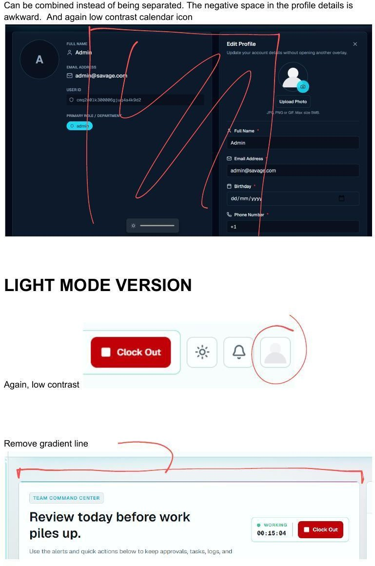

#43–44 Profile Panel Layout + Birthday Icon Contrast | VISUAL | pg. 17

Issue #43: The profile view splits into a read-only left panel and an Edit Profile right panel. The left panel has significant empty space in the lower half, making the layout feel unfinished. Issue #44: The calendar icon in the Birthday date field in the Edit Profile modal is low contrast in both modes.
    - Option A: Consolidate into a single edit-in-place panel (most efficient).

    - Option B: Expand the left panel to include role details, join date, payslip count, etc. to fill the space.
    - Apply --icon-color token to the birthday field's calendar indicator (same fix as all other calendar icons).

Light Mode — Specific Component Issues
The following issues exist specifically in light/day mode and were called out by the designer explicitly. The root cause is the same in all cases: icons and buttons are too light-colored for a light background.



#45 Header Action Icons Low Contrast in Light Mode | VISUAL | pg. 17

In light mode, the Clock Out button, sun/brightness icon, notification bell, and profile icon in the header are all rendered light against a light background. They are barely visible.
/* Codex: Fix header icon contrast for light mode */

/* Ensure --icon-color resolves to a dark value in light mode: */
:root { --icon-color: #4A5568; } /* dark gray — visible on white */
.dark { --icon-color: #CBD5E0; } /* light gray — visible on dark */

/* Apply to all header action elements */
.header-actions svg,
.nav-icon,
.clock-out-btn-icon { color: var(--icon-color);
}



#46 Dashboard — Remove Gradient Separator Line | VISUAL | pg. 17

A decorative gradient line sits between the page header and the Team Command Center section in light mode. This element adds visual noise without purpose and should be removed.
/* Codex: Remove dashboard gradient separator */
/* Find and remove or hide the gradient divider: */
.dashboard-gradient-separator,
.team-section-divider { display: none;
}
/* Or: find the element in the Dashboard JSX and delete it */

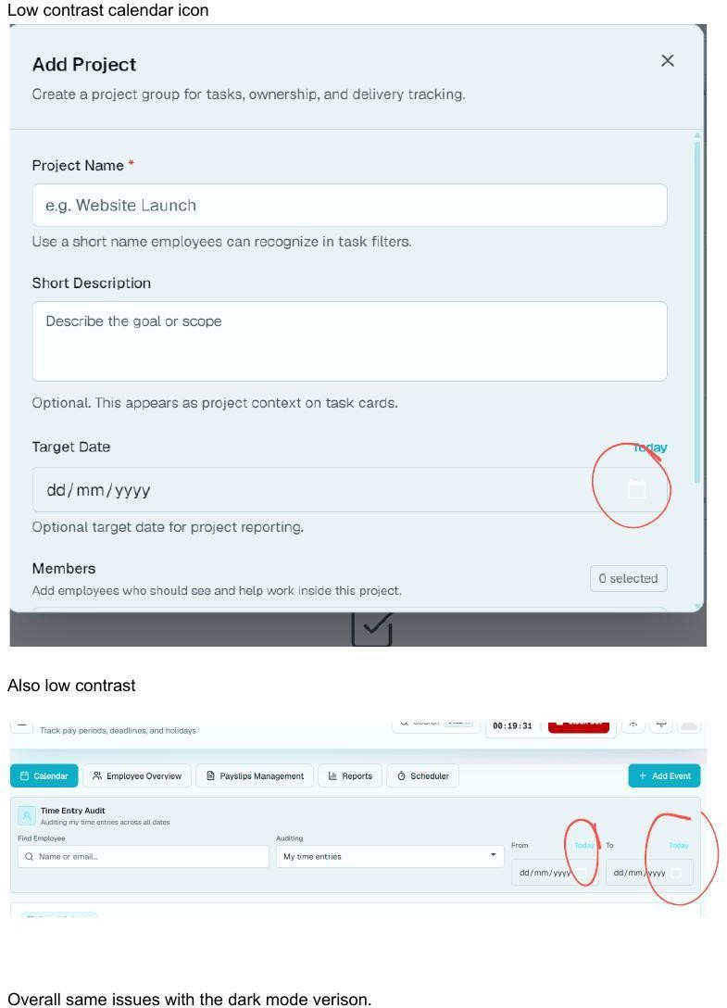

#47 Time Entry Audit — Low Contrast Icons in Light Mode | BUG | pg. 18

NEW in v2 — Missing from v1. The Time Entry Audit view (accessed from Payroll Calendar) has
low-contrast calendar and date range icons when viewed in light mode. The 'Also low contrast' note in the QA refers to this specific sub-view.

- Apply the --icon-color token to all icons in the Time Entry Audit component.
- The date range filter icons (From/To calendar icons) are specifically flagged.
- Test the 'Time Entry Audit' view in both dark and light mode after the global token fix — it may be resolved by Section 3.2.
/* Codex: Target Time Entry Audit icon contrast */
.time-entry-audit-view svg,
.time-entry-audit-view [data-icon] { color: var(--icon-color);
}
/* Alternatively, if the global sweep (Section 3.2) is applied, this view should inherit the fix automatically */

Designer's Final Notes

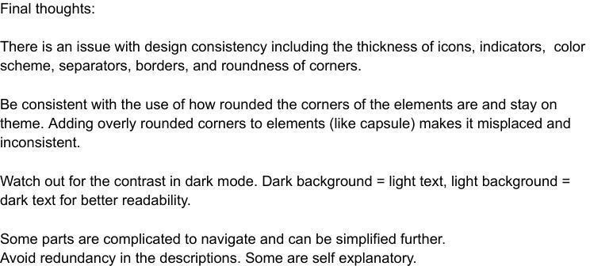

Designer Summary — Verbatim from QA

- There is an issue with design consistency including the thickness of icons, indicators, color scheme, separators, borders, and roundness of corners.
- Be consistent with the use of how rounded the corners of the elements are and stay on theme. Adding overly rounded corners to elements (like capsule) makes it misplaced and inconsistent.
- Watch out for the contrast in dark mode. Dark background = light text, light background = dark text for better readability.
- Some parts are complicated to navigate and can be simplified further.
- Avoid redundancy in the descriptions. Some are self explanatory.

- Codex Implementation Guide
Structured order of operations for working through all 47 issues using OpenAI Codex or any AI-assisted coding workflow.

Implementation Phase Order

Phase | Issues to Address
Phase 1 — Critical Bugs(Block feature use) | #19 Chat input broken · #21 Duplicate messages · #27 Daily log save fails · #30 Clock sync broken · #32 Cannot add employee · #33 Payroll Scheduler broken · #34 This Week nav broken · #38 File upload fails · #42 Client details fail
Phase 2 — Global Design Sweep(Apply once, fixes many) | Section 3: border-radius (all elements) · contrast token  (--icon-color) · focus ring (2px) · icon style (outline) · color semantics (no red on non-danger)
Phase 3 — Page Visual Fixes | #1–2 Login layout · #3–5 Nav icons · #6–10 Create Task modal · #11–14 Filter + EOD · #18 Calendar toggle · #20 Send button · #25 Daily log layout · #28 Reset button · #31 Capsule borders · #35–37 Payslips dropdowns/tabs
Phase 4 — UX & Interaction | #8 Date picker style suggestion · #22–23 Going toggle + remove icon · #24 Shortcuts description element · #40–41 Custom roles + remove redundant text
Phase 5 — Copy & Polish | #26 'Daily/EOD' → 'End of Day' · #43 Profile panel consolidation · #44 Birthday date icon · #45–47 Light mode icon sweeps

  - Codex Prompting Tips for This Stack
Deskii is built on Next.js + Tailwind CSS + Supabase. These patterns produce the best Codex results:

    - Always name the file: 'In /components/chat/ChatInput.tsx, fix the onChange handler so the input accepts keyboard input.'
    - Reference design tokens explicitly: 'Using the --icon-color CSS variable defined in globals.css, apply it to all SVG icons in the navigation header.'
    - For Supabase bugs, always ask for full error logging: 'Log error.message, error.details, error.hint, and error.code to the console before throwing.'
    - For RLS issues, ask for a migration: 'Write a Supabase SQL migration to add INSERT permission for authenticated users on the employees table.'
    - For layout fixes, reference Tailwind: 'Fix using Tailwind grid-cols-2 with gap-4, consistent with how other form rows are laid out in the codebase.'
    - After each Phase 1 bug fix, verify in the browser with devtools Network tab open to confirm no errors.

Testing Checklist — Dark Mode & Light Mode
After all fixes, verify each item in both modes. Check both boxes before marking an issue resolved.

Test Item | Dark ☐ | Light ☐
Login page has no awkward negative space; centered layout | ☐ | ☐
All buttons use border-radius ≤ 8px (no capsule/pill shapes) | ☐ | ☐
Profile, bell, and sun/moon icons match — all outline, all visible | ☐ | ☐
Focus ring: 2px cyan, consistent on all interactive elements | ☐ | ☐
All calendar/date picker icons are visible in both modes | ☐ | ☐
Chat input: can type, sends correctly, no duplicate messages | ☐ | ☐
Daily log saves without error; single Save button flow | ☐ | ☐
Clock in and Clock out sync between header and Payroll Calendar | ☐ | ☐
New employee can be added without error | ☐ | ☐
Payroll Scheduler 'Run Now' buttons respond and show feedback | ☐ | ☐
'This Week' and period arrows navigate correctly in Payslips | ☐ | ☐
Payslips tabs (Summary/Detailed/Archive) clearly readable | ☐ | ☐
Payslips + Employee Overview dropdowns show full text without clip | ☐ | ☐
Files can be uploaded in File Directory | ☐ | ☐
Client details load correctly from the list | ☐ | ☐
Generate EOD Report button is cyan, not red | ☐ | ☐
Going button toggles with hover + reverts to Not Going | ☐ | ☐
Event calendar icon at top of event cards is removed | ☐ | ☐
Shortcuts description text is not an editable input | ☐ | ☐
Reset filters button has visible button affordance | ☐ | ☐
Daily/EOD label now reads 'End of Day' | ☐ | ☐
Delete icons on role cards are gray by default, red on hover | ☐ | ☐
Roles can be created with custom names by admin | ☐ | ☐
Redundant role description sentence is removed | ☐ | ☐
Dashboard gradient separator line is gone (light mode) | ☐ | ☐
Time Entry Audit icons visible in light mode | ☐ | ☐
Update Announcement button is cyan, not pastel | ☐ | ☐
Event Date and Time are in separate fields | ☐ | ☐

Technical Reference

Tech Stack

Layer | Value
Frontend | Next.js (React) — App Router
Styling | Tailwind CSS — dark: variant for theme switching
Database | Supabase — database-per-tenant architecture
Auth | Supabase Auth — email/password, role-based sessions
File Storage | Supabase Storage — 100GB per tenant (Pro plan)
Hosting | Vercel — Next.js SSR + edge functions
Icon Library | Target: Heroicons outline OR Lucide React
Portal URL | internal-company-portal-savage-llc.vercel.app

  - Brand Color Tokens

Token / Hex | Usage
#00BCD4 | Cyan — primary CTAs, active states, focus rings
#0097A7 | Cyan dark — hover/pressed state for primary
#0D1117 | Navy — primary dark background
#1A2332 | Navy surface — cards, panels
#FFFFFF | White — text on dark, surfaces in light mode
#1A1A1A | Near-black — body text in light mode
#4A5568 | Dark gray — icon color in light mode, secondary text
#9BA8B5 | Mid gray — muted text, placeholder, muted icons
#CBD5E0 | Light gray — icon color in dark mode
#E53E3E | Red — DANGER ONLY: delete, destructive actions
#ED8936 | Orange — warnings only
#38A169 | Green — success, confirmed states

Document v2.0 — Gap-Corrected | Compiled by Savage LLC Design & Development Team | June 2026 For internal developer use only. Do not distribute externally.

# Deskii Internal Portal — Full Functionality Audit Report

**Audit Date:** June 26, 2026 | **Auditor Account:** admin@savage.com | **Portal:** internal-company-portal-savage-llc.vercel.app

---

## MODULE 1 — Login Page

**Screenshot findings:** Clean two-column login layout with SSO buttons, email/password form, Forgot Password link, and Request Access link.

✅ **WORKS**
- Page loads correctly at `/login`
- Email/password form accepts credentials and authenticates successfully, redirecting to Dashboard
- Forgot Password link navigates to `/forgot-password` — page renders with email input and "Send Reset Link" button
- "Show/hide password" toggle on password field works
- "Request access" link navigates to `/signup`
- Authenticated users are automatically redirected away from `/login` (correct session guard behavior)

❌ **BROKEN**
- **Google SSO button:** Clicking returns error toast — *"Google sign-in is not configured yet."* (URL param: `?provider=google&oauthError=not_configured`)
- **Apple SSO button:** Clicking returns error toast — *"Apple sign-in is not configured yet."* (URL param: `?provider=apple&oauthError=not_configured`)

---

## MODULE 2 — Dashboard

**Screenshot findings:** Welcome banner with Clock In/Out widget, 6 stat widgets, Needs Attention panel, Company Chat widget, Company Announcements feed, Quick Actions, Recent Shoutouts.

✅ **WORKS**
- All 6 stat widgets render: Today's Time (3h 23m), Assigned Tasks (0), In Progress (0), Completed Today (0), Overdue (0), Approvals (0)
- **Clock In** button works — toast: *"Clocked in successfully"*, timer switches to "WORKING 00:00:00"
- **Clock Out** button works — toast: *"Clocked out successfully"*, status resets to "READY"
- Announcements feed loads correctly (shows real posts including "happy bday rene", "kjrg", "Deskii launch party")
- "Needs Attention" panel shows actionable items (e.g., "Daily log not submitted")

- Quick Actions panel visible with Client Operations, Approvals, Review Payroll, Create Task shortcuts

❌ **BROKEN**
- **Company Chat widget** — fails to load conversations on every page load. Console error:
*"Dashboard chat init failed: Error: Failed to fetch conversations"*

---

## MODULE 3 — Task Tracking

**Screenshot findings:** Work Focus section, status counters, Create Task button, Project Organization section, task list, filter/organize controls.

✅ **WORKS**
- Page loads with Work Focus area, Open/Overdue/Due today/Review/Completed counters
- **Create Task modal** opens with all fields: Task Name, Description, Assign To, Priority (Low/Med/High), Collaborators, Project, Start/Due Date, Status, ETOC (HH:MM)
- Priority dropdown fully functional (Low/Med/High options)
- **Generate EOD Report** button opens a modal with Daily/Weekly/Monthly period tabs, task count, total hours, and a "Post Daily to Daily Logs" button
- **Organize/Filter panel** opens with: Sort By (Due Date, Priority, Status, Title), Group By (Status, Priority, Department, Assignee, Project), Filter by Status (To Do, In Progress, Review, Completed), Filter by Priority (High, Med, Low), Assignee dropdown, Department dropdown, Project dropdown
- All Tabs (All Tasks, Open, Completed) are clickable
- Download PDF button visible

❌ **BROKEN**
- **Assign To dropdown** only shows "Unassigned" — no employees available to assign tasks. Console error: *"Failed to fetch users: Error: Failed to fetch users"*. This blocks task creation — submitting the form triggers a browser tooltip: *"Please select an item in the list."* along with an inline error: *"This account needs an assigned department and role before tasks can be assigned."*
- Tasks cannot be fully created or assigned due to missing user data

⚠ **PARTIAL**
- Task creation form opens and fields are fillable, but submission is blocked by the Assign To validation

---

## MODULE 4 — Daily Logs

**Screenshot findings:** "Log today's work" prompt with Add Log / Show Today buttons, 3 stat widgets (Today: 0, Your logs: 0, Review: 0), search bar, empty log list.

✅ **WORKS**
- Page renders correctly at `/daily-logs`
- "Add Log" modal opens with: Date (pre-filled today), Hours Logged (default 08:00), Log Type dropdown (Daily/EOD), "Import from Task Tracking" section, task entry input + Add button, EOD Shift Notes (optional) textarea
- Manual task entry via "Add a task..." input + Add button works — task appears in list with "In Progress" badge

❌ **BROKEN**
- **Saving daily log fails silently** — clicking "Add Log" button does nothing; modal stays open. Console errors:
  - *"Failed to create daily log: Error: Failed to create log"*
  - *"Failed to save log: Error: Daily log save returned no data"*
  - *"Failed to fetch daily logs: Error: Failed to fetch logs"*
- The log history also fails to load (same fetch error on page load)

---

## MODULE 5 — Payroll Calendar

**Screenshot findings:** Calendar tab selected by default, Time Entry Audit panel with date filters, calendar view with clock-in/out entries visible.

✅ **WORKS**
- Payroll Calendar page loads with all 5 tabs: Calendar, Employee Overview, Payslips Management, Reports, Scheduler
- **Date range filters** (From/To) work — page URL updates and header reflects: *"Auditing my time entries from Jun 1, 2026 to Jun 30, 2026"*. "Today" shortcut buttons work on both inputs
- **Add Event** button opens modal with Event Title, Date (pre-filled), Type (Pay Day/Holiday/Deadline/Meeting/Other), Description. Submitting a test event returned toast: *"Event added to calendar"*
- Calendar view renders with existing Clock In/Out entries visible
- Payroll stats display: Pay Days (0), Holidays (0), Deadlines (0), Total Events (0)
- **Clock In/Out** is also accessible via the Clock In banner at the top of the calendar

❌ **BROKEN**
- **Payslips Management tab** — clicking triggers error toast: *"Internal Server Error"* on every load. No payslip management content renders

---

## MODULE 6 — Payslips Management (My Payslips)

**Screenshots findings:** Summary widgets (Total Payslips: 1, YTD Gross: ₱6,199.55, YTD Net:
₱6,199.55, Last Pay Date: Jun 10), Payslip History list.

✅ **WORKS**
- My Payslips page at `/my-payslips` loads correctly with real data
- Payslip history entry for "Jun 1 – Jun 15, 2026 · Draft · ₱6,199.55" is visible
- Clicking the eye icon opens a **Payslip Details** panel showing period, status (Draft), earnings breakdown (Base/Hourly Pay: ₱6,199.55), Net Pay, Issue Date, and a "Download PDF" button

❌ **BROKEN**
- **Payslips Management tab** (within Payroll Calendar) — throws *"Internal Server Error"* and shows no content. The "This Week" button and < > period-navigation arrows described in the brief are part of this broken view. The Summary / Detailed / Payslip Archive tabs referenced in the audit spec are also inaccessible due to this server error.

---

## MODULE 7 — Payroll Scheduler

**Screenshot findings:** All 4 scheduler jobs visible with descriptions and Run Now buttons. "Run All Now" master button in header.

❌ **BROKEN — All 4 schedulers fail**
- **Period Advance** → Run Now → toast: *"Job run failed"*
- **Auto Payslip Generation** → Run Now → toast: *"Job run failed"*
- **Department Cost Report** → Run Now → toast: *"Job run failed"*
- **Client Invoice Generation** → Run Now → toast: *"Job run failed"*
- "Recent Job Runs" section confirms: *"No job runs yet."*
- The page UI renders correctly; the failures are backend errors on all four Vercel Cron jobs

---

## MODULE 8 — Announcements

**Screenshot findings:** Category cards (Company News, Shoutouts, Events, Birthdays), New Announcement button, post feed with likes, comments, Going buttons.

✅ **WORKS**
- Page loads all categories with post counts
- **Create Announcement** modal works — Category, Title, Message, "Mark as Important" checkbox all functional. Successfully created a "Company News" post (count went from 0 → 1)
- **Create Event** — selecting "Events" category in the modal adds "Event Date & Time" and "Location" extra fields. Event was successfully posted (Events count went from 2 → 3)

- **Comment via send button** — typed "Audit comment test", clicked send button → comment posted successfully, counter updated to "1 comment"
- **Going button** on event posts — toggles correctly between active (green ✓) and inactive states
- Announcements appear on the Dashboard's Company Announcements feed

⚠ **PARTIAL**
- **Enter key on comment field** — pressing Enter does NOT submit the comment; text stays in input box. Only the send (paper plane) button submits. This is an inconsistency vs. typical chat UX

---

## MODULE 9 — Messages & Chat

**Screenshot findings:** Chat & Messages page with "Active" / "Archived" tabs, Channels section ("No channels yet"), Direct Messages section ("No private chats yet"), "Your Conversations" empty state with "Start a New Discussion" button.

✅ **WORKS**
- Page loads correctly at `/chat`
- "Start a New Discussion" button opens a "Send a Message" search panel
- The + button next to Channels opens a channel creation input with Channel Name field

❌ **BROKEN**
- **Company Chat (Dashboard widget)** — conversations fail to load on every dashboard visit. Console error: *"Dashboard chat init failed: Error: Failed to fetch conversations"*
- **No channels exist** — "No channels yet" displayed; the Company Chat widget on Dashboard shows "No messages yet" placeholder
- **No team members** — "No team members found." in both the Start a New Discussion panel and Channel member search, blocking any DM creation. This stems from the same *"Failed to fetch users"* backend error

⚠ **PARTIAL**
- Chat UI structure loads; typing in the Company Chat dashboard input is technically possible, but messages cannot be sent to any recipient

---

## MODULE 10 — File Directory

**Screenshot findings:** Company File Directory page with Search, Global Directory filter, Sort by Name, Grid/List view toggle, Upload File and Add Folder buttons, "No folders found" empty state.

❌ **BROKEN**

- **Upload File** — file selection triggers the hidden file input, but upload fails silently. Console error:
*"Error: Failed to upload file"*
- **Add Folder** — modal opens with Folder Name, Department, and Folder Color fields; filling all fields and submitting shows toast: *"Failed to add folder. Please try again."* Console error: *"Failed to add folder: Error: Failed to create folder"*
- **Folder listing** also fails on page load: *"Error: Failed to fetch folders"*

⚠ **PARTIAL**
- The Add Folder modal UI renders correctly with all fields and color options; the upload UI is accessible but the backend rejects all operations

---

## MODULE 11 — Onboarding

**Screenshot findings:** "Create setup link" form with Email and Role fields, Generate Link button, Manage Roles link, Setup Result area.

✅ **WORKS**
- Page renders correctly at `/operations/onboarding`
- Role dropdown is fully populated with 21 role options across all departments (e.g., Analytics/Data VA, Content Creator/Designer, Web Developer, etc.)
- **Manage Roles** link navigates to Operations → Roles tab which shows existing roles: Analytics/Data VA, Automation/Tech VA, Content Creator/Designer, Digital Marketing Lead/Marketing VA, etc.

❌ **BROKEN**
- **Generate Link / Submit New Application** — filling email + role and clicking Generate Link shows a loading spinner but no link is generated. The "Setup result" area remains: *"Generated links will appear here. Nothing is sent until you copy and share the link."* No success toast or link output was produced

---

## MODULE 12 — Clients

**Screenshot findings:** Client Operations page with Overview/Accounts/Delivery/Requests/Approvals/Reports/Assets/Billing tabs, client list showing gemfield lawyer consulting, Summit Comfort Systems, Northstar Cooling & Heat, Gem Field HVAC, Test.

✅ **WORKS**
- Client list loads all 5 clients with slug and request count
- Clicking a client from the list selects it (URL updates with client ID)

- **Requests tab** navigates to `/operations/clients/requests` — page renders with header "Client Requests: Website change requests, support tickets, replies, and internal notes"
- Client dropdown at top switches between clients

❌ **BROKEN**
- **Client detail panel** fails to load — on page load: toast *"Failed to load client details"*; right-side panel remains in empty "Select a client" state even after selecting a client
- Client details (dashboard, delivery, approvals, reports, assets, billing) are all inaccessible

---

## MODULE 13 — Profile

**Screenshot findings:** Profile page showing Full Name (Admin), Email (admin@savage.com), User ID, Primary Role (admin badge), with an inline Edit Profile form.

✅ **WORKS**
- Profile page loads at `/profile` with correct user info
- **Edit Profile form** is rendered inline on the profile page (not a separate overlay)
- **Birthday date field** — interactive date picker accepts input; setting 1990-05-15 displays as "15/05/1990 · May 15, 1990" with correct formatting
- **Photo upload** — uploading an image via the hidden file input (or the camera icon on the avatar) works: the avatar updates to the new image, and a "Remove" button appears alongside "Upload Photo"
- Full Name, Email Address, Phone Number, Address, City fields are all present and editable

⚠ **PARTIAL**
- No save confirmation was tested for the full form; the birthday/photo interactions were individually verified. The admin account lacks a department/role assignment in the system, so some
profile-dependent features across the portal are restricted

---

## Summary: Critical Issues by Severity

**🔴 HIGH (Broken core functionality)**
- All 4 Payroll Scheduler jobs return "Job run failed" — automated payroll is non-functional
- Daily Logs cannot be saved — "Daily log save returned no data" on every attempt
- Payslips Management tab throws "Internal Server Error" — period navigation and Summary/Detailed/Archive tabs inaccessible
- File Directory: both folder creation and file upload fail with backend errors
- Google SSO and Apple SSO are not configured
- Company Chat fails to load — "Failed to fetch conversations" on every page load

**🟠 MEDIUM (Feature degraded)**
- Task creation blocked — "Failed to fetch users" means the Assign To field is always empty; no tasks can be assigned or created
- Client details panel fails to load — client-specific dashboards unavailable
- Onboarding Generate Link produces no output
- All payroll scheduler jobs fail silently

**🟡 LOW (UX inconsistency)**
- Enter key in comment box does not submit — only the send button works
- Admin account has no department/role assigned, which cascades into multiple module restrictions (Task Tracking, Chat member search, etc.)

