Software Requirements Specification
For
Kenovo_ElectricBlender

Version 1.0
ITI, Track Embedded System and Software Testing and Quality Assurance

April 3, 2018

Table of Contents

1. Introduction
1.1 Purpose
1.2 Document Conventions
1.3 Technologies to be used
1.4 Scope......................................................................................................................................

2. Overall Description
2.1 Product Features
2.2 Use Case Model and Description
2.3 System Diagram
2.4 Design and Implementation Constraints
2.5 Operating Environment
2.6 Assumptions and Dependencies
3. System Features
Core Functions
3.1 System Feature 1
3.2 System Feature 2
3.3 System Feature 3
4. Other Nonfunctional Requirements

Revision History
Name | Date | Reason For Changes | Version

Introduction

Purpose
This project is intended to design and produce a blender prototype that contains three different speeds and one button for the control with a protection circuit.

Definitions, Acronyms and Abbreviation

MC -> Micro Controller.
PWM –> Pulse width modulation.
RPM – Revolution per minute.
VCC – Voltage source.
GND – Ground.

Technologies to be used
- Software:
- IDE used for software development is ECLIPSE.
- C programming is used for the program development.
- Hardware:
- Micro-controller used is AVR 32.
- Motor is controlled using PWM signal.
- Safety:
- Voltage detection circuit is used.

Scope
Reference found in:

QA_Embedded_project\Kenovo_ElectricBlender\management\ Project Scope.docx

Overall Description

Product Features
- Electric blender with 3 speeds.
- Hardware protection circuit for over-voltage detection, In case of over-voltage detection the system shuts down completely.
- The blender have 4 operating states in sequence controlled using one tactile button (off >> speed 1 >> speed 2 >> speed 3).

Use Case Model and Description

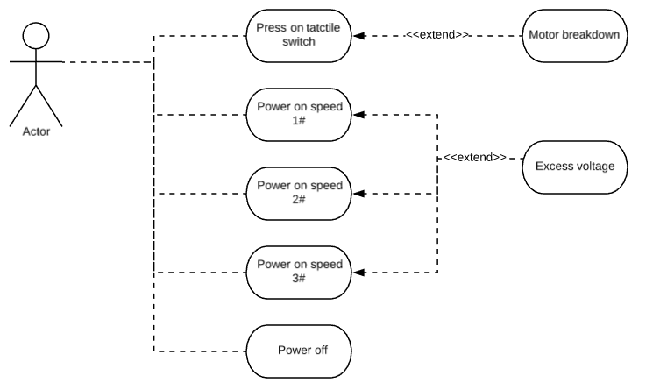
Use Case ID: | USE_CASE_1
Use Case Name: | Power on Blender
Created By: | Salma Mohammed Abo kamla | Last Updated By:
Date Created: | 31 March 2018 | Date Last Updated:

Actor: | Kenovo Blender User
Description: | The blender power on at three level of speed and power off.
Preconditions: | The blender is on off state.
Post conditions: | The blender returns to off state again.
Main Success Scenario | 1-The user press the button.  2-The blender switches from off state to speed 1 in one direction.  3-when the user needs to switch to speed 2, The user have to press on the button again.  4-without any delay the blender should switch to speed2 and rotate in the same direction.  5- When the user needs to switch to speed 3, The user have to press on the button again.  6-without any delay the blender should switch to speed3 and rotate in the same direction.  7-To power off the blender, the user should press on the button again.
Priority: | P1-High
Frequency of Use: | Every time the blender customer tries to use the blender.
Exceptions: | 1a.The motor may be breakdown.  2a. At this speed it may be there excess voltage.  3a.When the user still pressing on the button for a long time the speed1 never changes.  4a.If the user releases the button there may be delay to switch to the speed 2.  4b. At this speed it may be there excess voltage.  5a. 3a.When the user still pressing on the button for a long time the speed1 never changes.  6a. 4a.If the user releases the button there may be delay to switch to the speed 3.  6b. At this speed it may be there excess voltage.
Status: | Pending Review

System Diagram

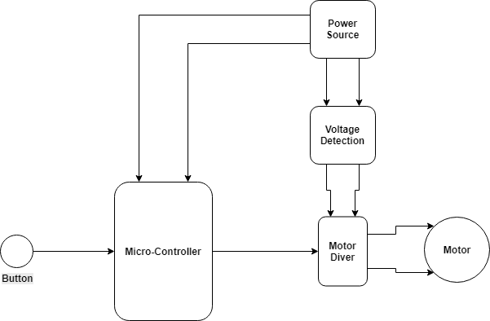

Design and Implementation Constraints
This section describes the system constrains in designing and implementation.

- Feature 1: No constrain applies during this feature implementation.
- Feature 2: No constrain applies during this feature implementation.
- Feature 3: No constrain applies during this feature implementation.

Operating Environment
This section describes what operating enviroment must be available for the system normal operations.

- Feature 1: No certain environment applies during this feature implementation.
- Feature 2: Power supply should be connected to the motor to provide voltage either inside or outside the voltage range.
- Feature 3:
- Motor must be supplied the sufficient voltage for normal operation.
- Tactile switch must be pulled either high or low depending on system design.

Assumptions and Dependencies
This sections describes what assumptions and dependencies must be taken into consideration for developing this system.

- Feature 1: Assuming that motor will rotate in clock wise direction.
- Feature 2:
- The voltage monitoring is for the motor supply voltage not the mc supply voltage.
- The microcontroller supply voltage is stable and remains 5 voltage.
- Power supply must be used to operate the voltage in either within or above the voltage operating range.
- Voltage detection circuit should be connected to the motor supply voltage.
- Feature 3:
- Assuming tactile switch pulled up.
- Assuming full speed at duty cycle of 100% PWM signal.

System Features
This section describes in detail each feature and lists the related requirements.

System Feature 1
The electric blender comes with three diffrenet speeds that the user can choose, also it should rotate in only one direction with no power button. This feature covers the listed requiremnts below:

- [SRS_1] The initial state of the blender is OFF. (Covers REQ_1)
- [SRS _2] The blender rotate in one direction. (Covers REQ_1)
- [SRS _3] There is no power button for blender. (Covers REQ_3)

System Feature 2
The system is protected with a Voltage-detection circuit to detect if there are any spikes or over voltage in the system, this feature protects the motor and the controller from burning out and in case
of any power failure the system shuts down. This feature covers the listed requiremnts below:

- [SRS _4] Additional hardware can be used to detect the over-voltage state. (Covers REQ_2)
- [SRS _5] If the voltage exceeds motor operating voltage it will stop. (Covers REQ_2)
- [SRS _6] Motor operating voltage is between 5 to 9V. (Covers REQ_2 and 1)
- [SRS _7] Motor should remain off in case of over-voltage condition. (Covers REQ_2)

System Feature 3
The speeds are controlled using one tactile button, this button change the states of the motors starting from the OFF state where the motor speed is zero until its maximum speed and back again to the OFF state. This feature covers the listed requiremnts below:

- [SRS_8] the speeds percentage from maximum speed: (Covers REQ_1)
- speed 1 = speed/3
- speed 2 = speed/3 + speed 1
- speed 3 = speed/3 + speed 2

- [SRS _9] Speed remains the same if user pressed button forever. (Covers REQ_1 and 3)
- [SRS _10] Blender stays active with current speed unless user changes its operating state using button. (Covers REQ_1 and 3)
- [SRS _11] Button used is tactile switch. (Covers REQ_3)
- [SRS _12] Action is taken after button release with no delays observed by the human eye. (Covers REQ_3)
- [SRS _13] Must press button and release it to initiate action. (Covers REQ_3)

Other Nonfunctional Requirements

Performance Requirements
- The action is supposed to be initiated in no time from the request time at button release.
- The motor should be supplied the sufficient voltage for optimum operating conditions.

Safety Requirements
- The motor driver circuit must be isolated from the control circuit to avoid reflected current from burning the controller.
- Motor must be isolated in a chase to protect the user from touching the blades.

