# CyPSA Quick-Start Guide

## User Workflow and Directory Structure

Our team agreed upon a tool design that uses a created “production” git code repository, “CyPsa.” It is designed so that a partner like CWLP can connect to this git repository from a Windows machine, pull the data down, and simply add their own files to the appropriate location in the directory structure.

Once those files are placed, to run CyPSA, the user will just have to click on the batch file **[]**. They will also be able to run the batch file from the UI. This will check for all of the necessary dependencies (in particular, the appropriate NP-View [] and PowerWorld installations **[]**) and then run the analysis. After the analysis is run, an output file will be automatically populated with the results **[]**.

Figure 1. CyPSA Input Data Files and Locations

|  |  |
| --- | --- |
| **case.pwb** | **CyPsaProduction\projects\utilityname\powerworld**  This is the PowerWorld case file placed here by the utility. In the current design of the tool, this file already contains the relay-breaker interconnections, where the relays can be identified by their IP Address. |
| **\*\*.txt** | **CyPsaProduction\projects\utilityname\firewall**  This directory contains the firewall rulesets which are read by NP-View and used by CyPSA in determining cyber path connectivity. |
| **nmap-**.xml** | **CyPsaProduction\projects\utilityname\nmap**  This directory contains nmap scan result files which are read by NP-View and used by CyPSA in determining vulnerability information for calculating path costs. |
| **attack_graph.xml** | **CyPsaProduction\projects\utilityname\npv**  This file is generated from NP-Graph after the batch file is run. |
| **connectivity.csv** | **CyPsaProduction\projects\utilityname\npv**  This file is generated from NP-View after the batch file is run. |

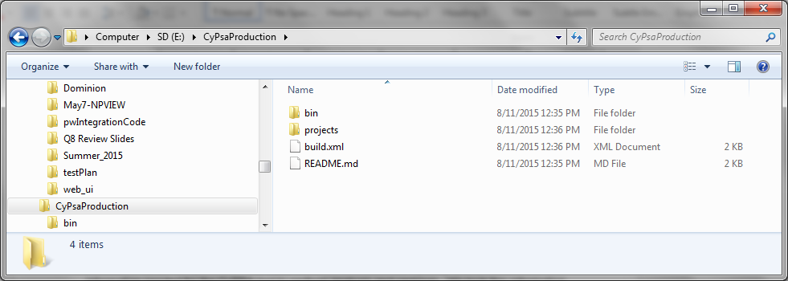

Figure 2. CyPSA Tool Directory Structure: Code/Executables (“bin”) and Input Data (“projects”)

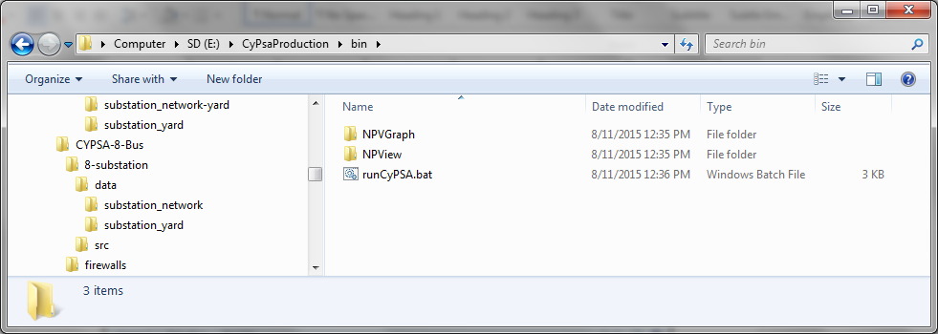

Figure 3. Directories Inside Code Folder

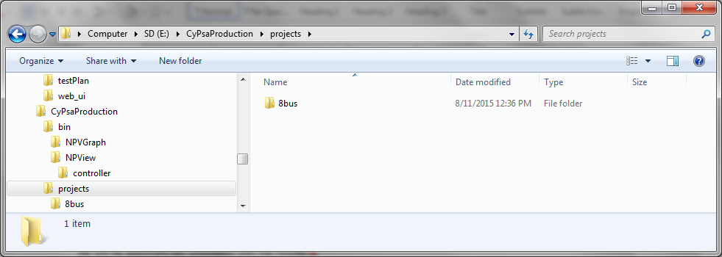

## CyPSA 2.0 Architecure

Modules and file exchanges