Required items:

-Arduino

-Laptop

-Android Phone

-A room for conducting the escape room in

First start by programming your Arduino. We utilized Arduino Nano. Check bomb.ino file for the code.

Connect LED, and sensor wires A0-A2 to ground. Sensor wires A0-A2 will be cut to defuse the bomb.

LED will turn on if the bomb is defused and speaker will go off if the incorrect wire is cut.

The connection diagram is shown below (ignore the wire colors in this diagram)

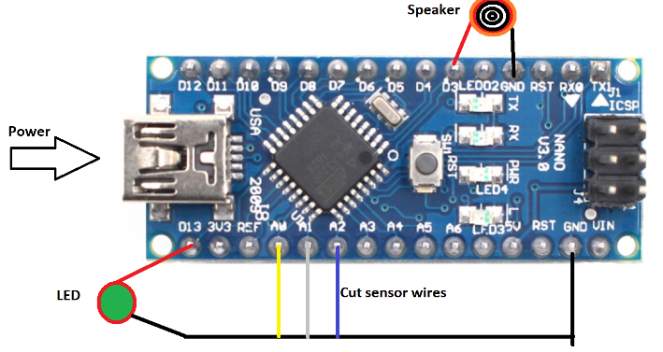

You should end up with something like this

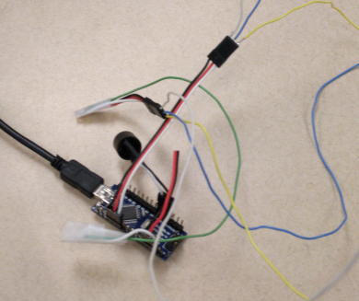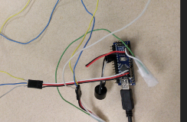

Now, it’s time to setup the laptop.

On the laptop, you will add an account. We used the password 123456 for the account.

Copy the bash history file from Files\Evidence folder to this user’s home folder.

Bash history should show the following:

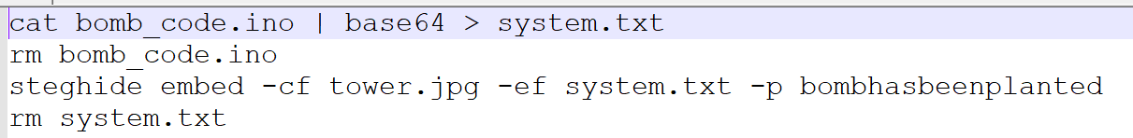

Now to setup the Android phone, take the pictures from Files\Evidence and put them on the Android phone. Lock the phone, write the pin on a paper, and put the paper in the back of the phone, under the battery cover.

Tower.jpg contains base64 bomb.ino code and login.png displays password of the laptop.

At this point, you’re almost ready.

Print out Partners in Crime.docx file from Story folder. Modify it if you need to.

Cut out Notes for body and laptop at the bottom.

Now it’s time to setup the room.

I put a fake body on the carpet, with a phone and note for the body next to it.

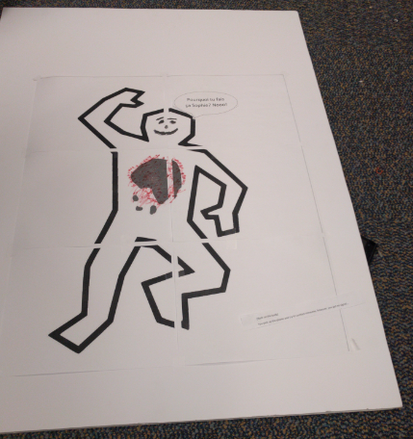

The phone has fingerprint marks on the numbers that are used as pin.

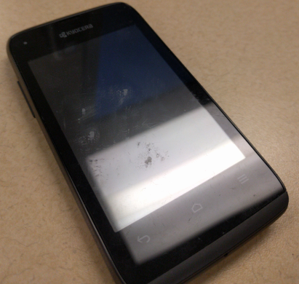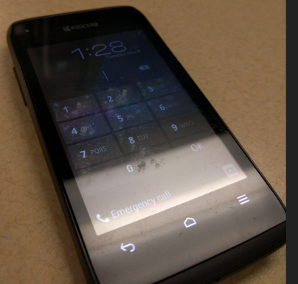

Back of the phone has the pin.

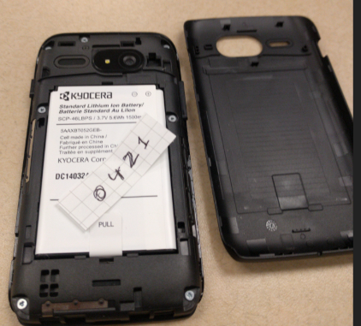

Laptop is left with a complaint form, the note that’s supposed be on the laptop, and a usb cable to connect the phone.

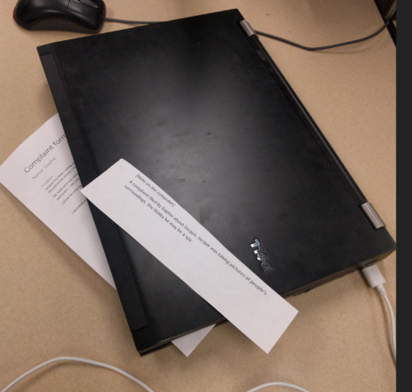

That’s it!

Arduino should be plugged in for power. You should utilize an external timer for timing the students. Provide the students with a wire cutting device and let them start.

If everything works correctly, this is how they should escape alive:

-Body is found with a cell phone

-Students are able to get into the cellphone

-Students see login info and get into the laptop

-Student view bash history

-Phone is connected and pictures are examined

-Steghide is used to extract base64 code

-Base64 is decoded and bomb code is found

-Students figure out the correct wire to cut from the code and cut it.

Regarding the ending:

At this point, you can tell them that they were found alive the next day or whatever else you can come up with.

Hints:

If they cannot get into the phone, tell them: “You’re allowed to take things apart”

If they cannot figure out that they need to look at the pictures: “Picture is worth 1000 lines of code”

If they don’t check history: “Those who do not learn history are doomed to repeat it.”

If they don’t check bash history: “I can no longer obey; I have tasted ***command***, and I cannot give it up.”

No more hints provided after this.