LAB 5 : JOINS and VIEWS

********************************************************************************************************

Purpose - In this lab you will learn how :

A. To use a JOIN for reports that needs data from more than 1 table.
B. To create a VIEW
- a VIEW contains no data
- the VIEW appears to the user as a table.
- the VIEW runs a “SELECT” to create a temporary table.
- the user can use this temporary table to produce reports or anything else that a table can be used for.
C. To use calculated fields that are derived from two or more attributes.
D. To copy data from one table to another.

********************************************************************************************************

PART A: What if we want to produce a report that contains data from CUSTOMER and SALESREP?

Fields: Customer_Number
CUSTOMER.First_Name
CUSTOMER.Last_Name
SALESREP.First_Name
SALESREP.Last_Name

Tables: PREMIERE.CUSTOMER, PREMIERE.SALESREP

The Salesrep data would be the customer’s corresponding Salesrep.
- We will use the common column Sales_Rep_Number.
- It is used in both the CUSTOMER and the SALESREP tables.
- The Sales_Rep_Number is the primary key in the SALESREP table
- The Sales_Rep_Number is the foreign key in the Customer table.
- When we put a row of the CUSTOMER table together with the corresponding row of the SALESREP table we get a temporary table called a join.
We can JOIN CUSTOMER with SALESREP with a SELECT statement:

SELECT c.CUSTOMER_NUMBER, c.FIRST_NAME, c.LAST_NAME,
s.FIRST_NAME, s.LAST_NAME
FROM PREMIERE.CUSTOMER c, PREMIERE.SALESREP s
WHERE c.SALES_REP_NUMBER = s.SALES_REP_NUMBER
ORDER BY c.CUSTOMER_NUMBER

NOTE:
The characters c and s are aliases.
c stands for PREMIERE.CUSTOMER
s stands for PREMIERE.SALESREP

- Let's create this report. On the green screen, type in the SELECT exactly as above.
You should obtain the following display.

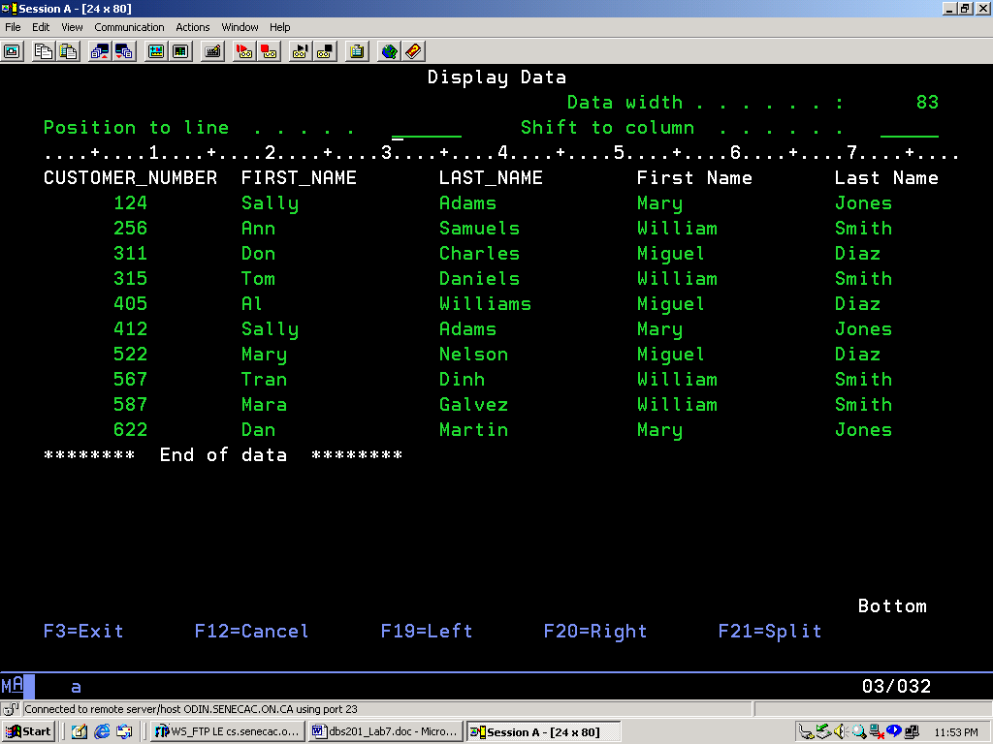

- What is the problem with this report? By looking at the report we cannot tell which is the Customer Name and which is the Sales Rep Name
We can fix this. The concatenation operator joins two character strings together.
It is || (“||” is the pipe key “|” pressed twice).
For example, ‘ABC’ || ‘/’ || ‘def’ will produce a result of ‘ABC/def’.
Retrieve the previous command (F9) and change it as follows:

SELECT c.CUSTOMER_NUMBER,
c.FIRST_NAME || c.LAST_NAME as CUST_NAME,
s.FIRST_NAME || s.LAST_NAME as REP_NAME
FROM PREMIERE.CUSTOMER c, PREMIERE.SALESREP s
WHERE c.SALES_REP_NUMBER = s.SALES_REP_NUMBER
ORDER BY c.CUSTOMER_NUMBER
You should get the following display:

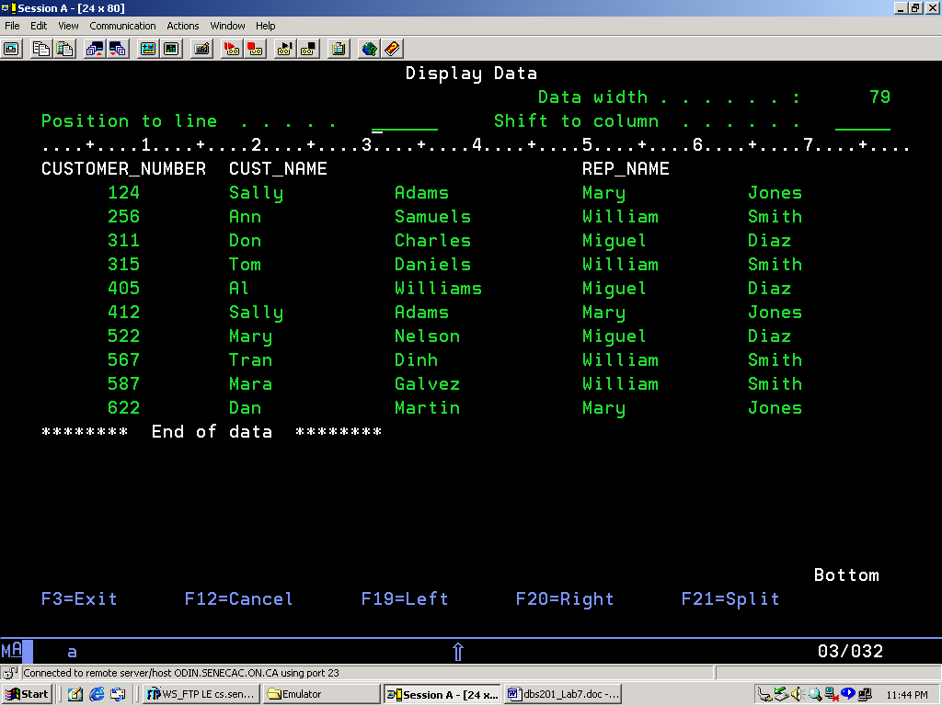

Much Better!!! This is the report to be handed in as part of this lab.

PART B: Creating a View
- In the previous section, we went to a lot of trouble to generate a report using multiple files, concatenation, and a change of column titles. What if this SELECT were required many, many times? It is possible to save that select statement as a View.

The general syntax to create a view is:
CREATE VIEW viewname
AS (SELECT …..[ insert your select statement here] ).

- Find and retrieve the SELECT that you used to create the previous report. With your cursor at the beginning of the command, press F15 (Split line). This should insert a new line at the beginning of the command. Now we can enter our CREATE VIEW AS command before the SELECT statement and save having to re-enter the whole thing!

- On the new line enter the command CREATE VIEW PRENxxx.CUST_REP AS
(where PRENxxx is the name of your collection created in Lab 2).
Your command should now look something like this:
===> CREATE VIEW PRENxxx.CUST_REP
AS ( SELECT
c.CUSTOMER_NUMBER,
c.FIRST_NAME || c.LAST_NAME as CUST_NAME,
s.FIRST_NAME || s.LAST_NAME as REP_NAME
FROM PREMIERE.CUSTOMER c, PREMIERE.SALESREP s
WHERE c.SALES_REP_NUMBER = s.SALES_REP_NUMBER )
- Press enter to execute the command. You should receive the following message:
View CUST_REP created in PRENxxx.
5. Once a VIEW is created, it can be used in much the same way as a TABLE. You can use SELECT statements to see the data. Run the SELECT statement to look at all the data in the view. (SELECT * FROM PRENxxx.CUST_REP.) Your report should look the same as before.

A VIEW can be thought of as a virtual table. It is virtual in the sense that it is not an actual table that stores data, but rather it is a way of presenting data from other tables to you in table format.

- You can also think of it as a way of "saving" a complicated select statement so you don't have to re-enter it every time you want to run that query.
To Hand In:
There are 5 items to hand in.

1. The report from PART A.

2. The command used to produce the report from Part A. Make sure that it is properly formatted (use indentation to make the command easy to read).

3. Create a view in your PRENxxx collection and produce a report.
The view should be called ORDER_INFO.
The view will use tables in the PREMIERE database.
The VIEW should contain the Customer Number and the Order Number from the ORDERS table and the Part Number, Number Ordered and Quoted Price from the ORDERLINE table.
Use a SELECT statement that uses the ORDER_INFO view to produce a report that displays all fields in the view.
The report should be sorted by Customer Number (use ORDER BY). Hand in the report.

4. Hand in the formatted command used to create the ORDER_INFO view.

- Hand in the formatted command used to generate the report.

REMEMBER: when you select columns from more than 1 table, you must tell the database which column to match on using the "WHERE" clause.

The report should look like this:

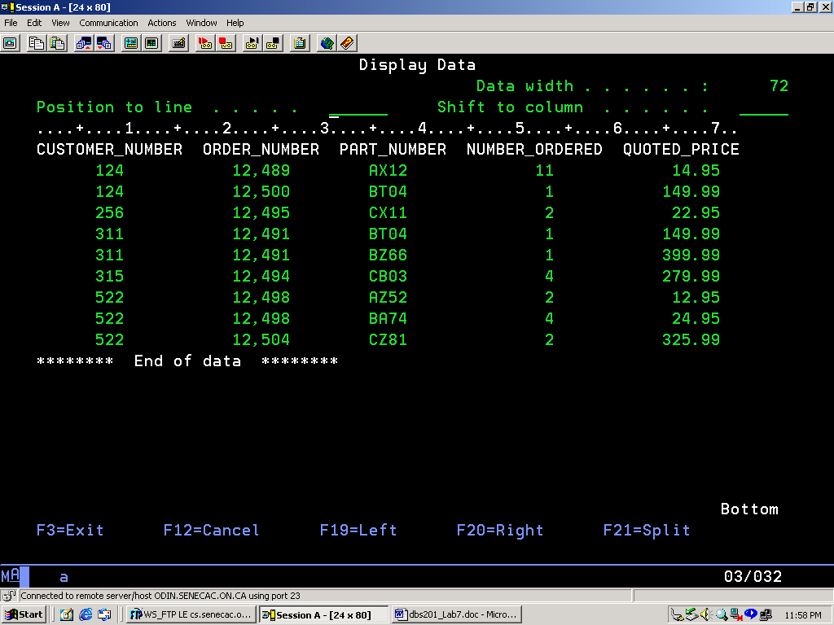

CHALLENGE:

Using the ORDER_INFO view produce the report on the next page.

