Field Project in Health Information Standards

Lisa Totton
School of Health Information Science, University of Victoria
HINF 597: Field Project in Health Informatics
Dr. Linda Bird
August 22, 2025

Abstract

Objectives: This project aimed to create semantically interoperable patient summaries using the Pan-Canadian Patient Summary (PS-CA) implementation guide and freely available tools. The goal was to support education, promote broader adoption of patient summary standards, and demonstrate how structured health data can be created, shared, and visualized in a reproducible and accessible way. By offering a practical example and clear documentation, the project also helps bridge the knowledge gap around interoperable patient summaries, a skillset that remains specialized despite ongoing international efforts.

Methods: Synthetic patient records were manually created in comma separated value (CSV) format and aligned with PS-CA resource profiles. A custom Python application transformed these records into HL7 FHIR-compliant bundles, which were posted to a locally hosted HAPI FHIR server. Microsoft Power BI was used to retrieve and visualize the data via Power Query. All project files and documentation were published in a public GitHub repository to support transparency and educational reuse.

Results: Seven synthetic patient summaries were successfully generated, validated, and visualized. Each summary bundle included required PS-CA resource types and applied appropriate terminology bindings using SNOMED CT CA, CCDD, and HL7 value sets. The Power BI dashboard enabled interactive exploration of the data, and the GitHub repository provided comprehensive documentation and setup instructions.

Discussion: The project demonstrated that Python, HAPI FHIR, and Power BI are effective, freely available tools for building and exploring standards-based patient summaries. Key lessons included handling CSV formatting issues, comprehending FHIR data types, understanding FHIR endpoints and their modifiers, and integrating patient photos using base64 encoding. Community engagement and open-source resources played a vital role in troubleshooting and learning.

Conclusion: This project shows that semantically interoperable patient summaries can be created and shared using open-source tools and synthetic data. By lowering technical barriers and providing hands-on resources, it supports broader adoption of patient summary standards that contribute to improved continuity of care across diverse healthcare settings.

1. Introduction

1.1 Project Purpose and Rationale
For clinicians to provide the best possible care, they require timely access to accurate and understandable patient information. Having the right data at the right time and in the right format can improve decision-making, reduce errors, and enhance patient outcomes (Kruse & Beane, 2018). However, many clinicians do not have easy access to comprehensive or usable data as information about a single patient may be scattered across multiple systems. For example, acute care data may reside in a hospital information system while primary care records exist in a separate electronic medical record (Smith et al., 2005). Even when clinicians have access to these systems, they may not be trained on how to navigate them effectively (Heponiemi et al., 2021). The high volume of data generated during each encounter further complicates this, often requiring clinicians to sift through extensive records to find what they need. Important information may be hidden in long, unstructured narrative notes, and even when located, it may be difficult to interpret due to the use of discipline-specific jargon and inconsistent terminology (Lee et al., 2024).
Standardized patient summaries help address the challenge of fragmented health information across care settings. A patient summary provides a concise overview of essential clinical information such as problems, medications, and allergies (IPS Web Editorial Team, 2025). To ensure they are useful in diverse clinical environments, they need to be interoperable. Interoperability is defined by the Healthcare Information and Management Systems Society (HIMSS) as:

“the ability of different information systems, devices and applications (systems) to access, exchange, integrate and cooperatively use data in a coordinated manner, within and across organizational, regional and national boundaries, to provide timely and seamless portability of information and optimize the health of individuals and populations globally.” (2020, “What is Interoperability?”)

HIMSS also defines a hierarchy of levels of interoperability (see Figure 1). At the technical level, systems must be able to connect and send data. At the structural level, the data must follow a consistent format, such as HL7 FHIR. At the semantic level, the meaning of the data must be preserved by using shared terminology systems.
To achieve structural and semantic interoperability, patient summaries must rely on health information exchange (HIE) standards and standardized clinical terminologies (SCTs). These components support the layered model defined by HIMSS and provide the foundation for standards like the Pan-Canadian Patient Summary (PS-CA), which aim to ensure consistent and meaningful data exchange across care settings. Based on the International Patient Summary (IPS), the PS-CA is a semantically interoperable patient summary standard that leverages national terminologies (Cameron, 2022). One implementation of the PS-CA uses Fast Healthcare Interoperability Resources (FHIR), a modern, web-based standard for health data exchange developed by HL7 International (Canada Health Infoway, 2022; HL7 International 2022-a, 2024). Together, the PS-CA, FHIR, and SCTs establish a clear framework for creating patient summaries that can be trusted and shared seamlessly across care settings.
Despite ongoing international efforts, knowledge of and experience with interoperable patient summaries remains a specialized skillset (Blessing et al., 2023). This field project was designed to help bridge that gap by providing a practical, accessible example. Using freely available tools, the project produced a semantically interoperable patient summary along with clear documentation to promote transparency and reproducibility. By sharing both the patient summary example and associated documentation, the project aims to support newcomers to the field and encourage broader adoption of patient summaries. In doing so, it contributes to improved continuity and quality of care.

1.2 Background
To inform the design and implementation of this field project, a targeted literature review was conducted. The goal was to identify published and unpublished work that could provide practical insights into three key areas: world-wide efforts to implement FHIR-based patient summaries, including how SCTs such as SNOMED CT and the Canadian Clinical Drug Database (CCDD) have been selected, mapped, and maintained; the use of the HL7 Application Programming Interface (HAPI) FHIR Server in pilot and proof-of-concept projects; and the role of open-source tools and educational initiatives in supporting the adoption and understanding of interoperability standards. These themes were selected to align with the project’s objectives of providing a reproducible and educational implementation of the PS-CA.

1.2.1 FHIR Based Patient Summaries

Overview. The IPS was developed in response to the growing need for a standardized, portable snapshot of essential health information that can be shared safely and reliably across countries and care settings (Krastev et al., 2020). It originated in Europe through the European Committee for Standardization (CEN) as the CEN 17269 standard, which defined a minimal core set of data elements to support the safe exchange of health information in scheduled, unscheduled, domestic, and cross-border care scenarios (CEN-CELEC 2021, 2022, 2025). Building on this foundation, the International Organization for Standardization (ISO) published ISO 27269, expanding the IPS for global use (ISO 27269, 2021). This work was completed with contributions from multiple Standards Development Organizations, including HL7 International and Integrating the Healthcare Enterprise (IHE). While HL7 standards define the structure and content of IPS documents, IHE creates integration profiles that describe how those documents are exchanged across systems in real-world healthcare workflows (IHE International, 2020, 2025; Osamika et al., 2025).
To ensure the IPS could be implemented using widely adopted technical approaches, HL7 created two complementary implementation guides (IGs): one based on the older Clinical Document Architecture (CDA), which is document-centric and XML-based, and another leveraging FHIR (HL7 International, n.d-a, n.d-b). FHIR supports IPS by structuring data into modular resources such as Patient, Condition, AllergyIntolerance, and MedicationStatement, which can be exchanged using standard web protocols. By outlining the required dataset and pairing it with FHIR implementation details, the IPS bridges the gap between high-level design and operational use (D'Amore et al., 2021).

Implementation Lessons. The implementation of the IPS and its national adaptations has revealed a range of practical insights, challenges, and innovations. This section explores key lessons learned from real-world deployments across Canada, the United States, and other regions in North America, with a focus on terminology standards, use case diversity, governance models, and technical infrastructure. These findings highlight the importance of balancing global consistency with local relevance, and they underscore the critical role of collaboration among stakeholders in achieving semantic interoperability.

Terminology Foundations. While FHIR provides the structural and technical foundation for exchanging IPS data, terminologies and value sets ensure the information being shared is meaningful and consistently interpreted across systems. SCTs define the concepts used in patient summaries, while value sets specify which subsets of those terminologies are appropriate for a given data element (Canada Health Infoway, 2024-d). For the IPS, globally recognized SCTs such as SNOMED CT, RxNorm, and Logical Observation Identifiers Names and Codes (LOINC), are used to maintain semantic interoperability (HL7 International, 2022-a, 2022-b). Among these terminologies, SNOMED CT has been a particular focus in IPS development. To lower adoption barriers, SNOMED International first released the IPS Free Set, a simplified collection of SNOMED CT concepts relevant to IPS use cases. It was distributed under a free license to reduce barriers to implementation. Building on this foundation, SNOMED International later introduced the IPS Terminology, which expands the Free Set into a structured sub-ontology. It includes basic groupings, relationships, and synonyms, and can be used in SNOMED CT-compatible servers to support consistent and meaningful data exchange (SNOMED International, 2025-a, 2025-b).
Clinical Value of Patient Summaries. The IPS provides a robust framework for patient summary exchange, and studies have revealed both valuable lessons and areas for improvement. For example, patient summaries have been shown to be useful in more than just emergencies. They allow clinicians to access structured, high-value information such as medications, allergies, and key diagnoses, which is vital in emergency or cross-border situations where time or language barriers limit the ability to gather a complete medical history (Digital Health Canada, 2021). Beyond acute care, patient summaries have also been leveraged in broader contexts such as COVID-19 vaccination tracking (Sass et al., 2020), disaster response efforts (Tageo et al., 2021), child vaccination programs (Sorsavanh et al., 2024), and clinical research initiatives (Francisco & Marques, 2024).
Country Specific Adaptations. Implementing the IPS often requires country-specific and domain specific adaptations. While the IPS defines a minimal global dataset, real-world use cases frequently demand extensions to meet local clinical needs or regulatory requirements (Kay Stephen et al., 2020). A compelling example is Canada’s PS-CA. Developed by Canada Health Infoway in collaboration with provinces, territories, and vendors, the PS-CA aligns closely with IPS standards while allowing for jurisdictional flexibility. This approach ensures semantic interoperability while accommodating Canada’s diverse healthcare landscape (Canada Health Infoway, 2025).
North American Implementation Landscape. Recent developments across North America illustrate the momentum and complexity of PS-CA adoption. As a G7 members, both Canada and the United States have committed to working toward a standardized minimum health dataset via the IPS framework (Department of Health and Social Care (UK), 2021). In Canada, Alberta released a production-ready IG (PS-AB) in October 2024 (Alberta Health, 2024), while Ontario and British Columbia have published draft guides (Ontario Health, 2022; BC Patient Summary FHIR Implementation Guide, n.d.). Manitoba and Saskatchewan operate Patient Summary–like applications, namely eChart and MySaskHealthRecord, which are not yet aligned with PS-CA (Owen, 2010; eHealth Saskatchewan, 2024). In 2024, New Brunswick (NB) launched MyHealthNB, becoming the most recent province to adopt a PS-CA-aligned application. This makes NB is the first in Canada to enable patients to create and share their own summaries, marking a significant milestone in patient empowerment and interoperability (Canadian Healthcare Technology, 2024; Seeley, 2024).
In the United States, IPS adoption is gaining traction through both public and private sector initiatives. The CommonHealth app, developed by the Commons Project Foundation in New York, has been available to U.S. residents since October 2023 and uses the IPS standard to enable individuals to manage and share their health data (CommonHealth International Patient Summary, n.d.; D’Amore, 2024). Washington State has also launched the Verify+ IPS web app, allowing residents to create and share verifiable health summaries using the IPS standard (Washington State Demonstrates IPS – The International Patient Summary, 2024). In addition to these implementations, EPIC and Meditech have announced plans to incorporate IPS into their products, signaling growing vendor support (D’Amore, 2024).
In the Latin America and Caribbean (LAC) region, sixteen countries including the Bahamas, Belize, Costa Rica, El Salvador, Guatemala, Honduras, and Panama participated in the 2023 LACPASS Connectathon. These countries exchanged IPS-LAC documents through their national FHIR server infrastructures, demonstrating regional commitment to interoperability (RACSEL, 2023; IPS Web Editorial Team, 2024-b).
International Efforts. Many other countries are also in the process of developing IPS adaptations, including Brazil, Australia, and New Zealand, and the Philippines (De Faria Leao et al., 2024; DevDays, 2025; Frankel, 2025; IPS Web Editorial Team, 2024-a). The IPS has also been adapted for targeted use cases. In Haiti, the IPS has been used to support HIV care by enabling the sharing of patient records across multiple treatment sites, helping address challenges related to a mobile population and fragmented care (IPS Web Editorial Team, 2023). Another adaptation occurred in the European Union, where the IPS was deployed during a large-scale earthquake simulation. Emergency responders accessed patient data directly from mobile devices, improving triage and treatment in the field (Tageo et al., 2021).
Governance Challenges and Models. IPS implementation depends on coordinated efforts among standards development organizations, governments, vendors, and healthcare providers. Strong governance models, adequate funding, and clear regulatory guidance are necessary to build trust and drive consistent use of the standard (Gotsadze et al., 2024). In Canada, it has been noted that the lack of centralized governance and federal oversight poses a significant challenge to national IPS implementation. Without a unified approach, regional disparities in readiness and funding risk creating a fragmented system that undermines the value of IPS. A consistent, pan-Canadian strategy is essential to fully realize the benefits of standardized, interoperable patient summaries (Digital Health Canada, 2021).
Terminology Challenges and Lessons. Studies have also highlighted important lessons about the use of SCTs. First, selecting globally recognized standards such as SNOMED CT, CCDD, and LOINC is essential for achieving semantic interoperability, but they often require adaptation to reflect local clinical and regulatory needs. For example, Germany’s GECCO dataset combined SNOMED CT and LOINC with the German Modification of the 10th revision of the International Statistical Classification of Diseases and Related Health Problems (ICD-10-GM), the Anatomical Therapeutic Chemical classification system (ATC), and Unified Code for Units of Measure (UCUM) to support COVID-19 research while maintaining compatibility with IPS value sets (Sass et al., 2020). These examples illustrate that while IPS promotes international alignment, local implementations must balance global consistency with domestic relevance.
This need for adaptation often translates into complex terminology mapping efforts, which have been identified as one of the most complex aspects of IPS adoption (Shivers et al., 2021). Many jurisdictions rely on legacy codes or fragmented vocabularies that do not align neatly with international standards, requiring manual mapping and validation to preserve accuracy. Human oversight remains critical to ensure clinical safety and usability, but automated tools exist that can help scale this process. In Brazil, the IPS initiative used Open Concept Lab and FHIR translate operations to automate the mapping of local terminologies to international standards, guided by the ISO/TR 12300:2014 framework (De Faria Leao et al., 2024). This approach demonstrated how open-source tools and international guidance can support scalable, accurate terminology alignment when combined with careful validation.
Terminology Maintenance. IPS implementations must account for frequent updates to standards like SNOMED CT and LOINC and ensure that value sets remain aligned with evolving clinical practice. For instance, Canada Health Infoway publishes regular updates for the Canadian Edition of SNOMED CT (SNOMED CT CA), the pan-Canadian LOINC Observation Code Database (pCLOCD), and the Canadian Clinical Drug Data Set (CCDD), ensuring that national IPS IGs like the PS-CA remain current and interoperable (Canada Health Infoway, 2024-e). Georgia’s experience further illustrates the importance of strong governance in terminology adoption. As part of its digital health transformation, Georgia convened workshops to define roles and responsibilities for terminology governance and to align national standards with international frameworks such as SNOMED CT, the International Statistical Classification of Diseases (ICD) , and Identification of Medicinal Products (IDMP). Despite challenges like fragmented systems, unclear responsibilities, and limited resources, Georgia’s efforts to assign terminology standards to functional domains such as “Patient Summary” and “Standards and Interoperability” highlight the foundational role of governance in sustaining IPS-aligned systems. These efforts also reflect a growing recognition that successful digital health transformation depends not only on technical standards but on clearly defined leadership and accountability structures (Gotsadze et al., 2024).

Conclusion. In summary, successful IPS implementation depends not only on SCTs and technical standards like FHIR, but also on robust governance, stakeholder coordination, and thoughtful localization. As countries like Canada, Brazil, and Georgia have shown, aligning international frameworks with national priorities requires ongoing investment in terminology mapping, maintenance, and policy leadership. These foundational efforts are essential to ensure that IPS remains a scalable, interoperable solution for improving continuity of care across diverse health systems.

1.2.2 HAPI FHIR JPA Server

Overview. HAPI FHIR is an open-source implementation of the HL7 FHIR specification developed by the University Health Network (UHN) in Toronto, Canada. It provides a mature, standards-based foundation for building FHIR-compliant solutions and has become one of the most widely used reference implementations in both research and healthcare innovation. HAPI FHIR supports RESTful APIs and integrates seamlessly with widely recognized terminologies such as SNOMED CT, LOINC, and ICD-10, ensuring that both structural and semantic interoperability can be achieved in line with HL7 standards (HAPI FHIR 2025-a; Smile CDR, 2025)

Key Features and Applications. The HAPI FHIR JPA Server extends the core HAPI FHIR library into a complete server solution that not only supports all core CRUD operations (create, read, update, delete) but also offers advanced capabilities for validation, terminology management, and IPS generation (HAPI FHIR 2025-b, 2025-c, 2025-d). Its validation features operate at two levels. Parser validation is quick and runs while a resource is being read, catching basic issues like elements that don’t match the data model. Instance validation is more detailed, checking a resource against official FHIR rules and profiles, and can also validate against specific IGs like the PS-CA. (HAPI FHIR 2025-c). Additionally, terminology services are integrated into the server, allowing terminology to be loaded using standard FHIR REST APIs (PUT and POST). At runtime, terminology validation uses CodeSystem, ValueSet, and ConceptMap resources stored within the server (FHIR 2025-d).
In addition to terminology and validation, HAPI FHIR also provides built-in support for generating IPS FHIR document bundles. The server includes a flexible IPS generation engine that uses the $summary operation to automatically create IPS documents that follow the HL7 IPS IG. This allows users to test IPS workflows and integrate them into health information exchange solutions (HAPI FHIR 2025-c). Together, these validation, terminology, and IPS generation capabilities make the server a powerful platform for both production use and educational or prototyping environments.
Beyond these built-in features, HAPI FHIR’s impact is evident in how it has been applied in research and healthcare innovation. A review of the literature revealed numerous examples where HAPI FHIR was leveraged. Bennett et al. (2023) described how the Medical Information Mart for Intensive Care (MIMIC-IV) database was converted into FHIR-compliant resources, validated against HAPI FHIR, and exported for use in downstream artificial intelligence (AI) systems. As one of the earliest publicly available de-identified critical care datasets in FHIR format, MIMIC-IV on FHIR offers extensive real-world data that is highly valuable for both research and the development of healthcare technologies. Prud’hommeaux et al. (2021) extended HAPI FHIR with Resource Description Framework (RDF) support, allowing FHIR data in JSON or XML to be converted into RDF so it can be linked and combined with other datasets. This makes it easier to connect healthcare data with external information for advanced analysis and research. The RDF implementation was merged into the HAPI FHIR master repository and included in the 5.2.0 (Numbat) release in December 2020 (p. 117).
In addition to research, HAPI FHIR has played a key role in building clinical and patient-facing applications. The server has been used to power personal health record platforms (Lee et al., 2020), integrate real-time monitoring and health coaching systems (Chatterjee et al., 2022), and support clinical decision-making in projects like diabetes complication screening (Francisco & Marques, 2024). Walinjkar (2018) demonstrated how trauma-related physiological data collected from IoT devices could be structured as FHIR resources and uploaded in real time to HAPI FHIR for visualization in an electronic health record (EHR) system. The server has also been integrated with domain-specific standards like Digital Imaging and Communications in Medicine (DICOM) to manage imaging data. Solar et al. (2024) described how 33,000 medical CT images and diagnostic reports were anonymized and ingested into a combined HAPI FHIR–DICOM system for AI analysis. These examples highlight the flexibility of HAPI FHIR, demonstrating its ability to support a wide range of clinical workflows.

Education and Community Support. Alongside its technical applications, HAPI FHIR is recognized as an educational and enablement tool. Its open-source licensing, extensive documentation, and strong community support make it ideal for teaching developers and healthcare professionals about HL7 FHIR. Hussain et al. (2018) published a step-by-step tutorial for clinical imaging informatics professionals, demonstrating how to build a FHIR playground using HAPI FHIR, synthetic imaging datasets, and other open-source tools. The server has also been widely adopted in interactive workshops, where participants gain experience setting up sandbox servers, building and validating resources, and testing FHIR interoperability workflows (Moehrke, 2017; Open Concept Lab, 2024; Soares et al., 2023).

Challenges and Lessons Learned. While these examples highlight how HAPI FHIR has been leveraged as an interoperability and educational tool, literature also emphasizes its core strengths and known limitations. HAPI FHIR is widely regarded for its robust validation capabilities, ensuring that resources stored and shared are structurally correct and semantically meaningful. The platform’s RESTful architecture simplifies integration with other systems, while its open-source licensing, extensive documentation, and active user community lower both technical and financial barriers. (Bennett et al., 2023; Francisco & Marques, 2024). Those seeking support can rely on resources such as the HAPI FHIR Google Group and the HAPI channel on chat.fhir.org, which provide peer assistance and guidance (HAPI FHIR Community, n.d.-a, n.d.-b)
Despite these strengths, several challenges have been observed in large-scale or complex implementations. Performance can degrade when working with very large datasets or highly complex queries, often requiring optimization strategies such as parallel processing or ElasticSearch integration (Francisco & Marques, 2024). Terminology binding and validation are also resource-intensive, particularly when mapping legacy or local codes to international standards like SNOMED CT and LOINC (Chatterjee et al., 2022). Lessons from the literature show that these challenges can be addressed through a combination of enablers and best practices. Dockerized deployment options and the use of synthetic datasets provide safe, reproducible environments for testing and optimization (Francisco & Marques, 2024; Jayathissa & Hewapathrana, 2024). Studies also highlight that HAPI FHIR’s open-source ecosystem and community-driven support networks are critical helping implementers troubleshoot issues (Jayathissa & Hewapathrana, 2024).

Summary. Overall, the literature highlights HAPI FHIR’s versatility and growing role in healthcare and research, with examples ranging from data transformation and validation to integration with external datasets. In this project, HAPI FHIR was used to host and validate PS-CA bundles, demonstrating how freely available, community-supported tools can support education and promote interoperability in healthcare.

1.2.3 FHIR Educational Initiatives, Communities, and Resources

Overview. Educational initiatives are an important way to build the technical and conceptual skills needed to implement HL7 FHIR in healthcare environments. Although FHIR is designed to be more accessible than older standards, its adoption still requires specialized knowledge (Snyder, 2025). To help bridge this gap, a range of learning opportunities, communities, and resources have emerged. Conferences such as HL7® FHIR® DevDays and various “marathon” events (hackathons, connectathons, and projectathons) introduce developers, clinicians, and organizations to FHIR in a hands-on way, while also lowering barriers by fostering collaboration between technical and clinical participants (Firely, 2025; Poncette et al., 2020; Zaffino, 2024). In addition to its technical capabilities, HAPI FHIR benefits from active user communities both internationally and within Canada. Ongoing peer support is available through platforms such as the official FHIR Zulip community and Canada Health Infoway’s InfoCentral, which hosts dedicated groups focused on HL7 FHIR, health terminologies, and the PS-CA (Canada Health Infoway 2024a, 2024b, 2024c; Procious, 2024). Additionally, numerous open-source proof-of-concept projects are publicly shared through blog posts, YouTube videos, and GitHub repositories, enabling self-directed learning at any time. Together, these educational initiatives, user communities, and open-source resources create an ecosystem that accelerates understanding and adoption of FHIR.

Collaborative Learning. The term hackathon combines hack, referring to intensive collaborative programming, and marathon, which reflects the time-constrained nature of the event, where participants work intensively within a defined period. They aim to bring diverse participants together to create innovative solutions to complex medical and health IT problems (“What Is a Hackathon?,” n.d.). Lessons from the literature show that hackathons are useful educational tools, as they combine innovation and learning in a time-limited, problem-focused format. They are especially effective when patients and clinicians are included, bringing in real-world perspectives and priorities (Poncette et al., 2020). However, they also face challenges. Tight schedules often limit how deeply participants can explore solutions, and organizing such events requires significant funding, planning, and institutional support. Some barriers have been successfully addressed through targeted interventions. Yarmohammadian et al. propose a solution through their three-phase model for planning, conducting, and evaluating healthcare- related hackathons (2021). Another major challenge for hackathon success was identified as the lack of realistic imaging test data. In one effort to address this challenge, patient narratives were created that linked believable fictional cases with DICOM images and FHIR resources, developed in collaboration with experienced radiologists (Hussain et al., 2018).
Cultural and institutional barriers can also limit participation. Awareness of hackathons or open educational initiatives in healthcare is still limited, and there are often misconceptions about their purpose. Additionally, issues related to diversity, inclusion, and intellectual property can arise in collaborative events, reducing trust or discouraging participation (Rigas et al., 2023). Without strong institutional support and clear communication these challenges can hinder the sustainability of educational initiatives. Despite these challenges, hackathons remain a valuable approach for advancing FHIR education and innovation, provided they are well-structured, adequately resourced, and supported by strong institutional backing (Poncette et al., 2020; Rigas et al., 2023; Yarmohammadian et al., 2021).

Free Tools and Open-Source Learning. Open-source ecosystems support learning by offering free tools, reference implementations, and datasets that allow experimentation and learning without licensing barriers. As mentioned previously, the HAPI FHIR reference implementation is a valuable educational tool (HAPI FHIR, 2025). Synthea is another open-source tool that creates realistic synthetic patient data in a variety of formats, including FHIR. It is free from privacy, cost, and security restrictions, making it an ideal educational resource (About Synthea, n.d.). Beyond software tools, high-quality tutorials, documentation, and well-maintained GitHub repositories provide accessible, self-directed learning opportunities beyond the event itself. For example, in their 2023 paper Major et al. provided a tutorial introducing FHIR and described how they configured a FHIR application and developed python code to send data from the Epic EHR to downstream AI systems. The MIMIC-IV dataset, previously mentioned in the context of HAPI FHIR, has also been used as an educational resource. All components of the project, including the de-identified FHIR dataset and tutorial walk-throughs were made available through a GitHub repository designed to support learning and experimentation (Major et al., 2023). A third study by Hussain et al., aimed at imaging informatics professionals and again published on GitHub, detailed how to build a FHIR playground using the HAPI FHIR server, a synthetic imaging dataset, and other open-source tools. These studies demonstrate the value of open-source platforms in supporting accessible, self-directed education in health informatics.

Terminology Education. The requirement to understand SCTs as they relate to FHIR adds an additional layer of complexity. Both the Regenstrief Institute and SNOMED International provide numerous free educational resources to support learning and implementation of LOINC and SNOMED CT, respectively (Regenstrief Institute, Inc., 2025-a; SNOMED International, 2019). SNOMED International also makes available both the IPS Free Set and IPS Terminology, previously described in Section 1.2.1, to support IPS implementations and terminology education (SNOMED International, 2025-a, 2025-b). Similarly, the Regenstrief Institute allows free access to search the LOINC terminology, download files, and participate in its user forum (Regenstrief Institute, Inc., 2025-b). These platforms make it easier for users to explore terminology standards and learn how to apply them effectively in real-world contexts.

Summary. In conclusion, FHIR educational initiatives thrive when undertaken within a broader ecosystem of open-source tools, collaborative events, and community-driven learning. By combining technical training with real-world problem solving and accessible resources, these initiatives lower barriers to adoption and empower a diverse range of stakeholders. Continued investment in inclusive, well-supported educational models will be essential to sustaining FHIR adoption and innovation across healthcare systems.

1.3 Scope
The scope of this project includes the creation of 10 synthetic patient records that comprise all required sections of the PS-CA: Composition, Problems, Allergies/Intolerances, and Medications. No real patient data was used, and the project is not intended as a production-level implementation.
In addition to data creation, the project involved developing a custom Python application to transform the synthetic records into HL7 FHIR-compliant bundles, deploying a local HAPI FHIR server for testing and validation, and building a Microsoft Power BI dashboard to access and visualize the data. All project files and documentation were published in a publicly accessible GitHub repository to support transparency, reproducibility, and educational reuse.

1.4 Lifecycle Stage
This project aligns with the fourth stage of the Canadian Institute for Health Information (CIHI) Data Standards Development Lifecycle: Support Uptake (see Figure 3). In this stage, health-related organizations and vendors are provided with support to implement the standard in their systems. This project contributes to the uptake of the PS-CA specification by demonstrating how synthetic patient data can be created, shared, and visualized using HL7 FHIR standards. Through the use of open-access tools and documentation, the project supports key goals of the Support Uptake phase by advancing education and capacity building, and by providing resources that can inform future system-level implementations.

2. Methods

This section outlines the approach used to design, implement, and share a standards-based patient summary application. It covers the manual creation of synthetic patient data, the development of a Python application for data transformation, the deployment of a local FHIR server for testing, the visualization of results using Power BI, and the distribution of all project materials in a publicly accessible GitHub repository.

2.1 Study Design
This project followed a structured, multi-step workflow to create, share, and visualize synthetic patient summaries aligned with PS-CA specification. The overall process involved data modeling, standards alignment, resource generation, server deployment, data visualization, and public dissemination.
The project began with the manual creation of synthetic patient records using Windows Notepad. A separate comma separated value (CSV) file was created for each FHIR resource type required by the PS-CA IG: Composition, Patient, MedicationStatement, Condition, and AllergyIntolerance. CSV files aligned with the Organization and Immunization resource types were also created to add additional educational value. Each file contained one or more rows per patient, depending on the resource type. Values were selected to align with the PS-CA resource profiles, and terminology bindings were applied using HL7 and Canada Health Infoway value sets. Details on the structure and contents of the CSV files are described in Section 2.2.
A Python program was then developed to automate the transformation of these CSV files into FHIR-compliant patient summary bundles. The program read in the data, created a FHIR Bundle for each patient, and posted the bundles to a locally hosted FHIR server. Details on the development environment, libraries used, and server setup are provided in Section 2.3.
To support data access and visualization, Power Query was used within Power BI to connect to the FHIR server and retrieve patient summary bundles from individual endpoints. The JSON data was transformed into structured tabular format using Power Query, enabling relational modeling. Power BI was then used to display the patient summaries in a user-friendly dashboard, allowing users to explore the clinical data interactively. The data transformation and visualization processes are described further in Section 3.3.
Finally, a GitHub repository was created to share all project files and documentation. This included the CSV files, Python code, Power BI dashboard, and setup instructions. The repository structure and educational goals are discussed in Section 3.4.

2.2 Data Sources
To support transparency, reproducibility, and educational accessibility, synthetic patient data was manually created in CSV format rather than using automated tools such as Synthea. This decision was made for two key reasons. First, manually creating simple records in CSV files allows learners and developers to easily open and explore the data using familiar tools like Microsoft Excel. Second, it allowed for full control over the structure and content of each record, ensuring that all data elements aligned precisely with the PS-CA IG.
To best understand the contents of the files and the rationale behind their structure, it is helpful to first introduce some key FHIR concepts related to coded data and terminology standards. Many fields in FHIR resources are represented using codes. These are known as coded elements, and they rely on SCTs to ensure consistency across systems. A value set is a curated list of allowable codes drawn from one or more code systems, such as SNOMED CT, LOINC, or HL7. Value sets define which codes are valid for a particular element in a FHIR resource. For example, a value set called ClinicalFindingCode, maintained by Canada Health Infoway, is a subset of SNOMED CT CA, containing only values that exist in the Clinical Finding subhierarchy. Terminology binding refers to the link between a coded element and a specific value set. This binding ensures that the data adheres to recognized standards and supports interoperability. In the PS-CA the Condition code is bound to the ClinicalFindingCode value set. Each binding includes a binding strength, which indicates how strictly the value set must be followed. FHIR defines four binding strengths:

- Required: Only codes from the specified value set may be used.
- Extensible: Codes from the value set should be used when applicable, but other codes may be included if necessary.
- Preferred: The value set is recommended, but not mandatory.
- Example: The value set is provided for illustration and is not expected to be used.
(HL7 International, 2019-a)

In FHIR, coded elements are typically represented using one of two data types: Code or CodeableConcept. A Code is a simple string that represents a single concept from a defined code system. It is compact and used when only the code itself is needed. A CodeableConcept is a more flexible structure that can include multiple codings, each with a code, display name, and code system. It is used when additional context or multiple coding systems are required (HL7 International, 2019-b). When creating the CSV files, the code, code system, and display name were included for all data elements with a data type of Code or CodeableConcept. While FHIR profiles with a Code data type typically only accept the code itself (and do not store the display name or system), these additional fields were included for consistency and educational clarity. This approach helps users understand where each value came from and supports transparency in how terminology was applied, even if some of this information is not pushed to the FHIR server or visible in the dashboard.
Additionally, while in general only fields marked as Required in the PS-CA IG were included, in some cases, additional fields such as address, telecom information, and patient photo were incorporated to enhance the educational value of the project and enrich the dashboard visualization. These additions help demonstrate how optional fields can be included to create more complete patient summaries.
The following subsections detail the contents of each CSV file, including the optionality of each field and the terminology bindings to value sets defined in the PS-CA Implementation Guide.

2.2.1 Organization
The organization CSV file contained two fields: organization name and organization type. Of these, only the organization name was mandatory. A single organization was used for all patient summaries to simplify the data. The organization type field was bound to the HL7 OrganizationType value set, with a binding strength classified as "example." This structure aligns with the Organization profile in the PS-CA IG.

2.2.2 Composition
The composition CSV file included patient identifier and the composition author, status, type, title, id, and URL. The patient identifier, author, status, type, and title fields were mandatory. The value for the author field was sourced from the Organization resource rather than the CSV file. Additional fields captured the coding system, code, and display name for the composition document and for each of the condition, allergy, medication, and immunization sections. This structure follows the CompositionPSCA profile in the PS-CA IG. As per the profile they were bound to the following LOINC documents:

  - 60591-5: Patient summary Document
  - 11450-4: Problem List – Reported
  - 48765-2: Allergies and adverse reactions Document
  - 10160-0: History of Medication use Narrative
  - 11369-6: History of Immunization Narrative

2.2.3. Patient
The patient CSV file contained synthetic demographic data modeled after cartoon characters. It included the following fields: patient identifier (health card number), name, birth date, gender, telephone number, email address, physical address, and photo (as a folder path). The name and birth date fields were mandatory. The gender field was bound to the AdministrativeGender HL7 value set with a binding strength of “required.” This format is based on the PatientPSCA profile in the PS-CA IG.

2.2.4 Condition
The condition CSV file included information about health concerns and diagnoses. It contained the patient identifier, condition code, condition coding system, and condition display name. Both the patient identifier and condition code fields were mandatory. The condition code field was bound to the ClinicalFindingCode value set with a binding of "preferred." This format is based on the ConditionPSCA profile in the PS-CA IG.

2.2.5 Allergy-Intolerance
The allergy-intolerance CSV file included data on patient allergies, such as the allergen substance, reaction manifestation, and various status indicators. The patient identifier and allergen substance fields were mandatory. As per the AllergyIntolerancePSCA profile in the PS-CA IG, several fields in this file are bound to HL7 and SNOMED CT CA value sets with varying binding strengths. The table below summarizes the relevant fields, their binding strengths, associated code systems, and the value sets to which they are bound:

Field | Binding Strength | Value Set | Code System
clinicalStatus | Required | AllergyIntoleranceClinicalStatusCodes | HL7
verificationStatus | Required | AllergyIntoleranceVerificationStatusCodes | HL7
criticality | Required | AllergyIntoleranceCriticality | HL7
reactionSeverity | Required | AllergyIntoleranceSeverity | HL7
allergy-intolerance code | Preferred | PharmaceuticalBiologicProductAndSubstanceCode | SNOMED CT CA
reactionManifestation | Required | ClinicalFindingCode | SNOMED CT CA

2.2.6 Medication
The medication CSV file contained information about prescribed medications, including the patient identifier and the medication effective date, details, and status. The patient identifier, effective date, medication, and status fields were mandatory. As per the MedicationStatementPSCA profile in the PS-CA IG, the medication and status fields are bound to value sets from CCDD and HL7, respectively. The table below outlines the relevant fields, their binding strengths, associated code systems, and the value sets to which they are bound.

Field | Binding Strength | Value Set | Code System
medication | Preferred | PrescriptionMedicinalProduct | CCDD
status | Required | Medication Status Codes | HL7

2.2.7 Immunization
The immunization CSV file contained details about administered vaccines, including the patient identifier and the immunization occurrence date, route, site, status, and vaccine. The patient identifier, occurrence date, status, and vaccine fields were mandatory. As per the ImmunizationPSCA profile in the PS-CA IG, several fields are bound to value sets from SNOMED CT CA and HL7, with varying binding strengths. The table below summarizes the relevant fields, their binding strengths, associated code systems, and the value sets to which they are bound.

Field | Binding Strength | Value Set | Code System
vaccine | Preferred | VaccineAdministeredTradeNameCode | SNOMED CT CA
route | Preferred | ImmunizationRouteOfAdministrationCode | SNOMED CT CA
status | Required | ImmunizationStatusCodes | HL7
site | Example | CodesForImmunizationSiteOfAdministration | HL7

2.3 Tools and Processes
This project was developed using a combination of freely available tools, standards-based services, and open-source software to ensure transparency, reproducibility, and accessibility for learners and developers.

2.3.1 Hardware and Development Environment
The project was undertaken on a Microsoft Surface 3 Laptop running 64-bit Windows 11 Home. Microsoft Visual Studio Code (version 1.102.1) was used as the integrated development environment (IDE) for writing and debugging the Python application. The Python application relied on several libraries, including: pandas, requests, json, uuid, datetime, sys, and fhir.resources. ChatGPT was also used as a support tool for debugging programming errors and troubleshooting implementation problems.

2.3.2 Containerization and Server Setup
To simulate a standards-based FHIR environment, Docker Desktop (version 4.00.0) was used to run the latest version of the HAPI FHIR JPA Server. This containerized server provided a local endpoint for posting and retrieving FHIR resources, enabling end-to-end testing of the synthetic patient summaries.

2.3.3 Terminology and Standards Tools
Two tools were used to assist with the design and validation of the CSV input files and their alignment with the PS-CA specification:

- Simplifier.net: The Pan-Canadian Patient Summary Project on Simplifier.net was used to explore the FHIR resource profiles. The “snap” view allowed the author to examine each profile’s data elements, descriptions, data types, cardinality, and terminology bindings. This ensured that all required fields were included and that the data conformed to the expected formats and value set bindings. Simplifier.net also provided access to HL7-maintained value sets, which were used to select appropriate codes for fields such as gender, status, and document sections.

- Canada Health Infoway Ontoserver: For value sets maintained by Canada Health Infoway, the Ontoserver was used extensively. Ontoserver is a FHIR-compliant terminology service that supports SNOMED CT, LOINC, and other code systems. It allows users to interactively browse, filter, and validate terminology. A free Canada Health Infoway account was required to access Ontoserver, which the author obtained. This tool was instrumental in selecting appropriate codes from Canadian-maintained value sets, ensuring semantic interoperability across the synthetic patient summaries.

2.3.4 Python Application Design
A custom Python application was designed to automate the transformation of structured CSV input files into HL7 FHIR-compliant bundles aligned with the PS-CA IG. The application was developed with a focus on modularity, transparency, and educational accessibility. The codebase consists of eight Python files, each responsible for a specific aspect of the data transformation pipeline. In total, the application includes over a dozen custom functions, grouped by resource type (e.g., create_allergy_resource(), create_condition_resource()), data handling (e.g., load_csv_data()), and FHIR server interaction (e.g., upload_bundle_to_server()). This modular design ensures that individual components can be updated or extended without affecting the entire pipeline, supporting future enhancements and educational reuse.
The application was structured to perform several key tasks: reading data from CSV files, transforming each row into a FHIR resource, grouping resources into a document-style FHIR Bundle, posting the bundle to a local FHIR server, and saving validation outputs. To support maintainability and reuse, resource creation was modularized using dedicated Python scripts for each FHIR resource. For example, the patient script generated Patient resources, while the medication script handled MedicationStatement resources. These scripts used the fhir.resources Python package (version 6.4.0), which supports FHIR R4.
To improve robustness and user feedback, basic error handling was implemented throughout the application. Each CSV file was checked to ensure it included all required columns before processing. If a file was missing required fields or if an error occurred during resource creation or bundle assembly, the program raised and caught exceptions, printed a descriptive error message to the terminal, and wrote the message to a log file. Similarly, server responses to each bundle upload were printed to the screen and saved to a separate log file. Validation outputs were also saved for each bundle. The raw server response was stored in a file named validation_<PatientID>.json, and any validation issues were tabulated in validation_issues_table.xlsx. A summary sheet aggregated key outcomes across all patients to support quality assurance and educational review.
Each patient’s resources were grouped into a FHIR Bundle of type document, with a Composition resource placed first as required by the FHIR specification. The Composition referenced each clinical resource in its sections, and the bundle included a unique identifier and timestamp. Bundles were saved locally as JSON files using the naming convention bundle_<PatientID>.json. The application was designed to post each bundle to a locally running HAPI FHIR server using an HTTP POST request with the application/fhir+json content type. Bundles were sent as transaction requests to ensure that all resources were created or updated as a single transaction. The results of running the application are described in Section 3.

2.3.5 Power BI and Power Query
Microsoft Power BI and Power Query were used to access, transform, and visualize the patient summary data stored on the local HAPI FHIR server. These tools offer extensive online learning resources and require no prior coding experience, making them ideal for newcomers. Power Query enabled direct connections to individual FHIR endpoints, allowing JSON data to be retrieved and unpacked into structured tabular format. Separate queries were created for each resource type, including Patient, MedicationStatement, Condition, AllergyIntolerance, Immunization, and Composition.
The resulting tables were linked using one-to-many relationships, with the Patient Identifier field serving as the key to connect each clinical record to the Patient table. This relational structure mirrored the organization of the original FHIR bundles and supported meaningful analysis and visualization. Each transformation step was labeled descriptively, and inline documentation was added to the query code to support educational reuse. Optional fields such as patient photos and contact information were included to improve realism, and a custom visual was created using JavaScript to enhance the display of patient images. These tools were selected for their accessibility, flexibility, and strong support for structured data transformation, making them well-suited for educational and prototyping environments.

3. Results

This section presents the outcomes of the project. Results are organized around four areas: the creation of HL7 FHIR–compliant patient summaries using a custom Python application, the deployment of a local HAPI FHIR server, the visualization of transformed data in Power BI, and the dissemination of project files and documentation on GitHub.

3.1 Successful Generation of FHIR-Compliant Patient Summaries
A custom Python application was successfully developed, tested, and debugged by the author to automate the transformation of synthetic patient data into HL7 FHIR-compliant PS-CA JSON bundles. The application successfully read structured CSV files and generated a complete FHIR Bundle for each of the seven synthetic patients. Each bundle included the required PS-CA resource types: Composition, Patient, MedicationStatement, Condition, and AllergyIntolerance. The optional resources Organization and Immunization were also included to enhance educational value. In total, the dataset contained 7 Patient records, 1 Organization, 13 MedicationStatements, 33 Conditions, 15 AllergyIntolerances, and 45 Immunizations. All required fields were populated, and terminology bindings were applied in accordance with the PS-CA IG.

3.2 Deployment of Local FHIR Server
The generated bundles were posted to a locally hosted HAPI FHIR JPA Server running in Docker. This enabled end-to-end testing of the patient summaries in a standards-based environment. All resources were successfully stored on the local FHIR server and could be retrieved in two ways: (1) by navigating directly to the resource endpoints in a web browser, and (2) by connecting to the endpoints using Power Query in Microsoft Power BI. Both methods confirmed that the FHIR bundles were accessible and correctly structured.

3.3 Data Transformation and Dashboard Visualization
To support interactive exploration of the synthetic patient summaries, Microsoft Power BI was used to connect to the locally hosted HAPI FHIR server via Power Query. A separate query was created for each resource type, targeting the following endpoints:

- http://localhost:8080/fhir/Patient
- http://localhost:8080/fhir/MedicationStatement
- http://localhost:8080/fhir/Condition
- http://localhost:8080/fhir/AllergyIntolerance
- http://localhost:8080/fhir/Immunization
- http://localhost:8080/fhir/Composition

Each query retrieved JSON data for a specific resource type and was unpacked into structured tabular format using Power Query transformations. The resulting tables were linked to the Patient table using one-to-many relationships, reflecting the organization of the original FHIR bundles and supporting meaningful analysis and visualization.
The final Power BI dashboard included five pages: Overview, Medications, Conditions, Allergies, and Immunizations. Users could select a synthetic patient from a list and view detailed information specific to that patient. Each page presented structured clinical data, and for every data element that included an associated code and code system in the FHIR resource, both were displayed in the user interface to support transparency and reinforce the use of standardized terminologies. Screenshots of each dashboard page are available in Appendix A, providing a visual reference for the interface and layout. Designed to be user-friendly and informative, the dashboard provided a practical demonstration of how structured FHIR data can be transformed into meaningful visualizations, helping users engage with interoperability concepts in an intuitive and accessible way.

3.4 Public Dissemination
To support education through transparency and reproducibility, a GitHub repository was created to make the project publicly accessible to learners (see Figure 4). The repository serves as a central hub for all project artifacts and documentation, including everything required for learners to download the project and try it themselves. This includes the CSV files, the complete Python codebase, all output files and the Power BI dashboard file. The repository also includes detailed documentation organized into six markdown files, each designed to educate and guide users through a specific aspect of the project:

- README File: Serves as the central entry point for the repository, summarizing the project’s goals, features, and setup instructions. It includes steps for cloning the repository, setting up the Python environment, running the Docker container, executing the Python application, and refreshing the Power BI report.

- Pan-Canadian Patient Summary Overview: Introduces the PS-CA IG and its alignment with the IPS. It explains the concepts of interoperability, health information exchange standards, and controlled terminology systems such as SNOMED CT CA, pCLOCD, and CCDD. It also includes curated educational links to YouTube presentations, implementation guides, and terminology resources maintained by Canada Health Infoway.

- CSV File Design and Value Sets: Describes the rationale behind the structure and content of the synthetic CSV files. It explains how each file maps to a specific FHIR resource and how terminology bindings were applied using value sets defined in the PS-CA IG. It also highlights formatting considerations, such as the need to wrap text fields containing commas in double quotes to avoid issues.

- Python Application Guide: Details the structure and logic of the Python application, including how CSV files are transformed into FHIR resources, grouped into document-style bundles, and posted to the local HAPI FHIR server. It also outlines the modular design of the codebase, the required Python packages, and the validation outputs generated during execution.

- HAPI FHIR Server Setup: Provides instructions for running the HAPI FHIR JPA Server locally using Docker. It explains the role of the server in supporting standards-based data exchange and includes commands for starting, restarting, and customizing the server configuration. Educational links are provided to help users understand the server’s capabilities and its role in sharing patient summaries.

- Power BI and Power Query Guide: Explains how Power BI was used to query the FHIR server, unpack JSON data into tabular format, and relate clinical records to patient data using one-to-many relationships. It includes annotated code for each query, screenshots of the dashboard interface, and a description of the data model used to support the visualization.

This open-access approach ensures that others can replicate, learn from, and build upon the project, supporting broader adoption of patient summary standards and tools in both educational settings and professional capacity-building efforts.

4. Discussion

The primary aim of this project was to create semantically interoperable patient summaries using freely available tools, supporting education and promoting broader adoption of patient summary standards. This goal was successfully achieved. The project resulted in a fully functional, standards-based patient summary pipeline, complete with documentation and a public GitHub repository to support transparency and reuse.
The successful generation of FHIR-compliant bundles using a self-developed Python application demonstrates that the Python programming language is a practical and approachable tool for working with HL7 FHIR standards. While some implementation challenges arose, the overall process was manageable, reinforcing the idea that both Python and FHIR are designed with usability in mind. This supports the project's educational goals by showing that learners can engage with these technologies without needing advanced programming expertise.
The use of a locally hosted HAPI FHIR server was instrumental in easily simulating a standards-based environment for testing and validating the patient summary bundles. Running the server in Docker provided a straightforward setup process, making it accessible even to those with limited technical experience. By enabling learners to post and retrieve FHIR resources in a controlled environment, the server supports hands-on exploration of interoperability concepts and reinforces the practical application of HL7 FHIR standards.
The use of Microsoft Power BI and Power Query further supported the project’s educational goals by providing an approachable interface for data access and visualization. By leveraging free versions of widely supported software, the project lowers the barrier to entry and introduces learners to powerful tools they may choose to explore further.
Publishing the project on GitHub enables learners and professionals to engage with the materials hands-on by downloading, running, and modifying the code for their own exploration or training purposes. The repository’s comprehensive documentation explains the technical implementation while also introducing key concepts in patient summary standards, fostering deeper understanding and encouraging reuse and adaptation.

4.1 Lessons Learned
Throughout the development of this project, several technical challenges provided valuable learning opportunities. One of the earliest issues encountered involved the comma-separated values (CSV) format. Because CSV files use commas to separate fields, any display name that also contained a comma (e.g., “Hypertensive disorder, systemic arterial (disorder)”) was misread as multiple fields. To resolve this, all values across all CSV files were wrapped in double quotes so the program would not misread commas inside field values as field separators. Another key insight involved formatting date values to align with server expectations. The server expected the dates to be in a standardized ISO format, which required converting them appropriately before resources could be posted. These nuances in data handling highlighted the importance of understanding both the structure of FHIR resources and the behavior of the tools used to generate them.
Another important lesson involved understanding the complexities of FHIR data types, particularly the distinction between Code and CodeableConcept. While CodeableConcept allowed for the inclusion of a code, code system, and display name, the Code data type accepted only the code itself. This became evident when attempting to include the code system and display name for fields with the Code data type (i.e. allergy reaction severity), which resulted in errors from the HAPI FHIR server. These errors were helpful in reinforcing the importance of adhering strictly to FHIR resource definitions, as the server performs structural validation and will reject improperly formatted resources.
The data connection component of the project offered yet another learning opportunity. One unexpected discovery involved endpoint behavior when using Power Query to connect to the Patient resources on the locally hosted FHIR server. Querying http://localhost:8080/fhir/Patient did not reveal the health card number field, whereas appending _summary=false to the endpoint did. This emphasized the importance of understanding how different endpoint modifiers affect the structure and completeness of returned data, which is especially relevant when designing queries for educational or analytical purposes.
Another valuable lesson involved the integration of synthetic patient photos into the dashboard. It was discovered that patient images could be embedded in FHIR resources using base64 encoding. A custom Python function was developed to convert image files into base64 strings, which were then posted to the FHIR server and retrieved for display in Power BI. The process also included learning how to decode these strings back into images within Power BI. Through experimentation, it became clear that image size was a critical factor: the base 64 strings for images over 7 KB in size were truncated during transformation, resulting in display errors. This limitation informed the selection and formatting of images used. To further enhance presentation, a custom Power BI visual was created using JavaScript, allowing for a more polished and user-friendly display of patient photos.
In addition to technical development, this project provided valuable experience with version control and community collaboration using Git (a version control system), and GitHub (a platform for hosting and sharing code repositories). Regular commits with descriptive messages helped track progress and enabled recovery from bugs by reverting to earlier versions. Markdown syntax was used to create clear and visually engaging documentation, including embedded images and tables. Beyond tooling, the project also fostered meaningful engagement with the broader health informatics community. Questions posted on chat.fhir.org received helpful and encouraging responses, and a LinkedIn post about the project was shared by the official International Patient Summary (IPS) account. One particularly memorable interaction involved an experienced UK health informatics professional who reached out with insights from intensive work with patient summaries. These exchanges reinforced the collaborative spirit of the field and highlighted the value of sharing work publicly.

4.2 Limitations and Future Work
While the project successfully achieved its primary goal of creating semantically interoperable patient summaries using freely available tools, several limitations were encountered that also point to valuable directions for future work. One area of challenge involved conformance validation against the PS-CA IG. Although the guide was successfully loaded into the HAPI FHIR server, interpreting the validation responses proved difficult. The server flagged several issues, but the feedback lacked clarity, making it challenging to pinpoint and resolve the underlying problems. Further investigation revealed that more detailed validation output could be enabled by modifying a server configuration file. Guidance was obtained from a member of the FHIR community regarding this approach, but implementation efforts were unsuccessful. This limitation suggests a need for deeper exploration into server configuration and validation tooling to better support conformance testing in future implementations.
Another limitation involved restrictions related to Power BI licensing. Microsoft offers a built-in FHIR connector, which is a tool that allows Power BI to connect directly to FHIR servers and retrieve clinical data using standard FHIR APIs. However, access to this connector requires an active Power BI Pro or Premium license. Investigation with the author’s educational institution revealed that Power BI licenses are available only to staff, not students. As a result, the FHIR connector could not be used during the project. The absence of a license also prevented the report from being published to the Power BI service, which meant the interactive dashboard could not be made publicly accessible online. Instead, users must download the report file and open it in Power BI Desktop to explore the visualizations, which introduces a barrier to sharing and limits ease of access for learners.
Time constraints also shaped the scope of the project. With only twelve weeks available, certain enhancements could not be pursued. For example, the Python application currently performs only POST operations, which results in duplicate resource creation if the program is run multiple times without resetting the server. A future version could include logic to check for existing resources and use PUT operations to update them when applicable, improving efficiency and reducing redundancy. It would also be worthwhile to expand the synthetic dataset. This would involve populating additional fields for the resources already being generated (e.g., Patient, Condition, Medication), as well as creating synthetic data for the remaining resource types identified in the PS-CA, such as Results, Medical Devices, and Vital Signs. Updates to both the Python application and the Power BI report would be required to support the broader dataset and maintain consistency.
Testing the Python application with publicly available synthetic patient summary data, such as records generated by Synthea, would also be beneficial. This would allow for evaluation of the application’s performance and adaptability with external datasets, and it would also provide insight into how well it handles more complex or realistic patient scenarios. A bilingual version of the Power BI report could also be developed to reflect Canada’s two official languages (English and French). The value sets managed by Canada Health Infoway are available in both languages via the terminology server, making this a meaningful and feasible enhancement. HL7 value sets appear to be available only in English, so further investigation would be needed to determine how best to handle those values. A bilingual report would better reflect the linguistic diversity of Canadian healthcare settings.
Regarding the GitHub repository, the documentation could be significantly expanded to better support users who are new to patient summary standards and terminology services. This could include links to Canada Health Infoway’s documentation and communities of practice, guidance on how to create an account and access the terminology server, and explanations of how to use the SNOMED CT browser. Additional educational content could include primers on SNOMED CT and pCLOCD/LOINC, as well as links to SNOMED education resources. These additions would help contextualize the technical implementation and provide learners with a more comprehensive understanding of the standards and tools involved. Finally, future work could include recruiting volunteers to review the GitHub repository and provide feedback on its clarity, usability, and completeness. Volunteers could be tasked with reading through the documentation, identifying any confusing instructions or missing information, and attempting to download and run the project files themselves. This kind of usability testing would help ensure that the repository is accessible to learners and developers, and that it supports independent exploration and reuse as intended.

5. Conclusion

This project applied the PS-CA and Canadian terminology systems like SNOMED CT CA and CCDD to create an educational tool that makes interoperability concepts more approachable. By using synthetic data, HL7 FHIR, and open-source tools, it demonstrated how standards-based patient summaries can be built, shared, and explored without requiring advanced infrastructure or specialized support. All resources and supporting documentation were openly shared to encourage reuse, learning, and experimentation. The key takeaway is that by equipping more people with the skills to build interoperable patient summaries, clinicians can gain improved access to clear and consistent patient information. This supports better decision-making, can help to reduce errors, and can ultimately lead to improved patient care across diverse healthcare settings.

References

About Synthea. (n.d.). Synthea. Retrieved July 21, 2025, from https://synthetichealth.github.io/synthea/#about-landing

Alberta Health. (2024). Alberta Patient Summary HL7 FHIR Implementation Guide (Version 1.1.0). Simplifier.net. https://simplifier.net/packages/ca.ab.fhir.psab/1.1.0

BC Patient Summary FHIR Implementation Guide. (n.d.). Retrieved August 12, 2025, from https://simplifier.net/guide/Draft-BC-Patient-Summary-V0.2-FHIR-Implementation-Guide/Home/Background/Vision-Scope.page.md?version=current

Bennett, A. M., Ulrich, H., Van Damme, P., Wiedekopf, J., & Johnson, A. E. W. (2023). MIMIC-IV on FHIR: Converting a decade of in-patient data into an exchangeable, interoperable format. Journal of the American Medical Informatics Association, 30(4), 718–725. https://doi.org/10.1093/jamia/ocad002

Blessing, A. I., Joy, M., & Brown, K. (2023). Introduction to FHIR (Fast Healthcare Interoperability Resources) and its Role in Health Data Interoperability.

Canada Health Infoway. (2024-a). HL7 Canada Community. InfoCentral. Retrieved July 21, 2025, from https://infocentral.infoway-inforoute.ca/en/collaboration/communities/hl7

Canada Health Infoway. (2024-b). Health Terminologies Community. InfoCentral. https://infocentral.infoway-inforoute.ca/en/collaboration/communities/health-terminologies

Canada Health Infoway. (2024-c). Patient Summaries Working Group. InfoCentral. https://infocentral.infoway-inforoute.ca/en/collaboration/wg/patient-summaries

Canada Health Infoway. (2024-d). ValueSets. InfoCentral. https://infocentral.infoway-inforoute.ca/en/standards/canadian/subsets

Canada Health Infoway. (2024-e). Standards Release Schedule. InfoCentral. https://infocentral.infoway-inforoute.ca/en/standards/release-schedule

Canada Health Infoway. (2025). Patient Summary. https://www.infoway-inforoute.ca/en/featured-initiatives/patient-summary

Canadian Healthcare Technology. (2024, August 14). Patients create their own summary with MyHealthNB. https://www.canhealth.com/2024/08/14/patients-create-their-own-summary-with-myhealthnb/

CEN-CENELEC. (2021). New CEN standard TS 17288: The International Patient Summary—Guideline for European implementation. https://www.cencenelec.eu/news-events/news/2021/eninthespotlight/2021-02-16-ts-17288-the-international-patient-summary/

CEN-CENELEC. (2022). CEN/TC 251 – Health informatics. European Committee for Standardization. https://standards.cencenelec.eu/dyn/www/f?p=205:29:0::::FSP_ORG_ID,FSP_LANG_ID:6232,25&cs=17A8DF68AE459FA05A3DD08F026BCF538#1

CEN-CENELEC. (2025). About CEN. https://www.cencenelec.eu/about-cen/

Chatterjee, A., Pahari, N., & Prinz, A. (2022). HL7 FHIR with SNOMED-CT to Achieve Semantic and Structural Interoperability in Personal Health Data: A Proof-of-Concept Study. Sensors, 22(10), 3756. https://doi.org/10.3390/s22103756

CommonHealth International Patient Summary. (n.d.). CommonHealth. Retrieved July 12, 2025, from https://www.commonhealth.org/international-patient-summary

D'Amore, J., Cangioli, G., & Hausam, R. (2021). Advancing the International Patient Summary. HL7 Blog. https://blog.hl7.org/advancing-the-international-patient-summary-ips

D’Amore, J. (2024). EHRs and Health IT Vendors Accelerate IPS Adoption. https://blog.hl7.org/ehrs-and-health-it-vendors-accelerate-ips-adoption

De Faria Leao, B., Costa, I. M. D. A., Machado, J., De Assis Molla, M., Zamarro, A. R., Motter, F. R., Oliveira, G. G., Costa, K. L. D. A. C., De Mello, B. H., Souza, E. S., Neves, G. N., De Melo Matos, R. W., Dos Santos, P. X., De Oliveira, J. E. B., & Gadenz, S. D. (2024). The Brazilian international patient summary initiative. Oxford Open Digital Health, 2, oqae015. https://doi.org/10.1093/oodh/oqae015

Department of Health and Social Care (UK). (2021). G7 International Patient Summary Roadmap. Department of Health and Social Care. https://www.gov.uk/dhsc

DevDays (Director). (2025, June 16). FHIR DevDays Impact Accelerator Showcase: The Strengthening Standards Capability Project (SSCP) [Video recording]. https://www.youtube.com/watch?v=VhenlkJbeoY

Digital Health Canada. (2021). The Value of the International Patient Summary in Canada: A CHIEF Executive Forum White Paper (White Paper Nos. 978-1-7779595-0–0). Digital Health Canada.

eHealth Saskatchewan. (2024). MySaskHealthRecord: Open clinical documents [Slide deck]. https://www.ehealthsask.ca/services/MSHR/Documents/MySaskHealthRecord_Open%20Clinical%20Documents_website%20slide%20deck.pdf

Firely. (2025). About HL7® FHIR® DevDays [FHIR DevDays]. Retrieved July 21, 2025, from https://www.devdays.com/about/

Francisco, M., & Marques, J. L. B. (2024). Use of a HAPI FHIR Server and Development of a Multi-user Web Interface for Visualization and Analysis of Data from Patients with Diabetes Mellitus. In J. L. B. Marques, C. R. Rodrigues, D. O. H. Suzuki, J. Marino Neto, & R. García Ojeda (Eds.), IX Latin American Congress on Biomedical Engineering and XXVIII Brazilian Congress on Biomedical Engineering (Vol. 101, pp. 88–97). Springer Nature Switzerland. https://doi.org/10.1007/978-3-031-49410-9_9

Frankel, H. (2025, July 3). AU PS Design Principles. HL7 Australia FHIR Work Group. https://confluence.hl7.org/spaces/HAFWG/pages/358876849/AU+PS+Design+Principles
Gotsadze, G., Zoidze, A., Gabunia, T., & Chin, B. (2024). Advancing governance for digital transformation in health: Insights from Georgia’s experience. BMJ Global Health, 9(10), e015589. https://doi.org/10.1136/bmjgh-2024-015589

HAPI FHIR. (2025-a). Introduction to HAPI FHIR. HAPI FHIR Documentation. https://hapifhir.io/hapi-fhir/docs/getting_started/introduction.html

HAPI FHIR. (2025-b). Getting Started with HAPI FHIR JPA Server. HAPI FHIR Documentation. https://hapifhir.io/hapi-fhir/docs/server_jpa/get_started.html

HAPI FHIR. (2025-c). Validation Introduction. HAPI FHIR Documentation. https://hapifhir.io/hapi-fhir/docs/validation/introduction.html

HAPI FHIR. (2025-d). JPA Server - Terminology. HAPI FHIR Documentation. https://hapifhir.io/hapi-fhir/docs/server_jpa/terminology.html

HAPI FHIR. (2025-e). JPA Server - International Patient Summary (IPS) Generator. HAPI FHIR Documentation. Retrieved July 21, 2025, from https://hapifhir.io/hapi-fhir/docs/server_jpa/ips.html

HAPI FHIR Community. (n.d.-a). HAPI channel [Online forum]. chat.fhir.org. https://chat.fhir.org/#narrow/stream/179166-hapi

HAPI FHIR Community. (n.d.-b). HAPI FHIR Google Group [Online forum]. Google Groups. https://groups.google.com/g/hapi-fhir

Healthcare Information and Management Systems Society, Inc. (2020, August 4). Interoperability in Healthcare | HIMSS. https://legacy.himss.org/resources/interoperability-healthcare

Heponiemi, T., Gluschkoff, K., Vehko, T., Kaihlanen, A.-M., Saranto, K., Nissinen, S., Nadav, J., & Kujala, S. (2021). Electronic Health Record Implementations and Insufficient Training Endanger Nurses’ Well-being: Cross-sectional Survey Study. Journal of Medical Internet Research, 23(12), e27096. https://doi.org/10.2196/27096

HL7 International. (n.d-a). HL7 Standards Product Brief—HL7 CDA® R2 Implementation Guide. Retrieved July 20, 2025, from https://www.hl7.org/implement/standards/product_brief.cfm?product_id=483

HL7 International. (n.d-b). HL7 Standards Product Brief—HL7 FHIR® Implementation Guide. Retrieved July 20, 2025, from https://www.hl7.org/implement/standards/product_brief.cfm?product_id=535

HL7 International. (2019-a). Using Codes (FHIR Release 4). https://hl7.org/fhir/R4/using-codes.html

HL7 International. (2019-b). Data Types (FHIR Release 4). https://hl7.org/fhir/R4/datatypes.html

HL7 International. (2022-a). International Patient Summary FHIR Implementation Guide: General principles (Version 1.1.0). https://hl7.org/fhir/uv/ips/principles.html

HL7 International. (2022-b). Terminology artifacts defined as part of the IPS Implementation Guide. Retrieved July 22, 2025, from https://hl7.org/fhir/uv/ips/terminology.html

Hussain, M. A., Langer, S. G., & Kohli, M. (2018). Learning HL7 FHIR Using the HAPI FHIR Server and Its Use in Medical Imaging with the SIIM Dataset. Journal of Digital Imaging, 31(3), 334–340. https://doi.org/10.1007/s10278-018-0090-y

IHE International. (2023). IHE Patient Care Coordination Technical Framework Supplement: International Patient Summary (IPS) – HL7 FHIR R4 (Revision 1.2, Trial Implementation). https://www.ihe.net/uploadedFiles/Documents/PCC/IHE_PCC_Suppl_IPS.pdf

IHE International. (2025). IHE developing integration profile for the International Patient Summary. https://www.ihe.net/news/ihe-developing-integration-profile-for-the-international-patient-summary/

IPS Web Editorial Team. (2023). Battling HIV in Haiti with the IPS. https://international-patient-summary.net/battling-hiv-in-haiti-with-the-ips/

IPS Web Editorial Team. (2024-a). New Zealand Patient Summary. https://international-patient-summary.net/new-zealand-patient-summary/

IPS Web Editorial Team. (2024-b). IPS in the Latin America and Caribbean region. https://international-patient-summary.net/ips-in-the-latin-america-and-caribbean-region/

IPS Web Editorial Team. (2025, March 18). The International Patient Summary – key health data, worldwide. https://international-patient-summary.net/

ISO 27269:2021 (Version 1). (2021). https://www.iso.org/standard/79491.html

Jayathissa, P., & Hewapathrana, R. (2024). HAPI-FHIR Server Implementation to Enhancing Interoperability among Primary Care Health Information Systems in Sri Lanka: Review of the Technical Use Case. European Modern Studies Journal, 7(6), 225–241. https://doi.org/10.59573/emsj.7(6).2023.23

Kay Stephen, Cangioli Giorgio, & Nusbaum Michael. (2020). The International Patient Summary Standard and the Extensibility Requirement. In Studies in Health Technology and Informatics. IOS Press. https://doi.org/10.3233/SHTI200615

Krastev, E., Kovatchev, P., Tcharaktchiev, D., & Abanos, S. (2020). International Patient Summary Standard Based on Archetype Concepts.

Kruse, C. S., & Beane, A. (2018). Health Information Technology Continues to Show Positive Effect on Medical Outcomes: Systematic Review. Journal of Medical Internet Research, 20(2), e41. https://doi.org/10.2196/jmir.8793

Lee, H.-A., Kung, H.-H., Lee, Y.-J., Chao, J. C.-J., Udayasankaran, J. G., Fan, H.-C., Ng, K.-K., Chang, Y.-K., Kijsanayotin, B., Marcelo, A. B., & Hsu, C.-Y. (2020). Global Infectious Disease Surveillance and Case Tracking System for COVID-19: Development Study. JMIR Medical Informatics, 8(12), e20567. https://doi.org/10.2196/20567

Lee, C., Vogt, K. A., & Kumar, S. (2024). Prospects for AI clinical summarization to reduce the burden of patient chart review. Frontiers in Digital Health, 6, 1475092. https://doi.org/10.3389/fdgth.2024.1475092

Major, V. J., Wang, W., & Aphinyanaphongs, Y. (2023). Enabling AI-Augmented Clinical Workflows by Accessing Patient Data in Real-Time with FHIR. 2023 IEEE 11th International Conference on Healthcare Informatics (ICHI), 531–533. https://doi.org/10.1109/ICHI57859.2023.00095

Moehrke, J. (2017, September 11). Healthcare Exchange Standards: FHIR Connectathon of the IHE-MHD Profile. Healthcare Exchange Standards. https://healthcaresecprivacy.blogspot.com/2017/09/fhir-connectathon-of-ihe-mhd-profile.html

Ontario Health. (2022). CA-ON PS R4 implementation guide: Introduction (Version 0.12.0). Simplifier.net. https://simplifier.net/guide/ca-on-ps-r4-iguide/Table-of-Contents/Home/Introduction?version=0.12.0

Open Concept Lab. (2024, October 23). OCL puts its FHIR Core to the Test at the HL7 Connectathon. Open Concept Lab. https://openconceptlab.org/2024/10/23/ocl-puts-its-fhir-core-to-the-test-at-the-hl7-connectathon/

Osamika, D., Adelusi, B. S., Kelvin-Agwu, M. T. C., Mustapha, A. Y., Forkuo, A. Y., & Ikhalea, N. (2025). A Critical Review of Health Data Interoperability Standards: FHIR, HL7, and Beyond.

Owen, B. (2010, December 6). New eChart system lets patients track who accesses their health records. Winnipeg Free Press. http://www.ombudsman.mb.ca/pdf/2010-12-06_NR_eHealth_10%20points.pdf

Poncette, A.-S., Rojas, P.-D., Hofferbert, J., Valera Sosa, A., Balzer, F., & Braune, K. (2020). Hackathons as Stepping Stones in Health Care Innovation: Case Study With Systematic Recommendations. Journal of Medical Internet Research, 22(3), e17004. https://doi.org/10.2196/17004

Procious, J. (2024, September 24). Chat.fhir.org Community Expectations. https://confluence.hl7.org/spaces/FHIR/pages/76158463/Chat.fhir.org+Community+Expectations

Prud’hommeaux, E., Collins, J., Booth, D., Peterson, K. J., Solbrig, H. R., & Jiang, G. (2021). Development of a FHIR RDF data transformation and validation framework and its evaluation. Journal of Biomedical Informatics, 117, 103755. https://doi.org/10.1016/j.jbi.2021.103755

RACSEL. (2023). RACSEL Connectathon 2023. RACSEL - Red Americana de Cooperación Sobre Salud Electrónica. https://racsel.org/en/conectaton2023/

Regenstrief Institute, Inc. (2025-a). Learn LOINC. https://loinc.org/learn/

Regenstrief Institute, Inc. (2025-b). Create a LOINC User Account. https://loinc.org/learn/

Rigas, E. S., Kostomanolakis, S., Kyriakoulakos, N., Kounalakis, D., Petrakis, I., Berler, A., Boumpaki, A., Karanikas, H., Kelepouris, A., Bamidis, P. D., & Katehakis, D. G. (2023). A hackathon as a tool to enhance research and practice on electronic health record systems’ interoperability for chronic disease management and prevention. Frontiers in Digital Health, 5, 1275711. https://doi.org/10.3389/fdgth.2023.1275711

Sass, J., Bartschke, A., Lehne, M., Essenwanger, A., Rinaldi, E., Rudolph, S., Heitmann, K. U., Vehreschild, J. J., Von Kalle, C., & Thun, S. (2020). The German Corona Consensus Dataset (GECCO): A standardized dataset for COVID-19 research in university medicine and beyond. BMC Medical Informatics and Decision Making, 20(1), 341. https://doi.org/10.1186/s12911-020-01374-w

Seeley, S. (2024, July 27). App lets patients make summaries of health information. The Times – Transcript, p. A.4.

Shivers, J., Amlung, J., Ratanaprayul, N., Rhodes, B., & Biondich, P. (2021). Enhancing narrative clinical guidance with computer-readable artifacts: Authoring FHIR implementation guides based on WHO recommendations. Journal of Biomedical Informatics, 122, 103891. https://doi.org/10.1016/j.jbi.2021.103891

Smile CDR. (2025, July 16). HAPI FHIR - A Free and Open Source Global Good. Smile CDR. https://smilecdr.com/

Smith, P. C., Araya-Guerra, R., Bublitz, C., Parnes, B., Dickinson, L. M., Van Vorst, R., Westfall, J. M., & Pace, W. D. (2005). Missing clinical information during primary care visits. JAMA, 293(5), 565–571. https://doi.org/10.1001/jama.293.5.565

SNOMED International. (2019). SNOMED CT Course Catalogue. https://courses.ihtsdotools.org/

SNOMED International. (2025-a). The International Patient Summary Terminology. https://www.snomed.org/international-patient-summary-terminology

SNOMED International. (2025-b). Global Patient Set. SNOMED International. https://www.snomed.org/gps

Snyder, E. (2025, May 8). FHIR in Healthcare: Navigating the Challenges of Adoption. HealthTech Magazines. https://www.healthtechmagazines.com/fhir-in-healthcare-navigating-the-challenges-of-adoption/

Soares, A., Afshar, M., Moesel, C., Grasso, M. A., Pan, E., Solomonides, A., Richardson, J. E., Barone, E., Lomotan, E. A., & Schilling, L. M. (2023). Playing in the clinical decision support sandbox: Tools and training for all. JAMIA Open, 6(2). https://doi.org/10.1093/jamiaopen/ooad038

Solar, M., Castañeda, V., Ñanculef, R., Dombrovskaia, L., & Araya, M. (2024). A Data Ingestion Procedure towards a Medical Images Repository. Sensors, 24(15), 4985. https://doi.org/10.3390/s24154985

Sorsavanh, T., Mori, Y., Yamamoto, G., Liu, C., & Kuroda, T. (2024). Developing a Sustainable Shared Child’s Health Record in Low Resources Setting, Lao PDR. In J. Mantas, A. Hasman, G. Demiris, K. Saranto, M. Marschollek, T. N. Arvanitis, I. Ognjanović, A. Benis, P. Gallos, E. Zoulias, & E. Andrikopoulou (Eds.), Studies in Health Technology and Informatics. IOS Press. https://doi.org/10.3233/SHTI240657

Tageo, V., Dantas, C. B. M. S., Chronaki, C., Lowe, C., Berler, A., & Porcu, F. (2021). Business model canvas for adoption of International Patient Summary standards in mHealth industry. Journal of Business Models, 91-106 Pages. https://doi.org/10.5278/JBM.V8I3.3428

Walinjkar, A. (2018). FHIR Tools for Healthcare Interoperability. Biomedical Journal of Scientific & Technical Research, 9(5). https://doi.org/10.26717/BJSTR.2018.09.001863

Washington State demonstrates IPS – The International Patient Summary. (2024, July 28). https://international-patient-summary.net/washington-state-demonstrates-ips/

What is a hackathon? (n.d.). Brightidea. Retrieved July 22, 2025, from https://www.brightidea.com/guide/hackathon/what-is-a-hackathon/

Yarmohammadian, M., Monsef, S., Javanmard, S., Yazdi, Y., & Amini-Rarani, M. (2021). The role of hackathon in education: Can hackathon improve health and medical education? Journal of Education and Health Promotion, 10(1), 334. https://doi.org/10.4103/jehp.jehp_1183_20

Zaffino, S. (2024, May 18). Connectathons, Projectathons, Prototyping, and Validation—Pan Canadian Interoperability—InfoScribe. https://infoscribe.infoway-inforoute.ca/display/PCI/Connectathons%2C+Projectathons%2C+Prototyping%2C+and+Validation

Figures

Figure 1
Levels of Interoperability

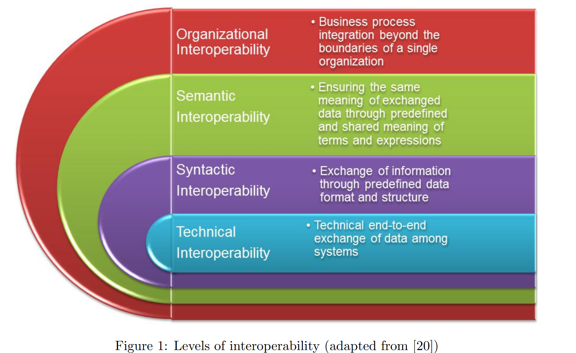
Note. From “A Review of Interoperability Standards in E-health and Imperatives for their Adoption in Africa,” by F. Adebesin, R. Foster, P. Kotzé, & D. Van Greunen, 2013, South African Computer Journal, 50. https://doi.org/10.18489/sacj.v50i1.176. Licensed under CC BY-NC 4.0.

Figure 2
The IPS Composition

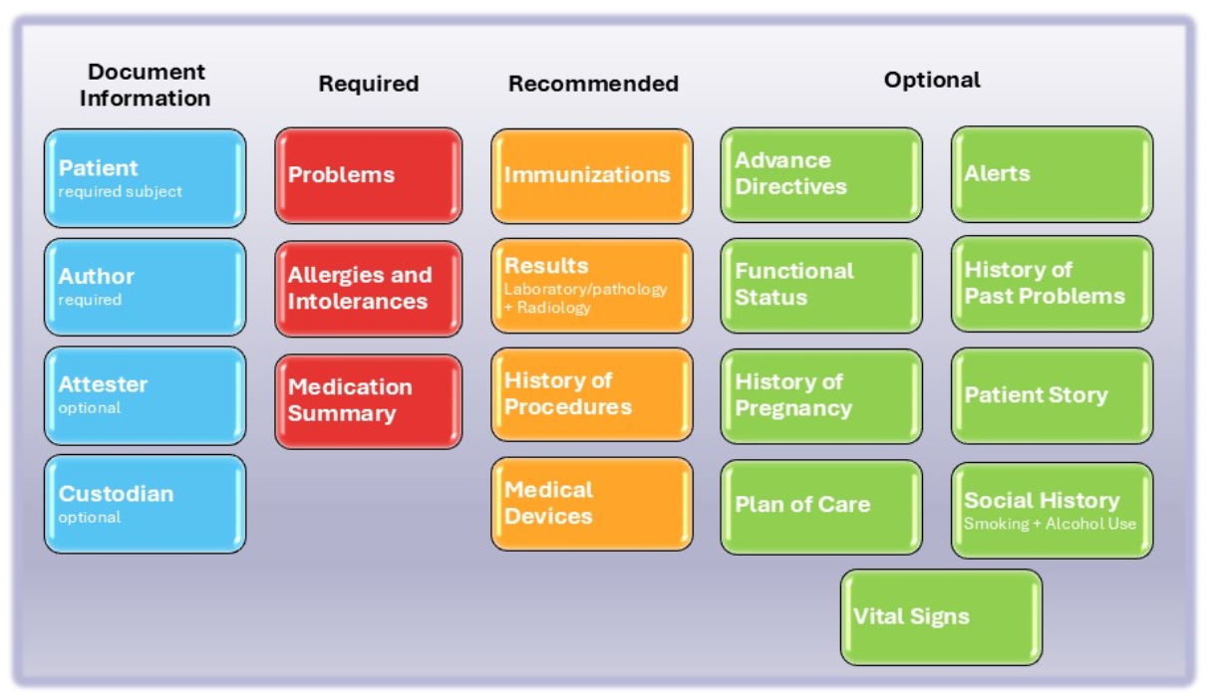
Note. From the International Patient Summary Implementation Guide (v2.0.0), HL7 International. Retrieved August 9, 2025, from https://build.fhir.org/ig/HL7/fhir-ips/Structure-of-the-International-Patient-Summary.html

Figure 3
Data Standards Development Lifecycle

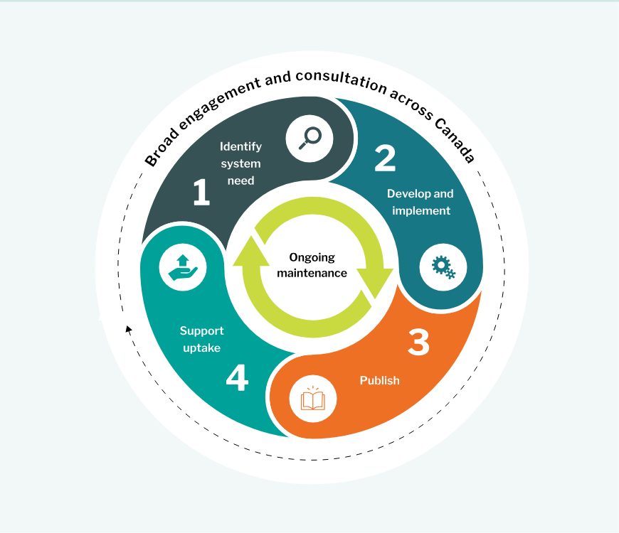
Note. From the Canadian Institute for Health Information. Retrieved August 9, 2025, from https://www.cihi.ca/en/data-standards-development-life-cycle

Figure 4
GitHub Repository

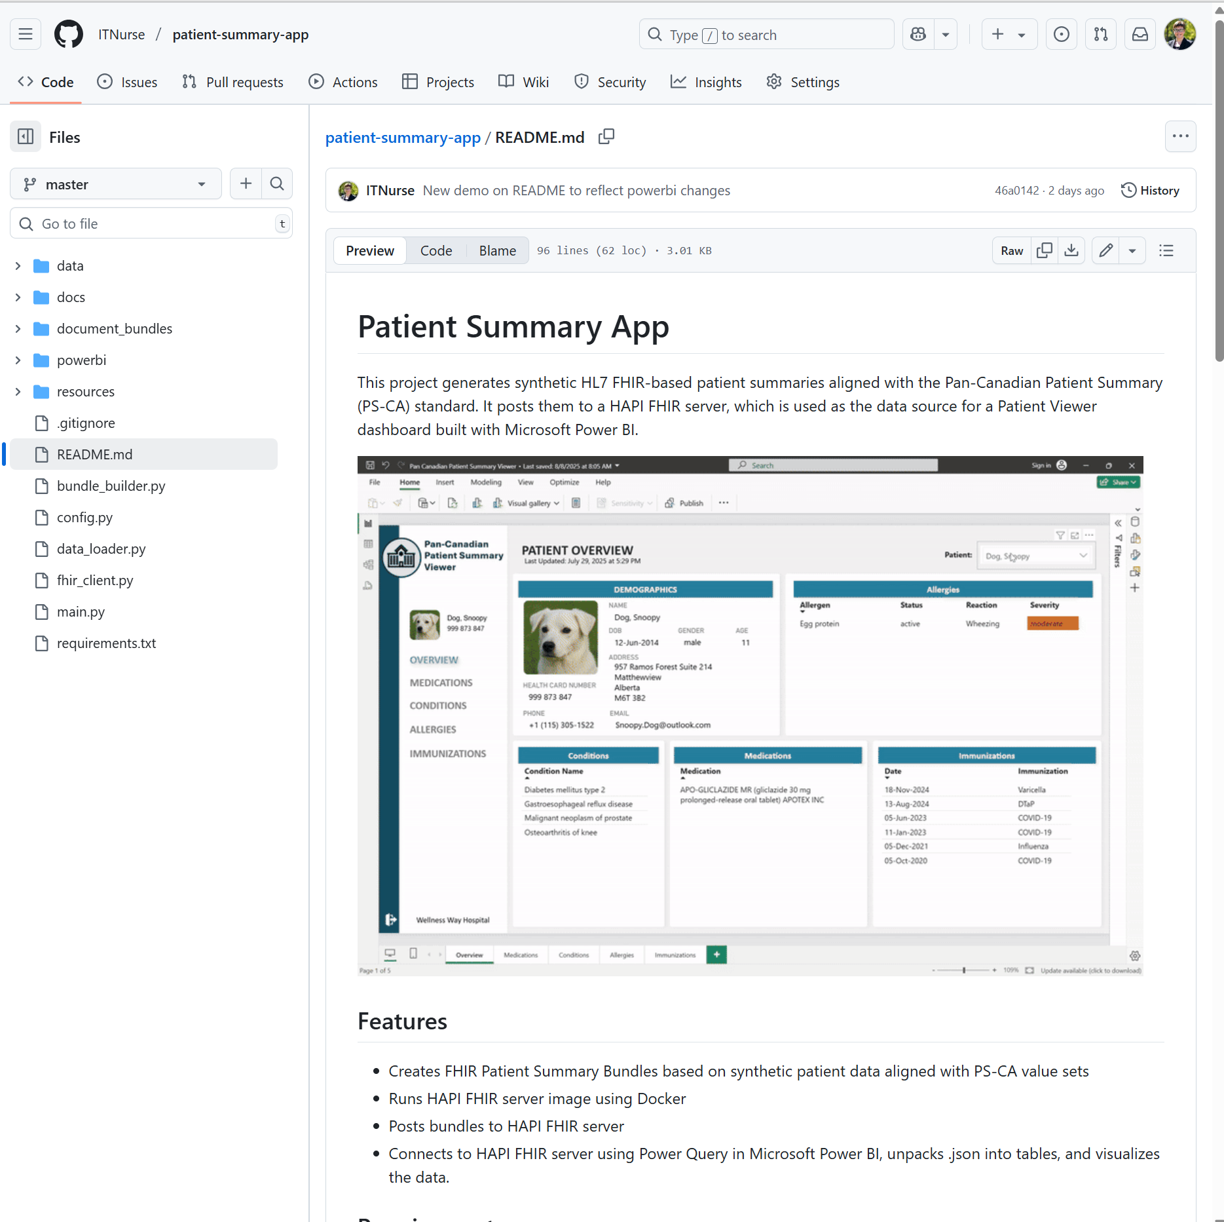

Appendix A – Power BI Dashboard Screenshots

Figure A1
Patient Overview Screen

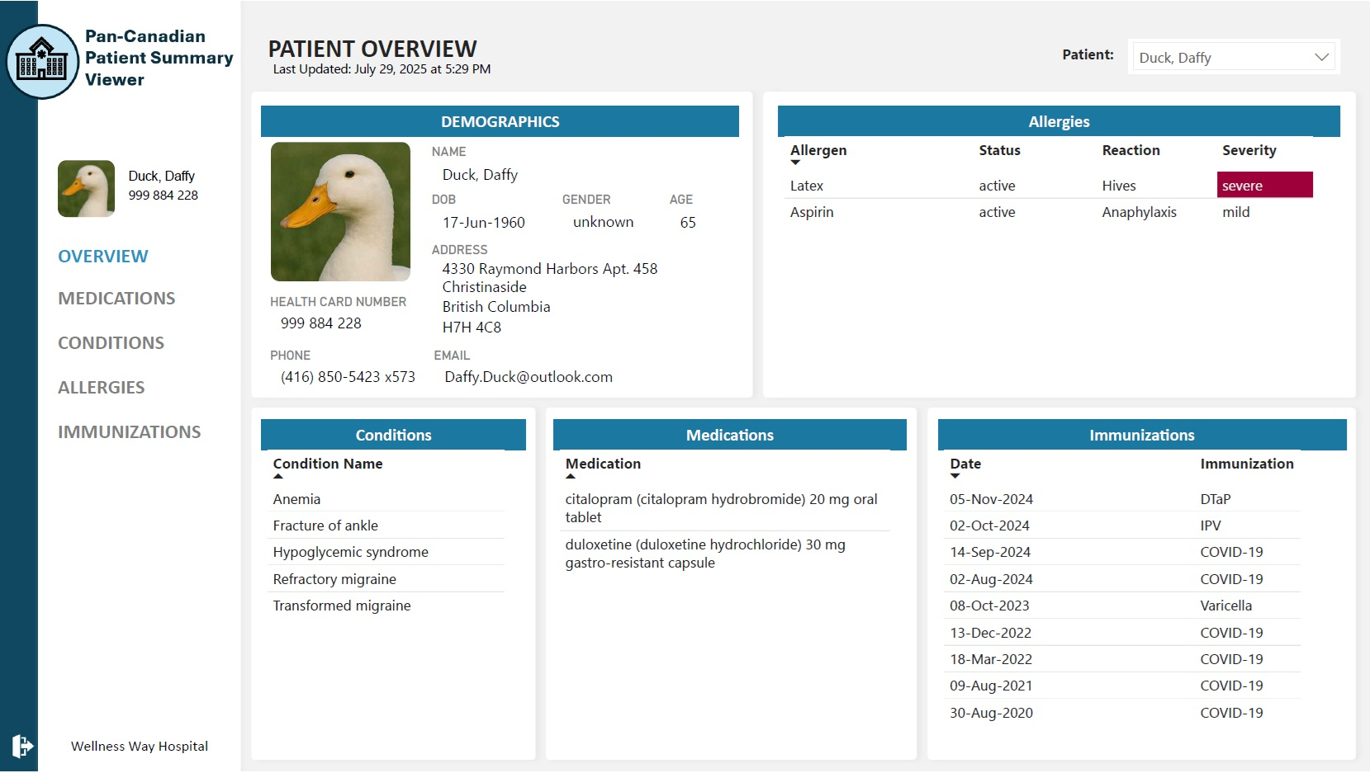

Figure A2
Patient Medication Screen

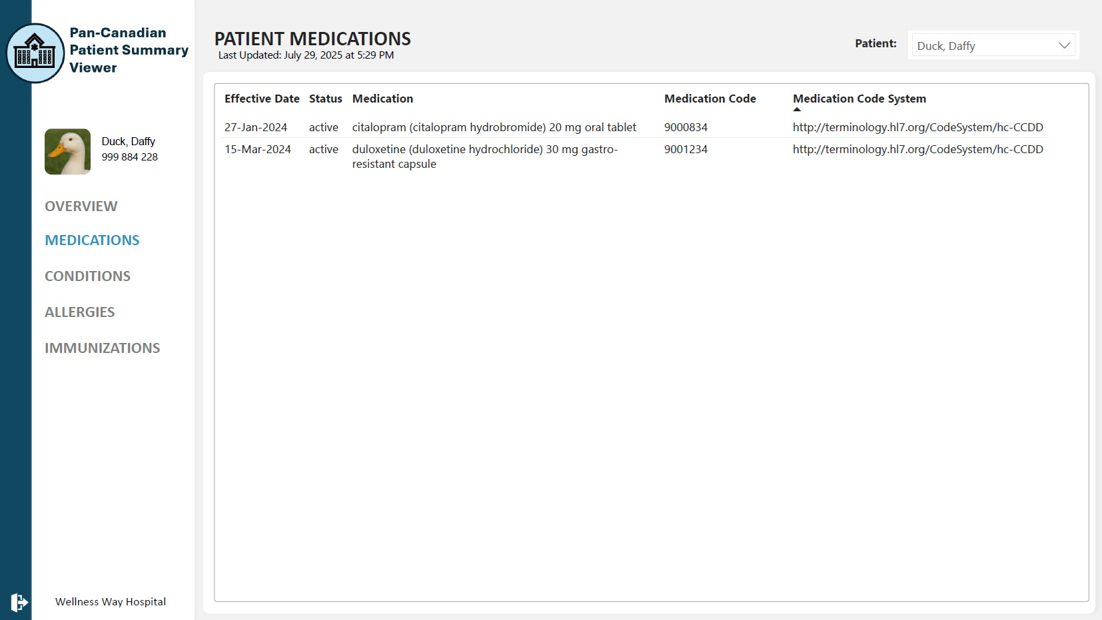
Figure A3
Patient Condition Screen

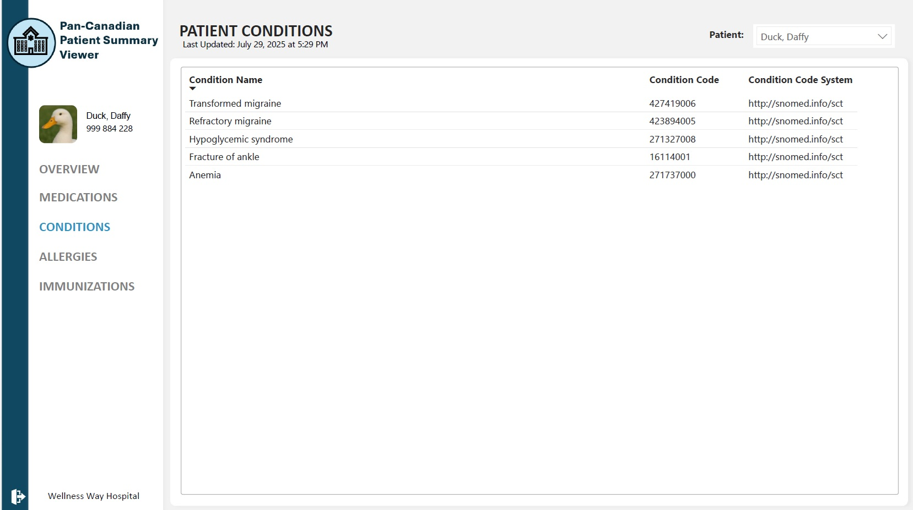

Figure A4
Patient Allergy and Intolerance Screen

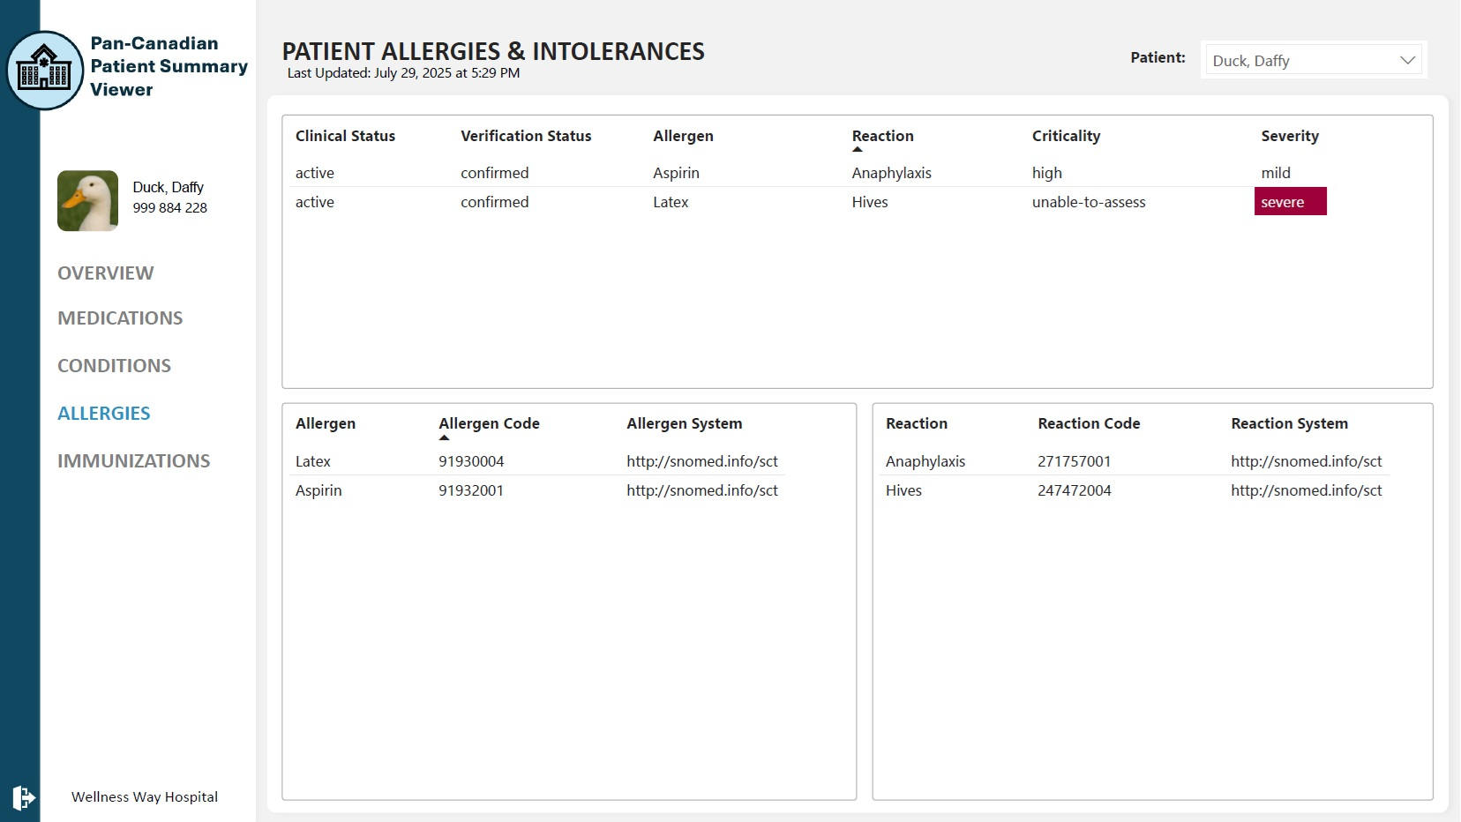

Figure A5
Patient Immunization Screen

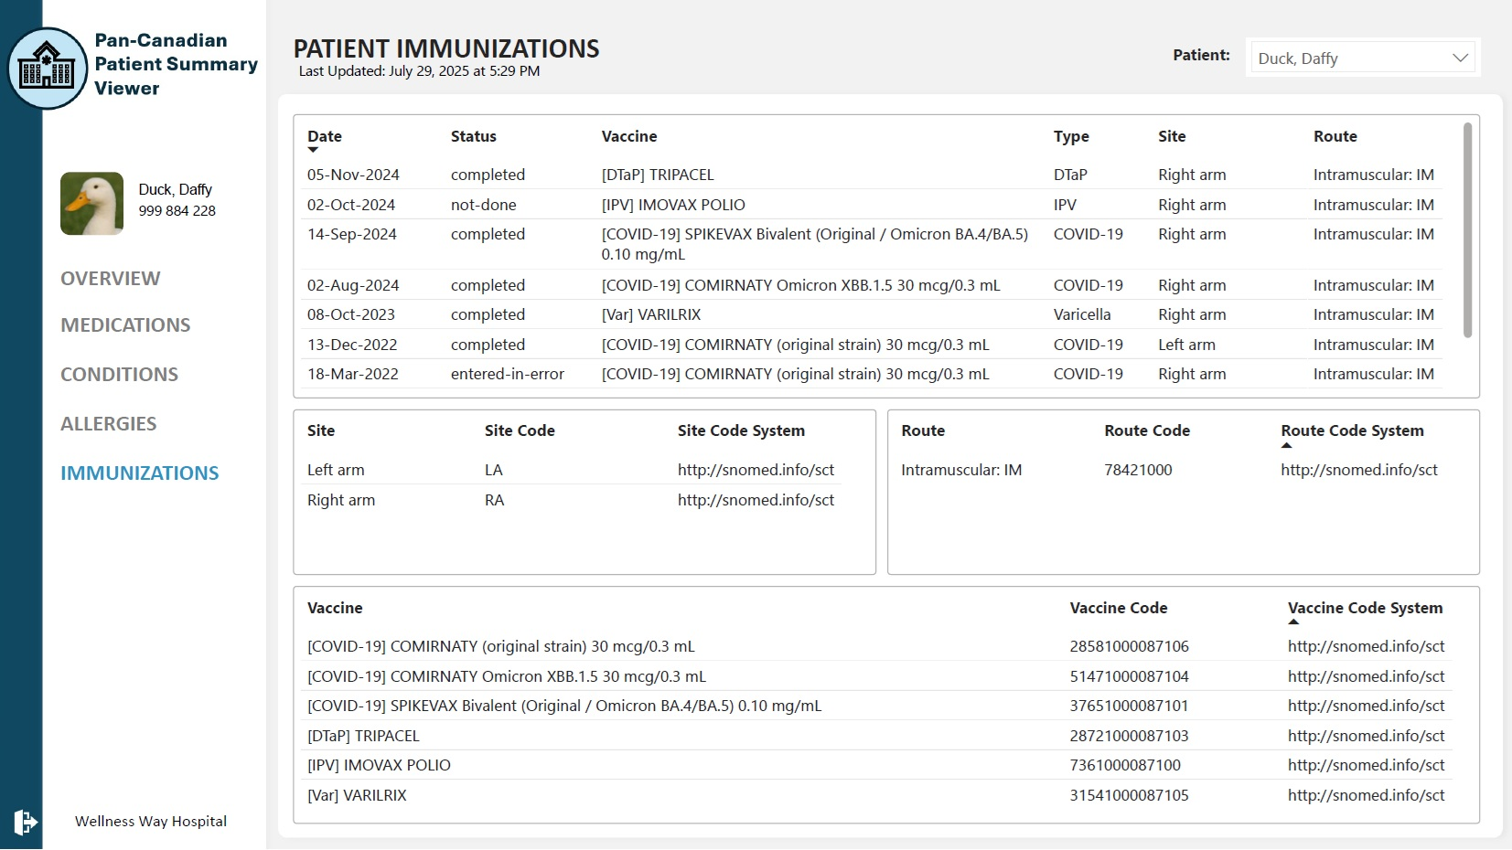

Appendix B – CHIMA Curricular Competencies

CHIMA Competency |  | Evidence of Competency Demonstration in Field Project
2.3 | Demonstrate terminology knowledge by contributing to the development, implementation and support of CT services, tools and technical infrastructure, to manage CT. | The project demonstrated terminology knowledge through the selection and use of SNOMED CT CA, HL7, and CCDD value sets in the synthetic data creation in accordance with the Pan-Canadian Patient Summary (PS-CA) Implementation Guide (IG). The Python application applied terminology bindings to appropriate FHIR fields, and Ontoserver was used to access Canadian value sets. To support the ongoing management of the value sets used in the synthetic data, the author joined the Patient Summary community of practice on Canada Health Infoway’s InfoCentral platform, where proposed changes to terminology bindings are discussed. The author also contributed to terminology support by publishing a GitHub repository with documentation on the project including interoperability basics and terminology use, making the project accessible for educational reuse.
2.7 | Develop learning resources and deliver educational/ training sessions for multiple audiences on the development, application and management of the content of specific CT services and tools used in the organization/jurisdiction. | Although no live classroom delivery was performed, the project created modular, openly accessible resources that function as self-paced training. These materials support education on the application and management of terminology services and tools relevant to PS-CA adoption. While the learning resources are primarily targeted to developers, the GitHub repository is also being shared through the author’s LinkedIn account to spark interest among clinical informatics professionals and broaden its reach to multiple audiences.
3.1 | Evaluate and recommend CT services and tools used in other jurisdictions to support adoption of CT within a health IT application. | The literature review component of the project reviewed terminology services and tools used in other jurisdictions. This included Brazil’s use of Open Concept Lab and the ISO/TR 12300:2014 mapping framework, which illustrated scalable approaches to terminology alignment. This also included Georgia’s structured governance model, which emphasized the importance of clearly defined roles in terminology stewardship.
3.4 | Evaluate technical design and implementation of health IT applications to incorporate CT standards including appropriate methods for CT-encoded data entry, storage, retrieval, and analysis. | The technical design of the Python application was evaluated and refined to ensure that terminology bindings for Code and CodeableConcept fields aligned with PS-CA resource profiles. The project implemented appropriate methods for representing CT-encoded data in HL7 FHIR resources and verified that this data could be stored on a FHIR server, retrieved via standard endpoints, transformed using Power Query, and visualized in Power BI.
3.9 | Develop terminology strategic roadmaps and operational/implementation plans ensuring alignment with health system plans and strategies. | Although the project was not part of a formal system implementation, it demonstrated an operational approach for PS-CA execution using freely available tools. The design emphasized alignment with Canadian terminology standards and demonstrated a repeatable roadmap for creating, sharing, and visualizing of interoperable patient summaries. By aligning with the Support Uptake phase of the CIHI Data Standards Development Lifecycle and referencing Canada Health Infoway’s terminology infrastructure, the project supports strategic goals related to interoperability and standards adoption.
4.11 | Demonstrate knowledge of the current trends and issues in the interoperability standards landscape in Canada and North America. | The project demonstrates awareness of current trends and issues in the interoperability standards landscape in Canada and North America. The literature review component detailed recent developments across Canada, including provincial implementation guides and patient-facing applications such as MyHealthNB. It also highlighted growing IPS adoption in the United States, including vendor support from EPIC and Meditech, and patient-facing tools like the CommonHealth app and Washington State’s Verify+ IPS web application.
5.1 | Collaborate and support the adoption of interoperability standards through their lifecycle stages. | The project supports the adoption of interoperability standards through the “Support Uptake” phase defined by the Canadian Institute for Health Information (CIHI). It demonstrated how FHIR-based patient summaries can be created, validated, and shared using standard tools. It contributed to the broader Canadian interoperability ecosystem by publishing reusable assets and educational materials to GitHub, enabling others to test, learn, and build on the work. Informal collaboration with the FHIR community (via chat.fhir.org) further demonstrated engagement in the adoption process.
5.3 | Analyze the selection of specific interoperability standard for adoption in the organization/jurisdiction. | The project utilized HL7 FHIR R4, the PS-CA IG, and the HAPI FHIR JPA Server as a standards-based foundation for building and sharing interoperable patient summaries. The rationale for choosing these tools was based on accessibility, alignment with national and international standards, and their ability to support semantically interoperable data exchange using recognized value sets.
5.4 | Manage the implementation of specific interoperability standards in the organization/jurisdiction. | The project managed the implementation of the PS-CA interoperability standard by designing and executing a complete workflow for creating, validating, and visualizing FHIR-based patient summaries. This included manually generating synthetic data aligned with the PS-CA IG, developing a modular Python application to transform the data into HL7 FHIR bundles and deploying a local HAPI FHIR server.
5.7 | Recommend the creation, distribution, and update of the documentation on specific interoperability standards adopted in the organization/jurisdiction. | The GitHub repository created for this project included comprehensive documentation. This included markdown guides covering terminology services, PS-CA profiles, resource mapping, tool setup, and Power BI integration. The documentation supports transparency, encourages adoption, and models how organizations can document local implementations of national standards.

http://terminology.hl7.org/CodeSystem/organization-type
http://hl7.org/fhir/administrative-gender
https://fhir.infoway-inforoute.ca/ValueSet/clinicalfindingcode
http://terminology.hl7.org/CodeSystem/allergyintolerance-clinical
http://terminology.hl7.org/CodeSystem/allergyintolerance-verification
http://hl7.org/fhir/allergy-intolerance-criticality
http://hl7.org/fhir/reaction-event-severity
https://fhir.infoway-inforoute.ca/ValueSet/pharmaceuticalbiologicproductandsubstancecode
https://fhir.infoway-inforoute.ca/ValueSet/clinicalfindingcode
https://fhir.infoway-inforoute.ca/ValueSet/prescriptionmedicinalproduct
http://hl7.org/fhir/CodeSystem/medication-statement-status
https://fhir.infoway-inforoute.ca/ValueSet/vaccineadministeredtradenamecode
https://fhir.infoway-inforoute.ca/ValueSet/immunizationrouteofadministrationcode
https://fhir.infoway-inforoute.ca/ValueSet/immunizationstatuscodes
http://hl7.org/fhir/ValueSet/immunization-site
https://simplifier.net/ps-ca-r1
https://ui.terminologystandardsservice.ca

