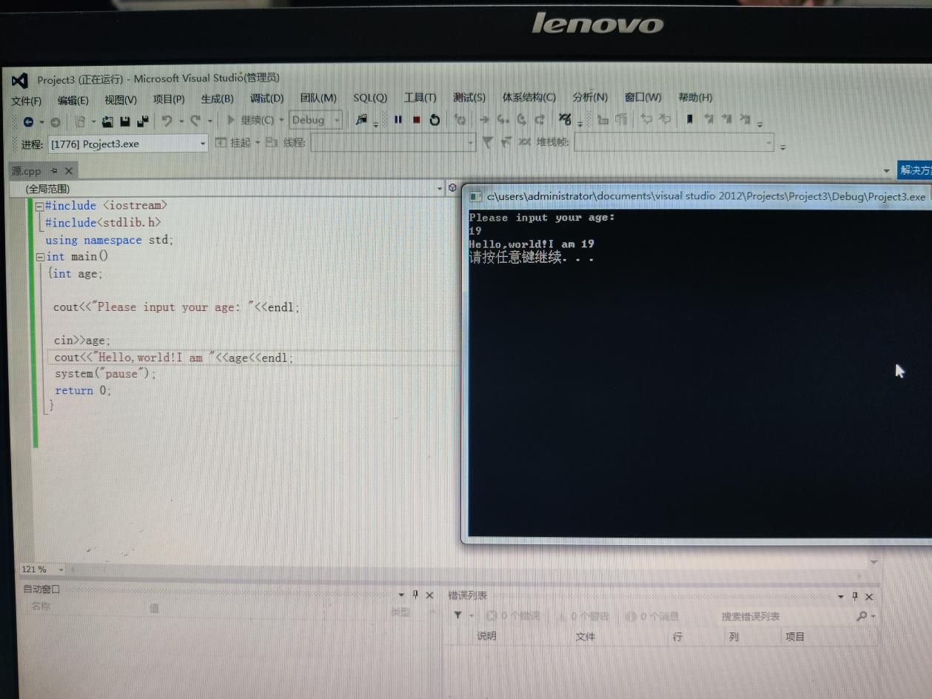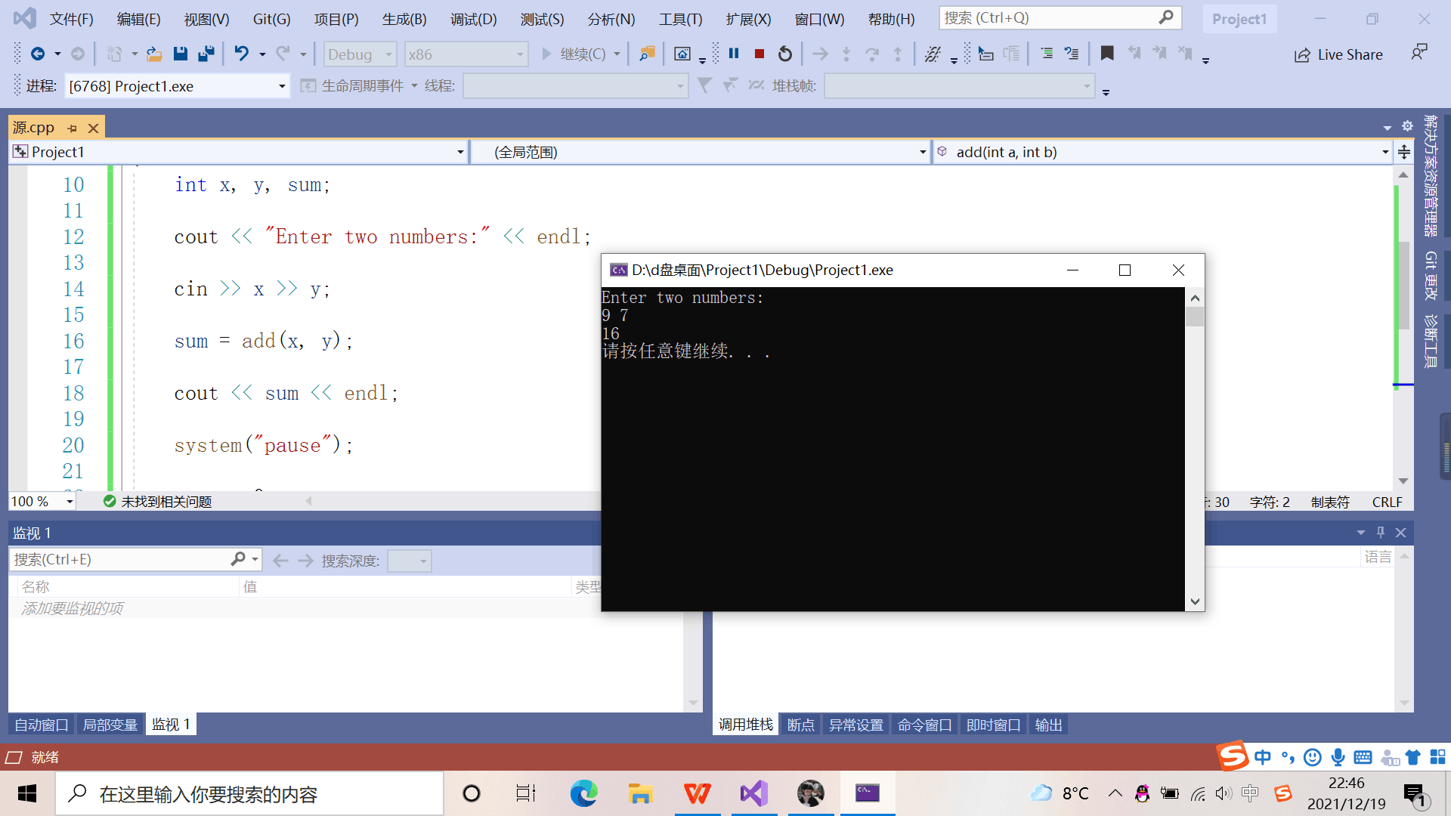输入cin>>

输出cout<< 会记混

Copyright ©2021-2099 HanxiaoZhang. All rights reserved