K.H.U. Faculty of Engineering and Natural Sciences

MIS_400 BACHELORS PROJECT
PROPOSAL



IT PROJECT GOVERNANCE
(EXAMINATION of PROJECT LIFE CYCLE, PRE-and POST LIFE CYCLE)

Project Advisor: Ebru DİLAN- Mehmet Nafiz AYDIN

Project Team: Bengüsu ÇELİK - Gamze ŞAHİN
(2010.01.04.057) (2010.01.04.055)

Submission Date: 11.12.2014

ABSTRACT:

Recent years; “IT Project governance” is most widely used term in information technology’s world. Senior executives mention about the importance of this term in their organization. But what is the IT project governance? When we look at the “governance” word, we see the combination of two words: “government” and “communication”. So governance occurs of these two words together. We need governance to; decision making, identify the priorities and following the budget with managing stakeholders. When we look at these steps, we can clearly understand that management is well -attended. Also moving to the “governance” in project processes; we clearly gain fine results with the communicating stakeholders. Briefly; IT project governance is related between the organization’s strategies which are making in the organization and IT works integration. IT labor resources and budget usage are decided by top management acceptance and involvement and here; IT unit is like a stakeholder for organization’s strategic decisions. They can describe their opinion. To sum up IT Project Governance is a very popular and effective phenomenon in public and private sectors which are raising the investments in information technologies (IT).

AIM:

The aim is to understand the IT Governance in an organization. Also we will review IT project processes and try to understand whatever achieve or not. In this stage organization’s business need is important to select the project.

METHODOLOGY:

We use some methodologies for this project. First of all we use “Literature Survey”. Analyzing and collecting the existent data and documents means literature survey (ÇOLAK, 2012). It is provided to understanding and determining the subject for researcher. Also literature survey gives us valid solutions. Because all data which we research refers to article in a journal, a conference or book published in scientific series. We use this survey for learning definitions which are related with project and then we able to connect association between data and problem in our project. When we start to use this method project subject became clearer and we can create ideas about project subject efficiently. In our project second useful methodology is “Qualitative Analysis”. Qualitative Analysis is the use of non-quantifiable methods to evaluate investment or business opportunities and make decisions. (Investing answers.[online],
http://www.investinganswers.com/ Accessed 2001-2014). To give an example; management expertise, industry cycles, strength of research and development also labor relations occurs in qualitative analysis. Organizations use this method for the future problems which they will meet. They can arrange their resources and movements against problems. Under the qualitative analysis “Data Collection Method” and “Case Study Method” help us. Data Collection Method approaches for qualitative research usually involves direct interaction with answerable on one to one basis or in a group setting. (M.IsraeL&I.Hay, 2006).When you apply this method to your project your information should be richer and deeper. This will show us our project include healthy decisions with this method. We collect our data by “interviewing” and “reviewing the project documents”. We found professional people whose are expert in their organizations and we will study them with asking questions. In the Interview stage we choose “Face –to- Face interviewing “and” Keywords analysis” to those answerable. Keyword research is one of the most essential, valuable, and high return activities in the search marketing field. In every project after the organization determined their project strategy, their first step is completing keyword analysis. This study is useful for customer. It helps to recognizing and identifying target market and their needs. In this methods corporation must identify their priorities firstly. Making this may give them quick and good results and also it helps to increase conversions. In ”Case Study Method” Becker(1970) explains that case study refers to a detailed analysis of an individual case supposing that one can properly acquire knowledge of the phenomenon from intensive exploration of a single (RAYA FEDEL,1984) Applying this method gain us for producing healthy comments about the project. Lastly; we utilize “Analyze collected data”. It is a process of inspecting, cleaning, transforming, and modeling data with the goal of discovering useful information, suggesting conclusions, and supporting decision making.”(Boundless,14. Nov.2014)

WORK PACKAGE DESCRIPTION

Number and name of the package: 1.1.Scope Definition

Start date: 14.11.2014
Finish date: 20.11.2014

Short description:
We determined aim and methodology in this package.

Methodology:

1. Literature Survey
2. Qualitative Analysis
Data Collection (Reviewing and Interviewing Document
Case Study Method (Analyzed collected data)

Outputs: Case Study’s Report

Relations to other packages:

1.1. Scope Definition: Start-to -Start
1.1.1. Determine Aim: Start- to- Start
1.1.2. Determine Methodology: Finish- to- Start

Working team members (with contributions as percentages of the work packet):
Gamze ŞAHİN 50% - Bengüsu ÇELİK 50%

Work to be done by anybody outside the team: NOT APPLICABLE

Number and name of the package: 1.2. Literature Review

Start date: 21.11.2014
Finish date: 04.12.2014

Short description:
We searching and reviewing our relevant studies.

Methodology:
1. Literature Survey
2. Qualitative Analysis
Data Collection (Reviewing and Interviewing Document
Case Study Method (Analyzed collected data)

Outputs: Case Study’s Report

Relations to other packages:

1.2. Literature Review: Finish- to –Start
1.2.1. Searching for Relevant Studies: Start- to- Start
1.2.2. Reviewing Relevant Studies: Finish- to- Start

Working team members (with contributions as percentages of the work packet):
Gamze ŞAHİN 50% - Bengüsu ÇELİK 50%

Work to be done by anybody outside the team: NOT APPLICABLE

Number and name of the package: 1.3.Case Study

Start date: 05.12.2014
Finish date: 12.02.2015

Short description:
We collected our data by interviewing, reviewing and analyzing.

Methodology:
1. Literature Survey
2. Qualitative Analysis
Data Collection (Reviewing and Interviewing Document
Case Study Method (Analyzed collected data)

Outputs: Case Study’s Report

Relations to other packages:

1.3. Case Study: Finish-to-Start
1.3.1. Data Collection by Interviewing: Start- to- Start
1.3.2. Data Collection by Reviewing Project Documents: Finish- to- Start
1.3.3. Analyzing Collected Data: Finish- to- Start

Working team members (with contributions as percentages of the work packet):
Gamze ŞAHİN 50% - Bengüsu ÇELİK 50%

Work to be done by anybody outside the team: NOT APPLICABLE

Number and name of the package: 1.4. Final Report

Start date: 13.02.2015
Finish date: 21.04.2015

Short description:
We prepared our content of table. After that we did case study analysis and finding and discussion. Finally we wrote our abstract and conclusion.

Methodology:
1. Literature Survey
2. Qualitative Analysis
Data Collection (Reviewing and Interviewing Document
Case Study Method (Analyzed collected data)

Outputs: Case Study’s Report

Relations to other packages:

1.4. Final Report: Finish-to-Start
1.4.1. Table of Content: Start- to- Start
1.4.2. Case Study Analysis: Finish- to- Start
1.4.3. Finding and Discussions: Finish- to- Start
1.4.4. Conclusion: Finish- to- Start
1.4.5. Abstract: Finish- to- Start

Working team members (with contributions as percentages of the work packet):
Gamze ŞAHİN 50% - Bengüsu ÇELİK 50%

Work to be done by anybody outside the team: NOT APPLICABLE

Number and name of the package: 1.5. Project Management

Start date: 22.04.2015
Finish date: 30.04.2015

Short description:
We submitted our application and prepared proposal.

Methodology:
1. Literature Survey
2. Qualitative Analysis
Data Collection (Reviewing and Interviewing Document
Case Study Method (Analyzed collected data)

Outputs: Case Study’s Report

Relations to other packages:

1.5. Project Management: Finish-to-Start

1.5.1. Submission of Application: Start- to- Start
1.5.2. Preparing Proposal: Finish- to- Start

Working team members (with contributions as percentages of the work packet):
Gamze ŞAHİN 50% - Bengüsu ÇELİK 50%

Work to be done by anybody outside the team: NOT APPLICABLE

Number and name of the package: 1.6.Final Report Submission

Start date: 01.05.2015
Finish date: 01.05.2015

Short description:
We submitted our final report
Methodology:
1. Literature Survey
2. Qualitative Analysis
Data Collection (Reviewing and Interviewing Document
Case Study Method (Analyzed collected data)

Outputs: Case Study’s Report

Relations to other packages:

1.6. Final Report Submission: Finish-to-Start

Working team members (with contributions as percentages of the work packet):
Gamze ŞAHİN 50% - Bengüsu ÇELİK 50%

Work to be done by anybody outside the team: NOT APPLICABLE

CONTRIBUTIONS OF THE TEAM MEMBERS:

Name, Surname | Work Packages |  |  |  |  |  |  |  |  |  |  |  | Total
Name, Surname | 1 |  | 2 |  | 3 |  | 4 |  | 5 |  | 6
Name, Surname | h | % | h | % | h | % | h | % | h | % | h | % | h | %
Gamze ŞAHİN |  | 50 |  | 50 |  | 50 |  | 50 |  | 50 |  | 50 |  | 50
Bengüsu ÇELİK |  | 50 |  | 50 |  | 50 |  | 50 |  | 50 |  | 50 |  | 50
Total |  | 100 |  | 100 |  | 100 |  | 100 |  | 100 |  | 100 |  | 100

PROJECT CALENDAR

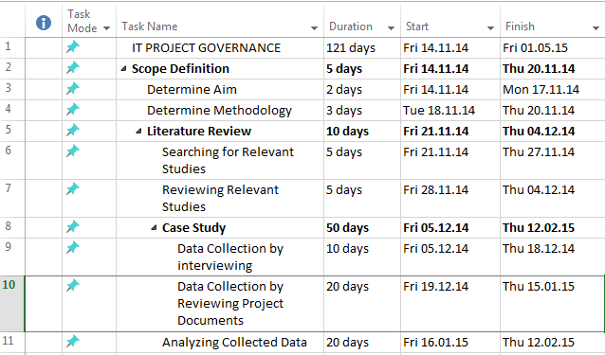
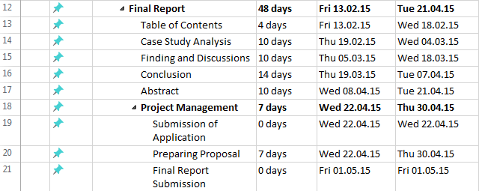

GANTT CHART

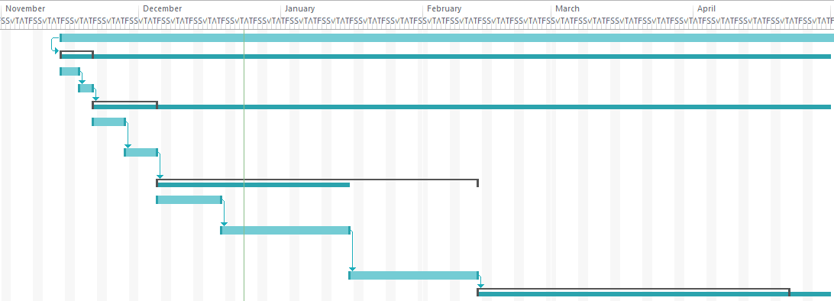

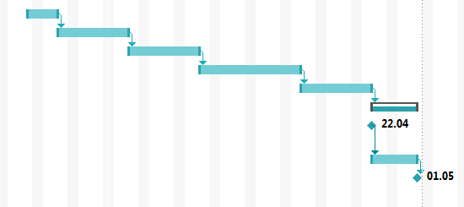

INFRA-STRUCTURE REQUIREMENTS:

Laboratory (ies):

NOT APPLICABLE

Equipment:

Artciles, documents, computer and our interviews

Computer(s):

We can search some information on the internet we can read articles and analyze them.

Personnel:

Company’s Corporate Analytiscs, Strategy and Project Manager

REFERENCES:

- Ahmet Ege,H. Mehmet Şahin,Gamze Karayaz(2014)”AKADEMİK ÇALIŞMALARIN KURGULANMASINDA PROJE YÖNETİMİ ve YÖNTEMLERİN KULLANILMASI” ,Project Management Summit

- “A Framework for governance of Post-Construction activities In IS development Project”, IJCSI international journal of computer science issues, vol. 9, no: 3, Issue 5

- Analyzing data and Growing Conclusions [online] https://www.boundless.com/sociology/textbooks/bondless-socilogy-texbook/sociological-research-2/the-research-process-26/analyzing-data-and-growing-conclusions-170-7474/)

- Boundless, (14. Nov.2014)[online] http://en.wikipedia.org/wiki/Data_analysis Accessed (21 December 2014)

- Emit M. Abdelmoniem, Sheriff Amazon and Heap E. Hassan in (3 September2012)
G. Van der Waldt (2008),”Project Governance: selected South African government experiments”[online] Koers - Bulletin for Christian Scholarship; Vol 73, No 4 729-750.

- HM TRESURY,(November 2007)”Project Governance : a guidance note for public sector projects”
http://www.koersjournal.org.za/index.php/koers/article/view/181 (Accessed 2014)
Investinganswers.[online],http://www.investinganswers.com/ Accessed (2001-2014)

- Keyword Analysis.”What's the Best Way to Analyze Keywords?”[online] http://www.wordstream.com/keyword-analysis

- M.IsraeL&I.Hay(2006) Research Ethics for Social Scientists[online]. Introduction to Research and Managing Information Leicester Sage Publications Ltd, http://libweb.surrey.ac.uk/library/skills/Introduction%20to%20Research%20and%20Managing%20Information%20Leicester/page_54.htm

- Musa Kayrak, (1/Ekim-Aralık 2013) “BİLİŞİM TEKNOLOJİLERİ YÖNETİŞİMİ” [online] Sayıştay Dergiṡi̇ Sayı:9 http://dergi.sayistay.gov.tr/icerik/der91m3.pdf

Mustafa Dönmez PMP [online] “BT Yönetişimi ve Proje Yönetim Ofislerinin BT YönetişimindekiRolü”http://www.projeyonetimi.com/ti.asp?eid=1010&BT%20Y%F6neti%FEimi%20ve%20Proje%20Y%F6netim%20Ofislerinin%20BT%20Y%F6neti%FEimindeki%20Rol%FC

- Prof. Dr. Rami’s ÇOLAK(24.03.2012)”Literatür Taraması Nasıl Yapılır?”,[online] http://www.samsuntabipodasi.org.tr/uploads/dosyalar/file/literat%C3%BCr%20tarams%C4%B1%20nas%C4%B1l%20yap%C4%B1l%C4%B1r.pdf

- RAYA FEDEL, “ The case study method: A Case Study” LSR 6,273-288 1984
Williams, P and Naumann, E. (2011) ‘Customer satisfaction and business performance: a firm-level analysis’ Jo urnal of Services Marketing, Vol. 25 No.1, pp20 – 32

