# Keyboard Auto Completion using QCompleter

## Introduction

In this paper, we investigate our enhanced text input method based on the PyQT QCompleter. With the help of our new input assistant, the user is offered auto-completion suggestions. In the following work, the performance of our supported text input is compared to an unimproved input. For this purpose, a within-subjects design study was conducted and evaluated.

## Auto Completion with QCompleter

To improve and speed up the text input with the keyboard, we have developed an auto completion based on the PYQT QCompleter. This displays text suggestions to the user right next to the current input after entering the first three characters of a word.

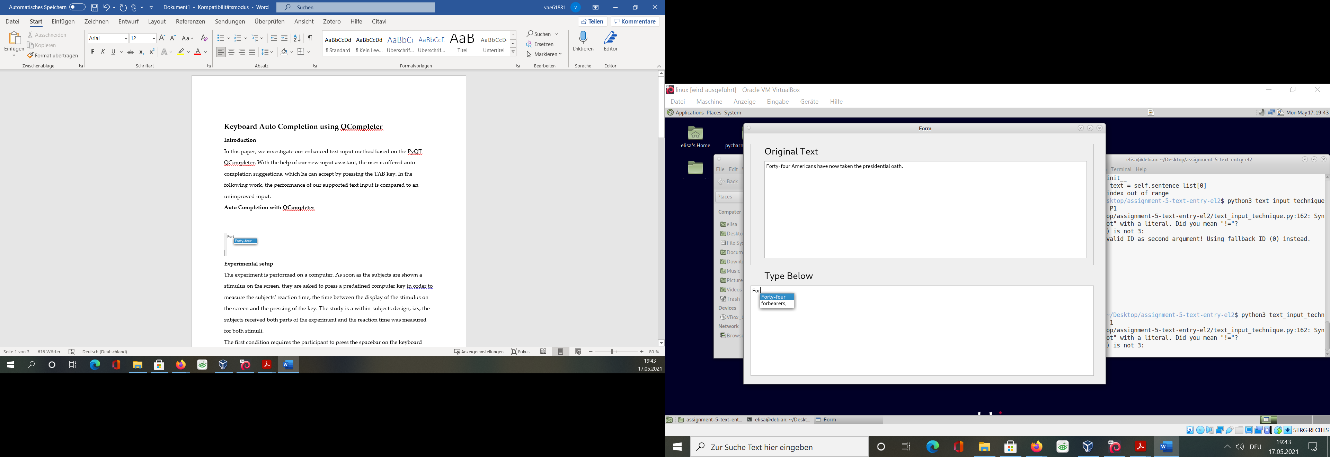

Figure 1 Suggestions for the auto completion

The user can then switch between the suggestions by pressing the arrow keys and select a suggestion by pressing the TAB key. If the searched word is not among the suggestions, the user can continue the input via the keyboard as usual.

## Research Question

With this study we want to find out whether our novel input method with input assistant brings an improvement compared to the normal keyboard input. For this purpose, we have set up the following hypothesis:

H1) The text input speed in time per word (TPW) is higher with the input assistant than without it.

The independent variable of the hypothesis is the keyboard mode, i.e., with or without input assistant. The dependent variable for hypothesis H1 is the text input speed in TPW.

## Experimental setup

## To investigate the research questions, two editor programs were implemented for the experiment. Both versions have the same basic structure: They are divided into two fields, where the text to be transcribed is displayed in the upper field and the actual text input is performed in the lower field (see figure 2). The only difference between the two programs is that in one of them our auto complete function has been implemented.

## 

Figure 2 Experimental setup

## The actual experiment is performed on the respective computers of the participants in their usual working environment and with their own keyboards. This has the advantage that the participants do not have to get used to a new setup.

## In the run-up to the study, the participants are presented with several test sets to familiarize them with the program and input support technique in a short learning phase. After the familiarization phase, the experiment begins as soon as the participants are ready for it. Depending on the participant number, the experiment was started with or without support assistance. This randomized order of the stimuli was intended to prevent a possible sequence or learning effect.

## In both conditions, the participants are given the same four sentences to copy. Only when the sentence has been copied completely and without errors, the next sentence is displayed for copying. After completion of the first part of the experiment, the study leader starts the second part.

For later analysis, the data recorded during the experiment is output to the command line in csv format. For each keystroke, each complete word and each finished sentence a timestamp and the used time in milliseconds is logged. Also, the use of the delete key is recorded as an absolute number. Additionally, when a sentence is completed, the number of words per minute is logged.

In the experiment part with auto completion, the use of the auto completion function is also recorded, both as an absolute number and as a boolean for each completed word and sentence.

## Participants

The experiment was performed on two subjects. Due to the pandemic situation, it is not that easy to recruit study participants. Since it is necessary to run a Python program on a Linux machine for the trial, we decided to test ourselves.

As a result, one man and one woman were tested each. The average age of the test subjects is 28 years. Both test subjects are master students of media informatics at the University of Regensburg.

Due to technical reasons, both test subjects performed the experiment three times each.

## Results

#### In general, the autocomplete function was well received and used. In the experiment part with input support, 141 words were completed by the completion and only 13 were completed manually.

#### Looking at the use of the backspace key, in the experiment part with input support participant 1 deleted a text entry eleven times and participant 2 nine times. In the experiment part with the normal keyboard, participant 1 pressed the backspace key ten times and participant 2 twenty times. Hypothesis 1

The values for TPW in the following paragraph are presented in milliseconds. Text input time without support assistance (M = 1012.37.75, SD = 631.11, n = 153) measured in time per word is on average faster than text input time with support assistance (M = 1255.10, SD = 760.39, n = 154), t = -4.03, p < 0.05.

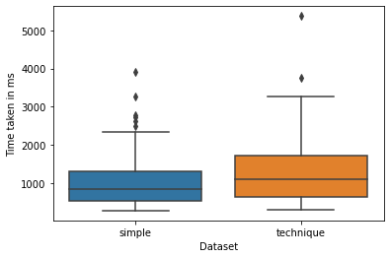

Figure 3 Time per word divided into both input systems

The difference in time per word between the two keyboard modes is therefore significant. The input time without support assistance is on average about 24.0% slower than input time with support assistance. Therefore, the hypothesis must be rejected.

Looking at the time in words per minute also gives a similar picture, as can be seen in Figure 4.

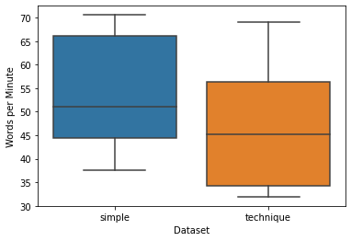

Figure 4 Words per minute divided into both input systems

## Limitations

The experiment did not show any improvement with the novel keyboard input method. In contrast, a significantly faster input with the standard keyboard was found. However, this result must be considered under limitations. Both participants are practiced with the normal keyboard and therefore it can be assumed that a change to a new system is more difficult. For future development it is therefore recommended to extend the learning phase.

In addition, the current autocomplete system is not yet fully developed. On the one hand, only the words that occur in the four sentences of the experiment are used for completion. Furthermore, no automatic space is added after the completion, which is contrary to the usual way of writing.

For subsequent new developments and experiments, these limitations should be taken into account. In this case, however, the experiment is severely limited by the number of subjects alone. Therefore, the presented results may explicitly be considered as preliminary results only and have to be consolidated by further experiments.