**Leveraging Machine Learning to predict the impact of faults on RAN KPIs.**

Adetomiwa Adedeji

Adetomiwa.adedeji@yahoo.com

**Abstract:**

Fault management is a crucial component of system and network administration aimed at ensuring the reliable and continuous operation of IT and telecommunications systems. It involves a range of activities, from detecting and isolating faults to diagnosing and resolving them, with the ultimate goal of minimizing system downtime and maintaining high availability and performance.

1. **Introduction:**

Fault management is a critical aspect of network and systems administration, particularly in the context of information technology and telecommunications. It involves the processes and tools used to detect, isolate, diagnose, and resolve faults or abnormalities in a system or network to ensure its reliable and continuous operation. Fault management is an essential component of overall network and system management, which also includes configuration management, performance management, and security management.

Here are some key aspects of fault management:

Fault Detection: Fault management starts with the detection of any deviations from normal system behavior. This can include hardware failures, software glitches, network congestion, or other issues that may disrupt the system's operation. Various monitoring tools and techniques, such as system logs, alarms, and sensors, are used to detect these faults.

Fault Isolation: Once a fault is detected, the next step is to isolate it to determine its source or cause. This involves narrowing down the scope of the issue to a specific component, device, or subsystem. Effective fault isolation reduces the time it takes to diagnose and resolve the problem.

Fault Diagnosis: After isolation, the fault must be diagnosed to understand its nature and severity. This process often requires more in-depth analysis and may involve reviewing logs, examining system configurations, and conducting various tests to identify the root cause of the fault.

Fault Resolution: Once the root cause is identified, appropriate actions can be taken to resolve the fault. This could involve hardware replacement, software updates, reconfiguration, or other corrective measures. The goal is to restore the system to its normal operating state as quickly as possible.

Fault Reporting: Fault management systems often include reporting mechanisms to document and track faults. This information is valuable for trend analysis, capacity planning, and improving the overall reliability and performance of the system.

Proactive Management: In addition to reactive fault management, proactive measures are taken to prevent faults from occurring in the first place. This may include redundancy, system hardening, regular maintenance, and predictive analysis to anticipate potential issues before they cause disruptions.

Automation: Many fault management tasks can be automated using network and system monitoring tools and artificial intelligence. Automated systems can detect, isolate, and even resolve common faults without human intervention, reducing downtime and response times.

Continual Improvement: Fault management is an ongoing process that benefits from continual improvement. Regular reviews of incidents and their resolutions can lead to better fault management strategies, more robust system designs, and improved overall system reliability.

**Aim**:

To develop a machine learning-based model to predict how each NE’s average data rate changes when a fault occurs based on network topology and historical data.

1. **Literature Review**

Previous research on the topic has covered the topic of how difficult the market actually is. During uncertain times in the stock market what is referred to as monkeys is beating the market. The monkey is in fact different simulations that are able to outperform the index [12]. The stock market is capitalization-weighted, meaning that the largest stocks of the index is more heavily weighted then compared to the smaller, less owned stocks.

The stock market is volatile and significant price fluctuations are not easily anticipated or predictable. Monetary policy and interest rate liberalization are one of several factors that affect price fluctuation in the stock market [13]. Time series analysis of stock prices using frameworks like FBProphet and various machine learning models like multi-modal graph neural networks, artificial neural networks (ANN), long short term memory networks (LSTM) and other deep neural networks are the most utilized approaches to stock market price foresting.

Only a few research papers have explored linear kernels in stock market price prediction. Though neural networks are expected to be advanced and sophisticated, they are not always suited for all use cases. Time series analysis shows the relevance of historical stock prices on future prices and correlation heatmaps showed highly correlated price features.

Indepth analysis of features, data preprocessing, feature engineering, historical prices, trend analysis and model evaluation and retraining are important aspects of end to end machine learning projects that need to be addressed irrespective of model selection. These steps if handled properly and analyzed accurately can improve accuracy of predicting stock prices even with simple linear model.

Support vector machines have been studied in predicting foreign exchange rates of EUR and USD as they outperformed other models. Mean squared error (MSE) and root mean squared errors (RMSE) were commonly used error metrics for model evaluation. Factors that influenced the predictive abilities were features like closing price and kernel value selection [14].

1. **Method**:

During the first year there will be data collection of the daily P/E ratios as well as the other key variables selected for 20 selected stocks in 4 different sectors. The sectors selected were be banking, technology, consumer goods and pharmaceuticals, 5 companies in each sector are selected based on market share during the years 2017 to 2019.

* 1st sector – Technology: Microsoft, Apple, Alphabet (Google), At&t, Oracle
* 2nd sector – Consumer & Medical: Amazon, Tesla, Pfizer, McDonalds, Coca-Cola
* 3rd sector – Bank & Finance: VISA, Mastercard, JP Morgan, Bank of America, Wells Fargo
* 4th sector – Energy & Industry: Exxon, Chevron, Lockheed Martin, Boeing, General Electric.

The first year (2017) will be the year the data is collected for training and the trading will occur during 2018 and 2019.

The data contains information on P/E ratios, opening & closing prices, trading volumes, and dates for these variables. The 20 individual stocks were selected based on the market cap in their respective industries. The data stretches years prior to the selected years to make prediction possible along with the selected variables. Model performance was judged by comparing to stock market estimates calculated from the quarterly estimated eps values for each stock symbol.

**Experiments:**

SVM models were trained with prices and earnings data for all 20 stocks from the year 2017. Earnings were available for each quarter; we used earning for each stock to calculate the P/E ratio for each day by dividing the daily prices by earning. Feature engineering was done by converting the dates to timestamp and one-hot encoding the stock symbols. Correlation heatmap was showed high correlations between close price and P/E ratio.

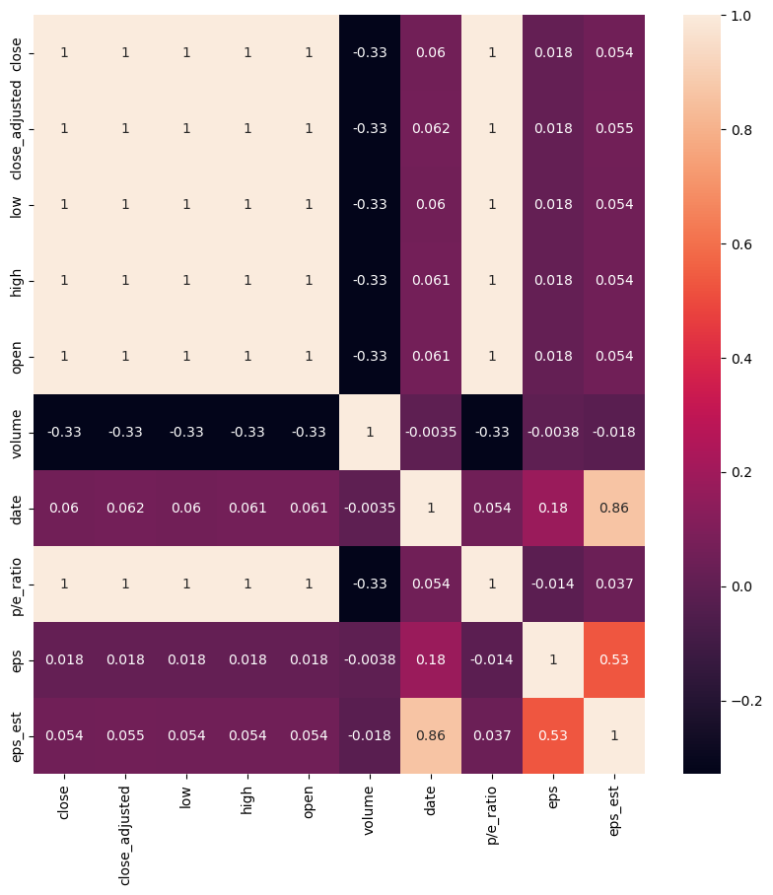

*Figure I: Correlation heatmap of the price features*

Preprocessing was done using standard scaler to scale all train features. Support vector regressor was from sklearn.svm library was used to train a baseline model using four (4) kernel types (linear, poly, rbf and sigmoid). Model evaluation was done using root mean squared error metric. Time series analysis was done by parsing historical prices as features to the model and trend analysis was done using by calculating changes in prices. Missing values were all handled by filling with zero (0). Model interpretation was done by extracting weight coefficients from the models with linear kernels.

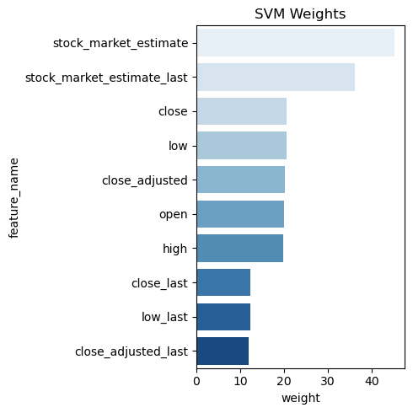

*Figure II: Weights results of the most impactful variables*

*of the SVM Model*

The SVM Model performed similarly with the stock market estimates for:

"MSFT","AAPL","PFE","TSLA","ORCL","MCD","KO","V","XOM","CVX","LMT","BA","GE","WFC","BAC","JPM","MA", "T"

The error was large for GOOGL and AMZN symbols. The accuracy of the model decreased as in latter months/years.

Training of the model with most recent month’s prices improved accuracy as latter more had higher errors compared to months closer to training period. AMZN and GOOGL stocks were harder for the model to predict

1. **Results & Analysis**:
2. **Conclusion**:

**References:**

1. Osisanwo, F. Y., et al. "Supervised machine learning algorithms: classification and comparison." *International Journal of Computer Trends and Technology (IJCTT)* 48.3 (2017): 128-138..