Department of Computer and Software Engineering- ITU
SE102 & CE101: Object Oriented Programming
Course Instructor: Usama Bin Shakeel | Dated: 9th March, 2026
Teaching Assistants: Abdullah, Saad, Tayyab, Daniyal, Fasiha | Semester: Spring 2026
Session: 2025-2029 | Batch: BSSE2025 & BSCE2025

Assignment 6. Implementing Classes Using Multilevel/Multiple Inheritance, Composition, and Operator Overloading

Name | Roll number | Obtained Marks/35

Checked on: ____________________________

Signature: _________________________

3.1 Equipment and Component

Component Description | Quantity
Computer | 1

3.2 Conduct of assignment

- Students are required to perform this assignment individually. Copying from other fellows is strictly prohibited. All assignments will be checked for plagiarism.
- Seek help from the course instructor, lab engineers, assigned teaching assistants (TA) only.

Task 1: Accept the assignment from the link posted in Google Groups and after accepting clone the repository to your computer for this ensure you have logged into github app with your account.
Task 2: Solve the given problems written after task instructions, write code through IDE like CLion
Task 3: Ensure your code/solution is in the cloned folder.
Task 4: Commit and Push the changes through the Github App

3.3 Objective

This assignment is about creating a Fantasy RPG (Role-Playing Game) Guild System. The goal is to use C++ to organize different types of heroes and manage how they work together in a group.You will use Inheritance to create a family tree of characters (like a Warrior becoming a Knight) and Multiple Inheritance to blend different skills together. You will also use Composition to build a Guild that holds a collection of these heroes using a list of pointers.

3.4 Theory and Background
This assignment focuses on ensuring data integrity through Encapsulation, which keeps character statistics like health and power safe from accidental external changes. It also utilizes Operator Overloading to customize standard C++ symbols such as +, >, and += for game objects, allowing for intuitive hero comparisons and recruitment logic. Furthermore, the system emphasizes proper Memory Management by implementing constructors and destructors to ensure that all game characters are created and removed from memory correctly throughout their lifecycle.

Scenario
In the kingdom of Eldoria, peace is maintained by the Guild, an elite organization that manages a roster of diverse Heroes. Every member of the guild starts as a basic Hero with a name, health, and power, but they can specialize into different roles through training and experience. Some heroes follow the path of the Warrior, mastering the use of heavy armor to increase their effective health. The most elite among them become Knights, famous for their "Burst Damage" during a charge. Other heroes explore the arcane, becoming Magical Entities capable of casting powerful spells. The rarest members of the guild are the Spellblades, unique individuals who combine the physical strength of a Warrior with the mystical energy of a Magical Entity.

Question 1: Use the following UML to code

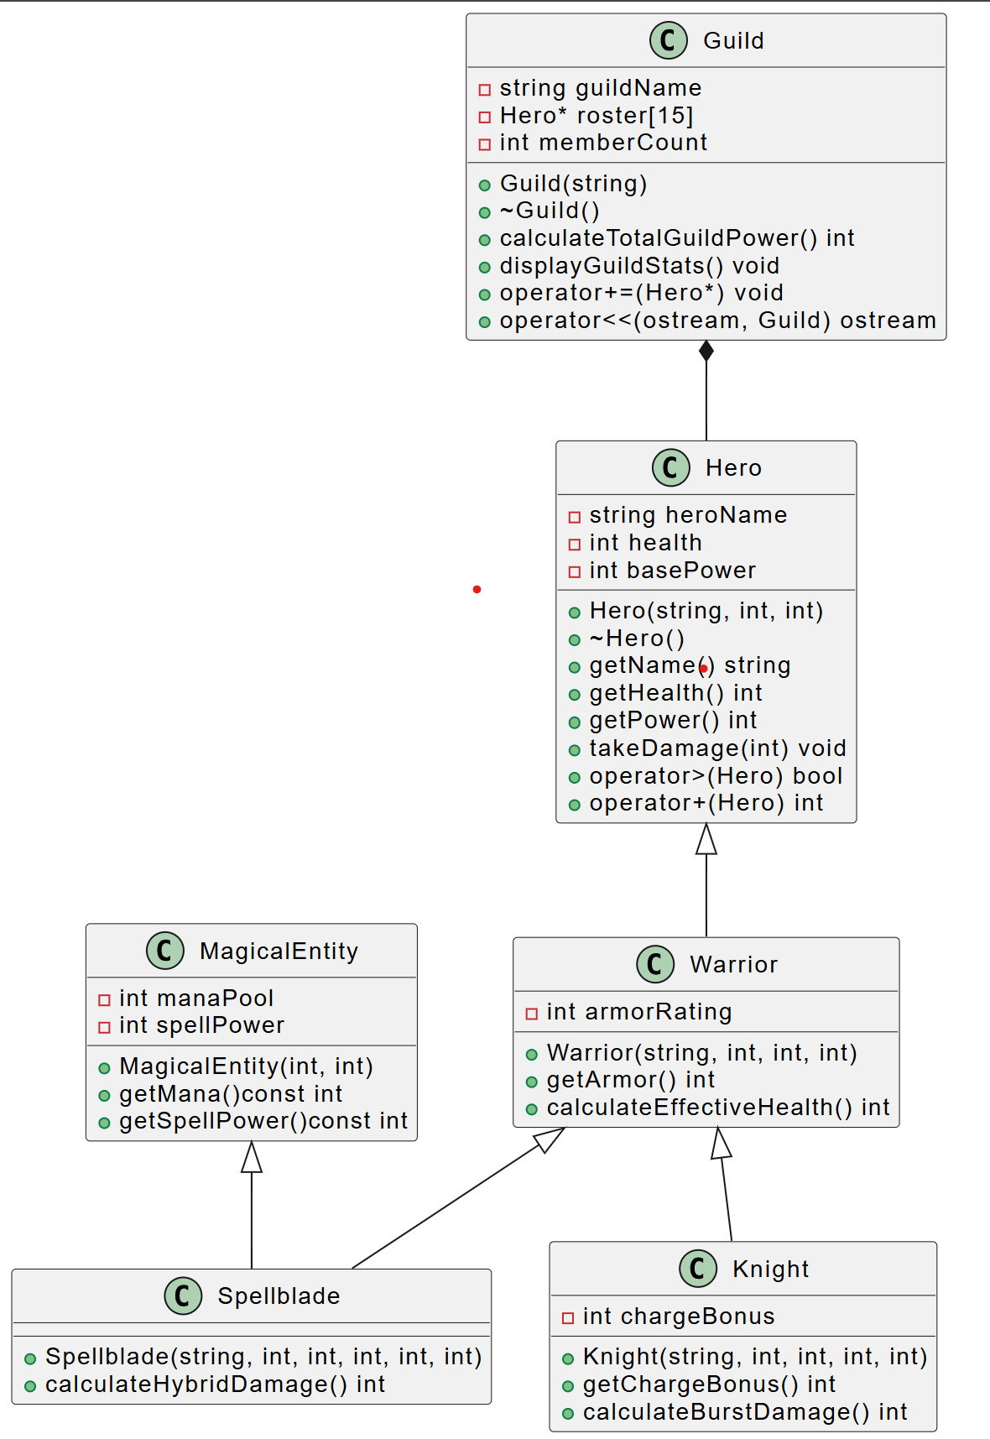

Hero Class

void takeDamage(int damage): This function should subtract the damage value from the hero’s current health. You should include a check to ensure that health does not drop below 0.
- bool operator>(const Hero &other) const: This is a comparison of strength. It should return true if the current hero’s basePower is strictly greater than the other hero’s basePower.
- int operator+(const Hero &other) const: This represents the "Combined Vitality" of two heroes. It should return the sum of the current hero's health and the other hero's health.
Warrior & Knight
- int calculateEffectiveHealth() const (Warrior): This function should return the hero's base health plus a bonus from the armorRating.
  - Formula: Effective Health = Health + (Armor Rating * 2)
- int calculateBurstDamage() const (Knight): This should return the sum of basePower and chargeBonus.
  - Formula: Burst Damage = Base Power + Charge Bonus

Spellblade

int calculateHybridDamage() const: This function should return the total of the basePower and the spellPower .
  - Formula: Hybrid Damage = Base Power + Spell Power

Guild: Management and Output
- void operator+=(Hero* newHero): This function is used to recruit a hero. It should check if memberCount is less than 15. If there is space, add the newHero pointer to the roster at the current memberCount index and increment the count. If the guild is full, it should print an error message: "Guild is at full capacity!"
- friend ostream& operator<<(ostream& os, const Guild& g): This allows you to print the entire Guild status using cout << myGuild;.
  - It should print the Guild Name and then loop through the roster to print the name and power of every hero currently in the guild.

Memory Management (The Destructor)
- ~Guild(): Since the guild "owns" its roster of heroes, the destructor must loop through the roster up to the memberCount and delete each hero pointer to prevent memory leaks. Finally, it should print: "The guild [GuildName] has been disbanded."
Program Requirements
Students must:
- Use separate header and implementation files
- Keep all data members private.
- Use constructors to initialize objects
- Demonstrate inheritance relationships clearly
- Demonstrate multilevel inheritance clearly
- Demonstrate multiple inheritance clearly
- Demonstrate composition clearly
- Demonstrate operator overloading correctly
- Show output in a properly formatted way

Appendix: Theoretical Foundation

1. Encapsulation (Chapter 6 and 7)
Encapsulation is the concept of hiding class data and allowing access only through public member functions.
Encapsulation ensures:
- Data security
- Controlled modification
- Validation of values
- Better modular design

2. Inheritance (Chapter 9)
Inheritance allows a class to reuse properties and behaviors of another class.
This reduces code duplication and promotes logical classification of products.

3. Multilevel Inheritance (Chapter 9)
Multilevel inheritance occurs when a derived class becomes the base of another class.

4. Multiple Inheritance (Chapter 9)
Multiple inheritance allows a class to inherit from more than one base class.

5. Composition (Chapter 9)
Composition represents a strong ownership relationship where one class contains objects of another class.

// Read book page no 376 and onwards for inheritance
// Read book page no 420 and onwards for composition

Access Link: Object-Oriented Programming in C++ (4th Edition) by Robert Lafore.www.eeeuniversity.com.pdf - Google Drive

6. Operator Overloading (https://www.geeksforgeeks.org/cpp/operator-overloading-cpp)
Operator overloading allows you to redefine how standard operators (like +, -, or <<) behave when used with custom class objects. It enables user defined types to be manipulated using the same intuitive syntax as built-in data types

Assessment Rubric for Assignment
Performance metric | CLO | Able to complete the task over 80% (4-5) | Able to complete the task 50-80% (2-3) | Able to complete the task below 50% (0-1) | Marks
- Realization of experiment | 3 | Executes without errors excellent user prompts, good use of symbols, spacing in output. Through testing has been completed . | Executes without errors, user prompts are understandable, minimum use of symbols or spacing in output. Some testing has been completed . | Does not execute due to syntax errors, runtime errors, user prompts are misleading or non- existent. No testing has been completed.
- Conducting experiment | 2 | Able to make changes and answered all questions. | Partially able to make changes and few incorrect answers. | Unable to make changes and answer all questions.
- Computer  use | 3 | Document submission timely. | Document submission late. | Document submission not done.
- Teamwork | 4 | Actively engages and cooperates with other group member(s) in effective manner. | Cooperates with other group member(s) in a reasonable manner but conduct can be  improved. | Distracts or discourages other group members from conducting the experiment
- Laboratory safety and disciplinary rules | 4 | Code comments are added and does help the reader to understand the code. | Code comments are added and does not help the reader to understand the code. | Code comments are not added.
- Data collection | 4 | Excellent use of white space, creatively organized work, excellent use of variables and constants, correct identifiers for constants, No line-wrap. | Includes name, and assignment, white space makes the program fairly easy to read. Title, organized work, good use of variables. | Poor use of white space (indentation, blank lines) making code hard to read, disorganized and messy.
- Data analysis | 3 | Solution is efficient, easy to understand, and maintain . | A logical solution that is easy to follow but it is not the most efficient. | A difficult and inefficient solution .
Total (out of 35):

