Department of Computer and Software Engineering- ITU
SE102 & CE101: Object Oriented Programming
Course Instructor: Usama Bin Shakeel | Dated: 23rd March, 2026
Teaching Assistants: Abdullah, Saad, Tayyab, Daniyal, Fasiha | Semester: Spring 2026
Session: 2025-2029 | Batch: BSSE2025 & BSCE2025

Assignment 8. Advanced OOP Relationships and Polymorphism in a Smart University System

Name | Roll number | Obtained Marks/35
ariba | Bsce22020

Checked on: ____________________________

Signature: _________________________

3.1 Equipment and Component

Component Description | Quantity
Computer | 1

3.2 Conduct of assignment

- Students are required to perform this assignment individually. Copying from other fellows is strictly prohibited. All assignments will be checked for plagiarism.
- Seek help from the course instructor, lab engineers, assigned teaching assistants (TA) only.

Task 1: Accept the assignment from the link posted in Google Groups and after accepting clone the repository to your computer for this ensure you have logged into github app with your account.
Task 2: Solve the given problems written after task instructions, write code through IDE like CLion
Task 3: Ensure your code/solution is in the cloned folder.
Task 4: Commit and Push the changes through the Github App

3.3 Objective

This assignment focuses on building a Smart University Management System in C++ using advanced OOP concepts. The system simulates an academic environment managing students, staff, and teaching assistants. It covers foundational concepts such as encapsulation, composition, aggregation, and association, while heavily emphasizing compile time polymorphism (method and operator overloading), run time polymorphism (virtual functions and overriding), and resolving the Diamond Problem using virtual inheritance.

3.4 Theory and Background
This assignment is based on complex Object Oriented class relationships. The goal is to design a robust and scalable architecture where objects interact securely. A key focus is placed on the Diamond Problem, a multiple inheritance scenario where a class inherits from two classes that both inherit from the same base class. Students will resolve this using virtual inheritance and utilize abstract classes and virtual functions to achieve run time polymorphism.

Scenario
A university operates a centralized digital system to manage its academic and administrative members. The university has distinct roles:
Students, who study and earn GPAs, and Staff members, who work and earn a salary.
However, the university also employs Teaching Assistants (TAs). A TA acts as both a Student and a Staff member, creating a multiple inheritance scenario. The system manages these individuals, issues access cards, tracks tutoring sessions between TAs and Students, and processes grading.

Question 1: Design and implement the following classes

UniversityMember (Abstract Base Class)  Private Attributes:  - string name  - int memberID  Public Functions:  - UniversityMember(string name, int memberID)  - Virtual ~UniversityMember()  - string getName()  - int getMemberID()  - virtual void displayRole() = 0; (Pure Virtual Function)  Purpose:  This acts as an abstract base class. The pure virtual function forces derived classes to override it, demonstrating Run Time Polymorphism and Method Overriding. | AccessCard Class  Represents the physical ID card given to staff members for building access.  Private Attributes:  - string cardID  - int accessLevel (e.g., 1 for basic, 2 for labs)  Public Functions:  - AccessCard(string cardID, int accessLevel)  - string getCardID()  - int getAccessLevel()  - void displayCardInfo() | Student Class (Virtually Derived from UniversityMember)  Private Attributes:  - double cgpa  Public Functions:  - Student(string name, int memberID, double cgpa)  - double getCGPA()  - void updateCGPA(double newCGPA)  - void displayRole() override (Overrides base class function)  Purpose:  Must use virtual inheritance from UniversityMember to prevent ambiguity later.

Staff Class (Virtually Derived from UniversityMember)  Private Attributes:  - double salary  - AccessCard card (Demonstrates Composition)  Public Functions:  - Staff(string name, int memberID, double salary, AccessCard card)  - double getSalary()  - void displayRole() override (Overrides base class function)  - void displayCard()  Purpose:  Must use virtual inheritance from UniversityMember. The inclusion of AccessCard demonstrates composition. | TeachingAssistant Class (Derived from Student and Staff)  Private Attributes:  - int workingHours  Public Functions:  - TeachingAssistant(string name, int memberID, double cgpa, double salary, AccessCard card, int workingHours)  - void displayRole() override  - void gradeAssignment(int score)  - void gradeAssignment(string letterGrade)  Purpose:  Inheriting from both Student and Staff causes the Diamond Problem. Because Student and Staff virtually inherited from UniversityMember, the TA class will only have one instance of the name and memberID attributes. The multiple gradeAssignment methods demonstrate Compile-Time Polymorphism (Method Overloading). | TutoringSession Class  Private Attributes:  - int sessionID  - double durationMinutes  - TeachingAssistant* ta (Demonstrates Association)  - Student* student (Demonstrates Association)  Public Functions:  - TutoringSession(int sessionID, double durationMinutes, TeachingAssistant* ta, Student* student)  - double getDuration()  - void displaySession()  - TutoringSession operator+(const TutoringSession& other); (Member Operator Overloading)  Rules:  - The + operator allows two sessions to be merged, returning a new TutoringSession object where the durationMinutes is the sum of both.  Non-member Operator Overloading:  - bool operator>(TutoringSession s1, TutoringSession s2); Compares two sessions and returns true if s1 is longer than s2.

Department Class

The department HAS-A collection of University Members.

Private Attributes:

string departmentName

UniversityMember* members[50] (Demonstrates Aggregation and Polymorphic Collections)

int memberCount (To track the current number of members added)

Public Functions:

Department(string departmentName)

void addMember(UniversityMember* member)

void displayAllRoles()

Logic for displayAllRoles():

Loop through the members array and call displayRole() on each pointer. Due to run-time polymorphism, this will automatically call the correct overridden method (Student, Staff, or TA).

University member.h ,cpp
#ifndef UNIVERSITYMEMBER_H
#define UNIVERSITYMEMBER_H

#include <string>
#include <iostream>

using namespace std;

class UniversityMember {
protected:
string name;
int memberID;
public:
UniversityMember(string n, int id);

// Virtual destructor for polymorphic
virtual ~UniversityMember();
// attributes
string getName() const;
int getMemberID() const;
virtual void displayRole() = 0;
};

#endif
.cpp
#include "UniversityMember.h"

// Corrected constructor logic
UniversityMember::UniversityMember(string n, int id) {
name = n;
memberID = id;
}

UniversityMember::~UniversityMember() {

}

string UniversityMember::getName() const {
return name;
}
int UniversityMember::getMemberID() const {
return memberID;
}

TUTORINGSESSION.h,cpp
#ifndef TUTORINGSESSION_H
#define TUTORINGSESSION_H

#include "TeachingAssistant.h"
#include "Student.h"

class TutoringSession {
private:
int sessionID;
double durationMinutes;
TeachingAssistant* ta; // Association
Student* student; // Association

public:
TutoringSession(int id, double dur, TeachingAssistant* t, Student* s);
double getDuration() const;

// Member + Operator
TutoringSession operator+(const TutoringSession& other);
};

// Non-member
bool operator>(const TutoringSession& s1, const TutoringSession& s2);

#endif

.cpp
#include "TutoringSession.h"

TutoringSession::TutoringSession(int id, double dur, TeachingAssistant* t, Student* s)
: sessionID(id), durationMinutes(dur), ta(t), student(s) {}

double TutoringSession::getDuration() const {
return durationMinutes;
}

TutoringSession TutoringSession::operator+(const TutoringSession& other) {
return TutoringSession(
this->sessionID, this->durationMinutes + other.durationMinutes, this->ta, this->student);
}

bool operator>(const TutoringSession& s1, const TutoringSession& s2) {
return s1.getDuration() > s2.getDuration();
}

Teachingasssistant.h
#ifndef TEACHINGASSISTANT_H
#define TEACHINGASSISTANT_H

#include "Student.h"
#include "Staff.h"

class TeachingAssistant : public Student, public Staff {
private:
int workingHours;

public:
TeachingAssistant(string n, int id, double g, double s, AccessCard c, int h);

void displayRole() override;

// Method Overloading for Test 6
void gradeAssignment(int score);
void gradeAssignment(string letterGrade);
};

#endif

.cpp
#include "TeachingAssistant.h"

TeachingAssistant::TeachingAssistant(string n, int id, double g, double s, AccessCard c, int h)
: UniversityMember(n, id), Student(n, id, g), Staff(n, id, s, c), workingHours(h) {}

void TeachingAssistant::displayRole() {
cout << "Role: Teaching Assistant" << endl;
}

void TeachingAssistant::gradeAssignment(int score) {
cout << "numeric score: " << score << "/100" << endl;
}

void TeachingAssistant::gradeAssignment(string letterGrade) {
cout << "letter grade: " << letterGrade << endl;
}

Student.h
#ifndef STUDENT_H
#define STUDENT_H

#include "UniversityMember.h"

class Student : virtual public UniversityMember {
protected:
double cgpa;

public:
Student(string n, int id, double g);
double getCGPA() const;
void updateCGPA(double newCGPA);

// Overriding
void displayRole() override;
};

#endif

.cpp
#include "Student.h"

Student::Student(string n, int id, double g) : UniversityMember(n, id), cgpa(g) {}

double Student::getCGPA() const {

return cgpa;
}

void Student::updateCGPA(double newCGPA) {
cgpa = newCGPA;
}

void Student::displayRole() {
cout << "Role: Student" << endl;
}

Staff.h
#ifndef STAFF_H
#define STAFF_H

#include "UniversityMember.h"
#include "AccessCard.h"

class Staff : virtual public UniversityMember {
private:
double salary;
AccessCard card;

public:
Staff(string name, int memberID, double salary, AccessCard card);

// Getters
double getSalary() const;

// Overriding
void displayRole() override;

void displayCard() const;
};

#endif

.cpp

#ifndef STAFF_H
#define STAFF_H

#include "UniversityMember.h"
#include "AccessCard.h"

class Staff : virtual public UniversityMember {
private:
double salary;
AccessCard card;

public:
Staff(string name, int memberID, double salary, AccessCard card);

//
Getters
double getSalary() const;

// Overriding
void displayRole() override;

void displayCard() const;
};

#endif

Department.h
#ifndef DEPARTMENT_H
#define DEPARTMENT_H

#include "UniversityMember.h"
#include <vector>

class Department {
private:
string departmentName;
vector<UniversityMember*> members; // Aggregation

public:
Department(string name);
void addMember(UniversityMember* member);
void displayAllRoles();
};

#endif

.cpp
#include "Department.h"

Department::Department(string name) {
departmentName =name;
}

void Department::addMember(UniversityMember* member) {
members.push_back(member);
}

void Department::displayAllRoles() {
for (auto m : members) {
m->displayRole(); // polymorphism
}
}

Main.cpp
#include "Department.h"
#include "TeachingAssistant.h"
#include "TutoringSession.h"

int main() {
AccessCard card("AC-101", 5);
TeachingAssistant ta("John Doe", 5001, 3.8, 2000, card, 10);
Student s("Jane Smith", 6001, 3.9);

Department cs("Computer Science");
cs.addMember(&ta);
cs.addMember(&s);

cout << "Displaying All Roles:" << endl;
cs.displayAllRoles();

TutoringSession sess1(1, 60.0, &ta, &s);
sess1.operator+(sess1); // Testing

return 0;
}

Uml
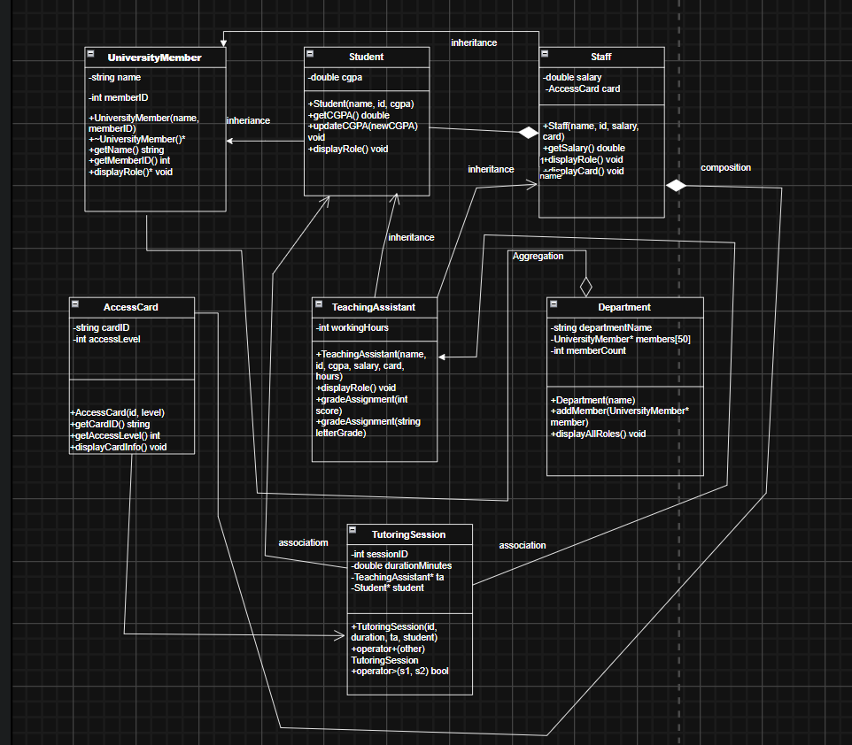

Program Requirements
Students must:
- Use separate header (.h) and implementation (.cpp) files for each class.
- Keep all data members private and access them using public getter/setter functions.
- Demonstrate Run Time Polymorphism by using an Abstract Base Class (UniversityMember) and overriding displayRole() in all derived classes.
- Solve the Diamond Problem by using virtual inheritance for Student and Staff.
- Demonstrate Compile Time Polymorphism by overloading the gradeAssignment() method in the TeachingAssistant class.
- Demonstrate Composition by including an AccessCard object inside the Staff class.
- Demonstrate Aggregation by storing a collection of UniversityMember* pointers inside the Department class.
- Demonstrate Association by linking TeachingAssistant and Student pointers in the TutoringSession class.
- Implement member operator overloading (+) in the TutoringSession class.
- Implement non-member operator overloading (>) to compare two TutoringSession objects based on duration.
- In the main() function:
  - Create multiple AccessCard, Student, Staff, and TeachingAssistant objects.
  - Add them to a Department object and invoke displayAllRoles() to prove run-time polymorphism works.
  - Demonstrate compile-time polymorphism by calling both versions of gradeAssignment().
  - Create two TutoringSession objects and demonstrate both the + and > operator overloads.

Appendix: Theoretical Foundation
1. Encapsulation (Chapter 6 and 7)
Encapsulation is the concept of hiding class data and allowing access only through public member functions. In this system, attributes such as memberID, cgpa, salary, durationMinutes, and workingHours are kept private within their respective classes and can only be accessed or modified safely through public getter and setter functions.

2. Inheritance (Chapter 9)
Inheritance allows a class to reuse properties and behaviors of another class, reducing code duplication and promoting logical classification. Both the Student and Staff classes inherit common attributes, such as name and memberID, from the UniversityMember base class.

3. Composition (Chapter 9)
Composition represents a strong ownership relationship where one class contains objects of another class by value. In this system, each Staff object contains an AccessCard object. When a Staff object is destroyed, its associated AccessCard object is also destroyed, as the card cannot exist independently of the staff member who owns it.

4. Aggregation (Chapter 9)
Aggregation represents a weak ownership relationship where one class contains references or pointers to objects of another class, but those objects can exist independently. The Department class manages a collection of UniversityMember pointers, but the students and staff members can exist independently outside of that specific department.

5. Association (Chapter 8)
Association represents a relationship between independent classes where objects interact with each other but do not own each other. The TutoringSession class connects a TeachingAssistant and a Student using pointers to represent an academic meeting between two independent individuals.
6. Operator Overloading (Chapter 8)
Operator overloading allows programmers to redefine the behavior of standard operators for user-defined classes.
- Member Operator Overloading: The + operator is overloaded in the TutoringSession class to combine the duration of two separate sessions into a single new session.
- Non-Member Operator Overloading: The > operator is overloaded to compare two TutoringSession objects based on their total duration in minutes.
7. Compile-Time Polymorphism (Chapter 8)
Compile-time polymorphism, achieved through method overloading, allows multiple functions with the same name to exist within a class, provided their parameter lists differ. The compiler determines which function to call based on the arguments passed. In the TeachingAssistant class, the gradeAssignment() method is overloaded to handle different grading formats: one accepts an integer (numeric score) and the other accepts a string (letter grade).

8. Run-Time Polymorphism and Method Overriding (Chapter 11)
Run-time polymorphism occurs when a derived class overrides a virtual function from its base class, allowing the program to dynamically determine which function to execute at run-time based on the object's actual type. In the system, the displayRole() function is declared as virtual in the UniversityMember base class and overridden in the Student, Staff, and TeachingAssistant classes. When the Department class iterates through a collection of base class pointers, it correctly executes the specific overridden function for each member type.

9. Abstract Classes and Pure Virtual Functions (Chapter 11)
An abstract class is a class that contains at least one pure virtual function and serves as a strict blueprint; it cannot be instantiated directly as an object. The UniversityMember class acts as an abstract base class because it contains the pure virtual function virtual void displayRole() const = 0;. This enforces a structural rule ensuring that any specific role derived from it must provide its own implementation of this method.

10. The Diamond Problem and Virtual Inheritance (Chapter 9)
The Diamond Problem is a logical ambiguity that arises in multiple inheritance when a class inherits from two derived classes that share a common base class. Without intervention, this results in duplicate copies of the base class's attributes. In this assignment, TeachingAssistant inherits from both Student and Staff, which both inherit from UniversityMember. To resolve this, Student and Staff use virtual inheritance (virtual public UniversityMember), which guarantees that only a single, shared instance of the name and memberID attributes is created for the TeachingAssistant object.

Access Link: Object-Oriented Programming in C++ (4th Edition) by Robert Lafore.www.eeeuniversity.com.pdf - Google Drive

Assessment Rubric for Assignment
Performance metric | CLO | Able to complete the task over 80% (4-5) | Able to complete the task 50-80% (2-3) | Able to complete the task below 50% (0-1) | Marks
- Realization of experiment | 3 | Executes without errors excellent user prompts, good use of symbols, spacing in output. Through testing has been completed . | Executes without errors, user prompts are understandable, minimum use of symbols or spacing in output. Some testing has been completed . | Does not execute due to syntax errors, runtime errors, user prompts are misleading or non- existent. No testing has been completed.
- Conducting experiment | 2 | Able to make changes and answered all questions. | Partially able to make changes and few incorrect answers. | Unable to make changes and answer all questions.
- Computer  use | 3 | Document submission timely. | Document submission late. | Document submission not done.
- Teamwork | 4 | Actively engages and cooperates with other group member(s) in effective manner. | Cooperates with other group member(s) in a reasonable manner but conduct can be  improved. | Distracts or discourages other group members from conducting the experiment
- Laboratory safety and disciplinary rules | 4 | Code comments are added and does help the reader to understand the code. | Code comments are added and does not help the reader to understand the code. | Code comments are not added.
- Data collection | 4 | Excellent use of white space, creatively organized work, excellent use of variables and constants, correct identifiers for constants, No line-wrap. | Includes name, and assignment, white space makes the program fairly easy to read. Title, organized work, good use of variables. | Poor use of white space (indentation, blank lines) making code hard to read, disorganized and messy.
- Data analysis | 3 | Solution is efficient, easy to understand, and maintain . | A logical solution that is easy to follow but it is not the most efficient. | A difficult and inefficient solution .
Total (out of 35):

